- Read multiple JSON files into a directory to convert into a dataset.
I have files text1, text2 and text3 in the directory JSON
Answer: .R file is saved in the GIT repository and below is the screenshot.
There are several ways but the way I got it is below one, there will be different approach all together if we have to read all the json files without knowing how much are available in directory, we can use iteration (preferably for loop) to get the result. But below is the only for 3 json files as per the question.
Below are the json source files text2,text3 and text4.json files
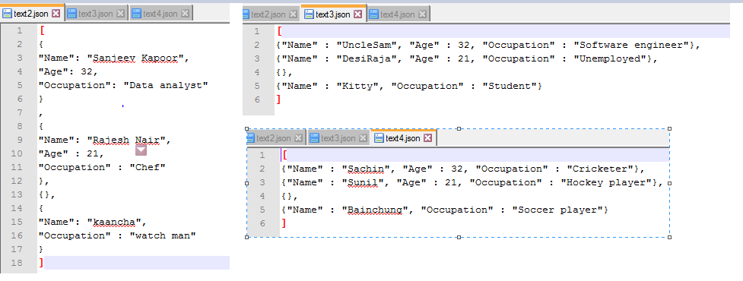
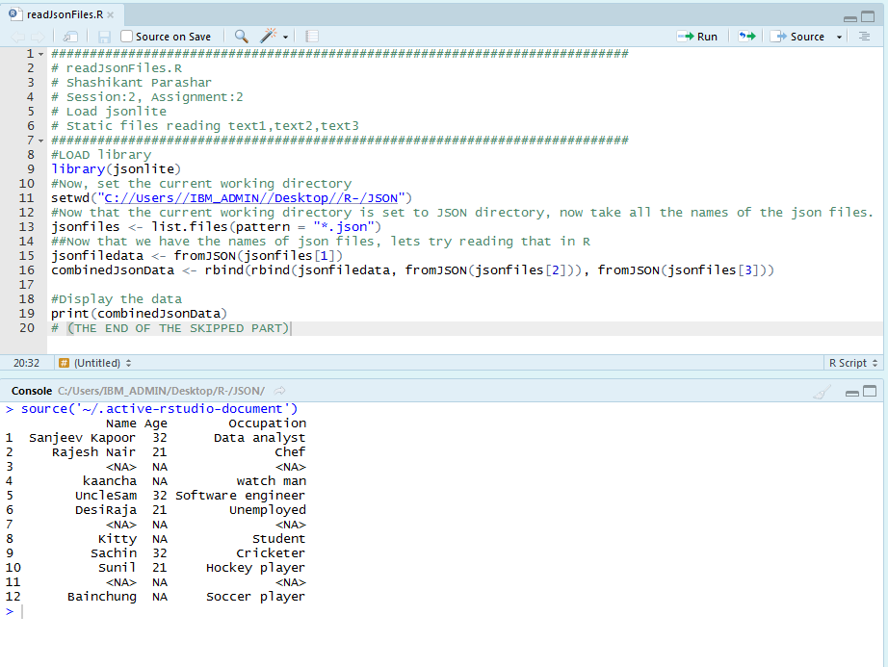
- Parse the following JSON into a data frame.
js<-'{ "name": null, "release_date_local": null, "title": "3 (2011)",
"opening_weekend_take": 1234, "year": 2011,
"release_date_wide": "2011-09-16", "gross": 59954
}'
Answer:
What I understand out of the question is to convert this character class into data frame, please correct if it’s not and based on my understanding below is the code snapshot, .R will be save in Git repository
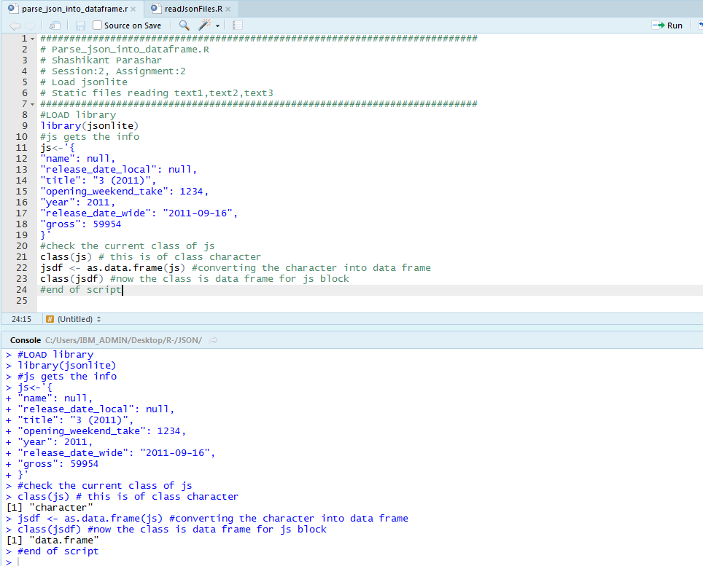
- Write a script for Variable Binning using R. (BinAge.R is placed in GIT repository as well)
