**Breath First Crawling:**

In Breath First Crawling, we do the following:

Step 1: When a page is visited, get all the links in page that match our criteria and add it to

list L = [L1, L2, L3] and increment Depth (D =1) by 1.

Step 2: Crawl all the links in the list L and get the new links from L1, L2 and L3

Step 3: Go to L1 and crawl all the links in L1, then do the same for L2 and L3

Step 4: Go to Step 1 and do the same with new links, stop crawling when you find 1000

unique links or When Depth is more than 5.

In our BFS crawling, we found 1000 unique links before we could reach depth 5. Below image displays the top 5 results

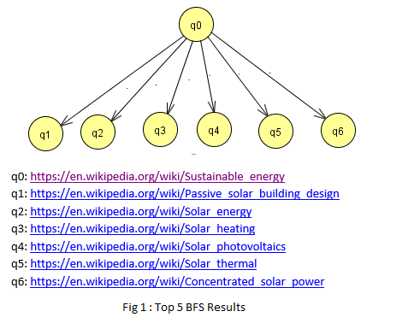

**Depth First Crawling:**

In Depth First Crawling, we do the following:

Step 1: When a page is visited, get all the links in page that match our criteria and add it to

list L = [L1, L2, L3] and increment Depth (D =1) by 1.

Step 2: Go to L1 and crawl all the links and add to another list S = [S1, S2, S3] and increment

Depth by 1 (now D = 2).

Step 3: Go to Step 4 if depth reaches 6 else Go to Step 2 and do the same with new links

from S1.

Step 4: If Depth has reached 6 for all the links or if 1000 unique links are crawled then stop

crawling

In our DFS crawling, we found 541 unique links with depth 5. Below image displays the top 5 results

