Crow:

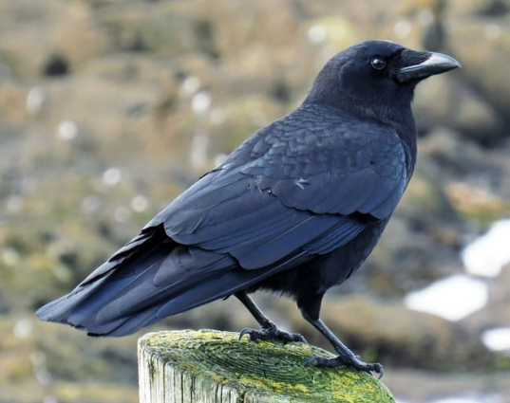

A **crow** is a common black bird that found everywhere. It has brown eyes, black legs, and a short tail. It eats fruits, grain, insects, warms and flesh. It has very harsh voice. It caws loudly. The common crow may usually live for about 7 years, although some have lived as long as 14 years in the wild. It eats fruits, worm, eggs and flesh. A crow is a natural cleaner. The crow lives in a tree and in groups. It is very intelligent bird.

Facts about Crow:

1. Crows have the biggest brain to body ratio among all bird species. Evolved with a highly developed fore brain, where intelligence is regulated, the anatomy of the crow brain is much similar to humans’.
2. Within the crow species, the smallest crow in the world is, the Dwarf Jay from Mexico, which is about 21.5 cm long. It weighs 40 g.
3. Crows are very social and can even bond with humans. Commonly, it has been noticed that crows forage on the food disposed by humans. Moreover,