## A

**Project Report**

**On**

**STUDY OF CONSTRUCTION EFFECTS AND PREVENTION OF FAILURES IN HIGH RISE BUILDING**

## Submitted to partial fulfilment for the award of the degree in

### BACHELOR OF TECHNOLOGY

### IN

**CIVIL ENGINEERING**

**OF**

**JAWAHARLAL NEHRU TECHNOLOGY UNIVERSITY, HYDERABAD**

**Submitted by**

**G.AMITHA (18S41A0117)**

**B.RAVITEJA (19S45A0108)**

**K.SHASHIVARDHAN (18S41A0126)**

**D.SAICHANDU (19S45A0121)**

**G.SAICHANDRA (18S41A0114)**

**Under the esteemed guidance of**

**Ms. V. HARIPRIYA**

**Asst.Prof.**

**CIVIL Department**



**Department of Civil Engineering**

#### VAAGESWARI COLLEGE OF ENGINEERING

#### (Recognized by AICTE & Affiliated to SBTET, Hyderabad)

**Ramakrishna Colony, Karimnagar-505481.**

**2018-2022**

**VAAGESWARI COLLEGE OF ENGINEERING**

**(Recognized by AICTE & Affiliated to SBTET, Hyderabad)**

**Ramakrishna Colony, Karimnagar-505481.**



**CERTIFICATE**

This is to certify that mini project report entitled **“STUDY OF CONSTRUCTION EFFECTS AND PREVENTION OF FAILURES IN HIGH RISE BUILDING”** submitted by the following students in partial fulfillment of the requirements for the award of the Degree of Bachelor of Technology in Civil Engineering, and is a bonafide record of the work performed by

**G.AMITHA (18S41A0117)**

**B.RAVITEJA (19S45A0108)**

**K.SHASHIVARDHAN (18S41A0126)**

**D.SAICHANDU (18S45A0121)**

**G.SAICHANDRA (18S41A0114)**

The work embodied in this mini project report has not been submitted to any other institution for the award of any degree.

Guide Head of the Department

**Ms. V. HARIPRIYA**  **Mr. K. RAJESH**

Asst. Prof. Head of the Department

Civil Engineering Department Civil Engineering Department

**ACKNOWLEDGEMENT**

We wish to pay our sincere thanks to **Dr.Ch.Srinivas**, Principal, Vaageswari College of Engineering, Karimnagar for providing all required facilities and his support during the project work.

We would like to thank **Mr. K.RAJESH,** Assistant Professor and HOD of Civil Engineering Department, for his valuable suggestions during the project work.

We sincerely extend our thanks to project guide **Ms. V.HARIPRIYA,** Assistant Professor of Civil Engineering Department for sparing her valuable time in guiding the project work and giving feedback with a lot of useful suggestion during the project work.

We are also conveying our heartfelt thanks to the Institute authority, Department, Library and Laboratory staffs of Vaageswari College of Engineering for their co-operation during our project. We thank our beloved friends for their help and encouragement regarding the concepts and experimentations.

**ABSTRACT**

High rise buildings are commonly constructed in densely populated cities or urban areas the construction of high rise buildings provides comfort living standard for people and also help in the planning of the cities. The main purpose of this project is to present the construction of high rise buildings using the different techniques and for the growing for the growing of population demand of the high rise buildings. In high rise buildings the people are affected in many pathways to infection spread, the form of epidemiological point of view is air borne transport microorganism can became airborne when droplets are generated during speech, coughing, sneezing, vomiting or atomization of faces during sewage removal. In high rise buildings to increase the stability the combination of modules with steel or concrete frames used to increase the range of design opportunities. Defects are categorized according to their causes, there are three major categories in which defects can be classified i.e, controllable failures, uncontrollable failures and design failures.

**CONTENTS**

**TITLE PAGE.NO**

**CHAPTER 1**

**INTRODUCTION**

* 1. Objectives of study
  2. High-Rise structures in India

**CHAPTER 2**

**LITERATURE REVIEW**

2.1 Types of foundation used for High-Rise building 5

**CHAPTER 3**

**MATERIALS USED FOR CONSTRUCTION OF HIGH RISE BUILDING**

3.1 High-Rise Buildings (Towers) Economics

**CHAPTER 4**

**CONSTRUCTION METHODS AND TECHNIQUES FOR HIGH RISE BUILDING**

4.1 Economic studies for High-Rise Building 32

4.2 Types of construction used for High-Rise Building 34

**CHAPTER 5**

**DESIGN STANDARDS OF HIGH-RISE BUILDINGS**

5.1 The location of High-Rise Building and its impacts 38

**CHAPTER 6**

**EFFECTS OF CONSTRUCTING HIGH-RISE BUILDING**

6**.**1 Preventions of constructing High-Rise Building

**CHAPTER 7**

**ADVANTAGES AND DISADVANTAGES OF HIGH-RISE BUILDING**

**NEEDS AND CONSEQUENCES**

**CONCLUSION** 39

**REFERENCES**

**LIST OF FIGURES**

**Figures Page No.**

Fig.1.1 Burj Khalifa, Dubai

Fig.1.2 Palais Royale, Mumbai

Fig.3.1 Vinderen (bouwkunde)

Fig.4.1 Slip Form

Fig.4.2 Braced Frames

Fig.4.3 John Hancock Centre, USA

Fig.4.4 Rigid frame structural system

Fig.4.5 Shear wall system

Fig.4.6 Core & outrigger structural system

Fig.4.7 In filled frame structural system

Fig.4.8 Flat plate structural system

Fig.4.9 Tube structural system

Fif.4.10 Coupled wall system

**CHAPTER 1**

**INTRODUCTION**

High-rise buildings have always been a key construction development over the years in keeping pace with the increasing demand of human population. This in turn had shifted the attention of engineers and designers in looking into various possible way of building or construction the safe sound structure. Typical high-rise building can be categorized as reinforced concrete frame or steel frame.

Rapid advancement in field of construction had given a platform for steel construction to develop at enlarging scale. Steel frame, for instance is a structure in which the weight is carried by steel skeleton or framework, as it is opposite to wall support system. It was true enough that steel frame has many advantages compared to ordinary reinforcement concrete frame in terms of faster time of erection, better quality control, design flexibility, sustainability, and lesser weight than RC structures which in turn requires lighter foundation, and occupies.

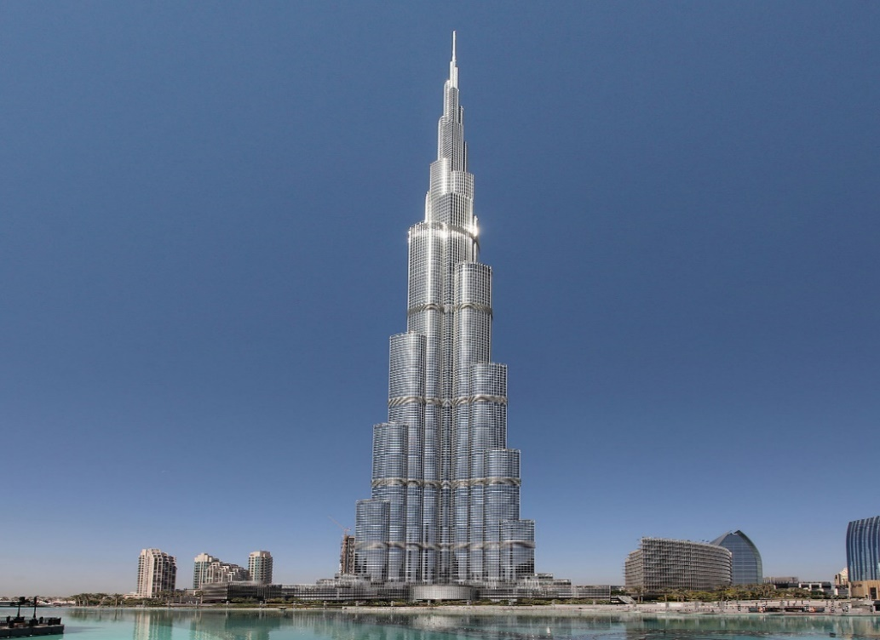

Fig. 1.1 Burj Khalifa, Dubai

less space which can be designed for larger span/column free spaces. Basically, the mechanism of loads distribution for both steel frame reinforced concrete frame are similar, in which load from the beam was transferred to column, and finally to the foundation. Steel frame particularly function well under high lateral (wind) loading, because of its ductility, and that’s make it preferable in high-rise structure.

**1.1 OBJECTIVES OF STUDY**

**The objectives of this study are;**

1. To study the effect of different bracing type on the lateral built of 30-stories steel frame building.
2. To analyze the effect of varying the position of bracing prior to minimization to lateral drift of 30-stories steel frame buildings.
3. To compare the effect of pin connection only to a combination of pin-moment connection in reducing the lateral built of 30-stories steel frame building.
4. To study elements effecting the constructing the high rise building.
5. To study the suitable location for constructing buildings.

**1.2 SCOPE OF STUDY**

1. “To study the different construction techniques like cast-in-situ and precast adopted by major players for high rise development, analyse and compare them to determine the ones that would be most suitable in the Indian high rise construction scenario.”

2. “The study encompasses the analysis of construction techniques used for high rise buildings which would be suitable for large scale used in the Indian scenario”.

**1.3 CLASSIFICATION OF HIGH RISE BUILDING**

* The development can be categorized in four categories considering different philosophy: High Rise with High Density; High Rise with Low Density; Low Rise with High Density; and Low Rise with Low Density.
* In India, a building greater than 75ft (23 m), generally 7 to 10 stories, is considered as high-rise.
* Also a building is considered to be high-rise when it extends higher than the maximum reach available to fire fighters.
* According to the building code of India, a tall building is one with four floors or more or a high-rise building is one 15 meters or more in height.

**1.4 HIGH RISE STRUCTURES IN INDIA**

Indian cities are witnessing immense demographic expansion due to migration from surrounding villages, leading to urban sprawl, housing demand, rise in cost of land. Many citizens all over India migrate to the cities for better jobs and education. Industries, trade and commerce activities and number of educational centres in cities attract floating population from all their surrounding villages and districts. This has expanded the cities in all directions and all aspects of development. With an urban sprawl of kilometres, these face the problems of congestion, pollution, everyday commuting to work place, competition, deforestation etc. Study of High Rise Residential Buildings in Indian Cities (A Case Study –Pune City) Rupali Kavilkar and Shweta Patil IACSIT International Journal of Engineering and Technology, Vol. 6, No. 1, February 2014 87 .

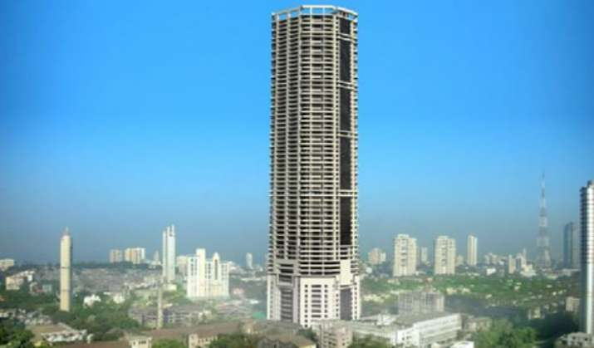

Fig.1.2 Palais Royale, Mumbai

Most of the tall buildings in India are in the commercial capital Mumbai. More than 2500 high-rise buildings are already constructed. In addition more than thousand mid-rises exists already in the city. Mumbai is undergoing a massive construction boom, with thousands of tall buildings and about fifteen high-rise structures are under construction. Delhi and its surrounding regions are witnessing huge construction activities with 1500 already constructed high-rises.

**CHAPTER 2**

**LITERATURE REVIEW**

A building 35 meters or greater in height, which is divided at regular intervals into occupiable levels. From structural point of view, a building is considered as tall when its structural analyses and design are affected by lateral loads, particularly sway caused by such loads. Under wind load the overturning moment at the base of a building varies in proportion to the square of the height of the building, and lateral deflection varies as the fourth power of the height of the building, other things being the equal. Tall buildings are increasingly being constructed across India’s modern landscape as the country grapples with the huge influx of people arriving in its major cities from rural areas. With 50 percent of India’s population expected to live in urban areas by 2030, there is a great demand for tall buildings and high rise structures in the residential and commercial space.

“Today it is almost impossible to imagine a major city without tall buildings. As the most important symbols of today’s cities, tall buildings have become a source of faith in technology and national pride, and have changed the concept of the modern city along with its scale and appearance. Despite the fact that tall buildings have moved city life away from the human scale, in general it is accepted that these buildings are an inevitable feature of urban development.” Even though, high–rise buildings occupied architectural and construction scene and do play an important role for solving excessive land consumption problems and problems of accommodation in overpopulated zones, architectural critic are generally describing high–rises as gigantic hazards in urban areas and tools to show off the prestige, power and wealth; which do create environment oversized if compared to human scale and do cause harmful influences on environment.

As everything, high-rise buildings do have its advantages and disadvantages, but one is sure, high–rise buildings are accepted by mass population. It is common for every urban area to have structures and buildings which are characterized as high–rise because they outstand among other buildings in surrounding, primarily by height.

Nowadays, around developed urban areas which are living high–rise, there are concrete plants which daily produce concrete with compressive strengths up to 95MPa.Bosnia and Herzegovina and Balkan area were undergoing rapid urbanization and development during late fifties and early sixties of the last century. Sarajevo, Zeneca Tuzla Mostar. Bihać were enriched with numerous high–rises. Unlike World’s scene Yugoslavia were strictly functioned as residential with few exceptions, and generally were structured with concrete. For the country at the beginning of industrialization process, where large migrations were toward urban zones, high–rise residential settlements were logic solution to prevent excessive land consumption and to for urban and spatial plans. The last war (1992–1995) stopped technological development in all fields in Bosnia and Herzegovina, and the years after the war were dedicated to suffered many accidental impacts during the war years. However the resistance of concrete structures largely saved many buildings. Lately, Bosnia and Herzegovina is being enriched by new samples of the high–rise buildings with more architectural valued high–rises. However, low material technological development is not enabling the possibility for any of futuristic worldwide seen structures. Structural engineers, architects and designers in Bosnia and Herzegovina are still rather choosing the concrete than any other material, but concrete technology is still remaining at conventional–normal strength concrete.

Thus, there are numerous rigid frame structures with oversized columns, beams, and overuse of raw material, meaning on aggregate, cement, and super plasticizer while there are materials which are sufficient for the first researches on high– strength concrete and later on productions. Presently, there are numerous easy ways to find out about newest technologies and knowledge. This book is being concerned at the high–rise buildings, from what are the most successful high–rises worldwide, its structural, architectural, mechanical design, its resistance as physical object in different environments, at different loadings and actions to the situation in Bosnia and Herzegovina and ability to catch up with new concrete technologies using domestic materials.

Concepts and forms of the high–rise buildings are under constant change. Specific and detailed analysis of phenomena, high–rise buildings raises different questions, opinions and understandings, both supportive and those critical ones. Along with the idea of high–rise buildings, there is mostly dose of skepticism after announcement of its primary design due to oversize when compared to human scales. However high– rise buildings are widely becoming accepted as part of the lifestyle and represent great urban development, national pride and construction, which is undoubtedly environmental friendly and efficient at least in decrease of land overconsumption.

Even though this book is concerned on contemporary high–rise building’s structures and material technology development, it also includes historical analysis of what, when and how society ended up with these monumental structures.

According to the short documentary published by New York Times “A Short History of the High-Rises” by Katarina Cizek, the historical analysis of high–rise begins back in 2500 BC. This documentary contain four parts “Mud”, “Concrete” , “Glass” and “Home”, which express the power of vertical living and variety in materials used for high-rise construction from mud and dusty sands in Yemen to advanced high–strength materials (steel and concrete) with curtain glass walls all around the world. Documentary “A Short History of High-Rises” gave excellent sinsight toward phenomena of high–rise buildings.

However, turnkey for high–rise buildings and forms we are familiar with nowadays according to Mark Sardinian are large fires which burnt large area of the Chicago and initiate diverse thinking in both designs and technologies. In his book, “Designing Tall Buildings, Structure as Architecture” he wrote:

“The fire of 1871 devastated the city of Chicago but created an opportunity to re-think design and construction in an urban environment, to consider the limits of available, engineered building materials, to expand on the understanding of others, and to conceive and develop vertical transportation systems that would move people and materials within taller structures.“

To enrich the collected data with situation in the area of Bosnia and Herzegovina, literature includes vision and perception of one of the most important modernist architect of former Yugoslavia, Ivan Straus. His book, “The Architecture of Bosnia and Herzegovina, 1945–1991”, [39] informs us about the most successful high–rise buildings in entire area of Bosnia and Herzegovina through this period. However, as the architect and architectural critic, Straus had chance to choose those building which outstand among the others and represent valuable architectural object partially expressing subjective opinion. Such approach to analysis of architecture in Bosnia and Herzegovina was more than supportive for high–rises, because exactly high–rises were main tool for directing architecture and urbanism for the above mentioned period. Another source, which explains the historical development at the Bosnian territory, is “Architecture Bosnia Herzegovina (The Architecture of Bosnia and Herzegovina)” [27] by Prof. Dr. Amir Pail, which as the Straus tended to explain how and in what directions Bosnian architecture and urban areas were developing during the 20th century.

Conducted historical analyses express rapid and advanced development of high–rises. By textual and visual sources, it is possible to analyze how societies worldwide were experiencing taller and taller structures year by year, and how the architects and engineers were pushing the limits of structural, mechanical and material technologies.

Each phenomena interconnected with high–rise building is subjected to CTBUH, Council on Tall Building and Urban Habitat. [106] CTBUH in criteria for defining and measuring of tall buildings, evokes the concept and form of the high–rise building, indicates architectural (form, concept and function), structural (structural systems, accent on specific actions on structure, structural material) parameters.

Thus, to satisfy world accepted criteria, literature focuses on structural system, new actions and hazards to high–rise structures and as final ability in materialization of the structure. Classification of structural systems in high–rise buildings was initiated by Failure Khan, which considered height and structural efficiency. Such classification was not supporting rapid classification and variety of new systems. Thus in 1972/3. He modified and delivered new classifications with accordance to the material used.

A high-rise building is a tall building, as opposed to a low rise building and is defined by its height differently in various jurisdictions. It is used as a residential, office building, or other functions including hotel, retail, or with multiple purposes combined. Residential high-rise buildings are also known as tower blocks and may be referred to as MDUS”, standing for multi- dwelling unit. High-rise buildings become possible with the invention of the elevator and less expensive, more abundant building materials. The materials used for the structural system of high-rise buildings are reinforced concrete and steel. Most north American while residential blocks are usually constructed of concrete. There is no clear difference between a tower block and a skyscraper, although a building with forty or more stories and taller than 150 is generally considered a skyscraper.

**2.1 TYPE OF FOUNDATION USED FOR HIGH RISE BUILDING**

Due to increasing economic development, rapid industrialization and decreasing availability of land for construction in thickly populated countries like India, scope for extending construction in horizontal direction is becoming increasingly lesser resulting in construction of high rise building with increasing number of floors. In such cases if raft foundations are proposed it is generally observed allowable bearing capacity of such rafts are quite high so that such foundation can withstand the applied loads due to high rise buildings to a great extent without causing shear failure but the major problem of such foundation is that the total settlement below the foundation at different location will be very high beyond permissible limits.

In design of foundation for large buildings on deep deposit of cohesive soils it is generally seen that if raft foundation be chosen the foundation will have sufficient factor of safety against shear failure but corresponding settlement will be very high to permit.

In such cases pile foundation are generally selected causing very large cost for such foundations. The settlements are successfully controlled in such foundations. However in the late, it has been recognized if few number of piles are installed at suitable locations below the raft foundation for such structures, the resultant settlement under such structures will be much smaller and will be within permissible limits compared to that below the raft without provision of costlier than in case where only raft is used if possible but much less than the case when only piles are used.

**CHAPTER 3**

**MATERIALS USED FOR CONSTRUCTING HIGH RISE BUILDINGS**

Concrete, in [construction](https://www.britannica.com/technology/construction), structural material consisting of a hard, chemically inert particulate substance, known as [aggregate](https://www.britannica.com/technology/aggregate) (usually [sand](https://www.britannica.com/science/sand) and gravel), that is bonded together by [cement](https://www.britannica.com/technology/cement-building-material) and [water](https://www.britannica.com/science/water).

Among the ancient Assyrians and Babylonians, the bonding substance most often used was clay. The [Egyptians developed](https://www.britannica.com/place/ancient-Egypt) a substance more closely resembling modern concrete by using lime and [gypsum](https://www.britannica.com/science/gypsum) as binders. Lime (calcium oxide), derived from [limestone](https://www.britannica.com/science/limestone), [chalk](https://www.britannica.com/science/chalk), or (where available) oyster shells, continued to be the primary pozzolanic, or cement-forming, agent until the early 1800s. In 1824 an English inventor, Joseph Aspin, burned and ground together a mixture of limestone and clay. This mixture, called [Portland cement](https://www.britannica.com/technology/portland-cement), has remained the dominant cementing agent used in concrete production.

[Aggregates](https://www.britannica.com/technology/aggregate) are generally designated as either fine (ranging in size from 0.025 to 6.5 mm [0.001 to 0.25 inch]) or coarse (from 6.5 to 38 mm [0.25 to 1.5 inch] or larger). All [aggregate](https://www.merriam-webster.com/dictionary/aggregate) materials must be clean and free from admixture with soft particles or vegetable matter, because even small quantities of organic soil [compounds](https://www.merriam-webster.com/dictionary/compounds) result in chemical reactions that seriously affect the strength of the concrete.

Concrete is characterized by the type of aggregate or cement used, by the specific qualities it [manifests](https://www.merriam-webster.com/dictionary/manifests), or by the methods used to produce it. In ordinary structural concrete, the character of the concrete is largely determined by a water-to-cement ratio. The lower the water content, all else being equal, the stronger the concrete. The mixture must have just enough water to ensure that each aggregate particle is completely surrounded by the cement paste, that the spaces between the aggregate are filled, and that the concrete is liquid enough to be poured and spread effectively. Another durability factor is the amount of cement in relation to the aggregate (expressed as a three-part ratio—cement to fine aggregate to coarse aggregate).

The strength of concrete is measured in pounds per square inch or kilograms per square centimeter of force needed to crush a sample of a given age or hardness. Concrete’s strength is affected by environmental factors, especially temperature and moisture. If it is allowed to dry prematurely, it can experience unequal tensile stresses that in an imperfectly hardened state cannot be resisted.

In the process known as curing, the concrete is kept damp for some time after pouring to slow the shrinkage that occurs as it hardens. Low temperatures also adversely affect its strength. To compensate for this, an additive such as calcium chloride is mixed in with the cement. This accelerates the setting process, which in turn generates heat sufficient to counteract moderately low temperatures. Large concrete forms that cannot be adequately covered are not poured in freezing temperatures.

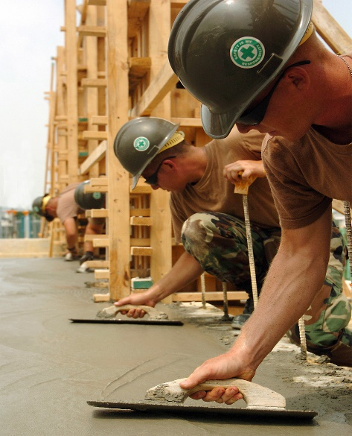

Fig.3.1 Vlinderen (bouwkunde)

Concrete that has been hardened onto imbedded [metal](https://www.britannica.com/science/metal-chemistry) (usually steel) is called [reinforced concrete](https://www.britannica.com/technology/reinforced-concrete), or ferroconcrete. Its invention is usually attributed to [Joseph Monies](https://www.britannica.com/biography/Joseph-Monier), a Parisian gardener who made garden pots and tubs of concrete reinforced with iron mesh; he received a patent in 1867. The reinforcing [steel](https://www.britannica.com/technology/steel), which may take the form of rods, bars, or mesh, contributes [tensile strength](https://www.britannica.com/science/tensile-strength). Plain concrete does not easily withstand stresses such as wind action, earthquakes, and vibrations and other bending forces and is therefore unsuitable in many structural applications. In reinforced concrete, the tensile strength of steel and the compression strength of concrete render a member capable of sustaining heavy stresses of all kinds over considerable spans. The fluidity of the concrete mix makes it possible to position the steel at or near the point where the greatest stress is anticipated.

Another [innovation](https://www.merriam-webster.com/dictionary/innovation) in [masonry](https://www.britannica.com/technology/masonry) construction is the use of [prestressed concrete](https://www.britannica.com/technology/prestressed-concrete). It is achieved by either [pretensioning](https://www.britannica.com/technology/pretensioning) or post tensioning processes. In pretensioning, lengths of steel wire, cables, or ropes are laid in the empty mold and then stretched and anchored. After the concrete has been poured and allowed to set, the anchors are released and, as the steel seeks to return to its original length, it compresses the concrete. In the post tensioning process, the steel is run through ducts formed in the concrete. When the concrete has hardened, the steel is anchored to the exterior of the member by some sort of gripping device. By applying a measured amount of stretching force to the steel, the amount of compression transmitted to the concrete can be carefully regulated. Prestressed concrete neutralizes the stretching forces that would rupture ordinary concrete by compressing an area to the point at which no tension is experienced until the strength of the compressed section is overcome. Because it achieves strength without using heavy steel reinforcements, it has been used to great effect to build lighter, shallower, and more elegant structures such as bridges and vast roofs.

In addition to its potential for immense strength and its initial ability to adapt to virtually any form, concrete is fire resistant and has become one of the most common building materials in the world.

**3.1 HIGH RISE BUILDINGS (TOWERS) ECONOMICS**

* Economic feasibility studies are considered one of the most important success elements in the investment projects. These studies focus on all the affecting elements in the project and all funding capabilities. Buildings economic studies have developed greatly especially after the technological progress and the advancement of construction materials variety, and construction methods. Feasibility studies have achieved an advanced level of precision in directing investments in terms of providing the necessary credits and completing goals within scheduled time limits and definitive investments with the lowest amount of modification to the project and its different components
* High rise buildings (Towers) are projects with huge investments and many varying components and systems. So its feasibility must be studied carefully through the application of value engineering in order to choose the most appropriate elements to use in order to achieve the best outcome with the best construction materials, construction system and operation systems, without any compromises to the general outline or the objective of the project.
* So value engineering is considered an organized methodology aims to remove the unnecessary components that increases the cost and in the same time increases the quality of the final product. And through the value analysis that can be applied on all services & operations and materials related to the building in order to reduce the construction cost and increase the quality in the same time, without compromising the building’s efficiency.
* Main points of value engineering can be summarized into the following points:
* Functions Analysis.
* A Balanced evaluation between the three primary elements of any building (performance - cost - quality).
* Creating a multi-phase work plan (data collection – analysis – evaluation & development).
* Achieving better savings as a result to proper consumption of (materials – working hours – enhancing performance).

**CHAPTER 4**

**CONSTRUCTION METHODS AND TECHNIQUES FOR HIGH RISE BUILDINGS**

The various construction methods used in high rise building are as follows:

* Slip form
* Jump form
* Climbing formwork
* Table form
* Column system formwork
* Tunnel form

**4.1 COST REDUCTION**

Cost reduction can be defined as a method to lower expenses paid on procedures that result in lower quality or performance in order to decrease the needed budget, its elements can be summarized into the following:

* Cost study to all project elements in all different stages.
* Cost reduction to different operations of the project.
* Cost reduction by changing the final product to a better one that achieves they require efficiency.
* Studying all of the project stages and the time schedule.
* Achieving the general requirements of the projects elements.

**4.2 ECONOMIC STUDIES FOR A HIGH RISE BUILDING:**

* First: Primary studies, marketing and feasibility of implementation.
* Second: Study of the design economics and other complementary studies.
* Third: Contract economics and bidding.
* Fourth: Implementation economics and organizational studies of the buildings construction stages.
* **First: Primary studies, marketing and feasibility of implementation:**

This can be achieved through the identification of the following objectives as an economic study:

* Determination of the extent of the projects success in achieving the desired objectives.
* Determination of the project’s viability in its planned location.
* The possibilities of the expected economic outcome from the project.
* Ensuring the integrity of the employed capital and other sources of fund.
* Assessment of the expected income from the project and the total cost of its operation.
* The overall scale of the project and the general situation in the market.
* Location of the project and its scale.
* Sources of funding.
* Studying the availability of raw materials, labor and the other equipment.
* **Second: Study of the design economics and other complementary studies:**

This can be achieved by studying the following:

* The area of the required spaces.
* The expected finishing materials applied to the building’s components.
* Project’s components and how they relate.
* Number and categories of the users and their living standards.
* The general shape of the building and its impact on the building’s economics, as it plays an important role, particularly in high rise buildings. Because the overall shape is one of the most important elements which could affect the economics of the building.
* **Third: Contract economics and bidding:**

This can be achieved by studying the following:

* Beneficial contract and its impact on the economics of the building.
* Repetition.
* The distribution of the facility’s elements, spaces and internal links.
* Number of floors and vertical linking elements.
* Construction methods economics.
* Contract economics and bidding.
* Project management system.
* **Fourth: Implementation economic and organizational studies of the buildings construction stages**:

Where the process of organizing and planning implementation procedures is considered one of the most important factors that helps in the organization of work in an economic way through the following:

* General implementation policy.
* Implementation time schedule.
* Organization and business conduction plans.
* Management and decision making.
* Funding and money flow.
* Project’s labor wages.

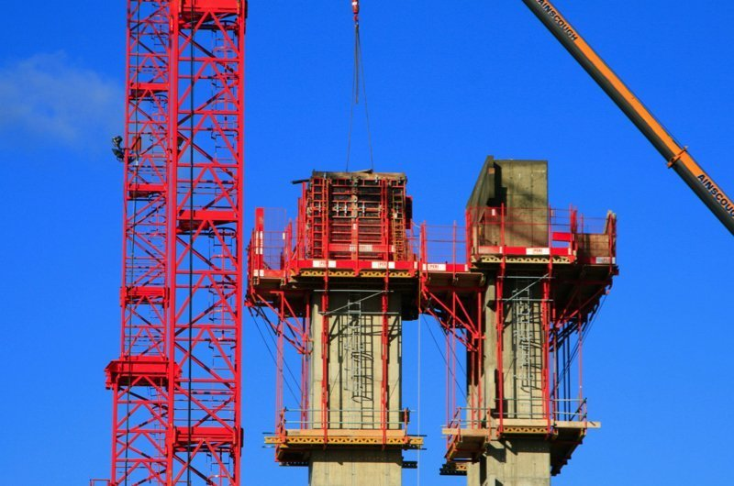

Fig.4.1 Slip Form

**4.3 TYPE OF CONSTRUCTION USED FOR RISE BUILBINGS**

A multistory building higher than 21m or 21 to 29 floor buildings with unknown height described as high-rise structure. Various structural systems are available to be used in the construction of high rise building.

**Types of High-Rise Buildings Structural Systems**

**1. Braced frame structural system**

* Braced frames are cantilevered vertical trusses resisting laterals loads primarily diagonal members that together with the girders, form the “web” of the vertical truss, with the columns acting as the “chords’’.
* Bracing members eliminate bending in beams and columns.
* It is used in steel construction
* This system is suitable for multistory building in the low to mid height range.
* Efficient and economical for enhancing the lateral stiffness and resistance of rigid frame system.
* This system permits the use of slender members in a building.
* An outstanding advantage of braced frame is that, it can be repetitive up the height of the building with obvious economy in design and fabrication.
* However, it might obstruct internal planning and the location of doors and windows. That is why it shall be incorporated internally along with lines of walls and partitions.

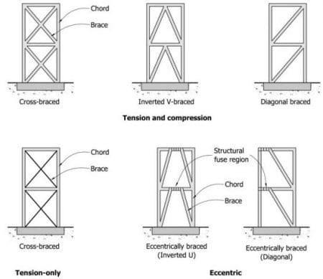

Fig.4.2 Braced Frames

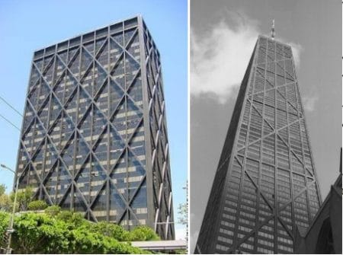

Fig. 4.3 John Hancock Centre, USA

**2. Rigid frame structural system**

* In rigid frame structure, beams and columns are constructed monolithically to withstand moments imposed due to loads.
* The lateral stiffness of a rigid frame depends on the bending stiffness of the columns, girders and connections in-plane
* It is suitable for reinforced concrete buildings.
* It may be used in steel construction as well, but the connections will be costly.
* One of the advantages of rigid frames is the likelihood of planning and fitting of windows due to open rectangular arrangement.
* Members of rigid frame system withstand bending moment, shear force, and axial loads.
* 20 to 25 storey buildings can be constructed using rigid frame system.
* Advantages of rigid frame include ease of construction, labors can learn construction skills easily, construct rapidly, and can be designed economically.
* Maximum beam span is 12.2m and larger span beams would suffer lateral deflection.
* A disadvantage is that the self-weight is resisted by the action from rigid frames.
* Finally, Burl Al kalian which is the tallest structure in the world is constructed using rigid frame system.

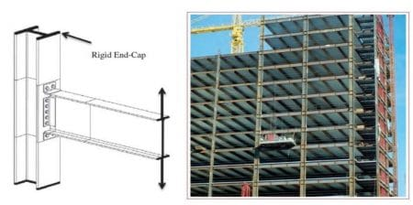

Fig.4.4 Rigid frame structural system

**3. Shear wall system**

* It is a continuous vertical wall constructed from reinforced concrete or masonry wall.
* Shear walls withstand both gravity and lateral loads, and it acts as narrow deep cantilever beam.
* Commonly, constructed as a core of buildings
* It is highly suitable for bracing tall buildings either reinforced concrete or steel structure. This because shear walls have substantial in plane stiffness and strength.
* Shear wall system is appropriate for hotel and residential buildings where the floor-by floor repetitive planning allows the walls to be vertically continuous.
* It may serve as excellent acoustic and fire insulators between rooms and apartments.
* Shear wall structural system can be economical up to 35 stories building structure.
* Shear walls need not to be symmetrical in plan, but symmetry is preferred in order to avoid tensional effects.

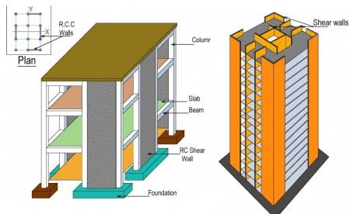

Fig.4.5 Shear wall system

**4. Core and outrigger structural system**

* Outrigger are rigid horizontal structures designed to improve building overturning stiffness and strength by connecting the core or spine to closely spaced outer columns
* The central core contains shear walls or braced frames.
* Outrigger systems functions by tying together two structural systems (core system and a perimeter system), and render the building to behave nearly as composite cantilever.
* The outriggers are in form of walls in reinforced concrete building and trusses in steel structures.
* Multilevel outrigger systems can provide up to five times the moment resistance of a single outrigger system.
* Practically, Outrigger systems used for buildings up to 70 stories. Nonetheless, it can be used for higher buildings.
* Not only does the outrigger system decline building deformations resulting from the overturning moments but also greater efficiency is achieved in resisting forces.

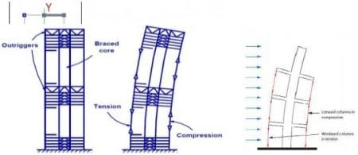

Fig. 4.6 Core and outrigger structural system

**5. In filled frame structural system**

* In filled frame structure system consists of beam and column framework that some of the bays in filled with masonry, reinforced concrete, or block walls.
* Infill walls can be part-height or completely fill the frame.
* The walls may or may not be connected to the formwork.
* Great in plan stiffness and strength of the walls prevent bending of beams and columns under horizontal loads. As a result, frame structural performance will be improved.
* During an earthquake, diagonal compression struts form in the in fills so the structure behaves more like a Braced Frame rather than a Moment Frame.
* It can build up to 30 storey buildings.

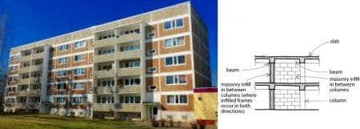

Fig. 4.7 In filled frame structural system

**6. Flat plate and flat slab structural system**

* This system consists of slabs (flat or plate) connected to columns (without the use of beams).
* Flat plate is a two-way reinforced concrete framing system utilizing a slab of uniform thickness, the simplest of structural shapes.
* The flat slab is a two-way reinforced structural system that includes either drop panels or column capitals at columns to resist heavier loads and thus permit longer spans.
* Lateral resistance depends on the flexural stiffness of the components and their connections, with the slab corresponding to the girder of the rigid frame.
* Suitable for building up to 25 stories.

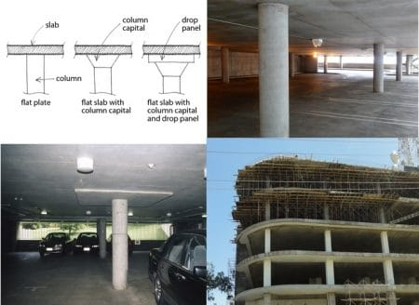

Fig.4.8 Flat plate structural system

**7. Tube structural system**

* This system consists of exterior columns and beams that create rigid frame, and interior part of the system which is simple frame designed to support gravity loads.
* The building behaves like equivalent hollow tube.
* It is substantially economic and need half of material required for the construction of ordinary framed buildings.
* Lateral loads are resisted by various connections, rigid or semi-rigid, supplemented where necessary by bracing and truss elements.
* It is used for the construction of buildings up to 60 stories.
* Types of tube structure system include framed tube system (fig.9), trussed tube system (fig.10), bundled tube system (fig.11), and tube in tube system (fig.12).
* Trussed tube system is formed when external bracing added to make a structure stiffer. This structure type suitable for building up to 100 stories.
* Bundled tube system consists of connected tubes and it with stand massive loads.
* A tube-in-tube system (hull core) is obtained, if the core is placed inside the tube frame structure.

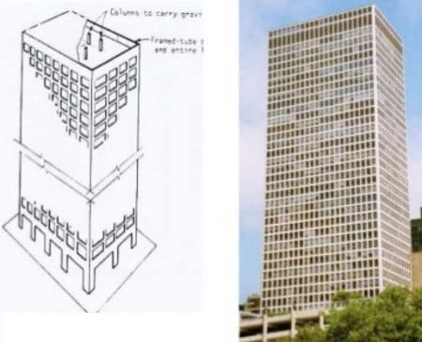

Fig. 4.9 Tube structural system

**8. Coupled wall system**

This system composed of two or more interconnected shear walls

* Shear walls connected at the floor levels by beam or stiff slabs.
* Stiffness of the whole system is far greater than that of its components.
* The effect of the shear-resistant connecting members is to cause the sets of walls to behave in their partly as a composite cantilever, bending about the common centriodal axis of the walls.
* The system is suitable for buildings up to 40 storey height.
* Since planer shear walls support loads in their plane only, walls in two orthogonal directions need to withstand lateral loads in two directions. 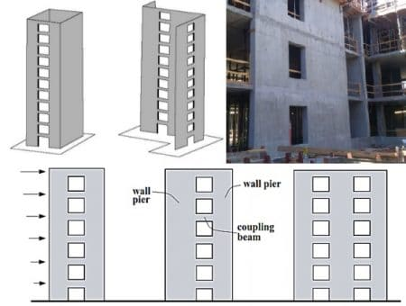

Fig. 4.10 Coupled wall system

**9. Hybrid structural system**

* It is the combination of two or more of basic structural forms either by direct combination or by adopting different forms in different parts of the structure.
* Its lack of tensional stiffness requires that additional measures be taken, which resulted in one bay vertical exterior bracing and a number of levels of perimeter vierendeel “bandages”

**CHAPTER 5**

**HIGH RISE BUILDINGS (TOWERS) DESIGN STANDARDS**

There are many building design standards that must be taken into consideration when design high rise buildings, and they are as follows:

* Location & surrounding building planning (high rise buildings gathering forms).
* Project’s scale and the general view.
* Keeping an open city view.
* Environment (handling wind issues – shadows – other environmental issues).
* Transportation & car parking.
* On the level of ground floor policies.
* Infrastructure, energy efficiency & sustainable development.
* Management & operation.
* Safety and security and building standards.
* The building must achieve all building laws related to internal spaces.
* The building must apply modern technological systems.
* The building must constructed using suitable structure systems.
* The building should have a distinctive.
* Application of all civil defense requirements related to safety and fire fighting.
* Provision of all services (car parking – fire fighting water tanks – water supply tanks, etc).
* Fire escape stairs should consist of 2 flights each flight must not be less than 90 cm wide.
* Fire escape staircase must connect to outside of the building.
* Ease of access of all floors to civil defense units.
* The building must be constructed out of fire resistant materials (or materials with a high rate of fire resistance).
* The main stair case flight must not be less than 135 cm wide.
* The main staircase & elevators should be present in every main core of the building.
* Provision of sufficient parking slots to the number of the building users & designing the
* Basement floors with all the suitable systems to the required use.

**5.1 THE LOCATION OF HIGH RISE BUILDING AND ITS IMPACT:**

* The location selection of high rise building is considered one of the most important elements affecting the success of the project and this can be shown as following:
* The distinction of the projects layout to the city center.
* The relationship between the layout and the surrounding main streets.
* The relationship between the location and the surrounding buildings.
* Site area.
* The site’s general determinants.
* The project’s location and the surrounding important buildings.
* Vision angles and aesthetics deemed by the site.
* Role of the designer:
* Facades must be distinct and able to achieve a good balance between form and economic cost
* Making a good use of local finishing materials and detail study and how they fit in the project
* The environmental standards and requirements must be applied when it comes to the selection of finishing materials used in external facades
* Selection of finishing materials that suit the efficiency and the competency of local employment
* Creating laws and principles governing high rise buildings construction in order to stimulate capital and investment in such projects

**On the level of investors and capital owners:**

* Encourage the formation of investment entities to finance such projects
* Formation of an investment committee to provide all the required economic studies to ensure the success of these projects
* Encouragement of foreign capital with good expertise in high rise projects.

**CHAPTER 6**

**EFFECTS OF CONSTRUCTING HIGH-RISE BUILDING**

Urbanization as a socio-economic process manifested in the concentration of the population in modern big cities contributes to the development of high-rise building construction. With the development of education and culture, changing leisure habits, city residents put forward new architectural and functional requirements to the living environment and urban infrastructure. This calls for the creation of new types and forms of residential buildings, the structure of the city and transport networks.

* In addition, the need to develop high-rise building construction is justified by the growing demand for residential, public and administrative buildings and the lack of free space. The paper analyzes the development of high-rise building construction in urban areas. The problem of the impact of high- rise building construction in big cities on the living environment is considered.
* Using analytical methods, causes and sources of pollution, such as transport and engineering infrastructure have been identified. In some urban areas, there are zones with modified thermal conditions and air exchange resulting in the formation of the “urban heat island.
* The qualitative and quantitative characteristics of variations in temperature and wind speed with respect to the height of the building have been calculated, using the example of the Evolution Tower of the Moscow International Business Center (“Moscow City”). Calculation and comparative analysis for the cities of Moscow, Khanty-Mansiysk and Vladivostok has made it possible to assess the variation in temperature and wind speed and their impact on the living environment under different climatic conditions.
* The rapid growth of the economy of the leading countries is contributing to the development of big cities. In connection with intensive internal and external migration of people to big cities, the population density is increasing. As a result, the number of modern multi-storey buildings and high-rise buildings is increasing, and the engineering and transport infrastructure is developing at an incredible pace
* The growth of modern high-rise buildings significantly affects the existing climatic conditions of the terrain and the environmental balance of the living environment. At the same time, the density of urban development, the infrastructure and transport networks play an important role in changing the living environment. Urban development as a combination of complex architectural forms significantly affects the aerodynamics of the terrain. In this regard, both industrial areas and high-density residential areas are environmentally unfavorable. Thus, high-rise buildings and structures, being an integral part of a modern city, significantly aggravate the environmental conditions of urban areas.
* One of the important components of the living environment of a city is the residential environment. The unified system “man - apartment - building - neighborhood – residential area of the city” defined in the scientific literature as “residential environment” has complex features and mechanisms. A human being, interacting with the residential environment, performs non-productive activities on the territory of populated areas.
* In this regard, the most interesting are the convective currents that arise when the temperature difference between the surfaces of facades of buildings and public spaces.
* The amount of solar radiation and the coefficient of solar radiation absorption by the material of the outer surface of the enclosing structures create a temperature difference between the external surface of the building and the surrounding air.

**CHAPTER 7**

**PREVENTIONS OF CONSTRUCTING HIGH-RISE BUILDINGS**

* **Safety measures during high-rise building construction works:**

High-rise buildings are the current trend in construction nowadays because of its convenience, advantages, architectural design, grade and luxury. Not known to many, it has many safety risks for occupancy.

The most frequent problems\accidents related to safety in high-rise construction often include:

1. Ladders
2. Falling debris
3. Falling from heights
4. Electrical shock &machinery
5. Trips and slips
6. Crane and hoist operation

* **For overcoming these type problems, we focused the following objectives:**

1. To establish SMS (safety management system) at a high-rise construction project.
2. To study safety risk in construction of high-rise building.
3. To analyze strength, weakness and propose recommendations for improvement of safety in high-rise construction.

* **The ultimately goals as set out for the project are:**

1. To ensure safe and hazard free working environment so as to attain maximum efficiency.
2. To achieve confidence of customer as well as society at large by ensuring safety performance.

Throughout the core basis of safety literature and actual high-rise tower now under construction the main important issues can be summarized as below;

**Safety management system (SMS);**

The safety management system is a must for every construction project, especially for high-rise construction because this area is consisting of many latent hazard and risk. Without SMS, the owners, developers, investors, shareholders, and managers cannot reach the goal and target as expected. On the other hand, the contractors, suppliers, installers, and workers cannot fulfill and complete their mission.

In overall, without SMS, the construction of a high-rise will became very dangerous and the casualty/damage cannot be prevented. The SMS must be set up and strictly implemented and it should comprise of the main frames:

* Safety management /hierarchy/organization
* Scaffolding (fixed and mobile ) including ladders & platforms
* Electro-mechanical activities and controls
* Site status
* Temporary power supply and tools
* Health & welfares
* Storage condition
* Fire prevention
* Waste pollution control
* Monitoring and control of working on height
* Aid /first aid and evacuation
* Emergency plan for unanticipated circumstances

It is recommended that for biding the high-rise construction project, the owner should seek and hire professional project management team usually PMC companies (project management consultancy), as the project & construction manager and their representative as well. The project manager will be enthusiastically and heartily dedicated to the multi-goal completion of a high-rise construction projects: schedule reached, within budget, quality achieved and also well perform the high safety requirements demands.

**Hazard risk identification:**

This is the most important portion of every specific SMS especially for high-rise project. Depending on the specific condition and particular situation, the PM should:

* Far-seeing and for-seeing for all possible causes may lead to hazard
* Thoroughly analyze all aspect of the project: geographical, structure, sub-water, vicinity, surrounding inhabitants
* Focusing in the most would-be hazard of high-rise construction: falling slip, fire, electrical flashing of tower crane, hoist lift, elevator, scaffolding etc.
* Evaluation the site-safety check\audit and requires improvements
* Always available for an emergency plan to cope with an unanticipated circumstance
* Frequently review, analyze and search for other possible hazards and identification of its risks.

**Strength &weakness of the actual SMS:**

**Strength:**

* Strong and powerful: the PM monitor, control and force the contactors & their subs to execute the safety rules.
* Standardized & professional: the safety rules & items based on the advanced standards norms of site-safety and implemented by a long-history project management consultant like DDC.

**Weakness:**

* Lack of identification of hazard\risk from some potential possibilities such as: glass wall, lift, sub-water, overhead power line.
* No considering on the role 3rd safety party for audit verification
* No mentioning on safety training, especially for induction training

**CHAPTER 8**

**ADVANTAGES AND DISADVANTAGES OF HIGH-RISE BUILDING**

**8.1 ADVANTAGES:**

* More compact cities=reduce transportation Optimal land use due to concentration of population=reduced suburban development and reduced environment damage centralized cities=reduced density of urban infrastructural networks
* Less travel within the city=less waste of time
* Potential capability and possibility to create building with mixed use
* Increased wind speed in height (higher potential ability to use wind energy)
* Narrow and elongated and at an altitude floors=potential of natural skylight of space
* Space at sky=possibility of creating silent and calm spaces away from crow and noises of city, urban landscape

**8.2 DISADVANTAGES:**

* High consumption of energy and materials to build in height
* High energy consumption for elevators (up to 15% of total energy consumed by building)
* High energy consumption for maintenance and cleanness of building
* Negative impacts on urban scale (wind storm, wide shading, light barriers)
* High concentration of population in special places (lack of open spaces and recreation spaces)
* High loadings caused by wind in height (impact on size and dimensions of structural and view elements)
* Closed and isolated spaces in height (while construction for users)

**8.3 NEEDS & CONSEQUENCES:**

Tall buildings are built out of necessity as one of a wide range of tools to achieve high density development. They provide the opportunity to control urban sprawl with their relatively small foot print. Identifying what unique characteristics a tall building brings could be represented in the need for a particular built form the concentration of activity the proximity to important facilities for large no. of people which is more than image and being a more sustainable form of development.

High rise buildings bring impacts at strategic and local levels. The huge people load of a high building, particularly at peak times, may overload the cities infrastructures its public transport, roads and utilities. The size of a building has important direct influences on our emotional

There is rising concern for the safety from fires, and in order to develop appropriate plans for combating high rise incidents, there needs to be an understanding of the whole process. Basic concept behind fire safety measures.

**CHAPTER 9**

**CONCLUSION**

**From the findings of the study, the following conclusions can be drawn:**

* Modern urban areas with high-rise buildings have an impact both the local aerodynamics and the temperature conditions of the territory. As a result, environmentally unfavorable zones with stagnant air develop in public open spaces.
* High-rise buildings in urban areas, being an effective system of solar heating of the vertical surfaces of buildings and horizontal surfaces of roofs, sidewalks and roads, accumulate heat and result in the formation of urban heat islands.
* When designing high-rise buildings, it is necessary to take into account the specifics of the built-up areas, the spatial plasticity and the density of construction, which affect the aerodynamics of the terrain and the pollution of the atmospheric air.
* The calculations and studies made it possible to evaluate the impact of high-rise buildings on the microclimate and the environmental conditions. The variation in wind speed with respect to the height of the building, the formation of ascending convective flows at the outer surface of a high-rise building are the factors that can improve the environmental situation and the microclimate of the living environment

**CHAPTER 10**

**REFERENCES**

1.Investigating the Causes for Failures in Construction Yogen Sadashiv Masurkar 1, Abdulrashid Chand Attar 2

2. International Journal of Science and Research (IJSR) ISSN (online): 2319-7064 Index Copernicus Value (2013): 6.14 | Impact Facture (2013): 4.438

3. Risk assessment of construction projects Edmundas Kazimierasb Zavadskas, Zenonas Turskis & Jolanta Tamosaitiene

4. International Journals of Science and Research (IJSR) ISSN (online): 2319-7064 Index Copernicus Value (2014): 6.14 | Impact Factor (2014): 4.438

5. Mantri’s A to Z of buildings Construction