Statistical Analysis and Hypothesis Testing in Python
Analysis of Order Profit Across Customer Segments

YuvaIntern – Virtual Data Science with Python Apprentice Internship

Statistical Analysis Project – Week 3

1. Introduction
This project applies statistical analysis and hypothesis testing techniques in Python to investigate whether average order profit differs among Consumer, Corporate, and Home Office customer segments.
The analysis uses the Superstore dataset and focuses on order-level profit rather than individual product-line transactions. Statistical tests, confidence intervals, effect size, visualizations, and a non-parametric robustness check are used to evaluate the research question.

2. Research Question and Hypotheses
Research Question: Does average order profit differ significantly among Consumer, Corporate, and Home Office customers?
H₀ (Null Hypothesis): The mean order profit is equal across Consumer, Corporate, and Home Office segments.
H₁ (Alternative Hypothesis): At least one customer segment has a different mean order profit.
The significance level was set at α = 0.05.

3. Data and Data Preparation
The Superstore dataset contains 10,800 raw rows and 21 columns. The first 9,994 rows represent the main transaction dataset used for the analysis. The remaining records were associated with returns-related information and were excluded from the primary analysis.
The cleaned dataset contains 9,994 transaction rows. Duplicate transaction rows were removed through the selection of the main transaction portion of the dataset. The analytical fields required for this hypothesis test were complete.
Because individual orders can contain multiple product-line records, the data was aggregated to the order level. The resulting analytical dataset contains 5,009 orders.
A check of Order ID and Segment showed that no order contained more than one customer segment. Therefore, each order could be assigned unambiguously to one segment.

4. Methodology
The primary statistical method was a one-way ANOVA because the research question compares the mean order profit across three independent customer segments.
Levene's test was first used to examine equality of variances. The distribution of order profit was also examined visually because the data contains skewness and extreme observations.
The analysis also calculated 95% confidence intervals for each segment mean and eta-squared (η²) as an effect-size measure.
Because the order-profit distribution contains substantial skewness and outliers, a Kruskal-Wallis test was performed as a non-parametric robustness check.

5. Descriptive Statistics
The following table summarizes order-level profit for each customer segment.
Table 1. Order-level profit descriptive statistics
count | mean | median | std | min | max
2586.0000 | 51.8600 | 15.7800 | 351.4600 | -6892.3700 | 6734.4700
1514.0000 | 60.7500 | 16.7900 | 346.7300 | -3825.3400 | 8762.3900
909.0000 | 66.3400 | 16.1600 | 322.5700 | -3424.3500 | 4597.1700

6. Statistical Test Results
Table 2. Statistical hypothesis test results
Test | Statistic | p_value
Levene's Test | 0.1695 | 0.8441
One-way ANOVA | 0.7084 | 0.4925
Kruskal-Wallis | 1.8403 | 0.3985

7. Levene's Test
Levene's test produced a test statistic of 0.1695 and a p-value of 0.8441. Because the p-value is greater than 0.05, there is insufficient evidence to conclude that the variances differ significantly across the three customer segments.
Therefore, the equal-variance assumption for the one-way ANOVA is reasonably supported from this test.

8. One-way ANOVA
The one-way ANOVA produced an F-statistic of 0.7084 and a p-value of 0.4925.
Since the p-value is greater than the significance level of 0.05, the null hypothesis is not rejected.
Therefore, this analysis does not provide statistically significant evidence that average order profit differs among Consumer, Corporate, and Home Office customers.
Failing to reject the null hypothesis does not prove that the three population means are exactly equal.

9. Confidence Intervals
The estimated mean order profits and their 95% confidence intervals were:
Table 3. Mean order profit and 95% confidence intervals
Segment | Mean Order Profit | 95% CI Lower | 95% CI Upper
Consumer | 51.8600 | 38.3100 | 65.4200
Corporate | 60.7500 | 43.2700 | 78.2300
Home Office | 66.3400 | 45.3400 | 87.3300

The confidence intervals overlap substantially. This is consistent with the ANOVA result, which did not identify a statistically significant difference among the segment means.

10. Effect Size
The eta-squared (η²) effect size was approximately 0.0003.
This means customer segment accounts for approximately 0.03% of the variation in order profit in this analysis. The effect is therefore very small in terms of the proportion of variance explained.

11. Kruskal-Wallis Robustness Check
The Kruskal-Wallis test was performed because the order-profit distribution contains skewness and extreme observations.
The test produced an H-statistic of 1.8403 and a p-value of 0.3985.
Because the p-value is greater than 0.05, the Kruskal-Wallis test also does not provide statistically significant evidence of differences among the three customer segments.
The agreement between the ANOVA and Kruskal-Wallis results provides a consistent finding for this dataset.

12. Visual Analysis
The following visualizations support the statistical analysis by showing the distribution, mean estimates, and order counts across the three customer segments.

12.1 Order Profit Distribution by Segment
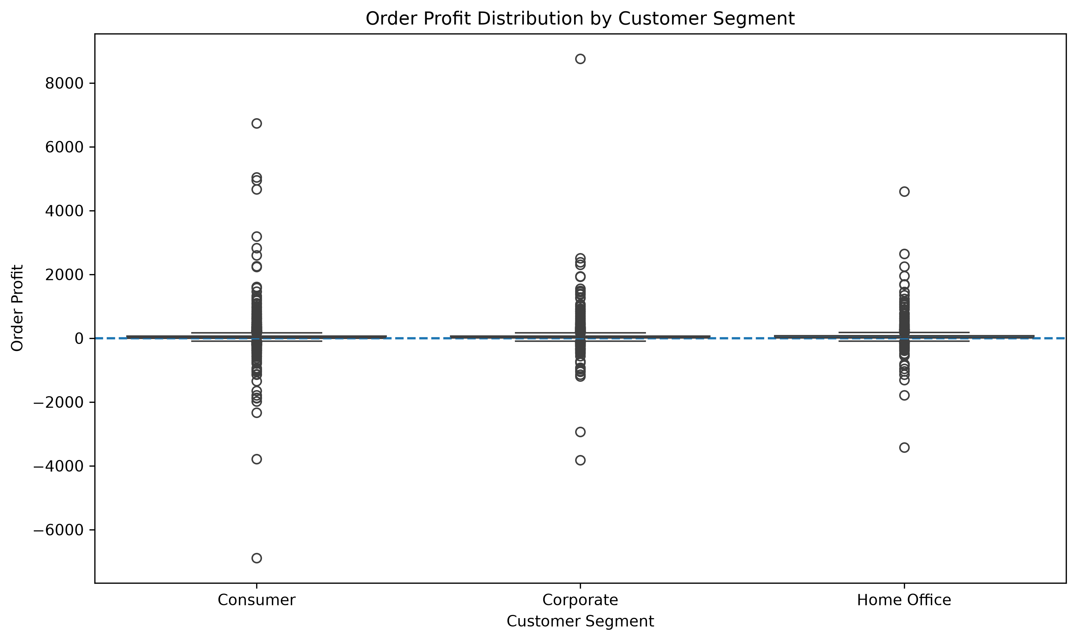

The boxplot shows substantial variation and several extreme observations in order profit across all three segments.

12.2 Mean Order Profit with 95% Confidence Intervals
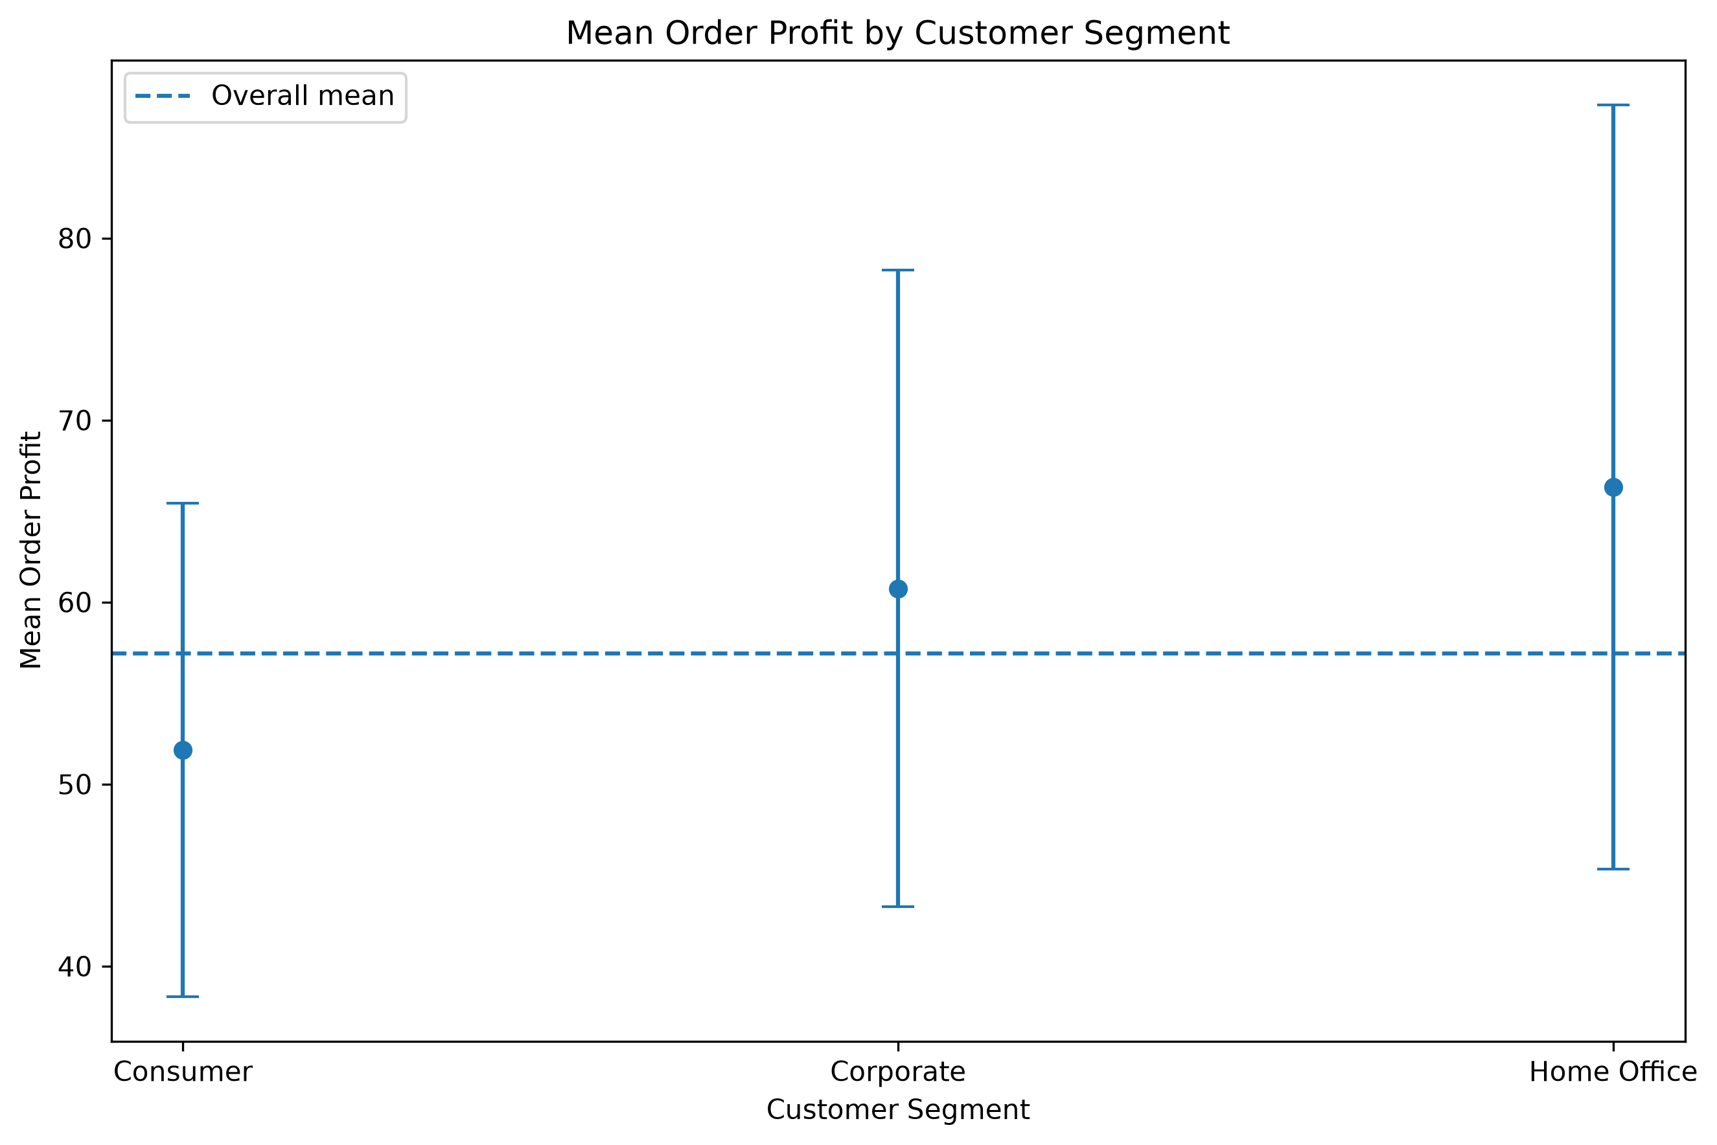

The mean-profit chart displays the estimated mean for each segment together with 95% confidence intervals. The substantial overlap between the intervals is consistent with the hypothesis-test results.

12.3 Average Order Profit by Segment
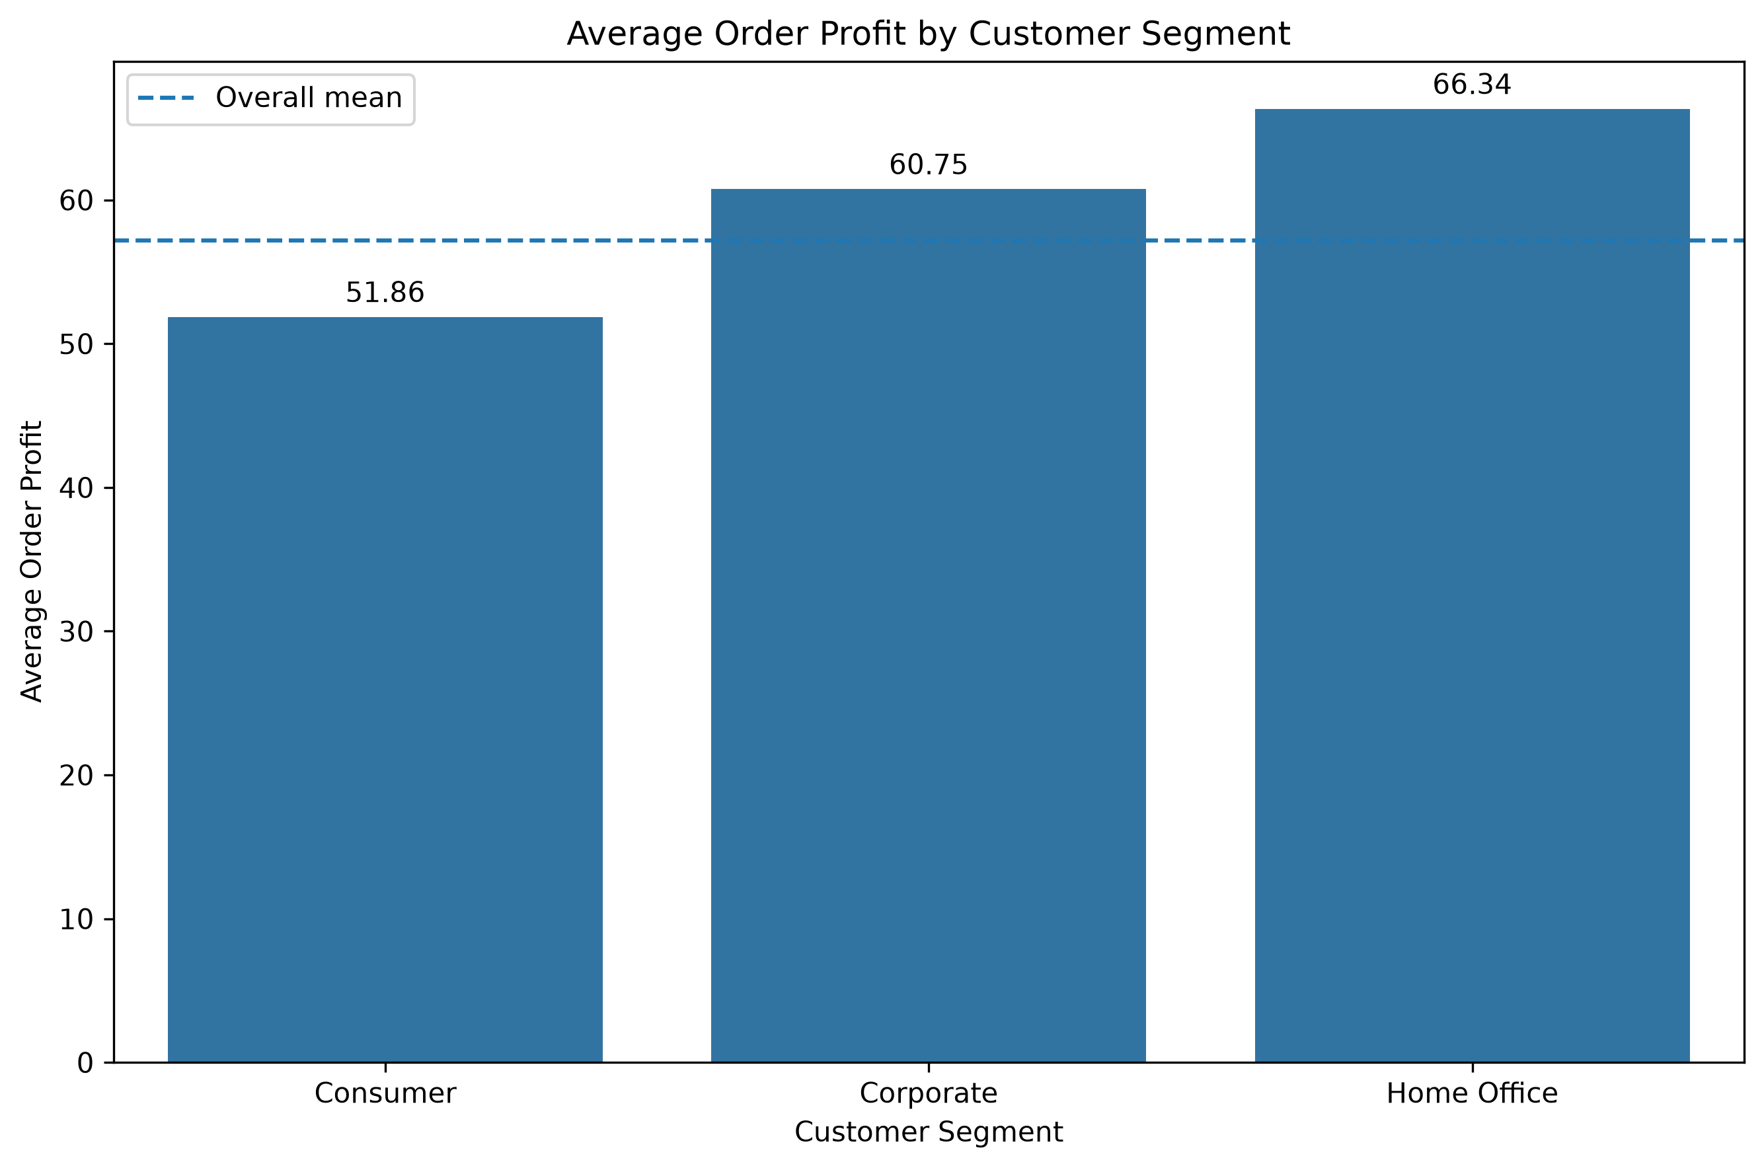

The average order profit is approximately 51.86 for Consumer, 60.75 for Corporate, and 66.34 for Home Office orders. These observed differences were not statistically significant.

12.4 Number of Orders by Segment
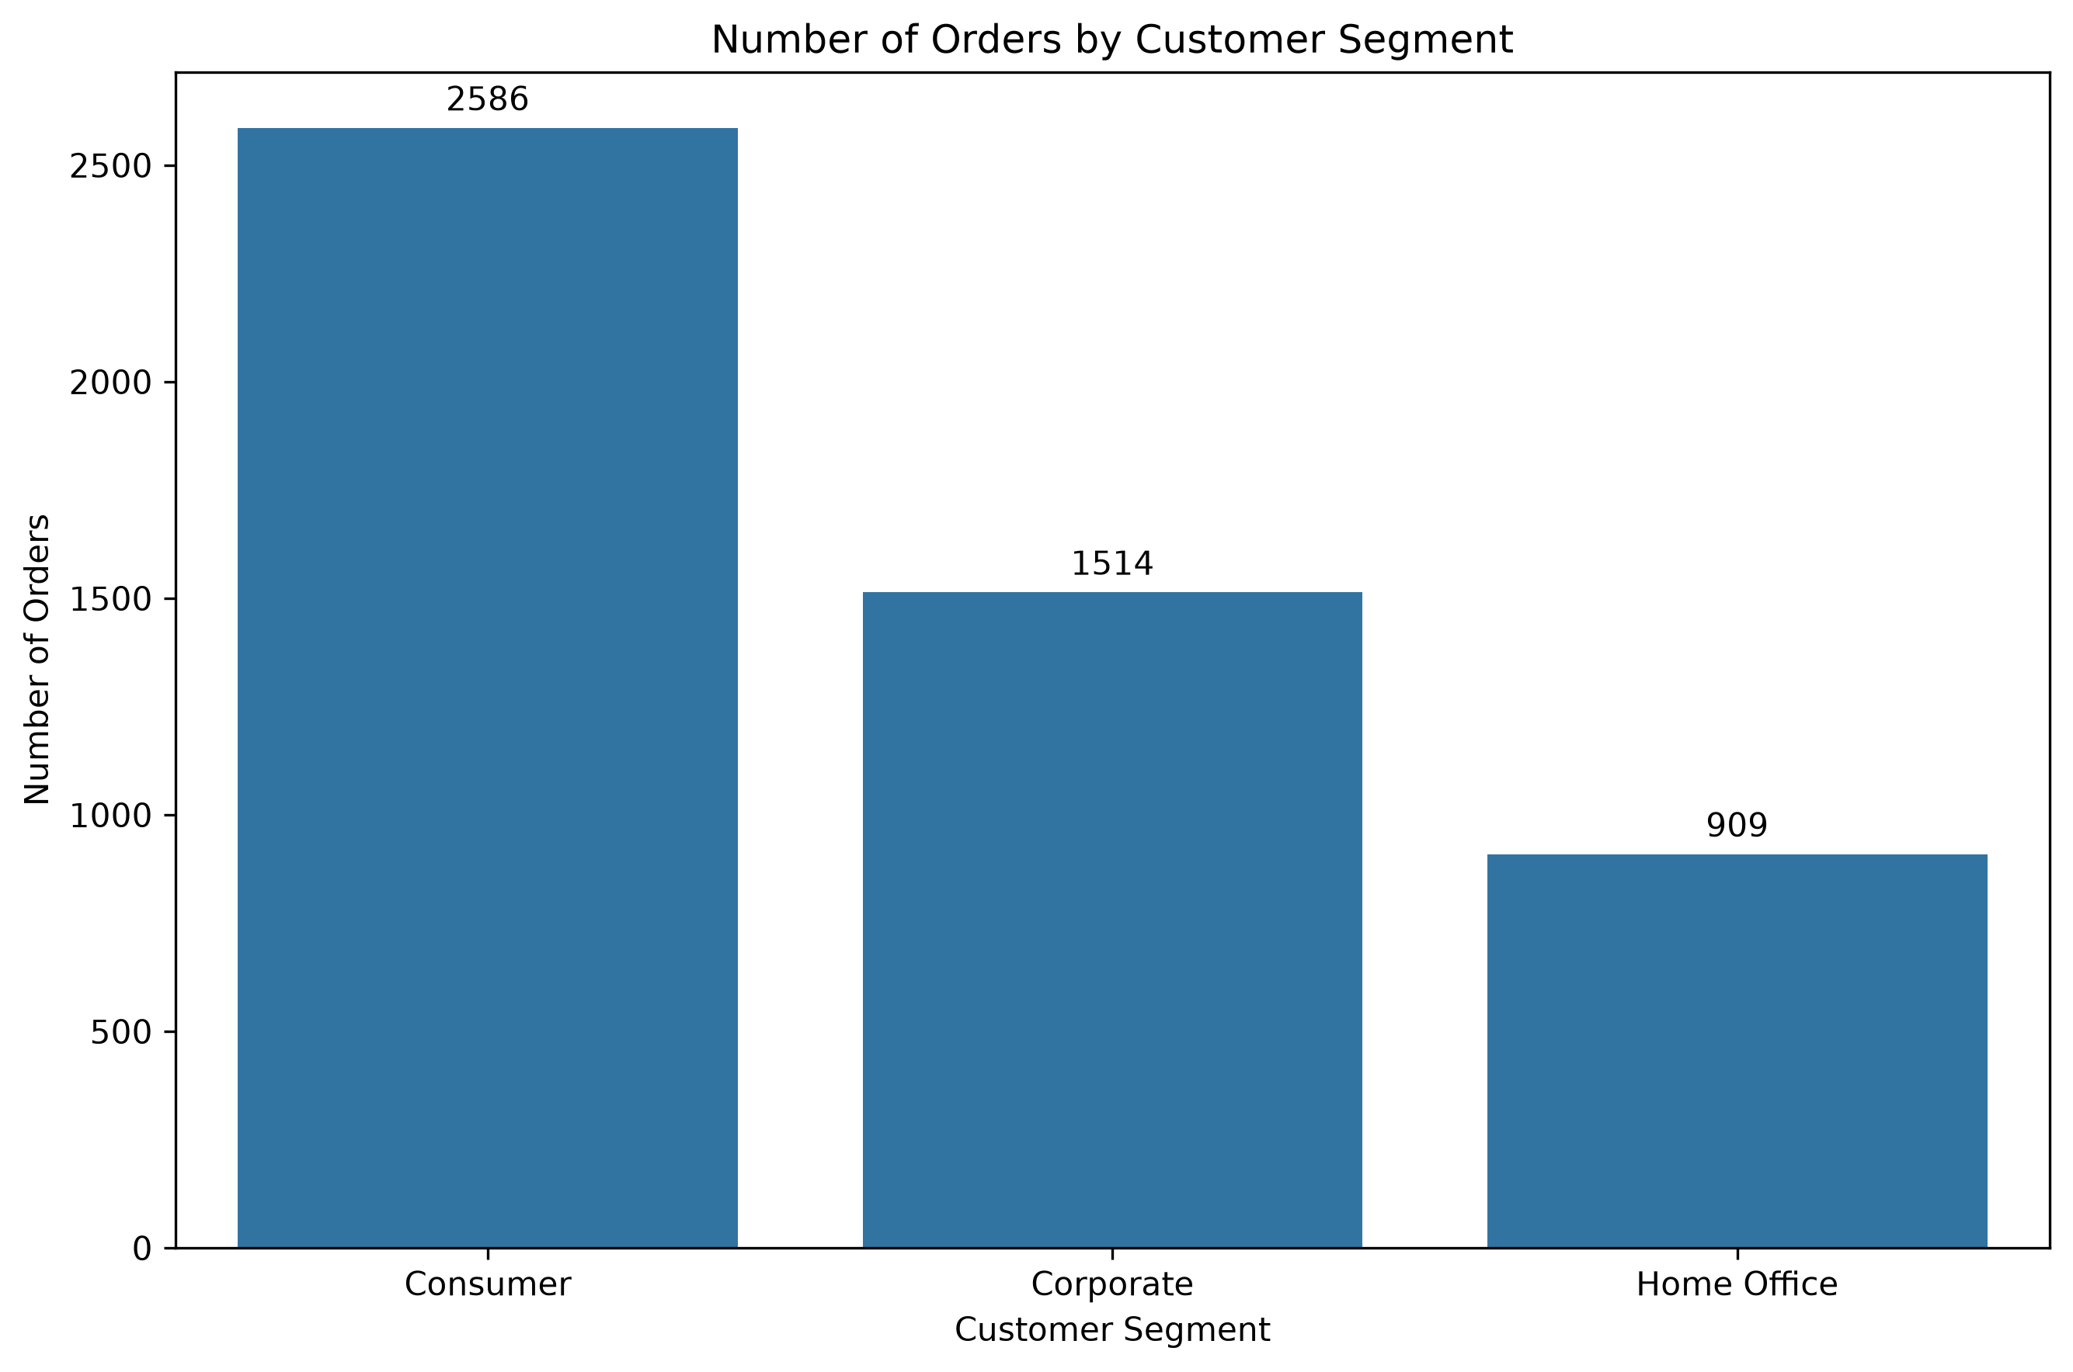

Consumer has the largest number of orders, followed by Corporate and Home Office. The different group sizes were retained in the statistical analysis rather than artificially balancing the groups.

13. Conclusion
The objective of this analysis was to determine whether average order profit differs significantly among Consumer, Corporate, and Home Office customers.
The one-way ANOVA produced an F-statistic of 0.7084 with a p-value of 0.4925. Since the p-value is greater than 0.05, the null hypothesis was not rejected.
Therefore, the analysis does not provide statistically significant evidence that average order profit differs among the three customer segments.
The Kruskal-Wallis robustness check produced a p-value of 0.3985 and reached the same overall conclusion.
Although the observed sample means differ, the effect size was very small (η² ≈ 0.0003), indicating that customer segment explained only a very small proportion of the variation in order-level profit.

14. Practical Implications
The results suggest that customer segment alone may not be an important explanatory factor for differences in order-level profit in this dataset.
Other variables such as discount, product category, region, sales volume, and product-level characteristics could potentially contribute more to profit variation.
These results describe an association in the analyzed dataset and should not be interpreted as evidence of a causal relationship.

15. Limitations
- The analysis uses an observational dataset, so causal conclusions cannot be established.
- Order profit contains substantial skewness and extreme values.
- The dataset represents a specific Superstore sample and may not generalize to all businesses or customer populations.
- Customer segment was analyzed as the primary grouping variable; other potentially important explanatory variables were not included in the ANOVA.
- Aggregating transactions to the order level improves the unit of analysis, but orders may still share characteristics related to customers, products, regions, or time periods.

16. Future Work
Future analysis could investigate the effects of discount, product category, region, sales, and other variables using regression or other multivariable statistical methods.

17. Tools and Python Libraries
- Python
- Pandas
- NumPy
- SciPy
- Statsmodels
- Matplotlib
- Seaborn
- Jupyter Notebook

