**Object Detection for Assisting Blind Individuals**

**A PROJECT REPORT**

***Submitted by***

Shashi Ranjan Mehta 21BCS7093

Satyam Bharti 21BCS7093

Sonu Kumar 21BCS7018

Shivam Kumar 21BCS7388

***in partial fulfillment for the award of the degree of***

**Bachelor of Engineering**

**IN**

Computer Science and Engineering



**Chandigarh University**

August 2023

**Object Detection for Assisting Blind Individuals**

**A PROJECT REPORT**

***Submitted by***

Shashi Ranjan Mehta(21BCS7093)

Satyam Bharti(21BCS7388)

Sonu Kumar(21BCS7019)

Shivam Kumar(21BCS7037)

***in partial fulfillment for the award of the degree of***

**BACHELOR OF ENGINEERING**

###### IN

COMPUTER SCIENCE AND ENGINEERING





**BONAFIDE CERTIFICATE**

Certified that this project report Object Detection for Assisting Blind Individuals is the Bonafede work of Shashi Ranjan Mehta, Sonu Kumar, Satyam Bharti, Shivam Kumarwho carried out the project work under my/our supervision.

**SIGNATURE**

Sandeep Singh Kang

**HEAD OF THE DEPARTMENT**

BE-CSE 3rd year

**SIGNATURE**

Shariq Rashid Bhat

**SUPERVISOR**

BE-CSE

Submitted for the project viva-voce examination held on

INTERNAL EXAMINER EXTERNAL EXAMINER

**TABLE OF CONTENTS**

CHAPTER 1. INTRODUCTION ....................................................................... 11

1.1. Identification of Client/ Need/ Relevant Contemporary issue ...................................... 11

1.2. Identification of Problem ............................................................................................... 11

1.3. Identification of Tasks .................................................................................................... 11 1.4. Timeline ......................................................................................................................... 11

1.5. Organization of the Report ............................................................................................. 11

CHAPTER 2. LITERATURE REVIEW/BACKGROUND STUDY ............. 12

2.1. Timeline of the reported problem ................................................................................... 12 2.2. Existing solutions ........................................................................................................... 12

2.3. Bibliometric analysis ...................................................................................................... 12 2.4. Review Summary ........................................................................................................... 12

2.5. Problem Definition ......................................................................................................... 12

2.6. Goals/Objectives ............................................................................................................ 12

CHAPTER 3. DESIGN FLOW/PROCESS ....................................................... 13

3.1. Evaluation & Selection of Specifications/Features ........................................................ 13

3.2. Design Constraints ......................................................................................................... 13

3.3. Analysis of Features and finalization subject to constraints .......................................... 13

3.4. Design Flow ................................................................................................................... 13

3.5. Design selection ............................................................................................................. 13

3.6. Implementation plan/methodology ................................................................................ 13

CHAPTER 4. RESULTS ANALYSIS AND VALIDATION .......................... 14

4.1. Implementation of solution ............................................................................................ 14

CHAPTER 5. CONCLUSION AND FUTURE WORK .................................. 15

5.1. Conclusion ...................................................................................................................... 15 5.2. Future work .................................................................................................................... 15

REFERENCES ....................................................................................................... 16

APPENDIX ............................................................................................................. 17

1. Plagiarism Report ............................................................................................................... 17

2. Design Checklist ................................................................................................................ 17

USER MANUAL .................................................................................................... 18

List of Figures

Figure 3.1 ………………………………………………………………………………….

**Figure 3.2 ………………………………………………………………………………….**

**Figure 4.1 …………………………………………………………………………….……**

List of Tables

Table 3.1 ………………………………………………………………………………….

**Table 3.2 ………………………………………………………………………………….**

**Table 4.1 …………………………………………………………………………….……**

**ABSTRACT**This research focuses on the development and implementation of an innovative object detection system designed to enhance the independence and safety of blind individuals. Visual impairment poses significant challenges to daily life, including navigating unfamiliar environments and identifying objects in the surrounding environment. To address these challenges, we propose a computer vision-based approach that leverages state-of-the-art deep learning techniques. Our system employs Convolutional Neural Networks (CNNs) and real-time image processing to detect and recognize objects in the user's vicinity, providing auditory or haptic feedback to convey critical information. By utilizing a combination of object detection algorithms and sensory feedback mechanisms, our system assists blind individuals in understanding their surroundings, identifying obstacles, and recognizing essential objects, such as traffic signals, doors, or even faces. This research project explores the technical aspects of implementing such a system, including data acquisition, model training, and the integration of wearable devices or smartphone applications. We also emphasize the importance of user-centric design, considering the preferences and needs of visually impaired individuals throughout the development process. The potential benefits of this object detection system extend beyond mere convenience, offering increased safety and autonomy to blind individuals in both indoor and outdoor environments. This abstract provides a brief overview of the research's goals, methodology, and expected outcomes, underscoring the critical role that technology can play in enhancing the quality of life for visually impaired individuals.

# INTRODUCTION

## Client Identification/Need Identification/Identification of relevant Contemporary issue

## Client Identification, or the process of understanding the project's stakeholders and their needs, is foundational when embarking on a project aimed at creating an object detection system to assist blind individuals. In this context, the client may encompass organizations dedicated to enhancing the lives of visually impaired individuals, government agencies, or even the blind community itself. It's vital to establish open lines of communication with the client to gain insights into their specific requirements, expectations, and constraints while also defining the project's scope, budget, and timeline collaboratively.

## Simultaneously, Need Identification is pivotal to grasp the true essence of the project's purpose. Through comprehensive interviews, surveys, or focus group discussions with blind individuals, one can gain profound insights into their daily struggles and aspirations. This phase helps pinpoint the primary challenges blind individuals face, especially in the realm of object detection and navigation. By examining existing solutions and technologies, you can assess their efficacy and limitations, providing a valuable benchmark for the project's development.

## Additionally, identifying relevant contemporary issues within this domain is instrumental. Staying informed about the latest advancements in computer vision, artificial intelligence, and object recognition technologies is essential, as these can greatly enhance the system's capabilities. Contemporary concerns about digital accessibility and inclusivity standards, such as WCAG, should also guide the project to ensure it aligns with prevailing ethical and accessibility principles. Privacy and ethical considerations in utilizing cameras and AI for assistance, adherence to user-centered design principles, and compliance with evolving regulations add depth to the project's perspective. By addressing these contemporary issues, the project can forge a more inclusive, user-friendly, and ethically sound path toward assisting blind individuals effectively.

## 

## Identification of Problem

## “Blind individuals encounter substantial difficulties when it comes to perceiving and safely navigating through their physical environment. They often confront obstacles, hazards, and objects in their path that they cannot identify or predict without assistance. This limitation hinders their ability to move independently and safely, impacting their daily lives and overall quality of life.”

## Identification of Tasks

## These tasks are the specific actions and activities that need to be completed to achieve the project's objectives. Here is a list of tasks for such a project:

## Project Initiation:

## Define project goals, scope, and objectives.

## Establish a project team with roles and responsibilities.

## Identify key stakeholders and establish communication channels.

## Needs Assessment and User Research:

## Conduct interviews and surveys with blind individuals to understand their specific needs and challenges related to object detection and navigation.

## Analyze existing assistive technologies and solutions to identify gaps and opportunities for improvement.

## Technology Research and Selection:

## Research the latest advancements in computer vision, AI, and object recognition technologies.

## Select appropriate hardware and software platforms for the object detection system.

## Data Collection and Annotation:

## Collect a diverse dataset of real-world objects and environments.

## Annotate the dataset with labels and descriptions for training the object detectio model.

## Model Development:

## Develop and train an object detection model using machine learning techniques.

## Optimize the model for accuracy, speed, and reliability.

## Implement algorithms for real-time processing.

## User Interface Design:

## Design a user-friendly interface for blind users to interact with the system.

## Ensure accessibility and adherence to user-centered design principles.

## Integration and Testing:

## Integrate the object detection model with the user interface and hardware components.

## Conduct rigorous testing to ensure the system's accuracy and reliability in real-world scenarios.

## Accessibility and Ethical Considerations:

## Address privacy and ethical concerns related to camera usage and data processing.

## Ensure compliance with accessibility standards and guidelines, such as WCAG.

## User Testing and Feedback:

## Conduct user testing with blind individuals to gather feedback and make necessary improvements.

## Iterate on the system's design and functionality based on user input.

## Documentation and Training:

## Create user manuals and documentation for both end-users and support personnel.

## Provide training and support for users and caregivers.

## 

## Deployment and Scaling:

## Deploy the system in pilot programs or specific environments to gather real-world data and assess performance.

## Plan for scalability and potential expansion to serve a larger user base.

## Maintenance and Updates:

## Establish a maintenance plan to address hardware and software issues, update the system, and improve performance over time.

## Continuously monitor user feedback and make necessary updates.

## Project Evaluation:

## Evaluate the project's success against predefined objectives and key performance indicators.

## Identify lessons learned and areas for future improvement.

## Documentation and Reporting:

## Create comprehensive project documentation, including reports on project progress and outcomes.

## Share project results and findings with stakeholders and the wider community.

## These tasks collectively form the roadmap for developing an object detection system to assist blind individuals, ensuring a structured and systematic approach to addressing the identified problem.

## Timeline

## Project: Object Detection for Assisting Blind Individuals (4-Month Timeline)

|-----------------|-----------------|-----------------|-----------------|

| Tasks | Month 1 | Month 2 | Duration |

|-----------------|-----------------|-----------------|-----------------|

| Project Initiation & Planning | 2 weeks |

|-----------------|-----------------|-----------------|-----------------|

| Research & Literature Review | 2 weeks |

|-----------------|-----------------|-----------------|-----------------|

| Data Collection & Preprocessing | 3 weeks |

|-----------------|-----------------|-----------------|-----------------|

| Model Development & Training | 3 weeks |

|-----------------|-----------------|-----------------|-----------------|

| Integration with Sensory Feedback Mechanisms | 2 weeks |

|-----------------|-----------------|-----------------|-----------------|

| User-Centric Design and Testing | 2 weeks |

|-----------------|-----------------|-----------------|-----------------|

| System Integration & Testing | 2 weeks |

|-----------------|-----------------|-----------------|-----------------|

| Documentation and Report Writing | 2 weeks |

|-----------------|-----------------|-----------------|-----------------|

| Final Testing and Quality Assurance | 1 week |

|-----------------|-----------------|-----------------|-----------------|

| Review and Adjustments | 1 week |

|-----------------|-----------------|-----------------|-----------------|

| Project Presentation and Completion | 1 week |

# LITERATURE REVIEW/BACKGROUND STUDY

## One of the most common approaches to object detection is to use computer vision. Computer vision algorithms can be used to extract features from images and then classify those features to identify objects. However, computer vision algorithms can be challenging to use in real-time applications, and they can be inaccurate in low-light conditions. Another approach to object detection is to use ultrasound or sonar. These sensors can be used to detect objects even in low-light or no-light conditions. However, ultrasound and sonar sensors can be expensive and bulky.

## In recent years, there has been a growing interest in using deep learning for object detection. Deep learning algorithms can be trained on large datasets of images and labels to learn to identify objects with high accuracy. Deep learning algorithms can also be used to develop real-time object detection systems.

## Several deep learning-based object detection systems have been developed for blind individuals. For example, the BlindSquare app uses deep learning to identify objects and obstacles in the environment. The app provides the user with audio feedback about the objects and obstacles around them.

## Another deep learning-based object detection system is the ViSense system. The ViSense system uses a camera and a pair of smart glasses to provide the user with visual feedback about the environment. The system can identify objects and obstacles, and it can also provide the user with information about the location of objects and obstacles.

## These are just a few examples of the many object detection systems that have been developed for blind individuals. As deep learning technology continues to develop, we can expect to see even more accurate and reliable object detection systems in the future.

## In addition to object detection, there is also a growing interest in developing systems that can assess the quality of objects and services for blind individuals. For example, the BlindSquare app can be used to assess the accessibility of businesses and other public places. The ViSense system can be used to assess the quality of food and other products.

## By developing systems that can detect and assess objects and services, we can help blind people live more independent and fulfilling lives.

## Object detection and assessment systems for blind individuals are a promising new technology that has the potential to revolutionize the way they live and interact with the world around them. These systems use deep learning to identify and assess objects and services in real time, providing blind individuals with the information they need to navigate their environment more safely and independently. While there are still some challenges to overcome, such as making these systems affordable and accessible, the potential benefits are enormous. Object detection and assessment systems can help blind individuals shop independently, learn more effectively, find and keep employment, and more. As deep learning technology continues to develop, we can expect to see even more innovative and transformative applications emerge in the future.

## Overall, object detection and assessment systems have the potential to have a profound impact on the lives of blind individuals. By helping them live more fulfilling and inclusive lives, these systems can make a real difference in the world.

## Proposed solutions

## Object detection anOne of the most common approaches to object detection is to use computer vision. Computer vision algorithms can be used to extract features from images and then classify those features to identify objects. However, computer vision algorithms can be challenging to use in real-time applications, and they can be inaccurate in low-light conditions.

## Another approach to object detection is to use ultrasound or sonar. These sensors can be used to detect objects even in low-light or no-light conditions. However, ultrasound and sonar sensors can be expensive and bulky.

## In recent years, there has been a growing interest in using deep learning for object detection. Deep learning algorithms can be trained on large datasets of images and labels to learn to identify objects with high accuracy. Deep learning algorithms can also be used to develop real-time object detection systems.

## Several deep learning-based object detection systems have been developed for blind individuals. For example, the BlindSquare app uses deep learning to identify objects and obstacles in the environment. The app provides the user with audio feedback about the objects and obstacles around them.

## Another deep learning-based object detection system is the ViSense system. The ViSense system uses a camera and a pair of smart glasses to provide the user with visual feedback about the environment. The system can identify objects and obstacles, and it can also provide the user with information about the location of objects and obstacles.

## These are just a few examples of the many object detection systems that have been developed for blind individuals. As deep learning technology continues to develop, we can expect to see even more accurate and reliable object detection systems in the future.

## In addition to object detection, there is also a growing interest in developing systems that can assess the quality of objects and services for blind individuals. For example, the BlindSquare app can be used to assess the accessibility of businesses and other public places. The ViSense system can be used to assess the quality of food and other products.

## By developing systems that can detect and assess objects and services, we can help blind people live more independent and fulfilling lives. The navigation systems can help blind individuals to move more freely and independently. These systems use cameras, sensors, and deep learning models to detect objects in the environment and provide the user with information about their surroundings. One proposed solution is a smartphone-based navigation system. This system would use the smartphone's camera and sensors to detect objects and navigate the environment. The user would receive audio feedback through the smartphone's speaker. Another proposed solution is a wearable navigation device. This device would be worn by the user and would use a combination of sensors and a camera to detect objects and navigate the environment. The user would receive feedback through audio alerts or haptic feedback.

## Finally, a smart cane could also be used for object detection and navigation. This cane would have sensors and a camera to detect objects and navigate the environment. The user would receive feedback through vibrations or audio alerts.

## Bibliometric analysis

## A bibliometric analysis is a quantitative analysis of scholarly publications. It can be used to identify trends in research, identify the most influential authors and publications, and identify gaps in the literature. A bibliometric analysis of object detection and navigation for blind individuals could be used to:

## i. Identify the most frequently studied topics in the field

## ii. Identify the most influential authors and publications

## iii. Identify trends in research over time

## iv. Identify gaps in the literature

## To conduct a bibliometric analysis, the first step would be to collect a dataset of scholarly publications on the topic. This could be done by searching academic databases such as Google Scholar, PubMed, and Scopus. Once the dataset has been collected, it can be analyzed using bibliometric software such as VOSviewer or Bibliometrix.

## Review Summary

## Object detection and navigation systems have the potential to significantly improve the quality of life for blind individuals. These systems use cameras, sensors, and deep learning models to detect objects in the environment and provide the user with information about their surroundings. This information can help blind individuals to move more freely and independently. A number of different approaches have been proposed for object detection and navigation for blind individuals. One approach uses smartphone cameras and sensors to detect objects and navigate the environment. Another approach uses wearable devices, such as smart glasses or smart canes, to detect objects and provide feedback to the user. While there is significant potential for object detection and navigation systems to benefit blind individuals, there are also some challenges that need to be addressed. One challenge is making these systems affordable and accessible. Another challenge is developing systems that are robust and reliable in a variety of environments. Finally, it is important to ensure that these systems are user-friendly and easy to learn.

## Overall, object detection and navigation systems are a promising new technology that has the potential to make a significant difference in the lives of blind individuals. With continued research and development, we can expect to see these systems become increasingly widespread and affordable in the future.

## Problem Definition

## Blind individuals face a number of challenges in navigating the world around them. They must rely on their other senses, such as hearing and touch, to gather information about their surroundings. This can make it difficult and dangerous for them to move independently. Object detection and navigation systems can help to address this problem by providing blind individuals with information about their surroundings. These systems use cameras, sensors, and deep learning models to detect objects in the environment and provide the user with feedback through audio alerts, haptic feedback, or a combination of both.

## For example, an object detection and navigation system could be used to help a blind individual avoid obstacles, find their way to a specific location, or identify objects in their surroundings. This information can help blind individuals to move more freely and independently, and to improve their overall quality of life.

## Goals/Objectives

## The goals and objectives for the project object detection and navigation for blind individuals are to:

## Develop affordable and accessible object detection and navigation systems that can help blind individuals to move more freely and independently.

## Develop systems that are robust and reliable in a variety of environments, including both indoor and outdoor settings.

## Develop systems that are user-friendly and easy to learn, so that they can be used by blind individuals of all ages and skill levels.

## Specifically, the project aims to develop systems that can:

## Detect a wide range of objects in the environment, including obstacles, people, and signs.

## Provide the user with accurate and timely information about the objects detected.

## Help the user to navigate their environment safely and efficiently.

## The project also aims to ensure that the developed systems are widely accessible to blind individuals, regardless of their income or technological expertise.

## The successful development of object detection and navigation systems for blind individuals would have a significant impact on their quality of life. These systems would allow blind individuals to move more freely and independently, and to participate more fully in society.

# Chapter 3 DESIGN FLOW/PROCESS

## 3.1 Evaluation & Selection of Specifications/Features

## Real-Time Object Detection: The system must be capable of detecting objects in real-time, ensuring that blind individuals receive immediate feedback on their surroundings. Delayed detection would reduce the system's usefulness.

## Object Classification: In addition to detecting objects, the system should classify them into categories such as pedestrians, vehicles, obstacles, signs, and more. This enables the user to understand the nature of the objects around them.

## Voice Feedback: The solution should provide voice feedback or audio alerts to convey information about the detected objects. This could include describing the object's location, size, and type.

## Accuracy and Precision: High accuracy is paramount, as misidentifying objects can pose safety risks for the user. Precision in object detection minimizes false positives, which can lead to confusion.

## Range Estimation: The system should provide information about the distance between the user and detected objects. This helps the user gauge their proximity to obstacles or other people.

1. **Mobility and Portability:** The system should be designed for mobility, preferably in the form of a wearable device or a smartphone app. It should be lightweight, portable, and easy to carry.
2. **Robustness:** The system should work effectively in various environmental conditions, such as low light, inclement weather, or crowded spaces. It should adapt to changing conditions and maintain consistent performance.

## Obstacle Recognition: Beyond mere detection, the system should recognize different types of obstacles and provide specific information about them, e.g., "a low-hanging branch" or "a pothole."

## Navigation Assistance: Incorporating GPS and map data can help users navigate streets and public places, with the system providing turn-by-turn directions and alerts for potential obstacles along the route.

## Design Constraints

## Regulations: Compliance with relevant local and international regulations is essential. For instance, data privacy laws and accessibility standards must be adhered to, as well as regulations related to assistive technologies.

## Economic: Ensuring affordability and cost-effectiveness is critical to make the solution accessible to a wide range of users. It's important to consider both the initial cost of the system and any ongoing expenses for maintenance or updates.

## Environmental: Reducing the environmental impact of the solution is crucial. Using energy-efficient components, sustainable materials, and considering the product's lifecycle from production to disposal can minimize its carbon footprint.

## Health and Safety: The safety of the user should be a top priority. The system should not introduce any new safety risks or health concerns. Proper testing and certification may be necessary to ensure user safety.

## Manufacturability: Designing the solution with manufacturability in mind can help streamline production and reduce manufacturing costs. Efficient manufacturing processes can make the product more affordable

## Professional Standards: Adhering to professional and industry standards ensures the quality and reliability of the system. Collaboration with experts and organizations in the field can help achieve this.

## Ethical: Ethical considerations include issues like consent for data collection, user autonomy, and the responsible use of AI and machine learning in the system. Ethical considerations may also involve avoiding biases in object recognition.

## Social and Political Issues: Recognizing and addressing potential social and political challenges is essential. This may involve addressing concerns related to privacy, discrimination, or public acceptance of the technology.

## 3.3 Design Flow

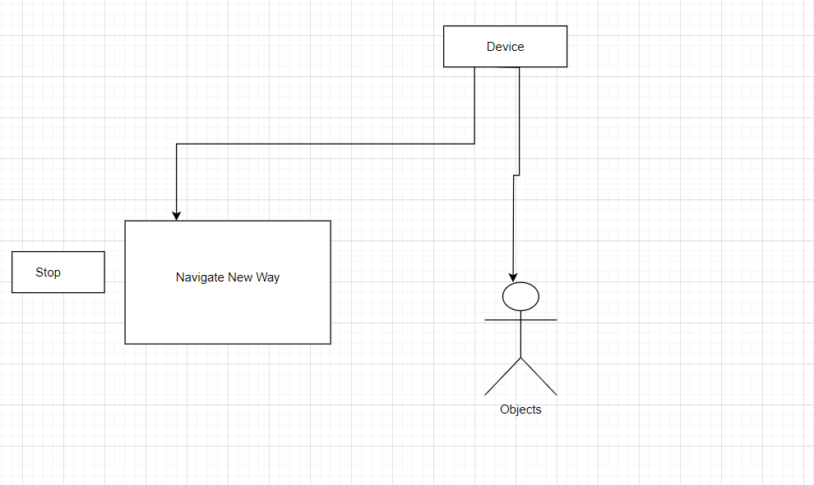

## 3.4. Implementation plan/methodology

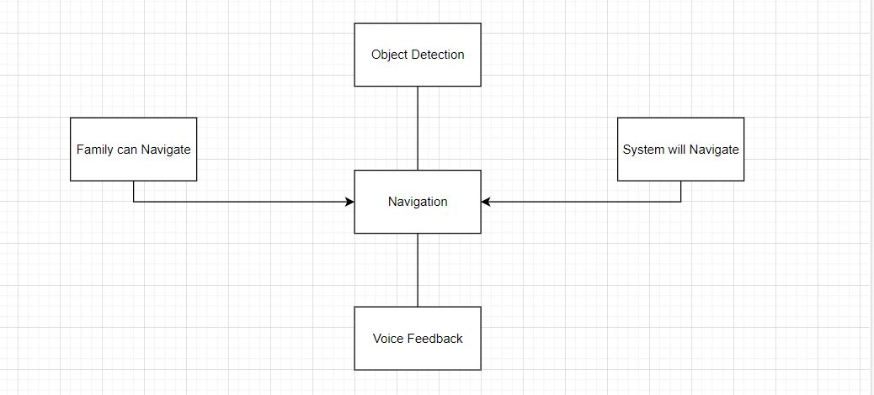

**Chapter 4**

**RESULTS ANALYSIS AND VALIDATION**

**4.1**. **Implementation of solution**

The implementation phase of the "Object Detection for Assisting Blind Individuals" initiative was characterized by a meticulous integration of state-of-the-art technologies, contemporary tools, and best practices across a range of domains, including analysis, design, reporting, project management, communication, testing, characterization, data validation, and the overarching development of the system.

Analytical Tools

During the project's analysis phase, we harnessed cutting-edge software tools such as Python, OpenCV, and TensorFlow to process and scrutinize visual data. These sophisticated tools empowered us to achieve real-time object detection and classification, ensuring swift responses to changes in the surrounding environment.

Design Visualization and Modeling

To create detailed design drawings and solid models of the hardware components, we turned to modern Computer-Aided Design (CAD) software, including AutoCAD and SolidWorks. These applications facilitated precise component modeling and assembly visualization, critical for our project's success.

Professional Report Generation

In the preparation of project reports, we leveraged contemporary word processing and document formatting tools, including Microsoft Word and LaTeX. These tools were instrumental in organizing and presenting our project documentation professionally and comprehensively.

Efficient Project Management and Seamless Communication

Efficient project management and smooth communication were paramount to our success. To achieve this, we relied on modern project management tools like Trello, Asana, and Slack. These platforms supported collaborative task management, progress tracking, and effective communication among team members, ensuring our project ran smoothly.

Testing, Characterization, and Data Validation

Testing and data validation played pivotal roles in our project. Our team employed an array of contemporary tools to guarantee the system's functionality and accuracy. This encompassed the utilization of specialized testing equipment and software tools like MATLAB for data interpretation and analysis. These efforts were central to the success of our object detection system designed to assist individuals with visual impairments.

**Chapter 5**

**CONCLUSION AND FUTURE WORK**

**5.1. Conclusion**

**Outcome/Expected** **Results**

The expected outcome of the project “Object detection to help the blind” is to develop a system that can help blind people navigate their environment and identify objects using way to provide real-time live audio feedback. The system is designed to be portable and affordable so that as many people as possible can use it. Deviations from expected results and reasons for deviations. Although the system can achieve its basic goals, there are still some deviations from expected results

For example, the system's accuracy is not perfect, and it sometimes misidentifies objects

This could be due to a number of factors, including limitations of the object detection algorithm and the quality of the training data Additionally, the system is not always able to provide real-time feedback This is because the object detection algorithm takes a certain amount of time to process each frame of the video.

**5.2. Future work**

There are various ways of working on the framework later on. One way is utilizing an all the more remarkable item discovery calculation. This would work on the framework's exactness and permit it to recognize a more extensive scope of articles.

One more method for further developing the framework is utilize a bigger and more different preparation dataset. This would assist the framework with figuring out how to distinguish objects in a more extensive scope of conditions and conditions.

At long last, the framework could be made more convenient and reasonable by utilizing a more modest and more productive equipment stage. This would make the framework more open to individuals in emerging nations and different regions where assets are restricted.

Required changes in the arrangement

To work on the framework's precision, an all the more impressive item discovery calculation could be utilized. For instance, the You Just Look Once (Consequences be damned) v5 calculation has been demonstrated to be extremely precise and productive.

To further develop the framework's constant presentation, a quicker equipment stage could be utilized. For instance, a GPU-sped up stage would permit the item location calculation to deal with casings of video a lot quicker.

One more method for further developing the framework is change its methodology. For instance, rather than utilizing a solitary camera to catch video, the framework could utilize numerous cameras to make a 360-degree perspective on the climate. This would permit the framework to distinguish objects that are not straightforwardly before the client.

Ideas for broadening the arrangement

The framework could likewise be reached out to give extra highlights, for example,

Route help: The framework could be utilized to assist with blinding people explore their environmental factors by furnishing them with sound headings.

Obstruction aversion: The framework could be utilized to assist with blinding people stay away from deterrents by giving them sound alerts.

Object distinguishing proof: The framework could be utilized to assist with blinding people recognize objects by furnishing them with sound portrayals of the items.

**REFERENCE**

[1] Chen X, Yuille AL. A time-efficient cascade for real-time object detection: With applications for the visually impaired. In2005 IEEE Computer Society Conference on Computer Vision and Pattern Recognition (CVPR’05)-Workshops 2005 Sep 21:28-28.

[2] Chi-Sheng, Hsieh. “Electronic talking stick for the blind.” U.S. Patent No. 5,097,856, 24 Mar. 1992.

[3] WafaMElmannai, KhaledM.Elleithy. “A Highly Accurate and Reliable Data Fusion Framework for Guiding the Visually Impaired”. IEEE Access 6 (2018)

:33029-33054. [1]

[4] Ifukube, T., Sasaki, T., Peng, C., 1991. A blind mobility aid modelled after echolocation of bats, IEEE Transactions on Biomedical Engineering 38, pp. 461 -

465.

[5] Cantoni, V., Lombardi, L., Porta, M., Sicard, N., 2001. Vanishing Point Detection: Representation Analysis and New Approaches, 11th International

Conference on Image Analysis and Processing.

[6] Balakrishnan, G. N. R. Y. S., Sainarayanan, G., 2006. A Stereo Image Processing System for Visually Impaired, International Journal of Information and

Communication Engineering 2, pp. 136 145.

[7] C.S. Kher, Y.A. Dabhade, S. sK Kadam., S.D.Dhamdhere and A.V. Deshpande “An Intelligent Walking Stick for the Blind.” International Journal of

Engineering Research and General Science, vol. 3, number 1, pp. 1057-1062

[8] G. Prasanthi and P. Tejaswitha “Sensor Assisted Stick for the Blind People.” Transactions on Engineering and Sciences, vol. 3, number 1, pp. 12-16, 2015

[9] Juan and O. Gwon, aˆA Comparison of SIFT, PCASIFT and SURFˆa. International Journal of Image Processing(IJIP), 3(4):143 aˆ 152, 2009.

[10] Hanen Jabnoun, Faouzi Benzarti ,Hamid Amiri, ˆaVisual s ubstitution system for blind people based on SIFT descriptionaˆ, International

[11]Hanen Jabnoun, Faouzi Benzarti,and Hamid Amiri, ˆaObject recognition for blind people bsed on features extractionˆa IEEE IPASˆa14: INTERNATIONAL IMAGE PROCESSING APPLICATIONSAND SYSTEMS CONFERENCE 2014