**SHASHIPAL REDDY PINGILI**

**PROJECT NO: 1**

**MPI_Scatter:** In this program I have used an array for size and used MPI_Scatter function

6 processes:

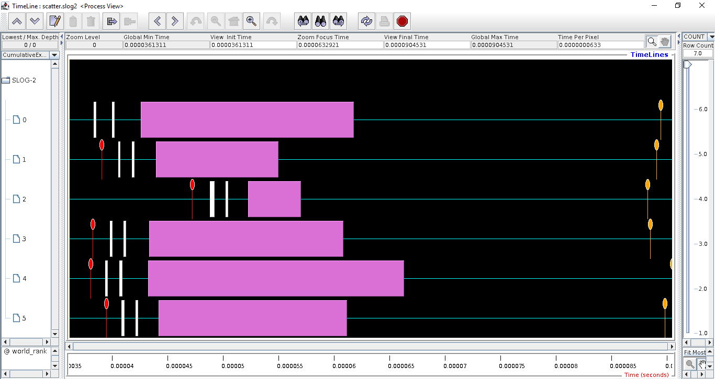

16 processes:

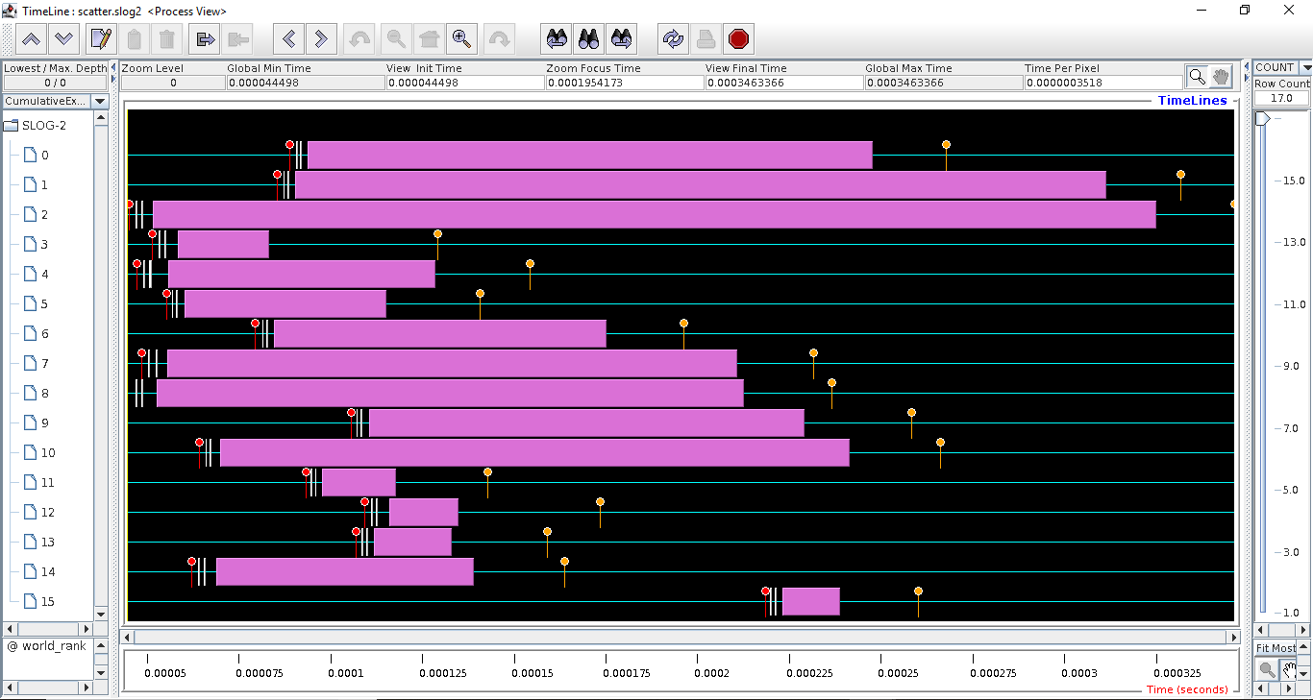

**My Scatter**

In this program in process 0, I have sent the data to all other processes and to itself. The data to be sent is stored in an array same as no. of process in all other processes I wrote a receive function that will receive the data sent by process 0. I used an integer variable to store the receiving data then I printed the data

6 Processes:

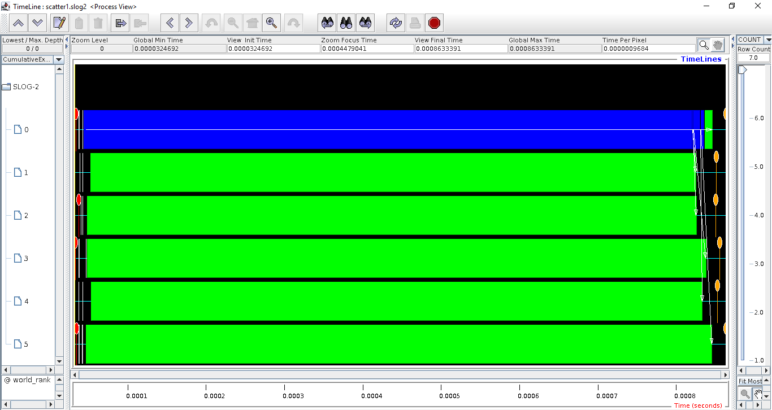

16 Processes:

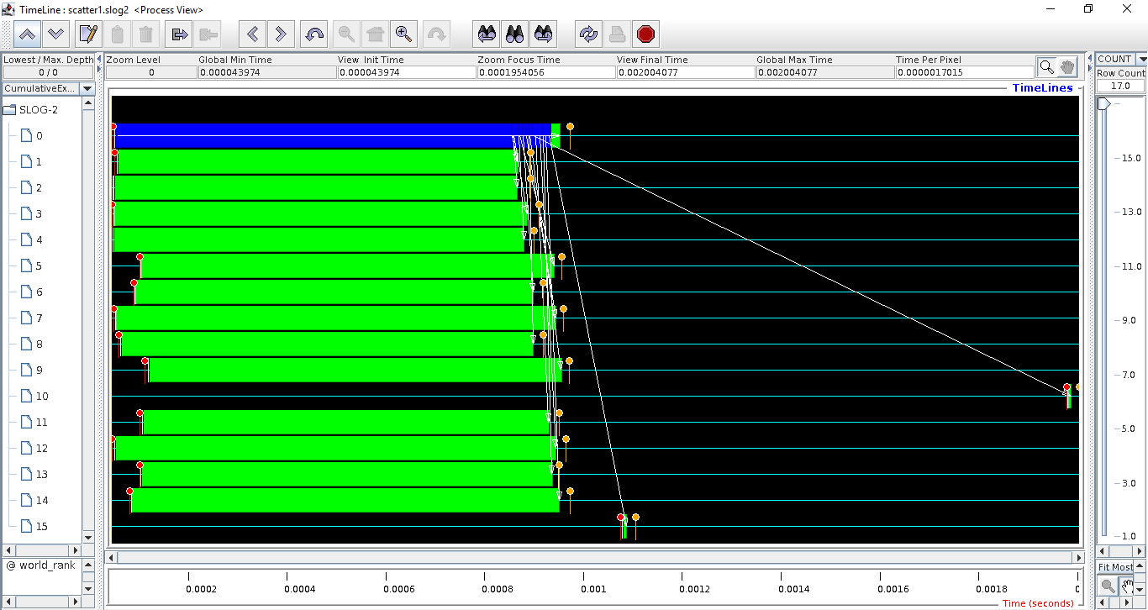

Graph:

**MPI_GATHER:**

In this program I have used an array for size I have used MPI_Gather function.

6 Processes:

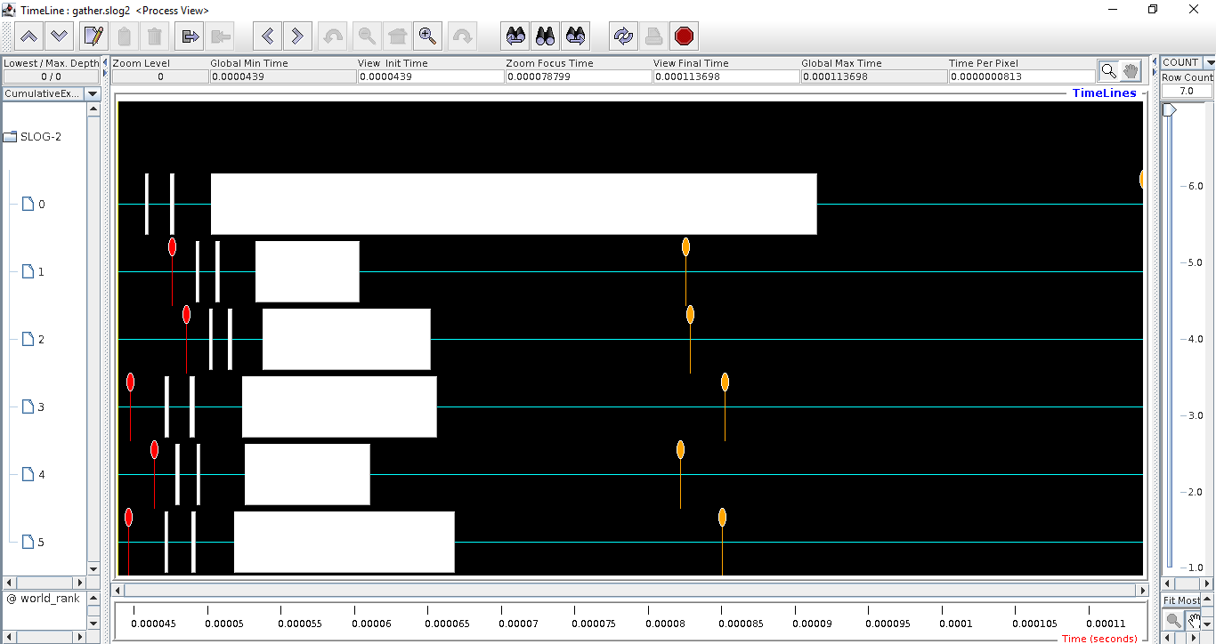

16 Processes:

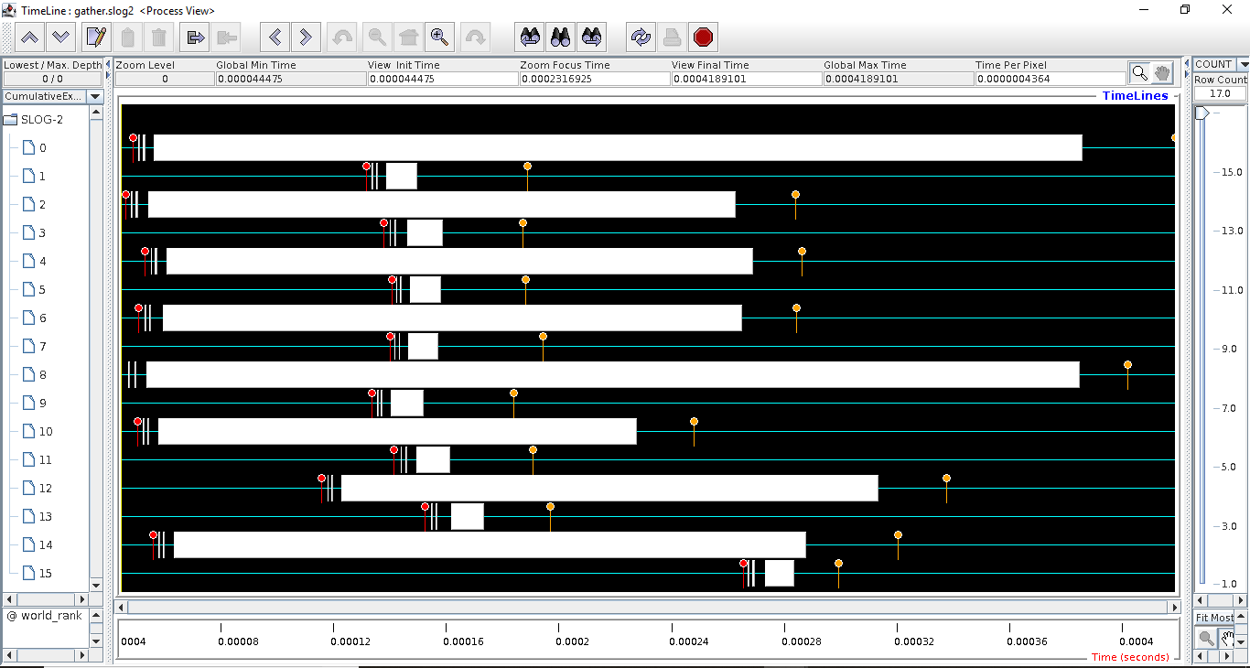

**My Gather:**

In this program in process 0, I have used a receive function to receive the data sent by all other processes, in this I have used an array with size same as no. of processes in all other processes I wrote a send function which sends data to process 0.

**6 Processes:**

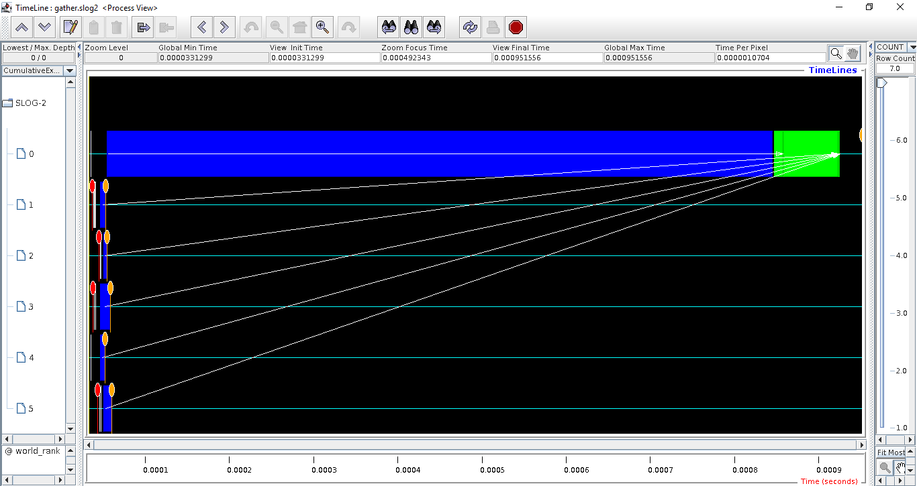

**16 Processes:**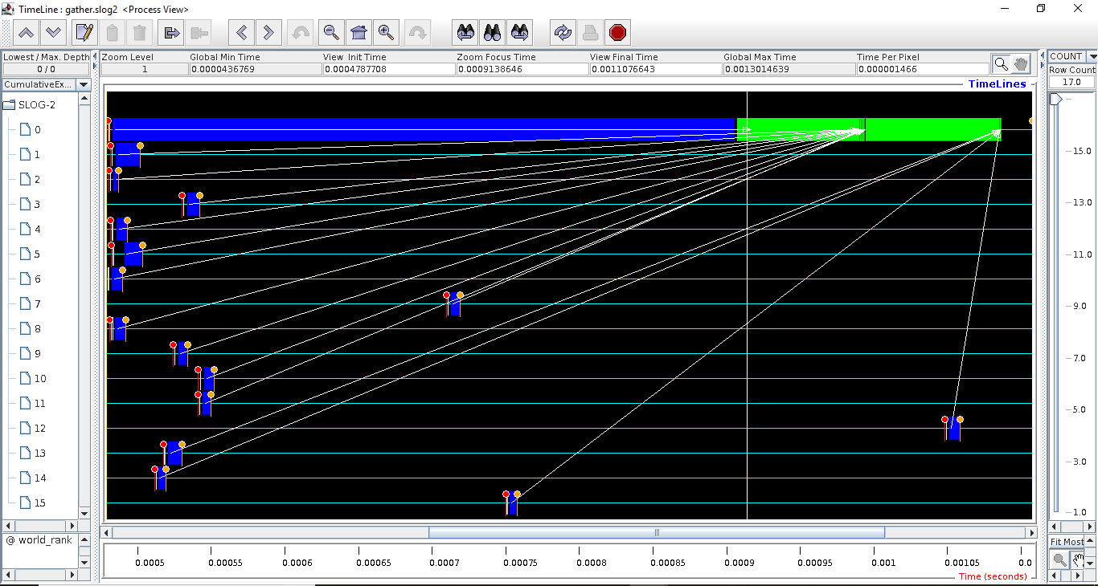

**Graph:**

**MPI_ALLGATHER:**

In this program I have used an array for size I have used MPI_Allgather function.

**6 Processes:**

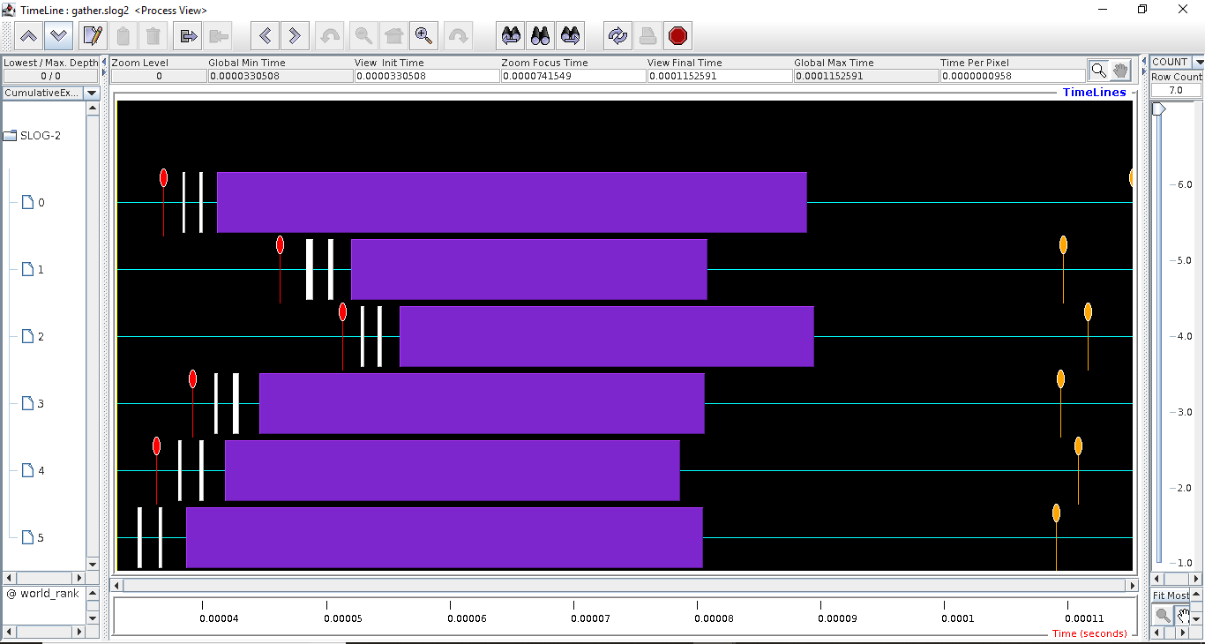

**16 Processes:**

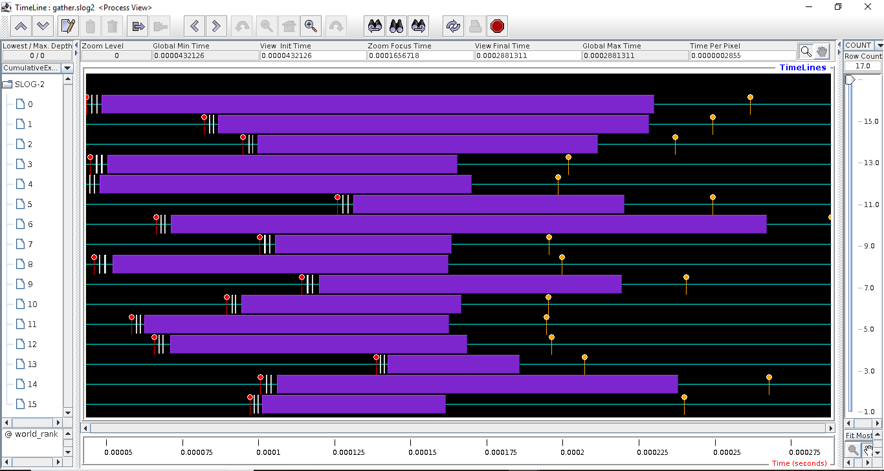

**My_AllGather:**

I have a send and receive function such a way that all the processes send and receive data to and from all other processes and itself in this I have used an array of size same as no. of processes to receive the data.

**6 Processes:**

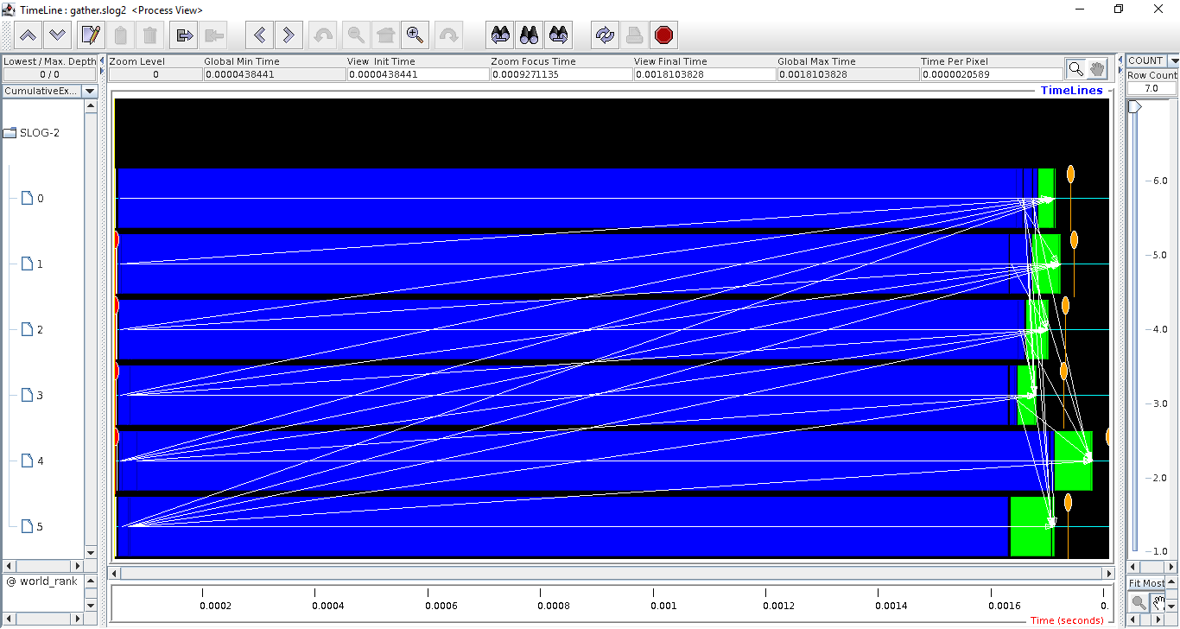

**16 Processes:**

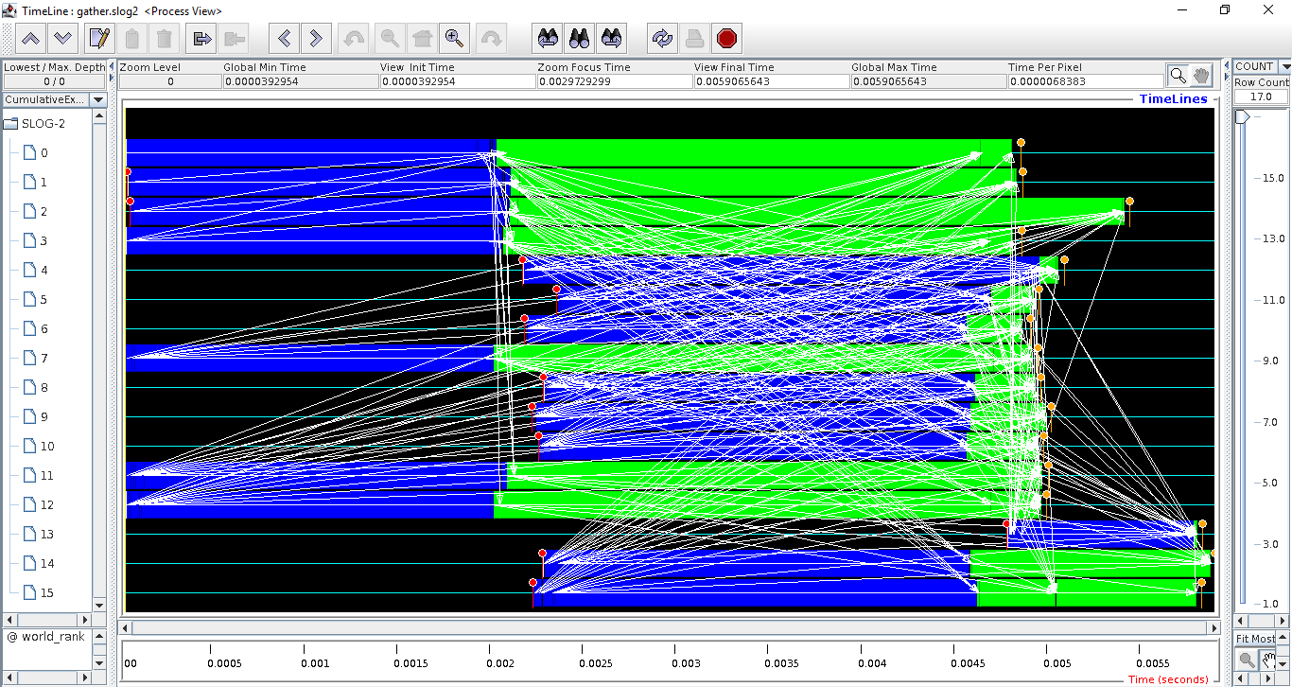

**Graph:**