

**Day 1 Task:**

* Write a JavaScript program to calculate days left until next Christmas

**CODE:**

function hai() {

today=new Date();

var cmas=new Date(today.getFullYear(), 11, 25);

if (today.getMonth()==11 && today.getDate()>25)

{

cmas.setFullYear(cmas.getFullYear()+1);

}

var one_day=1000*60*60*24;

console.log(Math.ceil((cmas.getTime()-today.getTime())/(one_day))+" days left until Christmas!");

**Output Screenshot :**  
  
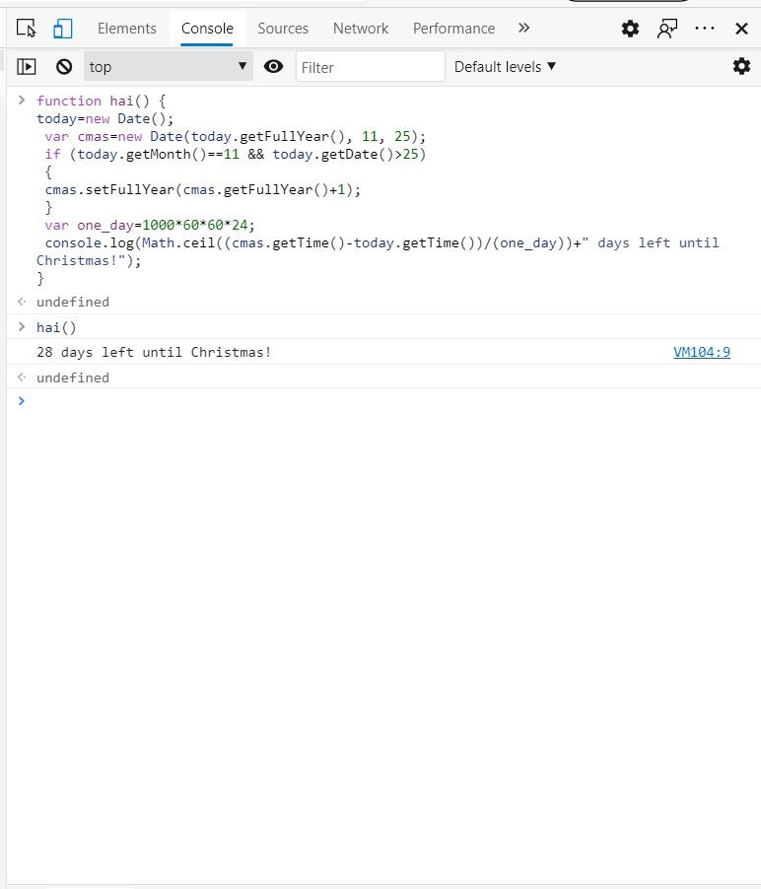

* Write a JavaScript program to check two given numbers and return true if one of the number is 50 or if their sum is 50

**CODE:**

function hai2(x, y)

{

return ((x == 50 || y == 50) || (x + y == 50));

}

console.log(hai2(20,30));

console.log(hai2(20,50));

console.log(hai2(40,30));

**Output Screenshot :**

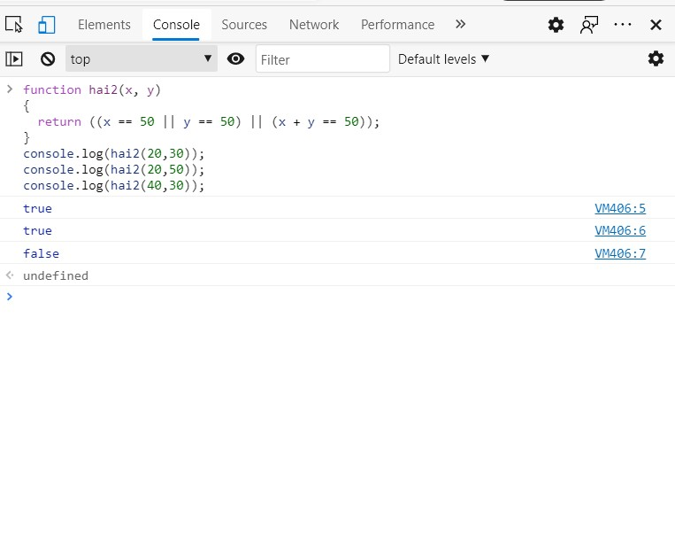

* Write a JavaScript program to check the length of the string

**CODE:**

function hai3() {

var str = "shashipreetham";

console.log(str.length);

}

**Output Screenshot :**

