

***REACTJS INTERNSHIP PROGRAM***

**Day 2 Task:**

* Write a javascript function with arguments that squares number

**CODE:**

function square(x) {

return(x*x)

}

console.log(square(5))

**OUTPUT SCREENSHOT:**

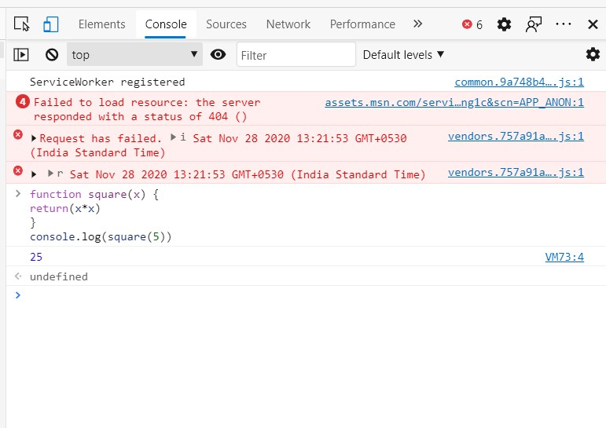

* Write a JavaScript function which returns random 6 digit numbers

**CODE:**

function random() {

return(Math.floor(Math.random()*1000000+1))

}

console.log(random())

**OUTPUT SCREENSHOT:**

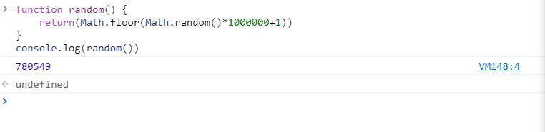

* Write a JavaScript function which display type and version of browser using alert

**CODE:**

function ShowBrowserDetails() {

var BrowserName = navigator.appName;

var appVersion = navigator.appVersion.substring(0,4);

alert("Browser Name:"+BrowserName+", Browser version:"+appVersion)

}

ShowBrowserDetails()

**OUTPUT SCREENSHOT:**

