

**Day 3 Task:**

* Create a javascript function that takes an integer and returns whether it's a repeated one or not print true if it's repeated else print false.

**CODE:**

function repeated(a){

var b = (a.toString().split(""));

return(b[a.toString().length-1]==b[a.toString().length-2])

}

console.log(repeated(556677)) //true

console.log(repeated(5467)) //false

console.log(repeated(22)) //true

**Output Screenshot :**  
  
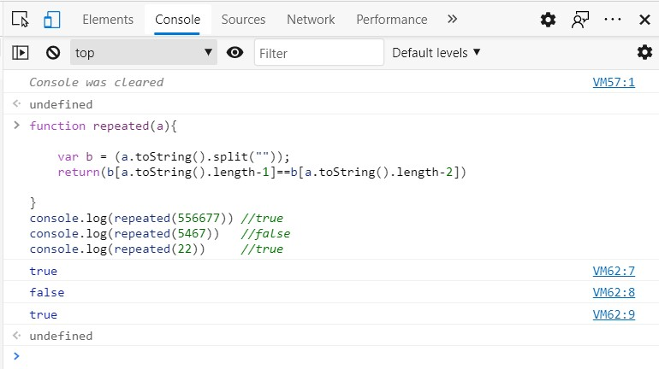

* Create a function that takes an array of numbers and returns the second largest number.

**CODE:**

function sLargest(arr){

arr.sort(function(a, b){

return a - b;

});

console.log(arr[arr.length-2]);

}

console.log(sLargest([1,5,12,3,7,15,9])) // 12

console.log(sLargest([4,6,3,2,1,5])) // 5

**Output Screenshot :**

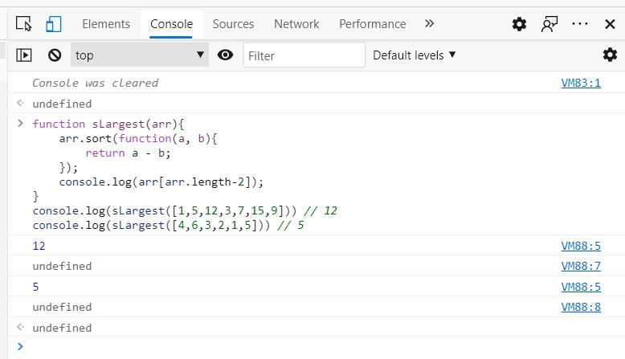

* Create a function that squares every digit of a number.

Ex input 3345

Expected output 3^23^24^25^2 = 991625.

**CODE:**

function squareEDOfNumber(a){

var arr = [];

var b = (a.toString().split(""));

for(var i=0;i<b.length;i++){

arr.push(b[i]*b[i]);

}

return(arr.join(""))

}

console.log(squareEDOfNumber(5566)) //25253636

console.log(squareEDOfNumber(3345)) //991625

**Output Screenshot :**

