Patient-level differential privacy, membership leakage and explanation fidelity in federated brain tumour MRI classification
Shashi Ranjanª, Poonguzhali N*ª
ªSchool of Computer and Systems Sciences, Jawaharlal Nehru University, New Delhi 110067, India
* Corresponding author. School of Computer and Systems Sciences, Jawaharlal Nehru University, New Delhi 110067, India. Telephone [CHECK: number with country and area code]. E-mail addresses shashi17_scs@jnu.ac.in, poonguzhali@jnu.ac.in.

Abstract
Background. Federated brain tumour classifiers for magnetic resonance imaging (MRI) on public collections report accuracies of 94% and above. These collections overlap, and privacy claims rarely state the budget or protected unit.
Purpose. The study measures what accounted differential privacy (DP) costs and protects per image and patient, and how it alters explanations.
Methods. Figshare, SARTAJ and Br35H were deduplicated into 3845 images with patient-disjoint splits, and a mirror-aware check removed 66 contaminated test images. A pretrained ResNet-18 was trained centrally and with federated averaging (FedAvg) under record- and patient-level DP stochastic gradient descent (Rényi accounting, $δ={10}^{−5}$, five seeds). A likelihood-ratio attack (LiRA, 16 shadow models) with source- and class-matched non-members audited leakage, and gradient-weighted class activation mapping (Grad-CAM) was scored against expert masks.
Results. Clean-set central balanced accuracy fell from 0.908 without DP to 0.778 at record-level $ε=8$, and patient-level DP needed $ε=64$ to reach 0.820. Against non-private FedAvg, LiRA found 11.1% of training images at a 1% false-positive rate and separated training from test patients with an area under the curve (AUC) of 0.805, whereas under record-level DP it found 1.0% to 1.5%, not significantly above chance. Higher-utility unclipped weight noise still exposed patients (AUC 0.745). Grad-CAM consistency across seeds fell from 0.700 to 0.235, tracking accuracy ($r=0.838$).
Conclusions. Record-level DP at $ε=8$ removed measurable membership leakage from audited federated models at a balanced-accuracy cost of 0.076 (0.130 centrally), whereas per-patient guarantees cost far more. Costs in real consortia remain untested, since clients were simulated.
Keywords. Federated learning; Rényi differential privacy; Membership inference attack; Gradient-weighted class activation mapping; Neuro-oncology; Dataset contamination

Introduction
Artificial intelligence is changing how brain tumours are detected and graded on magnetic resonance imaging (MRI), and deep learning now segments even small brain metastases.^{1,2} The clinical value of such models depends on training data drawn from many hospitals. Federated learning lets those hospitals train one shared model without moving scans, and early brain tumour studies showed that federated models approach the accuracy of centrally trained ones.³⁻⁵
Transparency and privacy preservation are both named as conditions for the clinical use of medical artificial intelligence.⁶ Sharing model updates is not the same as protecting patients, because updates and released models can reveal whether a person contributed data.^{7,8} Differential privacy (DP) bounds that risk formally, and its practical form for deep networks, differentially private stochastic gradient descent (DP-SGD), clips each example’s gradient and adds calibrated Gaussian noise.⁹ Slice-based MRI complicates the guarantee, since one Figshare patient contributes a median of 13 slices and a guarantee per image covers that patient only through group privacy.
Two further problems weaken the published evidence for private federated brain tumour classifiers. The public four-class collections assembled from Figshare, SARTAJ and Br35H overlap, so test images can have near-copies in training.¹⁰ The privacy budget and the protected unit are also often not reported in a form that can be checked. One recent federated brain tumour study leaves the values of $ε$ and $δ$ blank in its published text,¹¹ and a multi-disease study that includes brain tumour MRI reports the noise multiplier and clipping norm of DP-SGD without $ε$, $δ$ or the sampling rate.¹² A third study states an $ε$ that its unclipped mechanism cannot support.¹³
The present paper therefore measures, on a deduplicated benchmark with expert tumour masks, what record-level and patient-level DP cost in accuracy, whether measured leakage follows the formal guarantee, and how explanations change under privacy. The study uses only public data, simulated federated clients and post-hoc audits, and it reports every result on a test set cleaned of mirrored duplicates.

Related work
Federated learning for brain tumours began with multi-institutional segmentation, where models trained without sharing data matched those trained on pooled data.³⁻⁵ Later classification studies on the merged Figshare, SARTAJ and Br35H collections report accuracies from 94% to 99.29% with federated averaging (FedAvg),¹⁴ FedProx, SCAFFOLD or transfer learning, and some add Grad-CAM pictures.¹⁵⁻¹⁸ The present work differs by training on a deduplicated, patient-disjoint benchmark and by attaching an accounted privacy guarantee to every private model.
Differential privacy has been applied to medical imaging with dedicated DP-SGD libraries and accounting tools.¹⁹⁻²¹ Kaissis et al. trained a three-site federated chest radiograph model at $ε=6$ whose accuracy stayed comparable to that of two radiologists.²² Adnan et al. studied differentially private federated learning on histopathology with varying numbers of providers,²³ and Tayebi Arasteh et al. found that private training lowered accuracy mainly for difficult diagnoses.²⁴ Ziller et al. showed that large budgets can already block reconstruction attacks.²⁵ These studies protect single records, whereas the present work compares record-level and patient-level guarantees on the same data and audits both empirically.
Membership inference measures privacy empirically, and the likelihood-ratio attack (LiRA) compares a target model’s confidence on an example with that of shadow models trained with and without it.²⁶ Knolle et al. reported that patients with several similar records can face near-perfect attack success even when aggregate success looks random.⁸ The closest federated brain tumour study adds Gaussian noise with standard deviation 0.5 to client weights without clipping, so its stated $ε$ of about 3.4 cannot be derived from the mechanism.¹³ The present work runs LiRA at the image and the patient level against formally private models and against that unclipped mechanism.
Private training also changes explanations, since Saifullah et al. and Manna and Sett reported that DP alters attributions across many datasets and methods,^{27,28} and Adebayo et al. showed that some saliency methods ignore the learned weights.²⁹ The present work measures Grad-CAM localisation against expert tumour masks, its consistency across seeds and a randomisation check, and asks whether privacy affects explanations beyond its effect on accuracy.
Benchmark contamination is the last theme, and Vangala et al. found that 28.8% of a widely used Kaggle test split has a near-twin in training,¹⁰ and the source collections differ in class composition.³⁰⁻³² The present work adds a mirror-aware correlation check, because perceptual hashes do not match copies flipped left to right. Taken together, the accuracy cost and the empirical leakage of record-level and patient-level DP for federated brain tumour MRI on contamination-checked data, together with their effect on explanation fidelity, have not been measured side by side. The individual methods used here are established, so the contribution of the present work lies in applying them jointly, with accounted guarantees at two privacy units and an attack whose members and non-members are matched in composition.

Contributions
The study makes five contributions, each answered by the measurements summarised in the abstract.
- A deduplicated, patient-disjoint benchmark. Perceptual-hash deduplication reduced 7828 labelled images to 3845 images split by patient, and a mirror-aware correlation check found 66 contaminated test images, which are excluded from every reported result.
- An accounted privacy and utility comparison at two privacy units. Central and federated models were trained under record-level and patient-level DP-SGD with Rényi accounting and five seeds per setting. Record-level $ε=8$ cost 0.130 in central balanced accuracy, mostly through meningioma and no-tumour sensitivity, whereas patient-level DP needed $ε=64$ to exceed that accuracy.
- The effect of client count under DP. Splitting the same images across more clients lowered accuracy under DP by 0.096 per unit of $lnK$ at $ε=3$, consistent with the aggregated noise scale, and FedProx and SCAFFOLD did not recover the loss.
- An empirical privacy audit. LiRA with 16 shadow models per setting identified training images and patients in non-private federated models, found no rate significantly above chance at 1% FPR under record-level DP once non-members were matched to members by source and class, and still detected patients under an unclipped weight-noise mechanism of higher utility.
- Explanation fidelity under privacy. Grad-CAM localisation and cross-seed consistency declined as $ε$ decreased, consistency correlated with accuracy at $r=0.838$ across 31 configurations, and the noise multiplier added no explanatory power once accuracy was known.
Section 2 states the threat model and describes the curation, training, audit and explanation methods, Section 3 reports the results, Section 4 interprets them with their limitations, and Section 5 concludes.

Material and methods
The methods follow the four stages of the study, namely benchmark curation, private training, the membership audit and the explanation audit. Section 2 first fixes the notation, the threat model and the formal guarantee on which every later component relies. The following subsections describe each stage with its algorithm, and the last two give the experimental settings and the statistical conventions applied throughout.

Problem formulation and threat model
Consider $K$ clients, where client $j$ holds a dataset $D_{j}$ of $n_{j}$ images grouped into $U_{j}$ units, and N=j​nj=2610 training images form U=j​Uj=634 units. A unit is one Figshare patient, or a group of near-identical SARTAJ or Br35H images, because those two collections carry no patient identifiers. A server runs $T=100$ rounds, and in each round every client runs $S=10$ local steps on a model $f_{θ}$ with parameters $θ$.
A randomised training mechanism $M$ is $\left(ε,δ\right)$-differentially private if, for all neighbouring datasets $D$ and $D′$ and every set of outputs $O$,
$$Pr\left[M\left(D\right)∈O\right]≤e^{ε} Pr\left[M\left(D′\right)∈O\right]+δ.$$
Record-level neighbours differ in one image, and patient-level neighbours differ in one unit. Smaller $ε$ means stronger protection, and $δ={10}^{−5}$ lies below $1/N$.
Every client runs DP-SGD on its own data, so each update it sends is already a private release. The guarantee therefore holds against an honest-but-curious server, against other clients and against anyone who sees the released model. Client sizes $n_{j}$ and $U_{j}$ and the server-held validation split are treated as public, and no secure aggregation or other cryptographic protection³³ is used. A unit split across $m$ clients is protected by the composition of $m$ guarantees, and the worst case over units is reported. Client-level DP, which hides the participation of a whole hospital,³⁴ was not evaluated, because with three to 15 clients the noise needed to mask one client would dominate the aggregate.
The audit adversary has query access to the logits of the released model, knows the training recipe and the data distribution, and can train shadow models on samples of the same population. The adversary’s goal is to decide whether a given image, or a given patient, was used in training. The formal guarantee also covers every update that a client sends, but the empirical audit tests only the released model, and attacks that reconstruct images from individual updates²⁵ were not run. The study pursues three goals, namely the accuracy cost of each guarantee, the leakage that remains measurable, and the change in explanation quality.
The code enforces clipping, noise, sampling and accounting, whereas three elements rest on assumptions. The patient-level guarantee is exact only for Figshare, the round with the lowest validation loss is selected on the public validation split, and the federated learning-rate search adds a privacy cost that is reported but not calibrated. The central learning rate of 0.02 was chosen among three candidates in pilot runs on the same training data, and that selection is not included in any reported $ε$.

Evaluation framework
Fig. 1 shows the four stages of the study. Curation builds a deduplicated benchmark with patient units and a clean test set, private training produces central and federated models at two privacy units, and two audits measure leakage and explanation quality on the released models.
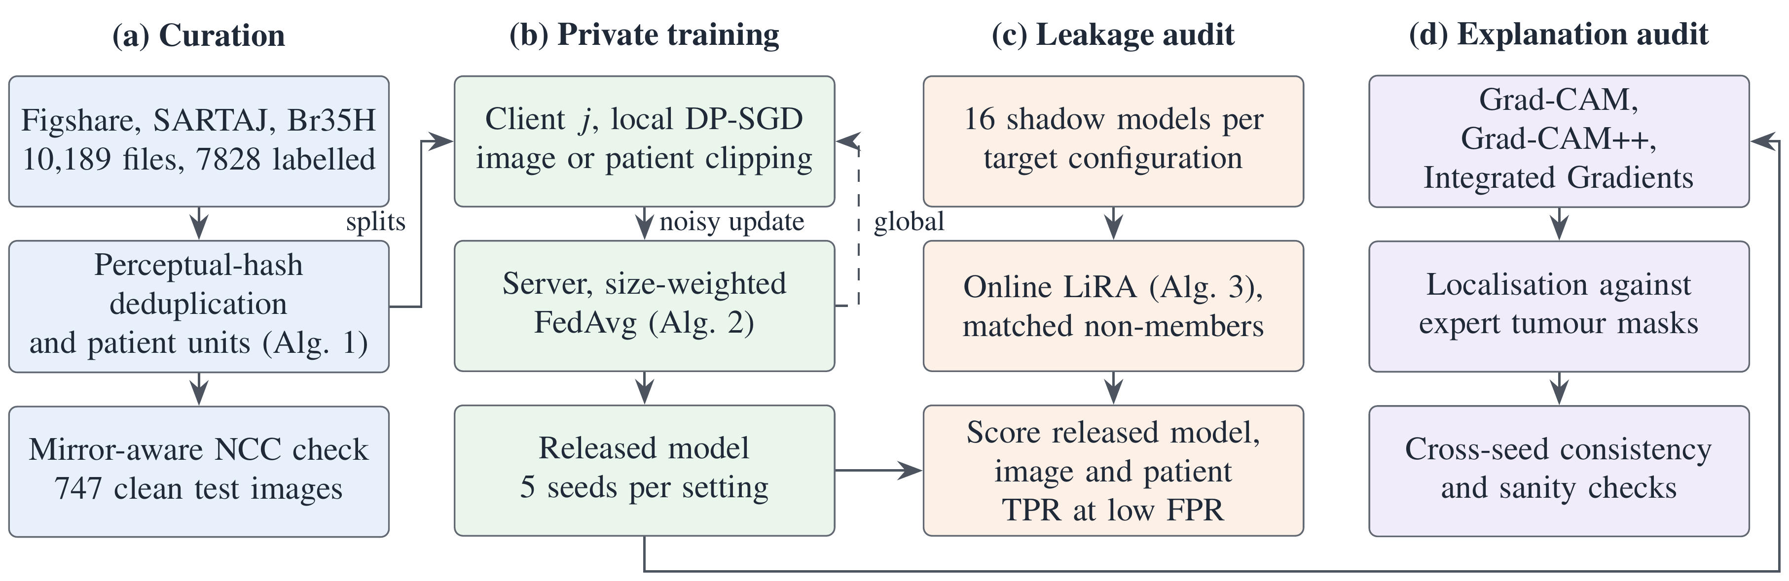
Fig. 1. Evaluation framework. (a) Curation. (b) Private federated training. (c) Leakage audit. (d) Explanation audit.

Data curation and leakage control
Three public collections were combined, namely Figshare (3064 T1-weighted contrast-enhanced slices from 233 patients with expert tumour masks),^{30,35} SARTAJ (3264 images)³¹ and Br35H (3861 images).³² Glioma, meningioma, pituitary tumour and no-tumour labels were kept, which left 7828 labelled images, and Algorithm 1 summarises the curation steps described next.
Each image was clipped to its 0.5th and 99.5th intensity percentiles, scaled to 8 bits, padded to a square and resized to $128×128$ pixels with box filtering. Deduplication used a 64-bit discrete cosine transform perceptual hash and visited images in the order Figshare, SARTAJ and Br35H, so that the expert-annotated copy was kept. An image within Hamming distance 4 of a kept image was removed, and a label disagreement removed both images unless the kept image came from Figshare. Deduplication removed 3934 images and label conflicts a further 49.
Split units are Figshare patients, with 48 pairs of patients that shared a slice merged into one unit, and groups of SARTAJ and Br35H images linked within Hamming distance 6. Units were assigned to training, validation and test splits in the proportions 70, 10 and 20%, stratified by dominant source and label with seed 2026. The result was 2610 training, 422 validation and 813 test images in 821 training and test units and 103 validation units, with no Figshare patient in two splits (Table 1).
Perceptual hashes do not match mirrored copies, so every pair of curated images was compared by normalised cross-correlation (NCC) at $64×64$ pixels, both as stored and with one image flipped left to right. A test image with NCC of at least 0.95 to any image in another split, a threshold fixed before the check, was marked contaminated, and the check covered $3845×3844/2=7,390,090$ pairs in two orientations.

Algorithm 1. Curation and leakage control
- Input. labelled images from Figshare, SARTAJ and Br35H, Figshare patient identifiers
- Output. curated images, split units, splits and the set $C$ of contaminated test images
- preprocess each image (percentile clipping, 8-bit scaling, square padding, $128×128$ box resizing)
- compute a 64-bit perceptual hash $h_{i}$ for every image
- $K←∅$
- for each image $i$ in source order Figshare, SARTAJ, Br35H, then file path do
- if no $k∈K$ has Hamming distance $d_{H}\left(h_{i},h_{k}\right)≤4$ then
- add $i$ to $K$
- else if the labels of $i$ and $k$ differ and $k$ is not from Figshare then
- remove $k$ from $K$ and discard $i$ (label conflict)
- else
- discard $i$ (duplicate, or copy of a Figshare slice)
- end if
- end for
- form units from Figshare patients, merging patients that share a slice with $d_{H}≤4$
- link SARTAJ and Br35H images with $d_{H}≤6$ into units
- assign units to train, validation and test (70, 10, 20%), stratified by source and label
- for each pair $\left(i,l\right)$ of curated images do
- $r_{il}←max\{NCC\left(x_{i},x_{l}\right), NCC\left(x_{i},flip\left(x_{l}\right)\right)\}$ at $64×64$
- end for
- $C←\{i∈\text{test}:r_{il}≥0.95\text{ for some }l\text{ in another split}\}$

Federated training with record-level and patient-level DP
Every client draws a Poisson batch $B$ in which each image is kept independently with rate $q=0.1$. Record-level DP-SGD⁹ clips each per-example gradient $g_{i}$ to norm $C=1$, adds Gaussian noise with noise multiplier $σ$ and divides by the expected batch size $q n_{j}$, which keeps the denominator independent of the data,
gj=1q nji∈B​gimin1,C∥gi∥2+N0,σ2C2I.
Patient-level DP samples units with rate $q$ instead of images. For each sampled unit $u$ with images $I_{u}$, the mean gradient gu=Iu−1i∈Iu​gi is clipped, so adding or removing a whole unit changes the sum by at most $C$,
gj=1q Uju∈BU​gumin1,C∥gu∥2+N0,σ2C2I.
The server averages client models with size weights, θ←j​nj/N θj. Client $j$ adds noise with standard deviation $σC/\left(q n_{j}\right)$ and receives weight $n_{j}/N$, so each client contributes noise $σC/\left(qN\right)$ to the average whatever its size, and $K$ independent clients give
$$s_{agg}=\frac{σC\sqrt{K}}{qN}.$$
Algorithm 2 lists one complete training run.
The noise multiplier $σ$ was calibrated by bisection so that Rényi DP accounting²⁰ in Opacus²¹ gives the target $ε$ at $δ={10}^{−5}$ over $T×S=1000$ steps. Record-level targets were $ε$ of 1, 3 and 8, central patient-level targets 3, 8, 16, 32 and 64, and federated patient-level runs used $ε=8$. A clip-only ablation with $σ=0$ separates the cost of clipping from that of noise. Because federated learning rates were chosen among $k=2$ candidates trained on the same records, the $ε$ composed over both candidates is also reported.³⁶

Algorithm 2. Federated training with client-side DP-SGD
- Input. client data $D_{j}$ (with units at patient level), rounds $T$, local steps $S$, rate $q$, clip norm $C$, noise multiplier $σ$, learning rate $η_{0}$, momentum $β$, optional weight noise $s$
- Output. released parameters $θ^{⋆}$ and accounted $ε$
- initialise $θ$ from ImageNet weights, $θ^{⋆}←θ$
- for $t=1,…,T$ do
- $η_{t}←η_{0} 1/2\{1+cos\left(π\left(t−1\right)/T\right)\}$ (cosine schedule)
- for each client $j$ do
- $θ_{j}←θ$
- for $l=1,…,S$ do
- draw a Poisson batch of images (record level) or units (patient level) with rate $q$
- compute ${\tilde{g}}_{j}$ by Eq. (2) or Eq. (3) on randomly flipped images
- add the FedProx or SCAFFOLD correction if used, then take a momentum step with $η_{t}$ and $β$
- end for
- if $s>0$, $θ_{j}←θ_{j}+N\left(0,s^{2}I\right)$ (weight-noise comparator, no DP)
- end for
- θ←j​nj/N θj
- if the validation loss of $θ$ is the lowest so far, $θ^{⋆}←θ$
- end for
- $ε←$ Rényi accountant$\left(σ,q,TS,δ\right)$
Per-example gradients were computed in physical chunks of 32 examples, so memory grows with the chunk size times the number of parameters $P$, and one local step costs $O\left(\left|B\right| P\right)$. Central training is the one-client case on the pooled training set.

Drift correction and the weight-noise comparator
FedProx³⁷ adds a proximal term with weight $μ$ to each local objective, and $μ$ of 0.01, 0.1, 1 and 10 was screened on validation loss at seed 0. SCAFFOLD³⁸ uses option II control variates with two corrections that the present setting requires. The control-variate normaliser uses the displacement of heavy-ball momentum, $η M\left(L,β\right)$ with $M=\sum_{l=1}^{L}{\left(1−β^{l}\right)}/\left(1−β\right)$ over $L$ local steps, in place of $Lη$, and the server control variate is averaged with the same size weights as the model. An ablation keeps the uniform average of the original algorithm.
To test the mechanism of the closest prior work,¹³ Gaussian noise $N\left(0,s^{2}\right)$ was added to each client’s weights after local training, without clipping or accounting. The published value $s=0.5$ was kept, and a utility-matched $s$ was chosen by a rule fixed beforehand. The rule took the largest value in $\{0.5,0.05,0.01,0.003,0.001\}$ whose seed-0 validation loss did not exceed that of record-level $ε=8$ FedAvg on the natural partition, which selected $s=0.003$.

Membership inference audit
LiRA²⁶ was run against FedAvg on the natural partition without DP and at $ε$ of 8, 3 and 1, and against the weight-noise comparator (Algorithm 3). Each target configuration has 16 shadow models trained with the target’s settings on a random half of the training and test units. Every patient is therefore wholly in or out of a shadow’s training set.
The attack statistic is the logit-scaled confidence ϕ=zy−logc≠y​ezc of the true class $y$, where $z$ are the logits, computed for the image ($a=1$) and its mirror image ($a=2$). For each example, Gaussian fits to the statistics of shadows that included (IN) and excluded (OUT) it give the online score
$$Λ=\sum_{a=1}^{2}{\left[logN​\left(ϕ_{a};μ_{a}^{in},σ_{a}^{in}\right)−logN​\left(ϕ_{a};μ_{a}^{out},σ_{a}^{out}\right)\right]},$$
with per-example means and one pooled standard deviation per side, the variant suited to few shadows. A patient’s score is the sum of $Λ$ over the patient’s slices.
Members are the training images and non-members the clean test images. Patient scores compare 126 Figshare training units with 40 test units. True-positive rates (TPR) at 1% and 0.1% false-positive rate (FPR) are the primary measures, and the area under the curve (AUC) is reported alongside. Because the clean non-members differ from the members in source and class mix, the TPR at 1% FPR is also computed with non-members reweighted to the members’ distribution over source and class strata, and with both groups restricted to Figshare. The diverged weight-noise models, which classify at chance, give an empirical reference for the rate reached without a usable classifier. A loss-threshold attack, computed overall and within each source and class stratum, served as a simpler reference.

Algorithm 3. Online LiRA at image and patient level
- Input. target models, 16 shadow models with membership masks, labels $y$, Figshare units
- Output. image-level and patient-level TPR at fixed FPR, and AUC
- for each shadow model $m$ and each example $i$ do
- ϕm,i,a←zy−logc≠y​ezc for the image ($a=1$) and its mirror ($a=2$)
- end for
- fit $μ_{i,a}^{in}$ and $μ_{i,a}^{out}$ per example and pooled $σ_{a}^{in}$ and $σ_{a}^{out}$
- for each target model do
- score every example by Eq. (5), keeping examples with at least one IN and one OUT shadow
- image level, training images against clean test images
- patient level, summed scores of Figshare training units against test units
- end for
The audit costs 16 shadow trainings per target configuration, in addition to inference of every model on all 3845 images and their mirrors.

Explanation evaluation
Grad-CAM³⁹ on the last residual block, Grad-CAM++⁴⁰ and Integrated Gradients (IG)⁴¹ with a black baseline and 32 steps were computed for the true class of the 645 Figshare test tumour images that have expert masks. At $128×128$ input the last block has $4×4$ resolution, and maps are upsampled bilinearly. Localisation used the pointing game with a 3-pixel tolerance, the intersection over union (IoU) of the top 15% of pixels with the mask and the share of saliency inside the mask, on correctly classified images.
Faithfulness used deletion and insertion curves over 20 steps.⁴² A model-parameter randomisation test²⁹ on 64 images compared maps of each trained model with those of a fully re-initialised network. The share of Grad-CAM mass on the outer 8-pixel rim of the brain tested for skull-border artefacts. Consistency across seeds adapts the metric of Gupta et al.,¹³ with the seeds of one configuration in place of clients, five for central and three for federated configurations. It is the IoU between the top 10% of pixels of each model’s $8×8$ Grad-CAM map and those of the mean map over seeds.

Experimental setup
Table 1 gives the data per source. The natural partition assigns each source to one client, giving clients of 2029 (Figshare), 351 (SARTAJ) and 230 (Br35H) training images with strong label skew, since no-tumour images come only from SARTAJ and Br35H. Synthetic partitions split the same 2610 images into 10 clients uniformly at random or by a Dirichlet prior over class proportions with $α$ of 0.1, 0.5 or 5.0.⁴³ The $α=0.5$ partition was also built with $K$ of 3, 5 and 15 clients, and a Dirichlet partition over whole units ($α=0.5$, $K=10$) serves patient-level DP.
Table 1. Images per source.
Source | Raw files | Four-class | Deduplicated | Train | Validation | Test | Clean test
Figshare | 3064 | 3064 | 3010 | 2029 | 336 | 645 | 644
SARTAJ | 3264 | 3264 | 505 | 351 | 52 | 102 | 97
Br35H | 3861 | 1500 | 330 | 230 | 34 | 66 | 6
Total | 10,189 | 7828 | 3845 | 2610 | 422 | 813 | 747
Each baseline isolates one effect. Non-private central and FedAvg models give the utility without protection, the clip-only ablation isolates clipping, and local-only models trained on one client give the floor that federation must beat. FedProx and SCAFFOLD are standard corrections for client drift, and the weight-noise comparator reproduces the mechanism of the closest prior work. Balanced accuracy is the primary utility metric because the four classes are imbalanced across sources, and Table 2 lists the training settings.
The classifier is an ImageNet-pretrained ResNet-18⁴⁴ whose first convolution sums the three colour filters into one input channel. Batch normalisation layers stay in inference mode with their pretrained statistics, so the network treats every example independently and per-example clipping remains valid, while their affine parameters are trained.
Table 2. Training and audit settings.
Setting | Value
Model | ResNet-18, ImageNet weights, one-channel stem, frozen BatchNorm statistics
Input and augmentation | $128×128$ pixels, random horizontal flip with probability 0.5
Optimiser | SGD, momentum 0.9, no weight decay, cosine decay over rounds
Learning rate | 0.02 central, 0.003 or 0.01 federated (selected at seed 0)
Rounds and local steps | $T=100$, $S=10$ (one local epoch at $q=0.1$)
Clipping | $C=1$ per example or unit under DP, global norm 1.0 without DP
Noise multiplier $σ$ | 12.885, 4.832, 2.179, 1.353, 0.922, 0.673 for $ε$ of 1, 3, 8, 16, 32, 64
Model selection | round with the lowest validation loss
Seeds | 1 to 5 reported, 0 for selection only
Membership audit | 16 shadow models per target configuration
All models were trained in PyTorch 2.11.0 with CUDA 12.8 and per-example gradients from torch.func and the Rényi accountant of Opacus 1.6.0, on Kaggle machines with two NVIDIA T4 GPUs. The 608 reported runs and the audit took 58.7 GPU hours. Each run is identified by a hash of its resolved configuration, and all tables and figures were regenerated on Kaggle from the stored run files and frozen with SHA-256 hashes before writing.

Statistical analysis
Every setting was trained with seeds 1 to 5, and seed 0 was reserved for learning-rate and $μ$ selection. Results are seed means with $t$-based 95% confidence intervals from the sample standard deviation, and SCAFFOLD was compared with FedAvg by paired $t$-tests over seeds with Holm correction across 15 configurations. The client-count effect is the least-squares slope of balanced accuracy on $lnK$ over 20 runs per setting.
Explanation metrics within one model carry 95% intervals from 2000 bootstrap resamples of test patients. The relation between explanation quality and privacy was tested with the Pearson correlation between each metric and clean balanced accuracy, and with an ordinary least-squares fit on accuracy and $σ$. Because consistency is measured against the mean map of each configuration, its seeds are not independent, so the primary analysis uses one point per configuration and the per-model analysis is reported alongside. Membership rates were compared with the nominal level by one-sample $t$-tests over the five targets. Only the SCAFFOLD comparison is corrected for multiplicity, and the other intervals and $p$-values are descriptive. Metrics are reported to three decimal places and $p$-values to three decimal places or as $p<0.001$.

Results
The results follow the order of the study goals. The curated benchmark and its contamination check come first, followed by the accuracy cost of each privacy unit, the effect of client count and drift correction, the membership audit, the explanation audit and the source controls. Unless a passage states otherwise, every value refers to the 747 clean test images and gives the mean over seeds with its 95% CI.

Curated benchmark
Table 1 shows that deduplication removed more than half of the labelled images, mostly because SARTAJ and Br35H repeat each other and Figshare. The NCC check then found 148 cross-split pairs at NCC of 0.95 or more, of which 120 matched only after flipping, and these pairs marked 66 of the 813 test images as contaminated. Of the 66, 60 were Br35H no-tumour images, 5 SARTAJ no-tumour images and 1 a Figshare glioma.
Removing the contaminated images changed configuration means of balanced accuracy by $−0.049$ to $+0.007$, and single runs by at most 0.072 in absolute value. Private configurations lost more on average ($−0.031$) than non-private ones ($−0.017$), so the full test set flattered private models slightly more. Every comparison below uses the 747 clean test images, and the full-set values appear in Supplementary Table S3.

Accuracy cost of record-level and patient-level DP
Table 3 and Fig. 2 show the cost of each guarantee. Record-level DP at $ε=8$ reduced central balanced accuracy from 0.908 to 0.778, a cost of 0.130, and accuracy approached the four-class chance level of 0.25 at $ε=1$. Clipping alone accounted for 0.063 of the 0.130 decrease ($0.908−0.845$) and noise for the remaining 0.067 ($0.845−0.778$).
Table 3. Clean-set balanced accuracy, mean (95% CI) over five seeds.
Setting | No DP | Clip only | $ε=8$ | $ε=3$ | $ε=1$
Central, image | 0.908 | 0.845 | 0.778 | 0.648 | 0.326
 | (0.894, 0.921) | (0.818, 0.871) | (0.739, 0.818) | (0.572, 0.723) | (0.272, 0.379)
Central, patient | 0.908 | 0.872 | 0.337 | 0.251 | not run
 | (0.894, 0.921) | (0.852, 0.891) | (0.284, 0.390) | (0.248, 0.253)
FedAvg, natural | 0.841 | not run | 0.765 | 0.674 | 0.525
 | (0.833, 0.848) |  | (0.731, 0.800) | (0.659, 0.688) | (0.463, 0.586)
FedAvg, Dir. 0.5ª | 0.870 | not run | 0.669 | 0.590 | 0.331
 | (0.852, 0.887) |  | (0.626, 0.712) | (0.548, 0.631) | (0.280, 0.383)
Table 4 shows where the cost fell. At record-level $ε=8$, central meningioma sensitivity fell from 0.861 to 0.520 and no-tumour sensitivity from 0.913 to 0.700, whereas glioma (0.880 to 0.915) and pituitary sensitivity (0.976 to 0.979) did not decline. The share of tumour images classified as no tumour stayed between 0.010 and 0.042 in every setting of Table 4, so the private models mostly confused tumour types.
Table 4. Clean-set sensitivity per class, mean over five seeds.
Training | Setting | Glioma | Meningioma | No tumour | Pituitary | Missed
Central | No DP | 0.880 | 0.861 | 0.913 | 0.976 | 0.016
 | Clip only | 0.883 | 0.711 | 0.800 | 0.986 | 0.025
 | $ε=8$ | 0.915 | 0.520 | 0.700 | 0.979 | 0.025
 | $ε=3$ | 0.922 | 0.178 | 0.587 | 0.905 | 0.042
 | $ε=1$ | 0.836 | 0.086 | 0.117 | 0.263 | 0.033
 | Patient, $ε=64$ | 0.787 | 0.711 | 0.873 | 0.911 | 0.038
FedAvg | No DP | 0.893 | 0.802 | 0.687 | 0.981 | 0.010
 | $ε=8$ | 0.903 | 0.588 | 0.587 | 0.984 | 0.024
 | Weight noiseª | 0.892 | 0.803 | 0.530 | 0.977 | 0.011
For FedAvg on the natural partition the cost at $ε=8$ was 0.076 ($0.841−0.765$), and the diamond in Fig. 2 marks the unclipped weight-noise comparator, which has no formal $ε$. Local-only training on any single natural client stayed below federated accuracy, at most 0.625 for the Figshare client (Supplementary Table S4). Patient-level DP was far more expensive at the same $ε$. Patient-level clip-only training reached 0.872, so counting each patient once did not by itself harm accuracy, but at $ε=8$ accuracy fell to 0.337.
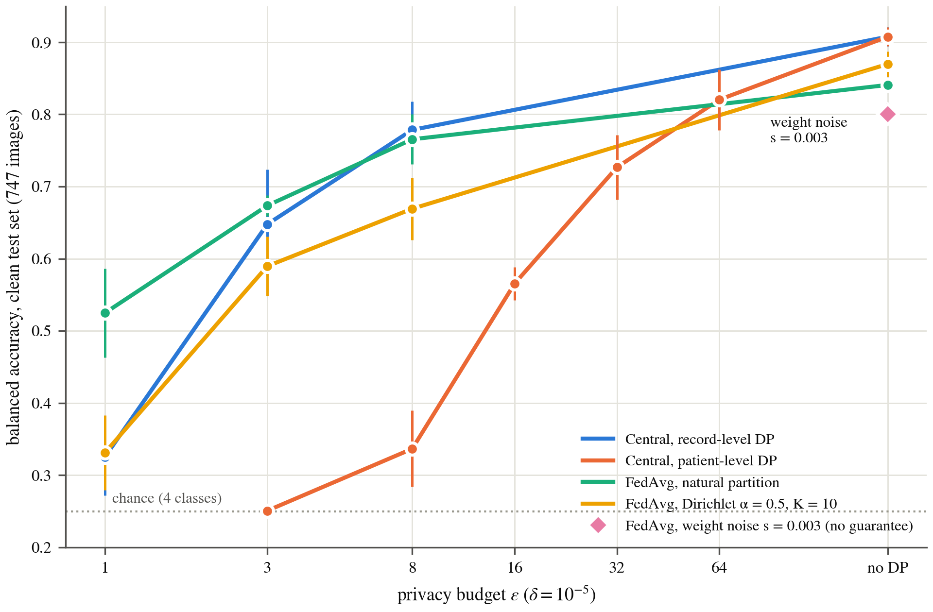
Fig. 2. Balanced accuracy against privacy budget $ε$ ($δ={10}^{−5}$). Means of five seeds with 95% CIs.
The patient-level curve recovered only at large budgets, with 0.565 at $ε=16$, 0.727 at $ε=32$ and 0.820 at $ε=64$, so a budget eight times larger than record-level $ε=8$ was needed to exceed its accuracy. Federated patient-level DP at $ε=8$ reached 0.398 on the natural partition and 0.271 on the Dirichlet partition over units (Supplementary Table S3). The gap follows from Eq. (3), whose noise is divided by 634 training units instead of 2610 images, a factor of $2610/634=4.117$ more noise in each averaged update at the same $σ$.
Record-level $ε=8$ gives little formal protection per patient. A Figshare patient contributes a median of 13 slices, and group privacy turns an $\left(ε,δ\right)$ guarantee for one image into $\left(kε, ke^{\left(k−1\right)ε}δ\right)$ for $k$ images.⁴⁵ For $k=13$, $ε=8$ and $δ={10}^{−5}$ the second term is $13e^{96}×{10}^{−5}≈6×{10}^{37}$, far above 1, so the record-level guarantee bounds nothing for such a patient. Composing over the two learning-rate candidates raised federated record-level $ε=8$ to 11.98 (Supplementary Table S7).

Client count under DP
Fig. 3 shows that, with the same 2610 images split across more clients, accuracy fell under DP but not without it. At $ε=3$ the slope was $−0.096$ per unit of $lnK$ ($p<0.001$), from 0.677 with three clients to 0.525 with 15. At $ε=8$ the slope was $−0.156$ ($p<0.001$) with learning rate 0.01, from 0.779 to 0.525, and $−0.016$ ($p=0.380$) with the rate of 0.003 selected for 10 clients (dashed in Fig. 3), whereas without DP the slope was $+0.013$ ($p=0.079$).
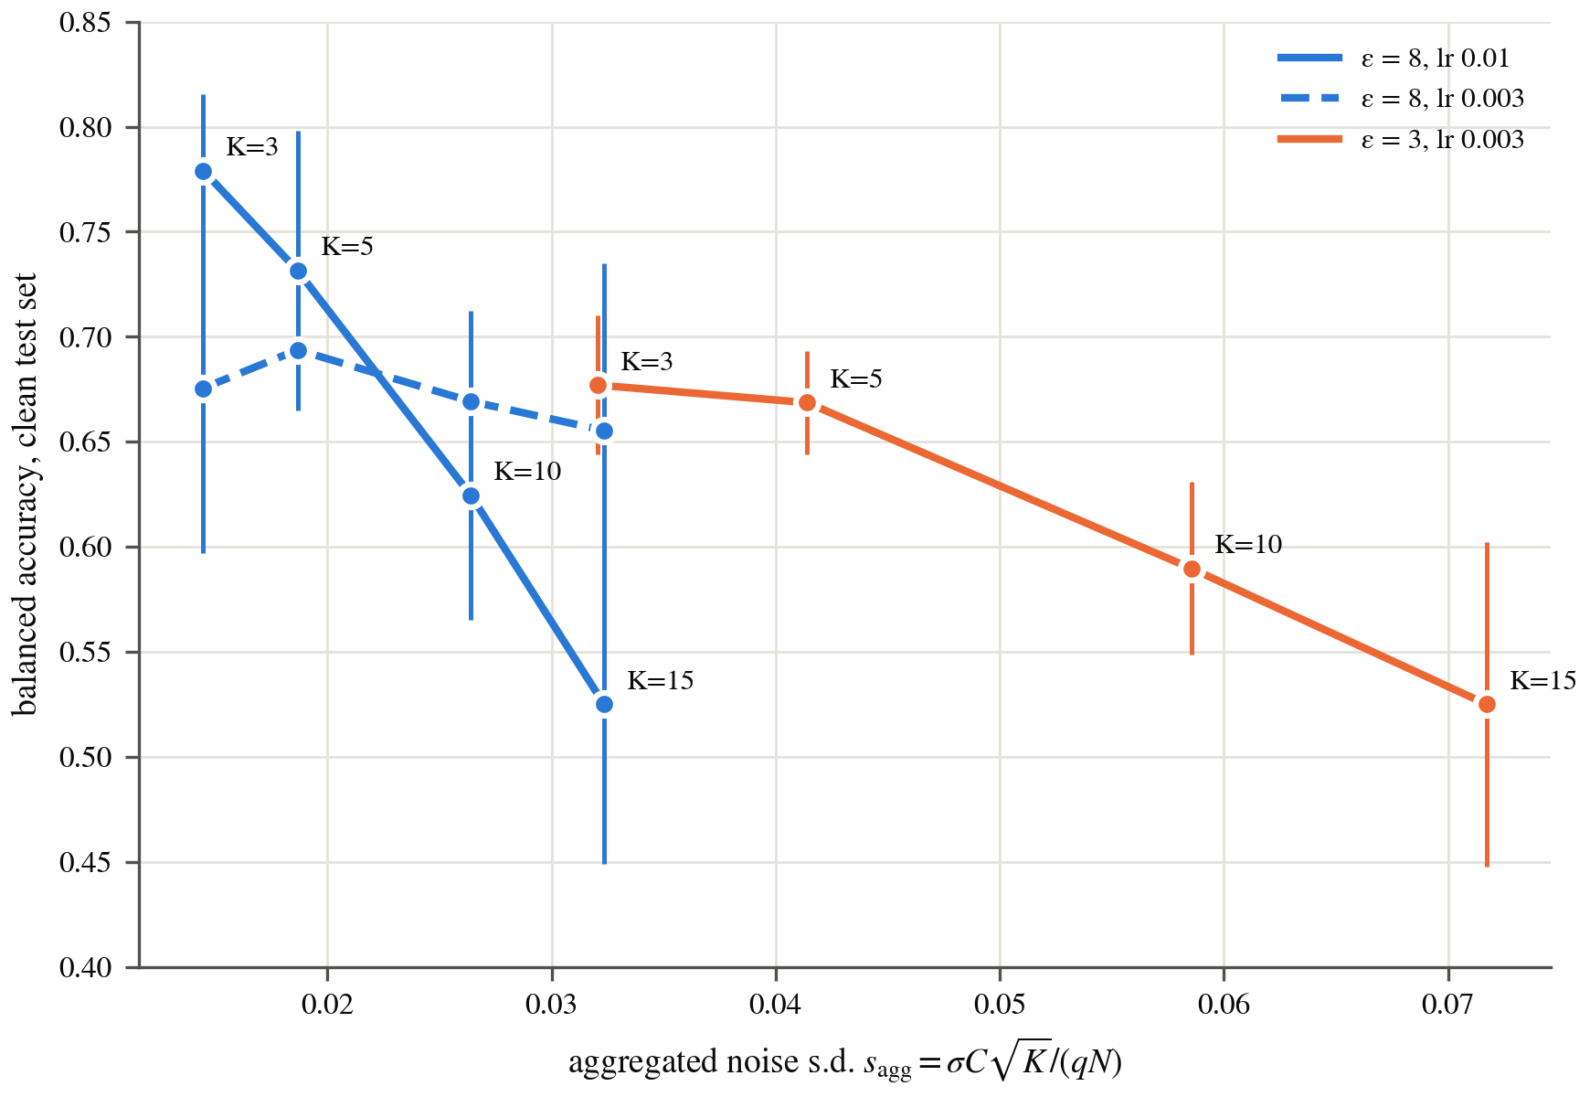
Fig. 3. Accuracy against aggregated noise $s_{agg}$ for $K=3$ to 15 clients. Means of five seeds with 95% CIs.
The decline follows the aggregated noise of Eq. (4), which grows with $\sqrt{K}$ at fixed $N$. Label skew mattered less, since at $K=10$ and $ε=3$ the Dirichlet partitions with $α$ of 0.1, 0.5 and 5.0 and the uniform partition reached 0.589, 0.590, 0.583 and 0.593. The three-client natural partition kept the highest federated accuracy at $ε=1$ (0.525).

Drift correction
Neither FedProx nor SCAFFOLD recovered the utility lost to DP. FedProx with $μ$ of 0.01 or 0.1 changed the seed-0 validation loss of FedAvg by at most 0.0098 in all 15 configurations, and $μ=1$ changed it by $−0.013$ to $+0.038$. A weight of $μ=10$ raised the loss in every configuration without DP and at $ε=8$ (Supplementary Table S10).
Size-weighted SCAFFOLD did not differ from FedAvg in any configuration after Holm correction, with the smallest adjusted $p=0.064$. With the uniform server average of the original algorithm, SCAFFOLD collapsed on unequal clients, reaching 0.590 against 0.825 for size-weighted SCAFFOLD on the natural partition at $ε=8$ (full test set, Supplementary Table S11).

Membership inference
Table 5 and Fig. 4 show that, without DP, LiRA identified training images and especially training patients above chance. At a 1% FPR it found 10.8% of training images (TPR 0.108), or 11.1% with composition-matched non-members, and summed over slices it separated training from test patients with AUC 0.805.
Table 5. Online LiRA against FedAvg on the natural partition, mean (95% CI) over five targets.
Target | Bal. acc. | Image AUC | TPR, 1% | Matched^{b} | TPR, 0.1% | Patient AUC
No DP | 0.841 | 0.666 | 0.108 | 0.111 | 0.033 | 0.805
 |  | (0.642, 0.689) | (0.081, 0.135) | (0.085, 0.138) | (0.019, 0.046) | (0.762, 0.848)
$ε=8$ | 0.765 | 0.464 | 0.017 | 0.015 | 0.006 | 0.454
 |  | (0.448, 0.480) | (0.012, 0.022) | (0.007, 0.023) | (0.003, 0.008) | (0.427, 0.481)
$ε=3$ | 0.674 | 0.545 | 0.015 | 0.013 | 0.003 | 0.567
 |  | (0.522, 0.567) | (0.008, 0.023) | (0.003, 0.023) | (0.002, 0.005) | (0.529, 0.605)
$ε=1$ | 0.525 | 0.479 | 0.010 | 0.010 | 0.003 | 0.457
 |  | (0.469, 0.489) | (0.006, 0.015) | (0.006, 0.015) | (0.000, 0.005) | (0.413, 0.500)
Weight noiseª | 0.801 | 0.594 | 0.045 | 0.047 | 0.016 | 0.745
 |  | (0.572, 0.616) | (0.038, 0.051) | (0.036, 0.057) | (0.012, 0.020) | (0.713, 0.778)
Diverged^{c} | 0.254 | 0.474 | 0.038 | 0.024 | 0.003 | 0.518
 |  | (0.437, 0.511) | (0.023, 0.053) | (0.010, 0.037) | (0.002, 0.003) | (0.497, 0.539)
Under DP the TPR at 1% FPR was 0.010 to 0.017, but the value at $ε=8$ exceeded the nominal 0.010 ($p=0.014$). The members and the clean non-members differ in composition, since Br35H forms 230 of 2610 members (8.8%) but 6 of 747 non-members (0.8%), and no-tumour images 432 of 2610 (16.6%) against 60 of 747 (8.0%). With non-members reweighted to the members’ source and class mix, the rate was 0.111 without DP and 0.010 to 0.015 under DP, none significantly above 0.010 ($p≥0.174$). Restricting both groups to Figshare gave 0.010 to 0.018 under DP ($p≥0.078$, Supplementary Table S20).
The diverged comparator models classify at chance (0.254), yet they reached 0.038 pooled and 0.024 matched, so rates of a few percent at 1% FPR can arise in this audit without a usable classifier. Average-case AUC under DP departed from 0.5 in both directions, from 0.464 at $ε=8$ to 0.545 at $ε=3$, where the patient AUC of 0.567 also excluded 0.5. The smaller training sets of the shadow models may explain part of this shift, and a weak average-case signal at $ε=3$ cannot be excluded.
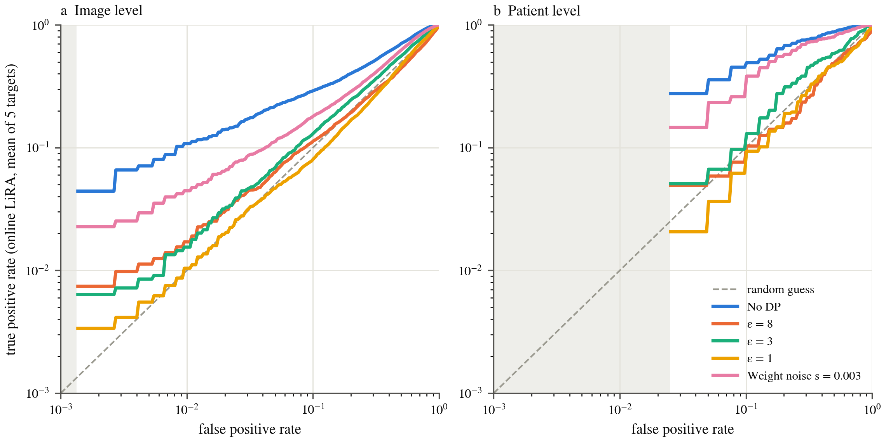
Fig. 4. LiRA ROC curves at image (a) and patient (b) level. Shading marks FPR below the test-set resolution.
The weight-noise comparator behaved differently, and at the published value $s=0.5$ training diverged in all 21 runs (five targets and 16 shadows) of this reproduction. At $s=0.003$ accuracy was 0.801, above FedAvg at $ε=8$ (0.765), yet the attack found 4.5% of training images at 1% FPR (4.7% matched) and separated training patients with AUC 0.745. The loss-threshold attack was weak even without DP, with pooled AUC from 0.521 to 0.550, and its within-stratum AUC under DP ranged from 0.458 to 0.507 (Supplementary Table S15).

Explanations
Grad-CAM localisation against expert masks declined as $ε$ decreased. For correctly classified test images of central models, the pointing-game hit rate fell from 0.197 without DP to 0.156 at $ε=8$ and 0.089 at $ε=1$, and the top-15% IoU fell from 0.087 to 0.032. Masks cover 1.76% of the image on average (0.01758). On the same images, the share of Grad-CAM mass inside the mask was 0.0323 against a mask area of 0.0177 without DP, 1.82 times the share of a uniform map, and 0.0267 against 0.0201 at $ε=1$, 1.33 times. Localisation therefore stayed above chance but far from precise.
Fig. 5a shows that consistency across seeds fell from 0.700 without DP to 0.663 with clipping alone and to 0.485, 0.309 and 0.235 at $ε$ of 8, 3 and 1. Patient-level models stayed between 0.218 and 0.291 up to $ε=32$ and reached 0.368 at $ε=64$. Some of these models classify near chance, such as patient-level $ε=3$ at 0.251, and their consistency describes maps of a model that has learned little.
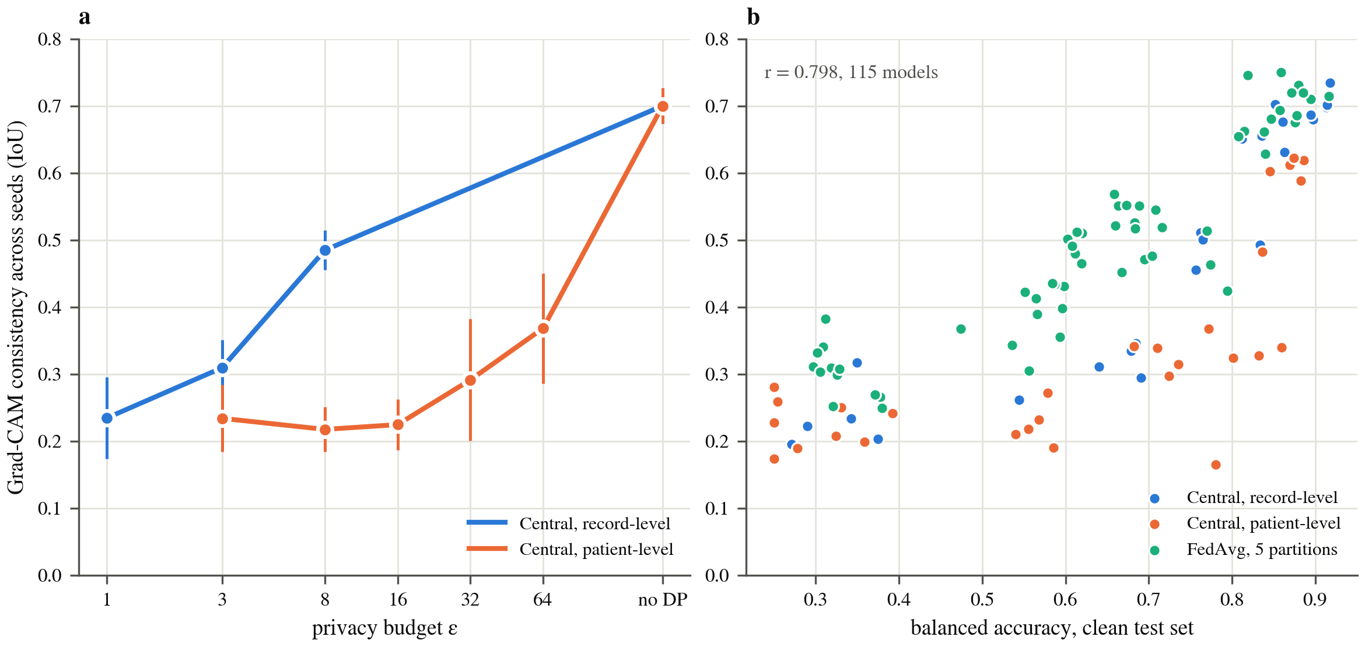
Fig. 5. Grad-CAM consistency across seeds against $ε$ for central models, five seeds with 95% CIs (a), and against accuracy, one point per model (b).
Across 31 configurations, with one point per configuration mean, consistency correlated with clean balanced accuracy at $r=0.838$ and top-15% IoU at $r=0.903$. With accuracy in the regression, $σ$ added no explanatory power for consistency ($p=0.389$) or IoU ($p=0.747$). Per model the correlations were $r=0.798$ over 115 models (Fig. 5b) and $r=0.839$ over 111, with $p=0.153$ and 0.834 for $σ$ (Supplementary Table S19). Fig. 6 illustrates the pattern on one image per tumour class, chosen by a rule fixed beforehand as the image with mask area closest to the class median among those the non-private model classifies correctly.
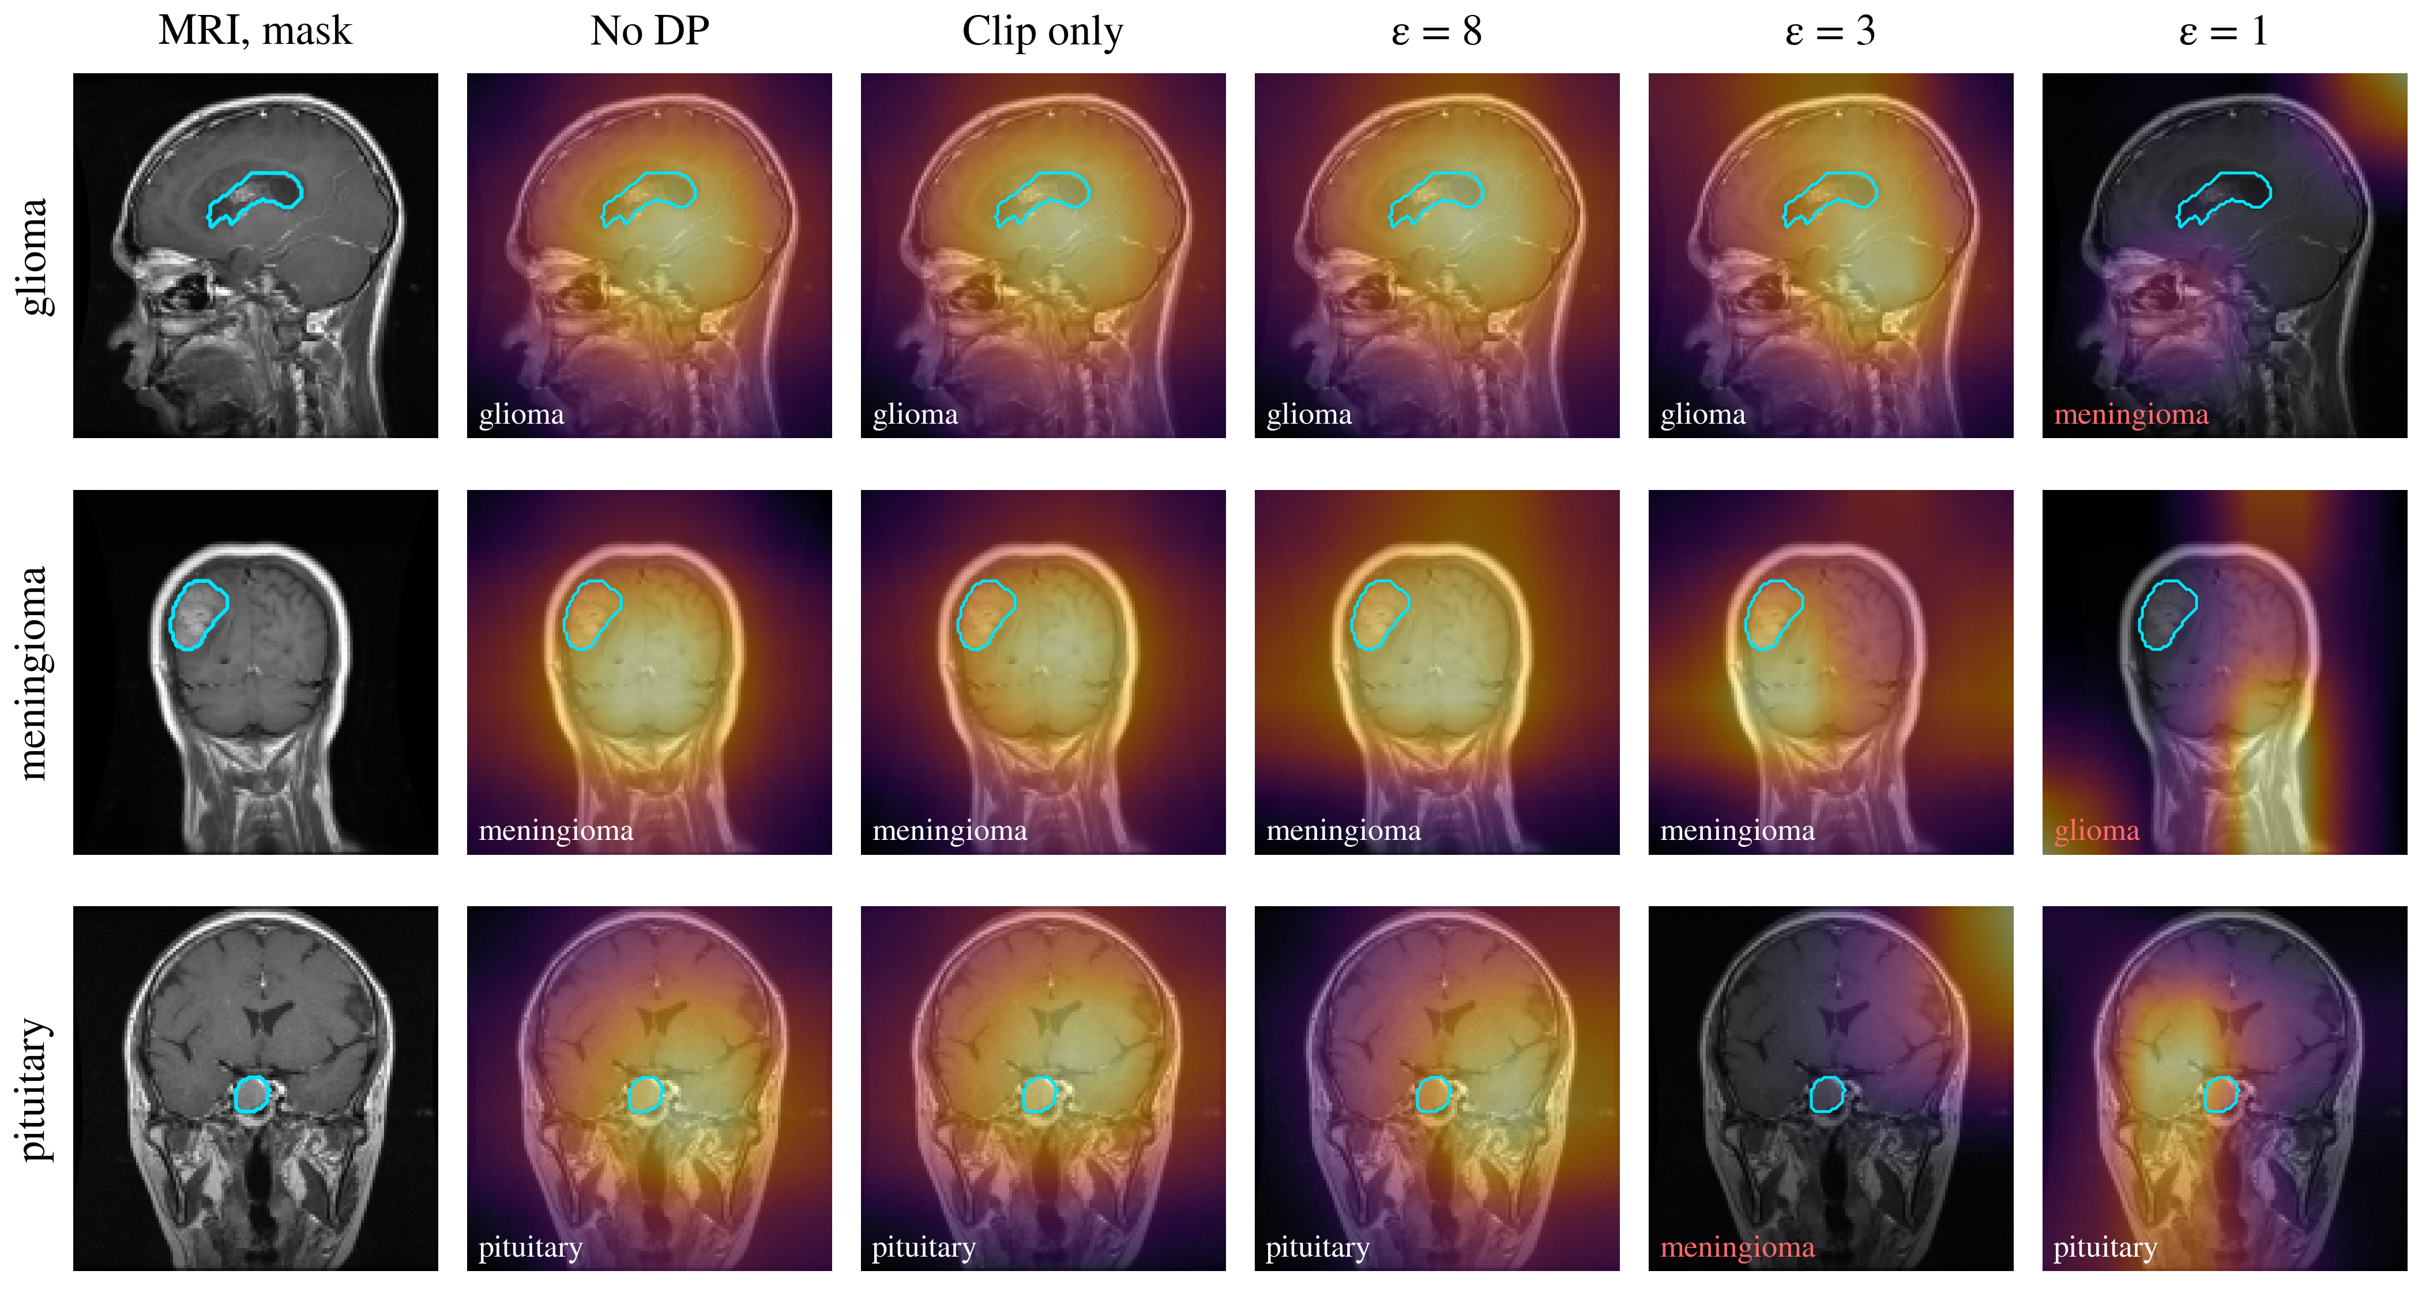
Fig. 6. Grad-CAM maps of central seed-1 models, one test image per class. Cyan, expert mask. Red, wrong prediction.
IG failed the randomisation test, since maps from a fully re-initialised network kept a Spearman correlation of 0.683 to 0.712 with the trained maps. Grad-CAM depended far more on the learned weights, with correlations from $−0.047$ to 0.388, so its numbers are the ones interpreted here. No absolute pass threshold exists for the test, and the comparison between methods is what it supports. Grad-CAM placed 0.174 to 0.181 of its mass on the outer brain rim, below the rim’s area share of 0.308 to 0.351, which indicates no skull-border artefact (Supplementary Table S18).

Source controls
The source collection was linearly decodable from penultimate features in every setting. Among tumour images, a probe separated Figshare from SARTAJ with balanced accuracy 0.913 for the central model without DP and 0.851 at $ε=1$. The ImageNet initialisation reached 0.871 and a random network 0.846, so training added only 0.042 ($0.913−0.871$). Accuracy on SARTAJ alone, the one source with all four classes, was 0.663 for central models without DP on the full test set, against 0.919 pooled (Supplementary Table S5).

Discussion
The discussion first considers what the privacy budget protected and what it cost, at both privacy units and across client counts. It then turns to the change in explanations, to benchmark leakage and source confounding, and finally to the limitations of the evaluation. Each subsection relates the findings to prior work and separates measured effects from interpretations that the experiments did not test directly.

Protection bought by the privacy budget
The audit and the accounting agree for the federated models that were attacked. Without DP, a federated model trained on 2610 images leaked enough for LiRA to flag one training image in ten at 1% FPR, and aggregating over slices made the patient-level signal stronger still (AUC 0.805). Record-level DP at $ε=8$ left no rate at 1% FPR significantly above chance once members and non-members were matched in composition, at a cost of 0.076 in balanced accuracy. The unmatched rate of 0.017 suggests that a composition gap between members and non-members can mimic leakage, so audits on merged collections should match the two groups. Central and patient-level models were not attacked, and an attack that fails does not prove that no stronger attack exists, although the result agrees with reports that moderate budgets defeat practical attacks.²⁵ Counting the learning-rate search, the federated guarantee is $ε=11.98$ instead of 8.
The weight-noise comparator separates noise from guarantee, since unclipped noise on weights can be tuned to keep accuracy, as at $s=0.003$, but it then leaves training patients identifiable (AUC 0.745), and at the published $s=0.5$ it destroyed the model in this reproduction. Details such as model size and normalisation may differ from the original implementation, but neither setting supports a stated $ε$ for that mechanism.¹³

Cost of patient-level protection
Patient-level DP protects the unit that matters clinically but needed a budget eight times larger for comparable accuracy. The clip-only control (0.872) shows that weighting each patient once is harmless, so the loss comes from noise divided among 634 units instead of 2610 images. The finding supports the observation of Knolle et al. that patients with several records carry the real privacy risk,⁸ and suggests that a larger number of patients is the most direct route to useful per-patient guarantees.

Client count and drift correction
Under DP, accuracy fell as the same data were spread across more clients, while label skew changed accuracy at $K=10$ and $ε=3$ by at most 0.010 ($0.593−0.583$). The trend is consistent with Eq. (4), because each client adds independent noise without adding data. The arithmetic is standard for DP-SGD and is not claimed as new. It implies that consortia of few large sites lose least, and that a learning rate tuned for one client count can hide the effect at another.
Drift correction likely did not help because one local epoch per round produced little drift, while noise dominated the error. The SCAFFOLD ablation also indicates that control variates must be averaged with the same weights as the model, or the correction harms the unequal and noisy settings in which it is most needed.

Explanations under privacy
DP degraded Grad-CAM localisation and cross-seed consistency, in line with reports on attribution methods in general.^{27,28} For brain tumour MRI, the degradation followed accuracy ($r=0.838$ for consistency and $r=0.903$ for IoU across configurations), and $σ$ added nothing once accuracy was known. The small change under clipping alone (0.700 to 0.663) suggests that noise affects explanations mainly through the accuracy it costs, although the correlational design cannot establish that pathway.
The low absolute localisation, with a pointing hit rate of 0.197 even without DP, is consistent with the $4×4$ resolution of the last ResNet block at 128-pixel input. Clinically, DP cost most in meningioma and no-tumour sensitivity while missed tumours stayed rare (Table 4), so a private model would mainly need review of its tumour-type calls. IG with a black baseline failed the randomisation test, which argues against reporting such maps without that check.²⁹

Benchmark leakage and source confounding
The correlation check found mirrored duplicates that perceptual hashing missed, concentrated in the Br35H no-tumour class, and training with random flips can then show a model the exact test image. Source was also decodable from images of one class even by a random network, so headline accuracy on merged collections partly measures which collection an image came from, as Vangala et al. reported for centralised benchmarks.¹⁰ Accuracies reported on these collections¹⁵⁻¹⁸ should therefore not be read as clinical performance, and flip-invariant deduplication with per-source reporting should become routine.

Limitations
Mirrored pairs remain between training and validation data (47 pairs), so round selection used slightly contaminated validation data, although every test result excludes contaminated images. SARTAJ and Br35H carry no patient identifiers, so their units are groups of similar images and the patient-level guarantee is exact only for Figshare.
Shadow models trained on about 1700 images against 2610 for the targets, which shifts average-case AUC, so the conclusions rest on low-FPR rates. Only 40 Figshare test units were available, so patient-level TPR below 2.5% FPR cannot be resolved. The membership audit covered only FedAvg on the natural partition at record level, so the leakage of central and patient-level models and of the update channel was not measured. All models are two-dimensional ResNet-18 classifiers on axial, coronal and sagittal slices from three public sources, and the federated partitions were simulated, not drawn from real institutions. Learning rates were chosen on private validation data, the $ε$ composed over both federated candidates is reported but was not used for calibration, and the central learning-rate selection is not accounted. Federated explanation metrics rest on three seeds per configuration.

Conclusions
On a deduplicated three-source brain MRI benchmark, a likelihood-ratio membership attack exposed non-private federated models but found no image-level rate significantly above chance under record-level DP at $ε=8$, once members and non-members were matched in source and class, and its patient-level AUC was 0.454. The price was a balanced-accuracy loss of 0.076 for federated and 0.130 for central training, borne mainly by meningioma and no-tumour sensitivity. A guarantee per patient cost far more and needed $ε=64$, because the noise is shared among 634 patients and patient groups instead of 2610 slices.
Under DP, splitting fixed data across more clients lowered accuracy through the aggregated noise scale, and drift correction did not offset the loss. Unclipped weight noise either destroyed the model or left patients identifiable, so it should not be reported with an $ε$. Grad-CAM localisation and consistency degraded with privacy in step with accuracy, and a composition gap between members and non-members was enough to push the attack rate on a private model significantly above chance.
Future work should test these costs on real multi-site data with patient identifiers, extend the audit to three-dimensional models and segmentation, attack central, patient-level and update-level releases, and study larger patient cohorts in which per-patient guarantees become affordable. Federated studies on public brain tumour collections should use flip-invariant deduplication, state $ε$, $δ$ and the privacy unit, and test their privacy claims with an attack.

Authors’ contribution
Shashi Ranjan: Conceptualization, Methodology, Software, Formal analysis, Investigation, Data curation, Visualization, Writing – original draft. Poonguzhali N: Conceptualization, Supervision, Validation, Writing – review & editing.

Ethic statement
The study used only publicly released, de-identified images from Figshare, SARTAJ and Br35H, and no new patient data were collected. Ethics approval and informed consent were therefore not required.

Declaration of competing interest
The authors declare that they have no known competing financial interests or personal relationships that could have appeared to influence the work reported in this paper.

Funding
This research did not receive any specific grant from funding agencies in the public, commercial, or not-for-profit sectors.

Data availability
The Figshare,³⁰ SARTAJ³¹ and Br35H³² collections are publicly available from the cited sources. Split, duplicate and hash manifests, all run results, frozen tables with their SHA-256 hashes, figure data, code and the manuscript source are archived on Zenodo as release v1.0-submission (doi:10.5281/zenodo.23601090)⁴⁶ and maintained at https://github.com/shashiranjan-jnu/dpfl-braintumor, where tag v0.9.5-results-frozen marks the reported results.

Acknowledgements
Training used free GPU time on Kaggle.

Declaration of generative AI and AI-assisted technologies in the writing process
During the preparation of this work the authors used Claude (Anthropic) in order to draft and edit the manuscript text and to write analysis code. After using this tool, the authors reviewed and edited the content as needed and take full responsibility for the content of the published article. [CHECK: the authors must confirm the extent of use]

References
- Ahmed MM, Adebayo UO, Othman ZK, et al. Artificial intelligence in neuro-oncology imaging: advancing brain tumor detection, grading, and treatment response evaluation. Intell Oncol. 2026;2(3):100071. doi:10.1016/j.intonc.2026.100071
- Jung JH, Sunwoo L, Ji H, Yoo S, Park JE, Lee JG. Deep learning-based segmentation of small-volume brain metastases in lung cancer patients. Intell Oncol. 2026;2(2):100049. doi:10.1016/j.intonc.2026.100049
- Sheller MJ, Reina GA, Edwards B, Martin J, Bakas S. Multi-institutional deep learning modeling without sharing patient data: a feasibility study on brain tumor segmentation. Brainlesion. 2019;11383:92-104. doi:10.1007/978-3-030-11723-8_9
- Sheller MJ, Edwards B, Reina GA, et al. Federated learning in medicine: facilitating multi-institutional collaborations without sharing patient data. Sci Rep. 2020;10(1):12598. doi:10.1038/s41598-020-69250-1
- Pati S, Baid U, Edwards B, et al. Federated learning enables big data for rare cancer boundary detection. Nat Commun. 2022;13(1):7346. doi:10.1038/s41467-022-33407-5
- Cai W. DeepSeek AI: transforming medical AI with cost-efficiency, transparency, and privacy preservation. Intell Oncol. 2025;1(2):172-175. doi:10.1016/j.intonc.2025.03.006
- Pati S, Kumar S, Varma A, et al. Privacy preservation for federated learning in health care. Patterns (N Y). 2024;5(7):100974. doi:10.1016/j.patter.2024.100974
- Knolle MA, Menten MJ, Jungmann F, et al. Disparate privacy risks from medical AI. Nature. 2026;656(8126):192-198. doi:10.1038/s41586-026-10688-0
- Abadi M, Chu A, Goodfellow I, et al. Deep learning with differential privacy. In: Proceedings of the 2016 ACM SIGSAC Conference on Computer and Communications Security. ACM; 2016:308-318. doi:10.1145/2976749.2978318
- Vangala BP, Guda S, Peddi L, Vangala N. Scores that hold, benchmarks that leak: measuring dataset contamination in public brain-tumor MRI classification. arXiv. Preprint posted online September 30, 2026. arXiv:2610.00421
- Lakshmi Vasanthi K, Sree Darshne J, Venkatasubbu P, Ramasubramanian P. A federated multimodal deep learning framework for brain tumor classification using MRI. Front Artif Intell. 2026;9:1754000. doi:10.3389/frai.2026.1754000
- Qazi EUH, Al-Ghanem WK, Faheem MH, Ullah H. Federated learning framework for privacy-preserving explainable AI-driven clinical decision-making. IEEE J Biomed Health Inform. Published online 2026. doi:10.1109/JBHI.2026.3679499
- Gupta S, Gupta M, Kumar R, Abraham A. A federated learning and explainable AI framework for privacy-preserving brain tumor diagnosis using multi-institutional MRI data. IEEE Access. 2026;14:22630-22643. doi:10.1109/ACCESS.2026.3660305
- McMahan HB, Moore E, Ramage D, Hampson S, Agüera y Arcas B. Communication-efficient learning of deep networks from decentralized data. In: Proceedings of the 20th International Conference on Artificial Intelligence and Statistics. PMLR; 2017;54:1273-1282.
- Albalawi E, T R M, Thakur A, et al. Integrated approach of federated learning with transfer learning for classification and diagnosis of brain tumor. BMC Med Imaging. 2024;24(1):110. doi:10.1186/s12880-024-01261-0
- Mastoi QU, Latif S, Brohi S, et al. Explainable AI in medical imaging: an interpretable and collaborative federated learning model for brain tumor classification. Front Oncol. 2025;15:1535478. doi:10.3389/fonc.2025.1535478
- Muntaqim MDZ, Smrity TA. Federated learning framework for brain tumor detection using MRI images in non-IID data distributions. J Imaging Inform Med. 2025;38(6):3909-3927. doi:10.1007/s10278-025-01484-9
- Paul M, Tiwari A, Barmashe B, Rai K, Panwar VS. Federated MobileNetV2 with ensemble meta-learning for privacy-preserving brain tumor classification. Sci Rep. 2026;16(1). doi:10.1038/s41598-026-55847-5
- Ziller A, Usynin D, Braren R, Makowski M, Rueckert D, Kaissis G. Medical imaging deep learning with differential privacy. Sci Rep. 2021;11(1):13524. doi:10.1038/s41598-021-93030-0
- Mironov I. Rényi differential privacy. In: Proceedings of the 30th IEEE Computer Security Foundations Symposium. IEEE; 2017:263-275. doi:10.1109/CSF.2017.11
- Yousefpour A, Shilov I, Sablayrolles A, et al. Opacus: user-friendly differential privacy library in PyTorch. arXiv. Preprint posted online 2021. arXiv:2109.12298
- Kaissis G, Ziller A, Passerat-Palmbach J, et al. End-to-end privacy preserving deep learning on multi-institutional medical imaging. Nat Mach Intell. 2021;3(6):473-484. doi:10.1038/s42256-021-00337-8
- Adnan M, Kalra S, Cresswell JC, Taylor GW, Tizhoosh HR. Federated learning and differential privacy for medical image analysis. Sci Rep. 2022;12(1):1953. doi:10.1038/s41598-022-05539-7
- Tayebi Arasteh S, Ziller A, Kuhl C, et al. Preserving fairness and diagnostic accuracy in private large-scale AI models for medical imaging. Commun Med (Lond). 2024;4(1):46. doi:10.1038/s43856-024-00462-6
- Ziller A, Mueller TT, Stieger S, et al. Reconciling privacy and accuracy in AI for medical imaging. Nat Mach Intell. 2024;6(7):764-774. doi:10.1038/s42256-024-00858-y
- Carlini N, Chien S, Nasr M, Song S, Terzis A, Tramèr F. Membership inference attacks from first principles. In: 2022 IEEE Symposium on Security and Privacy. IEEE; 2022:1897-1914. doi:10.1109/SP46214.2022.9833649
- Saifullah S, Mercier D, Lucieri A, Dengel A, Ahmed S. The privacy-explainability trade-off: unraveling the impacts of differential privacy and federated learning on attribution methods. Front Artif Intell. 2024;7:1236947. doi:10.3389/frai.2024.1236947
- Manna S, Sett N. Reconciling privacy and explainability in high-stakes: a systematic inquiry. arXiv. Preprint posted online December 30, 2024. arXiv:2412.20798
- Adebayo J, Gilmer J, Muelly M, Goodfellow I, Hardt M, Kim B. Sanity checks for saliency maps. In: Advances in Neural Information Processing Systems 31. 2018. arXiv:1810.03292
- Cheng J. Brain tumor dataset. figshare. Version 8. 2024. doi:10.6084/m9.figshare.1512427.v8
- Bhuvaji S, Kadam A, Bhumkar P, Dedge S, Kanchan S. Brain tumor classification (MRI). Kaggle. Version 3. 2020. doi:10.34740/kaggle/dsv/1183165
- Hamada A. Br35H :: Brain tumor detection 2020. Kaggle. Version 12. Accessed October 1, 2026. https://www.kaggle.com/datasets/ahmedhamada0/brain-tumor-detection
- Li D, Wei J, Lü Q, Le J, Liao X. Privacy-preserving medical image processing based on cryptography primitives: a review of methods. Intell Oncol. 2026;2(4):100083. doi:10.1016/j.intonc.2026.100083
- McMahan HB, Ramage D, Talwar K, Zhang L. Learning differentially private recurrent language models. arXiv. Preprint posted online 2017. arXiv:1710.06963
- Cheng J, Huang W, Cao S, et al. Enhanced performance of brain tumor classification via tumor region augmentation and partition. PLoS One. 2015;10(10):e0140381. doi:10.1371/journal.pone.0140381
- Papernot N, Steinke T. Hyperparameter tuning with Rényi differential privacy. In: International Conference on Learning Representations. 2022. arXiv:2110.03620
- Li T, Sahu AK, Zaheer M, Sanjabi M, Talwalkar A, Smith V. Federated optimization in heterogeneous networks. In: Proceedings of Machine Learning and Systems. 2020;2:429-450.
- Karimireddy SP, Kale S, Mohri M, Reddi S, Stich S, Suresh AT. SCAFFOLD: stochastic controlled averaging for federated learning. In: Proceedings of the 37th International Conference on Machine Learning. PMLR; 2020;119:5132-5143.
- Selvaraju RR, Cogswell M, Das A, Vedantam R, Parikh D, Batra D. Grad-CAM: visual explanations from deep networks via gradient-based localization. In: Proceedings of the IEEE International Conference on Computer Vision. IEEE; 2017:618-626. doi:10.1109/ICCV.2017.74
- Chattopadhay A, Sarkar A, Howlader P, Balasubramanian VN. Grad-CAM++: generalized gradient-based visual explanations for deep convolutional networks. In: 2018 IEEE Winter Conference on Applications of Computer Vision. IEEE; 2018:839-847. doi:10.1109/WACV.2018.00097
- Sundararajan M, Taly A, Yan Q. Axiomatic attribution for deep networks. In: Proceedings of the 34th International Conference on Machine Learning. PMLR; 2017;70:3319-3328.
- Petsiuk V, Das A, Saenko K. RISE: randomized input sampling for explanation of black-box models. In: Proceedings of the British Machine Vision Conference. 2018. arXiv:1806.07421
- Hsu TMH, Qi H, Brown M. Measuring the effects of non-identical data distribution for federated visual classification. arXiv. Preprint posted online 2019. arXiv:1909.06335
- He K, Zhang X, Ren S, Sun J. Deep residual learning for image recognition. In: Proceedings of the IEEE Conference on Computer Vision and Pattern Recognition. IEEE; 2016:770-778. doi:10.1109/CVPR.2016.90
- Dwork C, Roth A. The algorithmic foundations of differential privacy. Found Trends Theor Comput Sci. 2014;9:211-407. doi:10.1561/0400000042
- Ranjan S, N P. Code and frozen results for: patient-level differential privacy, membership leakage and explanation fidelity in federated brain tumour MRI classification. Zenodo. Version v1.0-submission. 2026. doi:10.5281/zenodo.23601090

Abbreviations. AUC, area under the receiver operating characteristic curve. CI, confidence interval. DP, differential privacy. DP-SGD, differentially private stochastic gradient descent. FedAvg, federated averaging. FPR, false-positive rate. Grad-CAM, gradient-weighted class activation mapping. IG, Integrated Gradients. IoU, intersection over union. LiRA, likelihood-ratio attack. NCC, normalised cross-correlation. ROC, receiver operating characteristic. TPR, true-positive rate.

