**Report for Part b**

Value of Learned Parameters in case of Gradient descent

theta 0 : 1.56715609177e-16

theta 1 : 0.0428972512435

theta 2 : 0.0281188977431

theta 3 : 0.04466378126

theta 4 : 0.481615427748

Value of Learned Parameters in case of IRLS

theta 0 : 1.58727198052e-16

theta 1 : 0.0428972510734

theta 2 : 0.0281188967372

theta 3 : 0.0446637802045

theta 4 : 0.481615429446

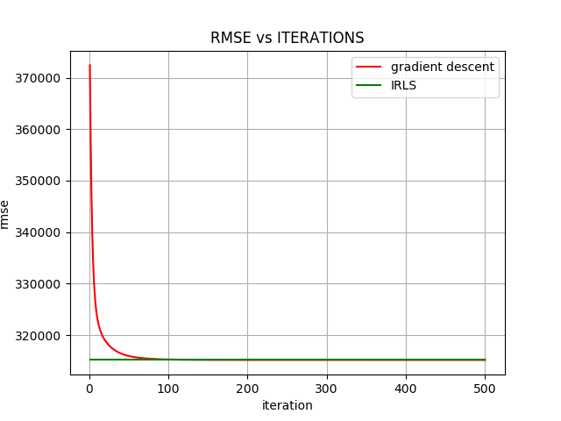

We should use IRLS in cases where the dataset size is not large otherwise the computation cost for computing the value of the weights will be enormous.

In cases where the dataset is failrly large we should use gradient descent.