**Report for Part c**

Value of Learned Parameters in case of Linear Hypothesis

theta 0 : 1.5675670952e-16

theta 1 : 0.0428972512372

theta 2 : 0.0281188977059

theta 3 : 0.044663781221

theta 4 : 0.48161542781

Value of Learned Parameters in case of Quadratic Hypothesis

theta 0 : -8.91055443734e-17

theta 1 : 0.0669486086992

theta 2 : -0.0110708314006

theta 3 : -0.0309019306183

theta 4 : -0.245189134173

theta 5 : -0.0197662655199

theta 6 : 0.0749403888499

theta 7 : -0.0475269815795

theta 8 : -0.0478444057821

theta 9 : -0.0787592693053

theta 10 : 0.244232611858

theta 11 : -0.077696722932

theta 12 : -0.0104011899354

theta 13 : -0.0818824345966

theta 14 : 0.850062795901

Value of Learned Parameters in case of Cubic Hypothesis

theta 0 : 2.97155482389e-17

theta 1 : -0.0219139775169

theta 2 : -0.0185175841757

theta 3 : 0.0134567585392

theta 4 : 0.0093001220319

theta 5 : -0.0557785815968

theta 6 : 0.0443758892054

theta 7 : 0.0384925069567

theta 8 : 0.167117423321

theta 9 : -0.0298173907605

theta 10 : 0.131810325923

theta 11 : -0.130807148946

theta 12 : 0.0397234639051

theta 13 : 0.0309668528689

theta 14 : 0.346236758823

theta 15 : 0.0896886231316

theta 16 : 0.00120535426524

theta 17 : -0.0808003062688

theta 18 : 0.00996859854375

theta 19 : 0.0490481102874

theta 20 : -0.013675309361

theta 21 : -0.0156282458088

theta 22 : -0.0112397396566

theta 23 : -0.0252908491713

theta 24 : -0.159978757602

theta 25 : 0.00862432948999

theta 26 : 0.152150703707

theta 27 : -0.180332552177

theta 28 : 0.123080576546

theta 29 : -0.03878468213

theta 30 : 0.101331294583

theta 31 : 0.0493904515262

theta 32 : -0.310970576025

theta 33 : -0.0901331408838

theta 34 : 0.457929578481

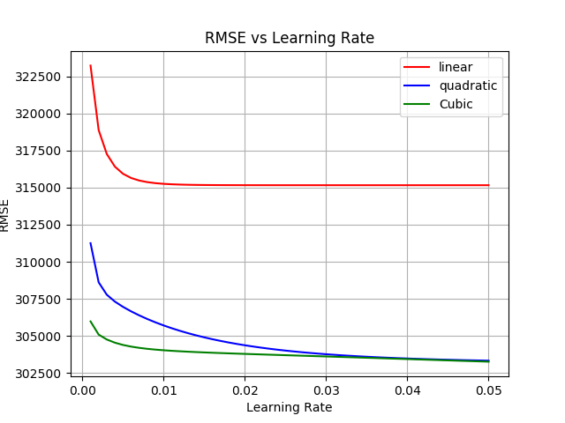

For the datset problrm we should use cubic or quadratic hypothesis beacuse tehy yeild lower value of rmse.

Please refer plots for reference