**Report for Part d**

Value of Learned Parameters in case of Mean Squared Error Function

theta 0 : 1.5675670952e-16

theta 1 : 0.0428972512372

theta 2 : 0.0281188977059

theta 3 : 0.044663781221

theta 4 : 0.48161542781

Value of Learned Parameters in case of Mean Absolute Error Function

theta 0 : -0.156727209625

theta 1 : 0.0478103073181

theta 2 : 0.0533913653697

theta 3 : 0.0511966029728

theta 4 : 0.30418322099

Value of Learned Parameters in case of Mean cube error function

theta 0 : -7.02828794513

theta 1 : -10.8798985407

theta 2 : -4.26490807002

theta 3 : -5.91002476329

theta 4 : -7.87522622031

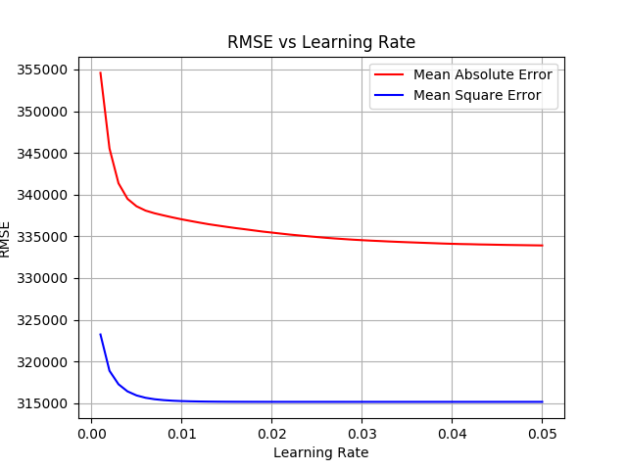

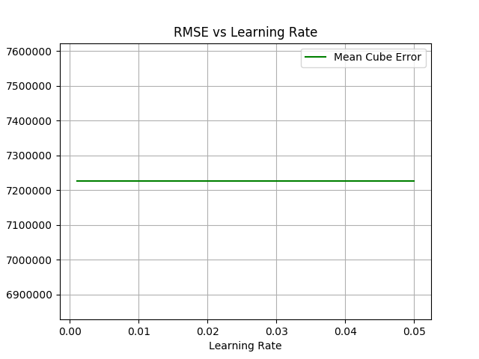For the dataset we should mean square error as it gives low RMSE value

Please refer Plots for reference