Apache Spark

Apache Spark

1) Spark introduced by apache for speeding up the hadoop computations ( Processing )

2) Spark is not modified version of Hadoop

3) Spark is not hadoop depenedent because, it has its own cluster Management

4) Hadoop is one of the ways to implement spark

5) Spark uses hadoop in two way 1) storage and 2) processing

6) since spark has its own cluster Management, it uses hadoop for storage purpose only.

7) Apache spark is lightning-fast cluster computing technology, designed for fast computing.

8) it is based on hadoop MapReduce and it extends MapReduce model

9) the main feature of spark is its in-memory cluster computing, that increases the processing speed of application.

10) spark designed to cover a wide range of work loads such as batch applications, iterative algorithems, interactive queries and streaming

11) it reduces the management burden of mainintaing tools.

Features of Apache Spark

Apache Spark has following features.

Speed − Spark helps to run an application in Hadoop cluster, up to 100 times faster in memory, and 10 times faster when running on disk. This is possible by reducing number of read/write operations to disk. It stores the intermediate processing data in memory.

Supports multiple languages − Spark provides built-in APIs in Java, Scala, or Python. Therefore, you can write applications in different languages. Spark comes up with 80 high-level operators for interactive querying.

Advanced Analytics − Spark not only supports ‘Map’ and ‘reduce’. It also supports SQL queries, Streaming data, Machine learning (ML), and Graph algorithms.

Spark Built on Hadoop
The following diagram shows three ways of how Spark can be built with Hadoop components.

Components of Spark

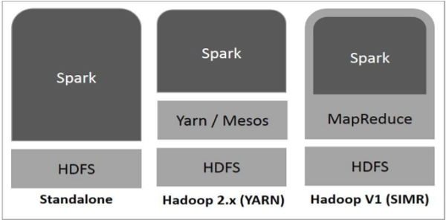

There are three ways of Spark deployment as explained below.

Standalone − Spark Standalone deployment means Spark occupies the place on top of HDFS(Hadoop Distributed File System) and space is allocated for HDFS, explicitly. Here, Spark and MapReduce will run side by side to cover all spark jobs on cluster.

Hadoop Yarn − Hadoop Yarn deployment means, simply, spark runs on Yarn without any pre-installation or root access required. It helps to integrate Spark into Hadoop ecosystem or Hadoop stack. It allows other components to run on top of stack.

Spark in MapReduce (SIMR) − Spark in MapReduce is used to launch spark job in addition to standalone deployment. With SIMR, user can start Spark and uses its shell without any administrative access.

Apache Spark Core

Spark Core is the underlying general execution engine for spark platform that all other functionality is built upon. It provides In-Memory computing and referencing datasets in external storage systems.

Spark SQL

Spark SQL is a component on top of Spark Core that introduces a new data abstraction called SchemaRDD, which provides support for structured and semi-structured data.

Spark Streaming

Spark Streaming leverages Spark Core's fast scheduling capability to perform streaming analytics. It ingests data in mini-batches and performs RDD (Resilient Distributed Datasets) transformations on those mini-batches of data.

MLlib (Machine Learning Library)

MLlib is a distributed machine learning framework above Spark because of the distributed memory-based Spark architecture. It is, according to benchmarks, done by the MLlib developers against the Alternating Least Squares (ALS) implementations. Spark MLlib is nine times as fast as the Hadoop disk-based version of Apache Mahout (before Mahout gained a Spark interface).

GraphX

GraphX is a distributed graph-processing framework on top of Spark. It provides an API for expressing graph computation that can model the user-defined graphs by using Pregel abstraction API. It also provides an optimized runtime for this abstraction.

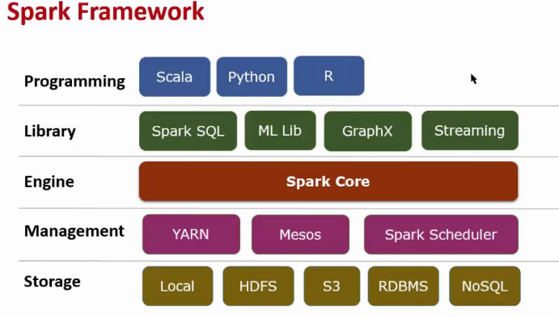

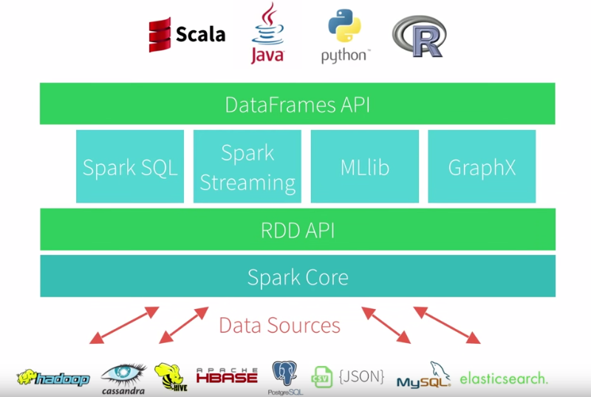

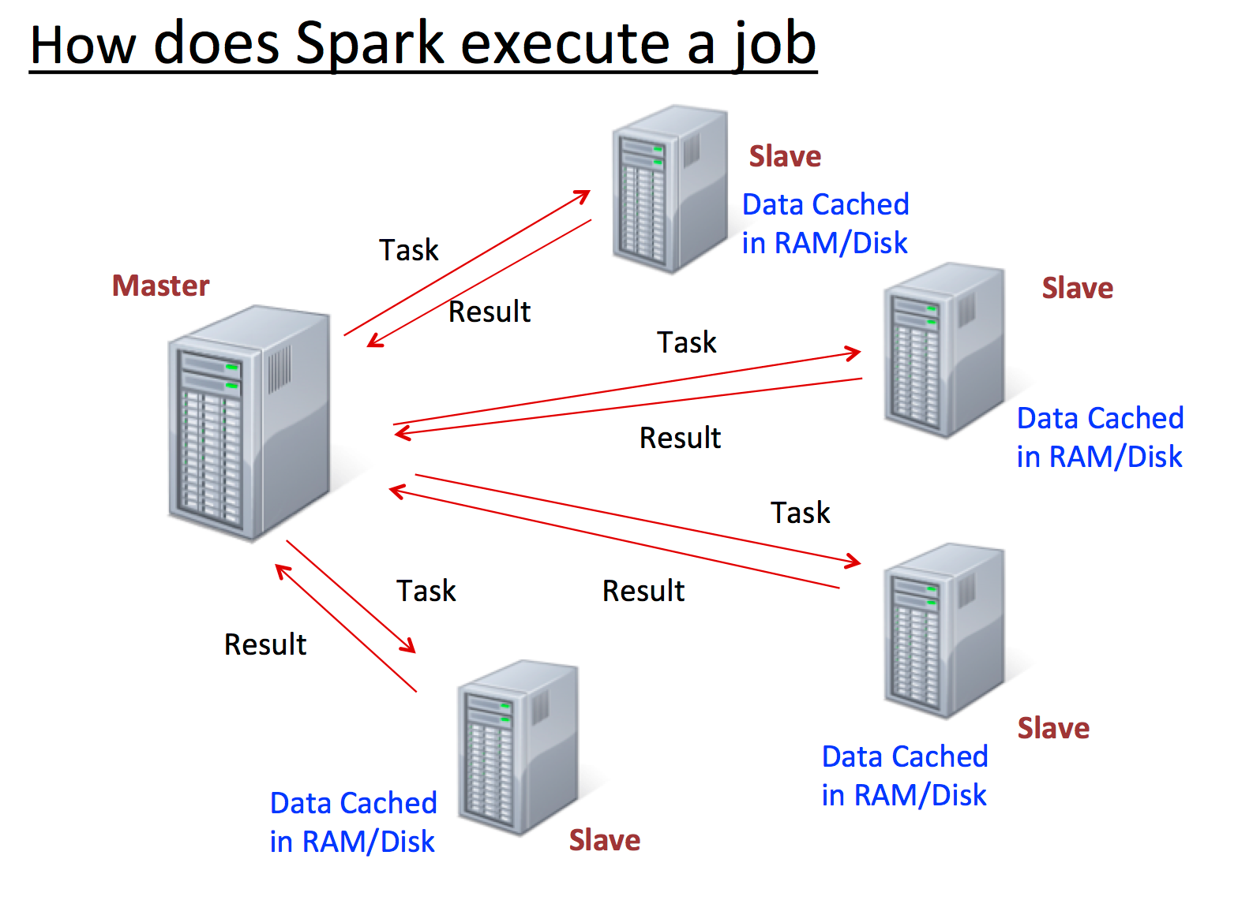

Resilient Distributed Datasets

Resilient Distributed Datasets (RDD) is a fundamental data structure of Spark. It is an immutable distributed collection of objects. Each dataset in RDD is divided into logical partitions, which may be computed on different nodes of the cluster. RDDs can contain any type of Python, Java, or Scala objects, including user-defined classes.

Formally, an RDD is a read-only, partitioned collection of records. RDDs can be created through deterministic operations on either data on stable storage or other RDDs. RDD is a fault-tolerant collection of elements that can be operated on in parallel.

There are two ways to create RDDs − parallelizing an existing collection in your driver program, or referencing a dataset in an external storage system, such as a shared file system, HDFS, HBase, or any data source offering a Hadoop Input Format.

Spark makes use of the concept of RDD to achieve faster and efficient MapReduce operations.

Let us first discuss how MapReduce operations take place and why they are not so efficient.

Data Sharing is Slow in MapReduce

MapReduce is widely adopted for processing and generating large datasets with a parallel, distributed algorithm on a cluster. It allows users to write parallel computations, using a set of high-level operators, without having to worry about work distribution and fault tolerance.

Unfortunately, in most current frameworks, the only way to reuse data between computations (Ex − between two MapReduce jobs) is to write it to an external stable storage system (Ex − HDFS). Although this framework provides numerous abstractions for accessing a cluster’s computational resources, users still want more.

Both Iterative and Interactive applications require faster data sharing across parallel jobs. Data sharing is slow in MapReduce due to replication, serialization, and disk IO. Regarding storage system, most of the Hadoop applications, they spend more than 90% of the time doing HDFS read-write operations.

Iterative Operations on MapReduce

Reuse intermediate results across multiple computations in multi-stage applications. The following illustration explains how the current framework works, while doing the iterative operations on MapReduce. This incurs substantial overheads due to data replication, disk I/O, and serialization, which makes the system slow.

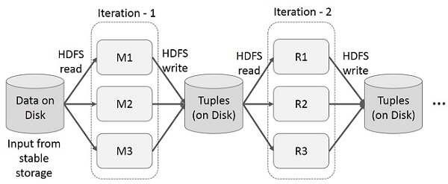

Interactive Operations on MapReduce

User runs ad-hoc queries on the same subset of data. Each query will do the disk I/O on the stable storage, which can dominates application execution time.

The following illustration explains how the current framework works while doing the interactive queries on MapReduce.

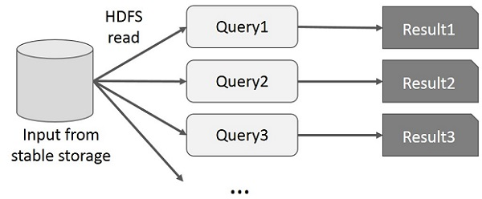

Data Sharing using Spark RDD

Data sharing is slow in MapReduce due to replication, serialization, and disk IO. Most of the Hadoop applications, they spend more than 90% of the time doing HDFS read-write operations.

Recognizing this problem, researchers developed a specialized framework called Apache Spark. The key idea of spark is Resilient Distributed Datasets (RDD); it supports in-memory processing computation. This means, it stores the state of memory as an object across the jobs and the object is sharable between those jobs. Data sharing in memory is 10 to 100 times faster than network and Disk.

Let us now try to find out how iterative and interactive operations take place in Spark RDD.

Iterative Operations on Spark RDD

The illustration given below shows the iterative operations on Spark RDD. It will store intermediate results in a distributed memory instead of Stable storage (Disk) and make the system faster.

Note − If the Distributed memory (RAM) is not sufficient to store intermediate results (State of the JOB), then it will store those results on the disk.

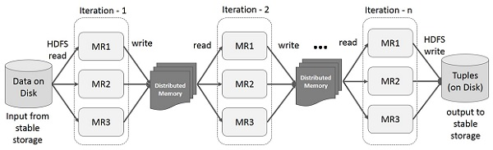

Interactive Operations on Spark RDD

This illustration shows interactive operations on Spark RDD. If different queries are run on the same set of data repeatedly, this particular data can be kept in memory for better execution times.

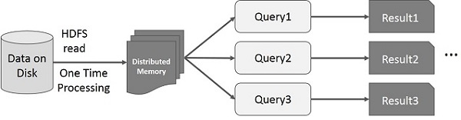

By default, each transformed RDD may be recomputed each time you run an action on it. However, you may also persist an RDD in memory, in which case Spark will keep the elements around on the cluster for much faster access, the next time you query it. There is also support for persisting RDDs on disk, or replicated across multiple nodes.

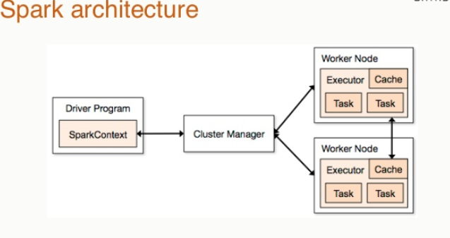

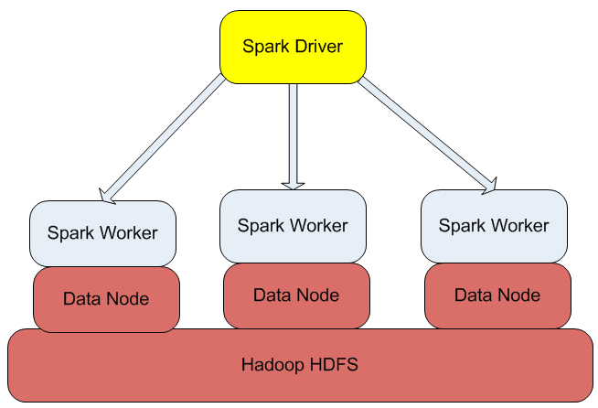

he following table summarizes terms you’ll see used to refer to cluster concepts:

Application :
User program built on Spark. Consists of a driver program and executors on the cluster.

Application jar:
A jar containing the user's Spark application. In some cases users will want to create an "uber jar" containing their application along with its dependencies. The user's jar should never include Hadoop or Spark libraries, however, these will be added at runtime.

Driver program :
The process running the main() function of the application and creating the SparkContext

Cluster manager :
An external service for acquiring resources on the cluster (e.g. standalone manager, Mesos, YARN)

Deploy mode :
Distinguishes where the driver process runs. In "cluster" mode, the framework launches the driver inside of the cluster. In "client" mode, the submitter launches the driver outside of the cluster.

Worker node :
Any node that can run application code in the cluster

Executor :
A process launched for an application on a worker node, that runs tasks and keeps data in memory or disk storage across them. Each application has its own executors.

Task:
A unit of work that will be sent to one executor

Job :
A parallel computation consisting of multiple tasks that gets spawned in response to a Spark action (e.g. save, collect);

Stage :
Each job gets divided into smaller sets of tasks called stages that depend on each other (similar to the map and reduce stages in MapReduce);

Spark and scala setup:

1.Copy the “scala-2.10.4.tgz” and “spark-1.3.1-bin-hadoop1.tgz” into /home/demo/work folder and extract

2.update .bashrc with following.

export SCALA_HOME=/home/demo/work/scala-2.10.4
export SPARK_HOME=/home/demo/work/spark-1.3.1-bin-hadoop1

export PATH=$PATH:$JAVA_HOME/bin:$HADOOP_HOME/bin:$SCALA_HOME/bin:$SPARK_HOME/bin

$cd $SPARK_HOME/conf
cp spark-env.sh.template spark-env.sh

$gedit spark-env.sh

export SPARK_MASTER_IP=
export SPARK_WORKER_CORES=1
export SCALA_HOME=$SCALA_HOME
export SPARK_WORKER_MEMORY=1g
export SPARK_WORKER_INSTANCES=2
#spark working directory
export SPARK_WORKER_DIR=/home/demo/work

#Spark build depends git.

$sudo apt-get install git

Sourcing .bashrc file

$source ~/.bashrc

Verifying Scala installation

$scala -version

Scala code runner version 2.10.4 -- Copyright 2002-2013, LAMP/EPFL

Use the following command for sourcing the ~/.bashrc file.

Verifying the Spark Installation

$spark-shell

Welcome to
____ __
/ __/__ ___ _____/ /__
_\ \/ _ \/ _ `/ __/ '_/
/___/ .__/\_,_/_/ /_/\_\ version 1.3.1
/_/

Using Scala version 2.10.4 (OpenJDK Server VM, Java 1.6.0_35)

scala>

Spark Core is the base of the whole project. It provides distributed task dispatching, scheduling, and basic I/O functionalities. Spark uses a specialized fundamental data structure known as RDD (Resilient Distributed Datasets) that is a logical collection of data partitioned across machines. RDDs can be created in two ways; one is by referencing datasets in external storage systems and second is by applying transformations (e.g. map, filter, reducer, join) on existing RDDs.

The RDD abstraction is exposed through a language-integrated API. This simplifies programming complexity because the way applications manipulate RDDs is similar to manipulating local collections of data.

Spark Shell

Spark provides an interactive shell − a powerful tool to analyze data interactively. It is available in either Scala or Python language. Spark’s primary abstraction is a distributed collection of items called a Resilient Distributed Dataset (RDD). RDDs can be created from Hadoop Input Formats (such as HDFS files) or by transforming other RDDs.
Open Spark Shell

scala>

Scala, short for Scalable Language, is a hybrid functional programming language. It was created by Martin Odersky and it was first released in 2003.

Scala smoothly integrates features of object-oriented and functional languages and Scala is compiled to run on the Java Virtual Machine. Many existing companies, who depend on Java for business critical applications, are turning to Scala to boost their development productivity, applications scalability and overall reliability.

Features of Scala :

Scala is object-oriented:

Scala is a pure object-oriented language in the sense that every value is an object.

Scala is functional:

Scala is also a functional language in the sense that every function is a value and because every value is an object so ultimately every function is an object.

Scala is statically typed:

Scala, unlike some of the other statically typed languages, does not expect you to provide redundant type information. You don't have to specify a type in most cases, and you certainly don't have to repeat it.

Scala runs on the JVM:

Scala is compiled into Java Byte Code which is executed by the Java Virtual Machine (JVM). This means that Scala and Java have a common runtime platform. You can easily move from Java to Scala.

The Scala compiler compiles your Scala code into Java Byte Code, which can then be executed by the scala command. The scala command is similar to the java command, in that it executes your compiled Scala code.

Scala can Execute Java Code:

Scala enables you to use all the classes of the Java SDK's in Scala, and also your own, custom Java classes, or your favourite Java open source projects.

Scala vs Java:

Scala has a set of features, which differ from Java. Some of these are:

All types are objects.

Type inference.

Nested Functions.

Functions are objects.

Domain specific language (DSL) support.

Traits

Closures

Scala Web Frameworks:

Scala is being used everywhere and importantly in enterprise web applications. You can check few of the most popular Scala web frameworks:

The Lift Framework

The Play framework

What is Lift?

Lift is the most powerful, most secure web framework available today. There are Seven Things that distinguish Lift from other web frameworks.

- Lazy Loading

- Parallel page rendering

- Comet and Ajax

- Wiring -- declare interdepencies between page elements

- Designer friendly templates

- Wizard -- multipage input screens with full back-button support

- Security

If you have good understanding on Java, then it will be very easy for you to learn Scala. The biggest syntactic difference between Scala and Java is that the ; line end character is optional. When we consider a Scala program it can be defined as a collection of objects that communicate via invoking each others methods

Object :
An object is an instance of a class. Objects have states and behaviors.

Class :
A class can be defined as a template/blueprint that describes the behaviors/states that object of its type support.

Methods:
A method is basically a behavior. A class can contain many methods. It is in methods where the logics are written, data is manipulated and all the actions are executed.

Fields:
Each object has its unique set of instant variables, which are called fields. An object's state is created by the values assigned to these fields.

Sample program:

object HelloWorld {
/* This is my first scala program.
* This will print 'Hello World' as the output
*/
def main(args: Array[String]) {
println("Hello, world!") // prints Hello World
}
}

the above save as “ HelloWorld.scala”

compilation :

$scalac HelloWorld.scala

it generates HelloWorld.class

Runninng the program :

$scala HelloWorld

Hello, world!

HelloWorld.scala --> scalac --> HelloWorld.java --> javac --> HelloWorld.class --> jvm

MapReduce Mode ( Pseudo Mode ):

$scalac HelloWorld.scala

$jar -cvf hw.jar HelloWorld*.class

$spark-submit --class HelloWorld --master local hw.jar

Basic Syntax:

The following are the basic syntaxes and coding conventions in Scala programming.

Case Sensitivity − Scala is case-sensitive, which means identifier Hello and hello would have different meaning in Scala.

Class Names − For all class names, the first letter should be in Upper Case. If several words are used to form a name of the class, each inner word's first letter should be in Upper Case.

Eg − MyFirstExample.

Method Names − All method names should start with a Lower Case letter. If multiple words are used to form the name of the method, then each inner word's first letter should be in Upper Case.

Eg − myMethodName()

Program File Name − Name of the program file should exactly match the object name. When saving the file you should save it using the object name (Remember Scala is case-sensitive) and append ‘.scala’ to the end of the name. (If the file name and the object name do not match your program will not compile).

Eg − Assume 'HelloWorld' is the object name. Then the file should be saved as 'HelloWorld.scala'.

def main(args: Array[String]) − Scala program processing starts from the main() method which is a mandatory part of every Scala Program.

Scala Keywords

The following list shows the reserved words in Scala. These reserved words may not be used as constant or variable or any other identifier names.

abstract case catch class
def do else extends
false final finally for
forSome if implicit import
lazy match new Null
object override package private
protected return sealed super
this throw trait Try
true type val Var
while with yield

Scala Data Types :

Data Type | Description
Byte | 8 bit signed value. Range from -128 to 127
Short | 16 bit signed value. Range -32768 to 32767
Int | 32 bit signed value. Range -2147483648 to 2147483647
Long | 64 bit signed value. -9223372036854775808 to 9223372036854775807
Float | 32 bit IEEE 754 single-precision float
Double | 64 bit IEEE 754 double-precision float
Char | 16 bit unsigned Unicode character. Range from U+0000 to U+FFFF
String | A sequence of Chars
Boolean | Either the literal true or the literal false
Unit | Corresponds to no value , similar to void
Null | null or empty reference
Nothing | The subtype of every other type; includes no values
Any | The supertype of any type; any object is of type Any
AnyRef | The supertype of any reference type

All the data types listed above are objects. There are no primitive types like in Java. This means that you can call methods on an Int, Long, etc.
Scala types Hierarchy

Val for single element is immutable not for collections
Array mutable
List is immutable

Scala - Variables
Variables are nothing but reserved memory locations to store values.
Based on the data type of a variable, the compiler allocates memory and decides what can be stored in the reserved memory.
Variable Declaration

Scala has the different syntax for the declaration of variables and they can be defined as value, i.e., constant or a variable. Following is the syntax to define a variable using var keyword:

var myVar : String = "Hello"

val myVal : String = "Hello"

Variable Data Types:

The type of a variable is specified after the variable name, and before equals sign. You can define any type of Scala variable by mentioning its data type as follows:

val or var VariableName : DataType [= Initial Value]

If you do not assign any initial value to a variable, then it is valid as follows

var myVar :Int;
val myVal :String;

var --> value of the variable can be changed.

val --> Value of the variable can not be changed.

Variable Declaration:

Var 2) val
Scala has a different syntax for declaring variables. They can be defined as value, i.e., constant or a variable.
Here, “a” is declared using the keyword var. It is a variable that can change value and this is called mutable variable.
Following is the syntax to define a variable using var keyword –

Syntax:

var VariableName : DataType = [Initial Value]

Eg:
var a : Int = 10;

a=20; → valid

Syntax:

val VariableName : DataType = [Initial Value]

Eg:
val b : Int = 10;

b=20; → invalid since it is a immutable.

var → mutable variable
val → immutable variable

scala> val x=5;
x: Int = 5

scala> val y=5;
y: Int = 5

scala> val z=x+y;
z: Int = 10

scala> val a="5"
a: String = 5

scala> val b=5;
b: Int = 5

scala> val c=a+b;
c: String = 55

Multiple assignments:

Scala supports multiple assignments. If a code block or method returns a Tuple, the Tuple can be assigned to a val variable

val (myVar1: Int, myVar2: String) = Pair(40, "Hello")

Type Casting:
==========
1) Implicit and 2)Explicit

premitive casting:

Explicit:

scala> val b = a.to[Tab]
toByte toChar toDouble toFloat toInt toLong
toShort toString

scala> 19.45.toInt
res0: Int = 19

scala> 19.toFloat
res1: Float = 19.0

scala> 19.toDouble
res2: Double = 19.0

scala> 19.toLong
res3: Long = 19

scala> val b = a.toFloat
b: Float = 1945.0

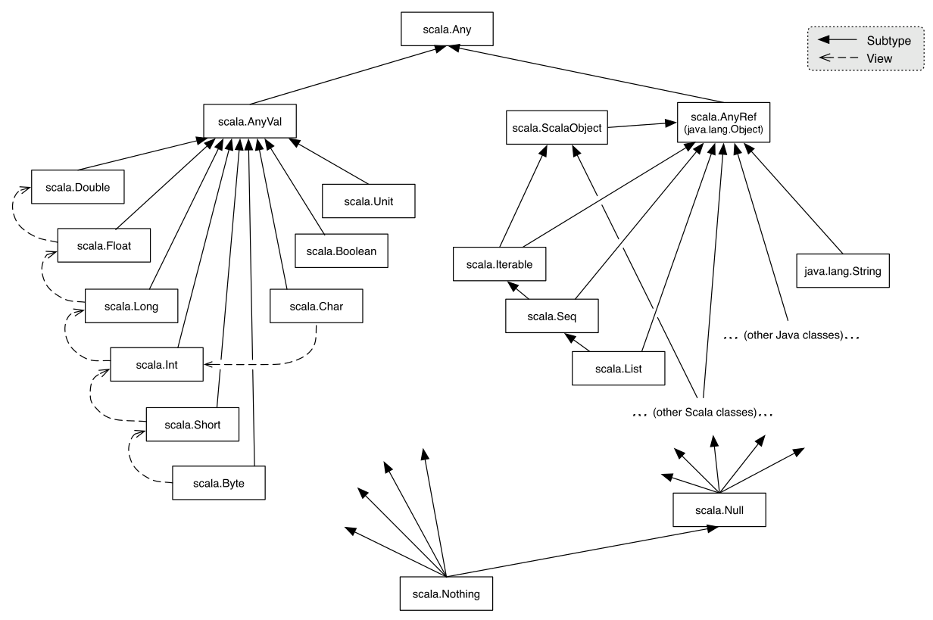

Scala – Operators:

Scala provides the following types of operators −

1) Arithmetic Operators
2) Relational Operators
3) Logical Operators
4) Bitwise Operators
5) Assignment Operators

Arithmetic Operators:

Operator | Task
+ | Addition
- | Subtraction
* | Multiplication
/ | Division
% | Modulus

Relational Operators:

Operator | Task
> | Greater than
>= | Greater than or equal to
< | Less than
<= | Less than or equal to
== | Is equal to
!= | Not equal to

Logical Operators:

Operator | Task
&& | And
|| | Or
! | Not

Assignment Operators

1) =
c= a+b

2) +=
c=c+a
c+=a

3) -=
c=c-a
c-=a

4) *=
c=c*a
c*=a

5) /=
c=c/a
c/=a

Scala IF...ELSE Statements

1) Simple – if :

if(Boolean_expression)
{
// Statements will execute if the Boolean expression is true
}

var age: Int = 20;

if (age > 18)
{
println("Major and allowed")
}

2) if...else

if(Boolean_expression)
{
//Executes when the Boolean expression is true
}
else
{
//Executes when the Boolean expression is false
}

object Test {

def main(args: Array[String]) {

var number:Int = 21

if(number%2==0)
{
println("Even number")
}
else
{
println("Odd number")
}

}

}

3) Nested if...else Statement:
if(Boolean_expression 1)
{
//Executes when the Boolean expression 1 is true
if(Boolean_expression 2)
{
//Executes when the Boolean expression 2 is true
}
}

object Test {

def main(args: Array[String]) {

var m1:Int = 55
var m2:Int = 65
var m3:Int = 75

if(m1>=40)
{
if(m2>=40)
{
if(m3>=40)
{
println("PASS")
}
else
{
println("FAIL")
}
}
else
{
println("FAIL")
}
}
else
{
println("FAIL")
}

}

}

4) Ladder if :

if(Boolean_expression 1)
{
//Executes when the Boolean expression 1 is true
}
else if(Boolean_expression 2)
{
//Executes when the Boolean expression 2 is true
}
else if(Boolean_expression 3)
{
//Executes when the Boolean expression 3 is true
}
else
{
//Executes when the none of the above condition is true.
}

package com.nrit.mnrao.test

object Test {

def main(args: Array[String]) {

var number:Int = 85

if(number>=70){
println("Grade A with Distinction")
}
else if(number>=60){
println("Grade A ")
}
else if(number>=50){
println("Grade B ")
}
else if(number>=40){
println("Grade c ")
}
else
{
println("fail")
}
}

}

case statement:

object Test {

def main(args: Array[String]) {

var a:Int = 3
a match{
case 1 => println("One")
case 2 => println("Two")
case 3 => println("Three")
case 4 => println("Four")
case _ => println("No")
}

}

}

object Test {

def main(args: Array[String]) {
var a:Any="one"

a match{
case 1 => println("Int")
case 10.5 => println("Double")
case "one" => println("string")
case "Hello" => println("Hello")
case _ => println("No")
}

}

}

Loops:

1) while

2) do-while

3) for

while :

while(condition)
{
statement(s);
}

object Test {

def main(args: Array[String]) {
var a = 1; // Initialization
while( a<=10 ){ // Condition
println(a);
a=a+1 // Incrementation
}

}

}

Infinite While Loop:

object Test {

def main(args: Array[String]) {

var a = 10; // Initialization
while( true ){ // Condition
println(a);
a = a+2 // Incrementation
}

}

}

do-while :

do
{
statement(s);
}
while( condition );

object Test {

def main(args: Array[String]) {

var a = 1; // Initialization
do{ // Condition
println(a);
a=a+1 // Incrementation
}
while( a<=10 )
}

}

Infinite do-while loop

object Test {

def main(args: Array[String]) {

var a = 10; // Initialization
do {
println( a );
a = a + 2; // Increment
}
while( true)
}

}

for-loop:

for( var x <- Range )
{
statement(s);
}

eg :

object Test {

def main(args: Array[String]) {

for( a <- 1 to 10)
{
println( "Value of a: " + a );
}
}

}

object Test {

def main(args: Array[String]) {

var a = 0;
// for loop execution with a range
for( a <- 1 to 10)
{
println( "Value of a: " + a );
}
}

}

o/p: 1 to 10

save as Test.scala

$scalac Test.scala

$scala Test

for loop using until keyword:

object Test {

def main(args: Array[String]) {

var a = 0;
// for loop execution with a range
for( a <- 1 until 10)
{
println( "Value of a: " + a );
}
}

}

o/p: 1 to 9

Scala for-loop Example using by keyword:

object Test {

def main(args: Array[String]) {
for(i<-1 to 10 by 2){
println(i)
}

}

}

The for Loop with Collections

for( var x <- List )
{
statement(s);
}

list of elements can be created using List()

object Test
{
def main(args: Array[String])
{
var a = 0;
val numList = List(1,2,3,4,5,6);

// for loop execution with a collection
for( a <- numList ){
println( "Value of a: " + a );
}
}
}
o/p:

value of a: 1
value of a: 2
value of a: 3
value of a: 4
value of a: 5
value of a: 6

The for Loop with Filters

for( var x <- List
if condition1;
if condition2...
)

{
statement(s);
}

eg:

object Test {

def main(args: Array[String]) {

var a = 0;
val numList = List(1,2,3,4,5,6,7,8,9,10);

// for loop execution with multiple filters
for( a <- numList
if a != 3; if a < 8 )
{
println( "Value of a: " + a );
}
}

}

O/p:

value of a: 1
value of a: 2
value of a: 4
value of a: 5
value of a: 6
value of a: 7

The for Loop with yield:

You can store return values from a for loop in a variable or can return through a function

yield is key word to return some value

var retVal = for{ var x <- List
if condition1; if condition2...
}yield x

eg :
object Test {

def main(args: Array[String]) {

var a = 0;
val numList = List(1,2,3,4,5,6,7,8,9,10);

// for loop execution with a yield
var retVal = for{ a <- numList
if a != 3; if a < 8
}yield a

// Now print returned values using another loop.
for( a <- retVal){
println( "Value of a: " + a );
}
}

}

value of a: 1
value of a: 2
value of a: 4
value of a: 5
value of a: 6
value of a: 7

Scala for-each loop Example for Iterating Collection

object Test {

def main(args: Array[String]) {
var list = List(1,2,3,4,5,6,7,8,9) // Creating a list
list.foreach{
println // Print each element
}
list.foreach(print)
println
list.foreach((element:Int)=>print(element+" "))

}

}

Scala for-loop filtering Example:

object Test {

def main(args: Array[String]) {

for( a <- 1 to 10 if a%2==0 ){
println(a);
}
}

}

Loop Control Statements:

Scala Break Example

import scala.util.control.Breaks._

object Test {

def main(args: Array[String]) {

breakable { // Breakable method to avoid exception
for(i<-1 to 10 by 2){
if(i==7)
break // Break used here
else
println(i)
}
}
}

}

eg :

import scala.util.control.Breaks

object Test {

def main(args: Array[String]) {
var a = 0;
val numList = List(1,2,3,4,5,6,7,8,9,10);

val loop = new Breaks;

loop.breakable
{
for( a <- numList)
{
println( "Value of a: " + a );
if( a == 4 )
{
loop.break;
}
}

println( "End of breakable" );
}

println( "After the loop" );
}

}

O/P:

Value of a: 1
Value of a: 2
Value of a: 3
Value of a: 4
After the loop

Breaking Nested Loops:

import scala.util.control._

object Test
{
def main(args: Array[String])
{
var a = 0;
var b = 0;
val numList1 = List(1,2,3,4,5);
val numList2 = List(11,12,13);

val outer = new Breaks;
val inner = new Breaks;

outer.breakable
{
for( a <- numList1)
{
println( "Value of a: " + a );
inner.breakable
{
for( b <- numList2)
{
println( "Value of b: " + b );
if( b == 12 )
{
inner.break;
}
}

} // inner breakable
println("end of outer breakable")

}

} // outer breakable.

}

}

Arrays

Scala provides a data structure, the array, which stores a fixed-size sequential collection of elements of the same type. An array is used to store a collection of data.

Declaring Array Variables

Syntax:

var a:Array[String] = new Array[String](3)

or

var a = new Array[String](3)

a(0) = "Java";
a(1) = "Scala";
a(2) = "Spark"

var a = Array("java", "scala", "spark")

Processing Arrays

object Test {

def main(args: Array[String]) {

var myList = Array(1.9, 2.9, 3.4, 3.5)

// Print all the array elements
for ( x <- myList ) {
println( x )
}

// Summing all elements
var total = 0.0;

for ( i <- 0 to (myList.length - 1)) {
total += myList(i);
}
println("Total is " + total);

// Finding the largest element
var max = myList(0);

for ( i <- 1 to (myList.length - 1) ) {
if (myList(i) > max) max = myList(i);
}

println("Max is " + max);
}
}

Multi-Dimensional Arrays

Syntax:

var myMatrix = ofDim[Int](3,3)

import Array._

object Test {
def main(args: Array[String]) {

var myMatrix = ofDim[Int](3,3)

// build a matrix
for (i <- 0 to 2) {
for ( j <- 0 to 2) {
myMatrix(i)(j) = j;
}
}

// Print two dimensional array
for (i <- 0 to 2) {
for ( j <- 0 to 2) {
print(" " + myMatrix(i)(j));
}
println();
}
}
}

Create Array with Range:

import Array._

object Test {
def main(args: Array[String]) {

var myList1 = range(10, 20, 2)
var myList2 = range(10,20)

// Print all the array elements
for ( x <- myList1 ) {
print( " " + x )
}

println()
for ( x <- myList2 ) {
print( " " + x )
}
}
}

O/P:

10 12 14 16 18
10 11 12 13 14 15 16 17 18 19

Scala Array Example: Iterating By using Foreach Loop:

object Test {

def main(args: Array[String]) {

var arr = Array(1,2,3,4,5)
// Creating single dimensional array
arr.foreach((element:Int)=>println(element)) // Iterating by using foreach loop
}

}

Scala Multidimensional Array by using Array of Array:

object Test {

def main(args: Array[String]) {

var arr = Array(Array(1,2,3,4,5), Array(6,7,8,9,10)) // Iterating by using foreach loop

for(i<- 0 to 1){ // Traversing elements using loop
for(j<- 0 to 4){
print(" "+arr(i)(j))
}
println()
}

}

}

Scala Addition of Two Matrix Example

object Test {

def main(args: Array[String]) {

var arr1 = Array(Array(1,2,3,4,5), Array(6,7,8,9,10)) // Creating multidimensional array
var arr2 = Array(Array(1,2,3,4,5), Array(6,7,8,9,10))
var arr3 = Array.ofDim[Int](2,5)

for(i<- 0 to 1){ // Traversing elements using loop
for(j<- 0 to 4){
arr3(i)(j) = arr1(i)(j)+arr2(i)(j)
print(" "+arr3(i)(j))
}
println()
}
}

}

Array Methods:

def apply( x: T, xs: T* ): Array[T]

Creates an array of T objects, where T can be Unit, Double, Float, Long, Int, Char, Short, Byte, Boolean.

val numbers = Array(10, 20, 30, 40)

// Get first number in array with apply.
val first = numbers.apply(0)

println(first) // O/p 10

val numbers = Array(10, 20, 30, 40)

// Get first number in array with apply.
val num = numbers.apply(1)

println(num)

val numbers = Array(10, 20, 30, 40)

val last = numbers.apply(numbers.length - 1)
println(last)

def concat[T]( xss: Array[T]* ): Array[T]

Concatenates all arrays into a single array.

Concatenate Arrays:

import Array._
object Test {
def main(args: Array[String]) {

var myList1 = Array(1.9, 2.9, 3.4, 3.5)
var myList2 = Array(8.9, 7.9, 0.4, 1.5)

var myList3 = concat( myList1, myList2)

// Print all the array elements
for ( x <- myList3 ) {
println( x )
}
}
}

object Test {

def main(args: Array[String]) {

val plants = Array("tree", "moss", "fern")

// Update first element to be a new string.
plants.update(0, "flower")

// Display array.
plants.foreach(println(_))

}

}

flower
moss
fern

scala> val a2 = Array(5, 15, 25, 35)
a2: Array[Int] = Array(5, 15, 25, 35)

scala> a2.head
res5: Int = 5

scala> a2.tail
res6: Array[Int] = Array(15, 25, 35)

scala> a2.last
res7: Int = 35

scala> val a1 = Array(10, 20, 30, 40)
a1: Array[Int] = Array(10, 20, 30, 40)

scala> val a2 = a1.clone
a2: Array[Int] = Array(10, 20, 30, 40)

scala> val a = (1 to 5).toArray
a: Array[Int] = Array(1, 2, 3, 4, 5)

scala> val dest = new Array[Int](a.size)
dest: Array[Int] = Array(0, 0, 0, 0, 0)

def copy( src: AnyRef, srcPos: Int, dest: AnyRef, destPos: Int, length: Int ): Unit

Copy one array to another. Equivalent to Java's System.arraycopy(src, srcPos, dest, destPos, length).

object Test {

def main(args: Array[String]) {

val a = (1 to 5).toArray
val dest = new Array[Int](a.size)

Array.copy(a, 0, dest, 0, a.size)

for ( x <- dest ) {
println( x )
}
}

}

object Test {

def main(args: Array[String]) {

val a = Array("apple", "banana", "cherry")

a(0) = ""

a(1) = null

for(x<-a)
{
println(x)
}

}
}

object Test {

def main(args: Array[String]) {

var a = Array("apple", "banana", "cherry")

var b = a.take(1)

for(x<-b)
{
println(x)
}

}
}

scala> val a1 = Array(10, 20, 30, 40)
a1: Array[Int] = Array(10, 20, 30, 40)

scala> a1.max
res0: Int = 40

scala> a1.min
res1: Int = 10

def fill[T]( n: Int )(elem: => T): Array[T]

Returns an array that contains the results of some element computation a number of times.

scala> val x = Array.fill(3)("hello")
x: Array[String] = Array(hello, hello, hello)

scala> val x = Array.fill(3)(10)
x: Array[Int] = Array(10, 10, 10)

def fill[T]( n1: Int, n2: Int )( elem: => T ): Array[Array[T]]

Returns a two-dimensional array that contains the results of some element computation a number of times.

scala>val x = Array.fill(3,3)(1)
x: Array[Array[Int]] = Array(Array(1, 1, 1), Array(1, 1, 1), Array(1, 1, 1))

def ofDim[T]( n1: Int ): Array[T]

Creates array with given dimensions.

def range( start: Int, end: Int, step: Int ): Array[Int]
Returns an array containing equally spaced values in some integer interval.

scala> val x = Array.range(0, 10, 2)
x: Array[Int] = Array(0, 2, 4, 6, 8)

def range( start: Int, end: Int ): Array[Int]

Returns an array containing a sequence of increasing integers in a range.

scala> val x = Array.range(1, 10)
x: Array[Int] = Array(1, 2, 3, 4, 5, 6, 7, 8, 9)

def tabulate[T]( n: Int )(f: (Int)=> T): Array[T]

Returns an array containing values of a given function over a range of integer values starting from 0.

scala> val x = Array.tabulate(10)(n => n * n)
x: Array[Int] = Array(0, 1, 4, 9, 16, 25, 36, 49, 64, 81)

scala> val x = Array.tabulate(10)(n => n + n)
x: Array[Int] = Array(0, 2, 4, 6, 8, 10, 12, 14, 16, 18)

scala> val x = List(1, 2, 3).toArray
x: Array[Int] = Array(1, 2, 3)

scala> "Hello".toArray
res0: Array[Char] = Array(H, e, l, l, o)

scala> val a1 = Array(1, 2, 3)
a1: Array[Int] = Array(1, 2, 3)

scala> val a2 = a1.reverse
a2: Array[Int] = Array(3, 2, 1)

scala> val a2 = a1 map (_ * 3)
a2: Array[Int] = Array(3, 6, 9)

scala> a2: Array[Int] = Array(3, 6, 9)

scala> val a3 = a2 filter (_ % 2 != 0)
a3: Array[Int] = Array(3, 1)

import scala.util.Sorting
object Test {

def main(args: Array[String]) {

val fruits = Array("cherry", "apple", "banana")

Sorting.quickSort(fruits);

for(x<-fruits)
{
println(x)
}

}
}

import scala.util.Sorting

object Test {

def main(args: Array[String]) {

val nums = Array(10,5,23,15,38,23,21)

Sorting.quickSort(nums);

for(n<-nums)
{
println(n)
}

}
}

object Test {

def main(args: Array[String]) {

val a = Array(1,2,3)

val b = Array(4,5,6)

val c = a ++ b

for(n<-c)
{
println(n)
}

}
}

union, intersect

object Test {

def main(args: Array[String]) {

val a = Array(1,2,3,4,5)

val b = Array(4,5,6,7,8)

val c = a.intersect(b)

for(n<-c)
{
println(n)
}

}
}

object Test {

def main(args: Array[String]) {

val a = Array(1,2,3,4,5)

val b = Array(4,5,6,7,8)

val c = a.union(b)

for(n<-c)
{
println(n)
}

}
}

object Test {

def main(args: Array[String]) {

val a = Array(1,2,3,4,5)

val b = Array(4,5,6,7,8)

val c = a.union(b).distinct

for(n<-c)
{
println(n)
}

}
}

object Test {

def main(args: Array[String]) {

val a = Array(1,2,3,4,5)

val b = Array(4,5,6,7,8)

val c = a diff b

for(n<-c)
{
println(n)
}

}
}

o/p:

1
2
3

object Test {

def main(args: Array[String]) {

val a = Array(1,2,3,4,5)

val b = Array(4,5,6,7,8)

val c = b diff a

for(n<-c)
{
println(n)
}

}
}

O/P:
6
7
8

object Test {

def main(args: Array[String]) {

val args = Array("Hello", "world", "it's", "me")

val str = args.mkString(" ")

println(str)

}
}

object Test {

def main(args: Array[String]) {

val args = Array("1001", "mnrao", "5000", "560.70")

val str = args.mkString(":")

println(str)

}
}

object Test {

def main(args: Array[String]) {

val args = "1001:mnrao:5000:560.70"

val str = args.split(":");

println(str(0))
println(str(1))
println(str(2))
println(str(3))

}
}

Variable Scope

there are three levels of scopes:

1) fields,
2) method parameters
3) local variables.

Fields
Fields are variables that belong to an object.
The fields are accessible from inside every method in the object.
Fields can also be accessible outside the object depending on what access specifier the field is declared with.
Object fields can be both mutable and immutable types and can be defined using either var or val.

Method Parameters

Method parameters are variables, which are used to pass the value inside a method, when the method is called. Method parameters are only accessible from inside the method but the objects passed in may be accessible from the outside, if you have a reference to the object from outside the method.

Method parameters are always immutable which are defined by val keyword.

Local Variables

Local variables are variables declared inside a method. Local variables are only accessible from inside the method.
Local variables can be both mutable and immutable types and can be defined using either var or val.

Scala - Classes :

package com.nrit.mnrao.test

class Sample (x: Int, y: Int)
{

var x1: Int = x
var y1: Int = y

def calculate(x: Int, y: Int) {
x1 = x1 + x
y1 = y1 + y
println ("x1 : " + x1);
println ("y1 : " + y1);
}
}

package com.nrit.mnrao.test

object Test {

def main(args: Array[String]) {

val sample = new Sample(10, 20);

// Move to a new location
sample.calculate(10, 20);

}
}

Extending a Class:

You can extend a base Scala class and you can design an inherited class in the same way you do it in Java (use extends key word), but there are two restrictions:

method overriding requires the override keyword, and only the primary constructor can pass parameters to the base constructor.

package com.nrit.mnrao.test

class Sample (x: Int, y: Int)
{
var x1: Int = x
var y1: Int = y

def calculate(x: Int, y: Int) {
x1 = x1 + x
y1 = y1 + y
println ("x1 : " + x1);
println ("y1 : " + y1);
}
}

package com.nrit.mnrao.test

class Example ( val x: Int, val y: Int, val z :Int) extends Sample(x, y)
{

var z1: Int = z

def calculate(x: Int, y: Int, z: Int)
{
x1 = x1 + x
y1 = y1 + y
z1 = z1 + z
println (" x1 : " + x1);
println (" y1 : " + y1);
println (" z1 : " + z1);
}
}

object Test {

def main(args: Array[String]) {

val example = new Example(10, 20,30);

// Move to a new location
example.calculate(10, 20,30);

}
}

Scala - Modifers Specifiers

Access Modifiers can be used with, Members of packages, classes or objects.

There are three types

1) private 2) protected, and 3) publlic
default is public.

Private Members

A private member is visible only inside the class or object.

class Outer
{
class Inner
{
private def m1()
{
println("m one")
}

class InnerMost
{
m1() // OK
}
}

(new Inner).m1() // Error: m1 is not accessible
}

Protected Members

A protected member is only accessible from subclasses of the class in which the member is defined.

package test
{

class Super
{
protected def m1()
{
println("m one")
}
}

class Sub extends Super
{
m1()
}

class Other
{
(new Super).m1() // Error: m1 is not accessible
}

}

Public Members:

Public members can be accessed from anywhere.

class Outer
{
class Inner
{
def m1()
{
println("m1")
}

class InnerMost
{
m1() // OK
}
}
(new Inner).m1() // OK because now f() is public
}

Access qualifiers:
Access modifiers in Scala can be augmented with qualifiers. A modifier of the form private[X] or protected[X] means that access is private or protected "up to" X, where X designates some enclosing package, class or singleton object.

Eg:

package sample
{
package example
{
class Test
{
private[example] var a = null

private[sample] var b = null

private[this] var c = null

def help(x : Test)
{
println(x.a)

println(x.b)

println(x.c) //ERROR
}

}

}

}

Note the following points from the above example:

Variable “a” will be accessible to any class within the enclosing package example.

Variable “b” will be accessible to any class within the enclosing package sample

Variable “c” will be accessible only on the implicit object within instance methods (this).

Scala – Functions:

A function is a set of statements that perform a task. You can divide up your code into separate functions.

Scala has both functions and methods and we use the terms method and function interchangeably with a minor difference.

A Scala method is a part of a class which has a name, a signature, optionally some annotations, and some bytecode.

function in Scala is a complete object which can be assigned to a variable.
a function, which is defined as a member of some object, is called a method.

A function definition can appear anywhere in a source file and Scala permits nested function definitions, that is, function definitions inside other function definitions.

Function Declarations

Syntax:

def functionName ( [list of parameters] ) : [return type] = {
function body
return [expr]
}

eg:

object Test
{

def addInt( a:Int, b:Int ) : Int = {
var sum:Int = 0
sum = a + b
return sum
}

}

A function, that does not return anything can return a Unit that is equivalent to void in Java and indicates that function does not return anything.
The functions which do not return anything in Scala, they are called procedures.

Eg:

object Hello{
def sayHello() : Unit = {
println("Hello, Scala!")
}
}

Calling Functions:

functionName( list of parameters )

If a function is being called using an instance of the object, then we would use dot notation similar to Java as follows −

[instance.]functionName( list of parameters )

object Test {
def main(args: Array[String]) {
println( "Returned Value : " + addInt(5,7) );
}

def addInt( a:Int, b:Int ) : Int = {
var sum:Int = 0
sum = a + b

sum
}
}

Functions Call-by-Name:

object Test {
def main(args: Array[String]) {

display(show());
}

def show() = {
println("In show method")
10
}
def display( x:Int ) = {
println("In display method")
println("Param: " + x)
}
}

Scala Function Example without using = Operator

object Test {
def main(args: Array[String]) {
functionExample() // Calling function
}
def functionExample() { // Defining a function
println("This is a simple function")
}
}

Scala Function Example with = Operator

object Test {
def main(args: Array[String]) {
var result = functionExample() // Calling function
println(result)
}
def functionExample() = { // Defining a function
var a = 10
a
}
}

Scala Parameterized Function Example:

object Test {
def main(args: Array[String]) = {
functionExample(10,20)
}
def functionExample(a:Int, b:Int) = {
var c = a+b
println(c)
}
}

Function with Variable Arguments:

eg:

object Test {
def main(args: Array[String]) {
display("Hello", "Scala", "Python");
}

def display( args:String* ) = {

for( arg <- args ){
println(arg );

}
}
}

eg:

object Test {
def main(args: Array[String]) {
display(1,2,3);
}

def display( args:Int* ) = {

for( arg <- args ){
println(arg );

}
}
}

eg:
object Test {
def main(args: Array[String]) {
display(1,"two",3.0);
}

def display( args:Any* ) = {

for( arg <- args ){
println(arg );

}
}
}

Default Parameter Values for a Function

object Test {
def main(args: Array[String]) {
println( "Returned Value : " + addInt() );
}

def addInt( a:Int = 5, b:Int = 7 ) : Int = {
var sum:Int = 0
sum = a + b

return sum
}
}

Functions with Named Arguments

object Test {
def main(args: Array[String]) {
display(b = 5, a = 7, c=10);
}

def display(c:Int, a:Int, b:Int ) = {
println("Value of a : " + a );
println("Value of b : " + b );
println("Value of b : " + c );
}
}

Recursion Functions:

object Test {
def main(args: Array[String]) {
println( "Factorial of 5 = " + factorial(5) )
}

def factorial(n: BigInt): BigInt = {
if (n <= 1)
1
else
n * factorial(n - 1)
}
}

Scala Constructor:

In scala, constructor is not special method. Scala provides primary and any number of auxiliary constructors.

Scala Default Primary Constructor

In scala, if you don't specify primary constructor, compiler creates a constructor which is known as primary constructor. All the statements of class body treated as part of constructor. It is also known as default constructor.

Eg:

class Student{
println("Hello from default constructor");
}

object Test {

def main(args: Array[String]) {

var s = new Student;

}
}

Output:
Hello from default constructor

Scala Primary Constructor

Scala provides a concept of primary constructor with the definition of class. You don't need to define explicitly constructor if your code has only one constructor.

class Student(id:Int, name:String){
private var sid:Int=id
private var sname:String=name

def showDetails(){
println(id+" "+name)
}
}

object Test {

def main(args: Array[String]) {

var s = new Student(101,"Rama");
s.showDetails()
}
}

}

Scala Secondary (auxiliary) Constructor

You can create any number of auxiliary constructors in a class. You must call primary constructor from inside the auxiliary constructor. this keyword is used to call constructor from other constructor. When calling other constructor make it first line in your constructor.

class Student(id:Int, name:String){

var sid:Int=id

var sname = name

var age:Int=0

def this(id:Int, name:String, age:Int){
this(id,name) // Calling primary constructor, and it is first line
this.age = age
}

def showDetails(){
println(id+" "+name+" "+age)
}

}

object Test {

def main(args: Array[String]) {

var s = new Student(101,"Rama",20);
s.showDetails()
}
}

Scala Example: Constructor Overloading:

class Student(id:Int){

var sid:Int=id
var name:String="hello"

def this(id:Int, name:String)={
this(id)
this.name=name
}
println(sid)
println(name)
}

object Test {

def main(args: Array[String]) {

new Student(101)
new Student(100,"India")

}
}

Scala Method Overloading
No of args:

class Sample {

def display()
{
println("No args")
}

def display(x:Int)
{
println("One args")
}

def display(x:Int, y:Int)
{
println("two args")
}

}

object Test {

def main(args: Array[String]) {

var s1:Sample = new Sample;
s1.display
s1.display(10)
s1.display(10, 20)
}
}

type of args:
class Sample {

def display(x:Int, y:Float)
{
println("One ")
}

def display(x:Int, y:Char)
{
println("two ")
}
def display(x:Double, y:Int)
{
println("three ")
}

}

Scala this:

class Sample{
var id:Int = 0
var name: String = ""
def this(id:Int, name:String){
this()
this.id = id
this.name = name
}
def show(){
println(id+" "+name)
}
}

object Test {

def main(args: Array[String]) {

var t = new Sample(101,"Martin")
t.show()

}
}

Scala Constructor Calling by using this keyword:

class Student(name:String){

var sname:String=name
var age:Int=0
def this(name:String, age:Int){
this(name)
this.age=age
println(name+" "+age)
}
}

Scala Inheritance

class SubClassName extends SuperClassName(){
/* Write your code
* methods and fields etc.
*/
}

Inheritance is an object oriented concept which is used to reusability of code. You can achieve inheritance by using extends keyword. To achieve inheritance a class must extend to other class. A class which is extended called super or parent class. a class which extends class is called derived or base class.

Types of Inheritance in Scala:

1) Single

2) Multi level

3) Hierachial

4) Hybrib

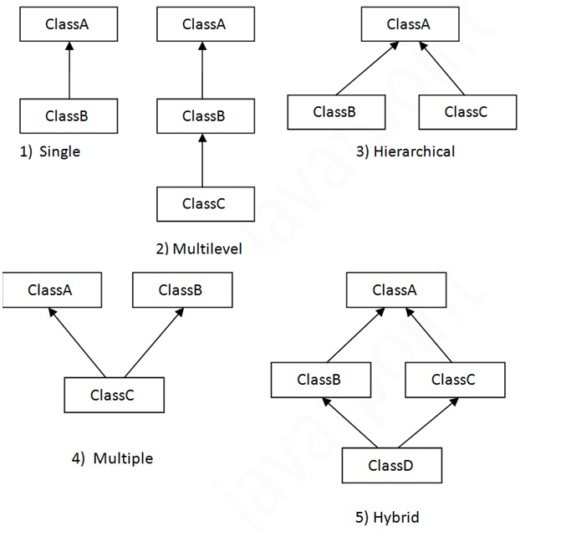

Mutli Level Inheritance

class A{
var salary1 = 10000
}

class B extends A{
var salary2 = 20000
}

class C extends B{
def show(){
println("salary1 = "+salary1)
println("salary2 = "+salary2)
}
}

object Test{
def main(args:Array[String]){
var c = new C()
c.show()

}
}

Scala Method Overriding:

class Vehicle{
def run(){
println("vehicle is running")
}
}

class Bike extends Vehicle{
override def run(){
println("Bike is running")
}
}

object Test{
def main(args:Array[String]){
var b = new Bike()
b.run()
}
}

Hierarchial Inheritance, method overriding

class Bank{
def getRateOfInterest()={
0
}
}

class SBI extends Bank{
override def getRateOfInterest()={
8
}
}

class ICICI extends Bank{
override def getRateOfInterest()={
7
}
}

class AXIS extends Bank{
override def getRateOfInterest()={
9
}
}

object Test{
def main(args:Array[String]){
var s=new SBI();
var i=new ICICI();
var a=new AXIS();
println("SBI Rate of Interest: "+s.getRateOfInterest());
println("ICICI Rate of Interest: "+i.getRateOfInterest());
println("AXIS Rate of Interest: "+a.getRateOfInterest());
}
}

Scala Field Overriding:

class Vehicle{
var speed:Int = 60

}
class Bike extends Vehicle{

var speed:Int = 100 //error

def show(){
println(speed)
}
}
object Test{
def main(args:Array[String]){
var b = new Bike()
b.show()
}
}

In scala, you can override only those variables which are declared by using val keyword in both classes.

Below Invalid:

class Vehicle{
var speed:Int = 60
}
class Bike extends Vehicle{
override var speed:Int = 100
def show(){
println(speed)
}
}
object Test{
def main(args:Array[String]){
var b = new Bike()
b.show()
}
}

below is valid.

class Vehicle{
val speed:Int = 60

}
class Bike extends Vehicle{

override val speed:Int = 100

def show(){
println(speed)
}
}
object Test{
def main(args:Array[String]){
var b = new Bike()
b.show()
}
}

Scala Final Variable:

Final is a keyword, which is used to prevent inheritance of super class members into derived class.

class Vehicle{
final val speed:Int = 60
}
class Bike extends Vehicle{
override val speed:Int = 100
def show(){
println(speed)
}
}

object Test{
def main(args:Array[String]){
var b = new Bike()
b.show()
}
}

Scala Final Method :

Final method declare in the parent class can't be override. You can make any method to final if you don't want to get it overridden.
class Vehicle{
final def show(){
println("vehicle is running")
}
}
class Bike extends Vehicle{

override def show(){
println("bike is running")
}
}
object Test{
def main(args:Array[String]){
var b = new Bike()
b.show()
}
}

Scala Final Class Example:

final class Vehicle{
def show(){
println("vehicle is running")
}

}

class Bike extends Vehicle{ //erro
override def show(){
println("bike is running")
}
}

object Test{
def main(args:Array[String]){
var b = new Bike()
b.show()
}
}

error: illegal inheritance from final class Vehicle
class Bike extends Vehicle{
^
one error found

Scala Abstract Class:

A class that extends an abstract class must provide implementation of its all abstract methods. You can't create object of an abstract class.

abstract class Bike{
def run()
}

class Hero extends Bike{
def run(){
println("running fine...")
}
}

object Test{
def main(args: Array[String]){
var h = new Hero()
h.run()
}
}

Scala Abstract Class Example: Having Constructor, Variables and Abstract Methods:

abstract class Bike{ // Creating constructor
var b:Int = 20 // Creating variables
var c:Int = 25
def run() // Abstract method
def performance(){ // Non-abstract method
println("Performance awesome")
}
}

class Hero(a:Int) extends Bike(a){
c = 30
def run(){
println("Running fine...")
println("a = "+a)
println("b = "+b)
println("c = "+c)
}
}

object MainObject{
def main(args: Array[String]){
var h = new Hero(10)
h.run()
h.performance()
}
}

Scala Abstract Class Example: Abstract Method is not implemented:

abstract class Bike{
def run() // Abstract method
}

class Hero extends Bike{ // Not implemented in this class

- def runHero(){
println("Running fine...")
}
}

object Test{
def main(args: Array[String]){
var h = new Hero() // can not create instance since it is an abstract class
h.runHero()
}
}

error: class Hero needs to be abstract, since method run in class Bike of type ()Unit is not defined
class Hero extends Bike{
^
one error found

To avoid this problem either you must implement all abstract members of abstract class or make your class abstract too.

Strings:

Creating a String

var str = "Hello world!";

or

var str:String = "Hello world!";

or

val str:String= new String("hello");

eg:

object Test {

def main(args: Array[String]) {

val line: String = "Hello, world!"
println( line )
}
}

String Length:

object Test {
def main(args: Array[String]) {
var line = "Hello Scala World";
var len = line.length();

println( "String Length is : " + len );
}
}

Concatenating Strings:

string1.concat(string2);

"My name is ".concat("Scala");

Strings are more commonly concatenated with the + operator,

"Hello" +"\t"+ " world"

object Test {
def main(args: Array[String]) {
var str1 = "Hello scala ";
var str2 = "Hello world";

println(str1 +"\t"+"hello java"+ "\t"+str2);
}
}

String formatting:

object Test {
def main(args: Array[String]) {
var fVar = 12.456
var iVar = 2000
var strVar = "Hello, Scala!"

printf("float value: %f " + " int value %d " + " String value %s\n", fVar, iVar, strVar);
}
}

String Methods:

char charAt(int index)

Returns the character at the specified index.

var str:String="hello"

var ch:Char =str.charAt(0)
println(ch)
o/p : h

int compareTo(String anotherString)

Compares two strings lexicographically.

object Test {
def main(args: Array[String]) {

var str1:String="hello"
var str2:String="hello"

if(str1.compareTo(str2)==0)
{
println("both are equal")
}
else if(str1.compareTo(str2)>0)
{
println("str1 > str2")
}
else
{
println("str2 > str1")
}

}
}

int compareToIgnoreCase(String str)

Compares two strings lexicographically, ignoring case differences.

object Test {
def main(args: Array[String]) {

var str1:String="HELLO"
var str2:String="hello"

if(str1.compareToIgnoreCase(str2)==0)
{
println("both are equal")
}
else if(str1.compareTo(str2)>0)
{
println("str1 > str2")
}
else
{
println("str2 > str1")
}

}
}

String concat(String str)

Concatenates the specified string to the end of this string.

object Test {
def main(args: Array[String]) {

var str1:String="HELLO"
var str2:String="SCALA"

var str3:String=str1.concat(str2)

println(str3);

}
}

boolean contentEquals(StringBuffer sb)

Returns true if and only if this String represents the same sequence of characters as the specified StringBuffer.

object Test {
def main(args: Array[String]) {

var str1:String="HELLO"
var str2:String="SCALA"

if(str1.contentEquals("HELLO"))
{
println("Yes")
}
else
{
println("NO")
}

}
}

boolean endsWith(String suffix)

Tests if this string ends with the specified suffix.

object Test {
def main(args: Array[String]) {

var str:String="hello java"

if( str.endsWith("java"))
{
println("yes")
}
else
{
println("No")
}
}
}

boolean equalsIgnoreCase(String anotherString)

Compares this String to another String, ignoring case considerations.

object Test {
def main(args: Array[String]) {

var str1:String="hello"
var str2:String="hello"

if( str1.equalsIgnoreCase(str2))
{
println("yes")
}
else
{
println("No")
}
}
}

byte getBytes()

Encodes this String into a sequence of bytes using the platform's default charset, storing the result into a new byte array.

object Test {
def main(args: Array[String]) {

var str:String="hello"

var res:Array[Byte]=str.getBytes();

for(x<-res)
{
println(x)
}

byte array to string.

var s1:String = new String(res);

println(s1)

}
}

int hashCode()

Returns a hash code for this string.

object Test {
def main(args: Array[String]) {

var str:String="hello"

var x:Int= str.hashCode()

println(x)

}
}

Int indexOf(int ch)

Returns the index within this string of the first occurrence of the specified character.

object Test {
def main(args: Array[String]) {

var str:String="hello"

var x:Int= str.indexOf('h')

println(x)

}
}

int indexOf(int ch, int fromIndex)

Returns the index within this string of the first occurrence of the specified character, starting the search at the specified index.

object Test {
def main(args: Array[String]) {

var str:String="hello scala. this is scala"

var x:Int= str.indexOf('s',10)

println(x)

}
}

int indexOf(String str)

Returns the index within this string of the first occurrence of the specified substring.

object Test {
def main(args: Array[String]) {

var str:String="hello scala. this is scala"

var x:Int= str.indexOf("this")

println(x)

}
}

to no of occurances :

package com.nrit.mnrao.str
import scala.util.control.Breaks._
object Test {

def main(args: Array[String]) {

var str: String = "this is scala. this is hadoop. this is nrit";

var count: Int = 0;

var i: Int = 0;
var temp: Int = 0;

breakable {
while (true) {

temp = str.indexOf("this", temp)
if (temp >= 0) {
count = count + 1;
temp = temp + 1;
} else {
break;
}
}
}

println(count)

}

}

int indexOf(String str, int fromIndex)

Returns the index within this string of the first occurrence of the specified substring, starting at the specified index.

object Test {
def main(args: Array[String]) {

var str:String="hello scala. this is scala"

var x:Int= str.indexOf("scala",10)

println(x)

}
}

String intern()

Returns a canonical representation for the string object.

object Test {
def main(args: Array[String]) {

var str:String="hello"

var res:String= str.intern()

println(res)

}
}

int lastIndexOf(int ch)

Returns the index within this string of the last occurrence of the specified character.

object Test {
def main(args: Array[String]) {

var str:String="hello scala.this is scala"

var res:Int= str.lastIndexOf('s')

println(res)

}
}

int lastIndexOf(int ch, int fromIndex)

Returns the index within this string of the last occurrence of the specified character, searching backward starting at the specified index.

object Test {
def main(args: Array[String]) {

var str:String="hello scala.this is scala"

var res:Int= str.lastIndexOf('s',str.length())

println(res)

}
}

object Test {
def main(args: Array[String]) {

var str:String="hello scala.this is scala"

var res:Int= str.lastIndexOf('s',10)

println(res)

}
}

int lastIndexOf(String str)

Returns the index within this string of the rightmost occurrence of the specified substring.

object Test {
def main(args: Array[String]) {

var str:String="hello scala.this is scala"

var res:Int= str.lastIndexOf("scala")

println(res)

}
}

int lastIndexOf(String str, int fromIndex)

Returns the index within this string of the last occurrence of the specified substring, searching backward starting at the specified index.

object Test {
def main(args: Array[String]) {

var str:String="hello scala.this is scala"

var res:Int= str.lastIndexOf("scala",10)

println(res)

}
}

int length()

Returns the length of this string.

object Test {
def main(args: Array[String]) {

var str:String="hello scala.this is scala"

var res:Int= str.length()

println(res)

}
}

String replace(char oldChar, char newChar)

Returns a new string resulting from replacing all occurrences of oldChar in this string with newChar.

object Test {
def main(args: Array[String]) {

var str:String="hello"

var res:String = str.replace('h', 'g')

println(res)

}
}

String replaceAll(String regex, String replacement)

Replaces each substring of this string that matches the given regular expression with the given replacement.

object Test {
def main(args: Array[String]) {

var str:String="hello"

var res:String = str.replaceAll("he", "ge")

println(res)

}
}

String replaceFirst(String regex, String replacement)

Replaces the first substring of this string that matches the given regular expression with the given replacement.

object Test {
def main(args: Array[String]) {

var str:String="hello scala. hello spark"

var res:String = str.replaceFirst("hello", "gello")

println(res)

}
}

String[] split(String regex)

Splits this string around matches of the given regular expression.

object Test {
def main(args: Array[String]) {

var str:String="hello scala hello spark"

var res:Array[String]=str.split(" ")

println(res(0)+":"+res(1)+":"+res(2)+":"+res(3))

for(x<-res)
{
println(x)
}

}
}

boolean startsWith(String prefix)

Tests if this string starts with the specified prefix.

object Test {
def main(args: Array[String]) {

var str:String="hello scala hello spark"

if(str.startsWith("hello"))
{
println("yes")
}
else
{
println("No")
}

}
}

boolean startsWith(String prefix, int toffset)

Tests if this string starts with the specified prefix beginning a specified index.

object Test {
def main(args: Array[String]) {

var str:String="hello scala hello spark"

if(str.startsWith("hello",12))
{
println("yes")
}
else
{
println("No")
}

}
}

CharSequence subSequence(int beginIndex, int endIndex)

Returns a new character sequence that is a subsequence of this sequence.

object Test {
def main(args: Array[String]) {

var str:String="hello scala hello spark"

var res:CharSequence= str.subSequence(6,11)

println(res)

}
}

String substring(int beginIndex)

Returns a new string that is a substring of this string.

object Test {
def main(args: Array[String]) {

var str:String="hello scala hello spark"

var res:String= str.substring(12)

println(res)

}
}

String substring(int beginIndex, int endIndex)

Returns a new string that is a substring of this string.

object Test {
def main(args: Array[String]) {

var str:String="hello scala hello spark"

var res:String= str.substring(10,20)

println(res)

}
}

char[] toCharArray()

Converts this string to a new character array.

object Test {
def main(args: Array[String]) {

var str:String="hello scala hello spark"

var res:Array[Char]= str.toCharArray()

println(res(0) )
println(res(1) )
println(res(2) )
println(res(3) )
println(res(4) )

}
}

String toLowerCase()

Converts all of the characters in this String to lower case using the rules of the default locale.

object Test {
def main(args: Array[String]) {

var str:String="HELLO SCALA"

var res:String= str.toLowerCase()

println(res )

}
}

String toString()

This object (which is already a string!) is itself returned.

String toUpperCase()

Converts all of the characters in this String to upper case using the rules of the default locale.

object Test {
def main(args: Array[String]) {

var str:String="hello scala"

var res:String= str.toUpperCase()

println(res )

}
}

String trim()

Returns a copy of the string, with leading and trailing whitespace omitted.

object Test {
def main(args: Array[String]) {

var str:String=" hello scala "

println(str.length())

var res:String= str.trim()

println(res.length() )

}
}

static String valueOf(primitive data type x)

Returns the string representation of the passed data type argument.

object Test {
def main(args: Array[String]) {

var a:Int=10;

var res:String=String.valueOf(a)

println(a)

}
}

String to numeric:

toX()

object Test {
def main(args: Array[String]) {

var str:String="10.5"

var d:Double=str.toDouble

println(d)

}
}

Scala – Closures

A closure is a function, whose return value depends on the value of one or more variables declared outside this function.

The following piece of code with anonymous function.

val mult = (i:Int) => i * 10

object Test {
def main(args: Array[String]) {
println( "mult(1) value = " + mult(1) )
println( "mult(2) value = " + mult(2) )
}
var factor = 3
val mult = (i:Int) => i * factor
}

Scala Trait:

A trait is like an interface with a partial implementation. In scala, trait is a collection of abstract and non-abstract methods. You can create trait that can have all abstract methods or some abstract and some non-abstract methods.

A variable that is declared either by using val or var keyword in a trait get internally implemented in the class that implements the trait. Any variable which is declared by using val or var but not initialized is considered abstract.

Traits are compiled into Java interfaces with corresponding implementation classes that hold any methods implemented in the traits.

package com.nrit.mnrao.test

trait Picture {
def draw()
}

package com.nrit.mnrao.test

class Triangle extends Picture {

def draw()
{
println("Triangle")
}

}

package com.nrit.mnrao.test

object Test {

def main(args:Array[String]){
var r = new Triangle()
r.draw()
}

}

====================

abstract class Triangle extends Picture {

def draw1()
{
println("Triangle")
}

}

object Test {

def main(args:Array[String]){
var r = new Triangle() // error
r.draw()
}

}

Scala Trait Example: Implementing Multiple Traits in a Class:

package com.nrit.mnrao.test

trait Picture1 {
def draw()
}

package com.nrit.mnrao.test

trait Picture2 {

def show()

}

package com.nrit.mnrao.test

class Triangle extends Picture1 with Picture2 {

def draw()
{
println("draw")
}

def show()
{
println("Show")
}

}

package com.nrit.mnrao.test

object Test {

def main(args:Array[String]){
var r = new Triangle()
r.draw()
r.show()
}
}

Scala Trait having abstract and non-abstract methods:

package com.nrit.mnrao.test

trait Picture {

def draw()

def show()
{
println("Show")
}

}

package com.nrit.mnrao.test

class Triangle extends Picture {

def draw()
{
println("draw")
}

}

package com.nrit.mnrao.test

trait Picture2 {

def show()

}

Scala Exception Handling:

Exception handling is a mechanism which is used to handle abnormal conditions.

Scala makes "checked vs unchecked" very simple. It doesn't have checked exceptions. All exceptions are unchecked in Scala, even SQLException and IOException.

Scala Program Example without Exception Handling

package com.nrit.mnrao.test

import scala.collection.immutable._

object Test {

def main(args:Array[String]){

var a=10;
var b=0

var c=a/b

println(c)

}

}

O/P:

Exception in thread "main" java.lang.ArithmeticException: / by zero
at com.nrit.mnrao.test.Test$.main(Test.scala:10)
at com.nrit.mnrao.test.Test.main(Test.scala)

eg1:

package com.nrit.mnrao.test

object Test {

def main(args:Array[String]){

println("main start")

try{
println("try start")
var a=10;
var b=0
var c=a/b
println(c)
println("try end")
}
catch
{
case e: ArithmeticException => println(e)
}
println("main end")

}

}

O/P:
main start
try start
java.lang.ArithmeticException: / by zero
main end

eg2:

package com.nrit.mnrao.test
import scala.collection.immutable._
object Test {

def main(args:Array[String]){

println("main start")

try{
println("try start")
var a=10;
var b=5
var c=a/b
println(c)

var arr = Array(1,2)
arr(2)=10
println("try end")
}
catch
{
case e: ArithmeticException => println(e)
case e: Throwable => println("found unknown Exception "+e)
}
println("main end")

}
}
O/P:
main start
try start
2
found unknown Exception java.lang.ArrayIndexOutOfBoundsException: 2
main end

Scala Finally:

package com.nrit.mnrao.test
import scala.collection.immutable._
object Test {

def main(args:Array[String]){

println("main start")

try{
println("try start")
var a=10;
var b=5
var c=a/b
println(c)

var arr = Array(1,2)
arr(1)=10
println("try end")
}
catch
{
case e: ArithmeticException => println(e)
case e: Throwable => println("found unknown Exception "+e)
case ex: Exception =>println(ex)
}
finally{
println("Finaly block")
}
println("main end")

}

}

Scala Throw keyword:

throwing exceptions explicitly:

package com.nrit.mnrao.test
import scala.collection.immutable._
object Test {

def main(args:Array[String]){

println("main start")

try{
println("try start")
var a=10;
var b=0
if(b==0)
{
throw new ArithmeticException("divide by zero")
}
var c=a/b
println(c)

var arr = Array(1,2)
arr(1)=10
println("try end")
}
catch
{
case e: ArithmeticException => println(e)

case ex: Exception =>println(ex)
}

println("main end")

}

}

Scala Throws Keyword:

Scala provides throws keyword to declare exception.

package com.nrit.mnrao.test

class Sample {

@throws(classOf[NumberFormatException])
def validate()={
"abc".toInt
}
}

package com.nrit.mnrao.test

object Test {

def main(args: Array[String]) {

var s = new Sample()
try
{
s.validate()

}
catch
{
case ex : NumberFormatException => println("Exception handeled here")
}

}

}

Scala Custom Exception

package com.nrit.mnrao.test

class SampleException (s:String) extends Exception(s){}

package com.nrit.mnrao.test

object Test {

def main(args: Array[String]) {

try
{
println("try start")
var a=10;
var b=0
if(b==0)
{
throw new SampleException("Sample Error")
}
var c=a/b
println(c)

var arr = Array(1,2)
arr(1)=10
println("try end")

}
catch
{
case ex : SampleException => println("Sample Exception handeled here")
}

}

}

Collections:

Collections are containers of things.

Collections may be strict or lazy. Lazy collections have elements that may not consume memory until they are accessed, like Ranges. Additionally, collections may be mutable (the contents of the reference can change) or immutable .

Scala.collection.mutable package contains all the mutable collections.

Scala.collection.immutable contains all the immutable collections.

Scala Immutable Collections Hierarchy

The scala.collection.immutable package contains all the immutable abstract classes and traits for collections.

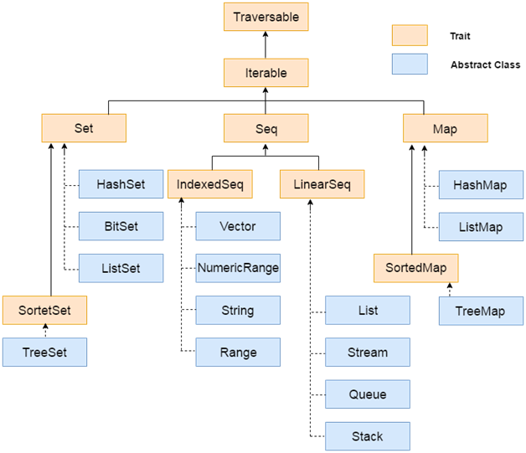

Scala Traversable:

It is a trait and used to traverse collection elements. It is a base trait for all scala collections.

Methods of Traversable Trait:

def head: A

It returns the first element of collection.

def init: Traversable[A]:

It returns all elements except last one.

def isEmpty: Boolean

It checks whether the collection is empty or not. It returns either true or false.

def last: A
It returns the last element of this collection.

def max: A

It returns the largest element of this collection.

def min: A

It returns smallest element of this collection

def size: Int

It is used to get size of this traversable and returns a number of elements present in this traversable.

def sum: A
It returns sum of all elements of this collection.

def tail: Traversable[A]

It returns all elements except first.

def toArray: Array[A]

It converts this collection to an array.

def toList: List[A]

It converts this collection to a list.

def toSeq: Seq[A]

It converts this collection to a sequence.

Scala Iterable

It is a next trait from the top of the hierarchy and a base trait for iterable collections. It extends traversable trait and provides important methods to concrete classes.

Scala Lists

Scala Lists are quite similar to arrays which means, all the elements of a list have the same type but there are two important differences. First, lists are immutable, which means elements of a list cannot be changed by assignment. Second, lists represent a linked list whereas arrays are flat.

// List of Strings
val fruits: List[String] = List("apples", "oranges", "pears")

// List of Integers
val nums: List[Int] = List(1, 2, 3, 4)

// Empty List.
val empty: List[Nothing] = List()

// Two dimensional list
val dim: List[List[Int]] = List( List(1, 0, 0), List(0, 1, 0), List(0, 0, 1) )

Operations on Lists:

head

This method returns the first element of a list.

tail

This method returns a list consisting of all elements except the first.

isEmpty

This method returns true if the list is empty otherwise false.

object Test {
def main(args: Array[String]) {

val fruits = "apples" :: ("oranges" :: ("pears" :: Nil))
val nums = Nil

println( "Head of fruit : " + fruits.head )
println( "Tail of fruit : " + fruits.tail )
println( "Check if fruit is empty : " + fruits.isEmpty )
println( "Check if nums is empty : " + nums.isEmpty )

}
}

object Test {
def main(args: Array[String]) {

val fruits1=("pears" :: Nil)

val fruits2=("oranges" ::fruits1 )

val fruits = "apples" :: fruits2

val nums = Nil

println( "Head of fruit : " + fruits.head )
println( "Tail of fruit : " + fruits.tail )
println( "Check if fruit is empty : " + fruits.isEmpty )
println( "Check if nums is empty : " + nums.isEmpty )

}
}

Concatenating Lists:

You can use either ::: operator or List.:::() method or List.concat() method to add two or more lists.

Eg:

object Test {
def main(args: Array[String]) {

val fruit1 = "apples" :: ("oranges" :: ("pears" :: Nil))

val fruit2 = "mangoes" :: ("banana" :: Nil)

// use two or more lists with ::: operator
var fruit = fruit1 ::: fruit2

println( "fruit1 ::: fruit2 : " + fruit )

// use two lists with Set.:::() method
fruit = fruit1.:::(fruit2)

println( "fruit1.:::(fruit2) : " + fruit )

// pass two or more lists as arguments
fruit = List.concat(fruit1, fruit2)

println( "List.concat(fruit1, fruit2) : " + fruit )

}
}

Creating Uniform Lists

You can use List.fill() method creates a list consisting of zero or more copies of the same element. Try the following example program.

object Test {
def main(args: Array[String]) {

val name = List.fill(3)("scala") // Repeats scala three times.
println( "name : " + name )

val num = List.fill(10)(2) // Repeats 2, 10 times.
println( "num : " + num )

}
}

Reverse List Order

You can use List.reverse method to reverse all elements of the list.

Eg:

object Test {
def main(args: Array[String]) {

val names = "scala" :: ("java" :: ("spark" :: Nil))

println( "Before reverse names : " + names )

println( "After reverse names : " + names.reverse )

}
}

O/P:

Before reverse names : List(scala, java, spark)
After reverse names : List(spark, java, scala)

List Methods:

scala> val abcde = List('a', 'b', 'c', 'd', 'e')
abcde: List[Char] = List(a, b, c, d, e)

scala> abcde.last
res4: Char = e

scala> abcde.init
res5: List[Char] = List(a, b, c, d)

scala> List().init
java.lang.UnsupportedOperationException: Nil.init
at scala.List.init(List.scala:544)
at ...

scala> List().last
java.util.NoSuchElementException: Nil.last
at scala.List.last(List.scala:563)
at ...

scala> abcde take 2
res8: List[Char] = List(a, b)

scala> abcde drop 2
res9: List[Char] = List(c, d, e)

scala> abcde splitAt 2
res10: (List[Char], List[Char]) = (List(a, b),List(c, d, e))

scala> abcde apply 2 // rare in Scala
res11: Char = c

scala> abcde(2) // rare in Scala
res12: Char = c

scala> abcde.indices
res13: List[Int] = List(0, 1, 2, 3, 4)

scala> abcde.toString
res16: String = List(a, b, c, d, e)

res18: String = abcde

scala> abcde.mkString
res19: String = abcde

scala> val arr = abcde.toArray
arr: Array[Char] = Array(a, b, c, d, e)

scala> arr.toString
res22: String = Array(a, b, c, d, e)

scala> arr.toList
res23: List[Char] = List(a, b, c, d, e)

scala> val arr2 = new Array[Int](10)
arr2: Array[Int] = Array(0, 0, 0, 0, 0, 0, 0, 0, 0, 0)

scala> List(1, 2, 3) copyToArray (arr2, 3)

scala> arr2.toString
res25: String = Array(0, 0, 0, 1, 2, 3, 0, 0, 0, 0)

object Test {
def main(args: Array[String]) {

val list = List('a', 'b', 'c', 'd', 'e')

val it = list.iterator

while(it.hasNext)
{
println(it.next)
}

}
}

def :::(prefix: List[A]): List[A]

Higher-order methods on class List:

scala> List(1, 2, 3) map (_ + 1)
res29: List[Int] = List(2, 3, 4)

scala> val words = List("the", "quick", "brown", "fox")
words: List[String] = List(the, quick, brown, fox)

scala> words map (_.length)
res2: List[Int] = List(3, 5, 5, 3)

scala> words map (_.toList.reverse.mkString)
res31: List[String] = List(eht, kciuq, nworb, xof)

scala> val res=words map (_.toList)
res: List[List[Char]] = List(List(t, h, e), List(q, u, i, c, k), List(b, r, o, w, n), List(f, o, x))

scala> val res1=res.reverse
res1: List[List[Char]] = List(List(f, o, x), List(b, r, o, w, n), List(q, u, i, c, k), List(t, h, e))
scala> val res2=res1.mkString
res2: String = List(f, o, x)List(b, r, o, w, n)List(q, u, i, c, k)List(t, h, e)

scala> var sum = 0
sum: Int = 0

scala> List(1, 2, 3, 4, 5) foreach (sum += _)

scala> sum
res6: Int = 15

scala>

scala> List(1, 2, 3, 4, 5) filter (_ % 2 == 0)
res37: List[Int] = List(2, 4)

scala> val words = List("the", "quick", "brown", "fox")
words: List[String] = List(the, quick, brown, fox)

scala> words filter (_.length == 3)
res7: List[String] = List(the, fox)

scala> List(1, 2, 3, 4, 5) partition (_ % 2 == 0)
res8: (List[Int], List[Int]) = (List(2, 4),List(1, 3, 5))

scala> List(1, 2, 3, -4, 5) takeWhile (_ > 0)
res9: List[Int] = List(1, 2, 3)

scala> words dropWhile (_ startsWith "t")
res10: List[String] = List(quick, brown, fox)

scala> List(1, 2, 3, -4, 5) span (_ > 0)
res11: (List[Int], List[Int]) = (List(1, 2, 3),List(-4, 5))

Methods of the List object:

scala> List.apply(1, 2, 3)
res12: List[Int] = List(1, 2, 3)

scala> List.range(1, 5)
res13: List[Int] = List(1, 2, 3, 4)

scala> List.range(1, 9, 2)
res14: List[Int] = List(1, 3, 5, 7)

scala> List.range(9, 1, -3)
res15: List[Int] = List(9, 6, 3)

scala> List.make(5, 'a')
res17: List[Char] = List(a, a, a, a, a)

scala> val xss = List(List('a', 'b'), List('c'), List('d', 'e'))
xss: List[List[Char]] = List(List(a, b), List(c), List(d, e))

scala>List.flatten(xss)
res18: List[Char] = List(a, b, c, d, e)

scala> List.concat(List('a', 'b'), List('c'))
res19: List[Char] = List(a, b, c)

scala> List.concat(List(), List('b'), List('c'))
res20: List[Char] = List(b, c)

scala> List.map2(List(10, 20), List(3, 4, 5)) (_ * _)
res0: List[Int] = List(30, 80)

Adds the elements of a given list in front of this list.

def contains(elem: Any): Boolean

Tests whether the list contains a given value as an element.

def distinct: List[A]

Builds a new list from the list without any duplicate elements.

scala> val list = List(10,23,2,10,2,23)
list: List[Int] = List(10, 23, 2, 10, 2, 23)

scala> list.distinct
res1: List[Int] = List(10, 23, 2)

def drop(n: Int): List[A]

Returns all elements except first n ones.

scala> val list1 =list.drop(2)
list1: List[Int] = List(2, 10, 2, 23)

scala> list1
res3: List[Int] = List(2, 10, 2, 23)

def dropRight(n: Int): List[A]

Returns all elements except last n ones.

scala> val list2 =list.dropRight(2)
list2: List[Int] = List(10, 23, 2, 10)

def equals(that: Any): Boolean

The equals method for arbitrary sequences. Compares this sequence to some other object.

scala> val list1 = List(1,2,3,4)
list1: List[Int] = List(1, 2, 3, 4)

scala> val list2 = List(1,2,3,4)
list2: List[Int] = List(1, 2, 3, 4)

scala> val res=list1.equals(list2)
res: Boolean = true

def exists(p: (A) => Boolean): Boolean

Tests whether a predicate holds for some of the elements of the list.

def head: A

Selects the first element of the list.

scala> val list = List(1,2,3,4)
scala> list.head
res0: Int = 1

def indexOf(elem: A, from: Int): Int

Finds index of first occurrence value in the list, after the index position.

scala> val list = List(1,2,3,4)
list: List[Int] = List(1, 2, 3, 4)

scala> list.indexOf(2,0)
res2: Int = 1

def init: List[A]

Returns all elements except the last.

scala> val list = List(1,2,3,4)
list: List[Int] = List(1, 2, 3, 4)

scala> list.init
res4: List[Int] = List(1, 2, 3)

def isEmpty: Boolean

Tests whether the list is empty.

scala> val list=List()
list: List[Nothing] = List()

scala> list.isEmpty
res5: Boolean = true

def iterator: Iterator[A]

Creates a new iterator over all elements contained in the iterable object.

object Test {
def main(args: Array[String]) {

val list = List('a', 'b', 'c', 'd', 'e')

val it = list.iterator

while(it.hasNext)
{
println(it.next)
}

}
}

def last: A

Returns the last element.

scala> val list = List(1,2,3,4)
list: List[Int] = List(1, 2, 3, 4)

scala> list.last
res6: Int = 4

def lastIndexOf(elem: A, end: Int): Int

Finds index of last occurrence of some value in the list; before or at a given end index.

scala> val list = List(1,2,3,4,1,2,3,4)
list: List[Int] = List(1, 2, 3, 4, 1, 2, 3, 4)

scala> list.lastIndexOf(2,4)
res7: Int = 1

scala> list.lastIndexOf(2,7)
res8: Int = 5

def length: Int

Returns the length of the list.

scala> val list = List(1,2,3,4,1,2,3,4)
list: List[Int] = List(1, 2, 3, 4, 1, 2, 3, 4)

scala> list.length
res9: Int = 8

def max: A

Finds the largest element.

scala> list.max
res10: Int = 4

def min: A

Finds the smallest element.

scala> list.min
res11: Int = 1

def mkString: String

Displays all elements of the list in a string.

scala> val list = List(1,2,3,4,1,2,3,4)
list: List[Int] = List(1, 2, 3, 4, 1, 2, 3, 4)

scala> list.mkString
res13: String = 12341234

def mkString(sep: String): String

Displays all elements of the list in a string using a separator string.

scala> list.mkString(":")
res14: String = 1:2:3:4:1:2:3:4

def reverse: List[A]

Returns new list with elements in reversed order.

scala> list.reverse
res15: List[Int] = List(4, 3, 2, 1, 4, 3, 2, 1)

def sum: A

Sums up the elements of this collection.

scala> list.sum
res16: Int = 20

def tail: List[A]

Returns all elements except the first.

scala> list.tail
res17: List[Int] = List(2, 3, 4, 1, 2, 3, 4)

def take(n: Int): List[A]

Returns first "n" elements.

scala> val list = List(1,2,3,4,1,2,3,4)
list: List[Int] = List(1, 2, 3, 4, 1, 2, 3, 4)

scala> list.take(2)
res18: List[Int] = List(1, 2)

def toString(): String

Converts the list to a string.

scala> list.toString()
res19: String = List(1, 2, 3, 4, 1, 2, 3, 4)

Scala - Sets

It is used to store unique elements in the set. It does not maintain any order for storing elements.

Scala Set is a collection of pairwise different elements of the same type. In other words, a Set is a collection that contains no duplicate elements. There are two kinds of Sets, the immutable and the mutable. The difference between mutable and immutable objects is that when an object is immutable, the object itself can't be changed.

By default, Scala uses the immutable Set. If you want to use the mutable Set, you'll have to import scala.collection.mutable.Set class explicitly. If you want to use both mutable and immutable sets in the same collection, then you can continue to refer to the immutable Set as Set but you can refer to the mutable Set as mutable.Set.

Syntax:

val variableName:Set[Type] = Set(element1, element2,... elementN) or
val variableName = Set(element1, element2,... elementN)

// Empty set of integer type
var s : Set[Int] = Set()

// Set of integer type
var s : Set[Int] = Set(1,3,5,7)

or

var s = Set(1,3,5,7)

Iterating Set Elements using for loop

package com.nrit.mnrao.test
import scala.collection.immutable._
object Test {

def main(args:Array[String]){

var books = Set("Java","Linux","Scala","Spark")

for(x<-books)
{
println(x)
}

}

}

Basic Operations on set:

head

This method returns the first element of a set.

tail

This method returns a set consisting of all elements except the first.

isEmpty

This method returns true if the set is empty otherwise false.

package com.nrit.mnrao.test

import scala.collection.immutable._
object Test {

def main(args:Array[String]){
val set1 = Set() // An empty set
val books = Set("Java","Linux","Scala","Spark") // Creating a set with elements
println(set1.isEmpty)
println(books.head)
println(books.tail)
println(books.init)
println(books.last)

}

}

Head of names : scala
Tail of names : Set(java, spark)
Check if names is empty : false
Check if nums is empty : true

Find Max, Min Elements in a Set

object Test {
def main(args: Array[String]) {
val num = Set(5,6,9,20,30,45)

// find min and max of the elements
println( "Min element in Set(5,6,9,20,30,45) : " + num.min )
println( "Max element in Set(5,6,9,20,30,45) : " + num.max )
}
}

o/p:

Min element in Set(5,6,9,20,30,45) : 5
Max element in Set(5,6,9,20,30,45) : 45

Scala Set methods:

def +(elem: A): Set[A]

Creates a new set with an additional element, unless the element is already present.

def -(elem: A): Set[A]

Creates a new set with a given element removed from this set.

Adding and Removing Elements:

package com.nrit.mnrao.test
import scala.collection.immutable._
object Test {

def main(args:Array[String]){

var books = Set("Java","Linux","Scala","Spark")

println(books)

books +="Hadoop"

println(books)

books +="Hive"

println(books)

books -="Java"

println(books)

books -="Scala"

println(books)

}

}

def contains(elem: A): Boolean

Returns true if elem is contained in this set, false otherwise.

package com.nrit.mnrao.test
import scala.collection.immutable._
object Test {

def main(args:Array[String]){
val books = Set("Java","Linux","Scala","Spark")

println(books)
println("Elements in set: "+books.size)
println("Java exists in the set : "+books.contains("Java"))
println("Spark exists in the set : "+books.contains("Spark"))

}

}
O/P:

Set(Java, Linux, Scala, Spark)
Elements in set: 4
Java exists in the set : true
Spark exists in the set : true

def &(that: Set[A]): Set[A]

Returns a new set consisting of all elements that are both in this set and in the given set.

def ++(elems: A): Set[A]

Concatenates this immutable set with the elements of another collection to this immutable set.

Concatenating Sets:

You can use either ++ operator or Set.++() method to concatenate two or more sets, but while adding sets it will remove duplicate elements.

package com.nrit.mnrao.test
import scala.collection.immutable._
object Test {

def main(args:Array[String]){
val names1 = Set("scala", "java", "spark")
val names2 = Set("hadoop", "oracle")

// use two or more sets with ++ as operator
var names = names1 ++ names2
println( "names1 ++ names2 : " + names )

// use two sets with ++ as method
names = names1.++(names2)
println( "names1.++(names2) : " + names )

}

}

names1 ++ names2 : Set(oracle, java, hadoop, spark, scala)
names1.++(names2) : Set(oracle, java, hadoop, spark, scala)

package com.nrit.mnrao.test
import scala.collection.immutable._
object Test {

def main(args:Array[String]){

var alphabet1 = Set("A","B","D","F","H")

var alphabet2 = Set("A","B","C","D","E","F")
var setIntersection = alphabet1.intersect(alphabet2)

println("Intersection by using intersect method: "+setIntersection)

println("Intersection by using & operator: "+(alphabet1 & alphabet2))
var setUnion = alphabet1.union(alphabet2)
println(setUnion)

}

}

O/P:
Intersection by using intersect method: Set(F, A, B, D)
Intersection by using & operator: Set(F, A, B, D)
Set(E, F, A, B, C, H, D)

def addString(b: StringBuilder): StringBuilder

Appends all elements of this immutable set to a string builder.

def addString(b: StringBuilder, sep: String): StringBuilder

Appends all elements of this immutable set to a string builder using a separator string.

def count(p: (A) => Boolean): Int

Counts the number of elements in the immutable set which satisfy a predicate.

def copyToArray(xs: Array[A], start: Int, len: Int): Unit

Copies elements of this immutable set to an array.

def diff(that: Set[A]): Set[A]

Computes the difference of this set and another set.

def equals(that: Any): Boolean

The equals method for arbitrary sequences. Compares this sequence to some other object.

def exists(p: (A) => Boolean): Boolean

Tests whether a predicate holds for some of the elements of this immutable set.

def find(p: (A) => Boolean): Option[A]

Finds the first element of the immutable set satisfying a predicate, if any.

def head: A

Returns the first element of this immutable set.

def init: Set[A]

Returns all elements except the last.

def isEmpty: Boolean

Tests if this set is empty.

def last: A

Returns the last element.
def max: A

Finds the largest element.

def min: A

Finds the smallest element

def mkString: String

Displays all elements of this immutable set in a string.

def mkString(sep: String): String

Displays all elements of this immutable set in a string using a separator string.

def product: A

Returns the product of all elements of this immutable set with respect to the * operator in num.

def size: Int

Returns the number of elements in this immutable set.

def splitAt(n: Int): (Set[A], Set[A])

Returns a pair of immutable sets consisting of the first n elements of this immutable set, and the other elements.

def sum: A

Returns the sum of all elements of this immutable set with respect to the + operator in num.

def tail: Set[A]

Returns a immutable set consisting of all elements of this immutable set except the first one.

def take(n: Int): Set[A]

Returns first n elements.

def toList: List[A]

Returns a list containing all elements of this immutable set.

def toString(): String

Returns a String representation of the object.

SortedSet Example:

package com.nrit.mnrao.test
import scala.collection.immutable._
object Test {

def main(args:Array[String]){

var numbers: SortedSet[Int] = SortedSet(5,8,1,2,9,6,4,7,2)
for(x<-numbers)
{
println(x)
}
}

}

HashSet Example:

package com.nrit.mnrao.test
import scala.collection.immutable.HashSet
object Test {

def main(args:Array[String]){

var numbers = HashSet(4,2,8,0,6,3,45)
for(x<-numbers)
{
println(x)
}
}

}

BitSet:

Bitsets are sets of non-negative integers which are represented as variable-size arrays of bits packed into 64-bit words.

package com.nrit.mnrao.test
import scala.collection.immutable._
object Test {

def main(args:Array[String]){

var numbers = BitSet(1,5,8,6,9,0)
for(x<-numbers)
{
println(x)
}
}

}

BitSet Example: Adding and Removing Elements

package com.nrit.mnrao.test
import scala.collection.immutable._
object Test {

def main(args:Array[String]){

var numbers = BitSet(1,5,8,6,9,0)

for(x<-numbers)
{
println(x)
}
numbers += 20 // Adding an element
print("\nAfter adding 20: ")

for(x<-numbers)
{
println(x)
}
numbers-=0 // Deleting an element
print("\nAfter deleting 0: ")

for(x<-numbers)
{
println(x)
}

}

}

Scala – Maps

Scala map is a collection of key/value pairs. Any value can be retrieved based on its key. Keys are unique in the Map, but values need not be unique. Maps are also called Hash tables. There are two kinds of Maps, the immutable and the mutable. The difference between mutable and immutable objects is that when an object is immutable, the object itself can't be changed.

By default, Scala uses the immutable Map. If you want to use the mutable Map, you'll have to import scala.collection.mutable.Map class explicitly. If you want to use both mutable and immutable Maps in the same, then you can continue to refer to the immutable Map as Map but you can refer to the mutable set as mutable.Map.

Eg:

// Empty hash table whose keys are strings and values are integers:
var A:Map[Char,Int] = Map()

// A map with keys and values.
val names = Map("J" -> "Java", "S" -> "SCALA")

Basic Operations on MAP:

keys

This method returns an iterable containing each key in the map.

values

This method returns an iterable containing each value in the map.

isEmpty

This method returns true if the map is empty otherwise false.

Eg:

object Test {
def main(args: Array[String]) {
val names = Map("J" -> "Java", "S" -> "SCALA", "H" -> "Hadoop")

val nums: Map[Int, Int] = Map()

println( "Keys in names : " + names.keys )
println( "Values in names : " + names.values )
println( "Check if names is empty : " + names.isEmpty )
println( "Check if nums is empty : " + nums.isEmpty )
}
}

O/P:

Keys in names : Set(J, S, H)
Values in names : MapLike(Java, SCALA, Hadoop)
Check if names is empty : false
Check if nums is empty : true

Concatenating Maps

You can use either ++ operator or Map.++() method to concatenate two or more Maps, but while adding Maps it will remove duplicate keys.

object Test {
def main(args: Array[String]) {
val names1 = Map("J" -> "Java", "S" -> "Scala", "H" -> "Hadoop")
val names2 = Map("O" -> "Oracle", "P" -> "Pig", "F" -> "Flume")

// use two or more Maps with ++ as operator
var names = names1 ++ names2
println( "names1 ++ names2 : " + names )

// use two maps with ++ as method
names = names1.++(names2)
println( "names1.++(names2)) : " + names )
}
}

names1 ++ names2 : Map(J -> Java, F -> Flume, P -> Pig, H -> Hadoop, O -> Oracle, S -> Scala)
names1.++(names2)) : Map(J -> Java, F -> Flume, P -> Pig, H -> Hadoop, O -> Oracle, S -> Scala)

Print Keys and Values from a Map:

object Test {
def main(args: Array[String]) {
val names = Map("J" -> "Java", "S" -> "Scala","H" -> "Hadoop")

names.keys.foreach{ i =>
print( "Key = " + i )
println(" Value = " + names(i) )}
}
}

O/P:

Key = J Value = Java
Key = S Value = Scala
Key = H Value = Hadoop

Check for a key in Map

You can use either Map.contains method to test if a given key exists in the map or not.

object Test {
def main(args: Array[String]) {
val names = Map("J" -> "Java", "S" -> "Scala", "H" -> "Hadoop")

if( names.contains( "J" )) {
println("J key exists with value :" + names("J"))
} else {
println("J key does not exist")
}

if( names.contains( "S" )) {
println("S key exists with value :" + names("S"))
} else {
println("S key does not exist")
}
}
}

Scala Map Methods:

def ++(xs: Map[(A, B)]): Map[A, B]

Returns a new map containing mappings of this map and those provided by xs.

def -(elem1: A, elem2: A, elems: A*): Map[A, B]

Returns a new map containing all the mappings of this map except mappings with a key equal to elem1, elem2 or any of elems.

def --(xs: GTO[A]): Map[A, B]

Returns a new map with all the key/value mappings of this map except mappings with a key equal to a key from the traversable object xs.

def get(key: A): Option[B]

Optionally returns the value associated with a key.

def iterator: Iterator[(A, B)]

Creates a new iterator over all key/value pairs of this map

def addString(b: StringBuilder): StringBuilder

Appends all elements of this shrinkable collection to a string builder.

def addString(b: StringBuilder, sep: String): StringBuilder

Appends all elements of this shrinkable collection to a string builder using a separator string.

def apply(key: A): B

Returns the value associated with the given key, or the result of the map's default method, if none exists.

def clear(): Unit

Removes all bindings from the map. After this operation has completed, the map will be empty.

def clone(): Map[A, B]

Creates a copy of the receiver object.

def contains(key: A): Boolean

Returns true if there is a binding for key in this map, false otherwise.

def copyToArray(xs: Array[(A, B)]): Unit

Copies values of this shrinkable collection to an array. Fills the given array xs with values of this shrinkable collection.

def count(p: ((A, B)) => Boolean): Int

Counts the number of elements in the shrinkable collection which satisfy a predicate.

def default(key: A): B

Defines the default value computation for the map, returned when a key is not found.

def drop(n: Int): Map[A, B]

Returns all elements except first n ones.

def dropRight(n: Int): Map[A, B]

Returns all elements except last n ones

def empty: Map[A, B]

Returns the empty map of the same type.

def equals(that: Any): Boolean

Returns true if both maps contain exactly the same keys/values, false otherwise.

def exists(p: ((A, B)) => Boolean): Boolean

Returns true if the given predicate p holds for some of the elements of this shrinkable collection, otherwise false.

def find(p: ((A, B)) => Boolean): Option[(A, B)]

Finds the first element of the shrinkable collection satisfying a predicate, if any.

def init: Map[A, B]

Returns all elements except the last.

def isEmpty: Boolean

Tests whether the map is empty.

def keys: Iterable[A]

Returns an iterator over all keys.

def last: (A, B)

Returns the last element.

def max: (A, B)

Finds the largest element.

def min: (A, B)

Finds the smallest element.

def mkString: String

Displays all elements of this shrinkable collection in a string.

def product: (A, B)

Returns the product of all elements of this shrinkable collection with respect to the * operator in num.

def remove(key: A): Option[B]

Removes a key from this map, returning the value associated previously with that key as an option.

def retain(p: (A, B) => Boolean): Map.this.type

Retains only those mappings for which the predicate p returns true.

def size: Int

Return the number of elements in this map.

def sum: (A, B)

Returns the sum of all elements of this shrinkable collection with respect to the + operator in num.

def tail: Map[A, B]

Returns all elements except the first.

def take(n: Int): Map[A, B]

Returns first n elements.

def takeRight(n: Int): Map[A, B]

Returns last n elements.

def toArray: Array[(A, B)]

Converts this shrinkable collection to an array.

def toBuffer[B >: A]: Buffer[B]

Returns a buffer containing all elements of this map.

def toList: List[A]

Returns a list containing all elements of this map.

def toSeq: Seq[A]

Returns a seq containing all elements of this map.

def toSet: Set[A]

Returns a set containing all elements of this map.

def toString(): String

Returns a String representation of the object.

Scala – Tuples:

A tuple is a collection of elements in ordered form. If there is no element present, it is called empty tuple.

Scala tuple combines a fixed number of items together so that they can be passed around as a whole. Unlike an array or list, a tuple can hold objects with different types but they are also immutable.

val t = (1, "hello", Console)
(or)
val t = new Tuple3(1, "hello", Console)

val t = (4,3,2,1)

val sum = t._1 + t._2 + t._3 + t._4

eg:

object Test {
def main(args: Array[String]) {
val t = (4,3,2,1)
val sum = t._1 + t._2 + t._3 + t._4

println( "Sum of elements: " + sum )
}
}

package com.nrit.mnrao.test

object Test {

def main(args: Array[String]) {

var tuple = (1,5,8,6,4) // Tuple of integer values
var tuple2 = ("Apple","Banana","Gavava") // Tuple of string values
var tuple3 = (2.5,8.4,10.50) // Tuple of float values
var tuple4 = (1,2.5,"India") // Tuple of mix type values
println(tuple)
println(tuple2)
println(tuple3)
println(tuple4)
}

}

Iterate over the Tuple:

object Test {
def main(args: Array[String]) {
val t = (4,3,2,1)

t.productIterator.foreach{ i =>println("Value = " + i )}
}
}

Scala Tuple Example: Function Return Multiple Values

package com.nrit.mnrao.test

object Test {

def main(args:Array[String]){
var tupleValues = tupleFunction()
println("Iterating values: ")
tupleValues.productIterator.foreach(println) // Iterating tuple values using productIterator
}
def tupleFunction()={
var tuple = (1,2.5,"India")
tuple
}

}

Converting to String:

eg:

object Test {
def main(args: Array[String]) {
val t = new Tuple3(1, "hello", Console)

println("Concatenated String: " + t.toString() )
}
}

o/p:

Concatenated String: (1,hello,scala.Console$@bc43e6)

Swap the Elements

You can use Tuple.swap method to swap the elements of a Tuple2.
eg:

object Test {
def main(args: Array[String]) {
val t = new Tuple2("Scala", "hello")

println("Swapped Tuple: " + t.swap )
}
}
Scala – Iterators

An iterator is not a collection, but rather a way to access the elements of a collection one by one. The two basic operations on an iterator it are next and hasNext.

object Test {
def main(args: Array[String]) {
val it = Iterator("Scala", "Spark", "RDD", "MLIB")

while (it.hasNext){
println(it.next())
}
}
}

Find Min & Max Valued Element:

object Test {
def main(args: Array[String]) {
val ita = Iterator(20,40,2,50,69, 90)
val itb = Iterator(20,40,2,50,69, 90)

println("Maximum valued element " + ita.max )
println("Minimum valued element " + itb.min )
}
}

Find the Length of the Iterator:

object Test {
def main(args: Array[String]) {
val ita = Iterator(20,40,2,50,69, 90)
val itb = Iterator(20,40,2,50,69, 90)

println("Value of ita.size : " + ita.size )
println("Value of itb.length : " + itb.length )
}
}

Scala Iterator Methods

def hasNext: Boolean

Tests whether this iterator can provide another element.

def next(): A

Produces the next element of this iterator.

def ++(that: => Iterator[A]): Iterator[A]

Concatenates this iterator with another.

def addString(b: StringBuilder): StringBuilder

Returns the string builder b to which elements were appended.

def addString(b: StringBuilder, sep: String): StringBuilder

Returns the string builder b to which elements were appended using a separator string.

def buffered: BufferedIterator[A]

Creates a buffered iterator from this iterator.

def contains(elem: Any): Boolean

Tests whether this iterator contains a given value as an element.

def count(p: (A) => Boolean): Int

Counts the number of elements in the traversable or iterator which satisfy a predicate.

def duplicate: (Iterator[A], Iterator[A])

Creates two new iterators that both iterate over the same elements as this iterator (in the same order).

def exists(p: (A) => Boolean): Boolean

Returns true if the given predicate p holds for some of the values produced by this iterator, otherwise false.

def find(p: (A) => Boolean): Option[A]

Finds the first value produced by the iterator satisfying a predicate, if any.

def foreach(f: (A) => Unit): Unit

Applies a function f to all values produced by this iterator.

def indexOf(elem: B): Int

Returns the index of the first occurrence of the specified object in this iterable object.

def isEmpty: Boolean

Returns true if hasNext is false, false otherwise.

def length: Int

Returns the number of elements in this iterator. The iterator is at its end after this method returns.

def max: A

Finds the largest element. The iterator is at its end after this method returns.

def min: A

Finds the minimum element. The iterator is at its end after this method returns.

def mkString: String

Displays all elements of this traversable or iterator in a string.

def size: Int

Returns the number of elements in this traversable or iterator.

def sum: A

Returns the sum of all elements of this traversable or iterator with respect to the + operator in num.

def take(n: Int): Iterator[A]

Returns an iterator producing only of the first n values of this iterator, or else the whole iterator, if it produces fewer than n values.

def toArray: Array[A]

Returns an array containing all elements of this traversable or iterator.

def toList: List[A]

Returns a list containing all elements of this traversable or iterator.

def toString(): String

Converts this iterator to a string.

Scala – Traits:

A trait encapsulates method and field definitions, which can then be reused by mixing them into classes. Unlike class inheritance, in which each class must inherit from just one superclass, a class can mix in any number of traits.

Traits are used to define object types by specifying the signature of the supported methods. Scala also allows traits to be partially implemented but traits may not have constructor parameters.

A trait definition looks just like a class definition except that it uses the keyword trait.

trait Test {
def isEqual(x: Any): Boolean
def isNotEqual(x: Any): Boolean = !isEqual(x)
}

This trait consists of two methods isEqual and isNotEqual. Here, we have not given any implementation for isEqual where as another method has its implementation. Child classes extending a trait can give implementation for the un-implemented methods.

So a trait is very similar to what we have abstract classes in Java.

example program to implement traits.

trait Example {
def isEqual(x: Any): Boolean
def isNotEqual(x: Any): Boolean = !isEqual(x)
}

class Sample(xc: Int, yc: Int) extends Example {
var x: Int = xc
var y: Int = yc

def isEqual(obj: Any) = obj.isInstanceOf[Sample] && obj.asInstanceOf[Sample].x == y
}

object Test {
def main(args: Array[String]) {
val s1 = new Sample(2, 3)
val s2 = new Sample(2, 4)
val s3 = new Sample(3, 3)

println(s1.isNotEqual(s2))
println(s1.isNotEqual(s3))
println(s1.isNotEqual(2))
}
}

Value classes and Universal Traits:

Value classes are new mechanism in Scala to avoid allocating runtime objects. It contains a primary constructor with exactly one val parameter. It contains only methods (def) not allowed var, val, nested classes, traits, or objects. Value class cannot be extended by another class. This can be possible by extending your value class with AnyVal. The typesafety of custom datatypes without the runtime overhead.

A value class not allowed to extend traits. To permit value classes to extend traits, universal traits are introduced which extends for Any.

trait Sample extends Any {
def print(): Unit = println(this)
}

class Wrapper(val underlying: Int) extends AnyVal with Sample

object Test {
def main(args: Array[String]) {
val w = new Wrapper(3)
w.print() // actually requires instantiating a Wrapper instance
}
}

When to Use Traits?

There is no firm rule, but here are few guidelines to consider −

If the behavior will not be reused, then make it a concrete class. It is not reusable behavior after all.

If it might be reused in multiple, unrelated classes, make it a trait. Only traits can be mixed into different parts of the class hierarchy.

If you want to inherit from it in Java code, use an abstract class.

If you plan to distribute it in compiled form, and you expect outside groups to write classes inheriting from it, you might lean towards using an abstract class.

If efficiency is very important, lean towards using a class.

Scala - Exception Handling:

Scala's exceptions work like exceptions in many other languages like Java. Instead of returning a value in the normal way, a method can terminate by throwing an exception. However, Scala doesn't actually have checked exceptions.

When you want to handle exceptions, you use a try{...}catch{...} block like you would in Java except that the catch block uses matching to identify and handle the exceptions.

Throwing Exceptions

Throwing an exception looks the same as in Java. You create an exception object and then you throw it with the throw keyword as follows.

throw new IllegalArgumentException

Catching Exceptions

Scala allows you to try/catch any exception in a single block and then perform pattern matching against it using case blocks.

Eg:

import java.io.FileReader
import java.io.FileNotFoundException
import java.io.IOException

object Test {
def main(args: Array[String]) {
try {
val f = new FileReader("input.txt")
} catch {
case ex: FileNotFoundException =>{
println("Missing file exception")
}

case ex: IOException => {
println("IO Exception")
}
}
}
}

The finally Clause:

import java.io.FileReader
import java.io.FileNotFoundException
import java.io.IOException

object Test {
def main(args: Array[String]) {
try {
val f = new FileReader("input.txt")
} catch {
case ex: FileNotFoundException => {
println("Missing file exception")
}

case ex: IOException => {
println("IO Exception")
}
} finally {
println("Exiting finally...")
}
}
}

Scala - Files I/O

Scala is open to make use of any Java objects and java.io.File is one of the objects which can be used in Scala programming to read and write files.

package com.nrit.mnrao.test
import java.io._
object Test {

def main(args:Array[String]){

val fileObject = new File("/home/hdp2/ScalaFile.txt" ) // Creating a file
val printWriter = new PrintWriter(fileObject) // Passing reference of file to the printwriter
printWriter.write("Hello, This is scala\n") // Writing to the file
printWriter.write("Hello, This is spark\n")
printWriter.write("Hello, This is hadoop\n")
printWriter.write("Hello, This is scala")
printWriter.close()
println("successfully created")
}

}

Scala Reading File Example: Reading Each Charecter:

package com.nrit.mnrao.test
import scala.io.Source
object Test {

def main(args:Array[String]){

// Creating a file
val filename = "/home/hdp2/ScalaFile.txt"
val fileSource = Source.fromFile(filename)
while(fileSource.hasNext){
print(fileSource.next)
}
fileSource.close()
}

}

Reading Each Line:

package com.nrit.mnrao.test
import scala.io.Source
object Test {

def main(args:Array[String]){
val filename = "/home/hdp2/ScalaFile.txt"
val fileSource = Source.fromFile(filename)
for(line<-fileSource.getLines){
println(line)
}
fileSource.close()
}

}

Introduction to Spark Programming

Apache Spark

Apache Spark

1) Spark introduced by apache for speeding up the hadoop computations ( Processing )

2) Spark is not modified version of Hadoop

3) Spark is not hadoop depenedent because, it has its own cluster Management

4) Hadoop is one of the ways to implement spark

5) Spark uses hadoop in two way 1) storage and 2) processing

6) since spark has its own cluster Management, it uses hadoop for storage purpose only.

7) Apache spark is lightning-fast cluster computing technology, designed for fast computing.

8) it is based on hadoop MapReduce and it extends MapReduce model

9) the main feature of spark is its in-memory cluster computing, that increases the processing speed of application.

10) spark designed to cover a wide range of work loads such as batch applications, iterative algorithems, interactive queries and streaming

11) it reduces the management burden of mainintaing tools.

Features of Apache Spark

Apache Spark has following features.

Speed − Spark helps to run an application in Hadoop cluster, up to 100 times faster in memory, and 10 times faster when running on disk. This is possible by reducing number of read/write operations to disk. It stores the intermediate processing data in memory.

Supports multiple languages − Spark provides built-in APIs in Java, Scala, or Python. Therefore, you can write applications in different languages. Spark comes up with 80 high-level operators for interactive querying.

Advanced Analytics − Spark not only supports ‘Map’ and ‘reduce’. It also supports SQL queries, Streaming data, Machine learning (ML), and Graph algorithms.

Spark Built on Hadoop
The following diagram shows three ways of how Spark can be built with Hadoop components.

Components of Spark

There are three ways of Spark deployment as explained below.

Standalone − Spark Standalone deployment means Spark occupies the place on top of HDFS(Hadoop Distributed File System) and space is allocated for HDFS, explicitly. Here, Spark and MapReduce will run side by side to cover all spark jobs on cluster.

Hadoop Yarn − Hadoop Yarn deployment means, simply, spark runs on Yarn without any pre-installation or root access required. It helps to integrate Spark into Hadoop ecosystem or Hadoop stack. It allows other components to run on top of stack.

Spark in MapReduce (SIMR) − Spark in MapReduce is used to launch spark job in addition to standalone deployment. With SIMR, user can start Spark and uses its shell without any administrative access.

Apache Spark Core

Spark Core is the underlying general execution engine for spark platform that all other functionality is built upon. It provides In-Memory computing and referencing datasets in external storage systems.

Spark SQL

Spark SQL is a component on top of Spark Core that introduces a new data abstraction called SchemaRDD, which provides support for structured and semi-structured data.

Spark Streaming

Spark Streaming leverages Spark Core's fast scheduling capability to perform streaming analytics. It ingests data in mini-batches and performs RDD (Resilient Distributed Datasets) transformations on those mini-batches of data.

MLlib (Machine Learning Library)

MLlib is a distributed machine learning framework above Spark because of the distributed memory-based Spark architecture. It is, according to benchmarks, done by the MLlib developers against the Alternating Least Squares (ALS) implementations. Spark MLlib is nine times as fast as the Hadoop disk-based version of Apache Mahout (before Mahout gained a Spark interface).

GraphX

GraphX is a distributed graph-processing framework on top of Spark. It provides an API for expressing graph computation that can model the user-defined graphs by using Pregel abstraction API. It also provides an optimized runtime for this abstraction.

Resilient Distributed Datasets

Resilient Distributed Datasets (RDD) is a fundamental data structure of Spark. It is an immutable distributed collection of objects. Each dataset in RDD is divided into logical partitions, which may be computed on different nodes of the cluster. RDDs can contain any type of Python, Java, or Scala objects, including user-defined classes.

Formally, an RDD is a read-only, partitioned collection of records. RDDs can be created through deterministic operations on either data on stable storage or other RDDs. RDD is a fault-tolerant collection of elements that can be operated on in parallel.

There are two ways to create RDDs − parallelizing an existing collection in your driver program, or referencing a dataset in an external storage system, such as a shared file system, HDFS, HBase, or any data source offering a Hadoop Input Format.

Spark makes use of the concept of RDD to achieve faster and efficient MapReduce operations.

Let us first discuss how MapReduce operations take place and why they are not so efficient.

Data Sharing is Slow in MapReduce

MapReduce is widely adopted for processing and generating large datasets with a parallel, distributed algorithm on a cluster. It allows users to write parallel computations, using a set of high-level operators, without having to worry about work distribution and fault tolerance.

Unfortunately, in most current frameworks, the only way to reuse data between computations (Ex − between two MapReduce jobs) is to write it to an external stable storage system (Ex − HDFS). Although this framework provides numerous abstractions for accessing a cluster’s computational resources, users still want more.

Both Iterative and Interactive applications require faster data sharing across parallel jobs. Data sharing is slow in MapReduce due to replication, serialization, and disk IO. Regarding storage system, most of the Hadoop applications, they spend more than 90% of the time doing HDFS read-write operations.

Iterative Operations on MapReduce

Reuse intermediate results across multiple computations in multi-stage applications. The following illustration explains how the current framework works, while doing the iterative operations on MapReduce. This incurs substantial overheads due to data replication, disk I/O, and serialization, which makes the system slow.

Interactive Operations on MapReduce

User runs ad-hoc queries on the same subset of data. Each query will do the disk I/O on the stable storage, which can dominates application execution time.

The following illustration explains how the current framework works while doing the interactive queries on MapReduce.

Data Sharing using Spark RDD

Data sharing is slow in MapReduce due to replication, serialization, and disk IO. Most of the Hadoop applications, they spend more than 90% of the time doing HDFS read-write operations.

Recognizing this problem, researchers developed a specialized framework called Apache Spark. The key idea of spark is Resilient Distributed Datasets (RDD); it supports in-memory processing computation. This means, it stores the state of memory as an object across the jobs and the object is sharable between those jobs. Data sharing in memory is 10 to 100 times faster than network and Disk.

Let us now try to find out how iterative and interactive operations take place in Spark RDD.

Iterative Operations on Spark RDD

The illustration given below shows the iterative operations on Spark RDD. It will store intermediate results in a distributed memory instead of Stable storage (Disk) and make the system faster.

Note − If the Distributed memory (RAM) is not sufficient to store intermediate results (State of the JOB), then it will store those results on the disk.

Interactive Operations on Spark RDD

This illustration shows interactive operations on Spark RDD. If different queries are run on the same set of data repeatedly, this particular data can be kept in memory for better execution times.

By default, each transformed RDD may be recomputed each time you run an action on it. However, you may also persist an RDD in memory, in which case Spark will keep the elements around on the cluster for much faster access, the next time you query it. There is also support for persisting RDDs on disk, or replicated across multiple nodes.

he following table summarizes terms you’ll see used to refer to cluster concepts:

Application :
User program built on Spark. Consists of a driver program and executors on the cluster.

Application jar:
A jar containing the user's Spark application. In some cases users will want to create an "uber jar" containing their application along with its dependencies. The user's jar should never include Hadoop or Spark libraries, however, these will be added at runtime.

Driver program :
The process running the main() function of the application and creating the SparkContext

Cluster manager :
An external service for acquiring resources on the cluster (e.g. standalone manager, Mesos, YARN)

Deploy mode :
Distinguishes where the driver process runs. In "cluster" mode, the framework launches the driver inside of the cluster. In "client" mode, the submitter launches the driver outside of the cluster.

Worker node :
Any node that can run application code in the cluster

Executor :
A process launched for an application on a worker node, that runs tasks and keeps data in memory or disk storage across them. Each application has its own executors.

Task:
A unit of work that will be sent to one executor

Job :
A parallel computation consisting of multiple tasks that gets spawned in response to a Spark action (e.g. save, collect);

Stage :
Each job gets divided into smaller sets of tasks called stages that depend on each other (similar to the map and reduce stages in MapReduce);

Spark History

At first, in 2009 Apache Spark was introduced in the UC Berkeley R&D Lab. Which is now known as AMPLab. Afterwards, in 2010 it became open source under BSD license. Further, the spark was donated to Apache Software Foundation, in 2013. Then in 2014, it became top-level Apache project.

Resilient Distributed Dataset – RDD

Resilient Distributed Datasets (RDD) is the fundamental data structure of Spark. RDDs are immutable and fault tolerant in nature. These are distributed collections of objects. The datasets are divided into a logical partition, which is further computed on different nodes over the cluster. Thus, RDD is just the way of representing dataset distributed across multiple machines, which can be operated around in parallel. RDDs are called resilient because they have the ability to always re-compute an RDD

Spark setup in Eclipse:

1) Launch eclipse

maven setup in eclipse:

help->Install new software:

Name:M2Eclipse

url:http://download.eclipse.org/technology/m2e/milestones/1.0

Scala prospective

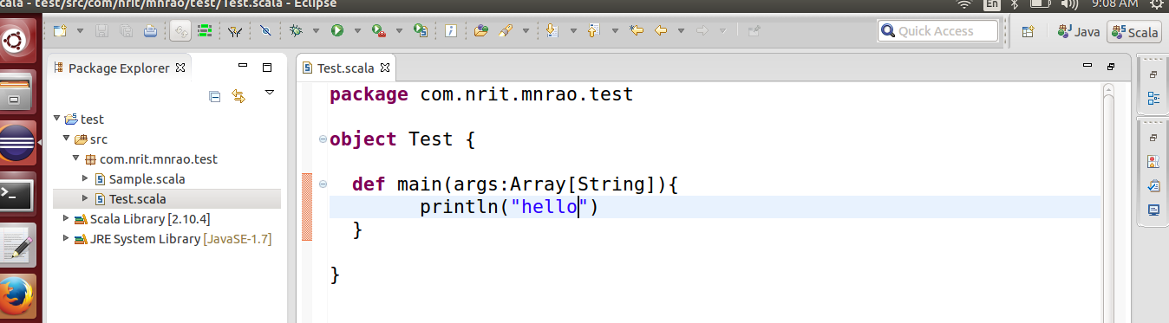

create maven project -->

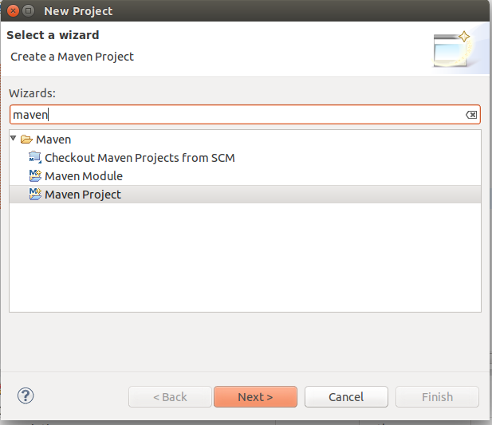

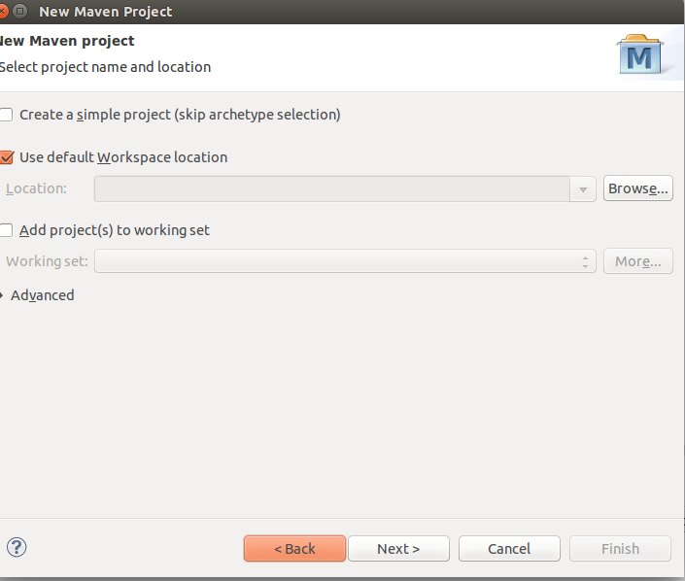

click on Next

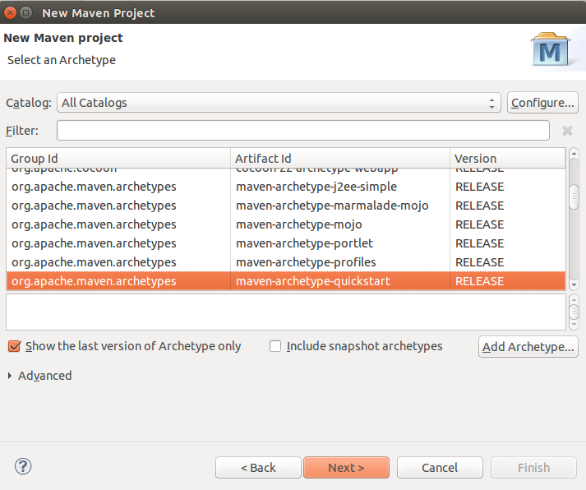

click on Next

Group Id : com.nrit.spark.test

Artifact Id : sparktest

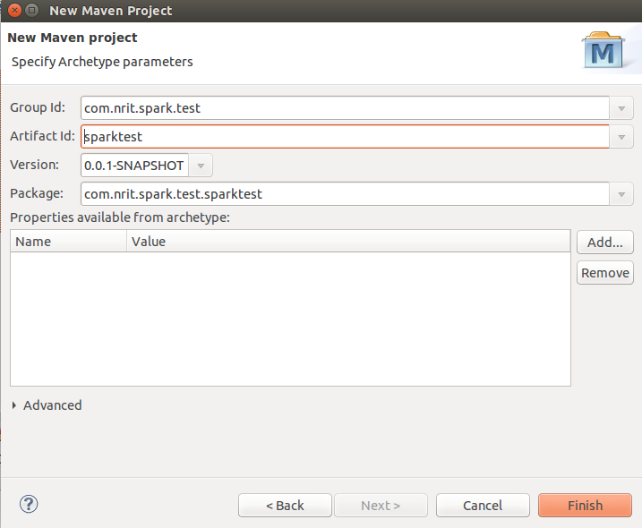

click in Finish

update pom.xml with following:

<dependency>
<groupId>org.scala-lang</groupId>
<artifactId>scala-library</artifactId>
<version>2.10.4</version>
</dependency>
<dependency>
<groupId>org.apache.spark</groupId>
<artifactId>spark-core_2.10</artifactId>
<version>1.4.0</version>
</dependency>

Add Scala Nature to this project :-

Right click on project -> configure - > Add Scala Nature.

Create a folder for scala package

rt.click on project --> properties --> Java Build Path --> Source tab -->add Folder -->main--> Create New Folder --> scala -->next-->add-->
Inclusion pattern: **/*.scala
finish --> ok--> ok

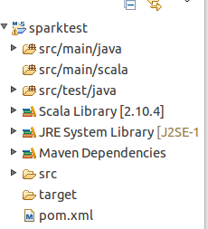

create package

rt.click on src/main/scala --> new --> package : com.nrit.spark.wc

create scala object

rt.click on package --> new --> scala object --> WordCount

package com.nrit.spark.wc

import org.apache.spark.SparkConf
import org.apache.spark.SparkContext

object WordCount {

def main(args: Array[String]) {

val conf = new SparkConf()

conf.setAppName("Word count")
conf.setMaster("local")

val sc = new SparkContext(conf)

//Read some example file to a test RDD
val test = sc.textFile("/home/hdp2/file1")

test.flatMap { line => //for each line
line.split(" ") //split the line in word by word.
}.map
{
word => //for each word
(word, 1) //Return a key/value tuple, with the word as key and 1 as value
}.reduceByKey(_ + _) //Sum all of the value with same key
.saveAsTextFile("/home/hdp2/output") //Save to a text file

//Stop the Spark context
sc.stop

println("generated")

}

}

Ways to create Spark RDD

i. Parallelized collections

By invoking parallelize method in the driver program, we can create parallelized collections.

ii. External datasets

One can create Spark RDDs, by calling a textFile method. Hence, this method takes URL of the file and reads it as a collection of lines.

iii. Existing RDDs

we can create new RDD in spark, by applying transformation operation on existing RDDs

Spark RDDs operations

There are two types of operations, which Spark RDDs supports:

i. Transformation Operations

It creates a new Spark RDD from the existing one. Moreover, it passes the dataset to the function and returns new dataset.

ii. Action Operations

In Apache Spark, Action returns final result to driver program or write it to the external data store.

Sparkling Features of Spark RDD:

1) In-memory computation

Basically, while storing data in RDD, data is stored in memory for as long as you want to store. It improves the performance by an order of magnitudes by keeping the data in memory.

2) Lazy Evaluation

Spark Lazy Evaluation means the data inside RDDs are not evaluated on the go. Basically, only after an action triggers all the changes or the computation is performed.

3) Fault Tolerance

If any worker node fails, by using lineage of operations, we can re-compute the lost partition of RDD from the original one. Hence, it is possible to recover lost data easily.

4) Immutability

Immutability means once we create an RDD, we can not manipulate it. we can create a new RDD by performing any transformation. Also, we achieve consistency through immutability.

5) Persistence

In in-memory, we can store the frequently used RDD. Also, we can retrieve them directly from memory without going to disk. It results in the speed of the execution. Moreover, we can perform multiple operations on the same data. It is only possible by storing the data explicitly in memory by calling persist() or cache() function.

6) Partitioning

Basically, RDD partition the records logically. Also, distributes the data across various nodes in the cluster. Moreover, the logical divisions are only for processing and internally it has no division. Hence, it provides parallelism

7) Parallel

While we talk about parallel processing, RDD processes the data parallelly over the cluster.

8) Location-Stickiness

To compute partitions, RDDs are capable of defining placement preference. Moreover, placement preference refers to information about the location of RDD. Although, the DAGScheduler places the partitions in such a way that task is close to data as much as possible. Moreover, it speeds up computation.

9) Coarse-grained Operation

Generally, we apply coarse-grained transformations to Spark RDD. It means the operation applies to the whole dataset not on the single element in the data set of RDD in Spark.

10) Typed

There are several types of Spark RDD. Such as: RDD [int], RDD [long], RDD [string].

Limitations of Apache Spark Programming:

1) No Support for Real-time Processing

Basically, Spark is near real-time processing of live data. In other words, Micro-batch processing takes place in Spark Streaming. Hence we can not say Spark is completely Real-time Processing engine.

2) Problem with Small File

In RDD, each file is a small partition. It means, there is the large amount of tiny partition within an RDD. Hence, if we want efficiency in our processing, the RDDs should be repartitioned into some manageable format. Basically, that demands extensive shuffling over the network.

3) No File Management System

A major issue is Spark does not have its own file management system. Basically, it relies on some other platform like Hadoop or another cloud-based platform.

4) Expensive

While we desire cost-efficient processing of big data, Spark turns out to be very expensive. Since keeping data in memory is quite expensive. However the memory consumption is very high, and it is not handled in a user-friendly manner. Moreover, we require lots of RAM to run in-memory, thus the cost of spark is much higher.

5) Less number of Algorithms

Spark MLlib have very less number of available algorithms. For example, Tanimoto distance.

6) Manual Optimization

It is must that Spark job is manually optimized and is adequate to specific datasets. Moreover, to partition and cache in spark to be correct, it is must to control it manually.

7) Iterative Processing

Basically, here data iterates in batches. Also, each iteration is scheduled and executed separately.

8) Latency

On comparing with Flink, Apache Spark has higher latency.

9) Window Criteria

Spark only support time-based window criteria not record based window criteria

Introduction to Apache Spark Ecosystem Components

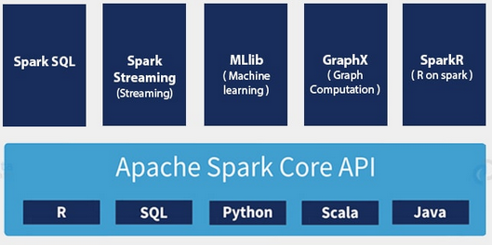

Apache Spark Core

All the functionalities being provided by Apache Spark are built on the top of Spark Core. It delivers speed by providing in-memory computation capability. Thus Spark Core is the foundation of parallel and distributed processing of huge dataset.

The key features of Apache Spark Core are:

It is in charge of essential I/O functionalities.
Significant in programming and observing the role of the Spark cluster.
Task dispatching.
Fault recovery.
It overcomes the snag of MapReduce by using in-memory computation.

Spark Core is embedded with a special collection called RDD (resilient distributed dataset). RDD is among the abstractions of Spark. Spark RDD handles partitioning data across all the nodes in a cluster. It holds them in the memory pool of the cluster as a single unit. There are two operations performed on RDDs: Transformation and Action-

Transformation: It is a function that produces new RDD from the existing RDDs.
Action: In Transformation, RDDs are created from each other. But when we want to work with the actual dataset, then, at that point we use Action.

The Spark SQL component is a distributed framework for structured data processing. Using Spark SQL, Spark gets more information about the structure of data and the computation. With this information, Spark can perform extra optimization. It uses same execution engine while computing an output. It does not depend on API/ language to express the computation.

Spark SQL works to access structured and semi-structured information. It also enables powerful, interactive, analytical application across both streaming and historical data. Spark SQL is Spark module for structured data processing. Thus, it acts as a distributed SQL query engine.

Features of Spark SQL include:

Cost based optimizer. Follow Spark SQL Optimization tutorial to learn more.

Mid query fault-tolerance: This is done by scaling thousands of nodes and multi-hour queries using the Spark engine. Follow this guide to Learn more about Spark fault tolerance.

Full compatibility with existing Hive data.

DataFrames and SQL provide a common way to access a variety of data sources. It includes Hive, Avro, Parquet, ORC, JSON, and JDBC.

Provision to carry structured data inside Spark programs, using either SQL or a familiar Data Frame API.

Apache Spark Streaming

It is an add-on to core Spark API which allows scalable, high-throughput, fault-tolerant stream processing of live data streams. Spark can access data from sources like Kafka, Flume, Kinesis or TCP socket. It can operate using various algorithms. Finally, the data so received is given to file system, databases and live dashboards. Spark uses Micro-batching for real-time streaming.

Micro-batching is a technique that allows a process or task to treat a stream as a sequence of small batches of data. Hence Spark Streaming, groups the live data into small batches. It then delivers it to the batch system for processing. It also provides fault tolerance characteristics. Learn Spark Streaming in detail from this Apache Spark Streaming Tutorial.

How does Spark Streaming Works?

There are 3 phases of Spark Streaming:

a. GATHERING

The Spark Streaming provides two categories of built-in streaming sources:

Basic sources: These are the sources which are available in the StreamingContext API. Examples: file systems, and socket connections.

Advanced sources: These are the sources like Kafka, Flume, Kinesis, etc. are available through extra utility classes. Hence Spark access data from different sources like Kafka, Flume, Kinesis, or TCP sockets.

b. PROCESSING

The gathered data is processed using complex algorithms expressed with a high-level function. For example, map, reduce, join and window.

c. DATA STORAGE

The Processed data is pushed out to file systems, databases, and live dashboards.

Spark Streaming also provides high-level abstraction. It is known as discretized stream or DStream.

DStream in Spark signifies continuous stream of data. We can form DStream in two ways either from sources such as Kafka, Flume, and Kinesis or by high-level operations on other DStreams. Thus, DStream is internally a sequence of RDDs.

Apache Spark MLlib (Machine Learning Library)

MLlib in Spark is a scalable Machine learning library that discusses both high-quality algorithm and high speed.

The motive behind MLlib creation is to make machine learning scalable and easy. It contains machine learning libraries that have an implementation of various machine learning algorithms. For example, clustering, regression, classification and collaborative filtering. Some lower level machine learning primitives like generic gradient descent optimization algorithm are also present in MLlib.

In Spark Version 2.0 the RDD-based API in spark.mllib package entered in maintenance mode. In this release, the DataFrame-based API is the primary Machine Learning API for Spark. So, from now MLlib will not add any new feature to the RDD based API.

The reason MLlib is switching to DataFrame-based API is that it is more user-friendly than RDD. Some of the benefits of using DataFrames are it includes Spark Data sources, SQL DataFrame queries Tungsten and Catalyst optimizations, and uniform APIs across languages. MLlib also uses the linear algebra package Breeze. Breeze is a collection of libraries for numerical computing and machine learning.

Apache Spark GraphX

GraphX in Spark is API for graphs and graph parallel execution. It is network graph analytics engine and data store. Clustering, classification, traversal, searching, and pathfinding is also possible in graphs. Furthermore, GraphX extends Spark RDD by bringing in light a new Graph abstraction: a directed multigraph with properties attached to each vertex and edge.

GraphX also optimizes the way in which we can represent vertex and edges when they are primitive data types. To support graph computation it supports fundamental operators (e.g., subgraph, join Vertices, and aggregate Messages) as well as an optimized variant of the Pregel API.

Apache SparkR

SparkR was Apache Spark 1.4 release. The key component of SparkR is SparkR DataFrame. DataFrames are a fundamental data structure for data processing in R. The concept of DataFrames extends to other languages with libraries like Pandas etc.

R also provides software facilities for data manipulation, calculation, and graphical display. Hence, the main idea behind SparkR was to explore different techniques to integrate the usability of R with the scalability of Spark. It is R package that gives light-weight frontend to use Apache Spark from R.

There are various benefits of SparkR:

Data Sources API: By tying into Spark SQL’s data sources API SparkR can read in data from a variety of sources. For example, Hive tables, JSON files, Parquet files etc.

Data Frame Optimizations: SparkR DataFrames also inherit all the optimizations made to the computation engine in terms of code generation, memory management.

Scalability to many cores and machines: Operations that executes on SparkR DataFrames get distributed across all the cores and machines available in the Spark cluster. As a result, SparkR DataFrames can run on terabytes of data and clusters with thousands of machines.

Spark Terminology :

1) What is Apache Spark?

Spark is project of apache software foundation. Spark is a fast, in-memory and general purpose data processing engine, spark lets you run program up to 100x faster than Hadoop MapReduce.

2) What does Spark Engine Do?

Spark Engine is responsible for scheduling distributing and monitoring the data application across the cluster.

3) What is partition in Apache Spark?
Partition is a smalled and logical division of data similar to split in MapReduce.
Partitioning the process to derive logical unit of data to speed up the data processing.

4) What does MLlib do?

MLlib aims at making machine learning easy and sclalble with common learning algorithms ilike clustering, regression filtering, dimensional reduction, classification etc.

5) What is Worker Node?

Worker node refer to slave node that runs the application code in cluster.

6) What is Spark SQL?

Spark SQL introduced to work structured data and perform structured data processing. Throgh this module , spark executes relational SQL queries on data.

7) What is Pair RDD?

Special operations can be performed on RDD in spark unsing key/value pairs and such RDD are referred to as Pair RDD.

8) What is Lazy Evaluation?

Transformation in spark are “Lazy” it means they will not be evaluated till you perform an action. This helps optimize the overall data processing workflow.

9)What is Spark Driver?

Spark Driver is program that runs on the master node of the machine and declares transformations actions on data RDDs.

10) What is Action in Spark?

It refers to an operations ( such as reduce, count, first and so on ) which also apply on RDD that perform computation and send the result back to driver.

Spark single node setup:

1) go to home folder create work folder

2) place the spark software and extract it ( spark-1.6.1-bin-hadoop2.6.tgz )

3) update .bashrc with following

export JAVA_HOME=/usr/lib/jvm/java-7-openjdk-i386
export HADOOP_HOME=/home/hdp2/work/hadoop-2.7.2
export HADOOP_COMMON_HOME=$HADOOP_HOME
export HADOOP_HDFS_HOME=$HADOOP_HOME
export HADOOP_MAPRED_HOME=$HADOOP_HOME
export YARN_HOME=$HADOOP_HOME
export HADOOP_COMMON_LIB_NATIVE_DIR=$HADOOP_HOME/lib/native
export HADOOP_OPTS="-Djava.library.path=$HADOOP_HOME/lib"
export SCALA_HOME=/home/hdp2/work/scala-2.10.4
export SPARK_HOME=/home/hdp2/work/spark-1.6.1-bin-hadoop2.6
export PATH=$PATH:$JAVA_HOME/bin:$HADOOP_HOME/bin:$HADOOP_HOME/sbin:$SCALA_HOME/bin:$SPARK_HOME/bin:$SPARK_HOME/sbin

$source ~/.bashrc

$cd /home/hdp2/work/spark-2.3.0-bin-hadoop2.7/conf

$ cp spark-env.sh.template spark-env.sh

update “spark-env.sh” with following:

export SPARK_MASTER_IP=
export SPARK_WORKER_CORES=1
export SCALA_HOME=$SCALA_HOME
export SPARK_WORKER_MEMORY=1g
export SPARK_WORKER_INSTANCES=2
export SCALA_HOME=/home/hdp2/work/scala-2.10.4
export SCALA_WORKER_DIR=/home/hdp2/work/spark-data

$cd /home/hdp2/work/spark-2.3.0-bin-hadoop2.7/conf

$cp slaves.template slaves

slave file :
localhost

$sudo apt-get install git

$spark-shell

$start-master.sh

http://localhost:8080/

$start-slaves.sh spark://hadoop:7077

spark://hadoop:7077 --> from “/etc/hosts”
127.0.1.1 hadoop

http://localhost:8080/

Read Data from HDFS file:

scala> var hFile = sc.textFile("hdfs://localhost:9000/nrit/input")

scala>val wc = hFile.flatMap(line => line.split(" ")).map(word => (word, 1)).reduceByKey(_ + _)

scala> wc.take(5)

scala> wc.saveAsTextFile("hdfs://localhost:9000/nrit/out")

Apache Spark Shell

Spark Shell is a Spark Application written in Scala. It offers command line environment with auto-completion. It helps us to get familiar with the features of Spark, which help in developing our own Standalone Spark Application. Thus, this tool helps in exploring Spark and is also the reason why Spark is so helpful in processing data set of all size.

SparkContext:

SparkContext is the entry gate of Apache Spark functionality. The most important step of any Spark driver application is to generate SparkContext. It allows your Spark Application to access Spark Cluster with the help of Resource Manager (YARN/Mesos).

To create SparkContext, first SparkConf should be made. The SparkConf has a configuration parameter that our Spark driver application will pass to SparkContext.

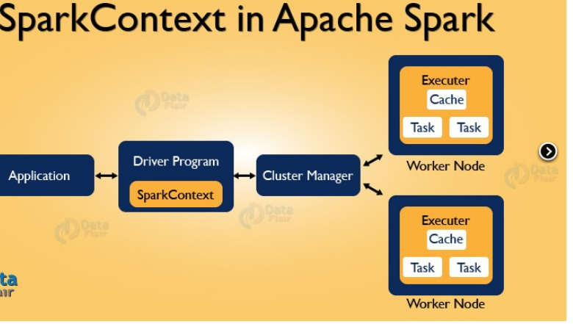

What is SparkContext in Apache Spark?

It is the entry point of Spark functionality. The most important step of any Spark driver application is to generate SparkContext. It allows your Spark Application to access Spark Cluster with the help of Resource Manager.

The resource manager can be one of these three- Spark Standalone, YARN, Apache Mesos.

How to Create SparkContext Class?

If you want to create SparkContext, first SparkConf should be made. The SparkConf has a configuration parameter that our Spark driver application will pass to SparkContext. Some of these parameter defines properties of Spark driver application. While some are used by Spark to allocate resources on the cluster, like the number, memory size, and cores used by executor running on the worker nodes.

val conf = new SparkConf()

val sc = new SparkContext(conf)

it guides how to access the Spark cluster. After the creation of a SparkContext object, we can invoke functions such as textFile, sequenceFile, parallelize etc. The different contexts in which it can run are local, yarn-client, Mesos URL and Spark URL.

val test = sc.textFile("/home/hdp2/file1")

Once the SparkContext is created, it can be used to create RDDs, broadcast variable, and accumulator, ingress Spark service and run jobs. All these things can be carried out until SparkContext is stopped.

Stopping SparkContext

Only one SparkContext may be active per JVM. You must stop the active it before creating a new one as below:

sc.stop

The main works of Spark Context are:

Getting the current status of spark application
Canceling the job
Canceling the Stage
Running job synchronously
Running job asynchronously
Accessing persistent RDD
Unpersisting RDD
Programmable dynamic allocation

Spark Application

The Spark application is a self-contained computation that runs user-supplied code to compute a result. A Spark application can have processes running on its behalf even when it’s not running a job.

Task

A task is a unit of work that is sent to the executor. Each stage has some task, one task per partition. The Same task is done over different partitions of RDD.

Job

The job is parallel computation consisting of multiple tasks that get spawned in response to actions in Apache Spark.

Stage

Each job gets divided into smaller sets of tasks called stages that depend on each other. Stages are classified as computational boundaries. All computation cannot be done in single stage. It is achieved over many stages.

Components of Spark Run-time Architecture of Spark:

Apache Spark Driver:

The main() method of the program runs in the driver. The driver is the process that runs the user code that creates RDDs, and performs transformation and action, and also creates SparkContext. When the Spark Shell is launched, this signifies that we have created a driver program. On the termination of the driver, the application is finished.

The driver program splits the Spark application into the task and schedules them to run on the executor. The task scheduler resides in the driver and distributes task among workers.

The two main key roles of drivers are:

Converting user program into the task.
Scheduling task on the executor.

The structure of Spark program at a higher level is:

RDDs are created from some input data, derive new RDD from existing using various transformations, and then after it performs an action to compute data. In Spark Program, the DAG (directed acyclic graph) of operations are created implicitly. And when the driver runs, it converts that Spark DAG into a physical execution plan.

Apache Spark Cluster Manager

Spark relies on cluster manager to launch executors and in some cases, even the drivers are launched through it.

On the cluster manager, jobs and action within a spark application are scheduled by Spark Scheduler in a FIFO fashion.

the scheduling can also be done in Round Robin fashion. The resources used by a Spark application can be dynamically adjusted based on the workload. Thus, the application can free unused resources and request them again when there is a demand. This is available on all coarse-grained cluster managers, i.e. standalone mode, YARN mode, and Mesos coarse-grained mode.

Apache Spark Executors:

The individual task in the given Spark job runs in the Spark executors. Executors are launched once in the beginning of Spark Application and then they run for the entire lifetime of an application. Even if the Spark executor fails, the Spark application can continue with ease.

There are two main roles of the executors:

Runs the task that makes up the application and returns the result to the driver.
Provide in-memory storage for RDDs that are cached by the user.

Internals of Job execution in the spark:

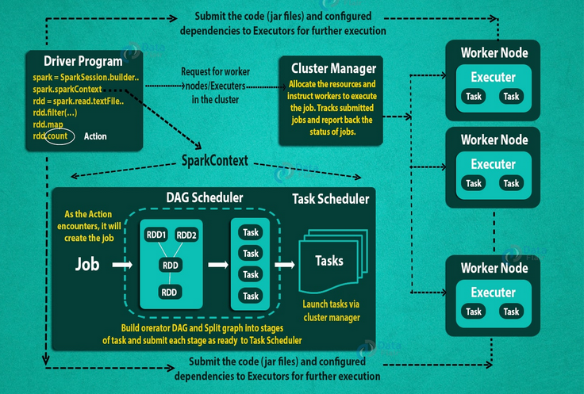
How to Run Apache Spark Application on a cluster:

- Using spark-submit, the user submits an application.

- In spark-submit, the main() method specified by the user is invoked. It also launches the driver program.

- The driver program asks for the resources to the cluster manager that is required to launch executors.

- The cluster manager launches executors on behalf of the driver program.

- The driver process runs with the help of user application. Based on the actions and transformation on RDDs, the driver sends work to executors in the form of tasks.

- The executors process the task and the result is sent back to the driver through cluster manager.

What is Apache Spark RDD?

RDD stands for “Resilient Distributed Dataset”. It is the fundamental data structure of Apache Spark. RDD in Apache Spark is an immutable collection of objects which computes on the different node of the cluster.

Decomposing the name RDD:

Resilient, i.e. fault-tolerant with the help of RDD lineage graph(DAG) and so able to recompute missing or damaged partitions due to node failures.

Distributed, since Data resides on multiple nodes.

Dataset represents records of the data you work with. The user can load the data set externally which can be either JSON file, CSV file, text file or database via JDBC with no specific data structure.

Hence, each and every dataset in RDD is logically partitioned across many servers so that they can be computed on different nodes of the cluster. RDDs are fault tolerant i.e. It posses self-recovery in the case of failure.

How to Create RDDs in Apache Spark?

There are three ways to create an RDD in Spark.

1) Parallelizing already existing collection in driver program.

2) Referencing a dataset in an external storage system (e.g. HDFS, Hbase, shared file system).

3) Creating RDD from already existing RDDs.

1) Parallelized collection (parallelizing)

val conf = new SparkConf()

val sc = new SparkContext(conf)

//Read some example file to a test RDD
val rdd = sc.parallelize(Seq(("maths",52),("english",75),("science",82), ("computer",65),("maths",85)))

val sorted = rdd.sortByKey()

sorted.foreach(println)

val rdd1 = sc.parallelize(Array("jan","feb","mar","april","may","jun"),3)

val result = rdd1.coalesce(2)

result.foreach(println)

External Datasets (Referencing a dataset):

distributed dataset can be formed from any data source supported by Hadoop, including the local file system, HDFS, Cassandra, HBase etc. In this, the data is loaded from the external dataset. To create text file RDD, we can use SparkContext’s textFile method. It takes URL of the file and read it as a collection of line. URL can be a local path on the machine or a hdfs://, s3n://, etc.

i) csv (String path)

It loads a CSV file and returns the result as a Dataset<Row>.

import org.apache.spark.sql.SparkSession
object Test {

def main(args: Array[String]) {

val spark = SparkSession.builder.appName("AvgAnsTime").master("local").getOrCreate()

//Stop the Spark context
val dataRDD = spark.read.csv("path/of/csv/file").rdd

}

}

pom.xml:

<dependency>
<groupId>org.apache.spark</groupId>
<artifactId>spark-sql_2.11</artifactId>
<version>2.1.0</version>
</dependency>

ii) json (String path)

It loads a JSON file (one object per line) and returns the result as a Dataset<Row>

import org.apache.spark.sql.SparkSession
object Test {

def main(args: Array[String]) {

val spark = SparkSession.builder.appName("AvgAnsTime").master("local").getOrCreate()

val dataRDD = spark.read.json("path/of/json/file").rdd

}

}

iii) textFile (String path)

It loads text files and returns a Dataset of String.

import org.apache.spark.sql.SparkSession
object Test {

def main(args: Array[String]) {

val spark = SparkSession.builder.appName("AvgAnsTime").master("local").getOrCreate()

val dataRDD = spark.read.textFile("path/of/text/file").rdd

}

}

Creating RDD from existing RDD

import org.apache.spark.sql.SparkSession
object Test {

def main(args: Array[String]) {

val spark = SparkSession.builder.appName("AvgAnsTime").master("local").getOrCreate()

val words=spark.sparkContext.parallelize(Seq("the", "quick", "brown", "fox", "jumps", "over", "the", "lazy", "dog"))
val wordPair = words.map(w => (w.charAt(0), w))
wordPair.foreach(println)

}

}

Spark RDD Operations-Transformation & Action

Spark RDD Operations:

Two types of Apache Spark RDD operations are-

1) Transformations and 2) Actions

A Transformation is a function that produces new RDD from the existing RDDs but when we want to work with the actual dataset, at that point Action is performed. When the action is triggered after the result, new RDD is not formed like transformation.

RDD Transformation:

Spark Transformation is a function that produces new RDD from the existing RDDs. It takes RDD as input and produces one or more RDD as output. Each time it creates new RDD when we apply any transformation. Thus, the so input RDDs, cannot be changed since RDD are immutable in nature.

Transformations are lazy in nature i.e., they get execute when we call an action. They are not executed immediately. Two most basic type of transformations is a map(), filter().

After the transformation, the resultant RDD is always different from its parent RDD.
It can be smaller (e.g. filter, count, distinct, sample),
bigger (e.g. flatMap(), union(), Cartesian()) or the same size (e.g. map).

There are two types of transformations:

Narrow transformation – In Narrow transformation, all the elements that are required to compute the records in single partition live in the single partition of parent RDD. A limited subset of partition is used to calculate the result. Narrow transformations are the result of map(), filter().

Narrow transformation are

1) Map
2) FlatMap
3) MapPartition
4) Filter
5) Sample
6) Union

Wide transformation – In wide transformation, all the elements that are required to compute the records in the single partition may live in many partitions of parent RDD. The partition may live in many partitions of parent RDD. Wide transformations are the result of groupbyKey() and reducebyKey().

Wide transformation are
1) Intersection
2) Distinct
3) ReduceByKey
4) GroupByKey
5) Join
6) Cartesian
7) Repartition
8) Coalesce

There are various functions in RDD transformation.

1) map(func)

The map function iterates over every line in RDD and split into new RDD. Using map() transformation we take in any function, and that function is applied to every element of RDD.

In the map, we have the flexibility that the input and the return type of RDD may differ from each other. For example, we can have input RDD type as String, after applying the map() function the return RDD can be Boolean.

import org.apache.spark.sql.SparkSession

object Test {

def main(args: Array[String]) = {
val spark = SparkSession.builder.appName("mapExample").master("local").getOrCreate()
val data = spark.read.textFile("/home/hdp2/file1").rdd
val mapFile = data.map(line => (line,line.length))
mapFile.foreach(println)
}

}

flatMap()

With the help of flatMap() function, to each input element, we have many elements in an output RDD. The most simple use of flatMap() is to split each input string into words.

Map and flatMap are similar in the way that they take a line from input RDD and apply a function on that line. The key difference between map() and flatMap() is map() returns only one element, while flatMap() can return a list of elements.

import org.apache.spark.sql.SparkSession

object Test {

def main(args: Array[String]) = {
val spark = SparkSession.builder.appName("flatMapExample").master("local").getOrCreate()
val data = spark.read.textFile("/home/hdp2/file1").rdd
val flatmapFile = data.flatMap(lines => lines.split(" "))
flatmapFile.foreach(println)
}

}

mapPartitions(func)

The MapPartition converts each partition of the source RDD into many elements of the result (possibly none). In mapPartition(), the map() function is applied on each partitions simultaneously. MapPartition is like a map, but the difference is it runs separately on each partition(block) of the RDD.

MapPartitionWithIndex()

It is like mapPartition; Besides mapPartition it provides func with an integer value representing the index of the partition, and the map() is applied on partition index wise one after the other.

filter(func)

Spark RDD filter() function returns a new RDD, containing only the elements that meet a predicate. It is a narrow operation because it does not shuffle data from one partition to many partitions.

For example, Suppose RDD contains first five natural numbers (1, 2, 3, 4, and 5) and the predicate is check for an even number. The resulting RDD after the filter will contain only the even numbers i.e., 2 and 4.

import org.apache.spark.SparkContext
import org.apache.spark.SparkConf
import org.apache.spark.sql.SparkSession

object mapTest{

def main(args: Array[String]) = {

val spark = SparkSession.builder.appName("filterExample").master("local").getOrCreate()

val data = spark.read.textFile("/home/hdp2/file1").rdd
val mapFile = data.flatMap(lines => lines.split(" ")).filter(value => value=="spark")
println(mapFile.count())

}

}

union(dataset)

With the union() function, we get the elements of both the RDD in new RDD. The key rule of this function is that the two RDDs should be of the same type.

For example, the elements of RDD1 are (Spark, Spark, Hadoop, Flink) and that of RDD2 are (Big data, Spark, Flink) so the resultant rdd1.

union(rdd2) will have elements (Spark, Spark, Spark, Hadoop, Flink, Flink, Big data).

import org.apache.spark.SparkContext
import org.apache.spark.SparkConf
import org.apache.spark.sql.SparkSession

object mapTest{

def main(args: Array[String]) = {

val spark = SparkSession.builder.appName("unionExample").master("local").getOrCreate()

val rdd1 = spark.sparkContext.parallelize(Seq((1,"jan",2016),(3,"nov",2014),(16,"feb",2014)))
val rdd2 = spark.sparkContext.parallelize(Seq((5,"dec",2014),(17,"sep",2015)))
val rdd3 = spark.sparkContext.parallelize(Seq((6,"dec",2011),(16,"may",2015)))
val rddUnion = rdd1.union(rdd2).union(rdd3)
rddUnion.foreach(println)

}

}

intersection(other-dataset)

scala>val rdd1 = sc.parallelize(Seq((1,"jan",2016),(3,"nov",2014, (16,"feb",2014))))

scala>val rdd2 = sc.parallelize(Seq((5,"dec",2014),(1,"jan",2016)))

scala> val common = rdd1.intersection(rdd2)

scala>common.foreach(println)
(1,jan,2016)

distinct()

It returns a new dataset that contains the distinct elements of the source dataset. It is helpful to remove duplicate data.

Scala> val rdd1 = sc.parallelize(Seq((1,"jan",2016),(3,"nov",2014),(16,"feb",2014),(3,"nov",2014)))

scala> val result = rdd1.distinct()

scala> println(result.collect().mkString(", "))
(3,nov,2014), (16,feb,2014), (1,jan,2016)

groupByKey()

When we use groupByKey() on a dataset of (K, V) pairs, the data is shuffled according to the key value K in another RDD. In this transformation, lots of unnecessary data get to transfer over the network.

scala> val data = sc.parallelize(Array(('k',5),('s',3),('s',4),('p',7),('p',5),('t',8),('k',6)),3)

scala> val group = data.groupByKey().collect()

scala> group.foreach(println)
(s,CompactBuffer(3, 4))
(p,CompactBuffer(7, 5))
(t,CompactBuffer(8))
(k,CompactBuffer(5, 6))

reduceByKey(func, [numTasks])

When we use reduceByKey on a dataset (K, V), the pairs on the same machine with the same key are combined, before the data is shuffled.

scala> val words = Array("one","two","two","four","five","six","six","eight","nine","ten")

scala> val data = sc.parallelize(words).map(w => (w,1)).reduceByKey(_+_)

scala> data.foreach(println)

sortByKey()

scala> val data = sc.parallelize(Seq(("maths",52), ("english",75), ("science",82), ("computer",65), ("maths",85)))

scala> val sorted = data.sortByKey()

scala> sorted.foreach(println)

join()

scala> val data = sc.parallelize(Array(('A',1),('b',2),('c',3)))

scala> val data2 =sc.parallelize(Array(('A',4),('A',6),('b',7),('c',3),('c',8)))

scala> val result = data.join(data2)

scala> println(result.collect().mkString(","))

coalesce()

In coalesce() we use existing partition so that less data is shuffled. Using this we can cut the number of the partition. Suppose, we have four nodes and we want only two nodes. Then the data of extra nodes will be kept onto nodes which we kept.

scala> val rdd1 = sc.parallelize(Array("jan","feb","mar","april","may","jun"),3)

scala> val result = rdd1.coalesce(2)

scala> result.foreach(println)

RDD Action:

Transformations create RDDs from each other, but when we want to work with the actual dataset, at that point action is performed. When the action is triggered after the result, new RDD is not formed like transformation. Thus, Actions are Spark RDD operations that give non-RDD values. The values of action are stored to drivers or to the external storage system. It brings laziness of RDD into motion.

An action is one of the ways of sending data from Executer to the driver. Executors are agents that are responsible for executing a task. While the driver is a JVM process that coordinates workers and execution of the task. Some of the actions of Spark are:

count()

Action count() returns the number of elements in RDD.

For example, RDD has values {1, 2, 2, 3, 4, 5, 5, 6} in this RDD “rdd.count()” will give the result 8.

import org.apache.spark.SparkContext
import org.apache.spark.SparkConf
import org.apache.spark.sql.SparkSession

object mapTest{

def main(args: Array[String]) = {

val spark = SparkSession.builder.appName("filterExample").master("local").getOrCreate()

val data = spark.read.textFile("spark_test.txt").rdd
val mapFile = data.flatMap(lines => lines.split(" ")).filter(value => value=="spark")
println(mapFile.count())

}

}

collect()

The action collect() is the common and simplest operation that returns our entire RDDs content to driver program. The application of collect() is unit testing where the entire RDD is expected to fit in memory. As a result, it makes easy to compare the result of RDD with the expected result.

Action Collect() had a constraint that all the data should fit in the machine, and copies to the driver.

import org.apache.spark.SparkContext
import org.apache.spark.SparkConf
import org.apache.spark.sql.SparkSession

object mapTest{

def main(args: Array[String]) = {

val spark = SparkSession.builder.appName("filterExample").master("local").getOrCreate()

val data = spark.sparkContext.parallelize(Array(('A',1),('b',2),('c',3)))
val data2 =spark.sparkContext.parallelize(Array(('A',4),('A',6),('b',7),('c',3),('c',8)))
val result = data.join(data2)
println(result.collect().mkString(","))

}

}

scala> val data = sc.parallelize(Array(('A',1),('b',2),('c',3)))

scala> val data2 =sc.parallelize(Array(('A',4),('A',6),('b',7),('c',3),('c',8)))

scala> val result = data.join(data2)

scala> println(result.collect().mkString(","))

take(n)

The action take(n) returns n number of elements from RDD. It tries to cut the number of partition it accesses, so it represents a biased collection. We cannot presume the order of the elements.

For example, consider RDD {1, 2, 2, 3, 4, 5, 5, 6} in this RDD “take (4)” will give result { 2, 2, 3, 4}

scala> val group = data.groupByKey().collect()

scala> val twoRec = result.take(2)

scala> twoRec.foreach(println)

top()

If ordering is present in our RDD, then we can extract top elements from our RDD using top(). Action top() use default ordering of data.

import org.apache.spark.SparkContext
import org.apache.spark.SparkConf
import org.apache.spark.sql.SparkSession

object mapTest{

def main(args: Array[String]) = {

val spark = SparkSession.builder.appName("filterExample").master("local").getOrCreate()
val data = spark.read.textFile("spark_test.txt").rdd
val mapFile = data.map(line => (line,line.length))
val res = mapFile.top(3)
res.foreach(println)

}

}

countByValue()

The countByValue() returns, many times each element occur in RDD.

For example, RDD has values {1, 2, 2, 3, 4, 5, 5, 6} in this RDD “rdd.countByValue()” will give the result {(1,1), (2,2), (3,1), (4,1), (5,2), (6,1)}

import org.apache.spark.SparkContext
import org.apache.spark.SparkConf
import org.apache.spark.sql.SparkSession

object mapTest{

def main(args: Array[String]) = {

val spark = SparkSession.builder.appName("filterExample").master("local").getOrCreate()
val data = spark.read.textFile("spark_test.txt").rdd
val result= data.map(line => (line,line.length)).countByValue()
result.foreach(println)

}

}

reduce()

The reduce() function takes the two elements as input from the RDD and then produces the output of the same type as that of the input elements. The simple forms of such function are an addition. We can add the elements of RDD, count the number of words. It accepts commutative and associative operations as an argument.

scala> val rdd1 = sc.parallelize(List(20,32,45,62,8,5))

scala> val sum = rdd1.reduce(_+_)
sum: Int = 172

scala> println(sum)
172

fold()

The signature of the fold() is like reduce(). Besides, it takes “zero value” as input, which is used for the initial call on each partition. But, the condition with zero value is that it should be the identity element of that operation. The key difference between fold() and reduce() is that, reduce() throws an exception for empty collection, but fold() is defined for empty collection.

For example, zero is an identity for addition; one is identity element for multiplication. The return type of fold() is same as that of the element of RDD we are operating on.

For example, rdd.fold(0)((x, y) => x + y).

scala> val rdd1 = sc.parallelize(List(("maths", 80),("science", 90)))
rdd1: org.apache.spark.rdd.RDD[(String, Int)] = ParallelCollectionRDD[53] at parallelize at <console>:27

scala> val additionalMarks = ("extra", 4)
additionalMarks: (String, Int) = (extra,4)

scala> val sum = rdd1.fold(additionalMarks){ (acc, marks) => val add = acc._2 + marks._2
("total", add)
}
sum: (String, Int) = (total,190)

scala> println(sum)
(total,190)

aggregate()

It gives us the flexibility to get data type different from the input type. The aggregate() takes two functions to get the final result. Through one function we combine the element from our RDD with the accumulator, and the second, to combine the accumulator. Hence, in aggregate, we supply the initial zero value of the type which we want to return.

foreach()

When we have a situation where we want to apply operation on each element of RDD, but it should not return value to the driver. In this case, foreach() function is useful. For example, inserting a record into the database.

scala> val data = sc.parallelize(Array(('k',5),('s',3),('s',4),('p',7),('p',5),('t',8),('k',6)),3)

scala> val group = data.groupByKey().collect()

scala> group.foreach(println)

Functions of SparkContext:

To get the current status of Spark Application:

SpkEnv – It is a runtime environment with Spark’s public services. It interacts with each other to establish a distributed computing platform for Spark Application. A SparkEnv object that holds the required runtime services for running Spark application with the different environment for the driver and executor represents the Spark runtime environment.

bin/spark-submit --class com.dataflair.spark.Wordcount --master local ../sparkJob.jar ../wc-data output

spark-submit --class com.nrit.spark.wc.WordCount --matser spark://hadoop:7077 /home/hdp2/word.jar

No limitation

There are no limitations to use the number of Spark RDD. We can use any no. of RDDs. Basically, the limit depends on the size of disk and memory.
Parallelized collection (parallelizing):

RDDs are generally created by parallelized collection i.e. by taking an existing collection in the program and passing it to SparkContext’s parallelize() method. This method is used in the initial stage of learning Spark since it quickly creates our own RDDs in Spark shell and performs operations on them. This method is rarely used outside testing and prototyping because this method requires entire dataset on one machine.

Consider the following example of sortByKey()

val data = spark.sparkContext.parallelize(Seq(("maths",52),("english",75),("science",82), ("computer",65),("maths",85)))
val sorted = data.sortByKey()
sorted.foreach(println)

