CSP Assignment Report
1. What is the User-Agent part of HTTP GET request sent to IP address 10.10.10.12.
∙ First power-on the pingu machine and note the IP of the
machine. In kali open the firefox browser and access the port 80 of pingu and download the pcap file
∙ into terminal,
wireshark scanme.pcapng
.Add the display filer :
http.request.method==GET
∙ Go to destination packet 10.10.10.12 and head to the detailes Pane to see the user agent
Proof of screenshort :-
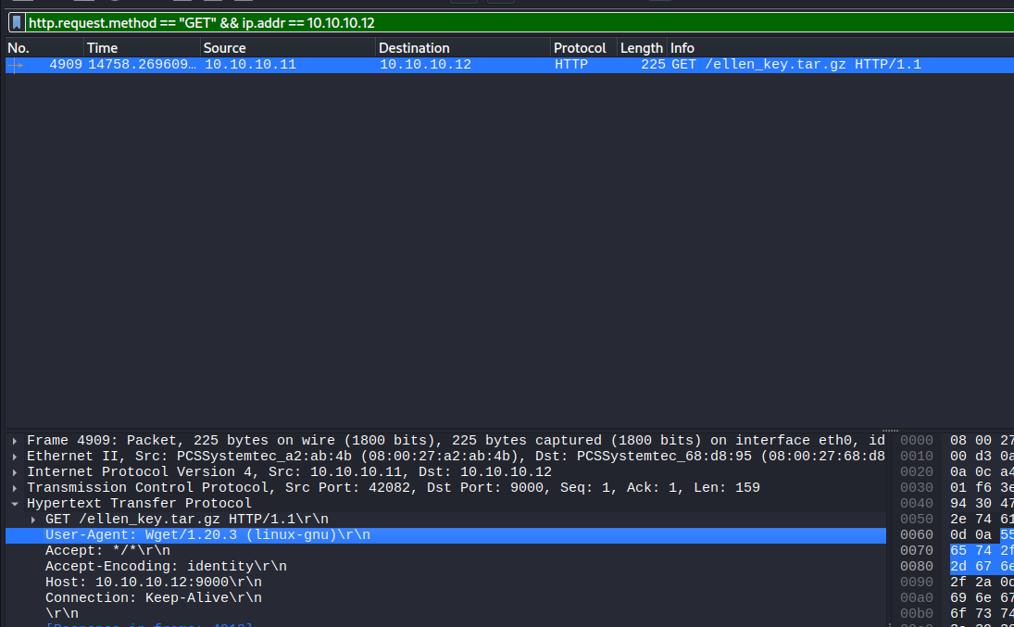
Machine Summary:-
Machine name :- Pingu IP : 10.0.0.221
Open ports | 80(HTTP)
Username | joker
Password | joker

2. Found any image in the Wireshark capture? What is the extension?
∙ Head towards kali Terminal first
Open wireshark scanme.pcapng
∙ Head towards, File 🡪 Export objects 🡪 HTTP A list of Downloaded files appears .
∙ You will find the images with extensions (jpg/png/jpeg) and select the option preview, to view the
image/Download it and save it into Downloads.
∙ In the pcapng you can find the file name with
guess_password with the extension type .png
Proof of screenshot :-
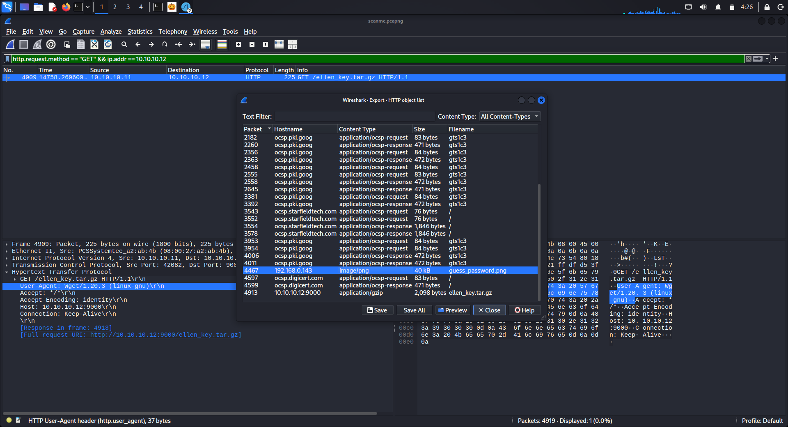
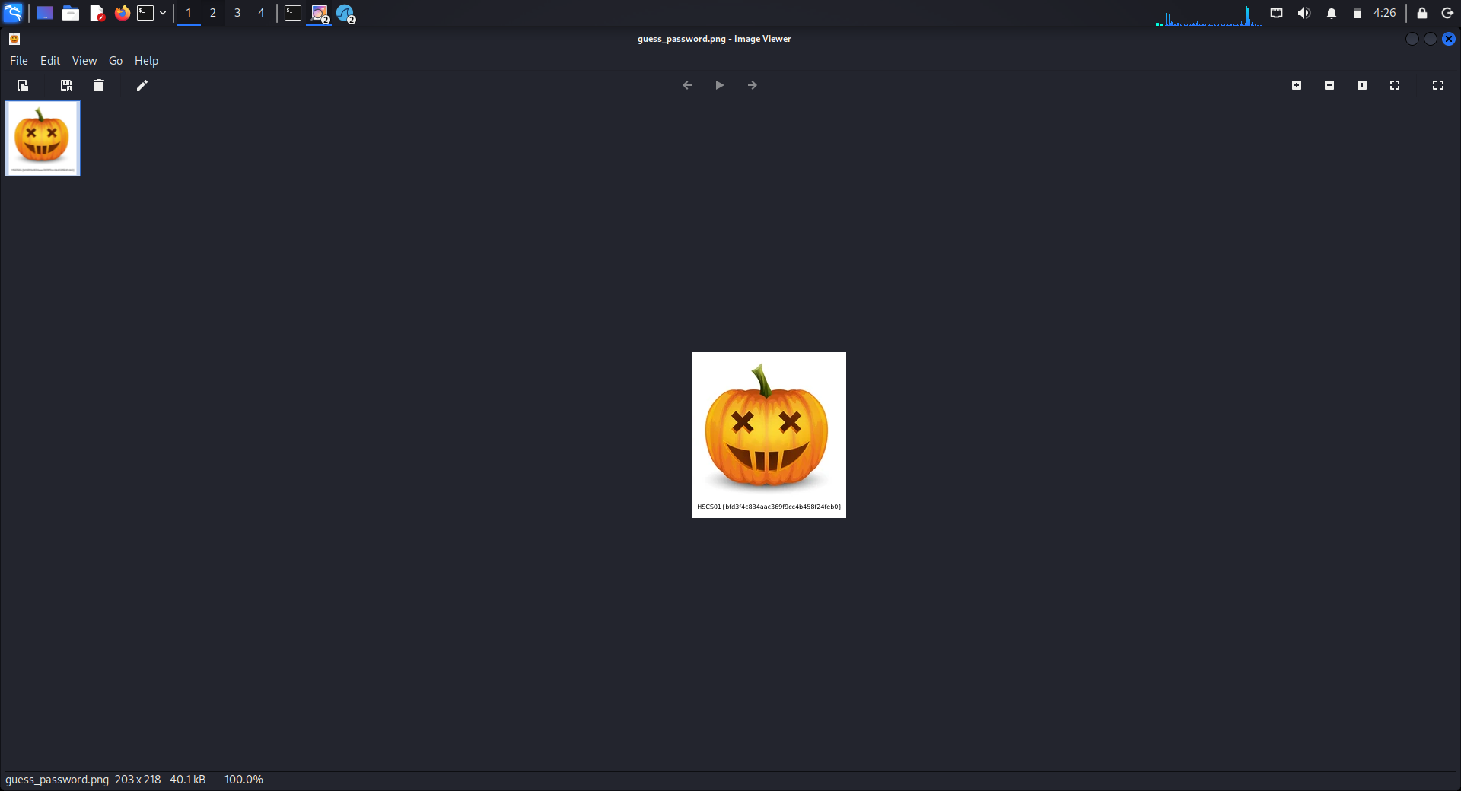

3 What is the transaction ID of DNS standard query for hacking
(A record )?
∙ Head towards kali Terminal ,
wireshark scanme.pcapng
∙ Now go to Display filters search for the DNS
∙ You can find the DNS related requests and responses. ∙ Search for a request sent to a hacker(record type A) requesting for IPV4 address .
∙ We can see the transaction id for each and every request, this ID response back will help to the client for same transaction ID
∙ Click on the hacker A request, than you can see the
Transaction ID in the Details pane
Proof of screenshort :-
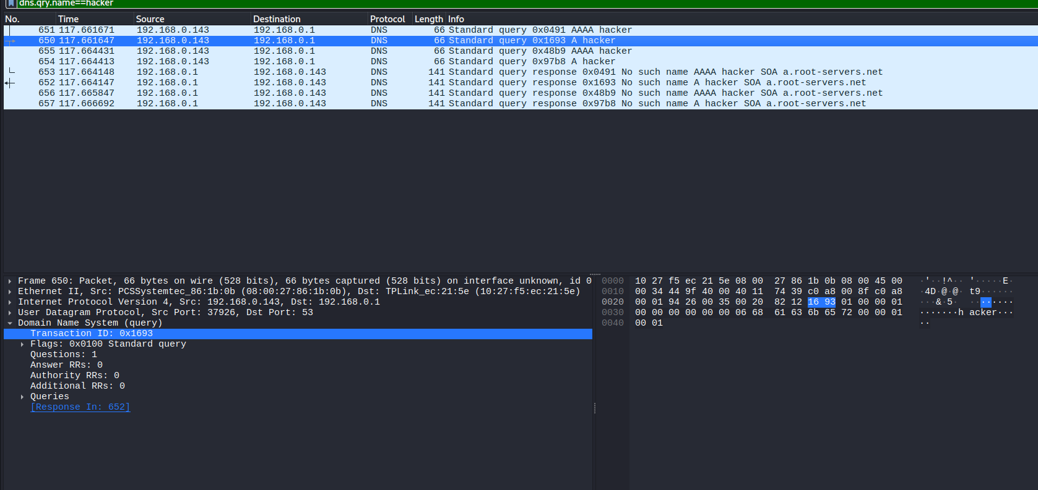

4. What is the User-Agent part of HTTP HEAD request with source and destination address as loopback address.
∙ Hrad towards kali Terminal ,
wireshark scanme.pcapng
∙ Use the Displayfiler,
Http,request,method==HEAD&& ipp.addr==127.0.0.1
To get the Source ip address and Destination ip
address as loopback IP address
∙ Search for the HTTP head request that is send by the localmachine(127.0.0.1)
∙ In the Application layer you can find the user
agent request
Proof of Screenshot:-
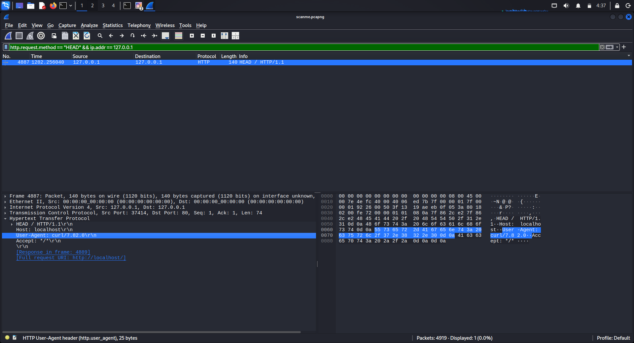

5.What is the IP address and MAC address of the machine which initiated the ICMP request?
∙ Head towards kali Terminal ,
wireshark scanme.pcapng
∙ Now the Display filter
ICMP
To view the ICMP (echo request sent/receive)
observe the request who initiated the ping
∙ Head to towards Details pane to know more
information of the packet
∙ You can see the MAC address in the Ethernet II (Data link layer ) and IP address at Internet
protocol(Network layer)
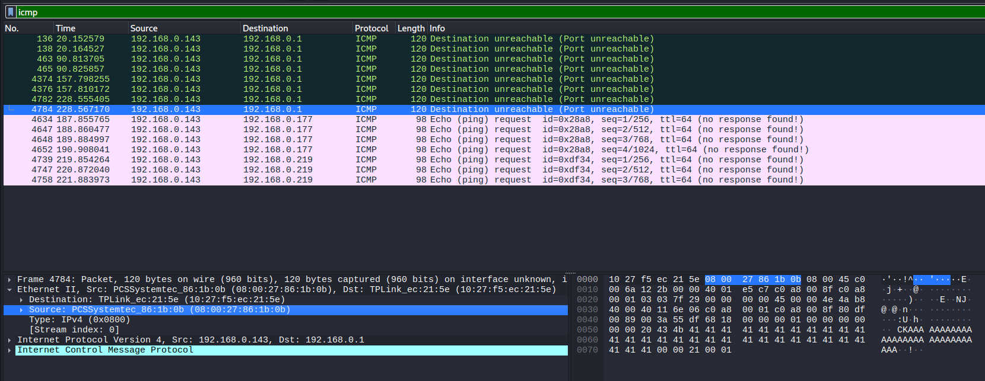
Proof of Screenshort:- MAC and IP

6. What is the Sequence Number (raw) in the last packet part of TCP three way-handshake established between 192.168.0.143 and 34.98.75.36
∙ Head towards kali Terminal ,
wireshark scanme.pcapng
∙ Use the display filter,
ip.addr == 192.168.0.143 && ip.addr== 34.98.75.36 to see the three way-handshake connection between between 192.168.0.143 and 34.98.75.36
192.168.0.143 🡪 SYN 🡪 34.98.75.36
192.168.0.143🡨 SYN -ACK 🡨34.98.75.36 192.168.0.143 🡪 ACK 🡪 34.98.75.36
Last packet of 3 way hand-shake is 192.168.0.143 🡪 SYN 🡪
34.98.75.36
∙ We can find the Sequence Number (raw) at Internet protocol(Network layer)
Proof of Screenshort :-
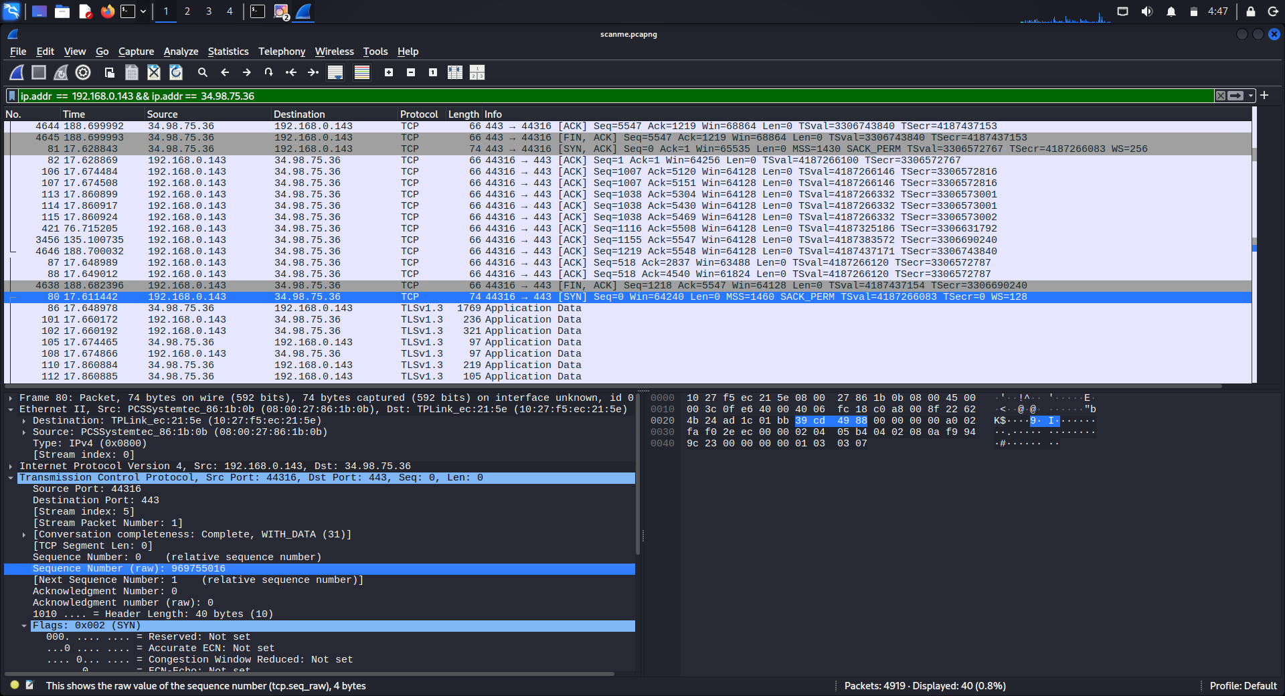
7.What is the Sequence Number (raw) in the second packet part of TCP three-way-handshake established between 192.168.0.143 and hackerschool.in
∙ Head towards kali Terminal
wireshark scanme.pcapng
∙ Use the display filter ,
tcp contains “hackersschool.in”
we can find the tcp connection between host and hackerschool.in
∙ Select 🡪 right click 🡪follow🡪 TCP stream
∙ We can see the conversation in clearly , the
second packet of tcp is SYN-ACK from
hackerschool.in to the host machine
∙ We can find the Sequence Number (raw) at Internet protocol(Network layer)
Proof of Screenshort:-
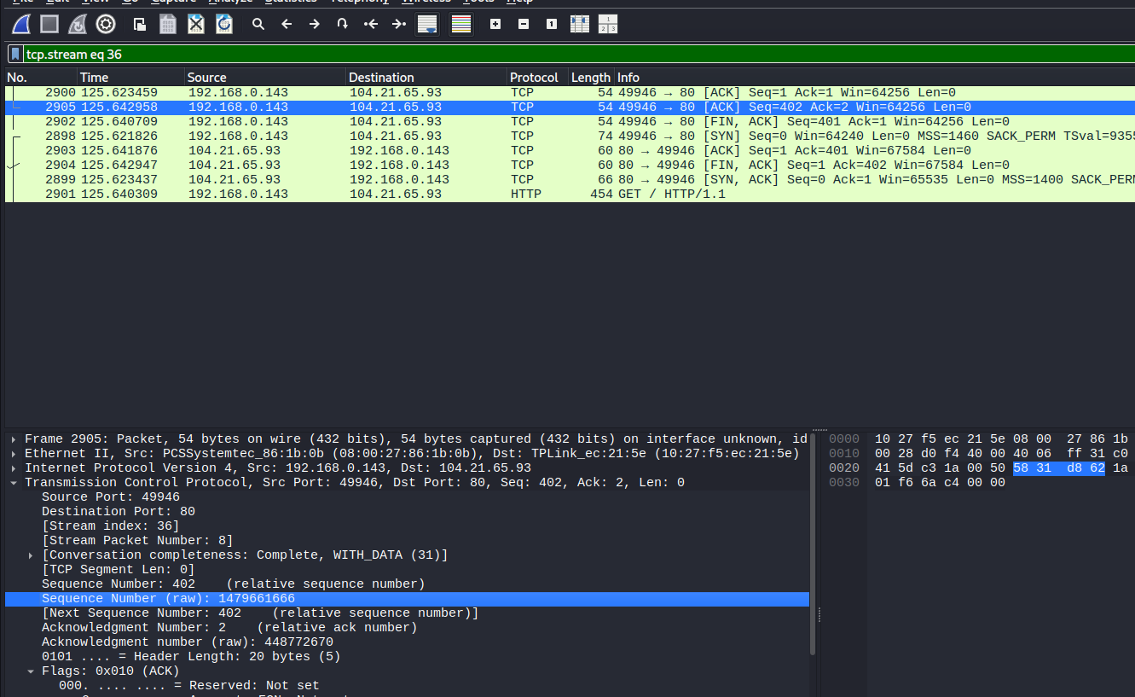

8. Login to Pingu machine as joker and start a listener on port 3535 to grab the flag.

∙ From kali , access the pingu using ssh
ssh joker@10.0.0.221
∙ To start a listener use netcat with -l (listen) -v (verbose) -p (port number)
nc -lvp 3535
∙ Wait for few movements to capture the flag 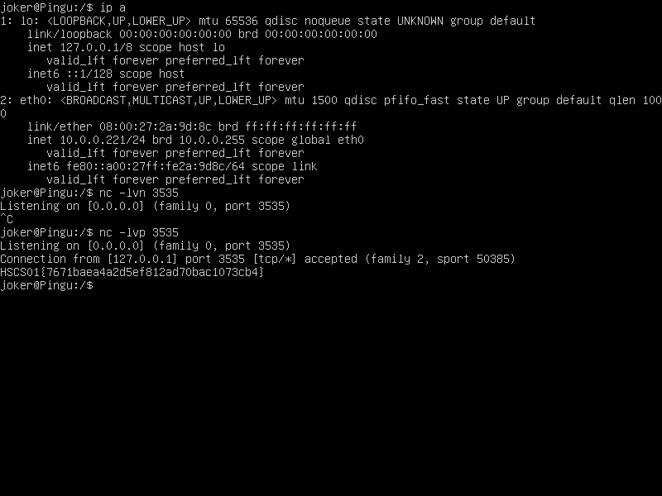
Machine summary:-

Machine :- Pingu IP :- 10.0.0.221
Open ports | 80(http) 21(ftp)
Username | joker
Password | joker

9. Login to Pingu machine as ellen and start snort and perform ping from Kali/ParrotSec machine to grab the flag.
To login into pingu machine as ellen we need to have a private key to get it we use the ftp service In kali , start the ftp service with the command ftp and <pinguip>
ftp 10.0.0.221

∙ Login as “anonymous” and use the password anything” ∙ After successful login list the contents by using ls ∙ Download the file named “ellenkey”into kali machine using command
get ellenkey
∙ After successful download of ellenkey into the kali machine, change the permissions of the file by
executing the command chmod(change modifications) chmod 600 ellenkey
∙ Now you can login into the user ellen from pingu
machine using the the private key(ellenkey)
∙ We use the service ssh(secure shell) port 22 to get into ping and access it
∙ Execute the command in shell,

ssh -i ellenkey ellen@10.0.0.221
∙ -I specifies to use this private key
∙ By using the private key you can successfully login into user ellen without any password
∙ To get the flag from user ellen we have you use a tool called Snort
∙ Snort is a used for detecting the attacks and generate the alerts
∙ Snort acts like a IDS(Intrusion Detection System) ∙ Use the below command to install the snort
sudo apt install snort
. After the successful installation have to make changes in the snort configuration file on which interface it should have to listen , snort configuration file is located in /etc/snort/snort.conf
∙ Use this command to execute
sudo nano /etc/snort/snort.conf
∙ Search for the line
∙
ipvar HOME_NET any
∙ In the place of any replace it with pingu ip address
∙
ipvar HOME_NET 10.0.0.221
∙ Now it will listen every thing coming towards 10.0.0.221
∙ Ensure that ICMP rule is enable in the conf rules ∙ Now it is one step away to generate the alerts
∙ Now use the command in terminal
sudo snort -q -A console -c /etc/snort/snort.conf -i eth0
∙ -q 🡪 quiet mode
∙ -c 🡪 to use this file
∙ -A🡪 generate the alerts in console
∙ -I 🡪 interface
∙ The snort is now actively listening for Alerts to generate In kali machine:
∙ Ping the pingu ip to generate the traffic
Ping 10.0.0.221
∙ In ellen you can see the alerts generated by kali, in the alerts we can find the flag
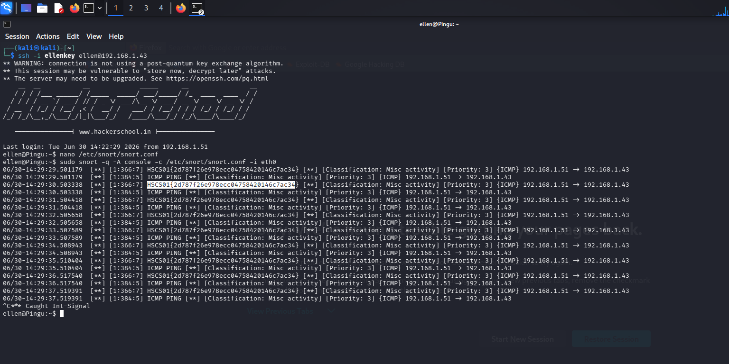
∙ Proof of Screenshort:-

. Here we see the flag in above image
Machine Summary:
Machine : Pingu IP : 10.0.0.221
open ports | 80(http) 22(ssh)  21(ftp)
Username | anonymous
Password | anything

10. What is the difference between grep, egrep and fgrep utilities in linux. Explain the differences with suitable examples.

grep | egrep | fgrep
Used to search for a single word or a simple pattern in a file. | Used to search for advanced or  multiple patterns in a file. | Used to search for an exact word or sentence.
It understands only basic regular  expressions. | It understands  extended regular expressions. | It does not use  regular  expressions. It  searches only for exact text.
Suitable for normal text searching. | Suitable when  searching for more than one word or complex patterns. | Suitable when the search text contains symbols such as *, ., ?, +, or
Special characters usually need to be escaped using \. | Special characters can be used directly without escaping. | All special  characters are  treated as normal characters.
Commonly used for simple file  searching and log analysis. | Commonly used for searching multiple words, email  patterns, phone  numbers, etc. | Commonly used for searching file  names, URLs,  passwords, or exact strings.
Output: Displays all lines containing the word error. | Output: Displays all lines containing  either cat or dog. | Output: Displays all lines containing the exact text file.txt*.

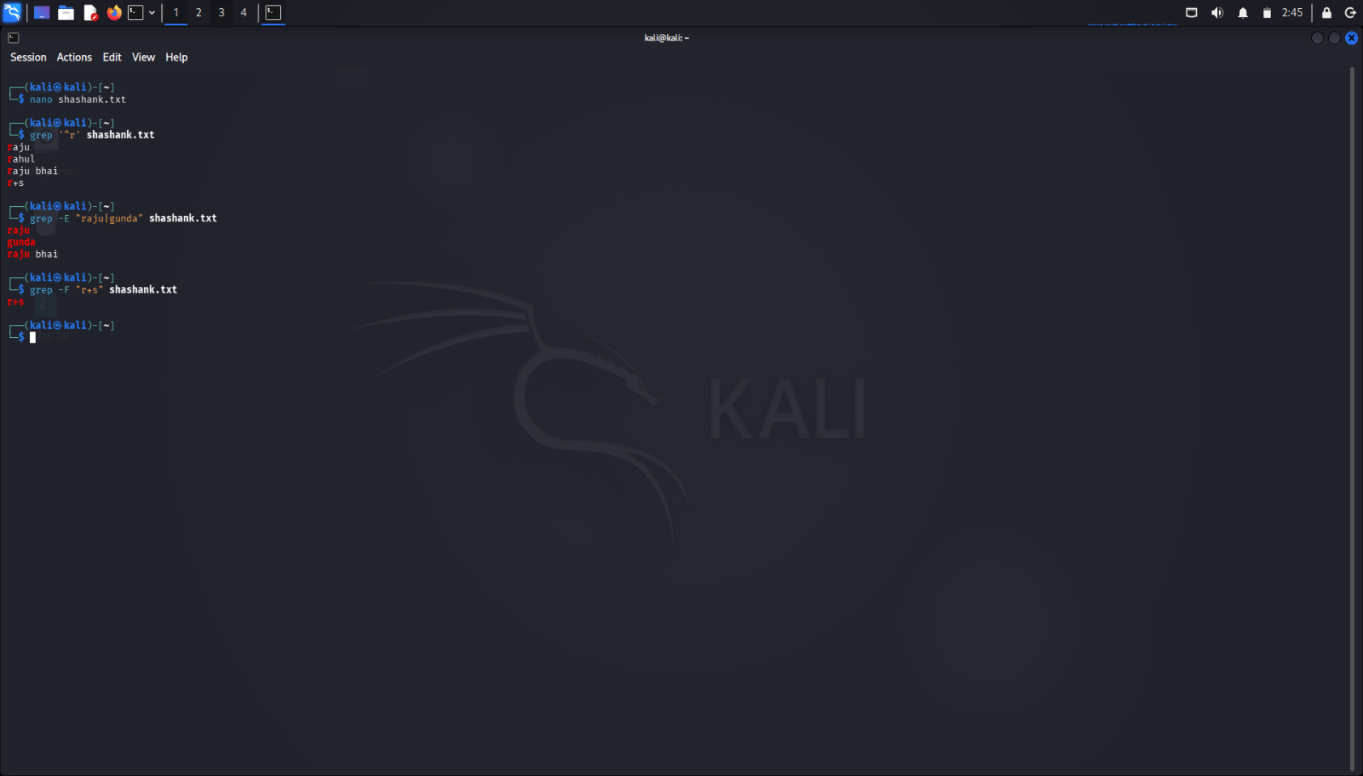
Examples with proof of screenshort:

11.Create a file that contains 10 words related to cyber security (one word per line). How to use sed utility to delete 2nd, 5th and last lines from the above file contents? (Use head command to display output of sed.)
Sed:- Is a stream editor used to perform basic text
transformations—such as search, replace, or delete—on an input stream or file.
∙ -e: Allows you to perform multiple commands in one execution.
∙ 2d: Used to delete line 2.
∙ 5d: Used to delete line 5.
∙ $: Used to delete last line
∙ | head: Pipes the result into head to display the final output.
. In kali use the command :-
Sed -e ‘2d;5f;$d’ names.txt | head

Proof of screenshort:-
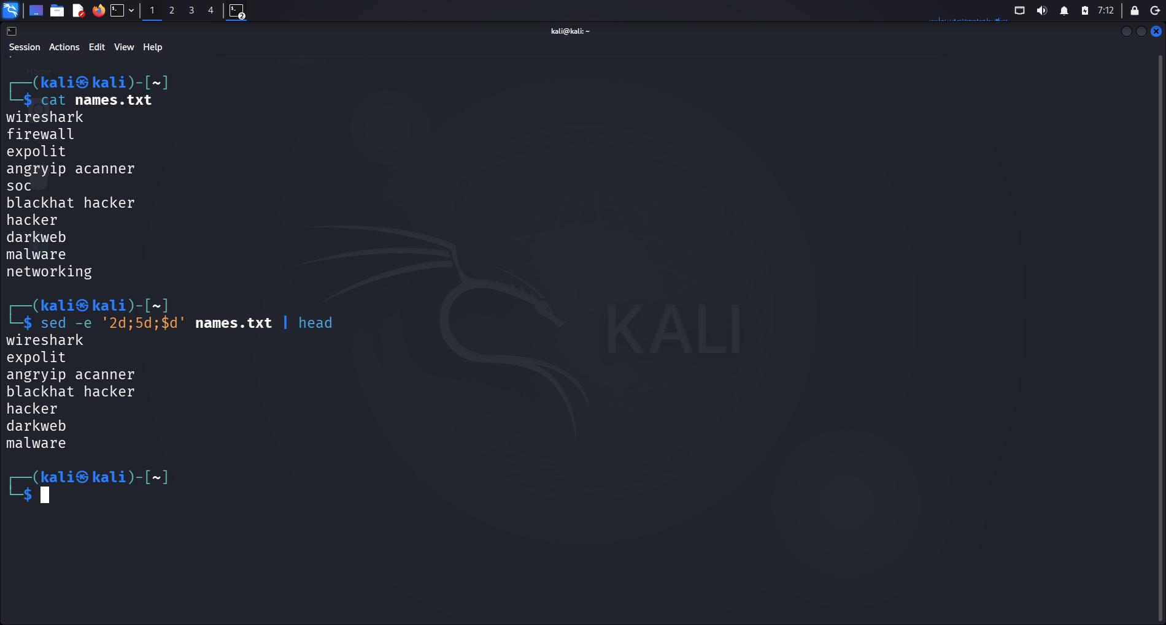

12. How to use awk to print fields 1 to 6 from /etc/passwd?
∙ awk: The utility used for pattern scanning and text processing.
∙ -F':': : defines the separator
∙ '{print $1, $2, $3, $4, $5, $6}': This is the action block. It tells awk to print the first six fields for every line it processes.
∙ /etc/passwd: The source file.
awk -F':' '{print $1, $2, $3, $4, $5, $6}' /etc/passwd
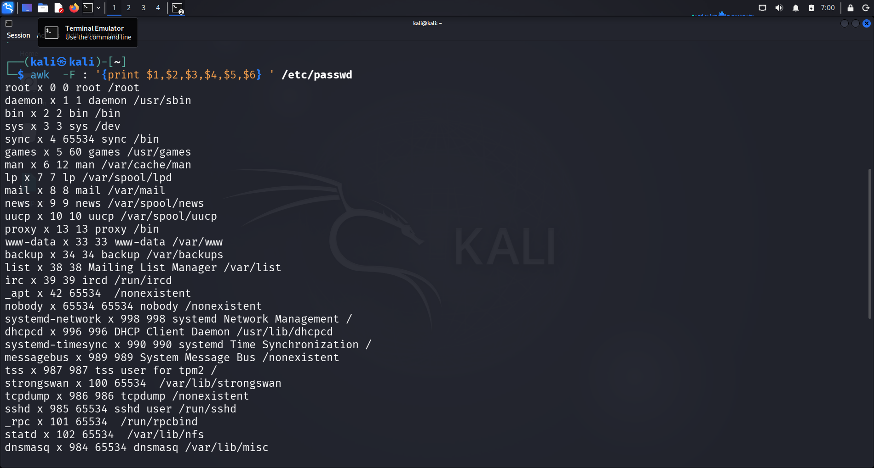
proof of screenshort:-

13. How to use find utility to display all executables with SUID bit set on Kali/ParrotSec?
∙ SUID : is a special file permission that allows a user to execute a file with the privileges of the file's owner instead of their own
∙ 4 : SUID
∙ -type f : specifies to search only for files
∙ 2>/dev/null : redirect errors into null file
∙ -perm : Tells find you are looking for specific file permissions.
∙ -4000 : Tells find to look for files where the SUID bit is set
proof of screenshort:-
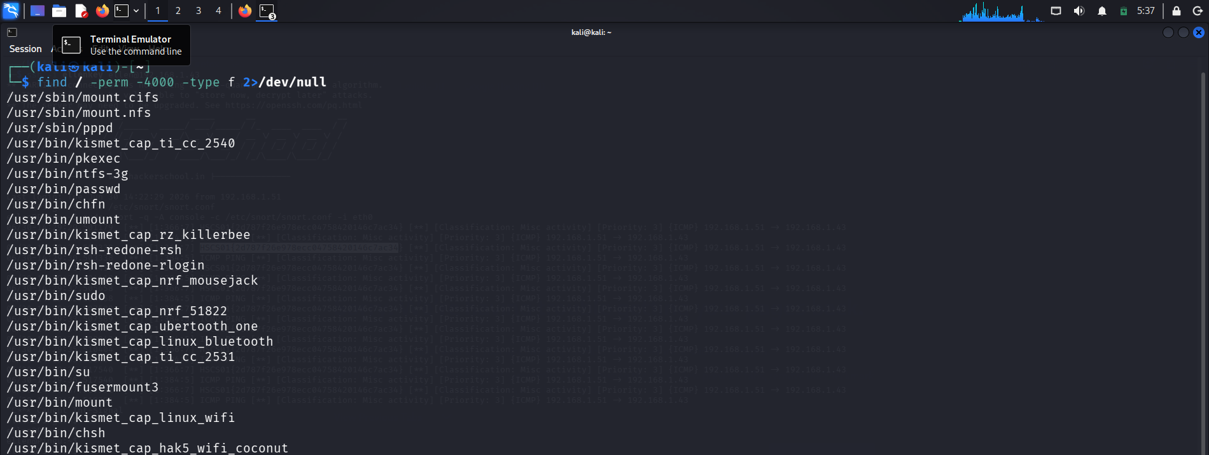

14. What is the difference between soft links and hard links in linux. Explain the differences with suitable examples.
Soft link : The linked file will be updated when we write content into original file. The linked file will be removed
Hard link : The linked file will be updated when we update content into original file, but when we remove the original file link file content remains same.
Examples:
Soft link:
∙ Create a file and add any content in it
nano <filename>
∙ Create a linked file to the created file
ln -s <filename> <linkedfile>
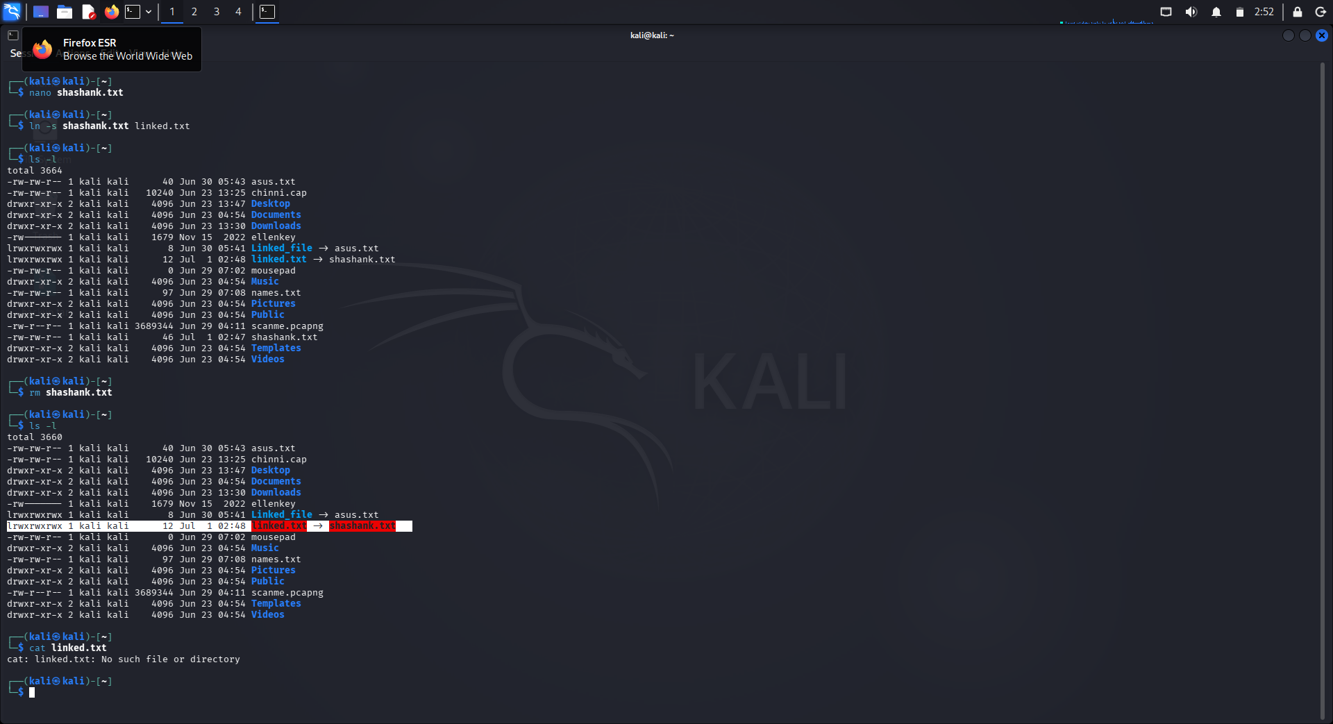
∙ -s 🡪 softlink
∙ Ln 🡪 link
Hard link:
∙ By default we don’t need to specify any thing for the hard link
∙ Create a file with the contents in it
nano <filename>
∙ To create a hard link use the command

ln <filename> <linkedfile>
∙ To see the content use cat <filename>
Proof of screenshort:-
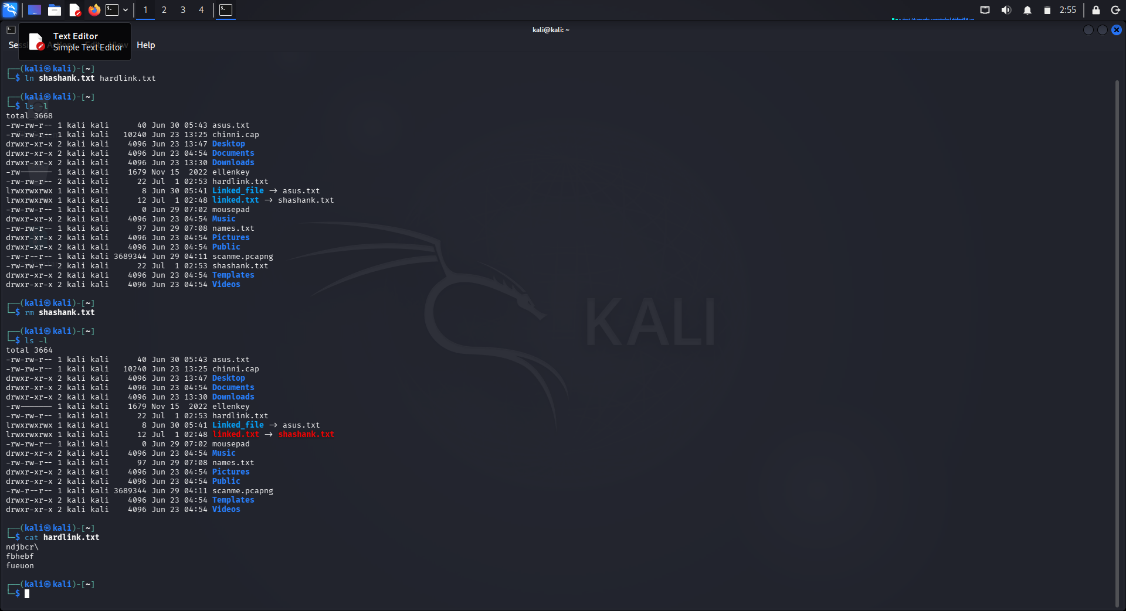

15. What is the difference between find and locate utilities in linux?
find | locate
Scans the live filesystem in real-time. | Queries a pre-built file database.
Slower (checks disk  directly). | Instant (searches an  index).
Highly advanced (size, date, permissions). | Limited (mostly just  filename searches).

locate:
∙ -I 🡪 ignores case sensitive
∙ -n 🡪 limits the number of results
∙ To use find we can you the command
locate <filename>
Find :
-name "file" : Filters by filename.
-type [type] : Filters by object type: f (file)
-size [+/-]n : Filters by file size.
-perm [mode] : Filters by permissions
-mtime [+/-]n : Filters by modification time
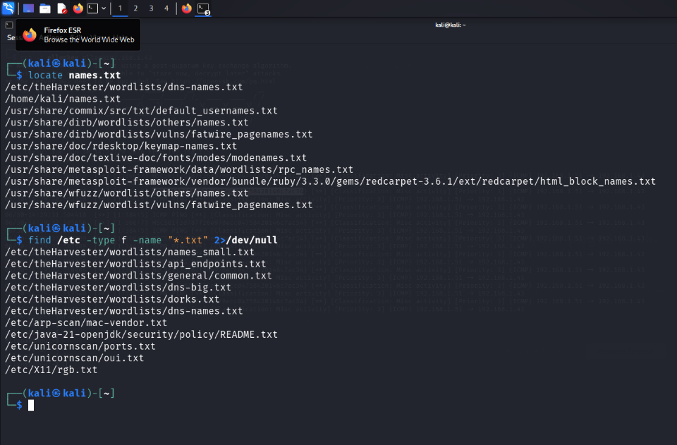
Proof of screenshort:-

16. Display the login shell details of users (on Kali/ParrotSec machine) whose names start with letter n and remove duplicates. (Hint: use grep and cut)
Grep : Searches through text for lines matching a pattern (regex) and prints those lines. Use it when you need to filter lines from a file or command output.
Cut : Extracts specific sections (columns/fields) from each line of text. Use it when you need to slice out particular parts of delimited data, like the username field from /etc/passwd.
∙ grep '^n' /etc/passwd : filters lines starting
with n from /etc/passwd
∙ cut -d: -f1,7 : extracts field 1 (username) and field 7 (login shell), using : as delimiter
∙ sort -u : sorts and removes duplicate lines
grep '^n' /etc/passwd | cut -d: -f1,7 | sort -u
Proof of screenshort:-
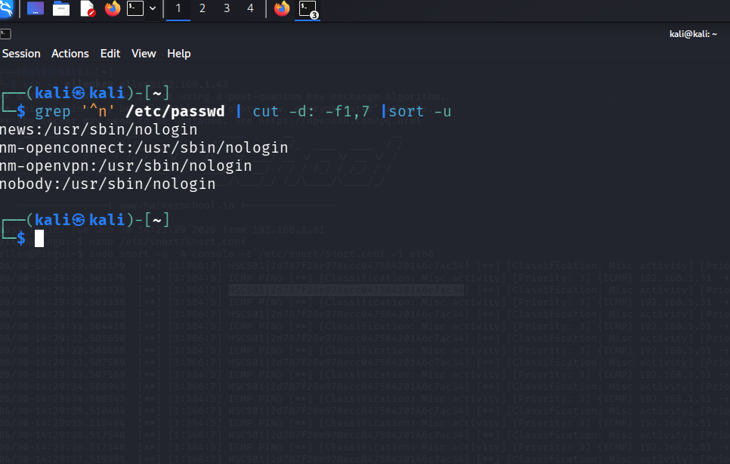

17. What is the absolute path and permissions of file named areyouthere? on Pingu machine.
∙ To find the absolute path and permissions of a file
named areyouthere? on the Pingu machine, you would use the find command combined with ls
∙ -type f : only look for regular files (not directories) -name ∙ "areyouthere" : exact filename match
∙ -exec ls -l {} ; : run ls -l on each found file to show permissions ∙ 2>/dev/null : suppress permission-denied errors
∙ Use the below command to get the obsolute path
find / -type f -name "areyouthere" -exec ls -l {} \; 2>/dev/null
∙ To get obsolute path , use the following command

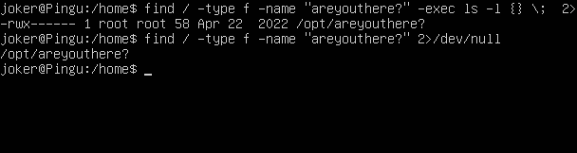
find / -type f -name "areyouthere?" 2>/dev/null Proof of screenshort:-

18. Login to Pingu machine as joker and find out the last password change date of user joker.
Login to pingu using SSH
ssh joker@10.0.0.221
∙ To find the last password change date for user joker on the Pingu machine, you can use the chage
chage -l joker
∙ chage -l joker — lists password aging information for user joker
∙ grep "Last password change" : filters to show only that line chage -l joker | grep "Last password change"
Proof of screenshort:-
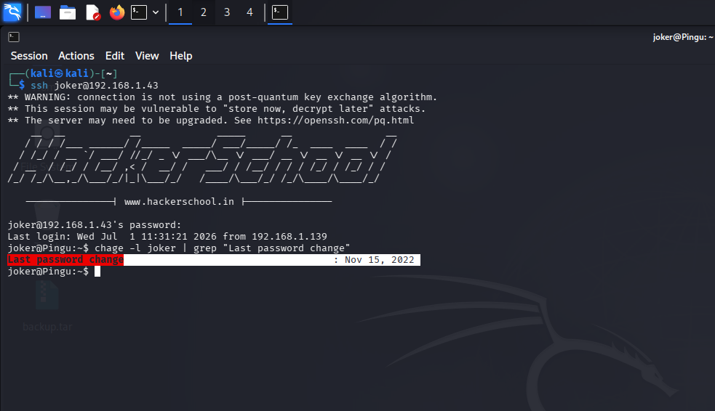
Machine Summary:-
Machine : Pingu IP : 10.0.0.221
Open ports | 22(ssh)
Username | joker
Password | joker

19. Login to Pingu machine as joker and create a file in tmp location and use scp utility to tranfer that file to your Kali/ParrotSec machine.

∙ Login to pingu machine as joker through port 22(SSH) ssh joker@192.168.1.43
∙ Create a temperory file
echo “pentest test file”
>/tmp/testfile_joker.txt
∙ In kali machine start the ssh service and appache2 servcice Service ssh start

∙ in the user joker , transfer the file /tmp/testfile_joker.txt to the kali machine we use the advantage of tool called secure copy protocol(scp)
scp /tmp/testfile_joker.txt jillala@192.168.1.43
∙ Confirm the transfer by submitng yes
∙ You can see the conformation massage of 100%, such that transfer is completed successfully .
∙ You can also check it in you kali machine by using the commands

cd /tmp/
∙ cd 🡪 change directory
∙ List the contents of the temp using ls
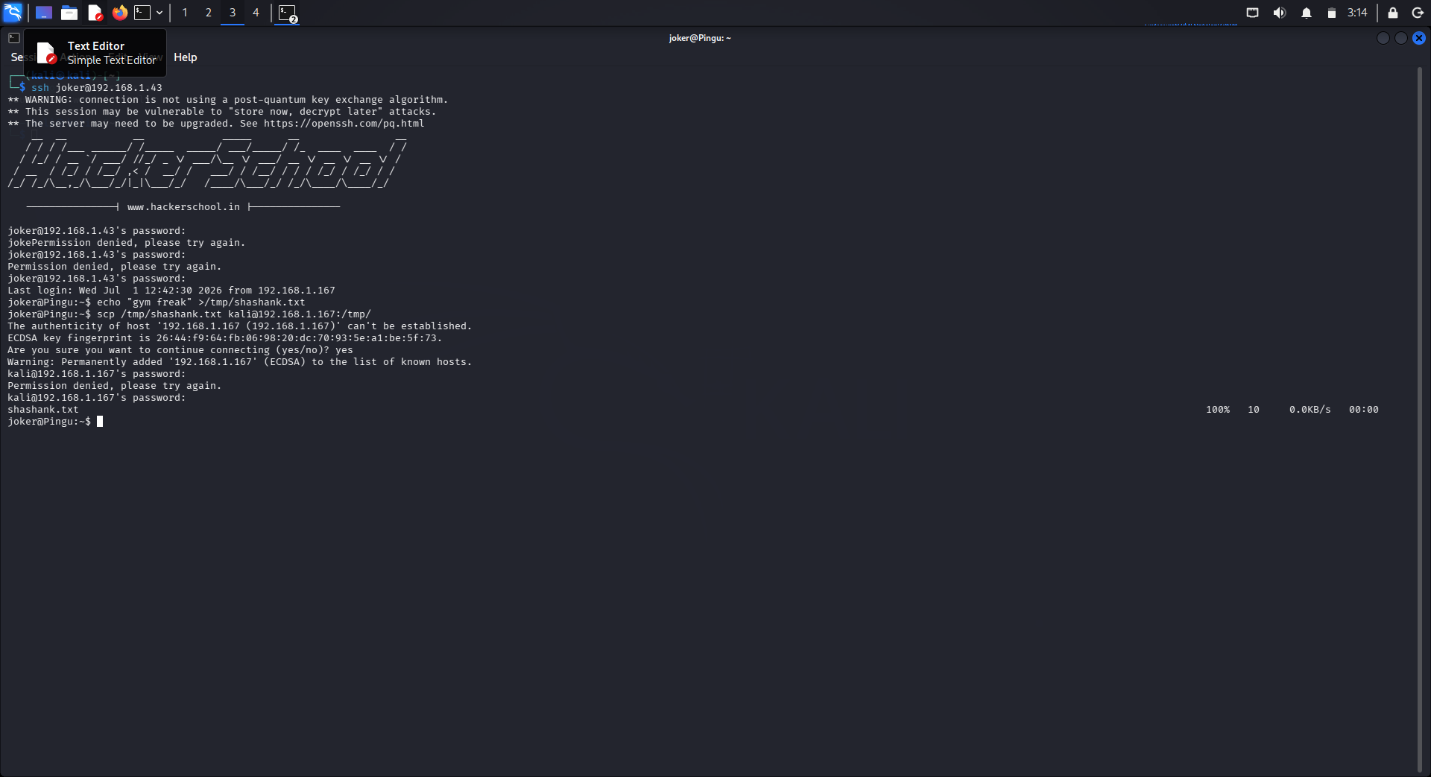
∙ Proof of screenshorts:-

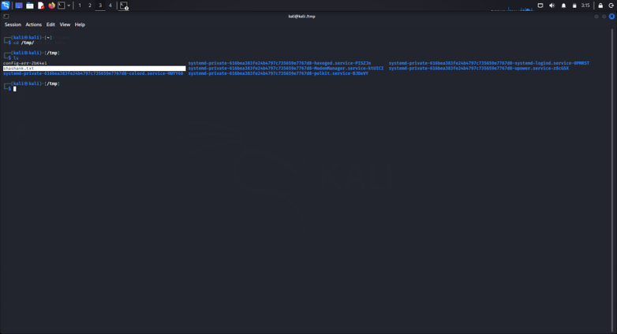
Machine Summary:
Machine : pingu ip : 192.168.1.43
Open ports | 22(ssh) , http(80)
Username | joker
protocol | scp

20. Create ssh keys on your Kali/ParrotSec machine and transfer the public key to Pingu machine using ssh-copy by logging in as joker. Now use ssh keys to login to Pingu as joker.
* initially create an ssh key in kali machine to transfer the public into pingu
* To generate a public key we use the command ssh-keygen -t rsa
∙ ssh 🡪 secure shell (port22)
∙ keygen 🡪 to generate a public key
∙ -t 🡪 to specify the algorithm
∙ rsa 🡪rivest-shamir-adleman
∙ A public key will generated we should transfer it to ping machine to login through the key without password

∙ By Default the keys are stored in a hidden directory .ssh ∙ To copy the key into pingu machine we use the command,
∙
ssh-copy-id joker@192.168.43
∙ When we try to login as pingu through ssh , by default it looks the key in the .ssh location if the key is not available it will switch into password based authentication
ssh joker@192.168.1.43
∙ Now we can login into pingu as joker without using any password

