SIMATS ENGINEERING
ASSIGNMENT - 2
Requirements Engineering and Software Architecture (UNIT – II)

Student Name | S.Shashi Vardhan Reddy
Register Number | 192311155
Subject Code | CSA1001
Subject Name | Software Engineering

Problem 3: Choosing Architecture for a Scalable Food Delivery Platform

Scenario
A startup wants to build a food delivery platform like Swiggy/Zomato that can scale during peak hours and process thousands of orders per minute. The CTO is unsure whether to use microservices, serverless, or a monolithic architecture.

Recommended Architecture Choice
A Microservices Architecture, augmented with an Event-Driven backbone (and selective use of serverless functions for bursty, stateless tasks such as image processing or push-notification fan-out), is recommended for this food delivery platform. Each core business capability — orders, payments, delivery, restaurants, and notifications — is built and deployed as an independent service that communicates asynchronously through events, allowing the platform to scale each function independently during peak hours (e.g., lunch/dinner rushes) without over-provisioning the entire system.

Three Technical Reasons for the Choice
- 1. Independent, targeted scalability: During peak hours, order volume and delivery-tracking traffic spike far more than, say, restaurant-menu updates. Microservices allow the Order Service and Delivery Service to be scaled horizontally (more instances) independently of less-loaded services, which is far more resource- and cost-efficient than scaling an entire monolith just because one function is under load.
- 2. Fault isolation and resilience: In a monolith, a bug or overload in one module (e.g., a payment gateway timeout) can bring down the entire application. With microservices, if the Payment Service slows down, Order placement and Delivery tracking can continue to function (perhaps in a degraded mode), which is critical for a platform where downtime directly costs revenue and customer trust.
- 3. Independent deployment and faster iteration: A food delivery platform evolves constantly — new promotions, surge-pricing logic, restaurant onboarding features, etc. Microservices let separate teams build, test, and deploy their services independently and frequently, without needing to redeploy (and risk) the entire monolithic codebase, which is essential for a fast-moving startup.
A pure serverless (Functions-as-a-Service) approach alone is not ideal as the sole architecture because many core workflows (order state management, real-time delivery tracking, payment transactions) are long-running, stateful, and latency-sensitive, and serverless functions can suffer from cold-start latency and are harder to reason about for complex, stateful business logic. A pure monolith, on the other hand, cannot scale or deploy its parts independently and becomes increasingly difficult to maintain as the platform grows — making microservices the most balanced choice, with serverless used selectively for well-suited, bursty, stateless tasks.

Role of Event-Driven Architecture (EDA)
In an event-driven architecture, services communicate by publishing and subscribing to events (e.g., “OrderPlaced,” “PaymentConfirmed,” “DeliveryAssigned”) through a central event bus or message broker (such as Apache Kafka or RabbitMQ), instead of calling each other directly and synchronously.
- Loose coupling: Services do not need to know about each other directly — the Order Service simply publishes an “OrderPlaced” event, and any interested service (Payment, Notification, Analytics) can subscribe to it, making the system easier to extend without modifying existing services.
- Asynchronous processing for high throughput: Thousands of orders per minute can be accepted and queued as events almost instantly, while downstream processing (payment verification, restaurant notification, delivery assignment) happens asynchronously, preventing the customer-facing request from being blocked by slower back-end operations.
- Resilience and buffering during traffic spikes: The message broker acts as a buffer during sudden peak-hour surges, absorbing bursts of order events so that downstream services can process them at a sustainable rate instead of being overwhelmed or crashing.
- Real-time responsiveness: Events naturally support real-time features such as live order tracking and delivery-partner location updates, which are core to the user experience of a food delivery app.
- Easier extensibility: New functionality (e.g., a fraud-detection service or a loyalty-rewards engine) can subscribe to existing events and be added to the system without touching or redeploying the services that originally produced those events.

Recommended Microservices
Microservice | Responsibility
Order Service | Handles order creation, order status, and the order lifecycle from cart to delivery.
Payment Service | Manages payment processing, refunds, and integration with payment gateways.
Delivery Service | Assigns delivery partners, tracks real-time location, and manages delivery status.
Restaurant Service | Manages restaurant profiles, menus, availability, and order acceptance.
Notification Service | Sends order updates, promotions, and alerts via push notifications, SMS, or email.

Architecture Diagram
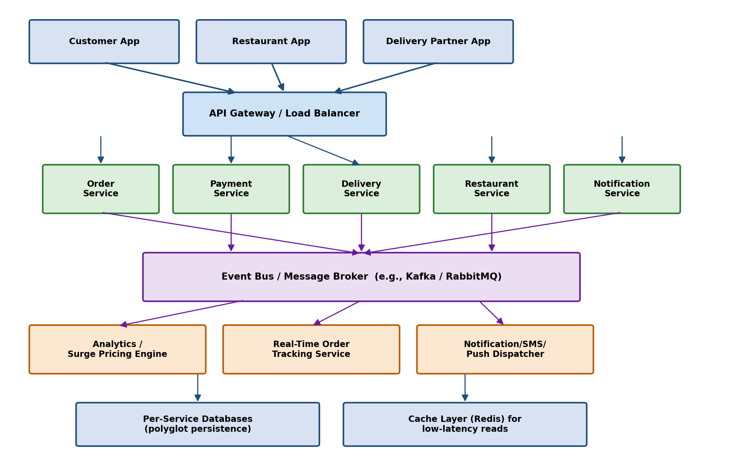
Figure 1: Recommended microservices + event-driven architecture for the food delivery platform
As shown above, client apps talk to the backend through an API Gateway, which routes requests to the appropriate microservice. Each microservice publishes events to a shared Event Bus, which decouples the producers of events from the consumers (such as analytics, real-time tracking, and notification dispatch), enabling the platform to scale, evolve, and stay resilient even while processing thousands of orders per minute during peak hours.

