SIMATS ENGINEERING
ASSIGNMENT - 4

Student Name | S.Shashi Vardhan Reddy
Register Number | 192311155
Subject Code | CSA1001
Subject Name | Software Engineering

Question 1
Explain Mutation Testing and Fuzz Testing. How do these testing techniques enhance the reliability and security of software systems?

1. Mutation Testing
Mutation Testing is a white-box testing technique used to evaluate the quality and effectiveness of an existing test suite rather than the software itself. It works by deliberately introducing small, artificial faults (called “mutants”) into the source code and then checking whether the existing test cases are able to detect these faults.
Process of Mutation Testing:
- Generate mutants: Small syntactic changes are made to the original program, such as replacing a “+” operator with a “−” operator, changing a relational operator (e.g., “<” to “<=”), or altering a constant value.
- Run the test suite: The existing test cases are executed against each mutant version of the program.
- Check the outcome: If a test case fails on the mutant, the mutant is said to be “killed,” meaning the test suite successfully detected the fault.
- Compute mutation score: Mutation Score = (Number of Killed Mutants / Total Number of Mutants) × 100. A high mutation score indicates a strong, fault-detecting test suite; a low score indicates weak or insufficient tests.
Mutation testing improves reliability by exposing gaps in test coverage that ordinary statement or branch coverage metrics fail to reveal. It forces developers to strengthen their test suites so that even subtle logical errors are caught before deployment, directly increasing confidence in the correctness of the software.

2. Fuzz Testing (Fuzzing)
Fuzz Testing is a black-box, automated testing technique in which a program is fed large volumes of random, unexpected, malformed, or boundary-value inputs to observe how it behaves. The goal is to uncover crashes, memory leaks, unhandled exceptions, and security vulnerabilities that normal testing might miss.
Types of Fuzzing:
- Random (generation-based) fuzzing: Inputs are generated randomly or based on a defined grammar/protocol specification.
- Mutation-based fuzzing: Valid sample inputs are taken and mutated (bits flipped, values altered, fields truncated) to create new test inputs.
- Common tools: AFL (American Fuzzy Lop), libFuzzer, Peach Fuzzer, and OWASP ZAP (for web applications).
Fuzz testing is especially effective at finding security vulnerabilities such as buffer overflows, injection flaws, and denial-of-service conditions, because it stresses the application with inputs that a human tester or a normal test case would rarely think to try.

Comparison: Mutation Testing vs Fuzz Testing
Aspect | Mutation Testing | Fuzz Testing
Testing type | White-box (code-based) | Black-box (input-based)
Primary goal | Evaluate quality of the test suite | Discover crashes and vulnerabilities
Technique | Injects small faults (mutants) into code | Feeds random/malformed inputs to the program
Success metric | Mutation score (% mutants killed) | Number of crashes/bugs found
Typical use | Unit-test suite strengthening | Security and robustness testing
Example tools | PIT, Stryker, MutPy | AFL, libFuzzer, Peach Fuzzer, OWASP ZAP

3. How These Techniques Enhance Reliability and Security
- Better fault detection: Mutation testing ensures test suites can actually catch real defects, not just execute code, improving overall reliability.
- Uncovering hidden vulnerabilities: Fuzz testing reveals crashes and security holes caused by unexpected or malicious inputs, which is critical for security-sensitive systems.
- Reduced production failures: By strengthening tests and hardening input handling before release, both techniques reduce the likelihood of failures once the software is deployed.
- Regulatory and safety assurance: In safety-critical or security-critical domains, mutation and fuzz testing provide measurable evidence that the software has been rigorously verified.
- Continuous improvement: Both techniques can be automated and integrated into CI/CD pipelines, allowing reliability and security checks to run on every code change.

Question 2
Describe the Key Stages of a CI/CD Pipeline (using Jenkins or GitHub Actions). How does using Docker for containerization support continuous delivery?

1. Key Stages of a CI/CD Pipeline
A Continuous Integration / Continuous Delivery (CI/CD) pipeline automates the process of building, testing, and deploying software. Using tools such as Jenkins or GitHub Actions, the pipeline is typically defined as a series of stages executed automatically whenever code is pushed to a repository.
- Source Stage: The pipeline is triggered automatically when a developer pushes code to a version control system such as GitHub. Jenkins uses webhooks or SCM polling; GitHub Actions triggers directly on events like “on: push” or “on: pull_request.”
- Build Stage: The source code is compiled and dependencies are resolved (e.g., using Maven, Gradle, npm, or pip) to produce a build artifact. Jenkins uses build steps in a Jenkinsfile; GitHub Actions uses job steps in a YAML workflow file.
- Test Stage: Automated unit tests, integration tests, and static code analysis are executed to verify code correctness and quality. Failures at this stage stop the pipeline, preventing broken code from moving forward.
- Code Quality and Security Scan: Tools such as SonarQube, ESLint, or security scanners analyze the code for style violations, bugs, and vulnerabilities.
- Package/Artifact Stage: The verified build is packaged into a deployable unit, such as a JAR/WAR file or, very commonly today, a Docker image, and stored in an artifact repository or container registry (e.g., Docker Hub, Amazon ECR).
- Deploy to Staging: The packaged artifact is automatically deployed to a staging/test environment that mirrors production, where further automated or manual acceptance testing can occur.
- Deploy to Production (Continuous Delivery/Deployment): After approval (manual gate) or automatically (continuous deployment), the build is released to the production environment using strategies like rolling updates, blue-green deployment, or canary releases.
- Monitoring and Feedback: Post-deployment monitoring tools track application health and performance, feeding results back to the development team for continuous improvement.

Pipeline Flow Diagram
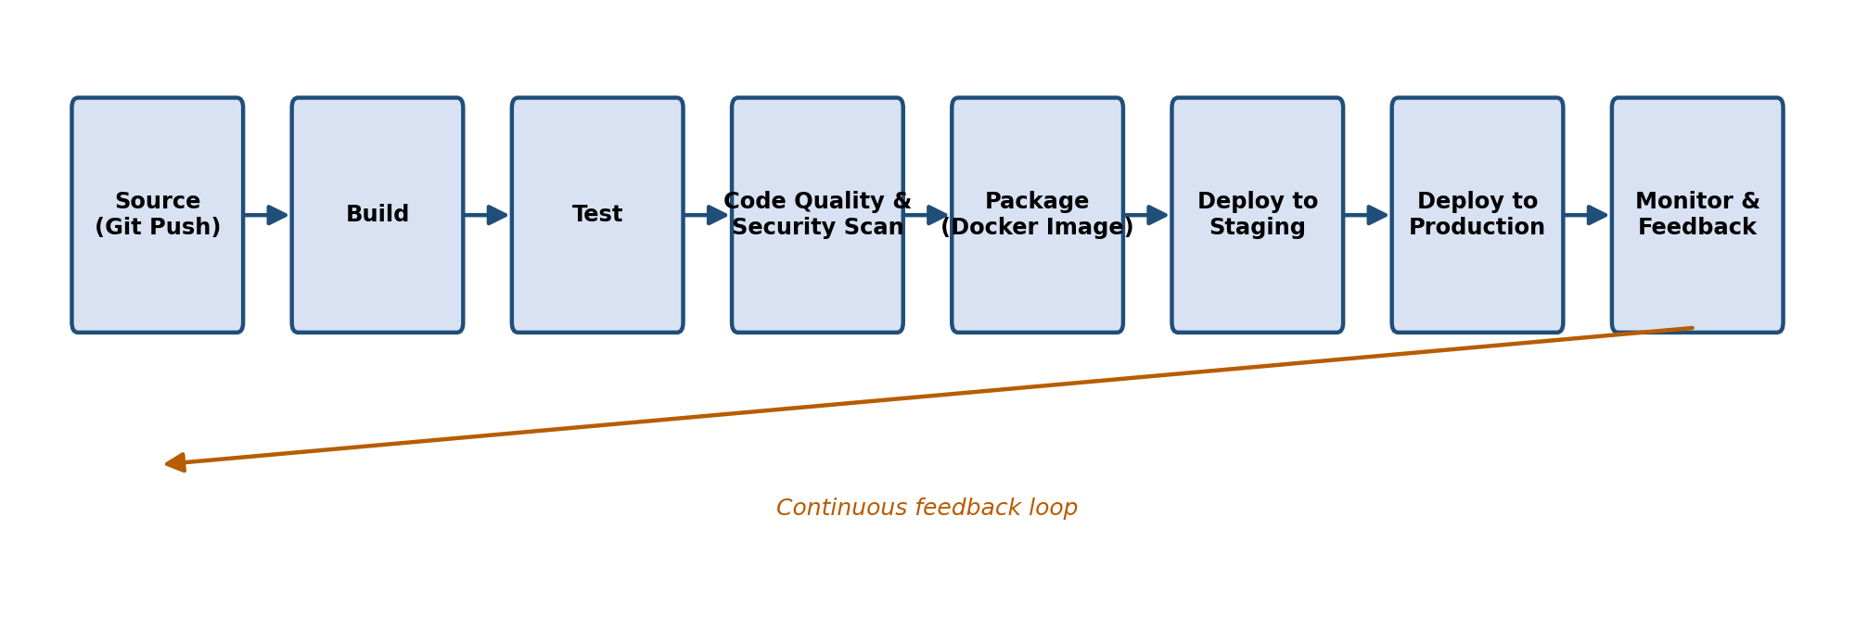
Figure 1: Stages of a typical CI/CD pipeline (Jenkins / GitHub Actions)

2. Role of Docker in Supporting Continuous Delivery
Docker packages an application along with all its dependencies, libraries, and configuration into a lightweight, portable container. This containerization plays a major role in enabling smooth and reliable continuous delivery:
- Consistency across environments: The same Docker image runs identically on a developer’s machine, in the CI server, in staging, and in production, eliminating the classic “it works on my machine” problem.
- Faster and lighter builds: Containers are much lighter than full virtual machines, so they start up quickly, which speeds up build, test, and deployment cycles in the pipeline.
- Isolation: Each container runs in its own isolated environment, so multiple services or versions can be tested in parallel without conflicts.
- Easy scalability: Container orchestration platforms such as Kubernetes or Docker Swarm can automatically scale containers up or down based on load, supporting reliable continuous delivery to production.
- Simplified rollback: Because each release is a versioned image, rolling back to a previous stable version is as simple as redeploying the earlier image tag.
- Seamless CI/CD integration: Both Jenkins and GitHub Actions have native support for building, tagging, and pushing Docker images as part of the pipeline, making containerized deployment a natural extension of the automated workflow.
Overall, Docker’s portability and consistency remove environment-related failures from the delivery process, allowing teams to release software faster, more frequently, and with greater confidence.

Question 3
Case Study – Intermittent Slowdowns in a Large SaaS Application: Explain how monitoring and logging tools such as Prometheus, Grafana, and the ELK Stack can help detect, diagnose, and resolve performance issues.

Case Study Background
A large SaaS application is experiencing intermittent slowdowns — the system performs normally most of the time, but occasionally response times spike, causing a poor user experience. Because the issue is intermittent and not constant, it is difficult to reproduce and diagnose without proper observability tools. Monitoring and logging tools such as Prometheus, Grafana, and the ELK Stack provide the visibility needed to detect, diagnose, and resolve such issues.

Tool Roles at a Glance
Tool | Category | Primary Role in This Case Study
Prometheus | Metrics collection | Scrapes latency/CPU/memory metrics and fires alerts on threshold breaches
Grafana | Visualization | Displays real-time dashboards to spot and correlate spikes visually
Elasticsearch | Log storage/search | Indexes logs for fast full-text search across all services
Logstash | Log processing | Collects and normalizes logs from distributed microservices
Kibana | Log visualization | Lets engineers filter/search logs to trace the exact root cause

1. Prometheus – Metrics Collection and Alerting
Prometheus is an open-source monitoring system that collects and stores time-series metrics (CPU usage, memory usage, request latency, error rates, database query times, etc.) from the application and its infrastructure at regular intervals.
- Detection: Prometheus continuously scrapes metrics from application endpoints and can be configured with alerting rules (via Alertmanager) that automatically notify the team when latency, CPU, or memory usage crosses a defined threshold — flagging a slowdown as soon as it starts, even if no one is actively watching.
- Diagnosis: Because Prometheus stores historical time-series data, engineers can query metrics (using PromQL) to correlate the timing of a slowdown with spikes in specific resources, such as a particular microservice’s CPU usage or database connection pool exhaustion.
- Resolution support: Once the correlated resource bottleneck is identified, engineers can target scaling, caching, or code-level fixes precisely at the affected component instead of guessing.

2. Grafana – Visualization and Dashboards
Grafana works alongside Prometheus (and other data sources) to visualize metrics through interactive dashboards and graphs.
- Detection: Real-time dashboards make it easy to visually spot unusual patterns, such as periodic latency spikes, that might otherwise be hidden in raw numbers.
- Diagnosis: Grafana allows engineers to overlay multiple metrics (e.g., request rate, response time, and memory usage) on the same timeline, making it easier to see whether the slowdown correlates with traffic spikes, memory pressure, or a specific deployment.
- Resolution support: Custom dashboards and alert panels help teams monitor the effect of a fix in real time after it is deployed, confirming whether the intermittent slowdown has actually been resolved.

3. ELK Stack – Centralized Logging and Analysis
The ELK Stack (Elasticsearch, Logstash, and Kibana) is used to collect, store, search, and visualize log data from across the distributed SaaS application.
- Logstash: Collects and processes logs from multiple services/servers, normalizing them into a structured format.
- Elasticsearch: Indexes and stores the log data, allowing very fast full-text search across massive volumes of logs.
- Kibana: Provides a visualization and search interface for exploring logs, building charts, and filtering by service, time range, or error type.
- Detection: Sudden increases in error rates, warning messages, or slow query logs appearing in Kibana dashboards can flag when and where a slowdown is occurring.
- Diagnosis: Engineers can search logs across all affected services around the exact timestamp of a reported slowdown to trace the request path, identify slow database queries, timeouts, or exceptions, and pinpoint the root cause (e.g., a specific API endpoint, a slow third-party call, or lock contention in the database).
- Resolution support: Once root cause logs are identified, teams can apply targeted fixes (e.g., query optimization, adding indexes, increasing connection pool size, adding caching) and use the same log searches to confirm the errors or slow entries disappear after the fix.

4. Combined Workflow for Resolving the Slowdown
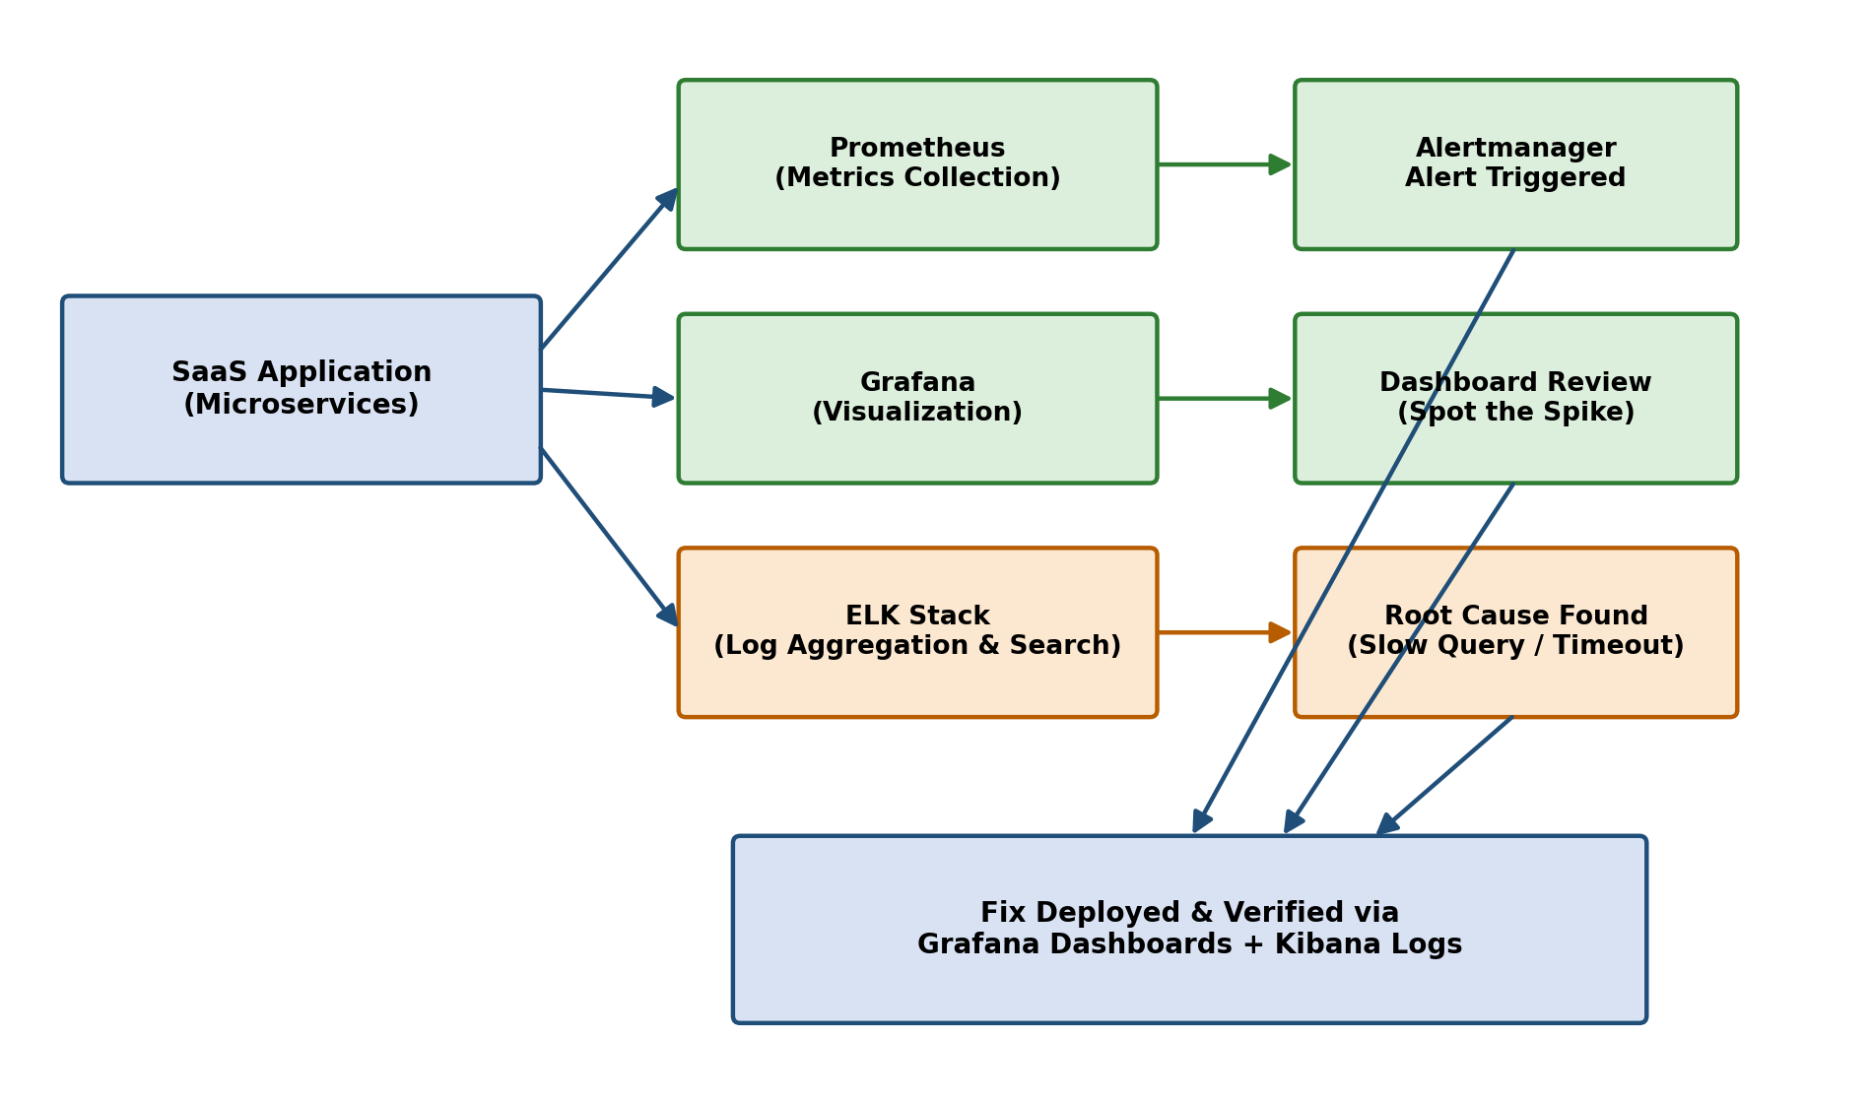
Figure 2: Combined Prometheus + Grafana + ELK workflow for diagnosing the SaaS slowdown
- Step 1 – Alert: Prometheus/Alertmanager detects abnormal latency or resource usage and triggers an alert.
- Step 2 – Visualize: The on-call engineer opens Grafana dashboards to see when the spike occurred and which metrics were affected.
- Step 3 – Investigate: The engineer searches the ELK Stack (Kibana) for logs in that exact time window to trace the request flow and find the root cause, such as a slow database query or an overloaded microservice.
- Step 4 – Fix and Verify: A fix is deployed, and both Grafana dashboards and Kibana logs are monitored afterward to confirm the intermittent slowdown no longer occurs.
By combining metrics-based monitoring (Prometheus and Grafana) with centralized log analysis (ELK Stack), the team gains full observability into the SaaS application. This enables them to move from reactively firefighting vague, intermittent complaints to proactively detecting anomalies, quickly diagnosing root causes, and verifying that performance issues are genuinely resolved — significantly improving the overall reliability of the application.

