Exp 04: Create a simple cloud software application for Library book reservation
system for SIMATS library using any Cloud Service Provider to demonstrate
SaaS.
Aim
To design and implement a simple cloud-based Library Book Reservation System for SIMATS library using Zoho Creator as a Cloud Service Provider, thereby demonstrating the Software as a Service (SaaS) model.
Procedure
- Login to Zoho Creator → Create a new application named “SIMATS Library Reservation System”.
- Create Forms → Build forms such as Student Registration, Book Catalog, Reservation Request, and Issue/Return.
- Define Fields → Add fields like Student Name, ID, Book Title, Author, Date of Reservation, Issue Date, Return Date.
- Set Workflows → Automate approval when a student reserves a book and send email/SMS notifications.
- Design Reports → Generate reports such as Available Books, Reserved Books, and Overdue Returns.
- Deploy as SaaS → Publish the app, provide cloud access to students and staff, and allow usage through web/mobile.
Output

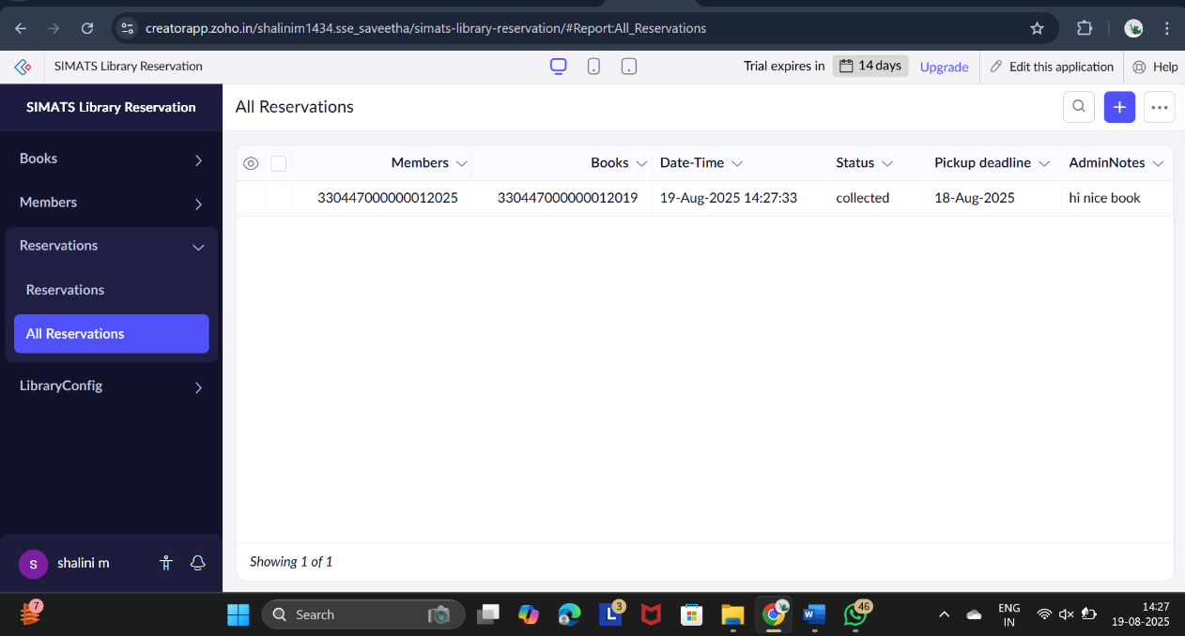
Figure 1 All reservations
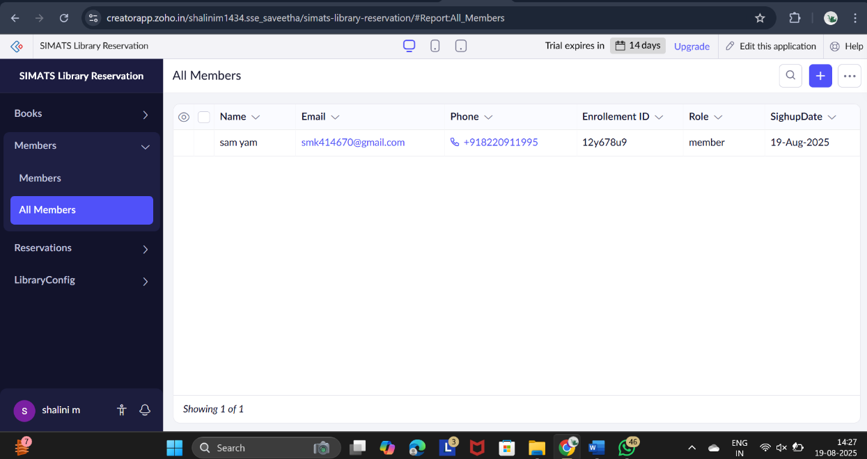
Figure 2 All Members

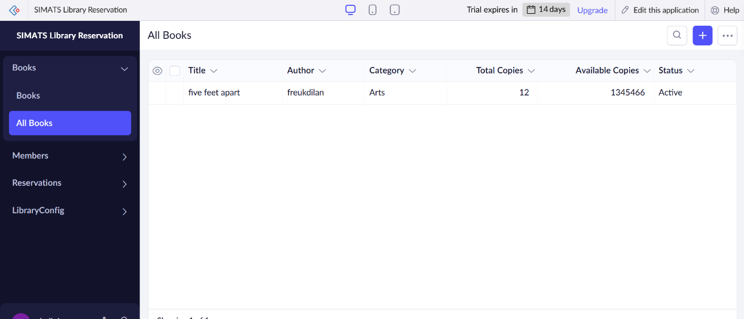
Figure 3 All bOOKS

Result
A simple cloud-based Library Book Reservation System was successfully created and deployed in Zoho Creator as a SaaS application. Students can reserve, borrow, and return books online, while the library can manage records efficiently.

