Exp 07: Create a Virtual Machine with 1 CPU, 2GB RAM and 15GB storage disk using
a Type 2 Virtualization Software, using virtual box.
Aim
To install and Create a Virtual Machine with 1 CPU, 2GB RAM and 15GB storage disk using
a Type 2 Virtualization Software, using virtual box.
Procedure
- Open VirtualBox → Launch the VirtualBox application installed on your system.
- Create New VM → Click on “New”, enter a name for the VM, and select the desired operating system type and version.
- Allocate Memory → Assign 2 GB (2048 MB) of RAM to the VM.
- Configure CPU → Set the Processor count to 1 CPU under “System → Processor” tab.
- Create Virtual Hard Disk → Choose “Create a virtual hard disk now”, select VDI, and allocate 15 GB of storage.
- Attach OS Installation Media → In the “Storage” settings, mount an ISO image of the operating system you want to install.
- Start VM → Click “Start” to boot the virtual machine and begin OS installation.
Output
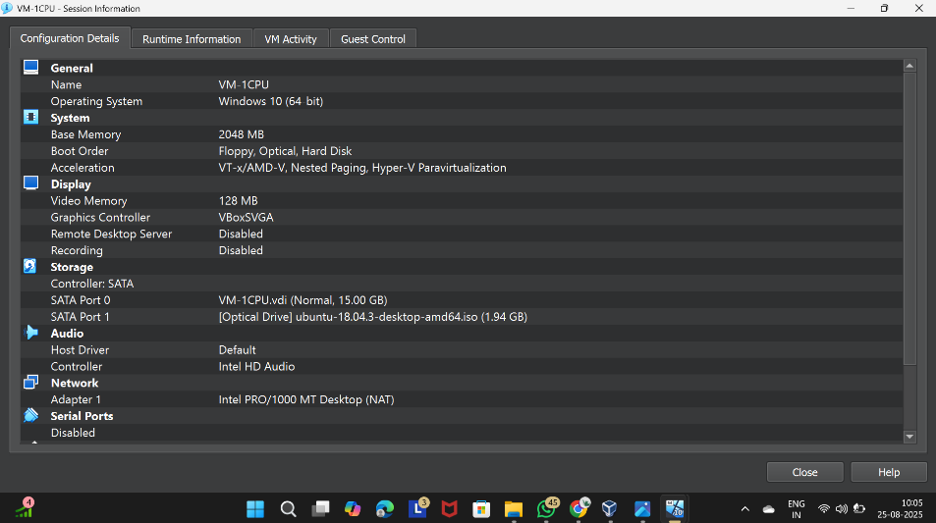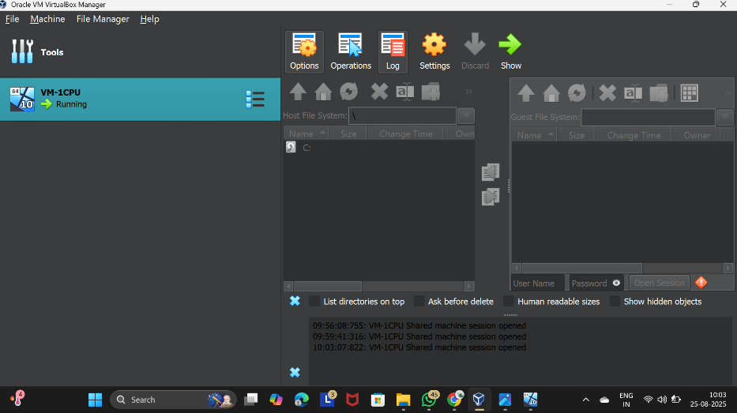
Figure 1 Virtual Machine with 1 CPU, 2 GB RAM, and 15 GB storage
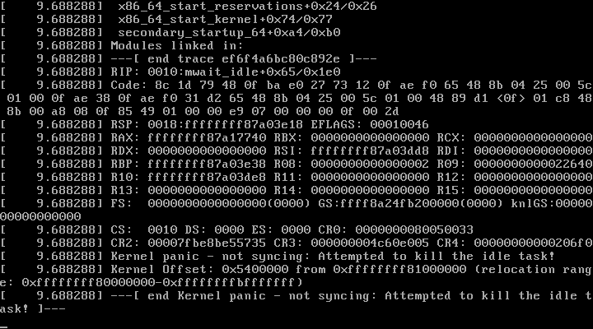

Result
A Type-2 hypervisor (VirtualBox) was successfully installed on the host machine. A Virtual Machine was created with the configuration 1 CPU, 2 GB RAM, 15 GB storage, and a guest operating system (Ubuntu/Windows) was installed and executed successfully.

