Exp 08: Create a Snapshot of a VM and Test it by loading the Previous Version/Cloned VM using a virtual box.
Aim
To create a snapshot of a Virtual Machine and test it by restoring the VM to its previous saved state (or by loading the cloned VM) using Oracle VirtualBox.
Procedure :
1.Start VirtualBox – Launch Oracle VM VirtualBox on your system.
2. Select Virtual Machine – Choose the VM for which you want to create a snapshot.
3. Take Snapshot – Click on “Machine” → “Take Snapshot”, give it a name/description, and save it.
4. Modify VM – Make some changes in the VM (install software, create files, etc.).
5. Restore Snapshot – Go to Snapshots Panel, select the saved snapshot, and click “Restore” to load the previous version.
6. Test by Running VM – Start the VM; it will revert to the exact state it was in when the snapshot was taken (previous configuration/files).
Output
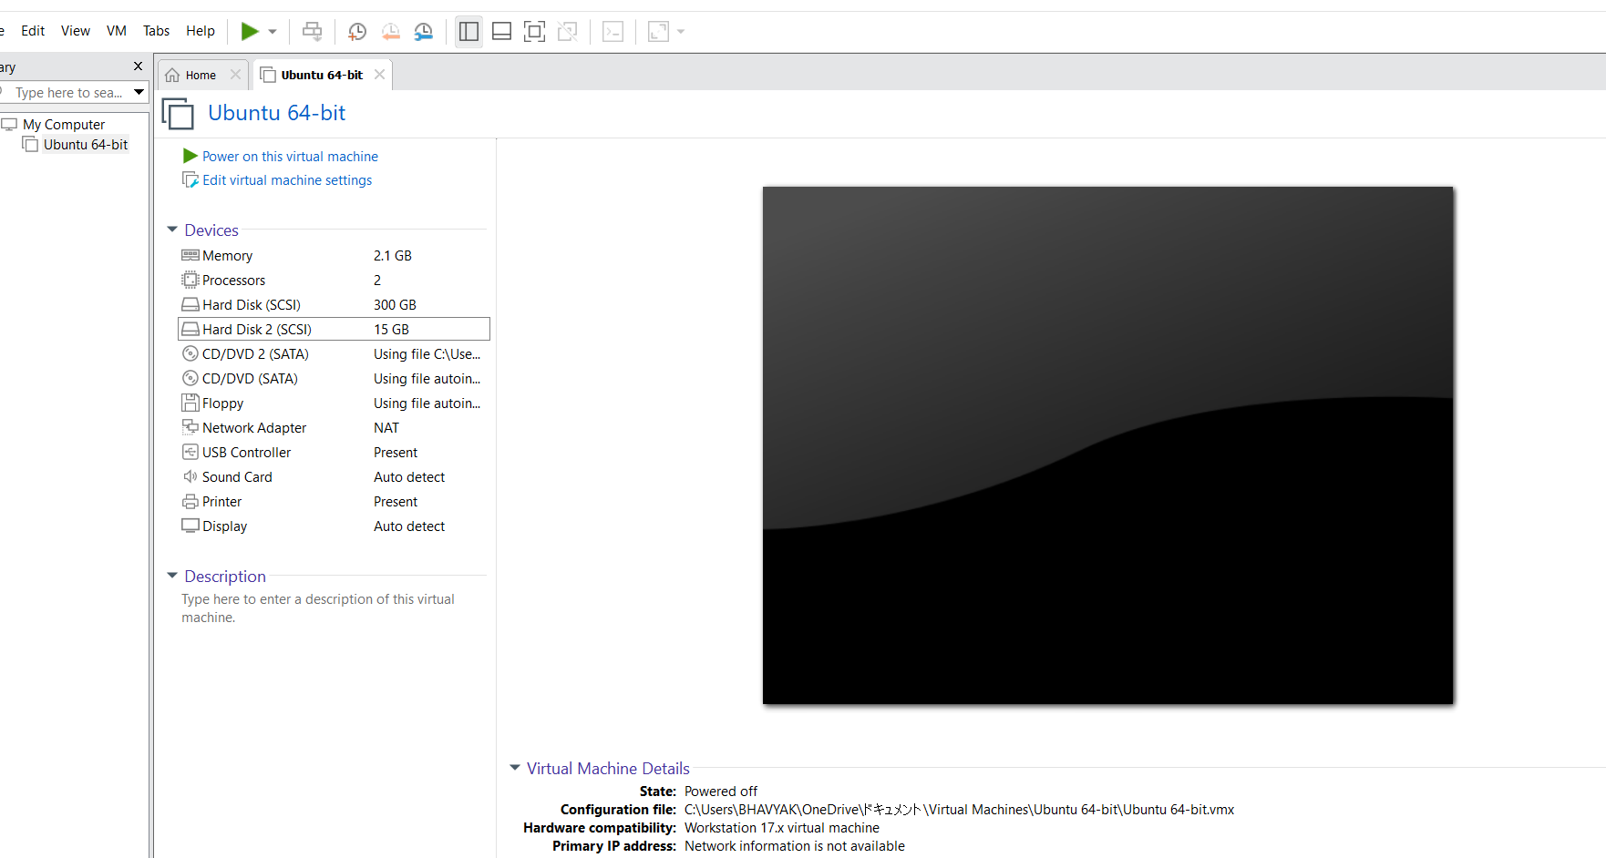

Result:
A snapshot of the Virtual Machine was successfully created and restore

