Exp 10 : Create a Snapshot of a VM and Test it by loading the Previous Version/Cloned VM using a virtual box.
Aim
To create a clone of a VirtualBox virtual machine (VM), and test recovery by (a) booting the cloned VM, and (b) restoring the VM to a previous state using VirtualBox snapshots. Verify that the clone is functional and the snapshot restore returns the VM to the earlier state.
Procedure :
1.Select the source VM (OriginalVM).
2. (Optional) Create a snapshot of OriginalVM named pre-clone-snap.
3. Power off OriginalVM.
4. Create a clone of OriginalVM → ClonedVM (register it in VirtualBox).
5. Start ClonedVM and verify OS boots and network.
6. Make a visible change to OriginalVM (e.g., create a text file or change hostname).
7. Restore OriginalVM to pre-clone-snap (or boot cloned copy made earlier).
8. Confirm the change is gone after restore (i.e., previous version is loaded).
9. Record results, timestamps, and any issues.
Output

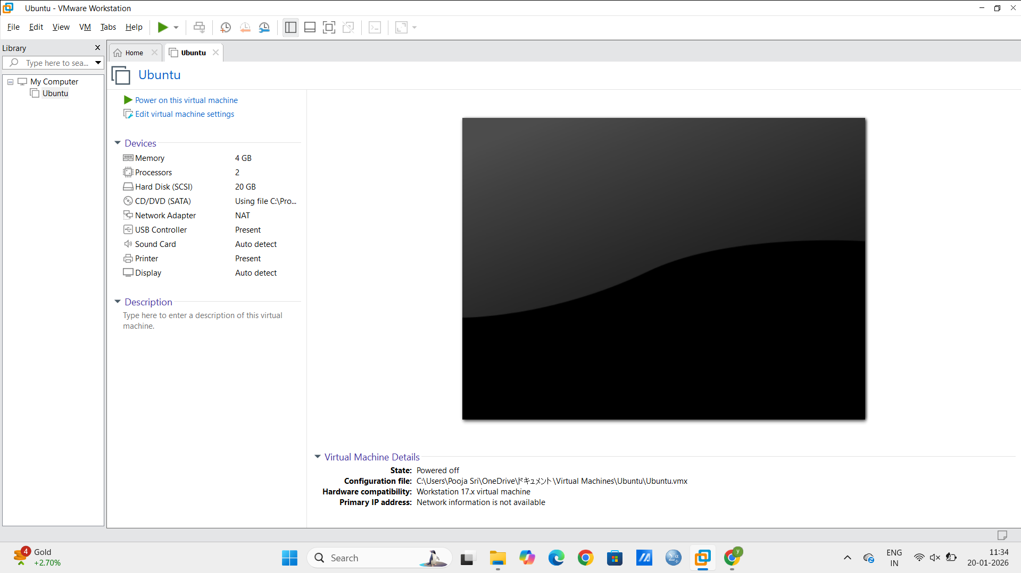

Result:
A snapshot of the Virtual Machine was successfully created and restore

