PARITY
How to use the Parity app
A step-by-step guide with screenshots
Parity helps property teams keep spaces clean and consistent. Workers photograph each room or area, the app compares the photo with a reference (master) image, and any missing or moved items are reported as issues.
This guide covers two roles
- Part 1, Property Owner: create an account, add a property and set up the spaces and inspection prompts.
- Part 2, Worker: join a property, photograph a space and review the issues found.
Before you start
- An Android or iOS phone with the Parity app installed.
- A mobile number that can receive an SMS verification code.
- Workers also need a Property Code from their manager or owner.

Part 1: Property Owner
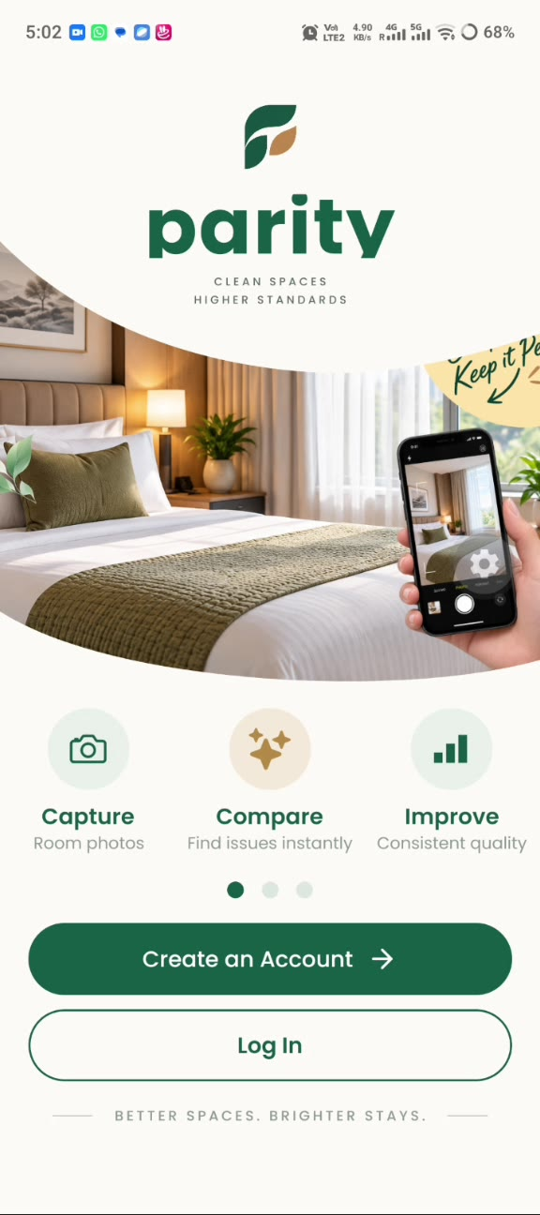 | Step 1  Open the app and get started  The welcome screen introduces Parity: capture room photos, compare them to find issues instantly, and improve quality consistently.  - New user: tap Create an Account.  - Returning user: tap Log In.
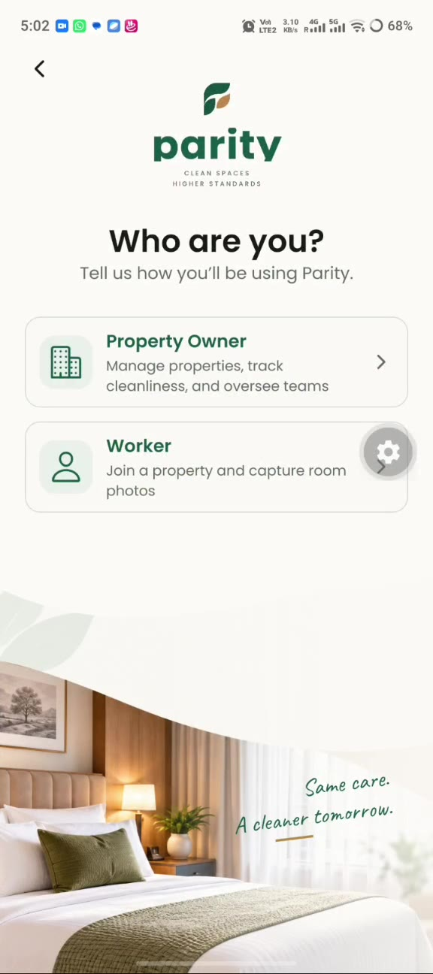 | Step 2  Choose your role  On the “Who are you?” screen, pick how you will use Parity.  - Property Owner: manage properties, track cleanliness and oversee teams (this section).  - Worker: join a property and capture room photos (see Part 2).
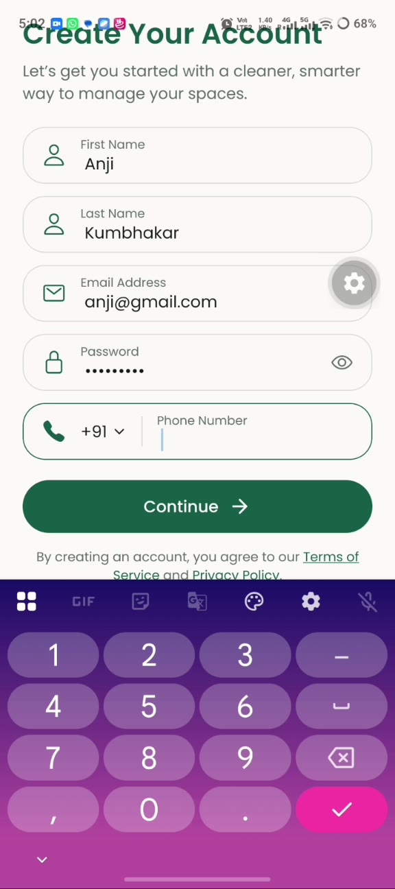 | Step 3  Create your account (Step 1 of 2)  Fill in your details, then tap Continue.  - First name and last name.  - Email address and password.  - Phone number (country code +91 is preselected).
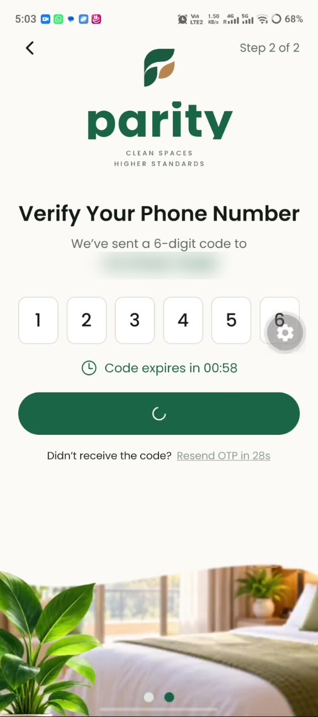 | Step 4  Verify your phone number (Step 2 of 2)  A 6-digit code is sent to your phone. Enter it in the boxes; the app verifies it and signs you in.  - The code expires after one minute.  - If it does not arrive, wait for the timer and tap Resend OTP.
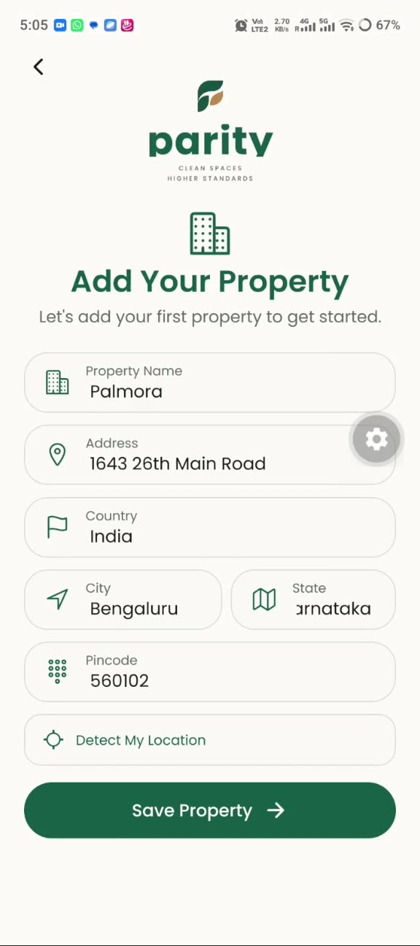 | Step 5  Add your first property  Enter the property name and address details, then tap Save Property.  - Fields: property name, address, country, city, state and pincode.  - Tap Detect My Location to fill in the location automatically.
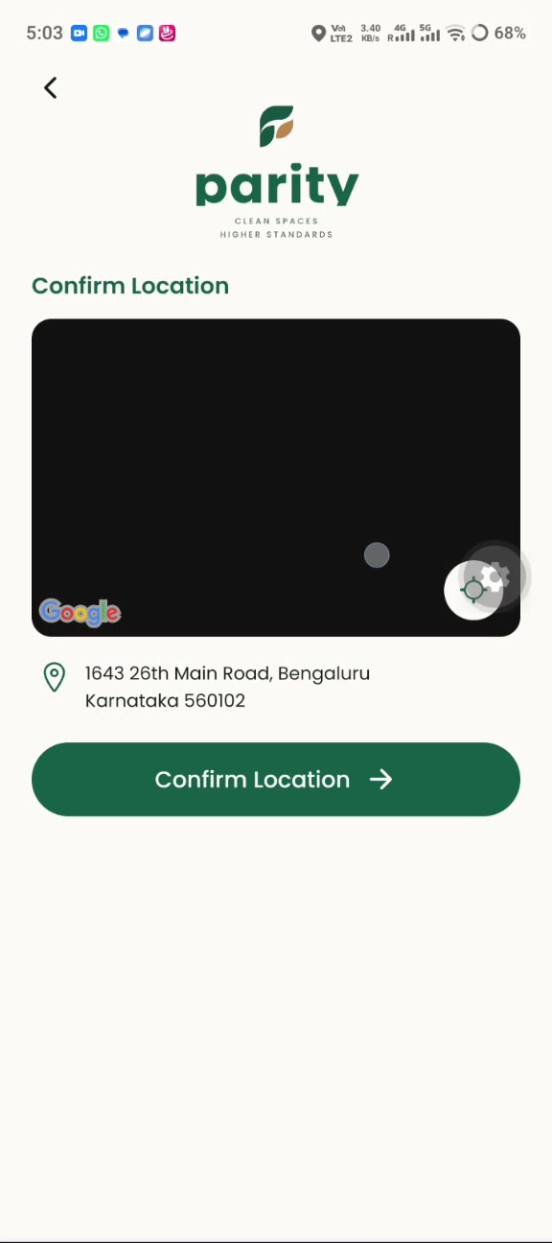 | Step 6  Confirm the location  Check the address shown under the map and tap Confirm Location.  - The map was still blank in the demo recording; the address below it is what you confirm.
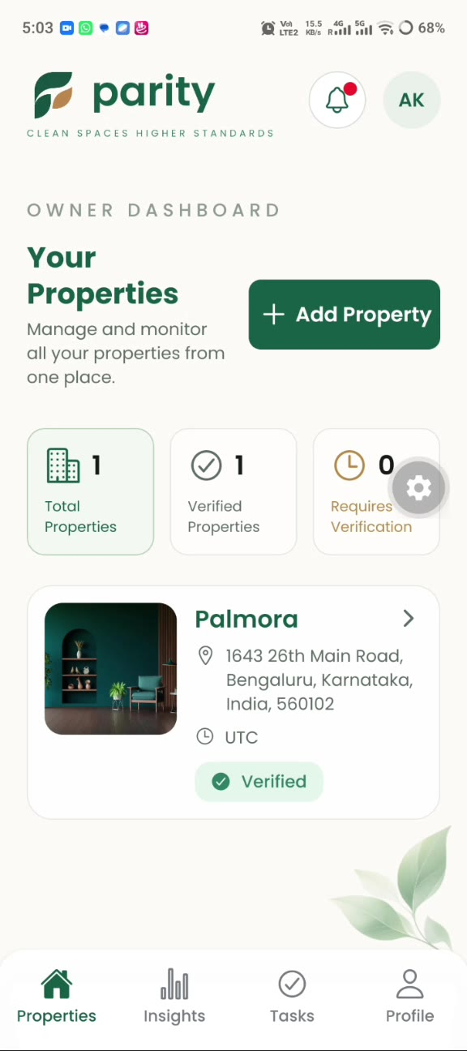 | Step 7  Your owner dashboard  After setup you land on the Owner Dashboard, which lists all your properties.  - Summary cards show Total Properties, Verified Properties and Requires Verification.  - Each property card shows its address, time zone and a Verified badge.  - Use Add Property to add more. The bottom tabs are Properties, Insights, Tasks and Profile.
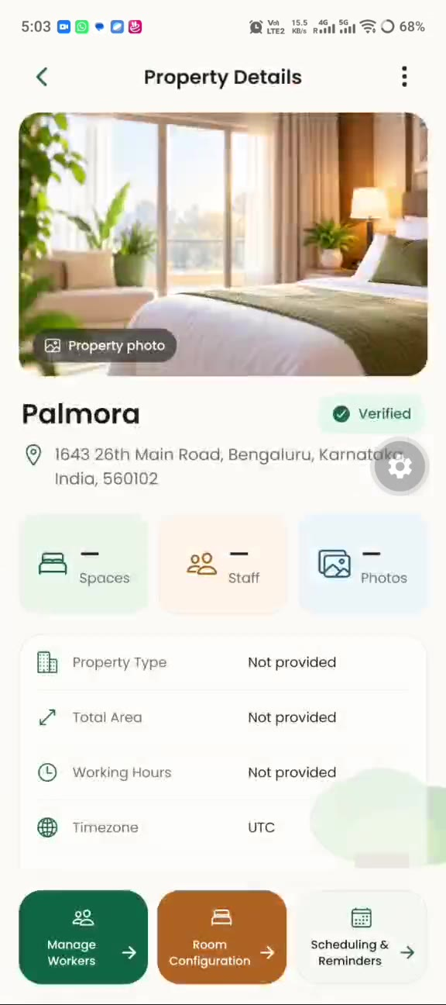 | Step 8  Open a property  Tap a property card to see its details: photo, name, verification status, address and tiles for Spaces, Staff and Photos.  - Details listed: property type, total area, working hours and time zone.  - Shortcuts: Manage Workers, Room Configuration, and Scheduling & Reminders.  - Tap Room Configuration to set up the areas that will be inspected.
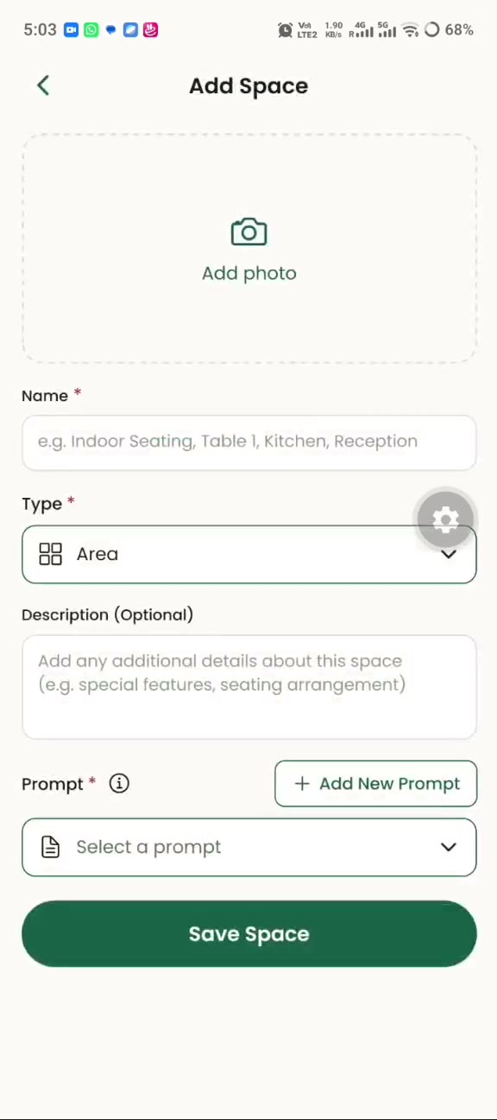 | Step 9  Add a space to inspect  In Room Configuration, tap the add button (+ Add Room, + Add Area or + Add Asset, depending on the tab) to open the Add Space form.  - Add photo (optional).  - Name (required), for example Indoor Seating, Table 1, Kitchen or Reception.  - Type (required) and Description (optional).  - Prompt (required): what the inspection should look for.
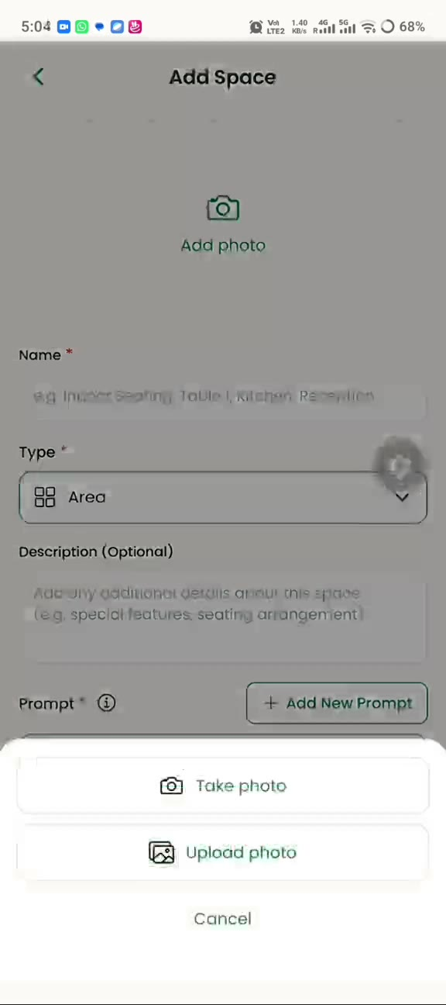 | Step 10  Add a photo of the space  Tap Add photo and choose how to provide the image.  - Take photo: opens the camera.  - Upload photo: picks an existing photo from your phone.
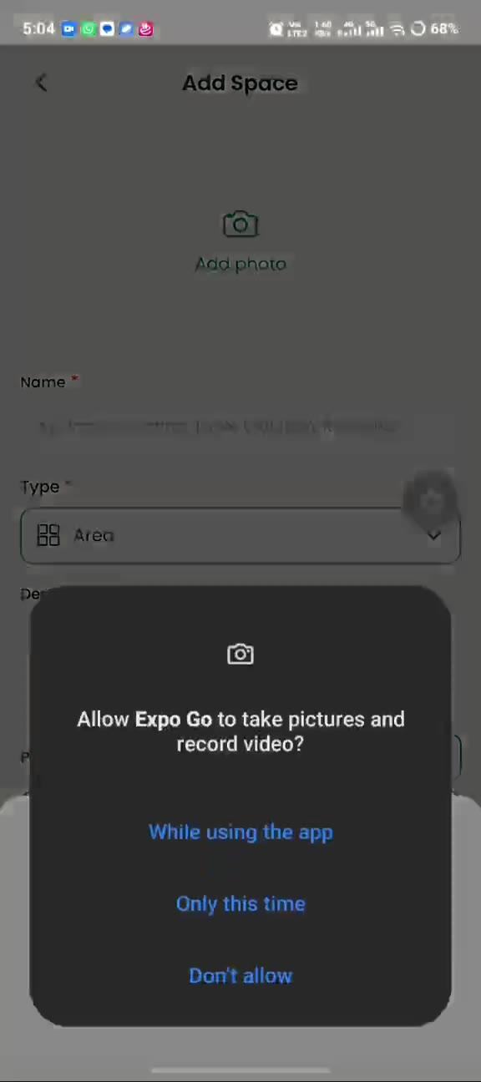 | Step 11  Allow camera access  The first time you use the camera, Android asks for permission. Choose While using the app (or Only this time) to continue.  In the test build shown in the video the prompt names Expo Go; in the final app it will show the Parity name.
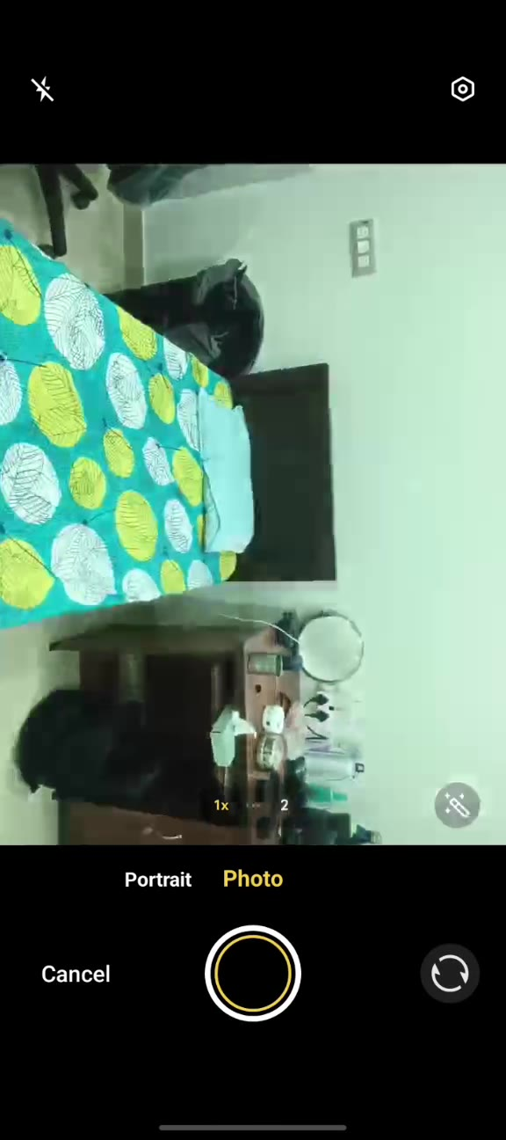 | Step 12  Take the picture  Frame the space and tap the round shutter button. Tap Cancel to go back without taking a photo.
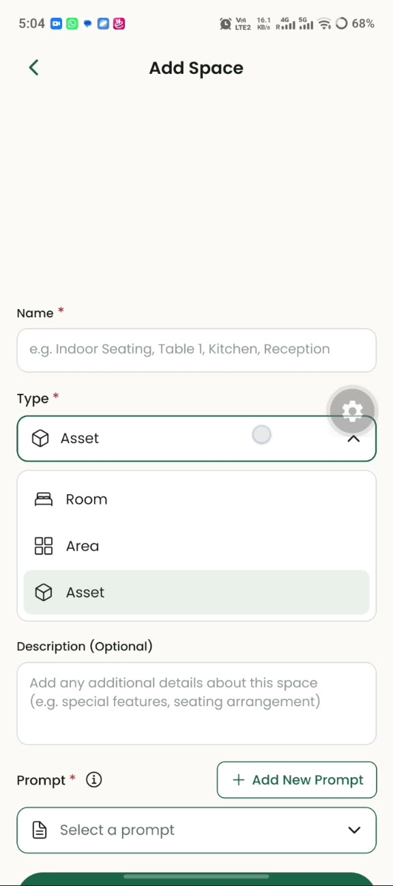 | Step 13  Pick the space type  Open the Type dropdown and choose what you are adding.  - Room, Area or Asset. The demo uses Area.
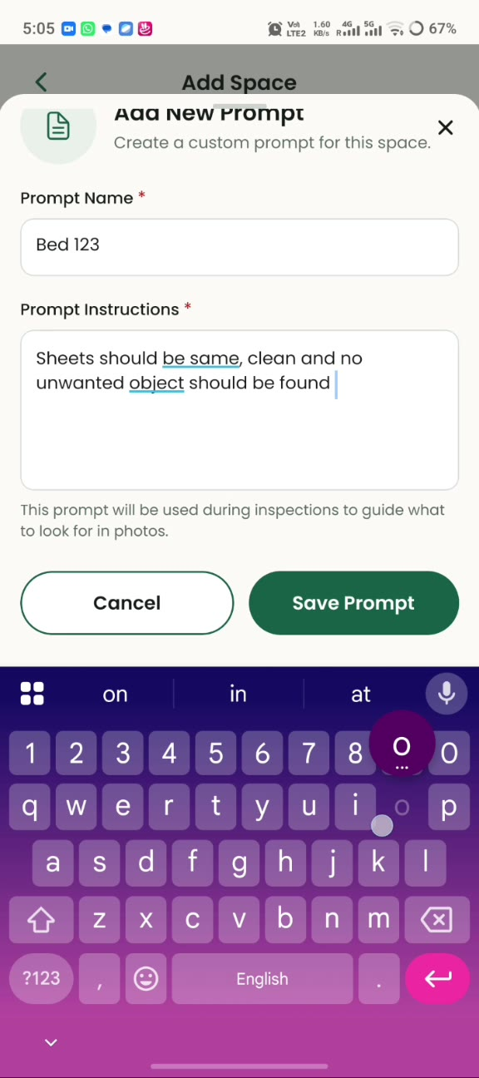 | Step 14  Write an inspection prompt  A prompt tells the inspection what to look for in photos. Tap + Add New Prompt, enter a Prompt Name and Prompt Instructions, then tap Save Prompt.  Example from the demo: “Sheets should be same, clean and no unwanted object should be found.”
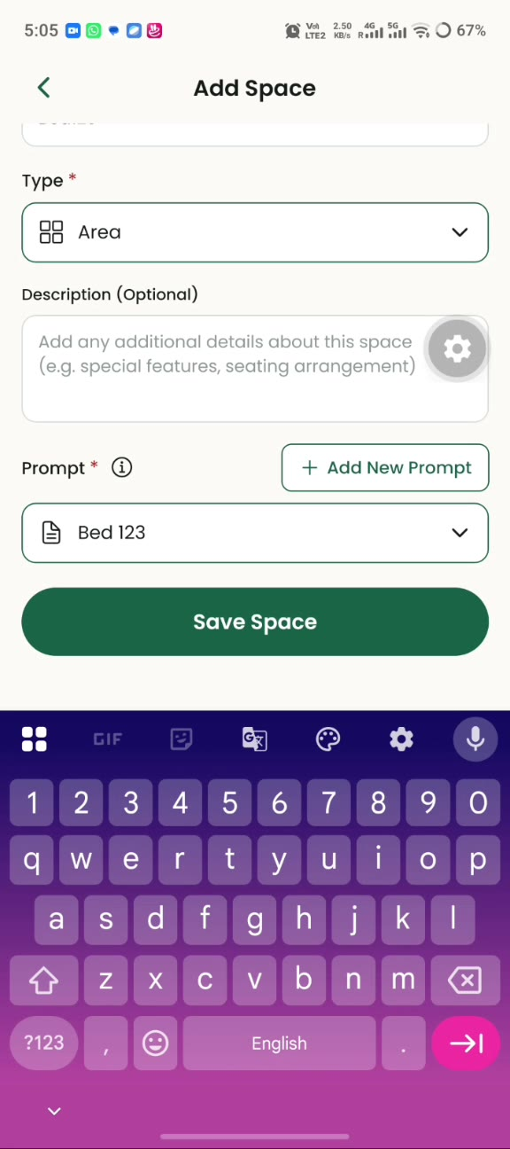 | Step 15  Select the prompt and save  The Prompt dropdown now shows your saved prompt. Tap Save Space to finish.
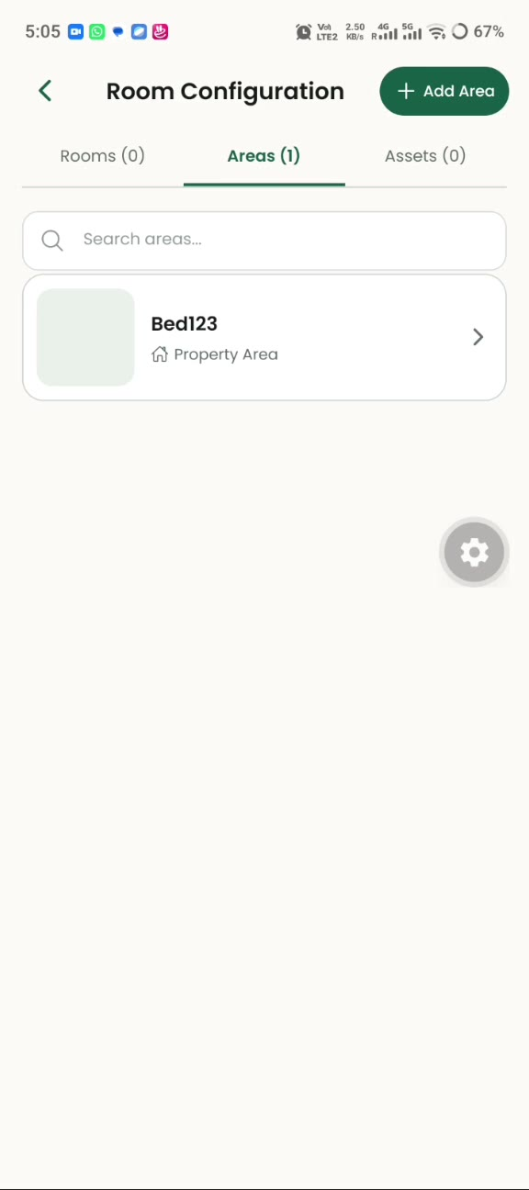 | Step 16  See your configured spaces  Room Configuration lists your spaces under the Rooms, Areas and Assets tabs, with a search box at the top. The new space appears under Areas.

Part 2: Worker
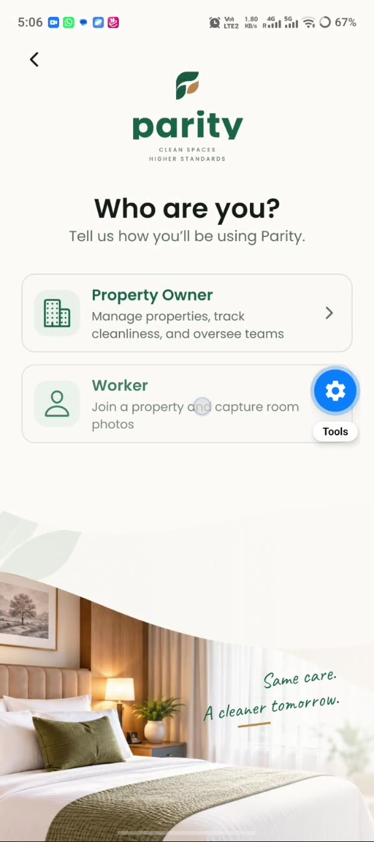 | Step 17  Choose “Worker”  Workers join a property that already exists. From the welcome screen tap Create an Account, then select Worker on the “Who are you?” screen.
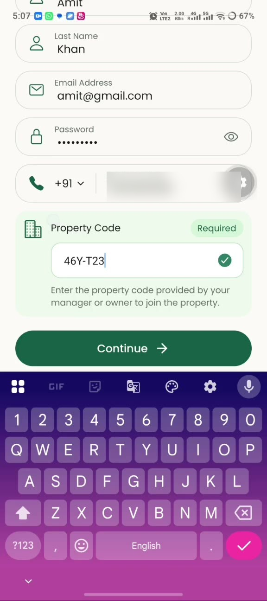 | Step 18  Create your worker account  Enter the same personal details as an owner, plus the Property Code.  - Get the property code from your manager or owner.  - A green tick appears when the code is accepted.  - Tap Continue.
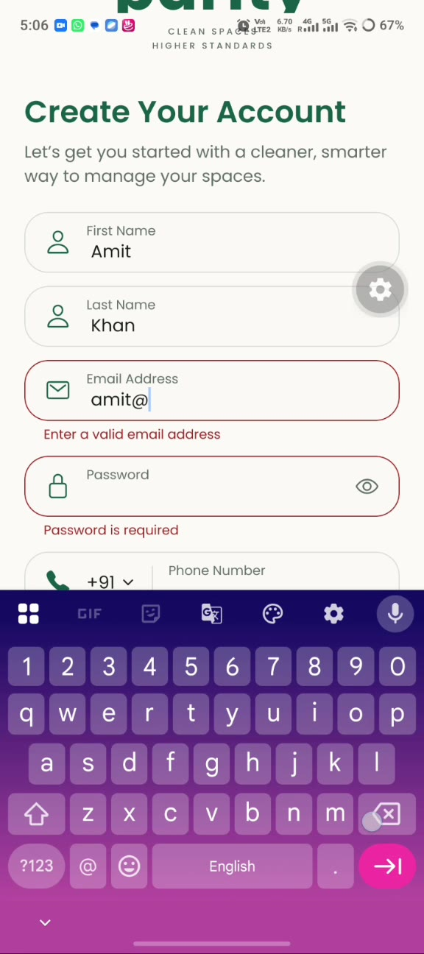 | Step 19  Fix any form errors  If something is missing or invalid, a red message appears under the field, for example “Enter a valid email address” or “Password is required”. Correct it and continue.
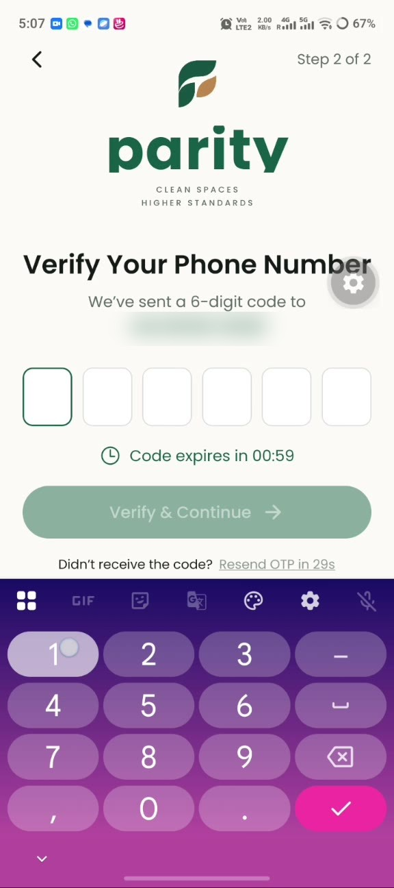 | Step 20  Verify your phone number  Enter the 6-digit code sent by SMS. It works the same way as in the owner flow, including the one-minute timer and Resend OTP.
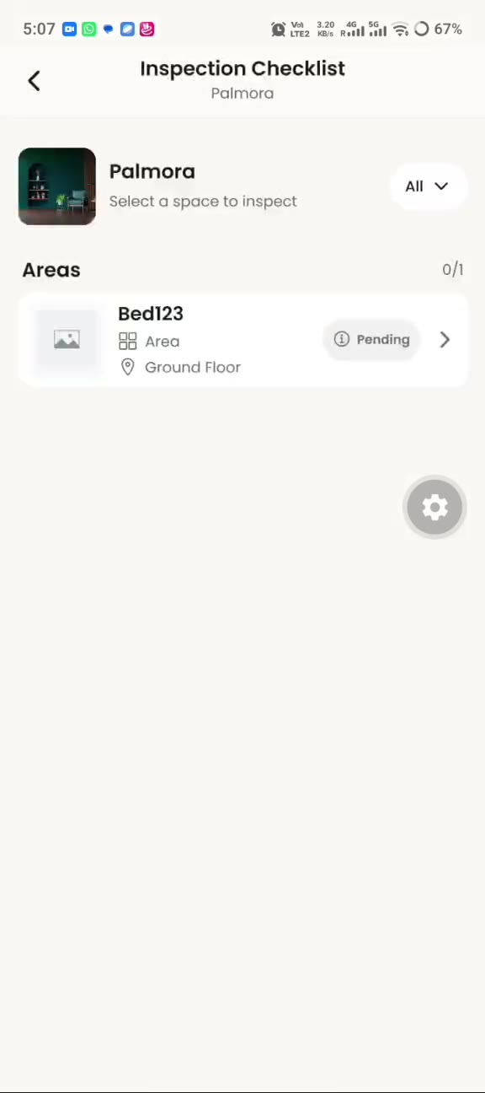 | Step 21  Open your inspection checklist  After sign-in you see the Inspection Checklist for your property.  - Spaces to inspect are listed under Areas with a status badge such as Pending.  - The filter at the top right narrows the list.  - Tap a space to start.
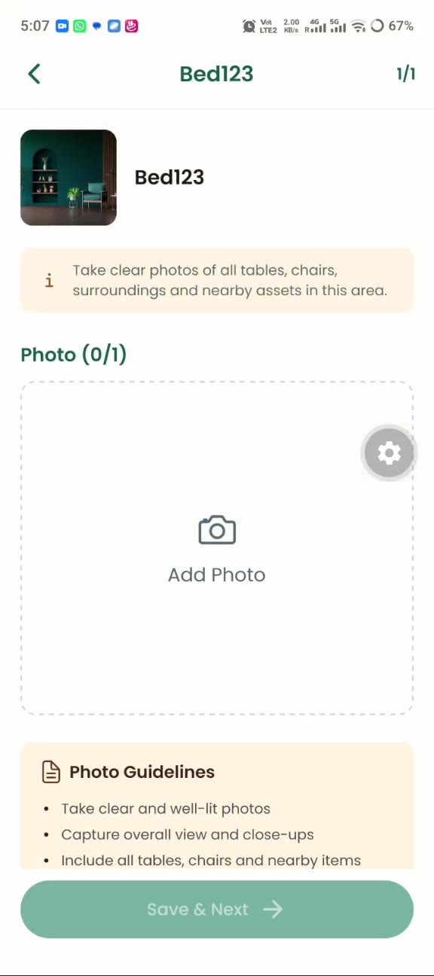 | Step 22  Read the photo instructions  The space screen explains what to capture: clear photos of all tables, chairs, surroundings and nearby assets.  - Photo guidelines: take clear, well-lit photos; capture an overall view and close-ups; include all tables, chairs and nearby items.  - Save & Next stays disabled until the required photo is added.
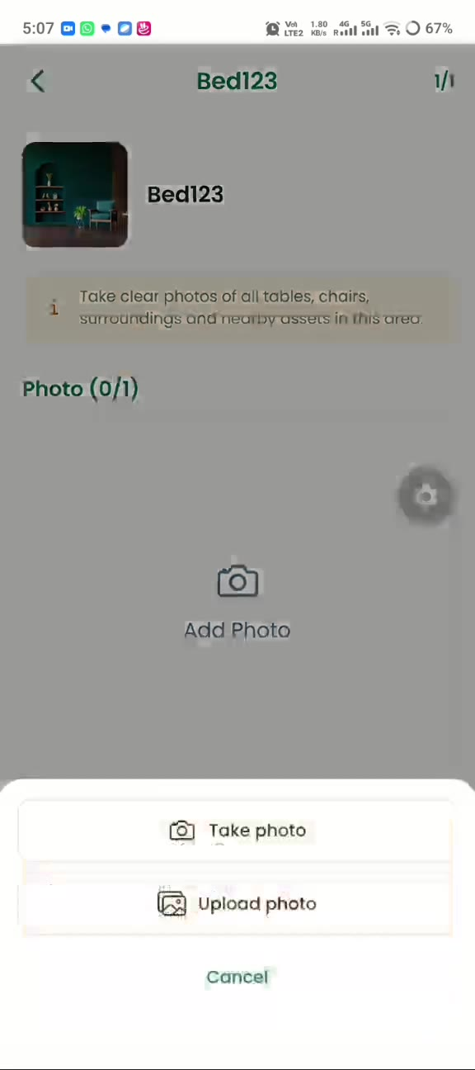 | Step 23  Take or upload a photo  Tap Add Photo, then choose Take photo to use the camera or Upload photo to pick one from your gallery.
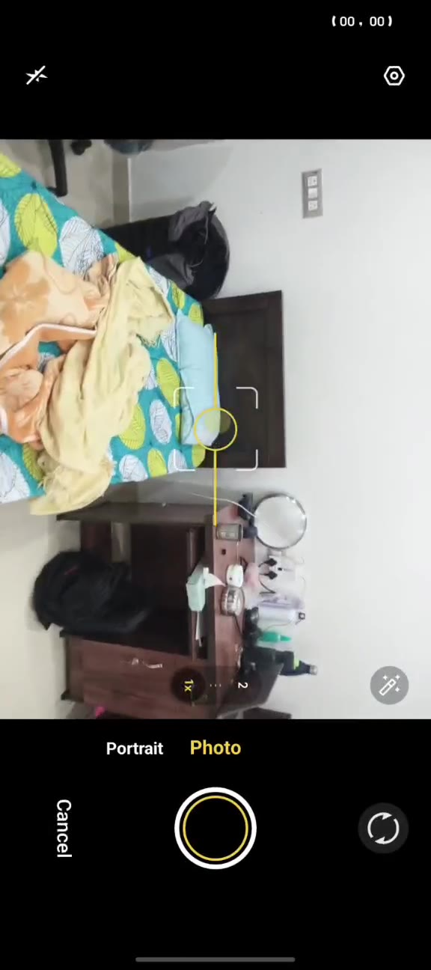 | Step 24  Capture the photo  Line up the whole space in the frame and tap the shutter button.
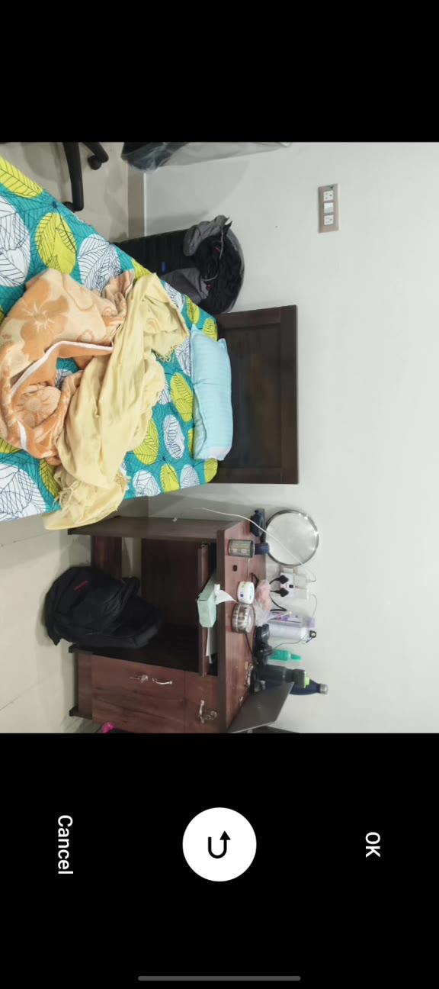 | Step 25  Keep or retake  After the shot, tap OK to use it or the retake arrow to try again.
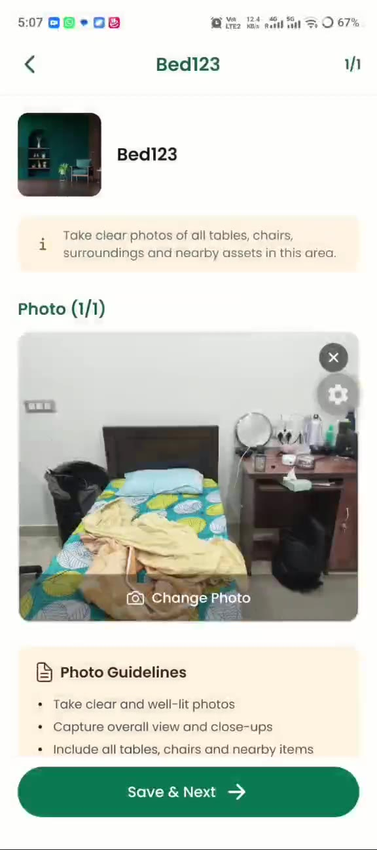 | Step 26  Save the photo  The photo appears in the photo box (1/1). Tap Change Photo to replace it, or Save & Next to submit it for inspection.
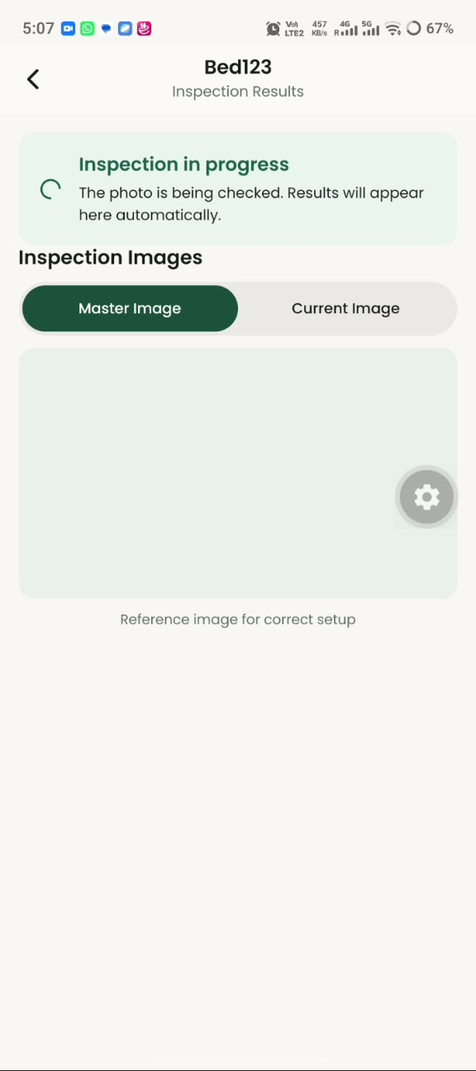 | Step 27  Wait for the inspection  The Inspection Results screen shows “Inspection in progress”. The results appear automatically; no action is needed.  - Switch between the Master Image and Current Image tabs. The master image is the reference for the correct setup.
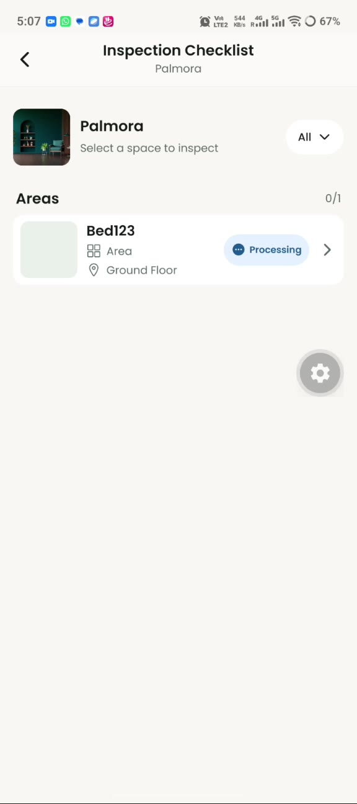 | Step 28  Check status on the checklist  Back on the checklist, the space shows a Processing badge while the photo is being checked.
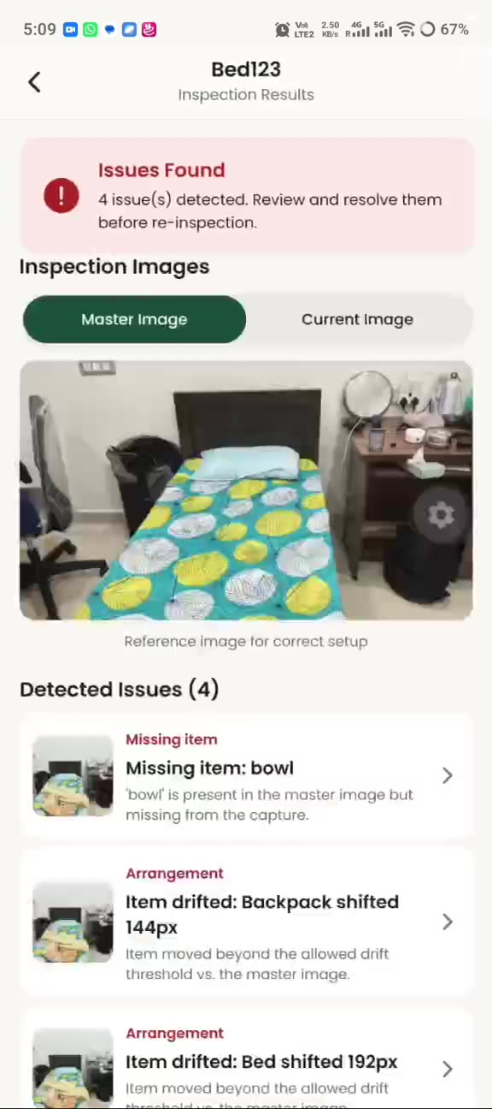 | Step 29  Review the result  When the check finishes, a red banner reports how many issues were found, for example “4 issue(s) detected. Review and resolve them before re-inspection.”
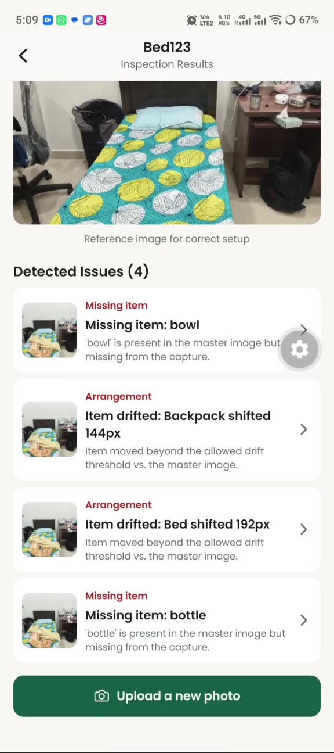 | Step 30  Go through the detected issues  Scroll to Detected Issues. Each card gives the type, a short title and an explanation; tap a card for details.  - Missing item: something in the master image is not in your photo (for example a bowl or bottle).  - Arrangement: an item moved beyond the allowed threshold (for example a backpack or the bed).  - Fix the problems, then tap Upload a new photo to re-inspect.
Tips for good inspections
- Take photos in good light and capture the whole space, then add close-ups.
- Frame the photo from the same angle each time so it can be compared fairly with the master image.
- Include tables, chairs and nearby items, since missing or moved items are what the inspection reports.
- After fixing the reported issues, use Upload a new photo to run the inspection again.

