Лекция 12

ПСКП

ПОИТ-3

**Node.js: MongoDB**

1. **MongoDB:** <https://metanit.com/nosql/mongodb/>

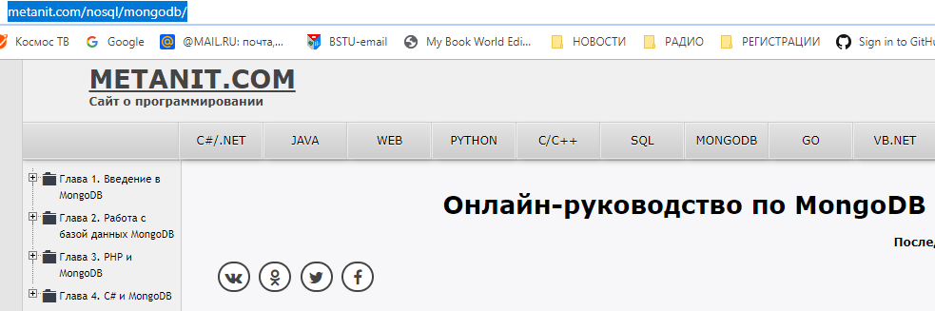

1. **MongoDB:** <https://metanit.com/web/nodejs/6.1.php>
2. **MongoDB:** <http://mongodb.github.io/node-mongodb-native/3.1/api/index.html>
3. **MongoDB:** <https://www.npmjs.com/package/mongodb>
4. **MongoDB:** <http://mongodb.github.io/node-mongodb-native/3.3/tutorials/connect/>
5. **MongoDB:** <https://www.npmjs.com/package/mongodb>
6. **MongoDB:** npm install mongodb
7. **MongoDB:** client, connect, db, collection, find



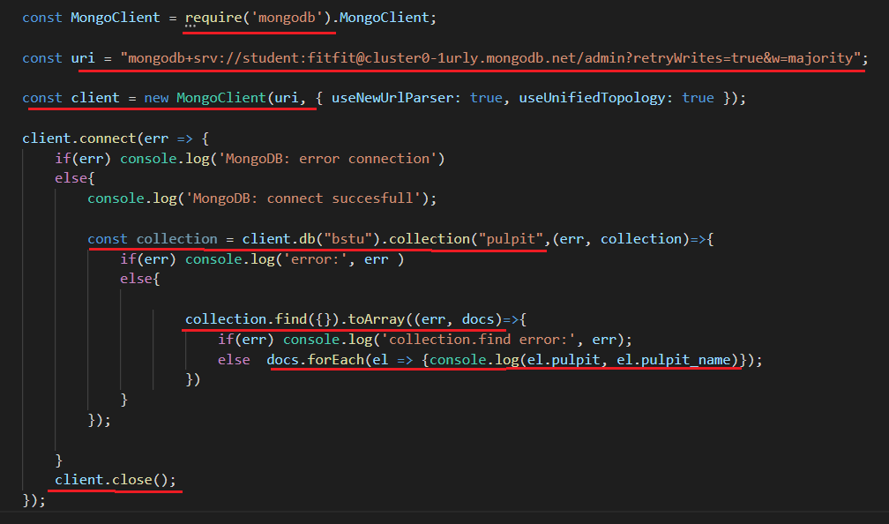

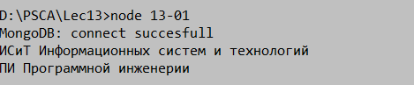

1. **MongoDB:** client, connect, db, collection, find, insertOne, insertMany



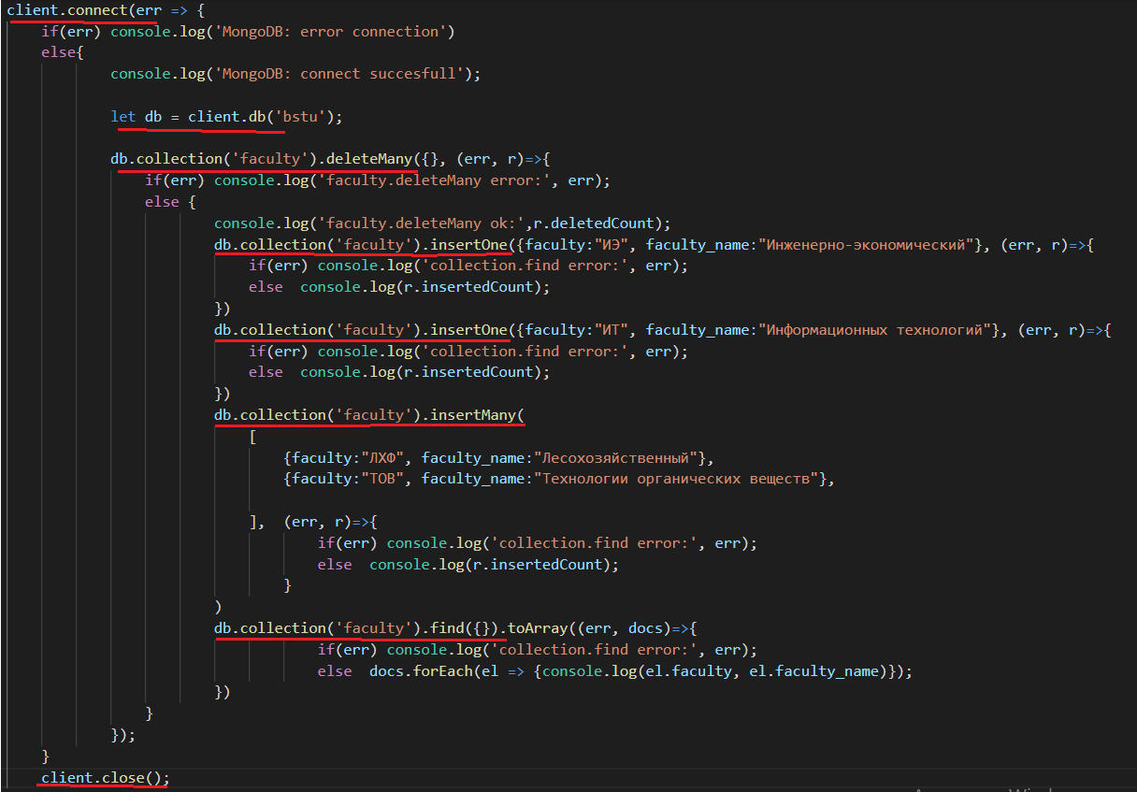

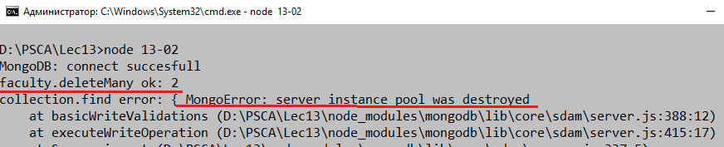

1. **MongoDB:** продолжение

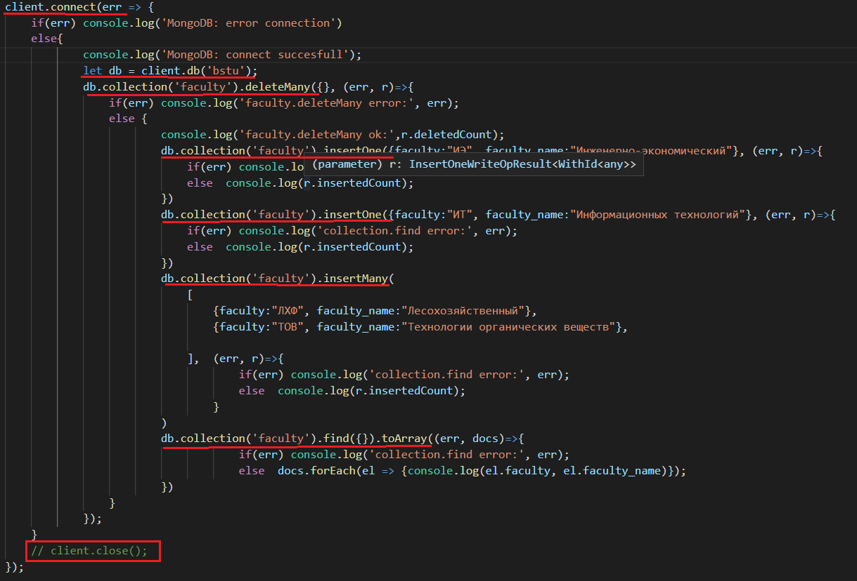

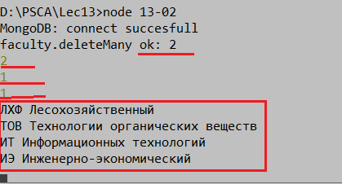

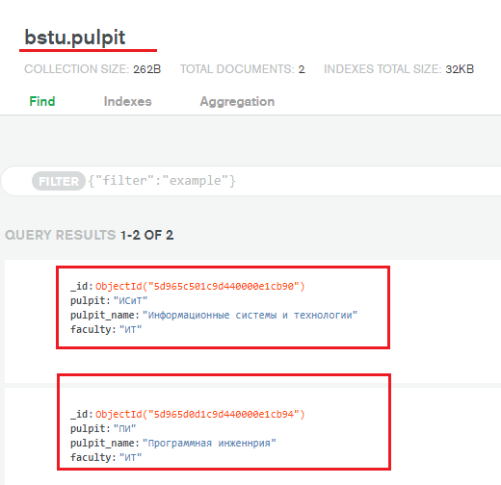

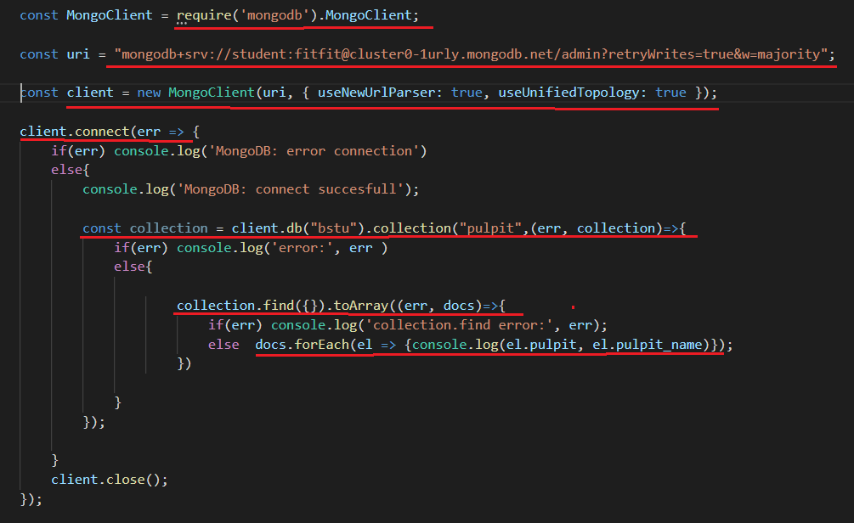

1. **MongoDB**:продолжение

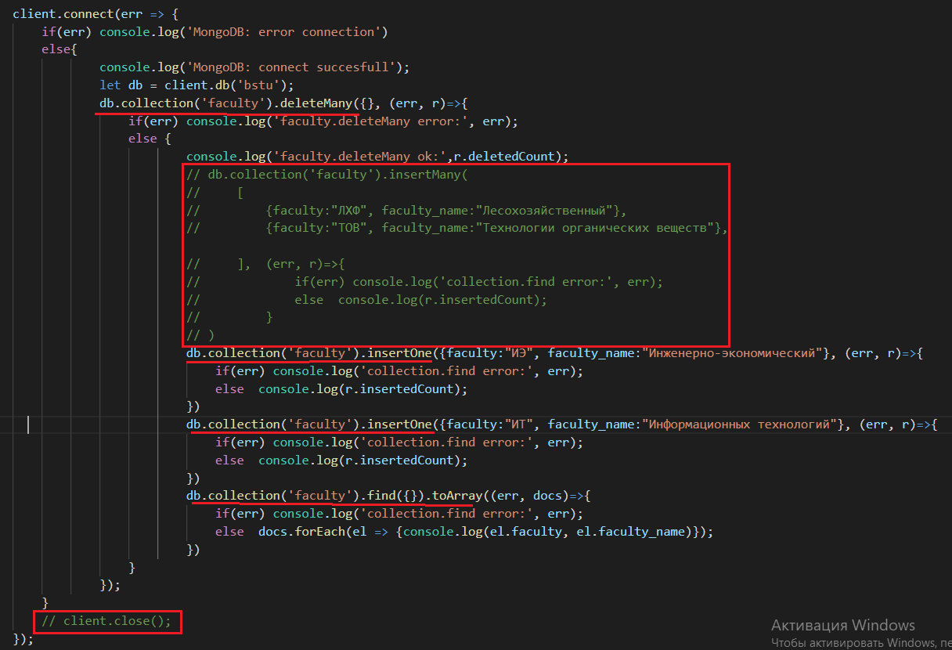

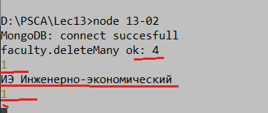



1. **MongoDB**: client, connect, db, collection, find, update

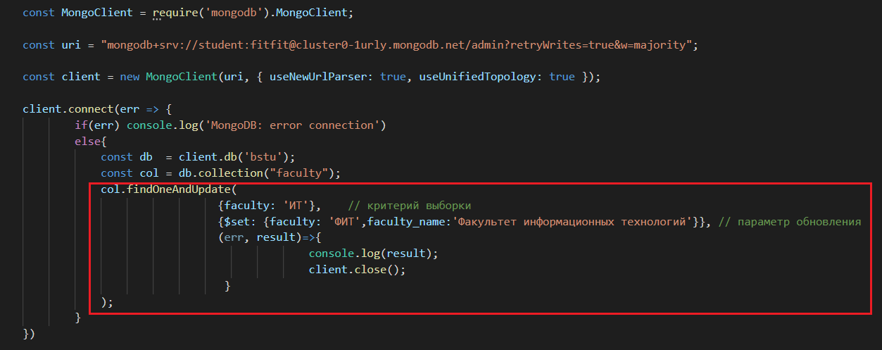

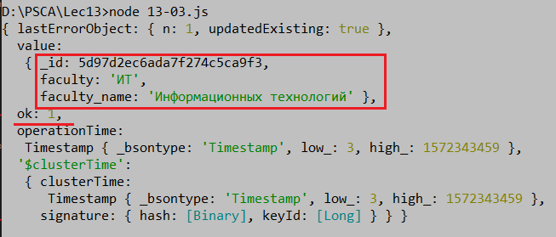

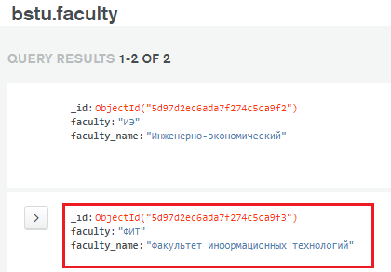

1. **MongoDB**: client, connect, db, collection, find, update, returnOriginal=false

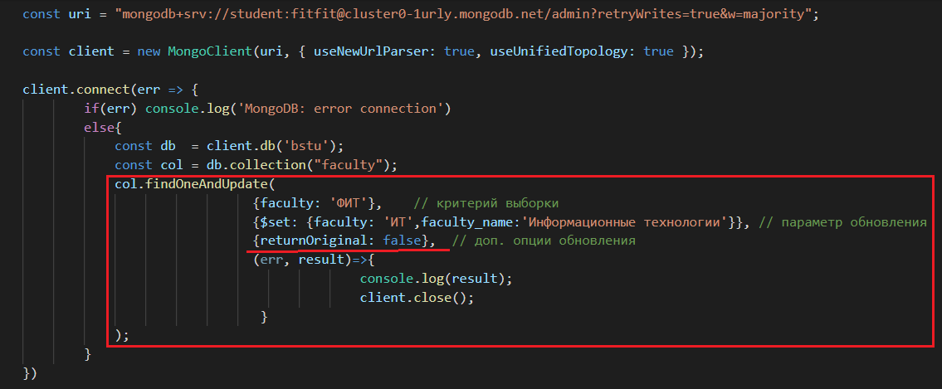

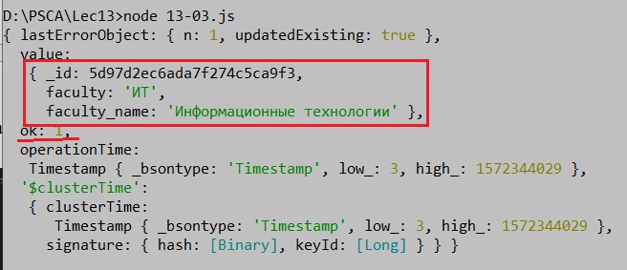

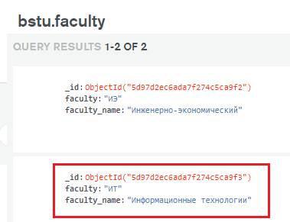

## Mongoose

**Odm object-document mapper**

1. **MongoDB:**
2. **MongoDB:**
3. **MongoDB:**
4. **MongoDB:**
5. **MSSQL:**