Core Security Concepts, Explained with Real-World Scenarios

1. The CIA Triad: Confidentiality, Integrity, Availability
The CIA Triad is the foundational model used to reason about what "security" actually protects. Every security control, policy, or attack can be described in terms of which of these three properties it defends or breaks:

Confidentiality
Information is only accessible to the people who are supposed to see it. Confidentiality is broken when data is exposed to, or read by, someone unauthorized — regardless of whether the data was changed.

Integrity
Information (and systems) remain accurate, complete, and unaltered except by authorized action. Integrity is broken when data is modified, corrupted, or tampered with — even if no one "stole" it.

Availability
Information and systems are accessible to authorized users when they need them. Availability is broken when a legitimate user cannot get to a resource, whether due to an attack, a failure, or an outage.
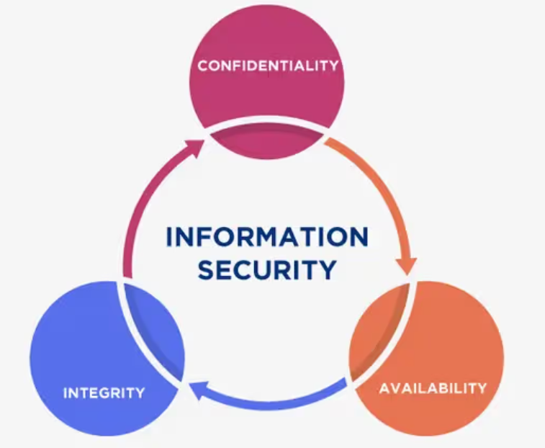

Scenario — An insider leaking a salary spreadsheet
What happened: An HR employee at a company exports the full employee salary spreadsheet and emails it to a friend at a rival firm, or accidentally shares it in a public Slack channel. No data is changed, and the system stays fully up and running.
Why it matters: This is a Confidentiality violation: sensitive information reached people who were never supposed to see it. Integrity and Availability are untouched (the data is accurate and everyone can still log in), which is exactly why access controls, least-privilege sharing, and data classification exist — Confidentiality can fail even when nothing is "broken" from a systems perspective.

2. Authentication vs. Authorization
These two terms are constantly confused because they usually happen back-to-back, but they answer different questions. Authentication answers "who are you?" — proving identity, typically via something you know (password), something you have (a security key or phone), or something you are (a fingerprint). Authorization answers "what are you allowed to do?" — it happens after identity is established, and determines which resources or actions that now-verified identity can access.
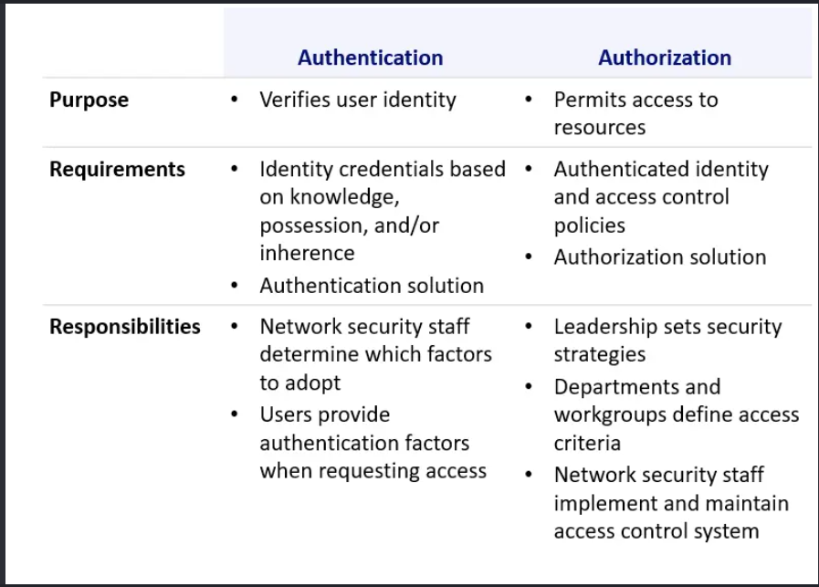

Scenario — A stolen but valid password (authentication succeeds, but shouldn't)
What happened: An employee's password is stolen through a phishing email. The attacker logs into the company VPN using the correct username and password. The system authenticates the attacker successfully because, as far as the system can tell, the correct credentials were presented.
Why it matters: This illustrates authentication working exactly as designed and still causing a breach — the system correctly verified "these are user X's credentials," but had no way to know the person typing them wasn't actually user X. This is precisely why multi-factor authentication (MFA) exists: it adds a second, independent factor (like a one-time code on a phone) so that a stolen password alone isn't enough to pass authentication.

3. Privilege vs. Permission
These two are closely related to authorization but describe different layers of "what you can do." A permission is a specific, granular right to perform an action on a specific resource (e.g., "read access to file X," "write access to database table Y"). A privilege is a broader, often system-level capability granted to an account or role, frequently independent of any single resource (e.g., "install software," "create new user accounts," "shut down the server," "bypass file permission checks entirely" as with a root/administrator account). In short: permissions are about specific resources; privileges are about system-wide powers, and high privilege can often override or ignore individual permissions.
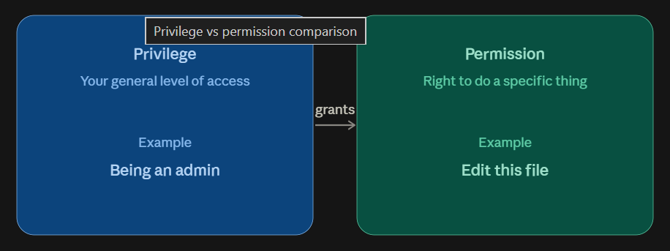

Scenario — Overly generous file-share permissions
What happened: A new employee is added to the "All-Staff" security group so they can access the company intranet. That group, set up years earlier, also happens to have read permission on a shared drive folder containing unreleased financial reports — nobody remembers configuring that, but it was never cleaned up. The employee, with completely ordinary, non-privileged account rights, stumbles onto the reports simply by browsing the shared drive.
Why it matters: Here the problem is purely at the permission layer — a specific resource (one folder) has an access-control entry that's too broad. No elevated system privilege was involved at all; a totally ordinary user account exposed sensitive data because of permission misconfiguration on that resource. This distinction matters operationally: fixing this requires an access review of file/folder permissions, not a review of who holds administrator privilege.

4. Hashing vs. Encryption vs. Encoding
All three transform data, which is why they're mixed up so often, but they exist for entirely different purposes and only one of them is reversible by design in the way people usually assume:

Hashing
A one-way mathematical function that turns data into a fixed-length value (a "hash" or "digest"). It is deliberately irreversible — you cannot get the original input back from the hash — and used to verify integrity or to store secrets (like passwords) without keeping the original value at all.

Encryption
A two-way, reversible transformation that uses a key to make data unreadable to anyone without that key, and readable again (decrypted) by anyone who has it. Its purpose is confidentiality — keeping data secret from unauthorized parties while still allowing authorized parties to get the original data back.

Encoding
A reversible transformation with no secret key at all, used purely to represent data in a different format for compatibility (e.g., Base64 turning binary data into safe-to-transmit text). Encoding provides zero security — anyone can decode it with a public, well-known algorithm — it's a data-format convenience, not a protection mechanism.
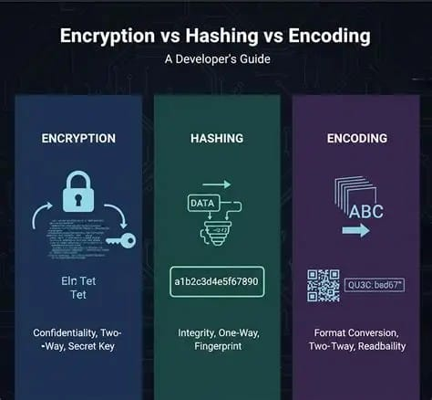

Scenario — Mistaking Base64 encoding for real protection
What happened: A developer building an internal API needs to send an API key and other configuration in a URL, so they Base64-encode it, and afterward describe it in a design document as "the key is encrypted before being sent." A security reviewer takes the resulting Base64 string, runs it through any online Base64 decoder with zero effort, and instantly reads the plaintext API key.
Why it matters: This is the most common real-world mistake involving these three concepts: Base64 is encoding, not encryption — it uses a fixed, public, and universally known algorithm with no secret key, so it provides literally no confidentiality at all; it only exists to make binary-safe data transportable as text. The scenario matters because this exact mistake shows up constantly in real audits and CTFs — data that "looks" scrambled and unreadable at a glance, but is actually one click away from being fully exposed, because encoding was mistaken for a security control.

