TryHackMe Networking Rooms — Completion Report
https://tryhackme.com/p/tvshashwanth
This report documents the completion of TryHackMe rooms covering the fundamentals of computer networking and basics of cybersecurity

Room 1: "What is Networking?"

Step-by-Step Account :
- Started the room and read Task 1 "What is Networking?" , which introduced the idea that a network is simply a collection of connected things , in computing, devices connected together (nodes),using everyday examples such as public transport systems
- Then I completed the first set of questions and started the second task
- I read the second task and Answered the question on who invented the World Wide Web by supplying Tim Berners
- The picture given below is based on the completion of task 2
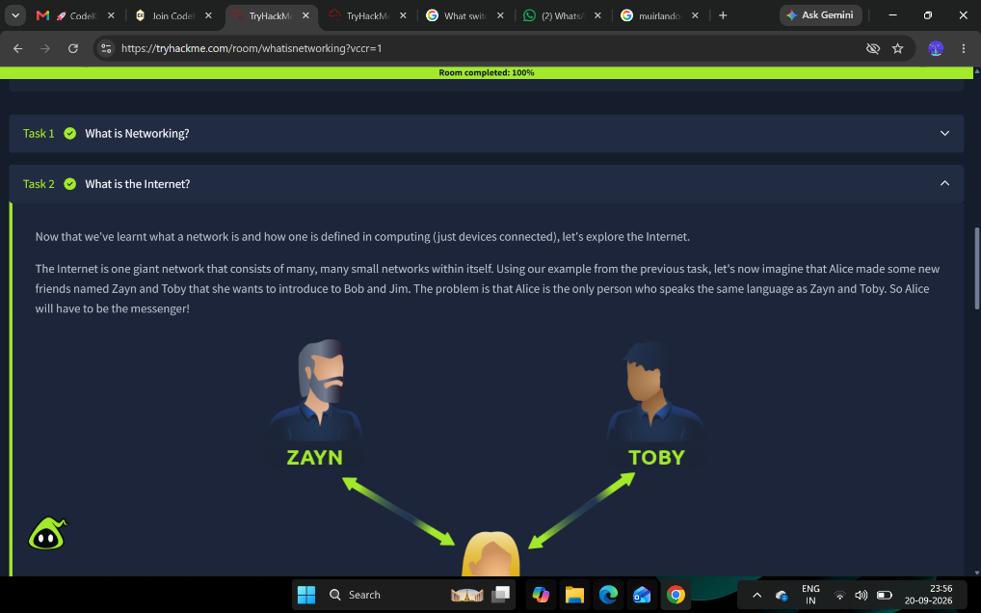

- Then Studied the third task explaining the two ways a device is identified on a network: an IP (internet protocol) address and a MAC (media access control) address
- Learnt the breakdown of an IPv4 address into four octets, and the explanation of public vs. private IP addresses
- Noted the comparison between IPv4 and IPv6 , and why IPv6 was introduced to address IPv4 exhaustion.
- Read the explanation of MAC addresses as a 12-character hexadecimal identifier burned into a device's network interface card, and how this address can be "spoofed" (impersonated) to defeat security controls that trust a device based on its MAC address.
- Used the room's interactive lab, which simulates a hotel Wi-Fi captive portal that only allows traffic from a MAC address that has "paid" for access. Used the lab given in the room to change the client's MAC address to match the address that was permitted through and successfully spoofed it .
- Answered the follow-up questions on this task and moved to task 4
- 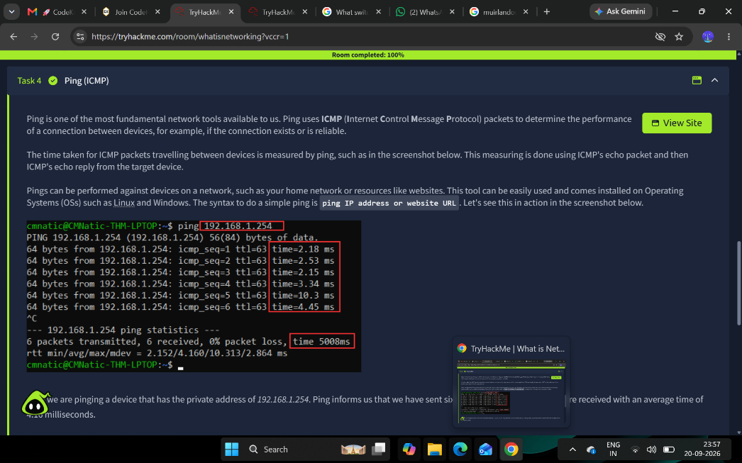
- Moved on to the fourth and final task on the ping utility, which uses ICMP (Internet Control Message Protocol) to test whether a connection to a remote host exists and how responsive it is.
- Used the given lab machine to run a ping against 8.8.8.8 as instructed, and read the returned output to retrieve the task's flag.
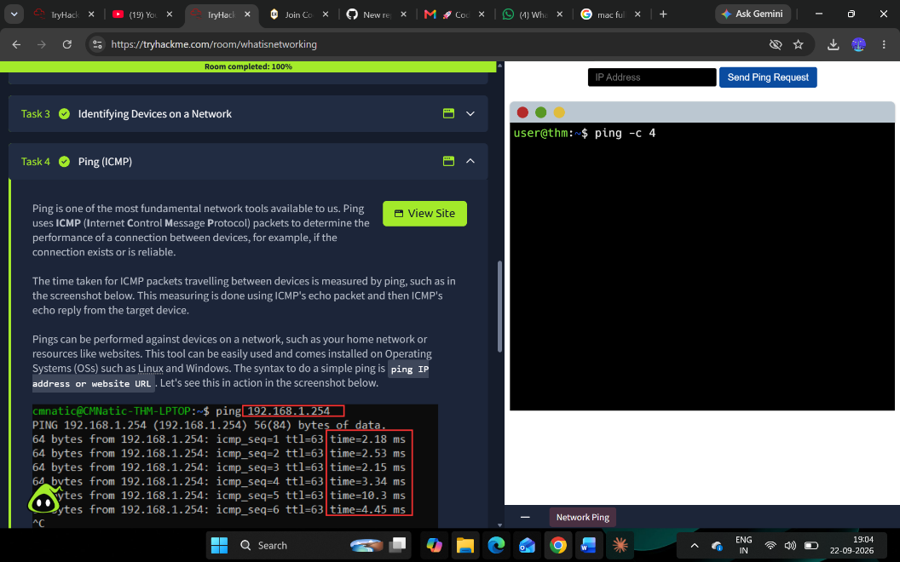
- Answered the remaining questions: the protocol ping uses (ICMP) and the correct syntax for pinging a target address.
- Completed the room by finishing the final read-through task, completing the room .
- 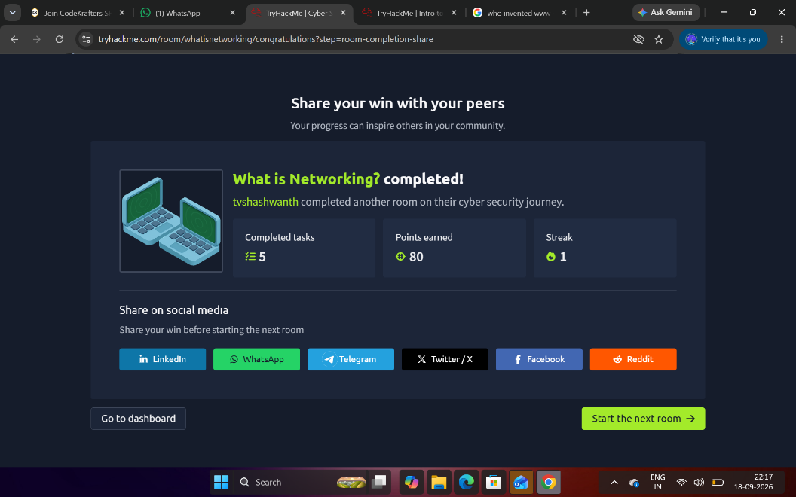

What I Learned :
- A network is any set of devices (nodes) connected so they can communicate, and the Internet itself is just a very large network made up of many smaller private networks joined by public infrastructure.
- Every networked device is identified in two complementary ways: a logical IP address and a physical MAC address .
- IPv4 addresses are written as four octets and are limited to roughly 4.3 billion unique values, which is why IPv6 with a vastly larger address space was introduced as device numbers grew.
- MAC addresses, despite being "burned in" at manufacture, are not a trustworthy security control on their own because they can be spoofed,systems that grant access purely on MAC address (such as some guest Wi-Fi setups) can be bypassed by an attacker who impersonates an allowed address.
- The ping utility is a fundamental diagnostic tool that uses ICMP echo request/reply packets to check both connectivity and latency between two devices, and it works the same way across virtually all operating systems.
- At the end of the room (what is networking?) I was able to clearly understand what basics of networking looks like.

Room 2: "Intro to Networking" (Introductory Networking)

Step-by-Step Account :
- Opened the room and read the introductory task, which outlined the four topics to be covered: the OSI model, the TCP/IP model, how the two models relate in practice, and a set of basic command-line networking tools.
- Worked through the task explaining all seven layers of the OSI model in descending order - Application, Presentation, Session, Transport, Network, Data Link, and Physical. reading the specific responsibility of each layer
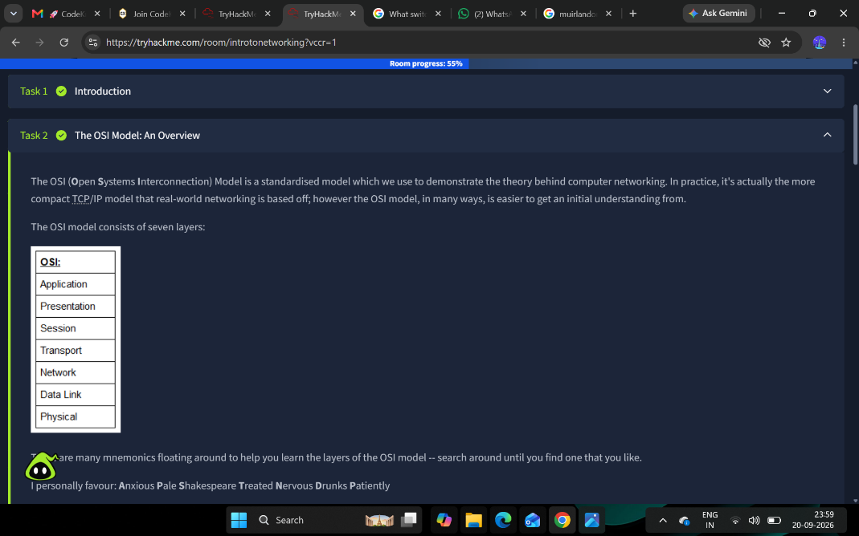

- Answered the set of "which layer" questions by matching each described function to its correct OSI layer number, and identified TCP segments as the "bite-sized pieces" of TCP data.
- Read the task on encapsulation and de-encapsulation, learning how data changes name at each layer as it is wrapped for transmission (data → segment/datagram → packet → frame → bits) and unwrapped again by the receiving computer.
- Studied the TCP/IP model as the four-layer, real-world counterpart to the OSI model (Application, Transport, Internet, Network Interface) and worked through how its layers map onto the seven OSI layers.
- Read the explanation of the TCP three-way handshake (SYN → SYN-ACK → ACK) used to establish a reliable, connection-based TCP session before any data is transferred.
- Moved into the practical tools section (for using practical tool I had to download ubuntu and linux wsl to work on ) and used the ping command against the target address supplied in the task to record its IPv4 address and read the man page to find the switches for adjusting the ping interval, restricting the tool to IPv4, and enabling verbose output.
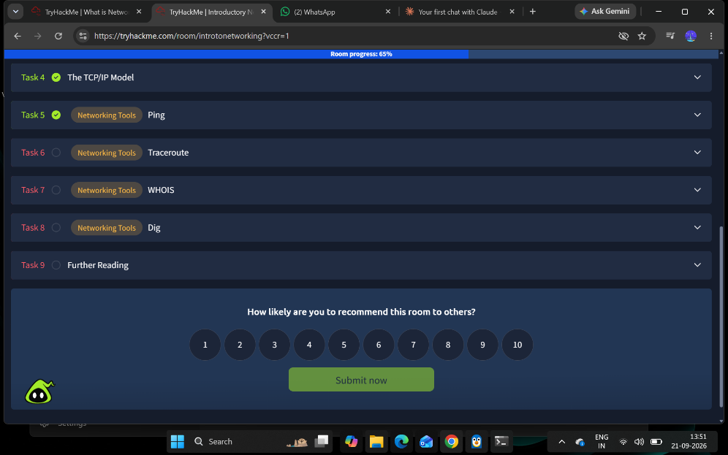

- Ran traceroute against tryhackme.com from the terminal to observe every intermediate hop the request passed through on its way to the destination server, then consulted the traceroute man page to find the switches for specifying a network interface and for using TCP SYN-based probes instead of the default protocol.
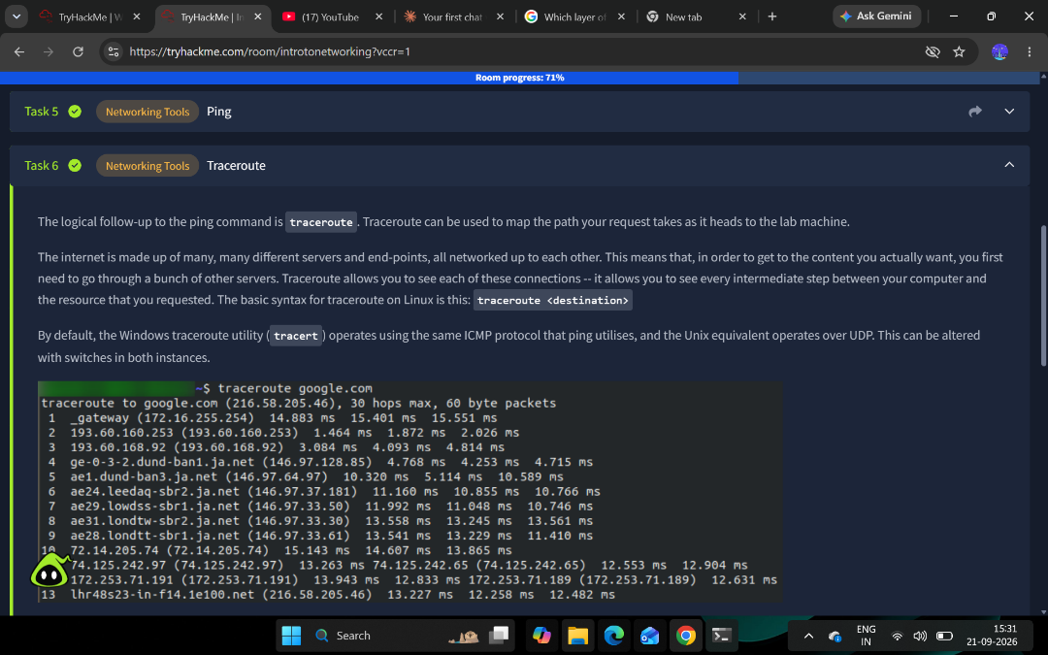
- Performed whois lookups against facebook.com and microsoft.com from the command line, reading the registrant and nameserver information returned to answer questions about registration dates, registrant location, and contact details listed in the WHOIS record.
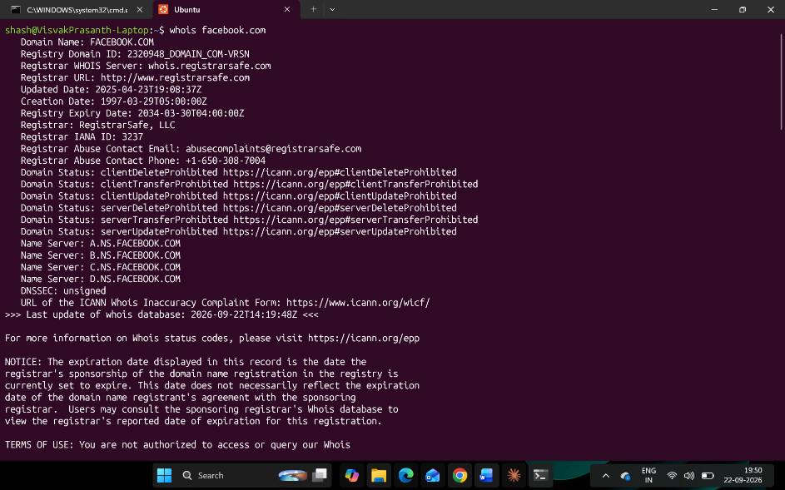

- Completed the final task on DNS by reading how a domain lookup travels from the local hosts file and cache, to a recursive resolver, to a root name server, to a Top-Level Domain (TLD) server, and finally to the Authoritative name server that holds the actual record.
- Ran dig against a domain to see a live DNS query and answer section in practice, and used it to answer the task's questions on DNS terminology, the order servers are queried in, and how to interpret a returned Time To Live (TTL) value.
- Finished the room by reading the closing "final thoughts" summary, completing the room .
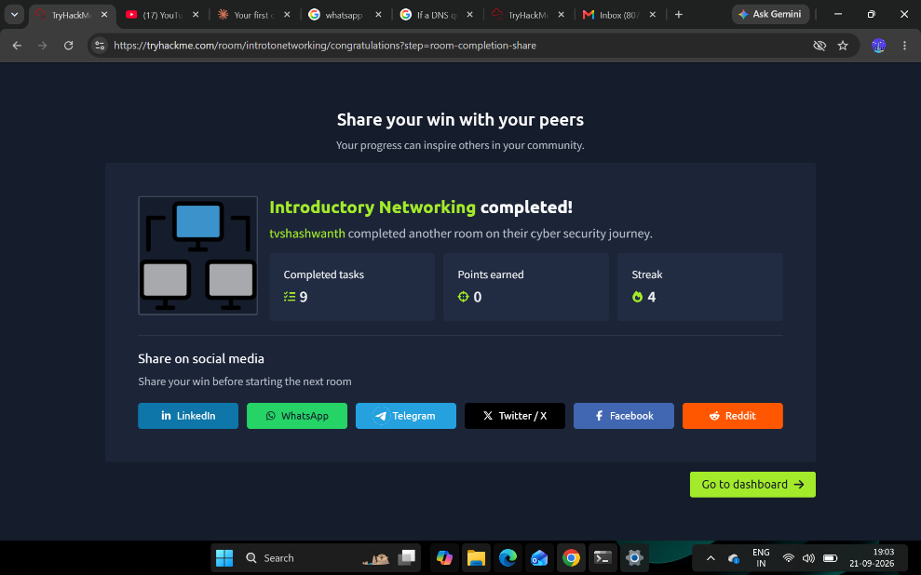

What I Learned :
- The OSI model is a seven-layer theoretical framework (Application, Presentation, Session, Transport, Network, Data Link, Physical) used to reason about networking, while the four-layer TCP/IP model is what real-world networking is actually built on; the two map onto each other even though they split responsibilities differently.
- Data is progressively wrapped with layer-specific headers as it moves down the model — becoming a segment/datagram, then a packet, then a frame, then raw bits — and this encapsulation is reversed (de-encapsulation) by the receiving device; the Data Link layer's trailer also provides a basic integrity/security check.
- TCP is a connection-oriented protocol that must establish a session via the three-way handshake (SYN, SYN-ACK, ACK) before transferring data reliably, whereas UDP is connectionless and prioritises speed over guaranteed delivery — which is why UDP suits live video/streaming and TCP suits file transfer or web pages.
- Command-line tools map directly onto the models covered: ping and traceroute rely on ICMP, and each has switches (interval, protocol version, verbosity, interface, probe type) that make them useful troubleshooting tools rather than just "is it up" checks.
- WHOIS lookups reveal who registered a domain and when, which is valuable both for legitimate administration and for open-source intelligence gathering, though privacy redaction varies by region.
- DNS resolution follows a defined hierarchy — local hosts file/cache, then a recursive resolver, then root servers, then TLD servers, then the authoritative name server for the specific domain — and the TTL value returned with a DNS answer tells a resolver how long it may cache that answer before it needs to ask again.

