Security Speherd

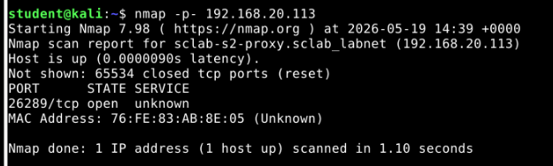
step0
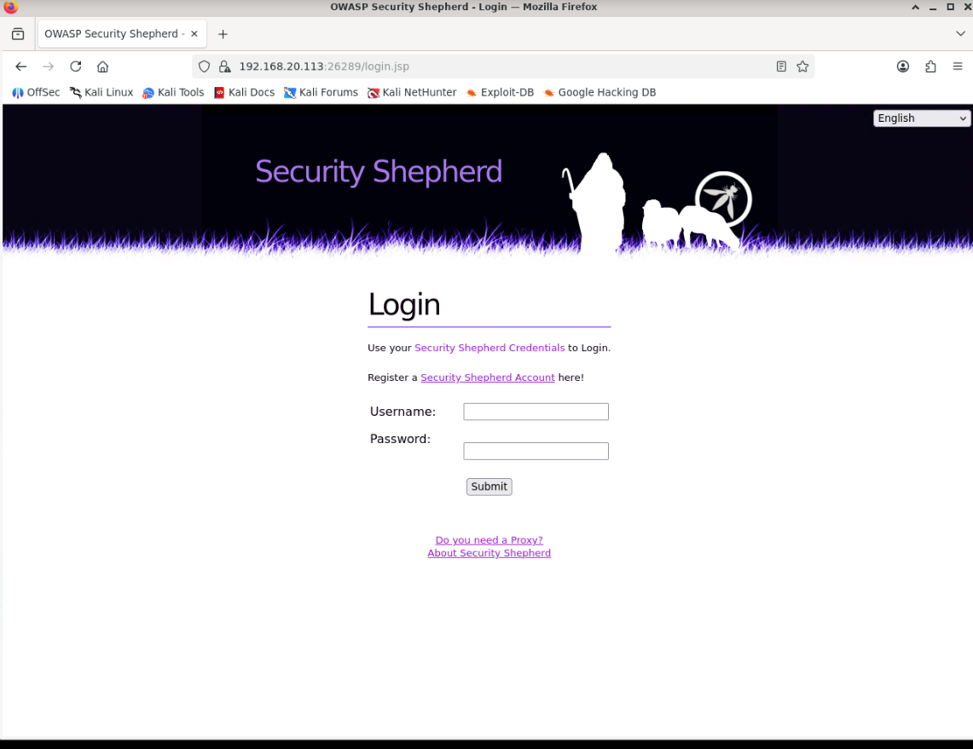
step1- register
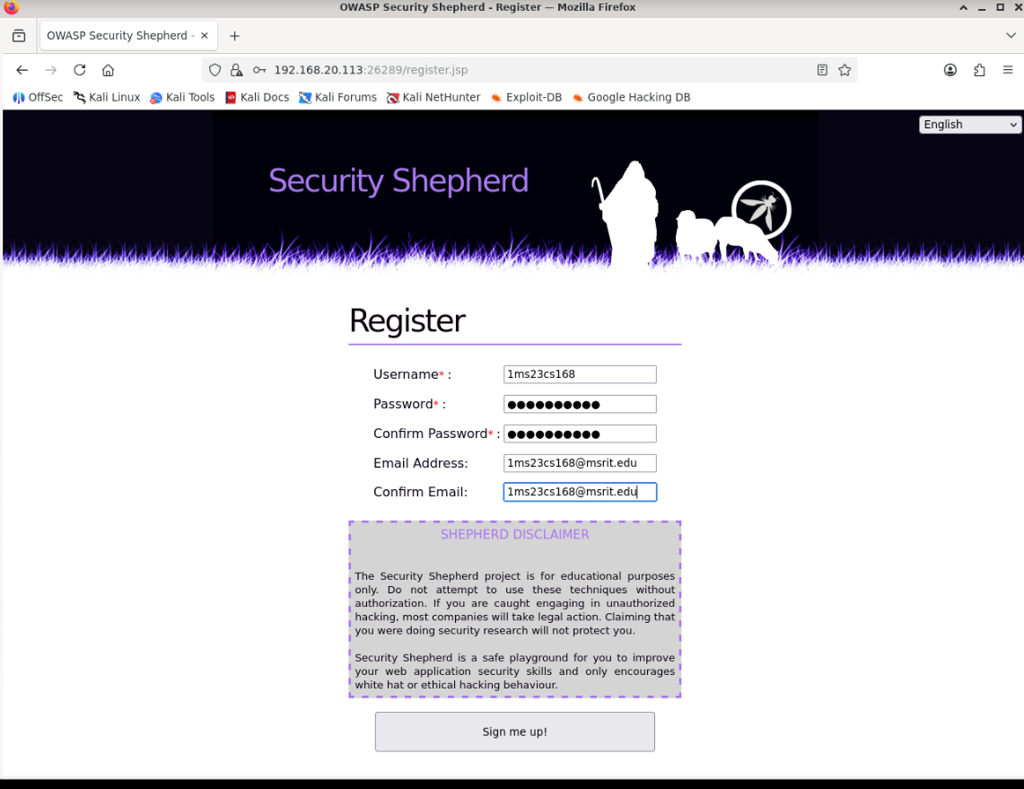
step2- login after login click on nxt challenge

Challenge1-Broken auth d session mgt

press f12 then move to storage tab, click on cookies go to whatever ur ip here pointed out with blue clr

Name value
lessoncomplete lessonnotcomplete
change value to lessonComplete nd then leave
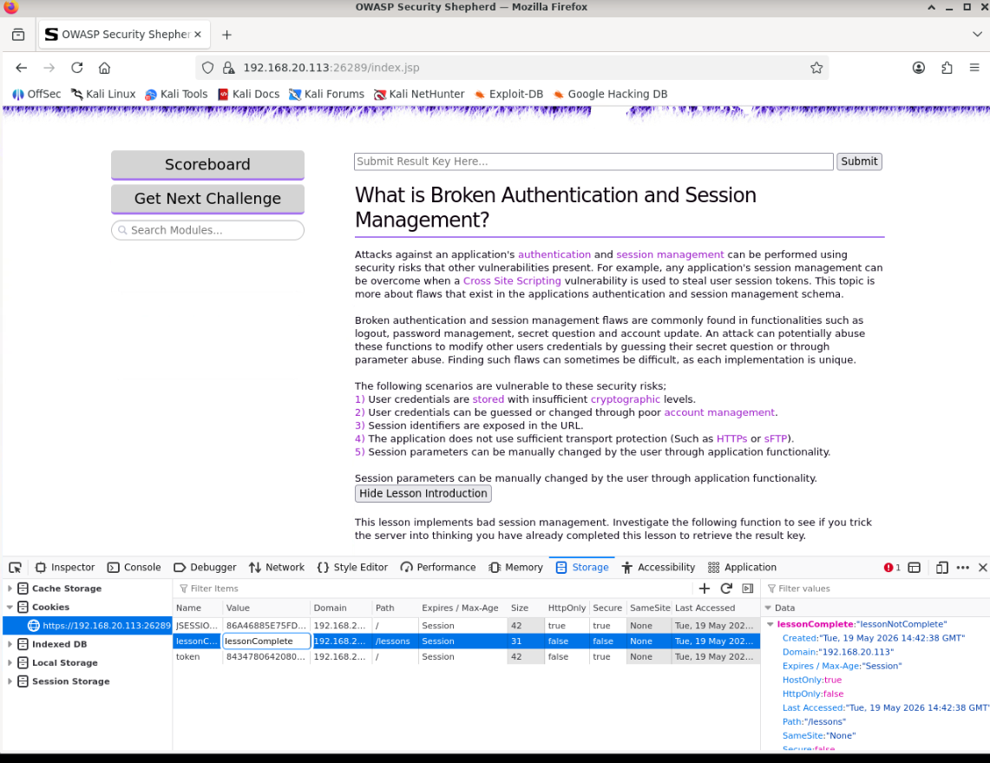
nd press complete this lesson after that res key genrated copy it
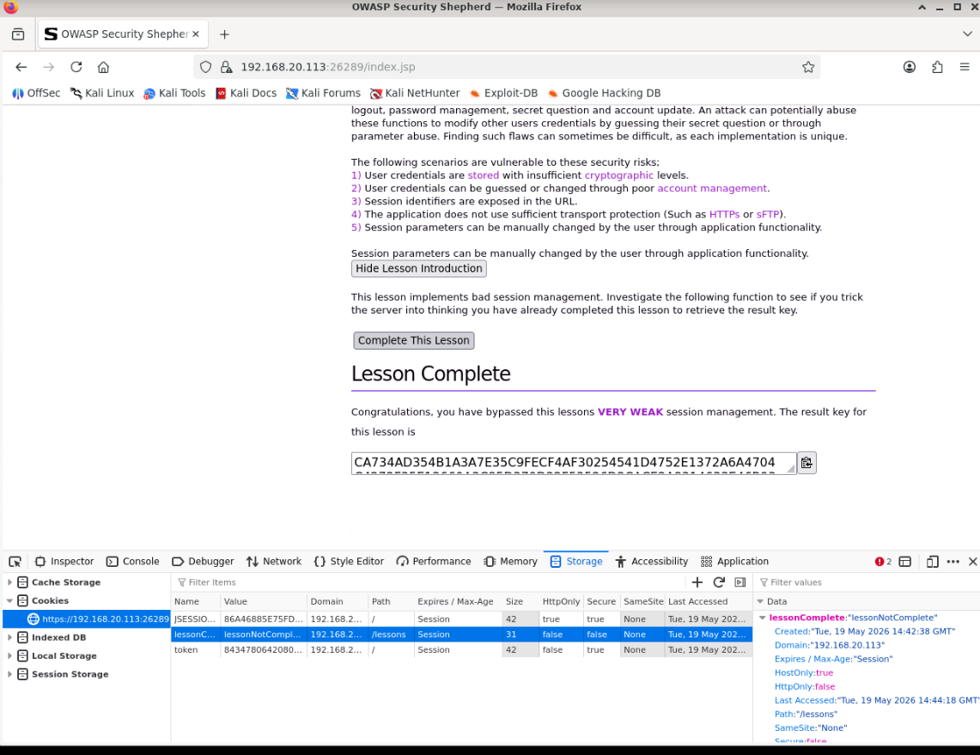
put res key in respective bar nd submit nd get nxt challenge
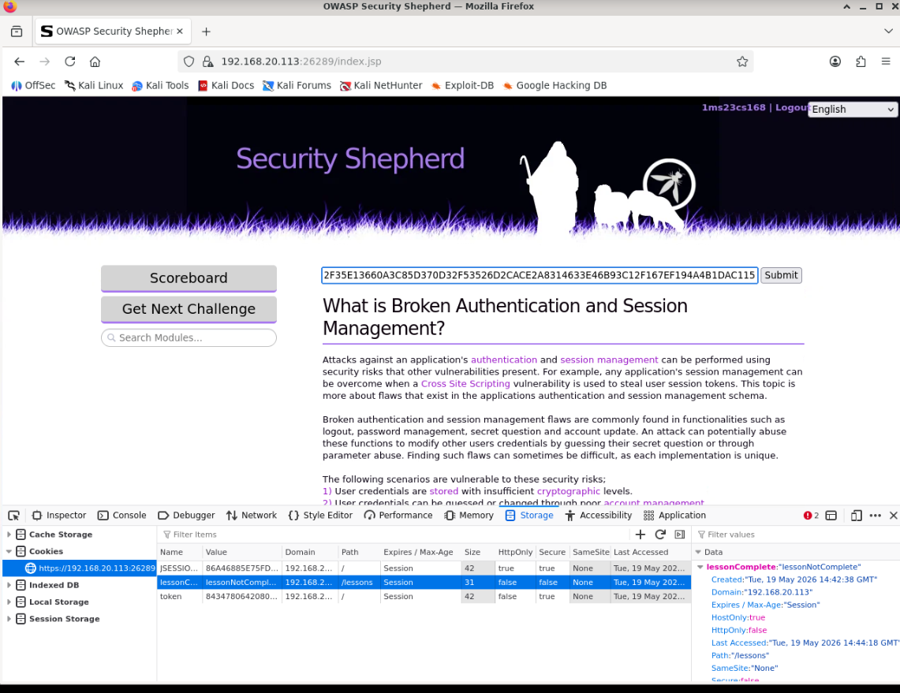
CVSS v3.1 Metrics

Metric Value

Attack Vector (AV) Network (N)
Attack Complexity (AC) Low (L)
Privileges Required (PR) None (N)
User Interaction (UI) None (N)
Scope (S) Unchanged (U)
Confidentiality (C) Low (L)
Integrity (I) High (H)
Availability (A) None (N)

CVSS Vector String

CVSS:3.1/AV:N/AC:L/PR:N/UI:N/S:U/C:L/I:H/A:N

https://nvd.nist.gov/vuln-metrics/cvss/v3-calculator?vector=AV:N/AC:L/PR:N/UI:N/S:U/C:L/I:H/A:N&version=3.1

challeneg 2 XSS

copy the respective 1st cmd d put search bar shown below

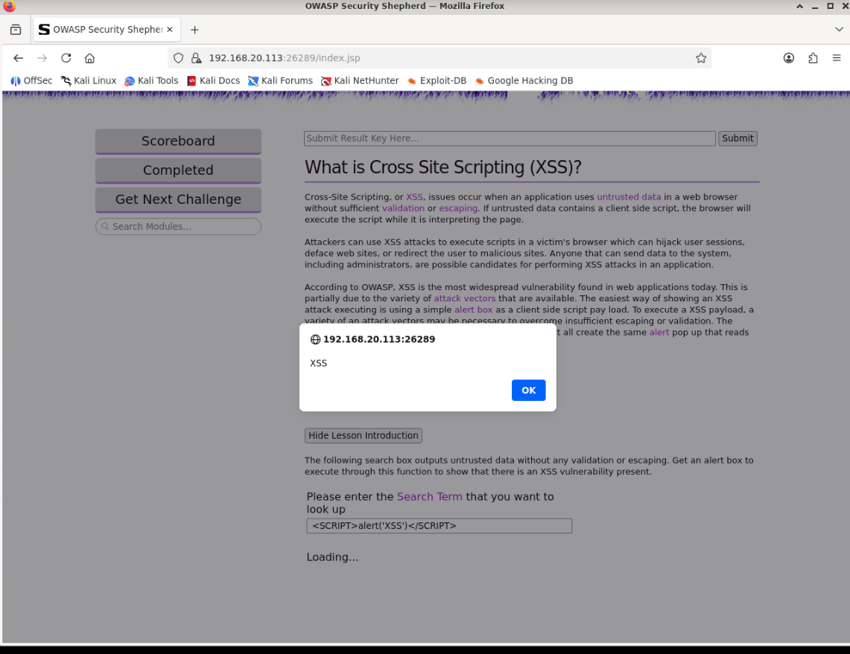
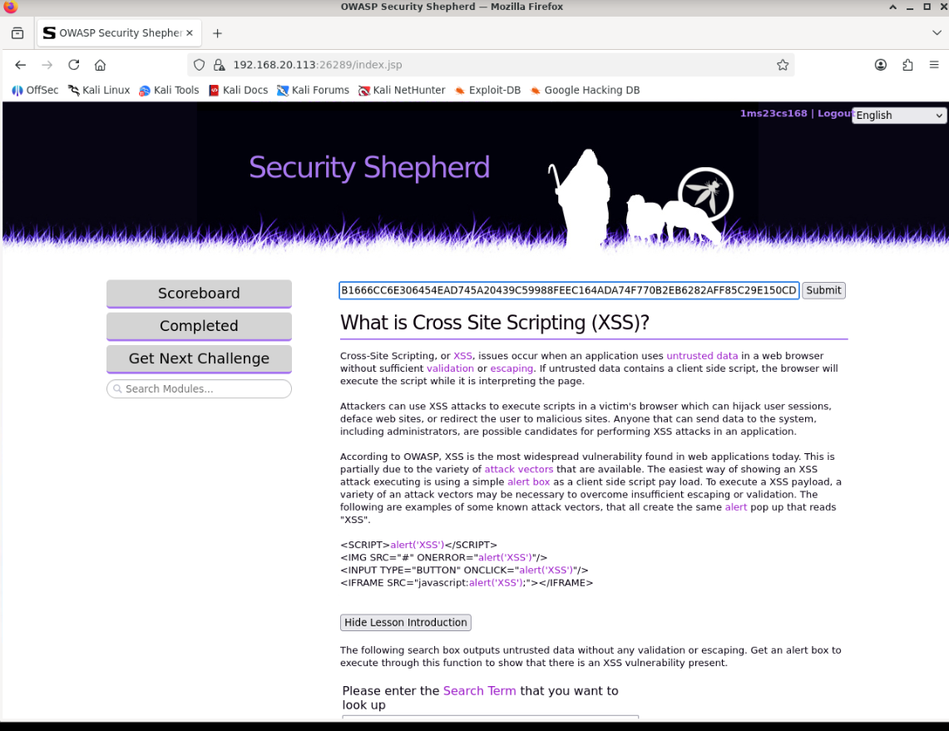
CVSS v3.1 Metrics

Metric Value

Attack Vector (AV) Network (N)
Attack Complexity (AC) Low (L)
Privileges Required (PR) None (N)
User Interaction (UI) Required (R)
Scope (S) Changed (C)
Confidentiality (C) Low (L)
Integrity (I) Low (L)
Availability (A) None (N)

CVSS Vector String

CVSS:3.1/AV:N/AC:L/PR:N/UI:R/S:C/C:L/I:L/A:N

https://nvd.nist.gov/vuln-metrics/cvss/v3-calculator?vector=AV:N/AC:L/PR:N/UI:R/S:C/C:L/I:L/A:N&version=3.1

challenege 3 – Cross site scripting one
copy cmd put on res bar shown below
<img src=x onerror=alert(XSS)>
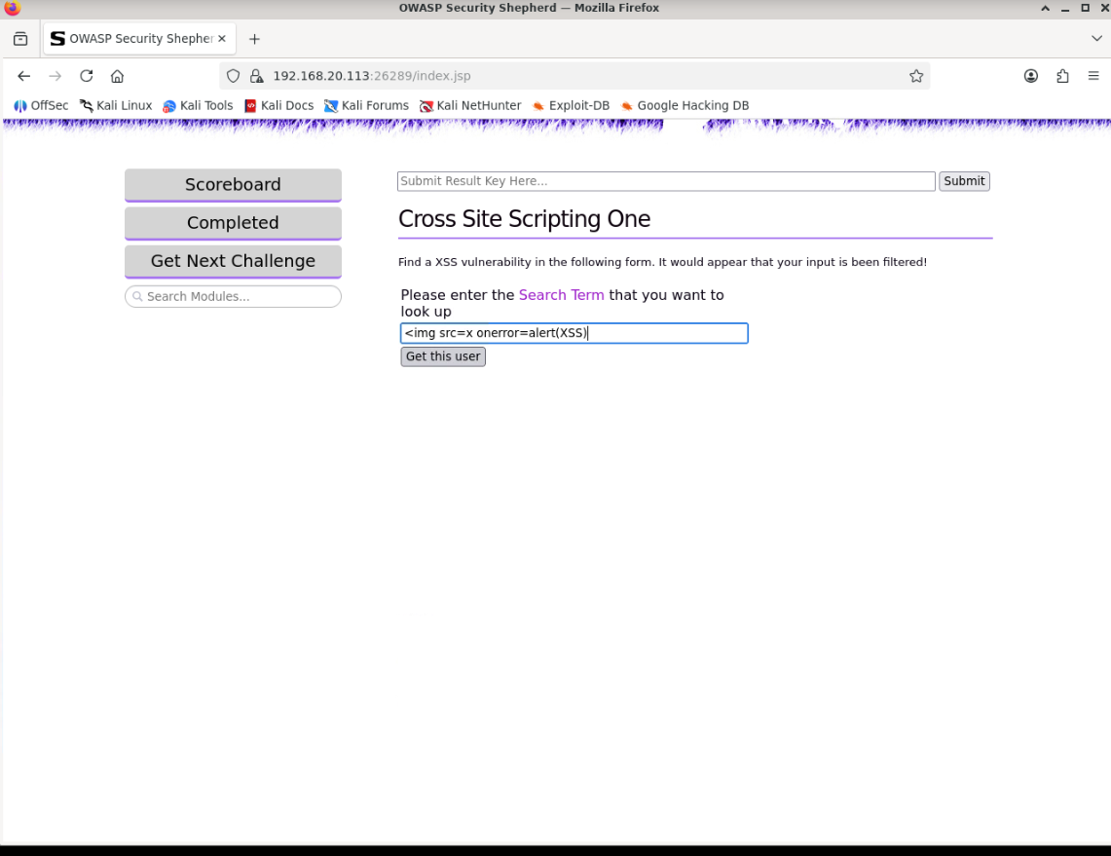
CVSS v3.1 Metrics
Metric Value
Attack Vector (AV) Network (N)
Attack Complexity (AC) Low (L)
Privileges Required (PR) None (N)
User Interaction (UI) Required (R)
Scope (S) Changed (C)
Confidentiality (C) Low (L)
Integrity (I) Low (L)
Availability (A) None (N)

CVSS Vector String

CVSS:3.1/AV:N/AC:L/PR:N/UI:R/S:C/C:L/I:L/A:N

https://nvd.nist.gov/vuln-metrics/cvss/v3-calculator?vector=AV:N/AC:L/PR:N/UI:R/S:C/C:L/I:L/A:N&version=3.1

challenge 4 – mobile insecure data storage

