**We have created a multi-functionality menu using Python scripting**

**Here are some functionalities: -**

* **To send an email**
* **To run a ML code**
* **To send WhatsApp message**

#Here is the code: -

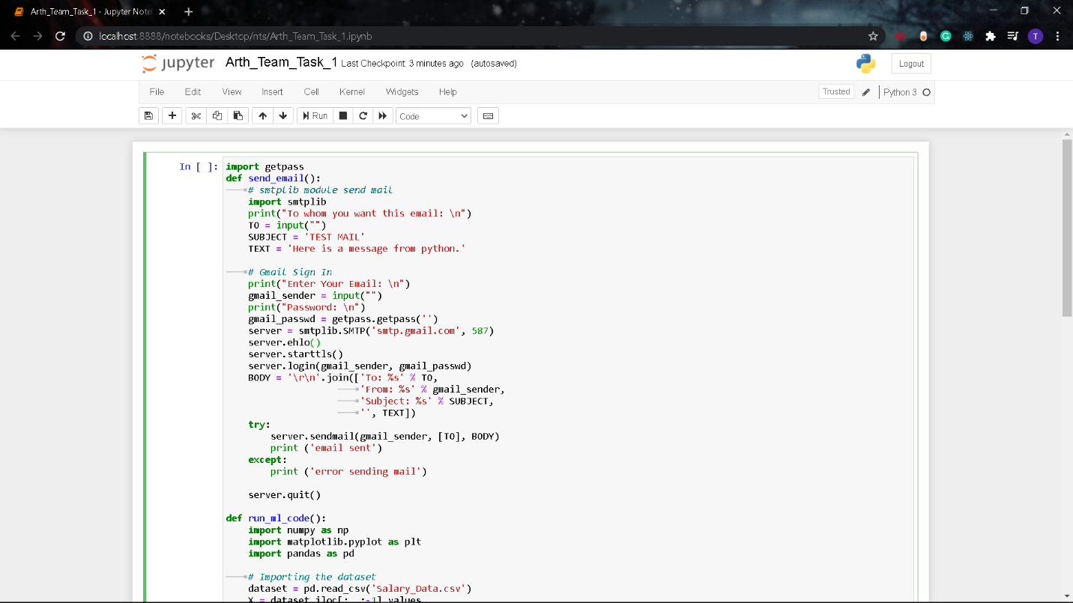

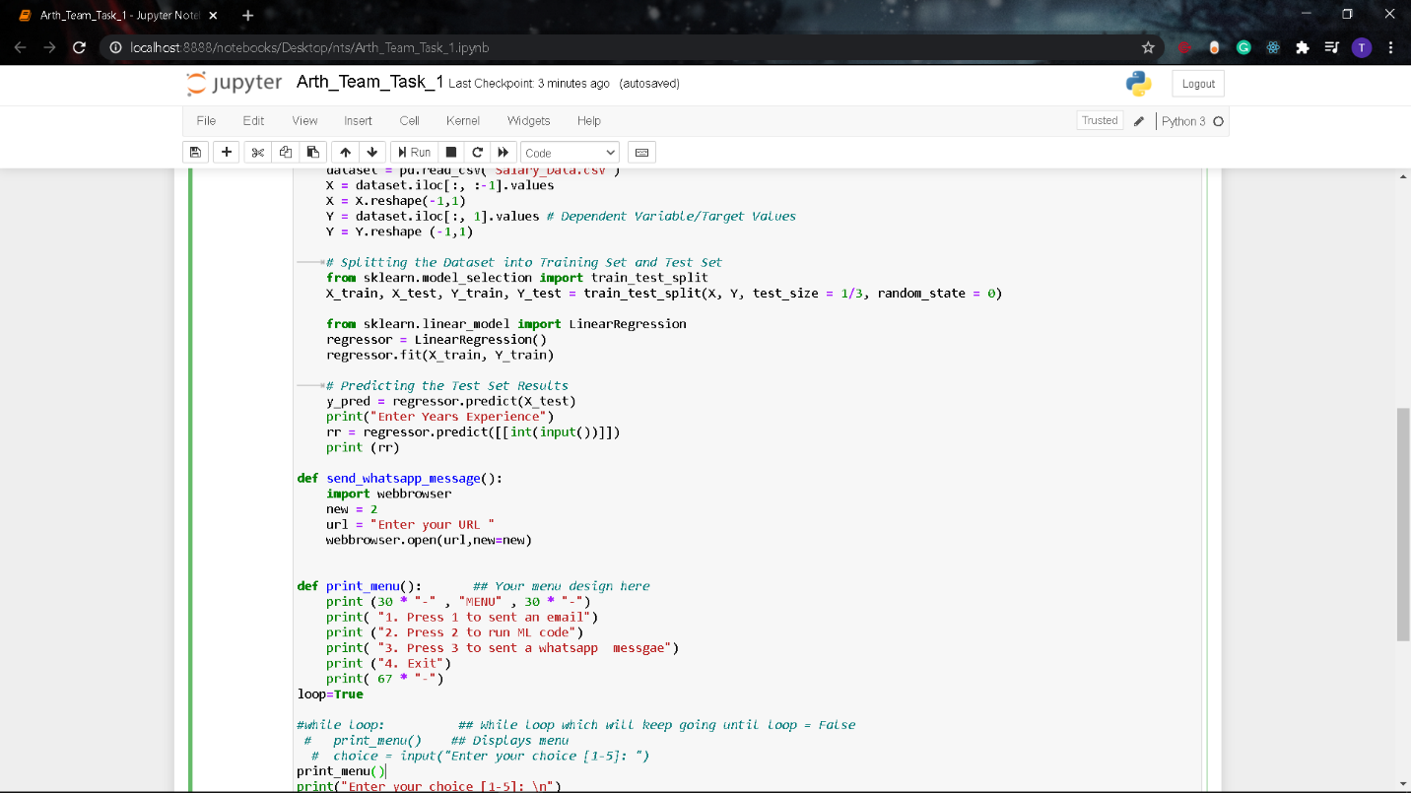

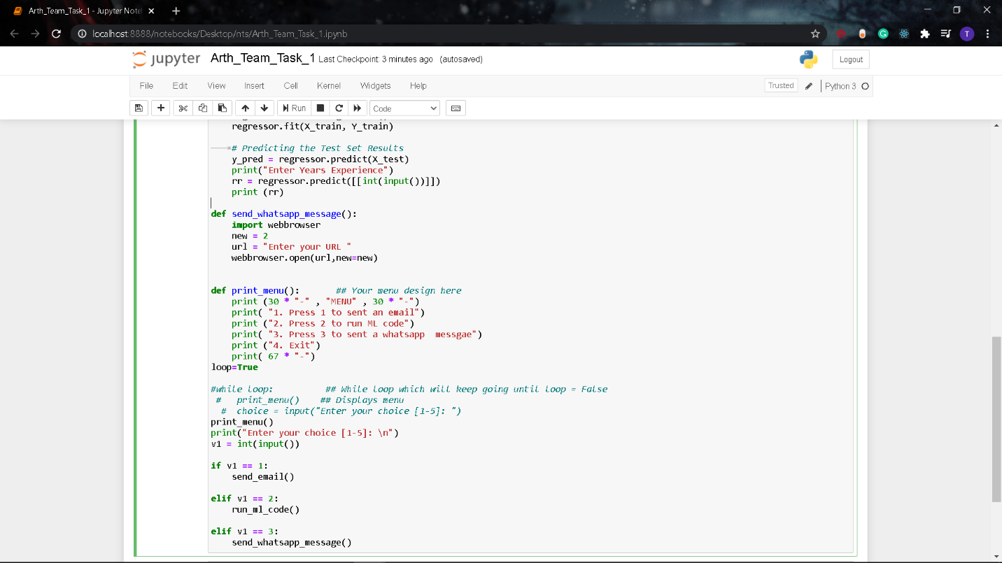

#1 To send an email

1. First of all, in order to send an email, we have to configure security setting of the account

<https://myaccount.google.com/lesssecureapps>

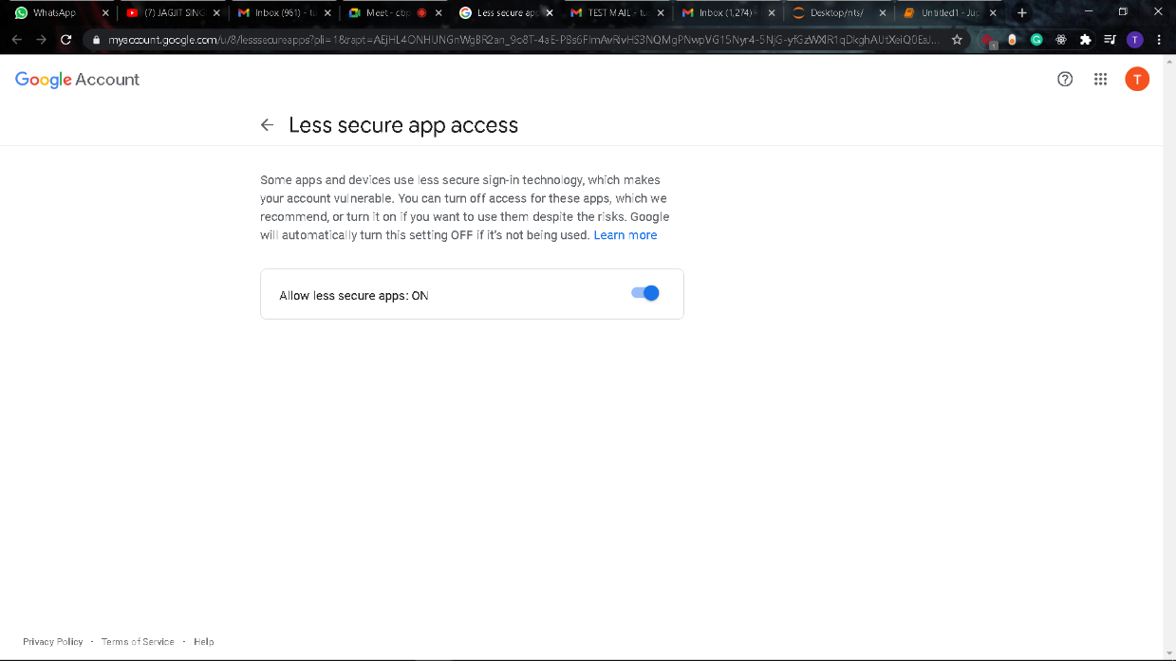

1. As you can see in the below mention code that we write a python script to send an email which take arguments for :-

* Recipient email
* Sender’s email
* Sender’s password
* Subject for email
* Text /Message

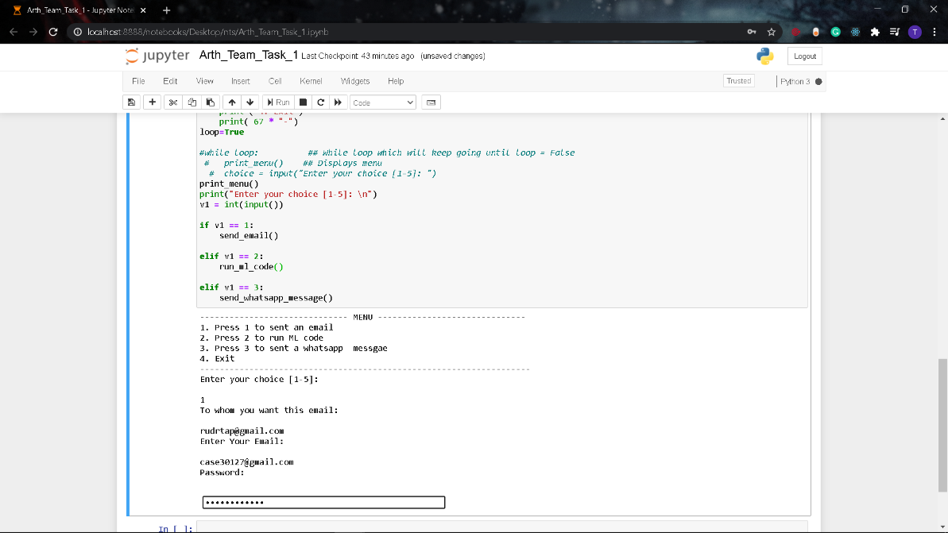

1. In the below we can clear see the output the email has been sent successfully.

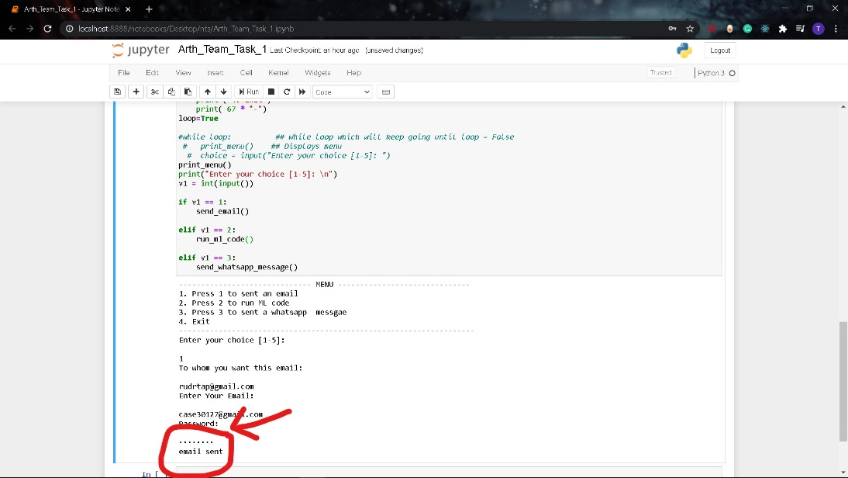

1. Here is the screenshot of that email

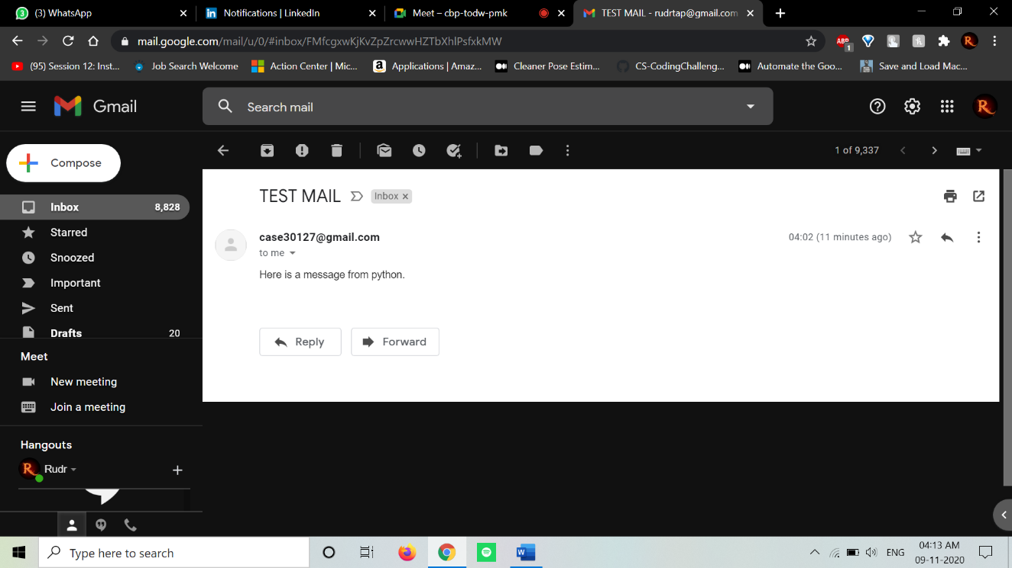

#2 To run a ML code

1. In order to run a ML code, we have trained one ML model to predict the salary w.r.t work experience.
2. We have attached one csv file which contains dataset for the model.

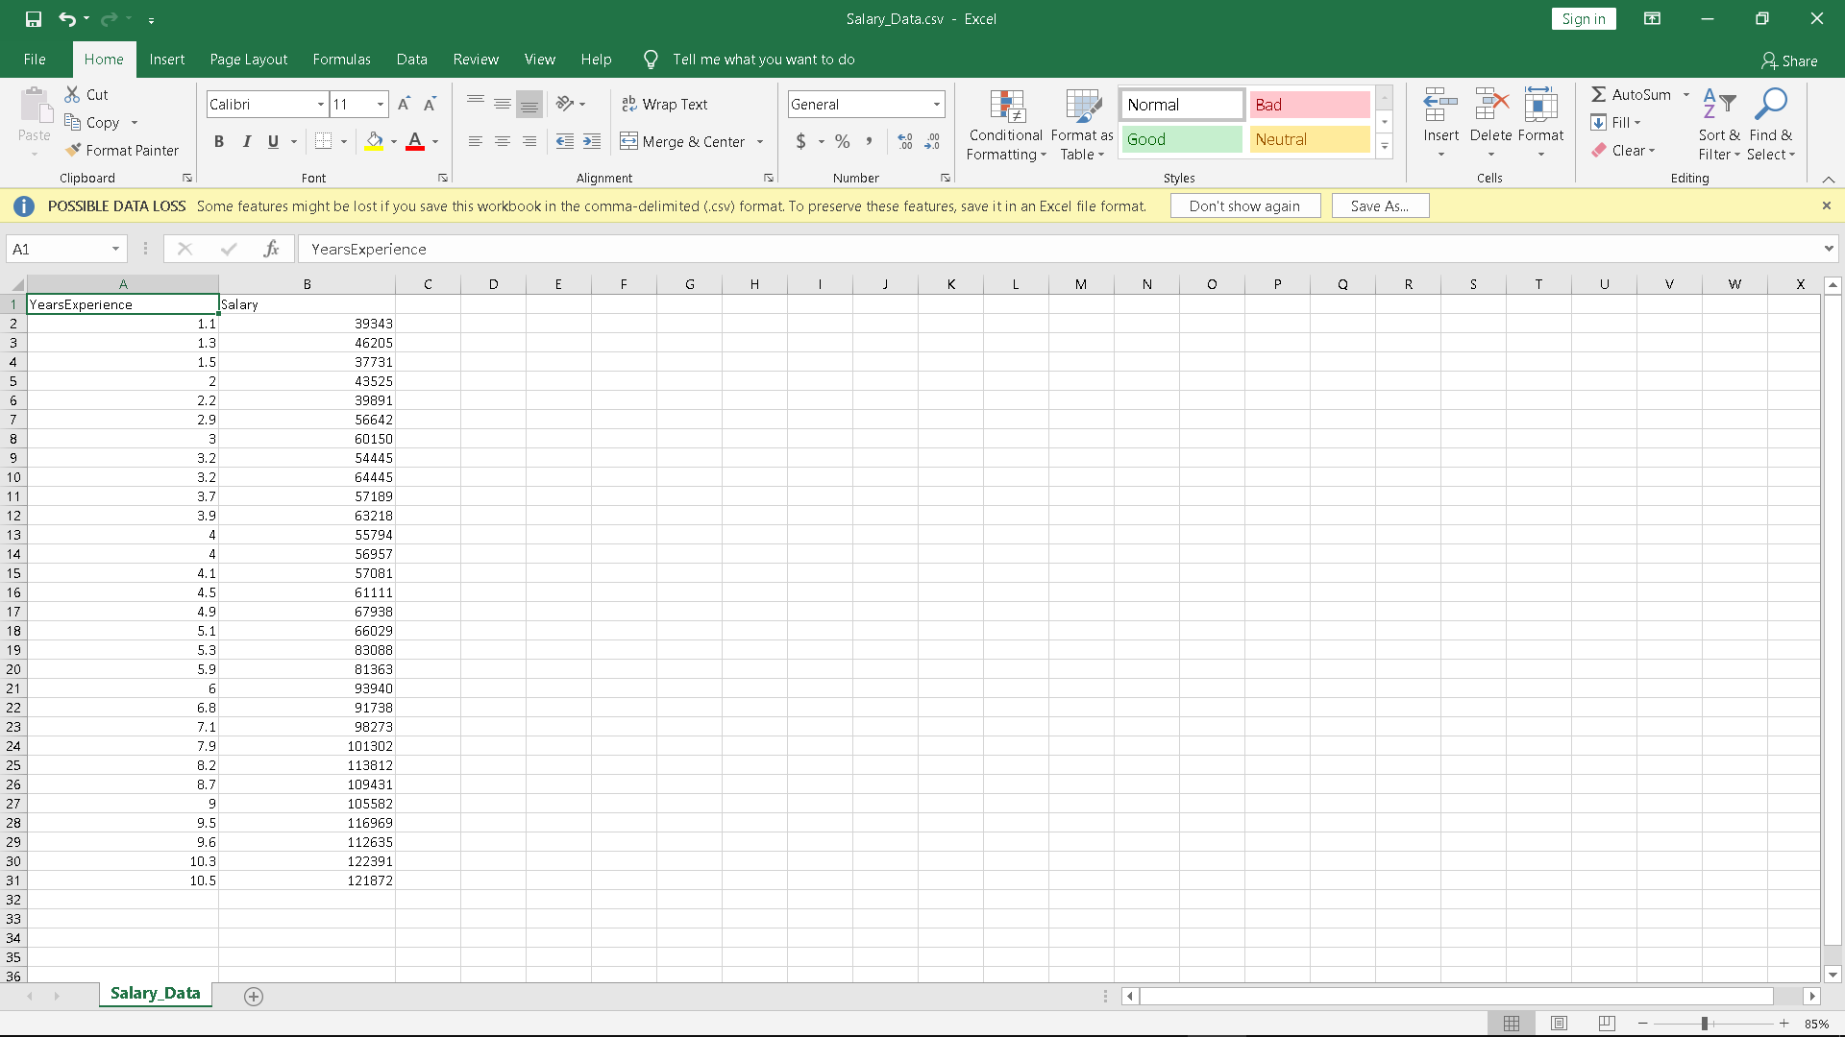

1. This model takes year of work experience as an argument and predict the salary of the employee.

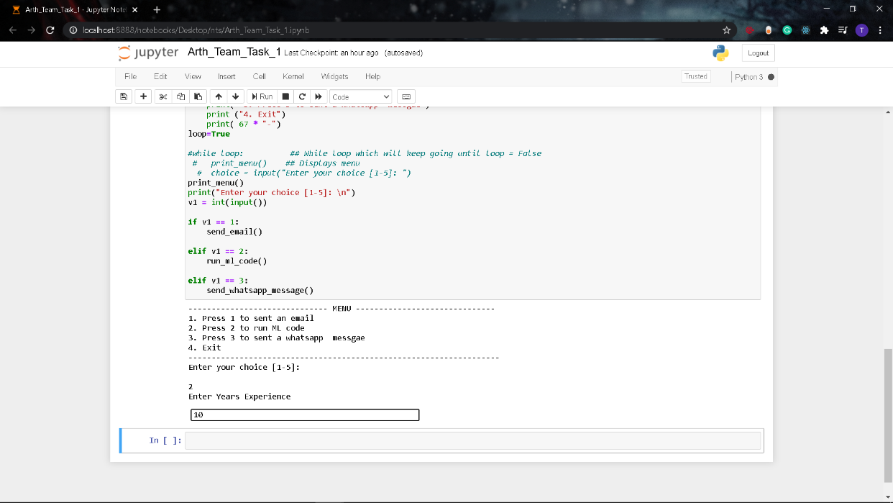

1. Here is predicted output

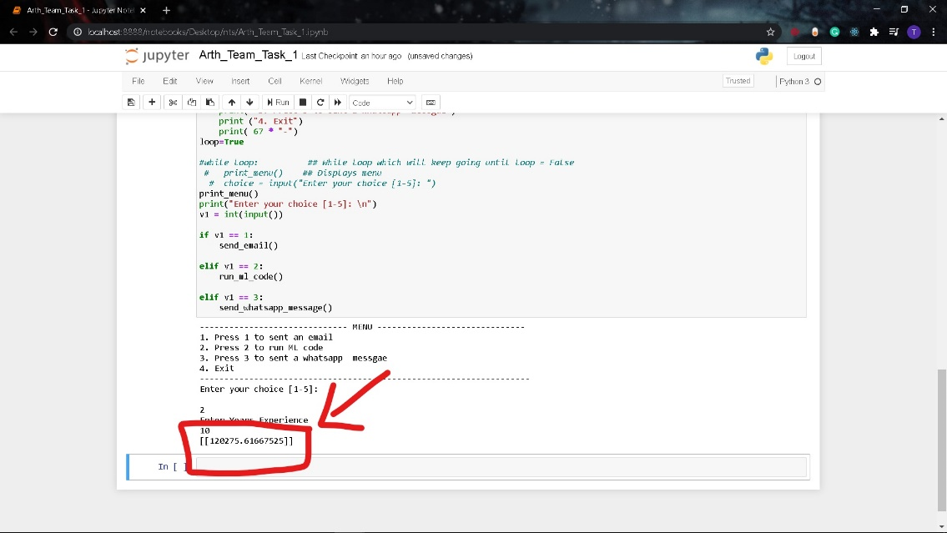

#3 To send a WhatsApp Message

1. In order to send the message, we have integrated python and html file.

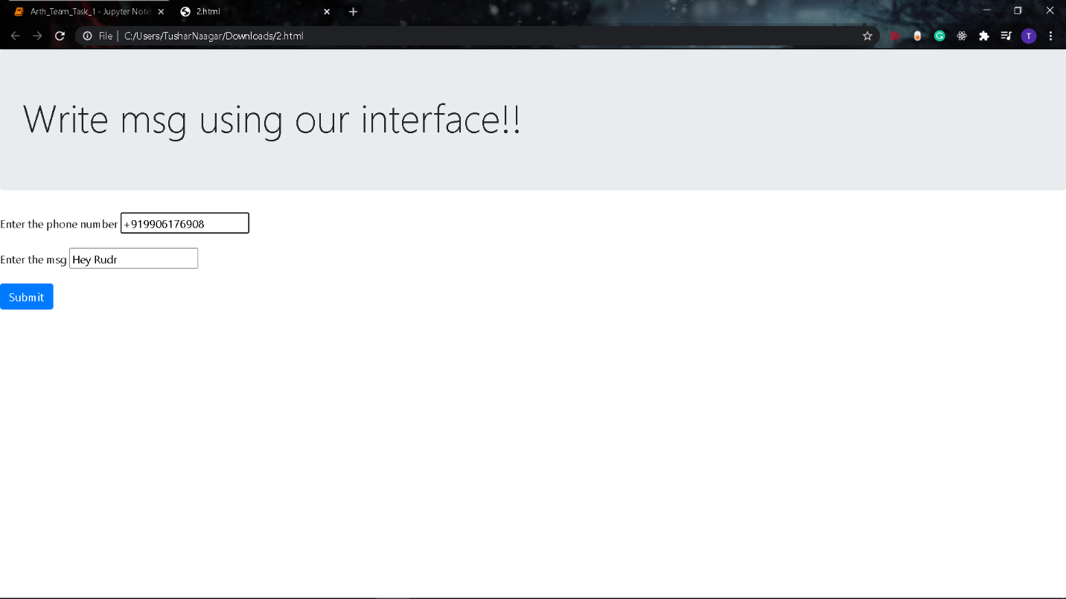

1. We are able to so by using a python library named as webbrower

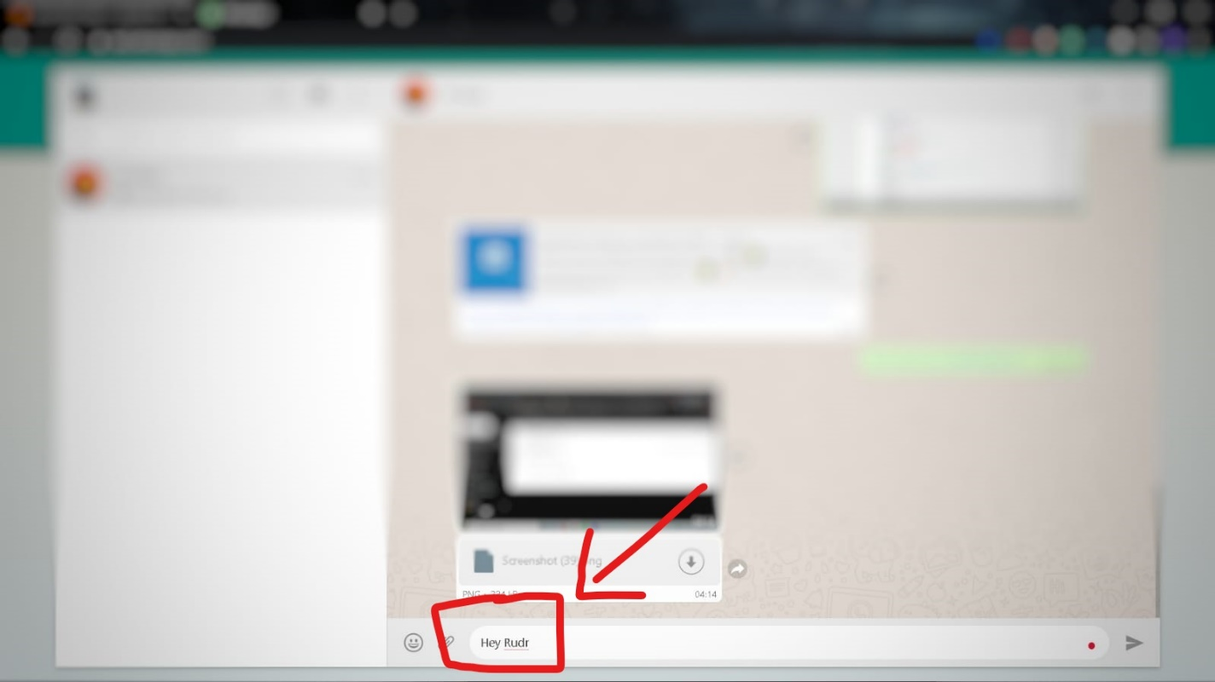

Ps:-

You can install this library by using this command:-

pip install pycopy-webbrowser