EduStream
An Intelligent, Path-Based Learning Management System

1. Project Title

Title: EduStream — Intelligent, Path-Based Learning Management System

2. Group Details

Group Number: [Insert Group Number]
Sr. | Enrollment Number | Student Name
1 | 230953304 | Shashwat Chandore
2 | 230953470 | Anuj Shukla

3. Project Abstract

EduStreamAI is a modern, full-stack web application designed to help students master Computer Science and Artificial Intelligence subjects through structured dependency graphs and diagnostic knowledge checks. Traditional learning platforms deliver content linearly, regardless of whether the learner actually has the required foundational knowledge. EduStreamAI solves this gap by enforcing a prerequisite-based learning model: before a student can progress to an advanced topic, they must demonstrate understanding of its foundational concepts via an integrated MCQ quiz.
When a learner fails a knowledge check, the system intelligently identifies the prerequisite gap and recommends the exact module the student should revisit — constructing a personalised learning path in real-time.

Key Functionalities
- Dynamic Curriculum Roadmap: Eight course domains — Programming Fundamentals, Data Structures, Algorithms, Database Internals, Artificial Intelligence, Web Development, Operating Systems, and Computer Networks — each broken into granular topics.
- MCQ Knowledge Gateways: Every topic starts with a diagnostic quiz before access to the lesson video is granted.
- Intelligent Prerequisite Routing: On quiz failure, the dependency graph resolves which prerequisite topic to study and renders a curated learning-path card.
- Progress Tracking & Auth: Google OAuth 2.0 authenticates users. Completed topic IDs are persisted in MongoDB so progress survives browser sessions.

Technologies Used
React.js • Vite • Tailwind CSS v4 • Framer Motion • Axios (Frontend) | Python • Flask • Flask-CORS • PyMongo (Backend) | MongoDB (Database) | Google OAuth 2.0 (Authentication)

4. High-Level Design

4.1 System Architecture
EduStreamAI follows a classic Client-Server (SPA + REST API) architecture. The React SPA executes entirely in the browser and communicates with the Flask backend over HTTP via Axios. The backend in turn reads from and writes to a locally hosted MongoDB instance. All sensitive operations (token verification, progress updates) are proxied through the Flask layer so that no direct database access is exposed to the browser.
┌───────────────────┐ HTTP / REST ┌──────────────────────────┐
│ React SPA │ ─────────────────────────► │ Flask Backend (port 5000)│
│ (Vite, port 5173)│ ◄───── JSON Responses ──── │ app.py │
└───────────────────┘ └──────────┬───────────────┘
│ │ PyMongo
Google OAuth ┌─────────▼──────────────┐
(JWT tokens) │ MongoDB │
│ learning_path_db │
│ collections: modules, │
│ users │
└────────────────────────┘

4.2 System API (RESTful Endpoints)
Method | Endpoint | Auth Required | Description
GET | /api/modules | No | Returns the complete curriculum — all courses, topics, prerequisites, quiz questions, and video URLs — from MongoDB.
POST | /api/auth/google | JWT | Verifies Google ID token, creates user profile on first login, returns user document with completed_topics array.
POST | /api/progress | JWT | Verifies Google token, then appends the submitted topic_id to the user's completed_topics set in MongoDB.

4.3 Database Architecture
EduStreamAI uses MongoDB (NoSQL document store, running on localhost:27017) with the database named learning_path_db. Below are the two primary collections:

Collection: modules
- topic_id (String) — Unique identifier for each topic (e.g., "prog_basics_1", "ai_2").
- course (String) — Name of the parent course (e.g., "Artificial Intelligence").
- name (String) — Human-readable topic name.
- difficulty (String) — "beginner" | "intermediate" | "advanced".
- learning_objective (String) — One-sentence outcome description.
- primary_video_url / fallback_video_url (String) — YouTube links for main and alternative explanations.
- prerequisites (Array<String>) — skill IDs or topic names this topic depends on.
- skills (Array<String>) — Skill tags this topic teaches (used by dependants' prerequisites).
- quiz (Array<Object>) — Array of MCQ objects: { question, options[], correct_index, explanation }.

Collection: users
- email (String) — Google account email (unique key).
- name (String) — Full display name from Google profile.
- picture (String) — Profile picture URL.
- role (String) — Defaults to "student".
- completed_topics (Array<String>) — Set of topic_id values the user has passed and marked complete.

4.4 Frontend Module Structure (React SPA)
- CourseLanding (route: /): Home page. Derives unique course names from the modules array, renders a responsive grid of coloured course cards with hover animations.
- TopicList (route: /course/:courseId): Filters topics by course. Displays each topic's name, learning objective, difficulty badge, prerequisite labels, and completion state.
- KnowledgeCheck (route: /topic/:topicId): Multi-screen component — quiz interface → results/learning-path → embedded YouTube lesson. Integrates struggle detection (pause/rewind tracking) and calls /api/progress on completion.

5. Components / Concepts Used

Component / Concept | Purpose in Application
React.js | Core frontend library used to build reusable, state-driven UI components (CourseLanding, TopicList, KnowledgeCheck).
Vite | Ultra-fast build tool and HMR dev-server; bundles the SPA for both development and production.
Tailwind CSS v4 | Utility-first CSS framework used for all styling — responsive grid layouts, hover effects, gradients, and badge components.
Framer Motion | Animation library used for smooth page-transition animations (fade + blur effects via AnimatePresence).
React Router v6 | Client-side routing enabling SPA navigation across /, /course/:id, and /topic/:id without full page reloads.
Axios | Promise-based HTTP client for API calls to the Flask backend.
react-youtube | YouTube player wrapper component used to embed lesson videos with event callbacks (onReady, onStateChange).
Lucide React | Icon library providing consistent iconography (BookOpen, Lock, CheckCircle2, ArrowRight, etc.).
@react-oauth/google | Google OAuth 2.0 client library providing the GoogleOAuthProvider context and GoogleLogin button.
Python / Flask | Backend web framework used to define and serve the three RESTful API endpoints.
Flask-CORS | Extension that attaches CORS headers so the React dev-server (port 5173) can communicate with Flask (port 5000).
PyMongo | Official MongoDB driver for Python; used to query and update the modules and users collections.
google-auth | Google's Python library used to verify the JWT ID tokens sent from the frontend.
MongoDB (NoSQL) | Document database that stores the entire curriculum (modules) and user progress (users) as flexible JSON-like documents.
Dependency Graphs | Core logical concept — topics declare prerequisite skill IDs, forming a directed acyclic graph that the router traverses on quiz failure.
JWT / OAuth 2.0 | Industry-standard token-based authentication: the browser sends a Google-signed JWT; Flask verifies it server-side before any data mutation.
localStorage | Browser storage API used to persist the logged-in user object across page refreshes without a dedicated session server.
RESTful API Design | Stateless HTTP communication pattern with structured JSON request/response bodies and appropriate HTTP status codes.
MCQ Quiz Engine | Custom quiz logic managing per-question answer tracking, scoring (≥70% = pass), and conditional routing to video or learning path.
Struggle Detection | Heuristic using YouTube player events to count pauses (≥3) and rewinds (≥5 sec, ≥5 occurrences) as signals of learner difficulty.

6. Screenshots and Descriptions

Below are the key screenshots of the working EduStream application

Screen 1 — Login & Authentication
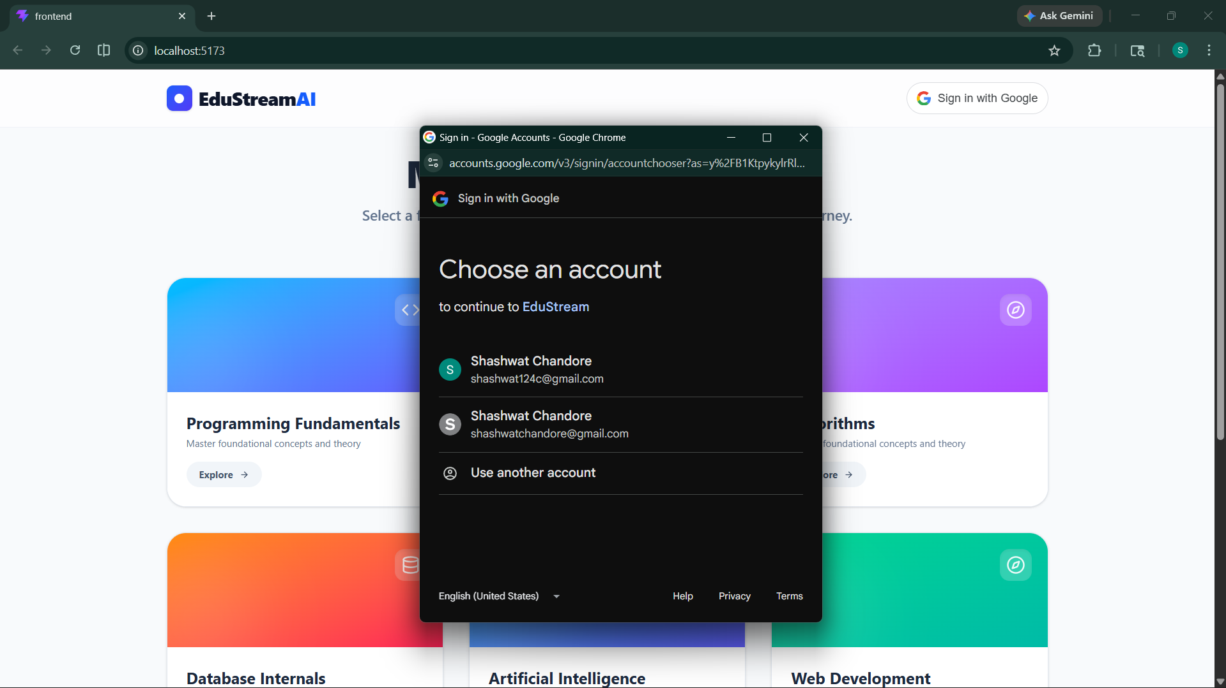

The landing navbar contains a Google Sign-In button (rendered by @react-oauth/google). Clicking it opens the standard Google OAuth consent popup. On success, the backend verifies the JWT, creates or retrieves the user document from MongoDB, and returns the user profile. The navbar then renders the user's profile picture and name in a pill-shaped badge.

Screen 2 — Course Catalogue (Home Page)
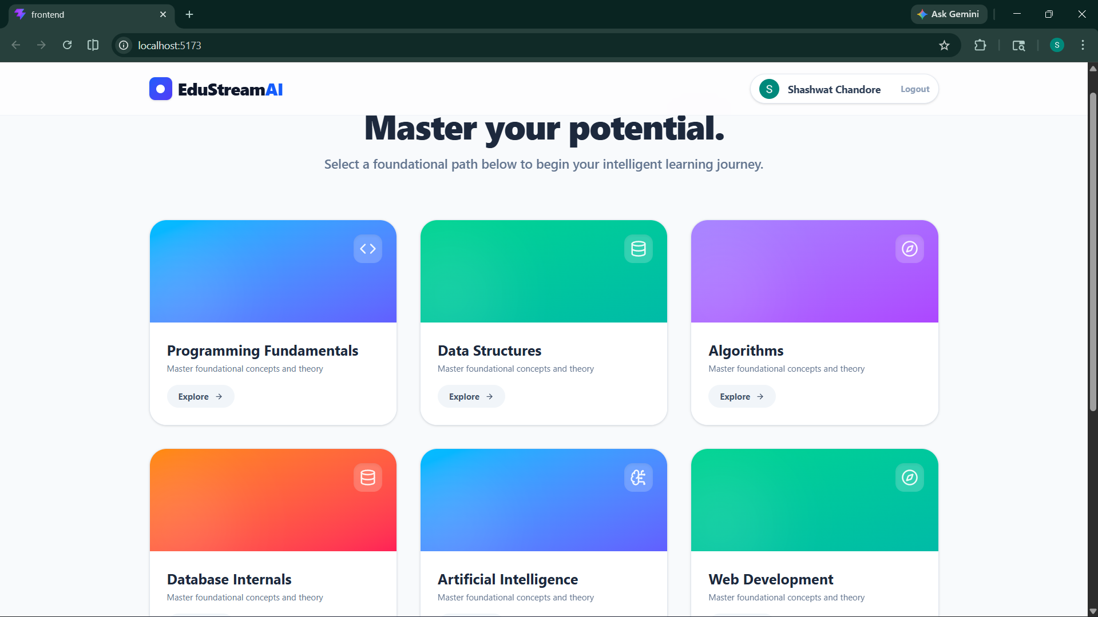

A responsive card grid shows all available course domains. Each card has a coloured gradient header, a subject-specific icon, and an "Explore" button. Courses available: Programming Fundamentals, Data Structures, Algorithms, Database Internals, Artificial Intelligence, Web Development, Operating Systems, and Computer Networks.

Screen 3 — Topic List
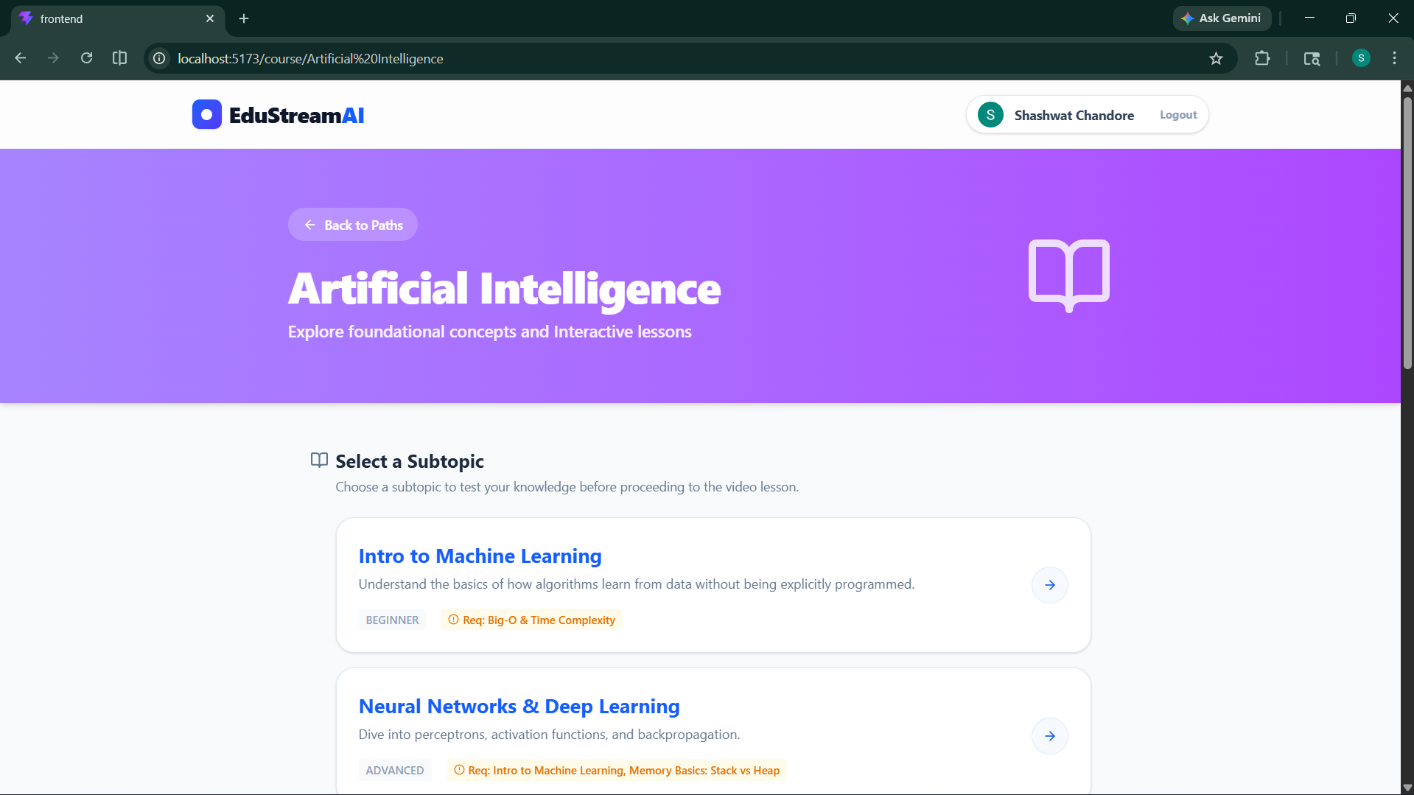
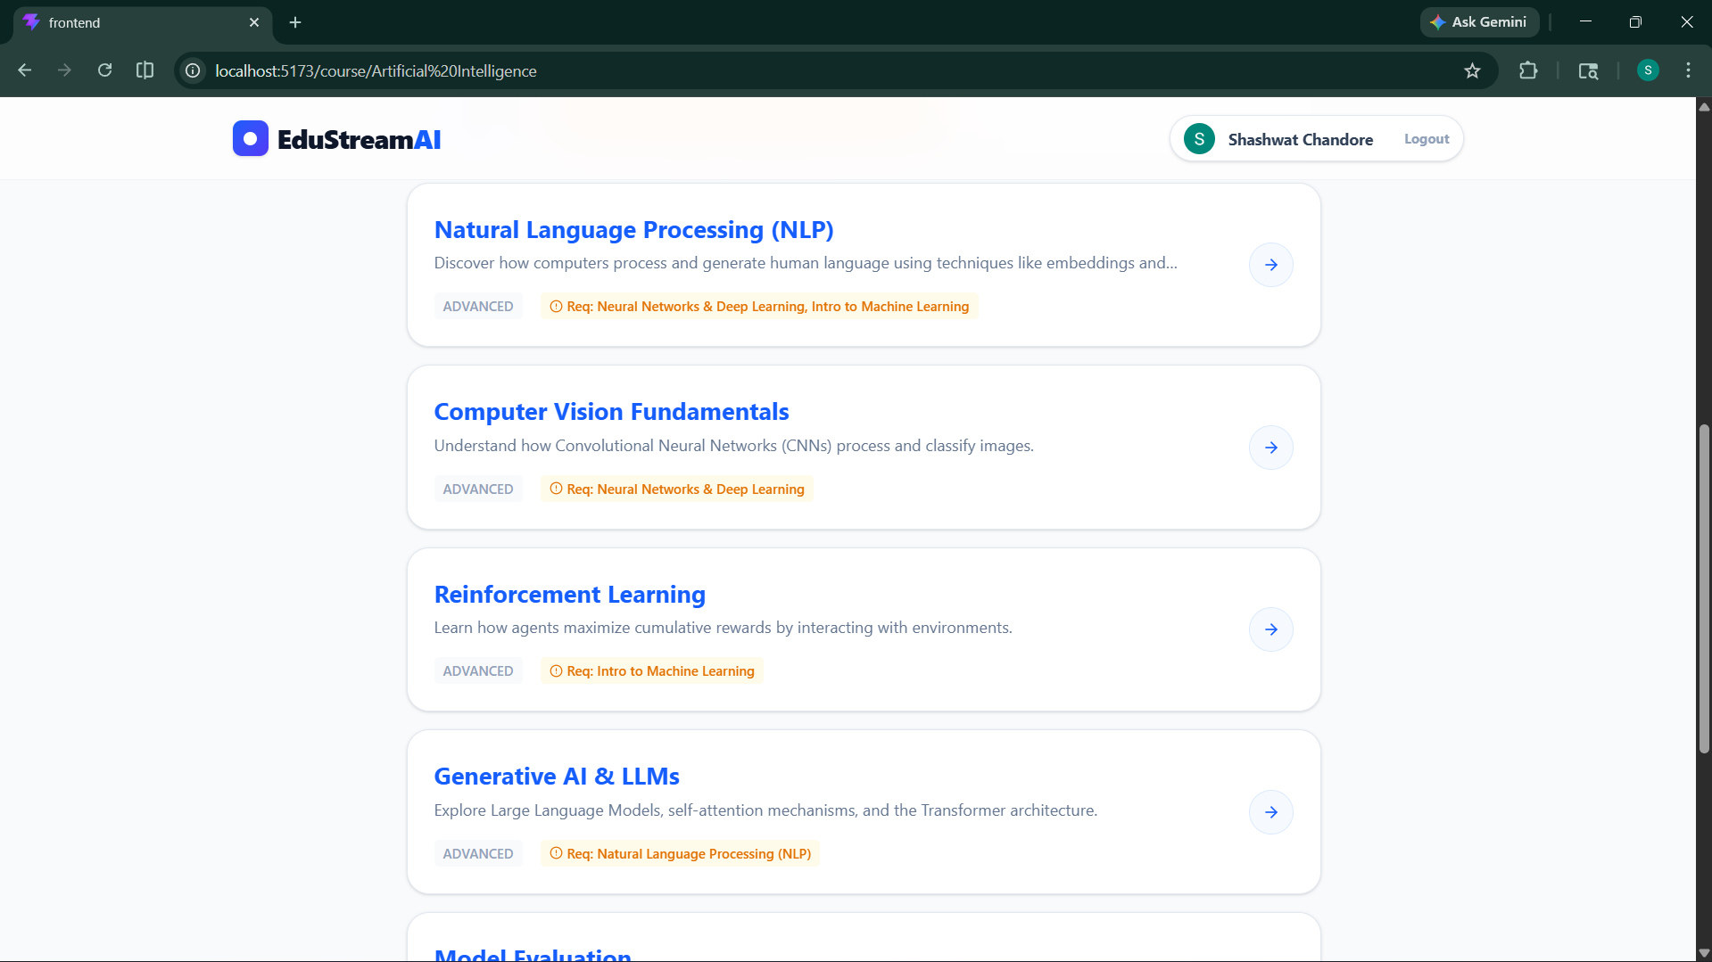

After selecting a course, the user sees a full-width header with the course name and a vertical list of topic cards. Each card shows the topic name, learning objective, difficulty badge, prerequisite labels , and a green "Completed" badge if the user has already passed the knowledge check.

Screen 4 — Knowledge Check / Quiz Interface
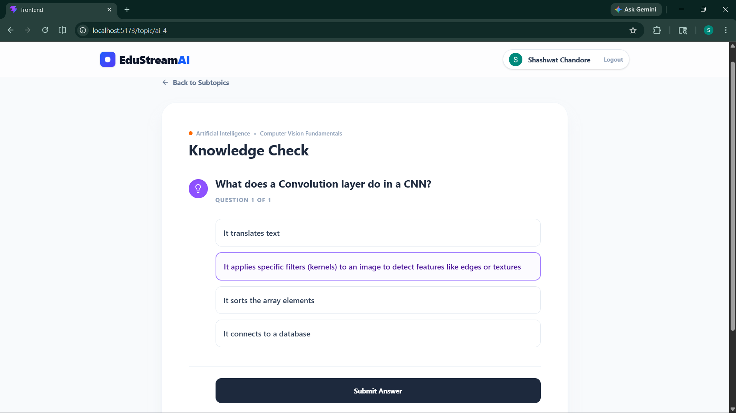

A white card displays the question. Selecting an option highlights it in violet. The "Submit Answer" button is conditionally rendered.

Screen 5 — Quiz Passed: Lesson Video
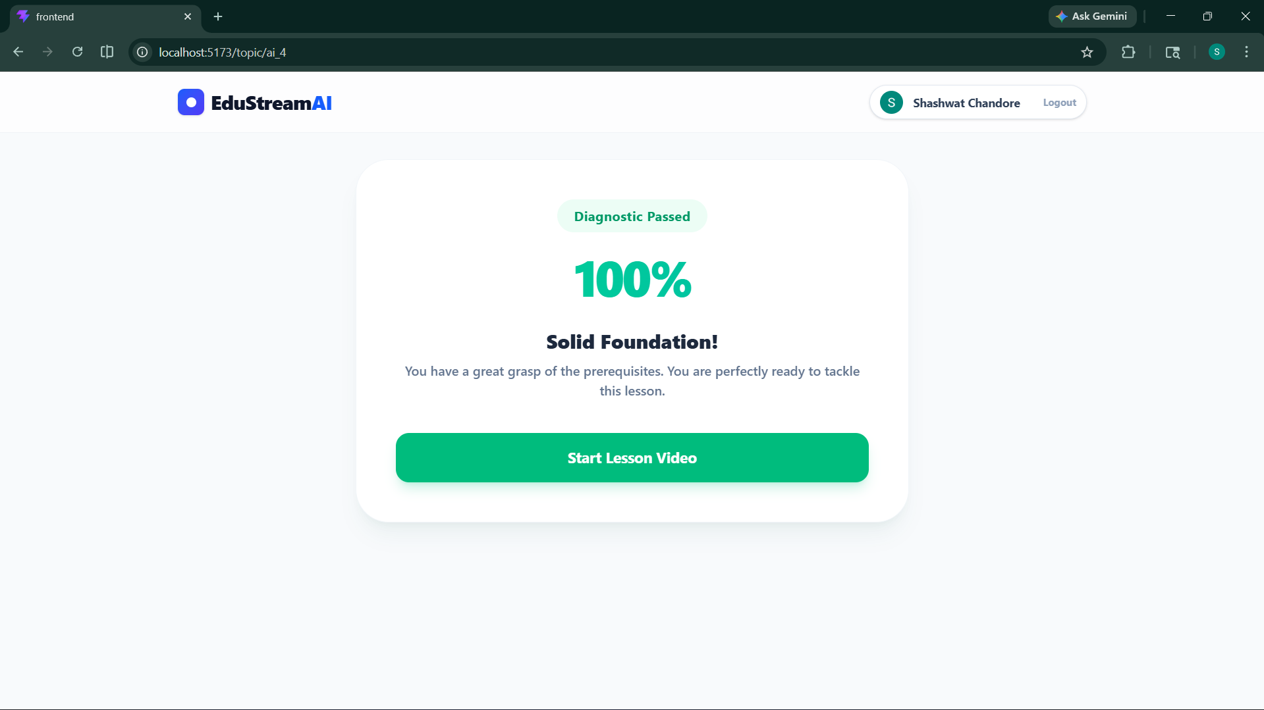
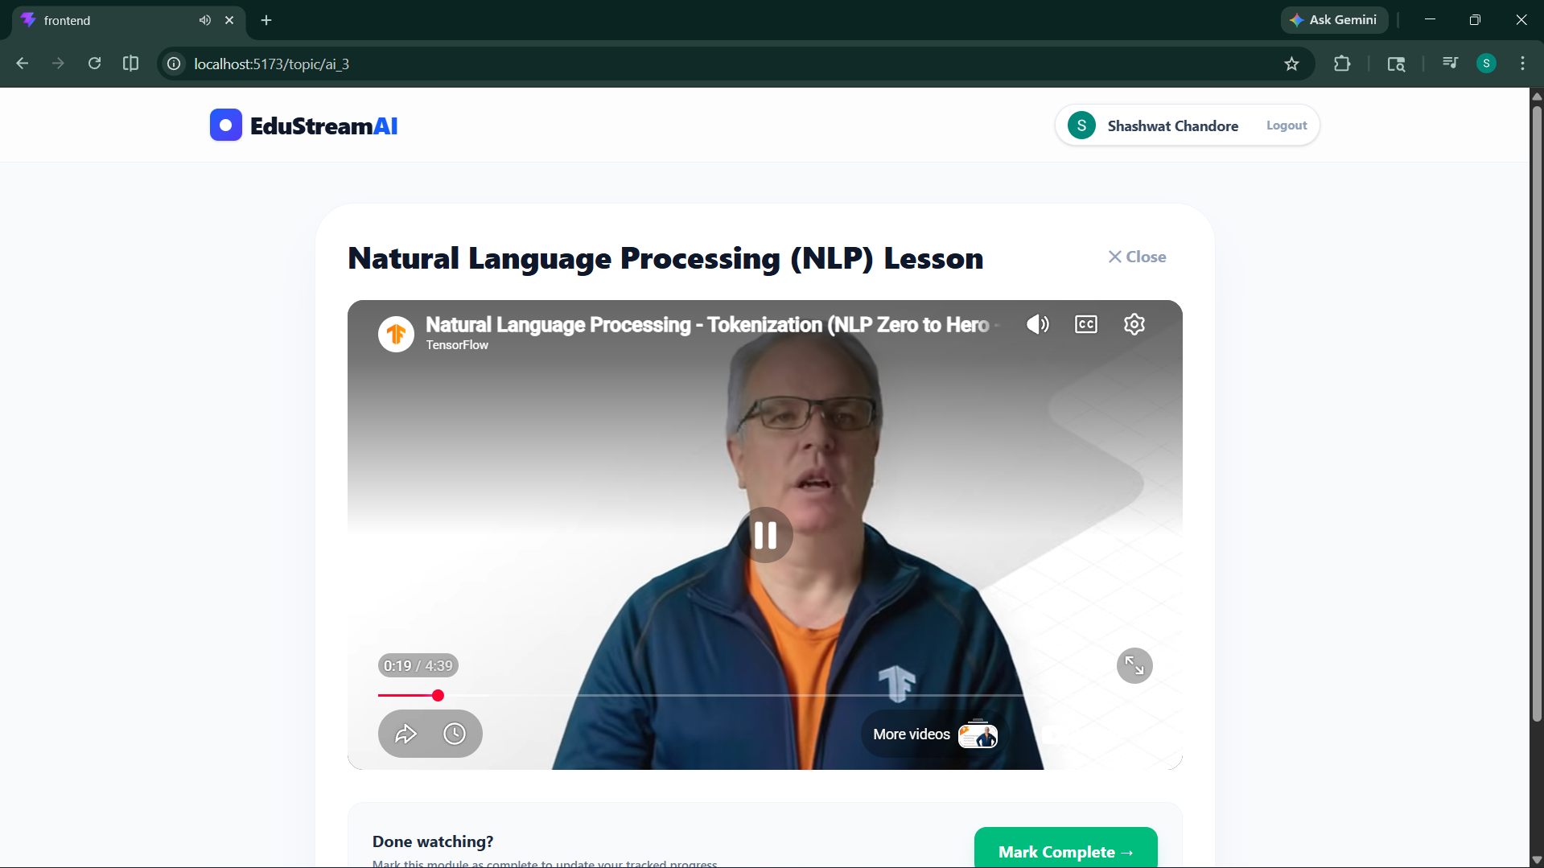

On passing, a success score badge and "Start Lesson Video" button appear. Clicking it renders a 16:9 embedded YouTube player. A "Mark Complete →" button updates the user's progress via /api/progress.

Screen 6 — Quiz Failed: Recommended Learning Path
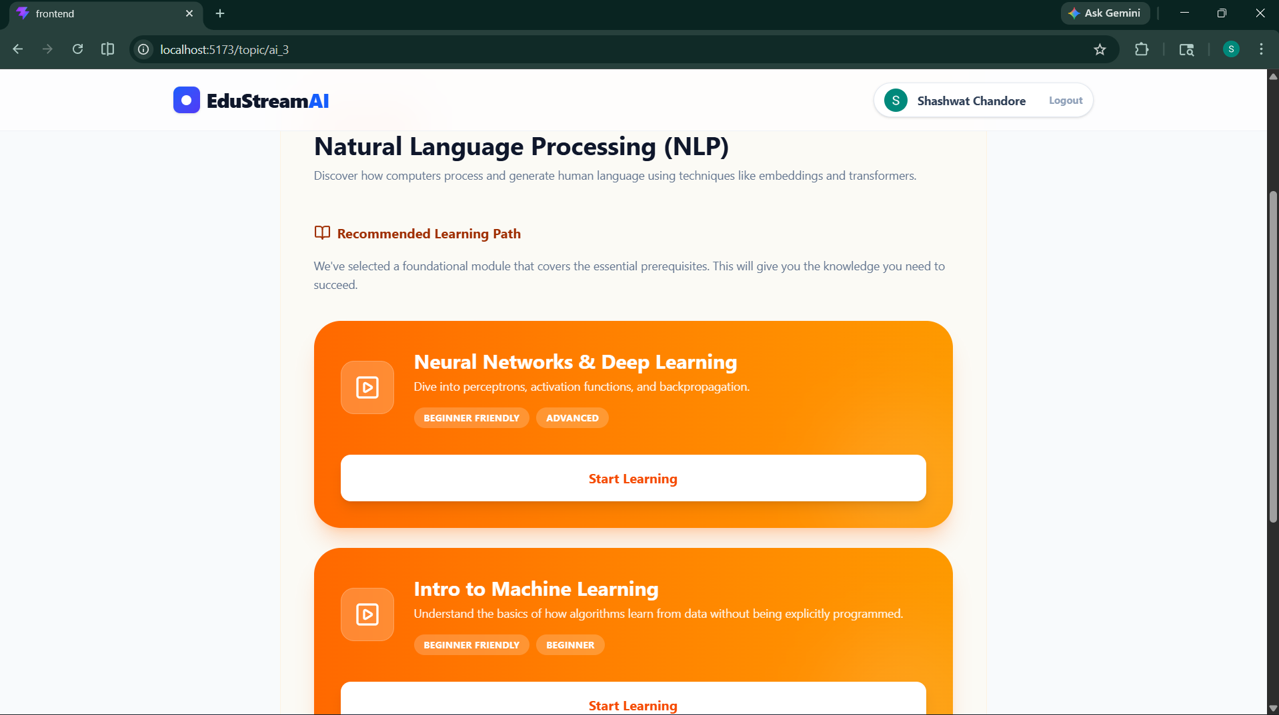

On failing, the system resolves prerequisite modules and renders an orange gradient "Start Learning" card for each recommended prerequisite. "Retry Question" and "Choose Another Topic" action buttons are also provided, plus a subtle "proceed anyway" escape link.

7. Details of Individual Contributions

The following table outlines each team member's primary area of responsibility during the development of EduStreamAI.
Student Name | Enrollment No. | Key Contributions
Anuj Shukla | 230953470 | Frontend SPA development — CourseLanding, TopicList, routing, Framer Motion animations.
Anuj Shukla | 230953470 | KnowledgeCheck component — quiz engine, struggle detection, YouTube integration.
Shashwat Chandore | 230953304 | Flask backend — API endpoint design, Google OAuth verification, CORS configuration.
Shashwat Chandore | 230953304 | MongoDB schema design, seed_db.py curriculum data (8 courses, 20+ topics, quizzes).

8. Conclusion

EduStreamAI successfully demonstrates that an intelligent, prerequisite-aware learning management system can meaningfully improve learner outcomes compared to linear video consumption platforms. By enforcing mastery of foundational concepts before unlocking advanced topics, the platform ensures students build a cohesive, gap-free knowledge base.
The project achieves a clean separation of concerns through its React SPA + Flask REST API + MongoDB architecture. The dependency-graph model powering prerequisite routing gives EduStream a genuine adaptive learning capability beyond basic video playlists.
The integrated Google OAuth 2.0 layer ensures that personalised progress is securely associated with a verified identity and persisted across sessions — making the platform usable in real educational contexts.

Future Enhancements
- AI-driven quiz generation using an LLM API (e.g., Gemini) to auto-create new questions for any topic.
- Detailed analytics dashboard for instructors — showing class-wide struggle hotspots and topic failure rates.
- Peer discussion threads and collaborative notes per topic.
- Mobile-responsive PWA packaging for offline-capable offline video viewing.
- Adaptive difficulty scaling — dynamically adjusting quiz difficulty based on a student's historical performance.

