OPERATING SYSTEMS • SUSTAINABLE & GREEN COMPUTING
ENERGY-OPTIMAL TASK SCHEDULING
USING CARBON-AWARE COMPUTING
Design and Evaluation of an OS-Level Carbon-Aware CPU Scheduling Framework

Authors | Shashwat — 24BCE2409  Lakshyajeet Narsinghani — 24BCE2419
Course | Operating Systems Project
Research Area | OS Process / CPU Scheduling × Sustainable & Green Computing
Current Implementation | Conventional FCFS and Carbon-Aware FCFS
Future System | SJF • SRTF • Priority • Round Robin • DVFS • Virtual-Machine Validation

PROJECT POSITION
This paper documents the first experimental stage of a larger research project. FCFS is the current working scheduler. The architecture is intentionally designed so that additional scheduling policies and virtual-machine validation can be added without changing the overall experimental methodology.

October 2026

RESEARCH SUMMARY

Abstract
Modern computing systems do not consume electricity under a constant environmental condition. The carbon intensity associated with electricity can change throughout the day depending on the electricity-generation mix. As a result, two executions that consume approximately the same amount of electrical energy can have different carbon footprints when they occur at different times. This observation motivates carbon-aware computing, where the timing and location of computation become part of the scheduling problem.
This project studies how the idea of carbon-aware computing can be brought down to the operating-system CPU scheduling level. Instead of treating carbon intensity as a datacenter-level planning parameter, the proposed framework treats it as an additional input available to a CPU scheduler. The first implementation extends First-Come, First-Served (FCFS) scheduling with a temporal carbon-awareness mechanism. When a process reaches the front of the FCFS queue during a high-carbon period, the scheduler checks whether it can safely postpone the process to a lower-carbon period without missing its deadline. If a feasible lower-carbon window exists, execution is shifted; otherwise, the process executes immediately.
The current prototype is implemented in C as a discrete-event simulation. Development began in a Windows-based workflow, and the benchmark suite was subsequently compiled and executed in an AWS EC2 Ubuntu 24.04 LTS environment using GCC. Five deterministic workloads containing 100, 200, 300, 400 and 500 processes were evaluated using conventional FCFS and carbon-aware FCFS. The model uses a synthetic time-varying carbon-intensity trace, a 500 gCO₂/kWh decision threshold and a constant 50 W power assumption. The EC2 runs show lower estimated carbon emissions for carbon-aware FCFS in all five workloads, while average waiting time and turnaround time rise substantially and more deadlines are missed. Modeled energy is identical for each paired workload because both schedulers execute the same total burst work under a constant-power model. These results quantify the environmental-performance trade-off rather than claiming a measured reduction in physical AWS electricity consumption.
The current implementation is not intended to represent the final system. It establishes the algorithmic and experimental foundation for a larger framework that will include SJF, SRTF, Priority Scheduling and Round Robin, followed by richer power and DVFS modeling and validation inside controlled virtual machines. The final objective is to evaluate the carbon benefit together with traditional operating-system performance metrics rather than optimizing carbon in isolation.
Keywords: carbon-aware computing; CPU scheduling; FCFS; operating systems; carbon intensity; temporal load shifting; energy efficiency; sustainable computing; DVFS; virtual-machine validation

Document Overview
The paper is organized so that a reader can understand the project without first reading the source code.
- Sections 1–3 explain the motivation, research background and problem being addressed.
- Sections 4–6 describe the proposed architecture, FCFS extension and carbon-accounting model.
- Sections 7–9 describe the experimental setup, controlled example, AWS EC2 benchmark, independently validated metrics and their interpretation. Sections 10–12 discuss limitations, completed VM and kernel-facing diagnostic checks, planned framework extensions, and reproducibility. Sections 13–15 cover future work, conclusion and references; appendices document the benchmark data format and carbon trace.
- Sections 10–12 discuss limitations, the planned multi-algorithm framework and VM validation.
- Sections 13–15 cover reproducibility, conclusion and references.

1. Introduction

1.1 Motivation
CPU scheduling is one of the fundamental responsibilities of an operating system. The scheduler decides which process receives CPU time and when that process should execute. Traditional scheduling policies are normally designed around objectives such as low waiting time, low turnaround time, fairness, responsiveness and high CPU utilization. Environmental impact is usually not part of the scheduling decision.
At the same time, computing has become a significant consumer of electricity. A conventional energy-aware scheduler may attempt to reduce the amount of energy consumed by changing CPU frequency, placing tasks on efficient cores or using power-management techniques. However, reducing energy does not automatically mean reducing carbon emissions. The carbon impact of electricity depends on how that electricity is generated at a particular time.
Carbon-aware computing therefore introduces a different question: if a task does not have to execute immediately, can it be moved to a period when the electricity supply is associated with lower carbon intensity? This is the central idea explored by this project.

1.2 From Datacenter Carbon Awareness to OS Scheduling
A large portion of existing carbon-aware scheduling research operates at the level of datacenters, cloud platforms, distributed workloads or geographic regions. Such systems can shift workloads between time periods or locations. The project takes a narrower operating-systems perspective. The goal is to examine whether a similar decision can be made by the CPU scheduler of a single machine.
This distinction is important. A datacenter scheduler may decide where an entire workload should run, while an OS scheduler decides which local process should receive CPU service. The available information, time scale and performance constraints are different. The project therefore treats carbon intensity as a scheduler input alongside familiar process properties such as arrival time, burst time and deadline.

2. Research Background

2.1 Carbon-Aware Computing
Carbon-aware computing considers the carbon intensity associated with electricity when deciding when or where computation should occur. Temporal shifting moves flexible work toward cleaner periods. Spatial shifting moves work toward regions with cleaner electricity. This project concentrates on temporal shifting because it maps naturally to a single-machine CPU scheduling problem.

2.2 Energy-Aware versus Carbon-Aware Scheduling
Energy-aware scheduling and carbon-aware scheduling are related but not identical. Energy-aware scheduling asks how much electricity is consumed. Carbon-aware scheduling asks how much carbon is associated with that electricity. If a processor consumes the same energy at two different times, but the electricity has different carbon intensities, the corresponding carbon emissions will also differ.
KEY CONCEPT
The project deliberately separates energy from carbon. Under the current constant-power model, the same CPU work consumes the same modeled energy, but the estimated carbon changes because the work is executed under different carbon-intensity values.

2.3 Existing OS-Level Energy Awareness
Energy-aware CPU scheduling already exists in real operating systems. The project review examined mechanisms including Linux Energy Aware Scheduling, learning-based extensions to EAS, SCHED_DEADLINE combined with CPU frequency management, and energy-aware process scheduling approaches. These systems demonstrate that CPU scheduling and power-management decisions can be integrated at the OS level.
The gap motivating this project is the additional use of an external, time-varying electricity carbon-intensity signal. In other words, the operating system may know how much power a CPU is using, but the prototype investigates what happens if the scheduler also knows whether the electricity being consumed is relatively carbon-intensive at that moment.

2.4 Broader Research Gaps
The literature review also highlights several broader challenges. Carbon-aware scheduling must eventually deal with forecast errors, interactive and latency-sensitive workloads, fine-grained task dependencies, network and data-transfer carbon, cooling, fairness, adaptive learning, renewable intermittency and real-world validation. These issues are outside the current FCFS prototype, but they influence the planned architecture.
- Forecast uncertainty can make a predicted clean period different from the actual clean period.
- Interactive applications may not tolerate deliberate waiting in the same way as batch workloads.
- Shared systems raise fairness questions when one process is delayed to reduce system-wide carbon.
- Real hardware introduces power behavior, thermal effects, multicore interactions and scheduler overhead.
- Standardized carbon accounting is required before results from different systems can be compared fairly.

3. Problem Definition and Objectives

3.1 Problem Statement
Consider a set of CPU-bound processes. Each process has an arrival time, CPU burst time and deadline. The machine also has a time-varying carbon-intensity trace. The scheduling problem is to determine the execution time of each process while preserving the base scheduling policy and attempting to reduce the carbon impact of execution. A process may be delayed only when that delay remains feasible with respect to its deadline.

3.2 Research Questions
- Can a classical CPU scheduling policy use carbon intensity as an additional scheduling signal?
- Can computation be shifted to lower-carbon periods without violating deadlines?
- How much simulated carbon reduction is obtained under controlled workloads?
- What performance cost is introduced in waiting time, turnaround time and CPU utilization?
- How does the behavior change as additional CPU scheduling policies are introduced?
- How closely can simulation behavior be reproduced in a controlled virtual-machine environment?

3.3 Project Objectives
- Design an OS-level carbon-aware CPU scheduling mechanism.
- Implement a carbon-aware extension of a classical scheduling policy.
- Use a time-varying carbon-intensity trace as an additional scheduling input.
- Maintain deadline feasibility and avoid indefinite postponement.
- Compare conventional and carbon-aware scheduling using common OS performance metrics.
- Extend the framework to SJF, SRTF, Priority and Round Robin.
- Introduce richer energy and DVFS models after the algorithmic stage.
- Validate the framework inside controlled virtual machines and compare simulation with observed system behavior.

4. Proposed System Architecture
The system is designed as a layered framework. Keeping the layers separate is important because the same experimental infrastructure should eventually support several scheduling algorithms.
1. Workload | 2. Base Scheduler | 3. Carbon Signal | 4. Carbon Decision | 5. Execution & Metrics
Processes  AT, BT, Deadline | FCFS now  SJF / SRTF / Priority / RR later | Time-indexed  carbon intensity | Immediate or  safe temporal shift | WT, TAT, CPU,  Energy, Carbon

The architecture deliberately separates the base scheduler from the carbon-awareness layer. This means that FCFS can be replaced by SJF or Round Robin without redesigning the entire carbon-data and measurement pipeline.

4.1 Inputs
- Process workload: process ID, arrival time, burst time and deadline.
- Carbon trace: time-indexed carbon-intensity values in gCO₂/kWh.
- Carbon threshold: the value used to classify a period as relatively high-carbon.
- CPU power model: currently a constant 50 W assumption.
- Scheduler policy: FCFS in the current implementation.

4.2 Outputs
- Process start and completion times.
- Waiting time and turnaround time.
- CPU utilization.
- Total modeled energy consumption.
- Estimated carbon emissions.
- Deadline status.
- Gantt-style execution timeline.

5. Carbon-Aware FCFS Algorithm

5.1 Conventional FCFS
In conventional FCFS, processes are served according to their arrival order. Once a process begins, it runs until its CPU burst is completed because FCFS is non-preemptive. The scheduler does not intentionally wait for a different electricity condition.

5.2 Carbon-Aware Extension
The proposed extension preserves the FCFS process order. The only new decision is whether the current start time is environmentally preferable. When a process reaches the front of the queue, the scheduler checks the carbon intensity at the current simulated time.
- If the current carbon intensity is at or below the threshold, the process starts immediately.
- If the current intensity is above the threshold, the scheduler searches forward for a lower-carbon time.
- The candidate start time must allow the complete CPU burst to finish by the process deadline.
- The earliest feasible lower-carbon start is selected.
- If no feasible lower-carbon start exists, the process is not postponed and executes immediately.

5.3 Example of the Decision
Suppose a process arrives at time 0, requires 3 seconds of CPU time and has a deadline of time 10. If carbon intensity at time 0 is high but the trace shows a cleaner period beginning at time 4, the scheduler can postpone the process from time 0 to time 4 because execution from 4 to 7 still completes before the deadline. The scheduler therefore trades four units of simulated waiting for a cleaner execution period.

5.4 Pseudocode
CARBON_AWARE_FCFS(processes, carbon_trace):
arrange processes in FCFS order
current_time = 0
for each process P:
if current_time < P.arrival:
current_time = P.arrival
if carbon(current_time) > THRESHOLD:
find earliest time T such that:
T >= current_time
carbon(T) <= THRESHOLD
T + P.burst <= P.deadline
if such T exists:
current_time = T
P.start = current_time
P.finish = current_time + P.burst
P.waiting = P.start - P.arrival
P.turnaround = P.finish - P.arrival
current_time = P.finish
calculate CPU utilization
calculate energy
calculate carbon emissions

6. Energy and Carbon Accounting

6.1 Current CPU Power Model
The first implementation uses a constant CPU power assumption of 50 W. This is a controlled simulation assumption. It is useful because it isolates the effect of execution timing: the amount of work is unchanged, so the modeled energy remains tied to the total burst time.

6.2 Energy Calculation
For an execution interval of Δt seconds:
Energy (J) = Power (W) × Execution Time (s)
For example, 50 W for 10 seconds gives 500 J of modeled energy.

6.3 Carbon Calculation
Carbon is calculated using the carbon intensity associated with each simulated second. Energy for each second is converted from joules to kWh and multiplied by the carbon intensity for that second.
Carbon (gCO₂) = Σ [ Power / 3,600,000 × CarbonIntensity(t) ]
This approach means that executing the same workload during a low-carbon period produces a lower estimated carbon value than executing it during a high-carbon period, even when the modeled energy is identical.
IMPORTANT MODELING NOTE
The current carbon values are estimated simulation outputs. They are not direct measurements of emissions from a physical CPU or electricity meter. The VM and later hardware-oriented stages are intended to improve realism.

7. Experimental Methodology

7.1 Experimental Philosophy
The experiments are paired comparisons. Conventional FCFS and carbon-aware FCFS receive the same workload and use the same carbon trace. This is important because changing the workload between algorithms would make it difficult to determine whether a difference came from the scheduler or from the input.

7.2 Experimental Configuration
Parameter | Current configuration
Base policy | FCFS
Carbon-aware policy | FCFS with temporal shifting
Implementation language | C
Execution model | Discrete-event simulation
Carbon trace | Synthetic time-varying trace
Carbon threshold | 500 gCO₂/kWh
CPU power | 50 W constant
Workload count | 5
Process attributes | PID, arrival time, burst time, deadline
Primary metrics | Carbon, energy, CPU utilization, waiting time, turnaround time
Development workflow | Initial development on Windows; benchmark execution reproduced on AWS EC2 Ubuntu 24.04 LTS
Cloud instance | AWS EC2 t3.micro; 8 GiB configured memory
Compiler / runtime | GCC 13.3.0 for C; Python 3.12.3 used for automation/analysis
Workload sizes | 100, 200, 300, 400 and 500 processes
Benchmark execution | Paired command-line runs using the same workload file for both schedulers; stdout saved under logs/
Carbon trace handling | Original 24-second synthetic pattern extended cyclically to 10,000 simulated seconds

7.3 Workload Design
The five workload configurations contain different numbers and combinations of processes. They were designed to create varied execution lengths and deadlines so that the carbon-aware scheduler encounters different opportunities for temporal shifting. The workload files are kept separate so that experiments can be repeated and later reused for SJF, SRTF, Priority and Round Robin.

7.4 Evaluation Metrics
Metric | Meaning
Average Waiting Time | Measures how long processes remain waiting before receiving CPU service.
Average Turnaround Time | Measures elapsed time from process arrival until completion.
CPU Utilization | Measures the proportion of simulated time during which the CPU is executing work.
Energy | Measures modeled electrical energy under the current CPU power assumption.
Carbon Emissions | Measures estimated carbon associated with the energy at the carbon intensity of each execution period.
Deadline Status | Checks whether each process completes within its specified deadline.

8. Experimental Results
The results are reported at two distinct scales. A four-process controlled example is retained as a unit test for the core scheduling decision; its results are not generalized to the full benchmark. The principal evaluation uses five reproducible workloads (100–500 processes) executed on AWS EC2 Ubuntu. In these larger workloads, carbon-aware FCFS lowers estimated carbon emissions in every paired comparison, but the savings are modest and come with longer waits and a substantial number of deadline misses. The results therefore support a trade-off analysis, not an unconditional claim that the carbon-aware policy is better on every metric.
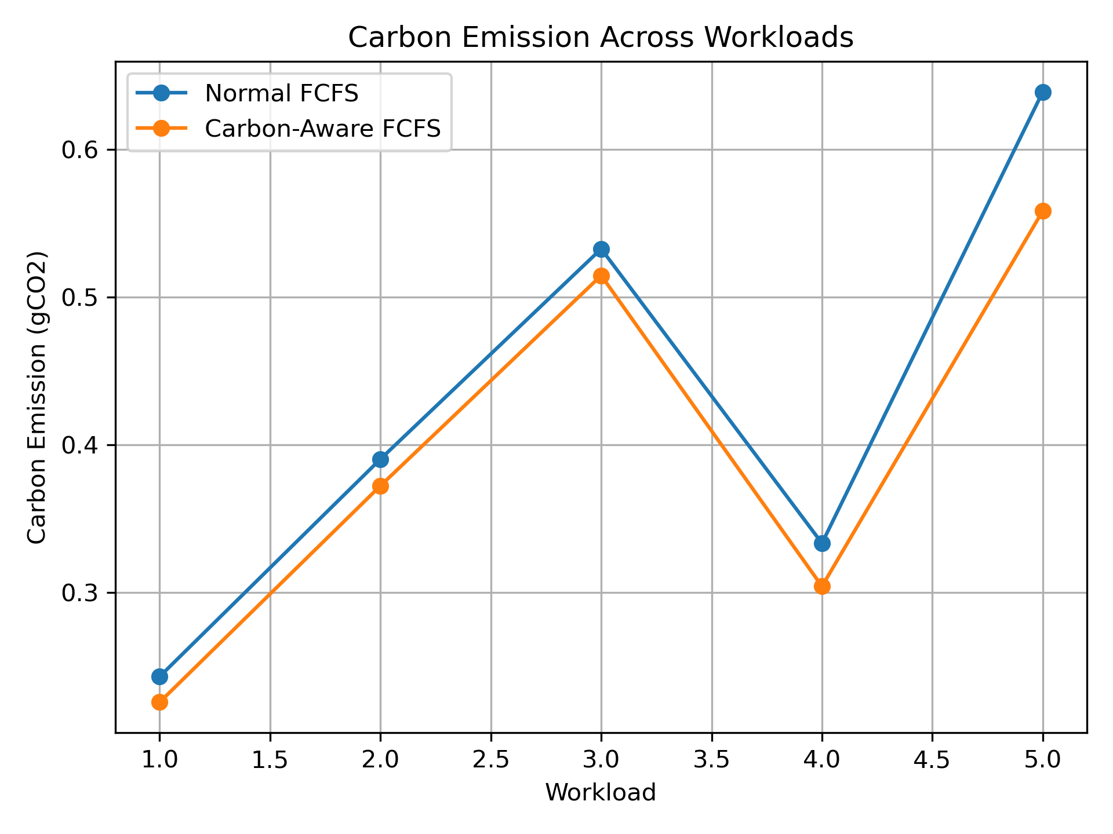
Figure 1. Preliminary carbon-emission plot from the earlier development-stage experiment; the updated AWS EC2 benchmark is reported separately in Section 8.7.
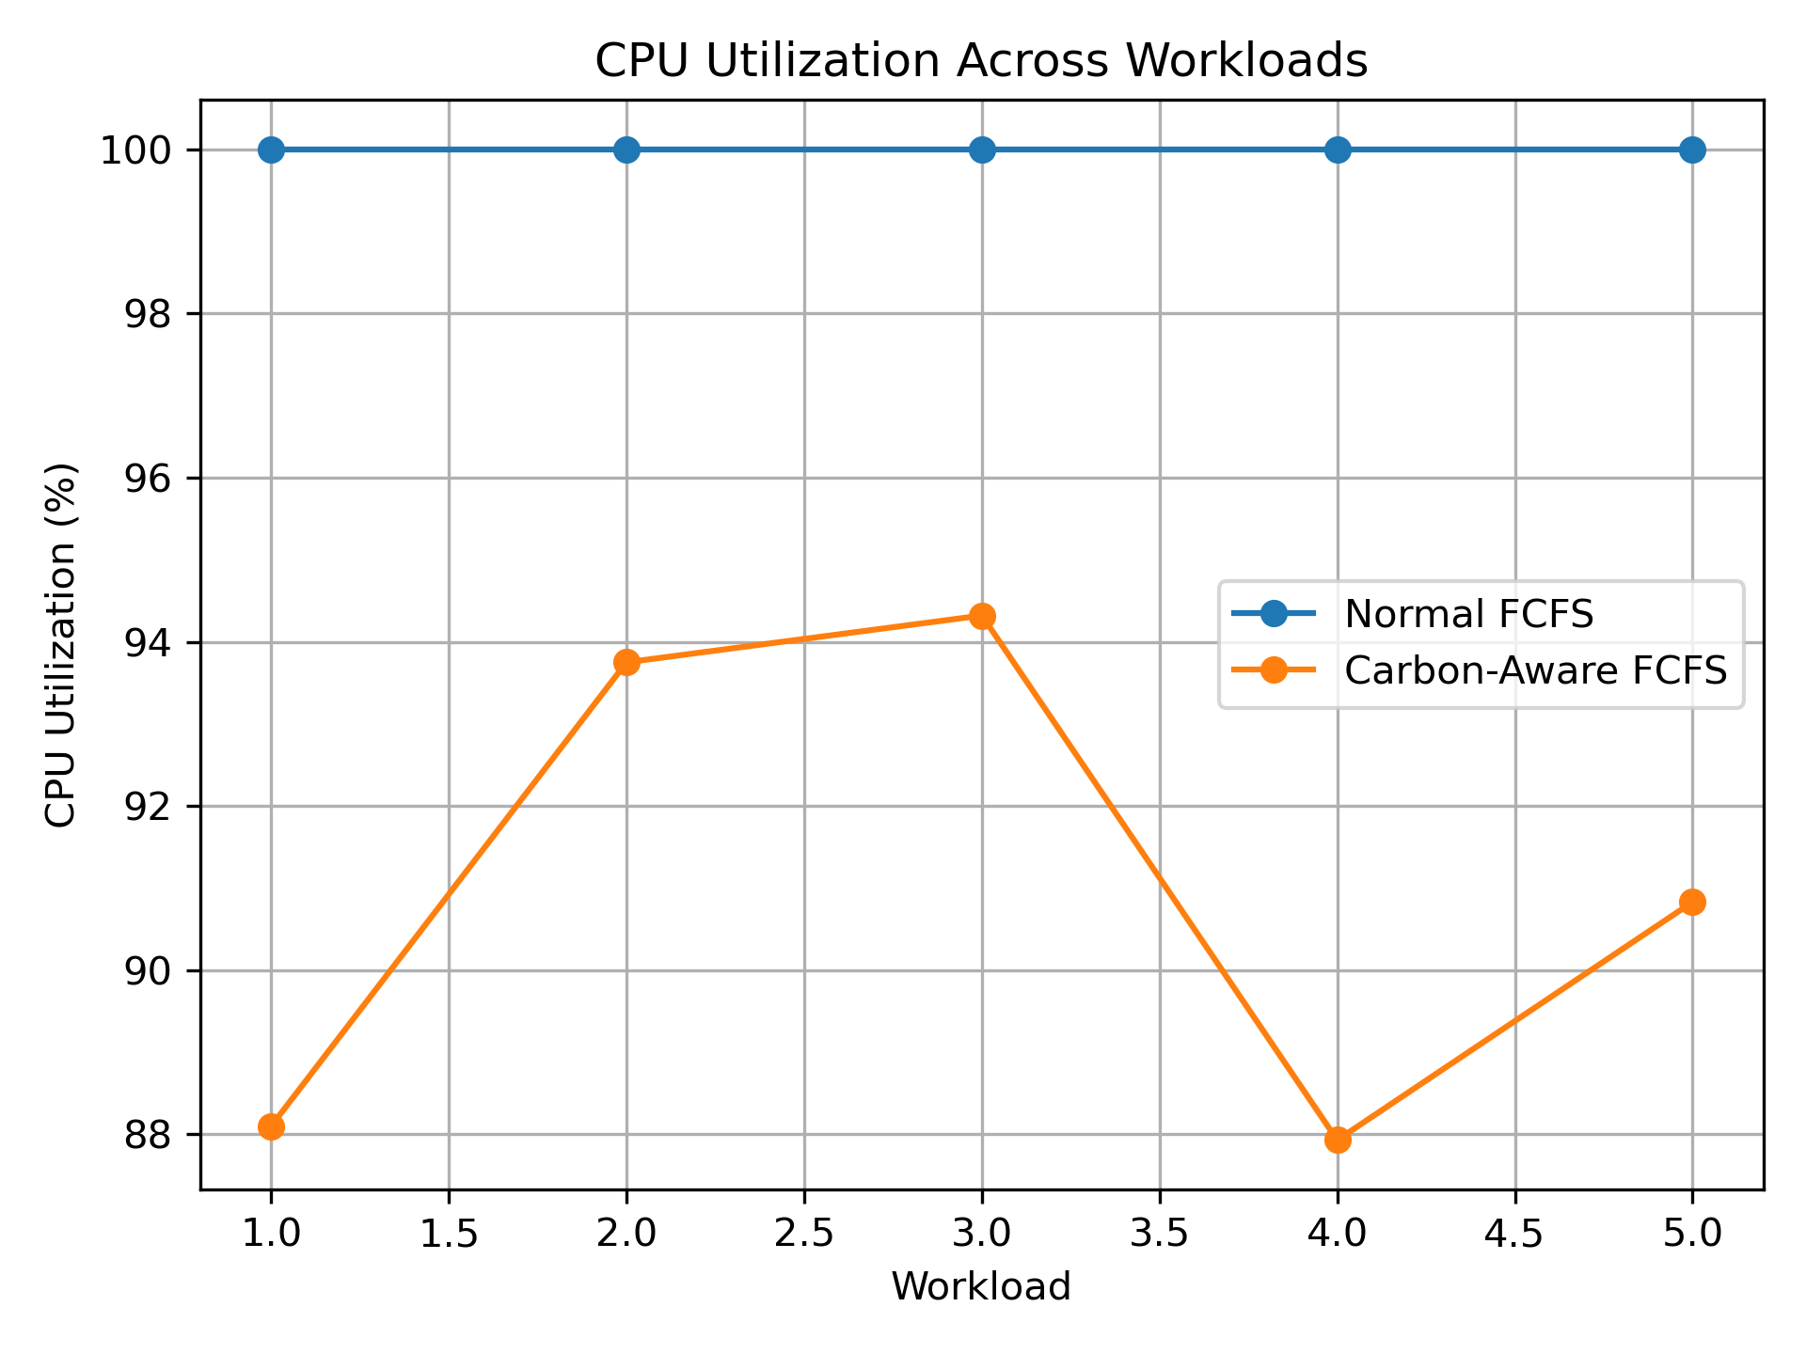
Figure 2. Preliminary CPU-utilization plot from the earlier development-stage experiment; the updated AWS EC2 benchmark is reported separately in Section 8.7.
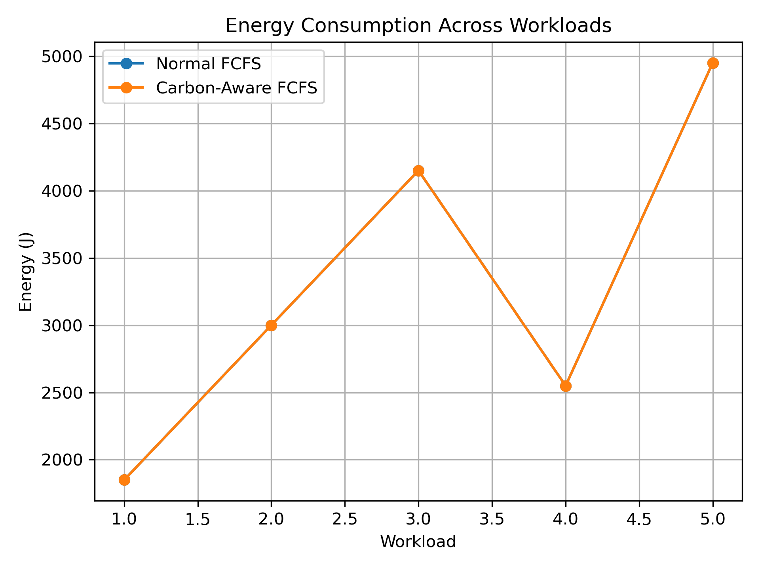
Figure 3. Preliminary modeled-energy plot from the earlier development-stage experiment; the updated AWS EC2 benchmark is reported separately in Section 8.7.
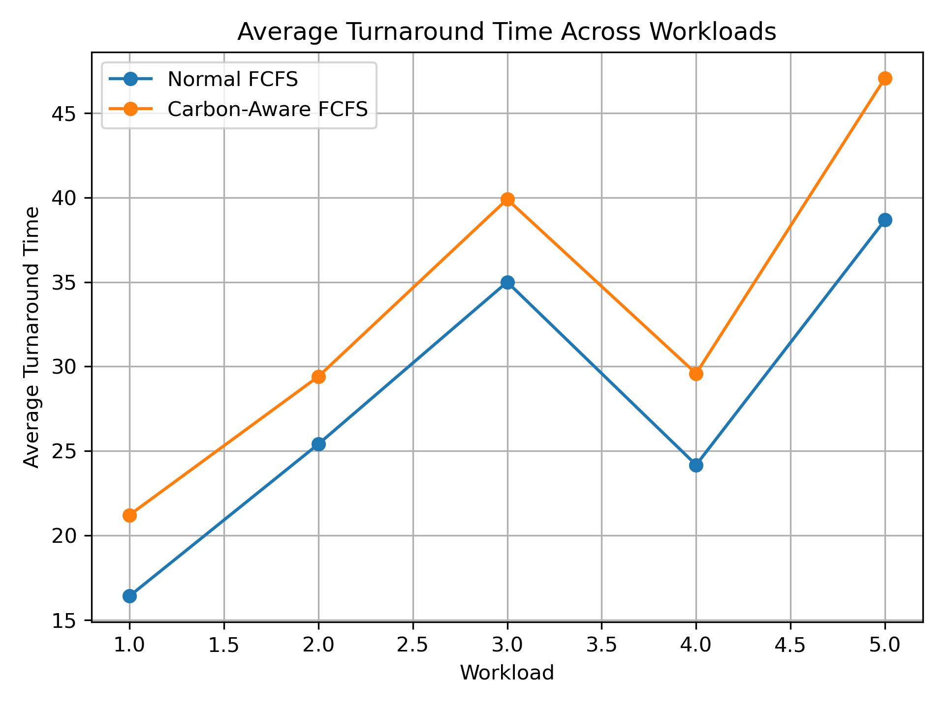
Figure 4. Preliminary turnaround-time plot from the earlier development-stage experiment; the updated AWS EC2 benchmark is reported separately in Section 8.7.
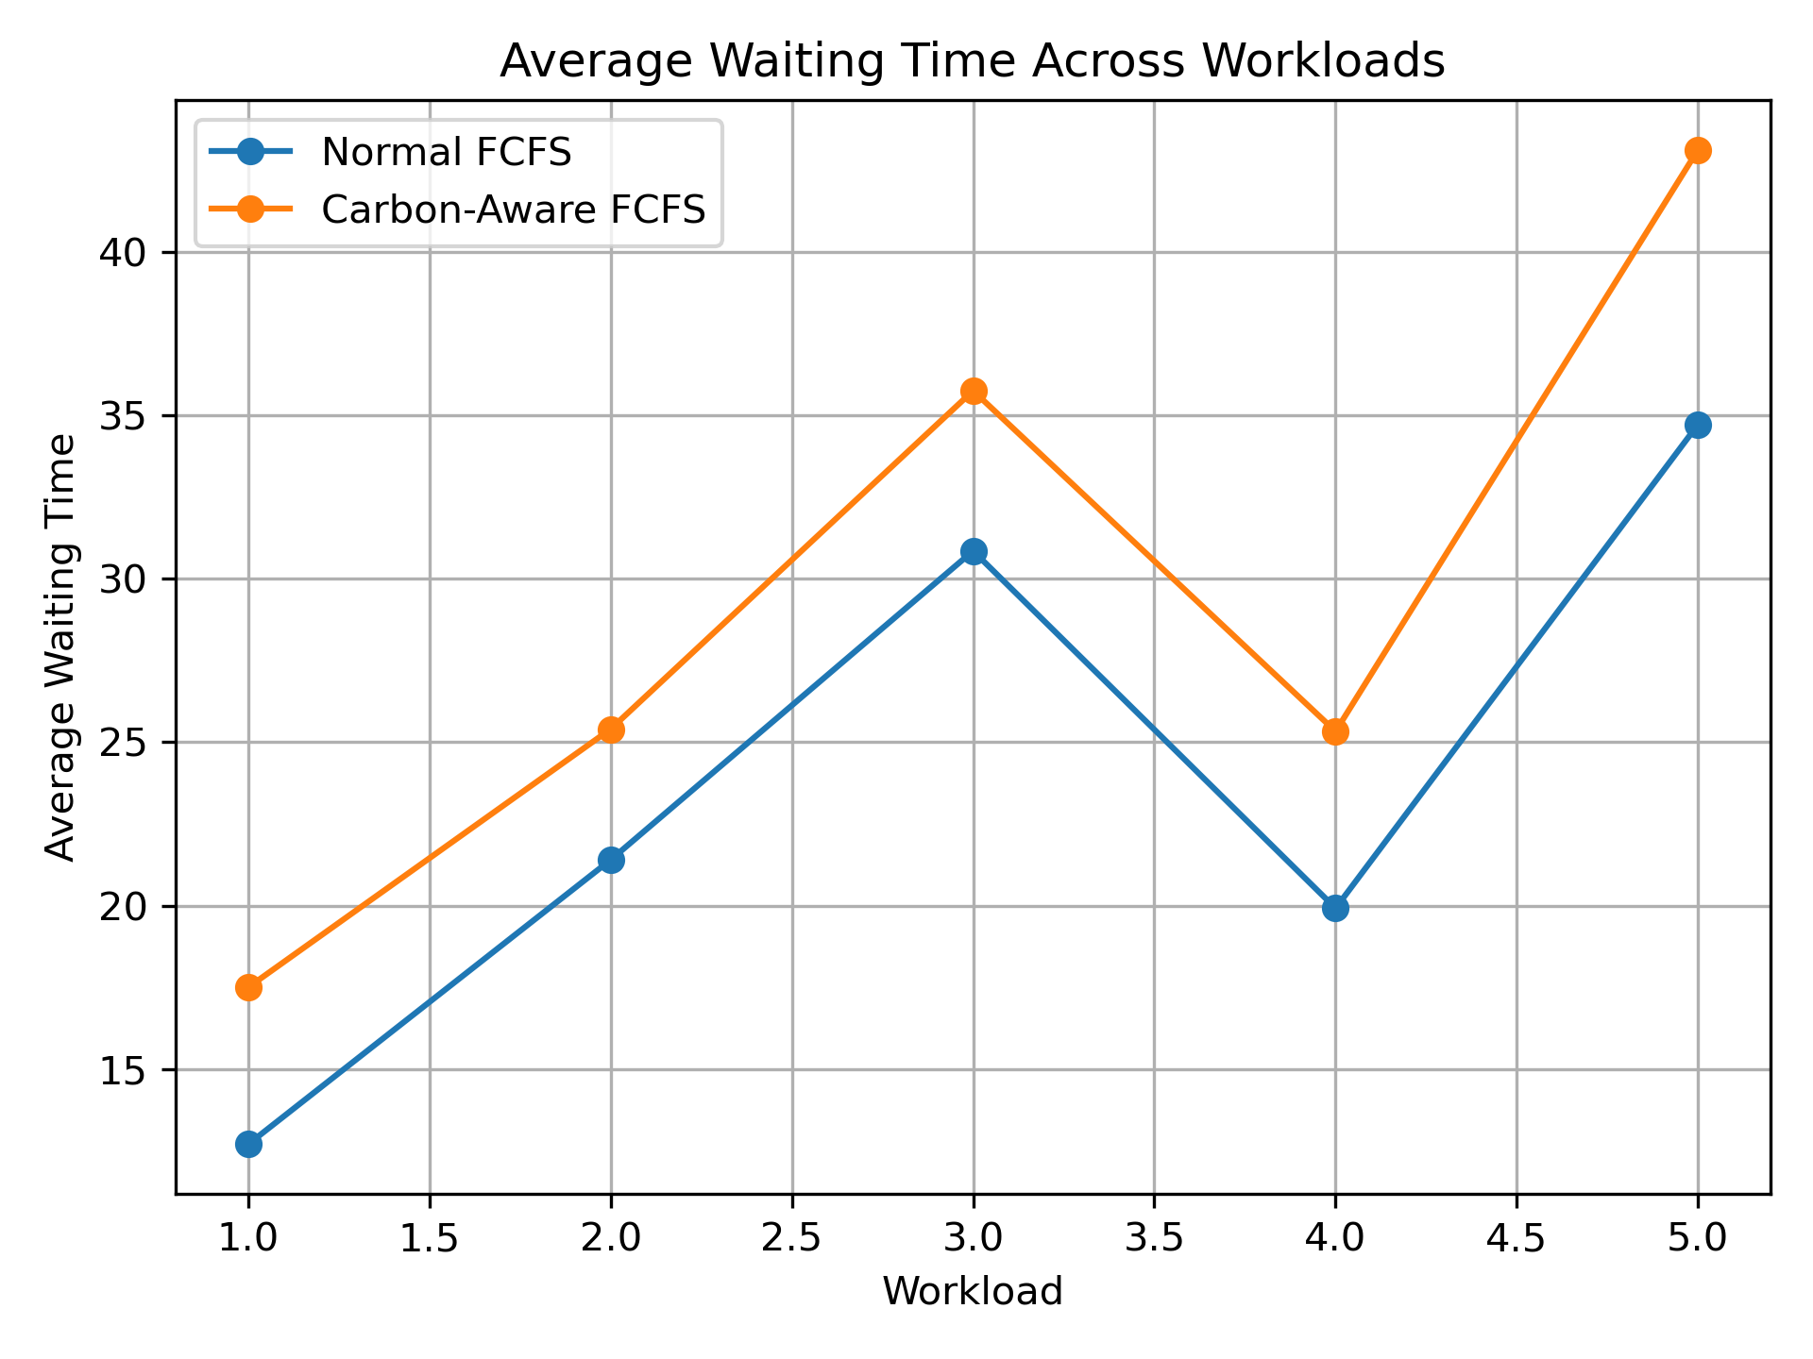
Figure 5. Preliminary waiting-time plot from the earlier development-stage experiment; the updated AWS EC2 benchmark is reported separately in Section 8.7.

8.1 Carbon Emission Behavior
In the AWS EC2 benchmark, estimated carbon emissions are lower for carbon-aware FCFS at every workload size. The absolute reduction is approximately 9.19% for 100 processes, 4.86% for 200, 3.16% for 300, 2.29% for 400 and 1.94% for 500. The declining percentage suggests that the benefit of this particular threshold and repeated synthetic trace does not scale proportionally with workload size. These are simulation estimates driven by the input carbon trace and assumed power model, not direct AWS energy or emissions measurements.
The reduction is not produced by executing fewer CPU instructions or by reducing the total burst time. Instead, the scheduler changes when the same work is performed. This distinction is central to the research idea and is one reason the carbon figure should be interpreted together with the energy and CPU-utilization figures.

8.2 CPU Utilization Behavior
For the AWS benchmark, carbon-aware FCFS has lower reported CPU utilization than conventional FCFS for each workload size, although its utilization rises as the workload grows. The scheduler deliberately creates idle intervals when it defers tasks to lower-carbon windows. The normal FCFS utilization is near 100% in these runs. These utilization values are simulator metrics, not host-level CloudWatch measurements of the EC2 virtual machine.
In a production system, this behavior would need to be controlled carefully. Excessive idle time could damage responsiveness or throughput. Therefore, future versions should introduce maximum-deferral limits, configurable carbon-versus-latency objectives and workload classifications.

8.3 Energy Behavior
Modeled energy is identical between the two policies for each workload: 10,000 J for 100 processes, rising to 50,000 J for 500 processes. The implementation assumes a constant 50 W and charges energy according to total CPU burst time. Since both algorithms execute the same total burst work, delaying execution changes the carbon intensity associated with that work but does not reduce modeled energy. This must not be interpreted as an observed EC2 power reading.
This result is useful because it demonstrates why carbon awareness should not simply be described as energy saving. A system can consume the same amount of modeled energy and still produce different estimated carbon emissions depending on when the energy is consumed.

8.4 Waiting and Turnaround Behavior
The AWS results show a large latency cost from temporal shifting. Average waiting time rises from approximately 0.49–0.50 s under normal FCFS to 32.90–38.98 s under carbon-aware FCFS; average turnaround time rises from approximately 2.49–2.50 s to 34.90–40.98 s. Deadline misses also increase with workload size: carbon-aware FCFS meets 69/100 deadlines for the 100-process workload and 269/500 for the 500-process workload, while normal FCFS meets all deadlines in these runs. This is a critical finding: the current policy needs stronger deadline-feasibility handling and a maximum-deferral control before it could be suitable for deadline-sensitive workloads.
These metrics should not be treated as unwanted side effects to be hidden. They are part of the multi-objective scheduling problem. A useful carbon-aware scheduler must expose the relationship between environmental benefit and user-visible performance so that an appropriate trade-off can be selected.

8.5 Supplementary Aggregate Comparisons
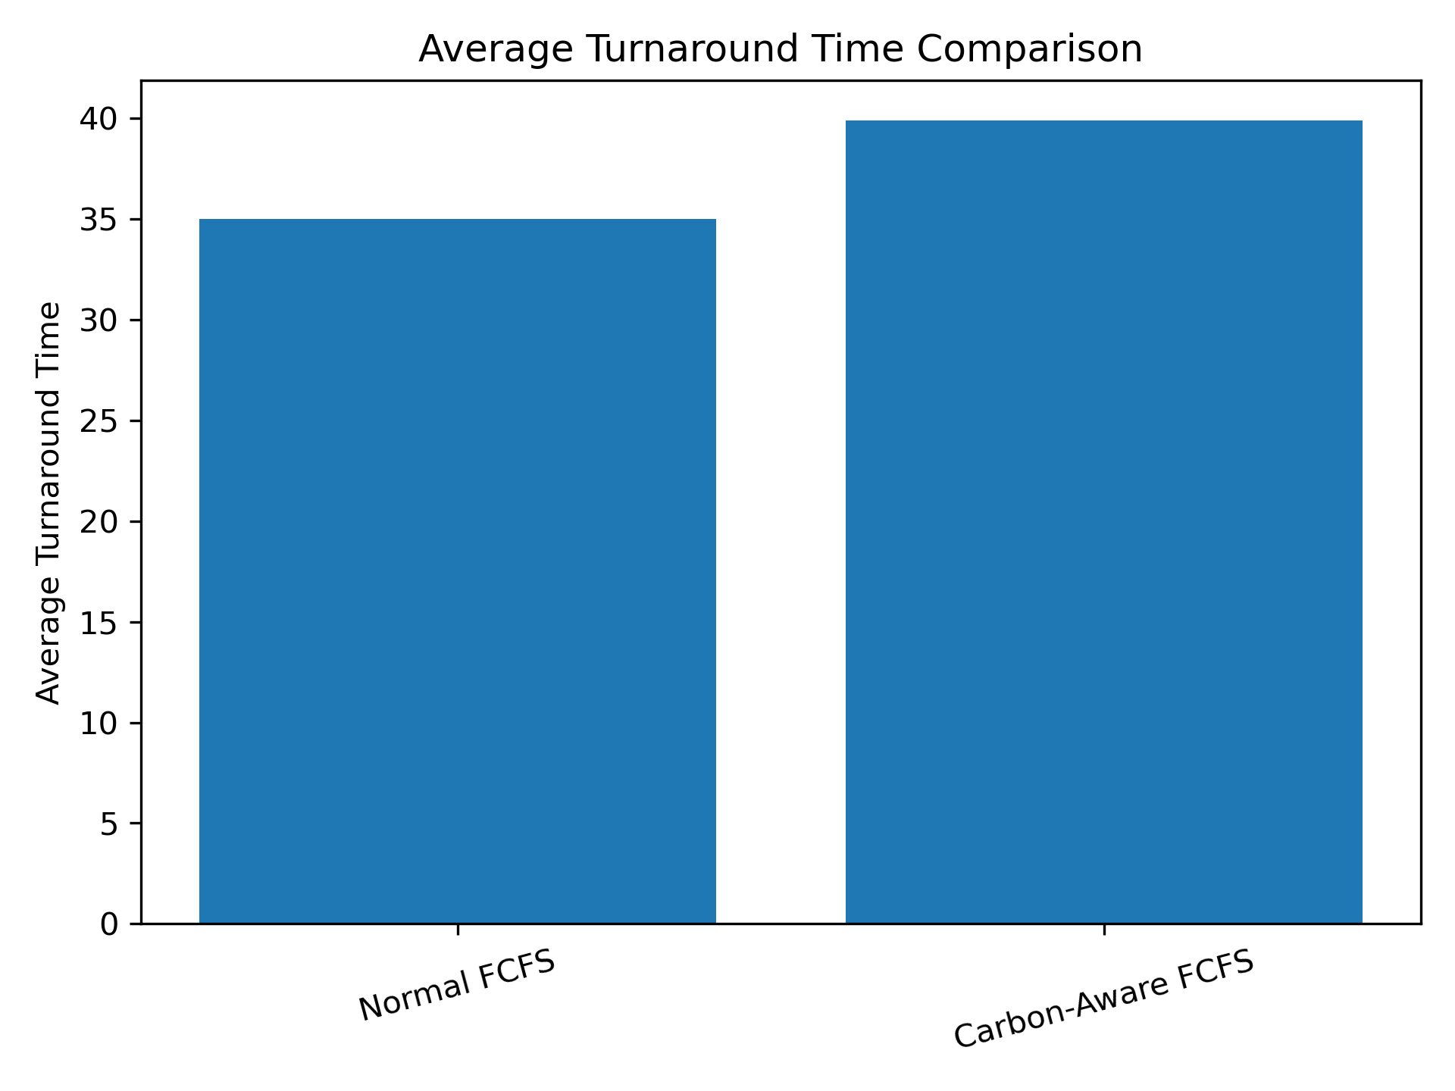
Figure 6. Aggregate average turnaround-time comparison.
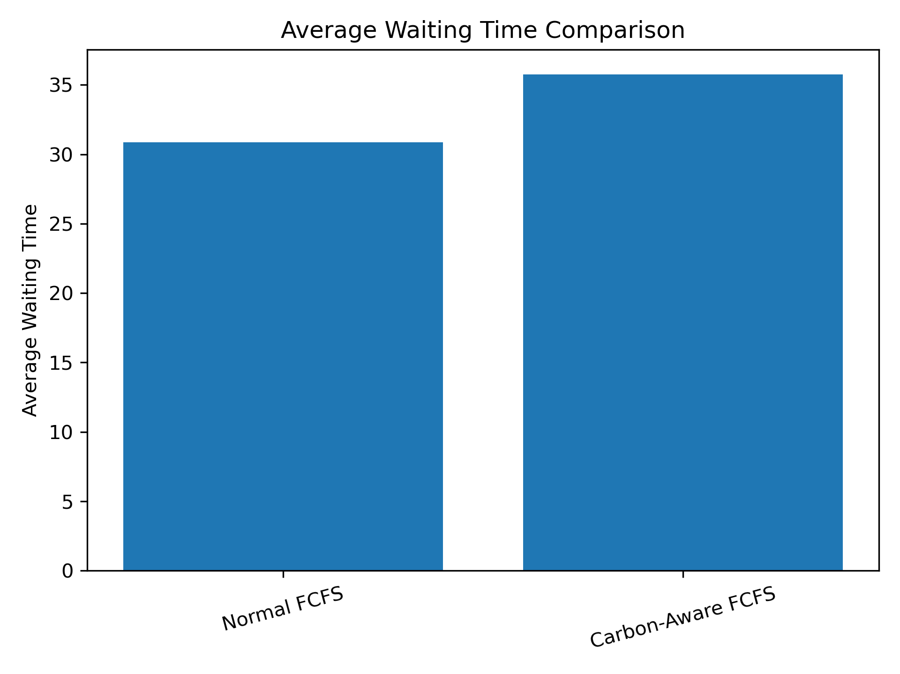
Figure 7. Aggregate average waiting-time comparison.

8.6 Controlled Four-Process Example
A separate four-process controlled workload was used as a functional check of the scheduling decision. In that small example, the carbon-aware version shifted the first process from an initial high-carbon interval into a cleaner interval while preserving all four deadlines. The approximately 14.95% carbon reduction belongs only to that specific four-process test. It is not the reduction observed across the 100–500-process AWS benchmark, where carbon reductions range from approximately 1.94% to 9.19% and deadline misses occur.
Metric | Normal FCFS | Carbon-Aware FCFS
Average Waiting Time | 2.75 | 6.75
Average Turnaround Time | 5.50 | 9.50
CPU Utilization | 100% | 73.33%
Energy | 550 J | 550 J
Estimated Carbon | 0.074306 gCO₂ | 0.063194 gCO₂
Deadline status | All met | All met
In this particular controlled test, the estimated carbon reduction is approximately 14.95%. This value belongs only to that four-process experiment and should not be presented as the overall performance of the complete project.

8.7 AWS EC2 Benchmark: Five Workload Sizes
To make the execution environment explicit and improve reproducibility, the C programs were compiled and run in AWS EC2 Ubuntu 24.04 LTS. The benchmark runner executed both binaries against the same generated workload file at each size (100, 200, 300, 400 and 500 processes); console outputs were saved in separate log files. The carbon-aware executable used the same synthetic carbon trace and 500 gCO₂/kWh threshold throughout. The table below transcribes the reported AWS terminal results.
Processes | Normal carbon (gCO₂) | Carbon-aware carbon (gCO₂) | Reduction | Modeled energy (both)
100 | 1.269444 | 1.152778 | 9.19% | 10,000 J
200 | 2.545833 | 2.422222 | 4.86% | 20,000 J
300 | 3.819444 | 3.698611 | 3.16% | 30,000 J
400 | 5.088889 | 4.972222 | 2.29% | 40,000 J
500 | 6.365278 | 6.241667 | 1.94% | 50,000 J
Processes | Avg. waiting (s) Normal / CA | Avg. turnaround (s) Normal / CA | CPU utilization Normal / CA | Deadlines met Normal / CA
100 | 0.49 / 32.90 | 2.49 / 34.90 | 99.50% / 82.99% | 100/100 / 69/100
200 | 0.49 / 36.70 | 2.50 / 38.70 | 99.75% / 90.70% | 200/200 / 119/200
300 | 0.50 / 37.97 | 2.50 / 39.97 | 99.83% / 93.60% | 300/300 / 169/300
400 | 0.50 / 38.60 | 2.50 / 40.60 | 99.88% / 95.12% | 400/400 / 219/400
500 | 0.50 / 38.98 | 2.50 / 40.98 | 99.90% / 96.06% | 500/500 / 269/500
Across the five workloads, estimated carbon reduction is positive but declines as workload size increases. The carbon-aware policy incurs substantially greater waiting and turnaround time and misses 31, 81, 131, 181 and 231 deadlines respectively. Normal FCFS reports no deadline misses in these runs. The current algorithm's candidate search checks that the candidate process's own burst fits its deadline and that its execution window is below the carbon threshold; however, it does not reserve all future processes' deadlines when shifting the current process. This limitation helps explain the larger-system deadline failures and must be addressed in a later version.
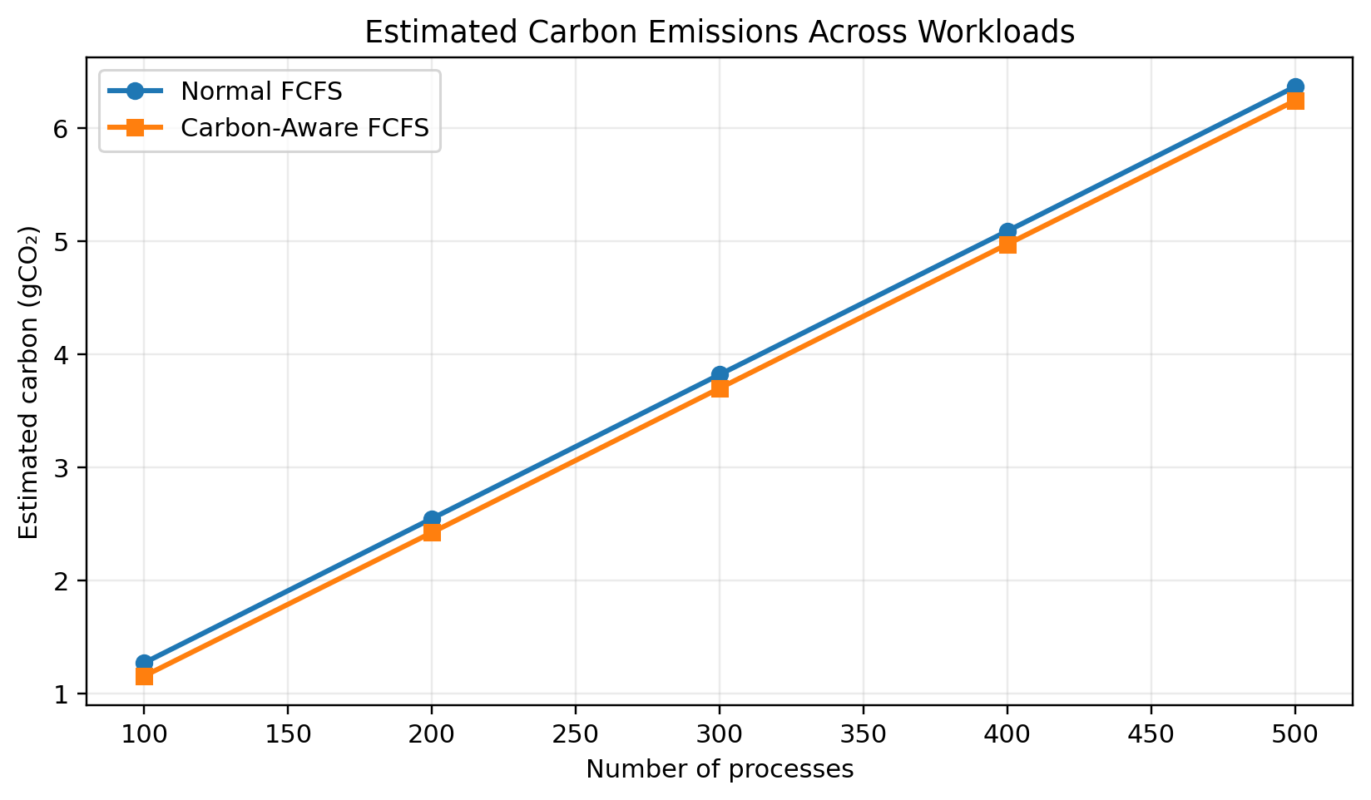
Estimated Carbon Emissions Across Workloads. AWS EC2 Ubuntu 24.04 benchmark; values are simulation outputs.
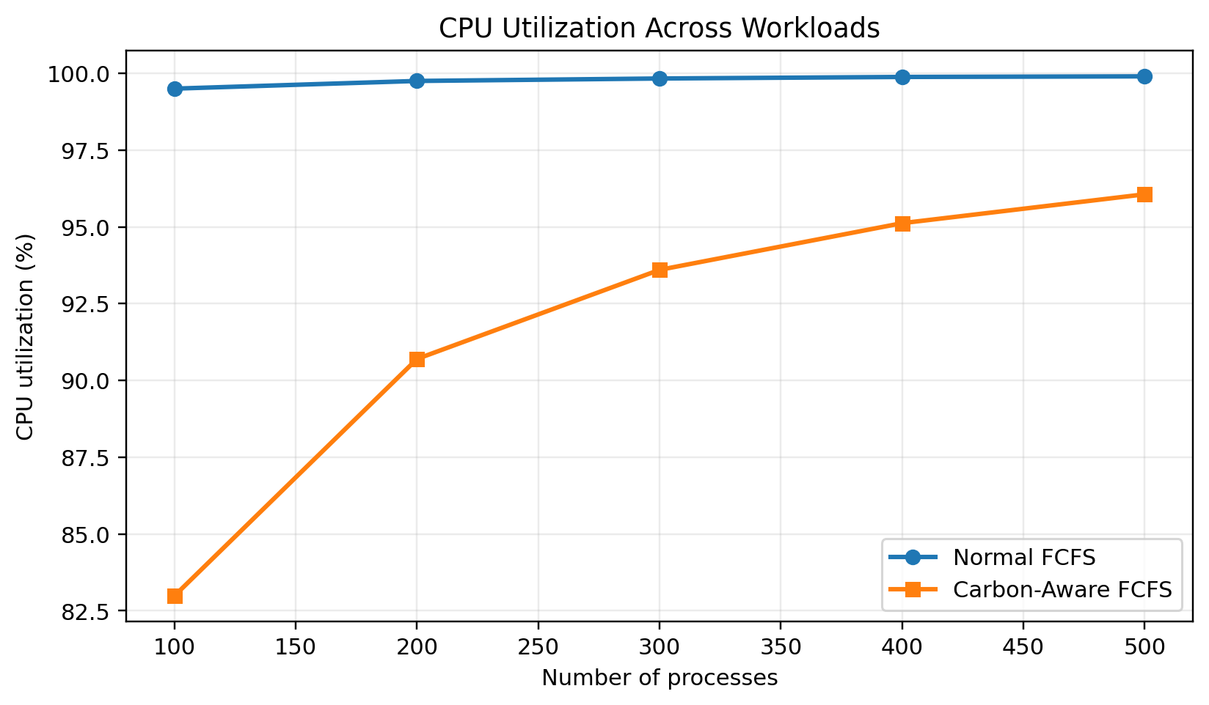
CPU Utilization Across Workloads. AWS EC2 Ubuntu 24.04 benchmark; values are simulation outputs.
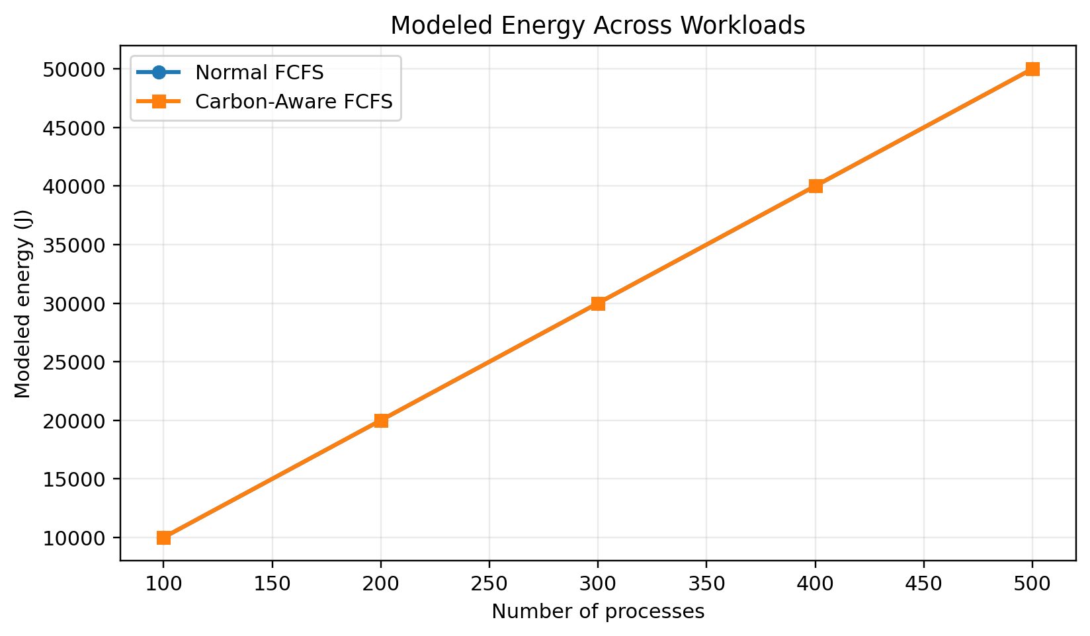
Modeled Energy Across Workloads. AWS EC2 Ubuntu 24.04 benchmark; values are simulation outputs.
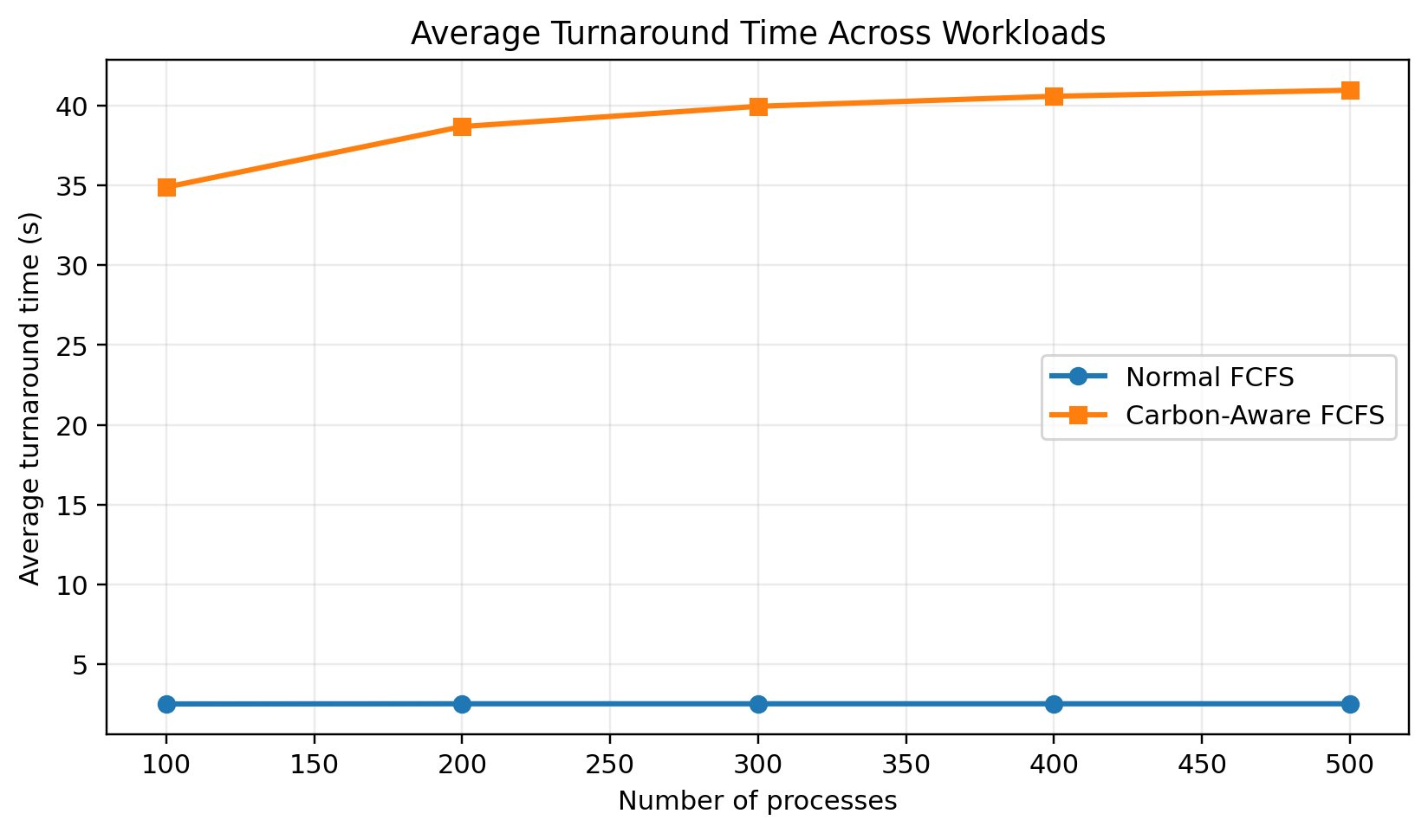
Average Turnaround Time Across Workloads. AWS EC2 Ubuntu 24.04 benchmark; values are simulation outputs.
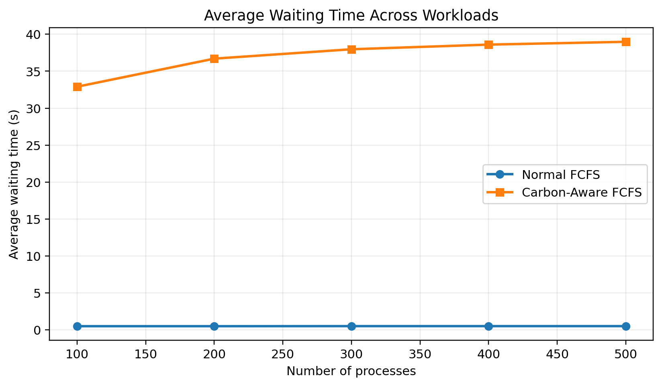
Average Waiting Time Across Workloads. AWS EC2 Ubuntu 24.04 benchmark; values are simulation outputs.

8.8 Independently Validated Metrics and Comparative Figures
To reduce the risk of transcription errors, the process-level output logs for both schedulers were re-parsed independently for each workload size (100, 200, 300, 400 and 500 processes). The validation script recomputed waiting time from start time minus arrival time, turnaround time from completion time minus arrival time, and completion time from start time plus burst time. It also checked the number of parsed process rows, valid time fields, completeness of the carbon trace over all simulated execution intervals, reported energy against burst-work energy, and reported carbon emissions against a separate calculation from the trace. All ten scheduler/workload log combinations passed all implemented checks. Independently calculated carbon totals agreed with the values printed by the programs to within the six-decimal rounding used in the logs; no simulated execution interval referenced a missing carbon-trace timestamp.
Table 3 summarizes the paired workload results. Under the constant-power model, energy is calculated as 50 J per unit of burst time, so both schedulers have identical modeled energy for a given workload. Carbon emissions differ because the carbon-aware policy shifts simulated execution across time-indexed carbon-intensity values. The observed execution span is the interval from the earliest simulated arrival to the latest completion; it is not the wall-clock runtime of the executable on EC2.
Processes | Scheduler | Avg. waiting | Avg. turnaround | Deadline success | Missed deadlines | Carbon (gCO₂)
100 | Normal FCFS | 0.490 | 2.490 | 100.00% | 0 | 1.269444
100 | Carbon-aware FCFS | 32.900 | 34.900 | 69.00% | 31 | 1.152778
200 | Normal FCFS | 0.495 | 2.495 | 100.00% | 0 | 2.545833
200 | Carbon-aware FCFS | 36.700 | 38.700 | 59.50% | 81 | 2.422222
300 | Normal FCFS | 0.497 | 2.497 | 100.00% | 0 | 3.819444
300 | Carbon-aware FCFS | 37.967 | 39.967 | 56.33% | 131 | 3.698611
400 | Normal FCFS | 0.498 | 2.498 | 100.00% | 0 | 5.088889
400 | Carbon-aware FCFS | 38.600 | 40.600 | 54.75% | 181 | 4.972222
500 | Normal FCFS | 0.498 | 2.498 | 100.00% | 0 | 6.365278
500 | Carbon-aware FCFS | 38.980 | 40.980 | 53.80% | 231 | 6.241667
Table 3. Independently re-calculated workload metrics from the AWS EC2 simulation logs. Time values use simulator time units; carbon values are model-derived, not physical AWS measurements.
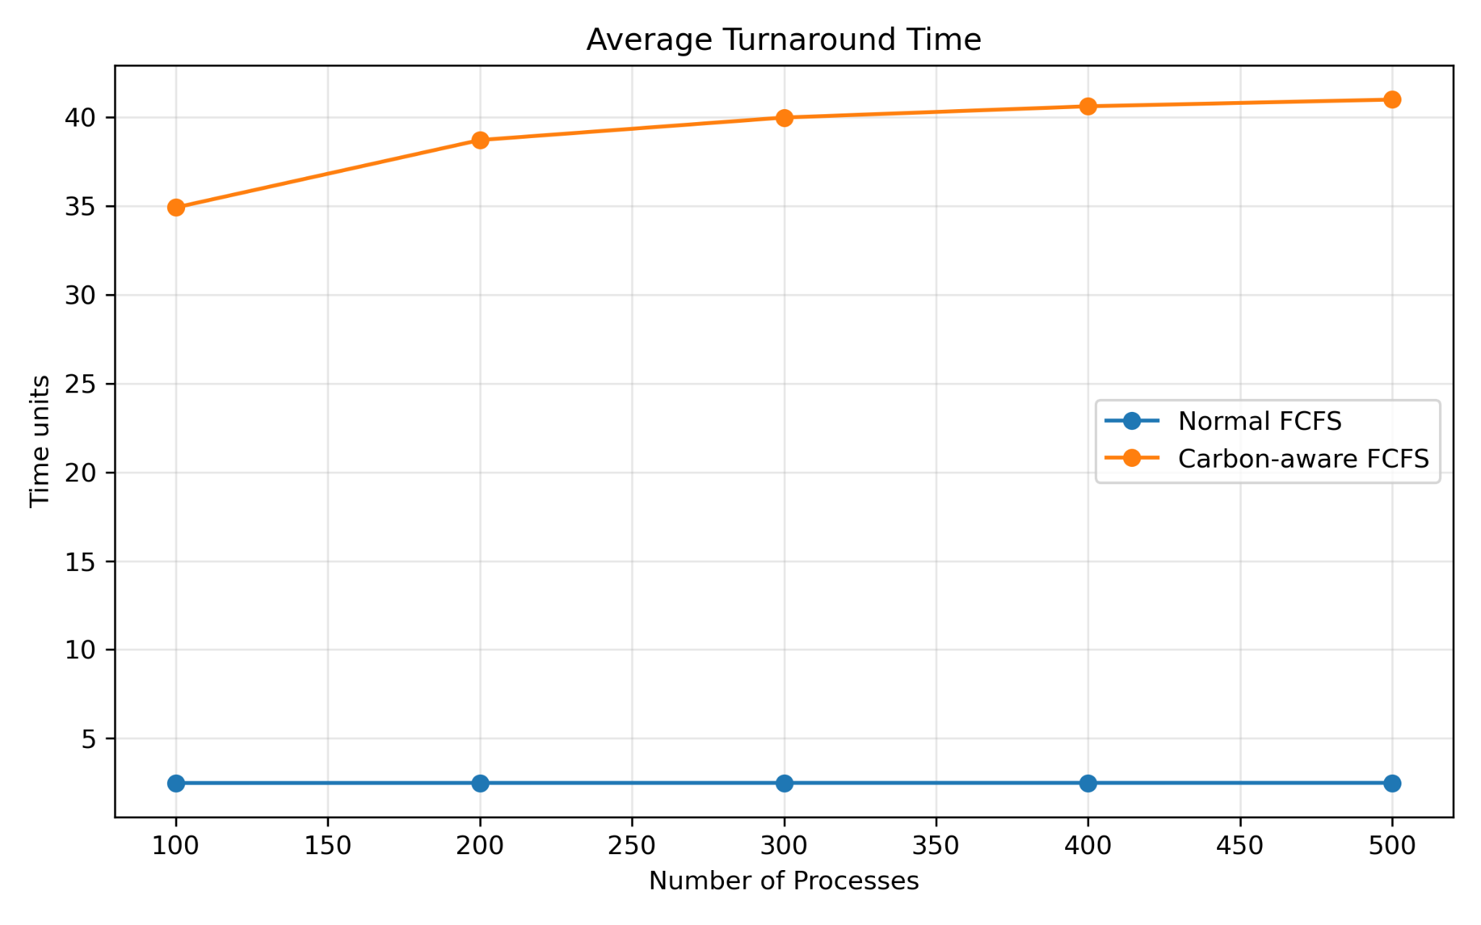
Figure 8. Average turnaround time versus workload size.
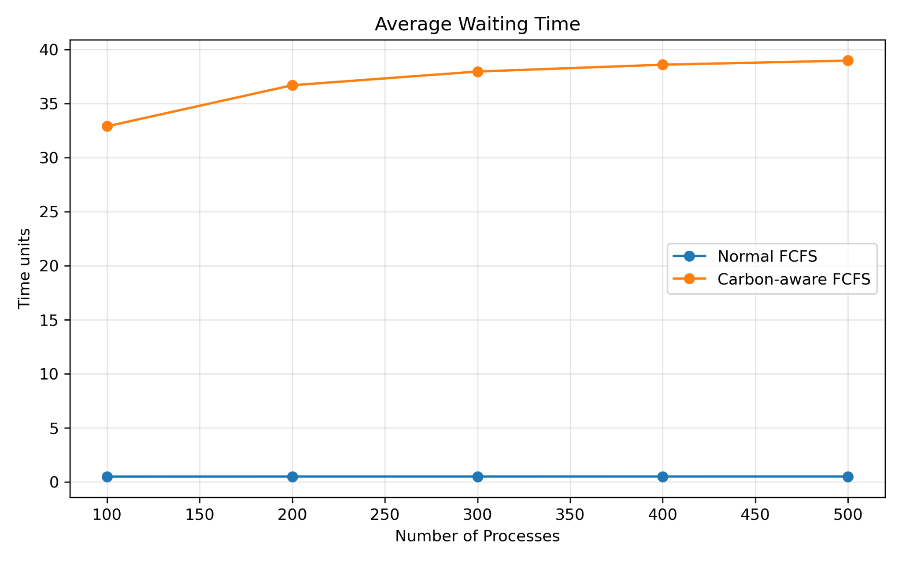
Figure 9. Average waiting time versus workload size.
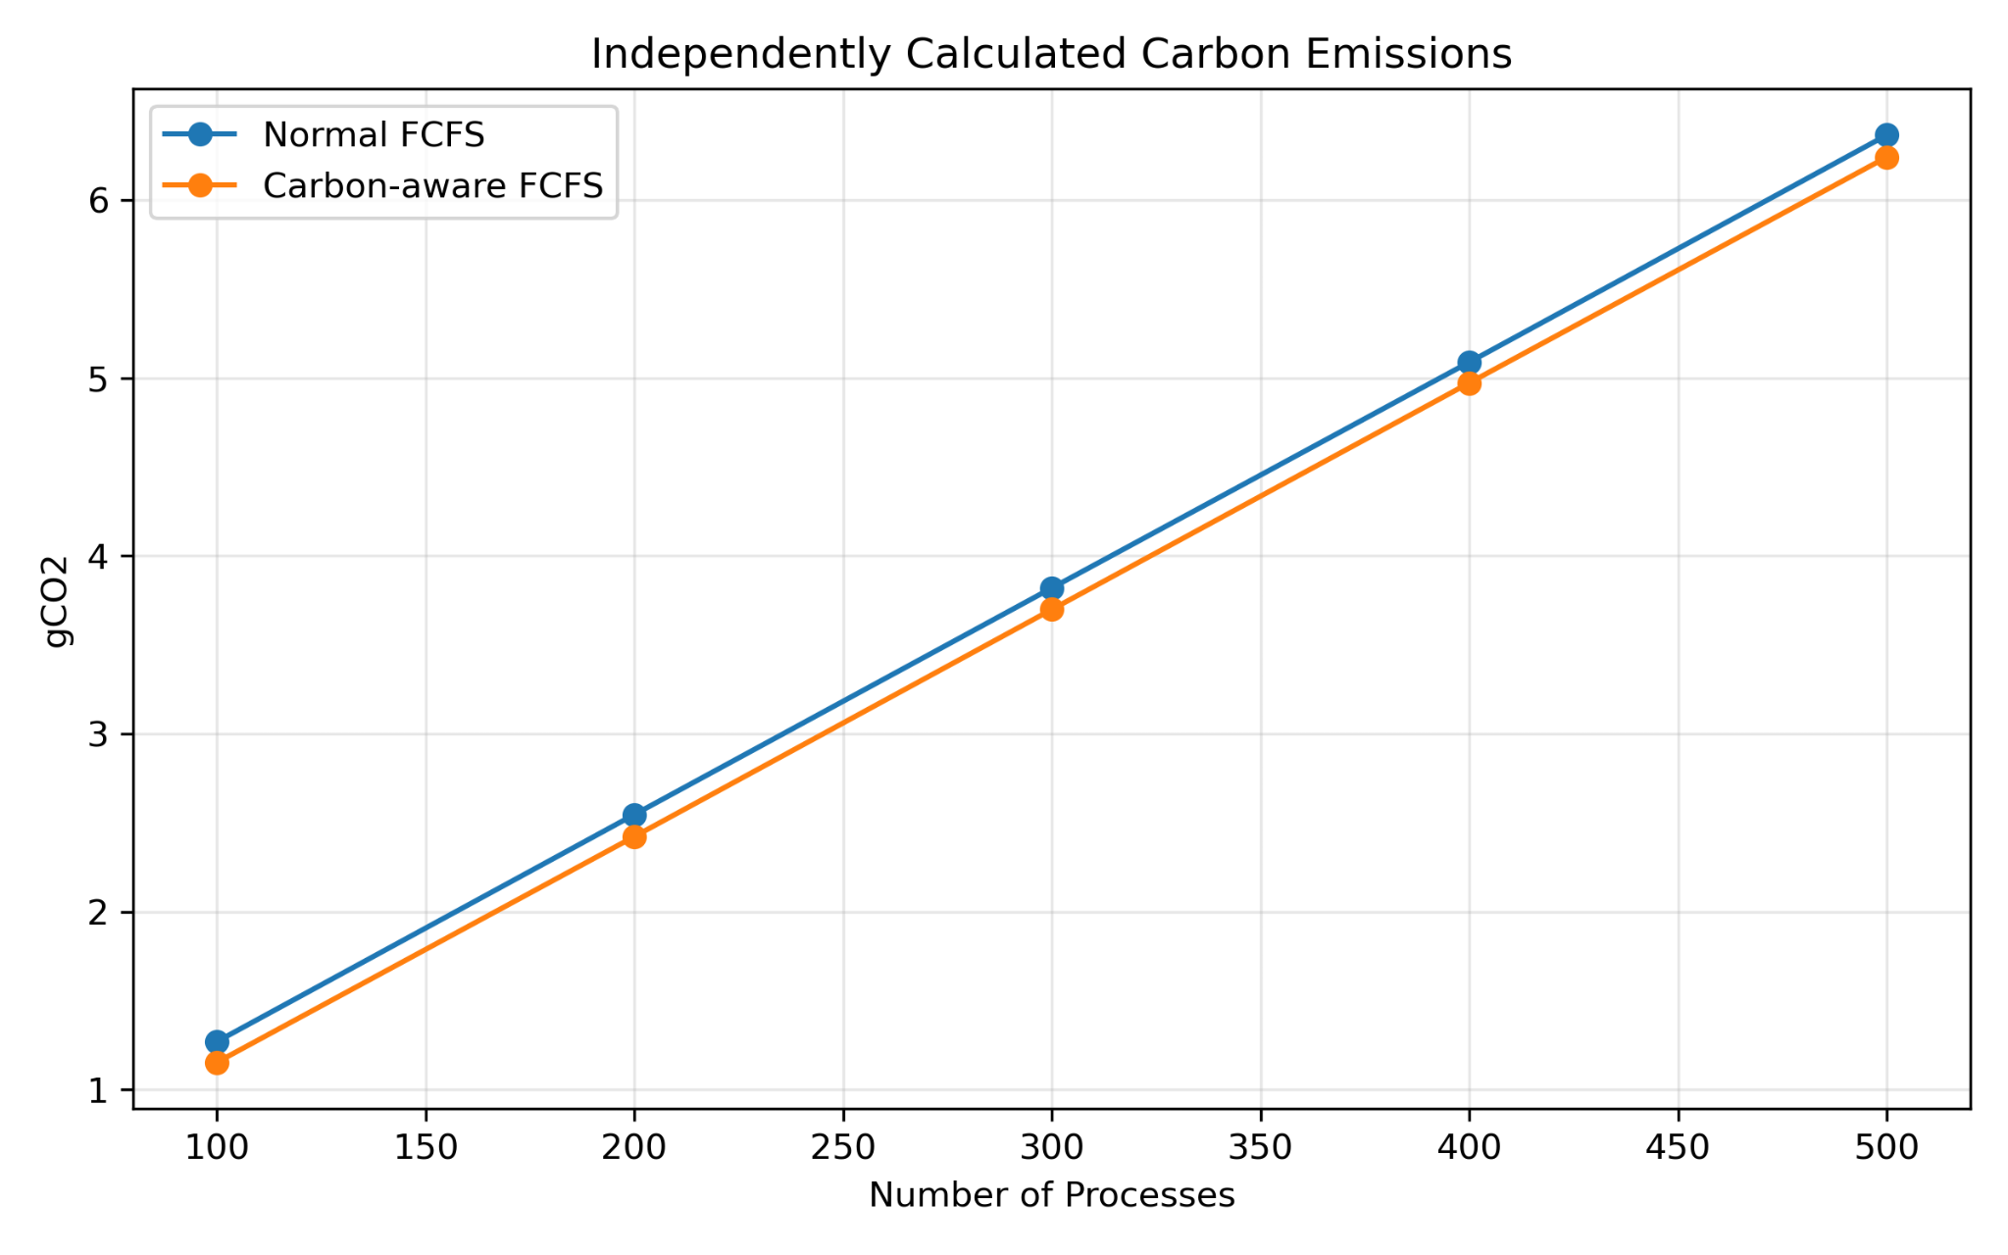
Figure 10. Independently calculated carbon-emission estimates versus workload size.
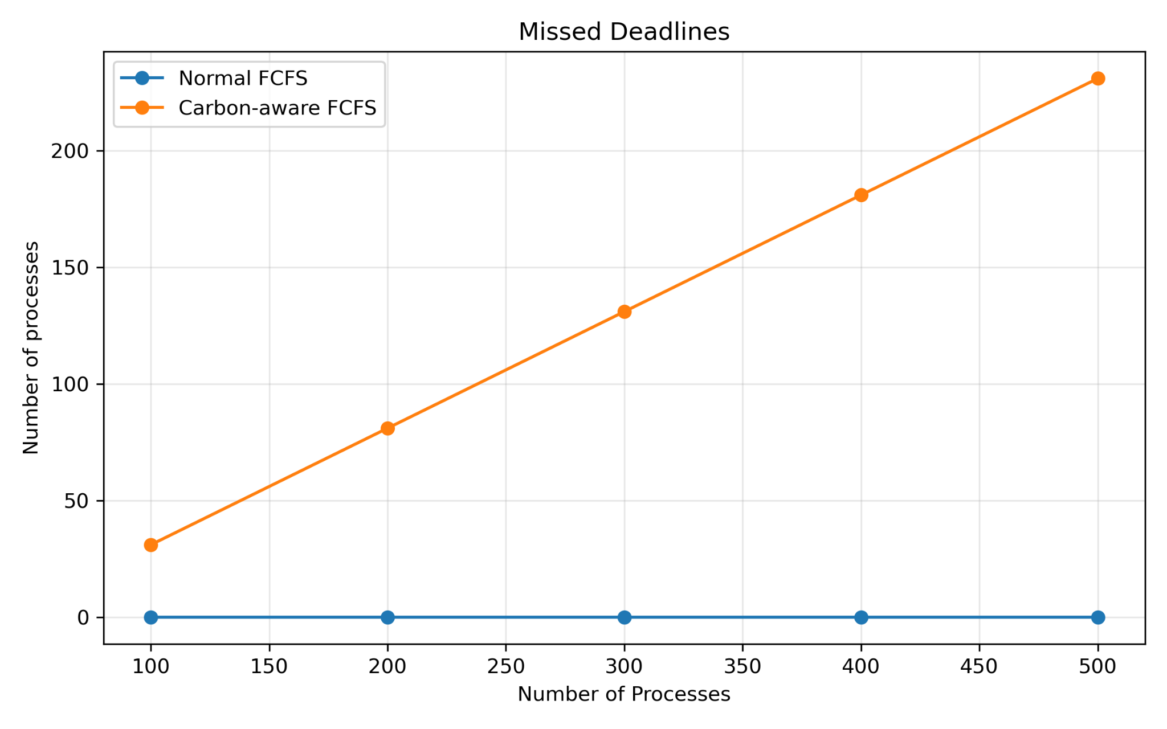
Figure 11. Number of missed deadlines for each scheduling policy.
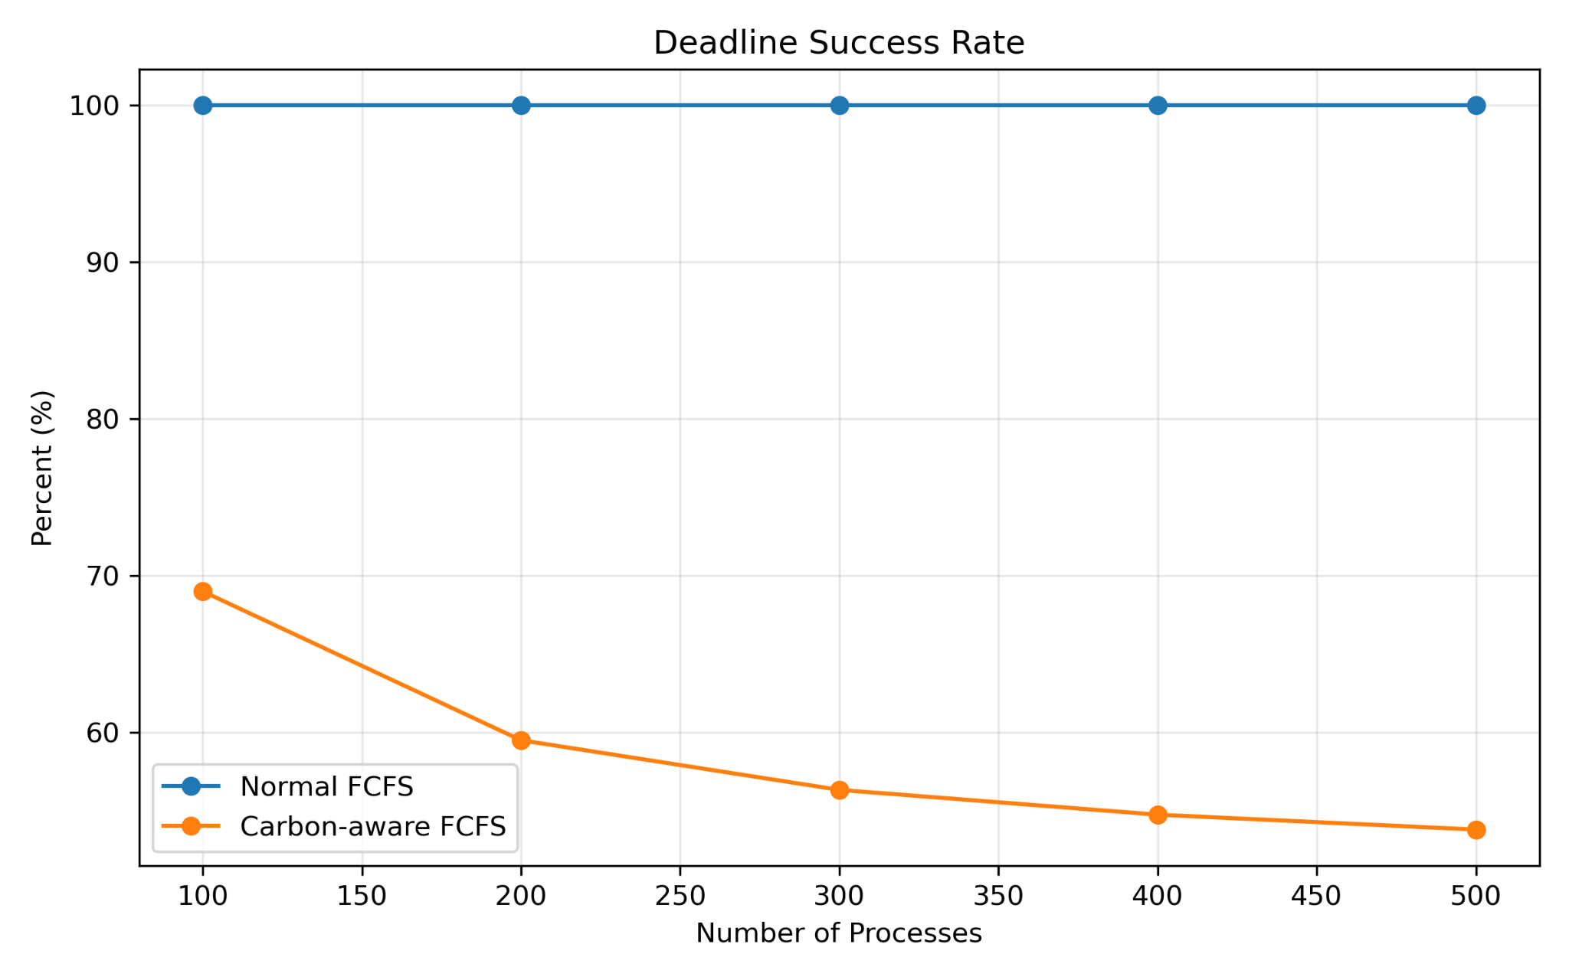
Figure 12. Deadline success rate across workload sizes.
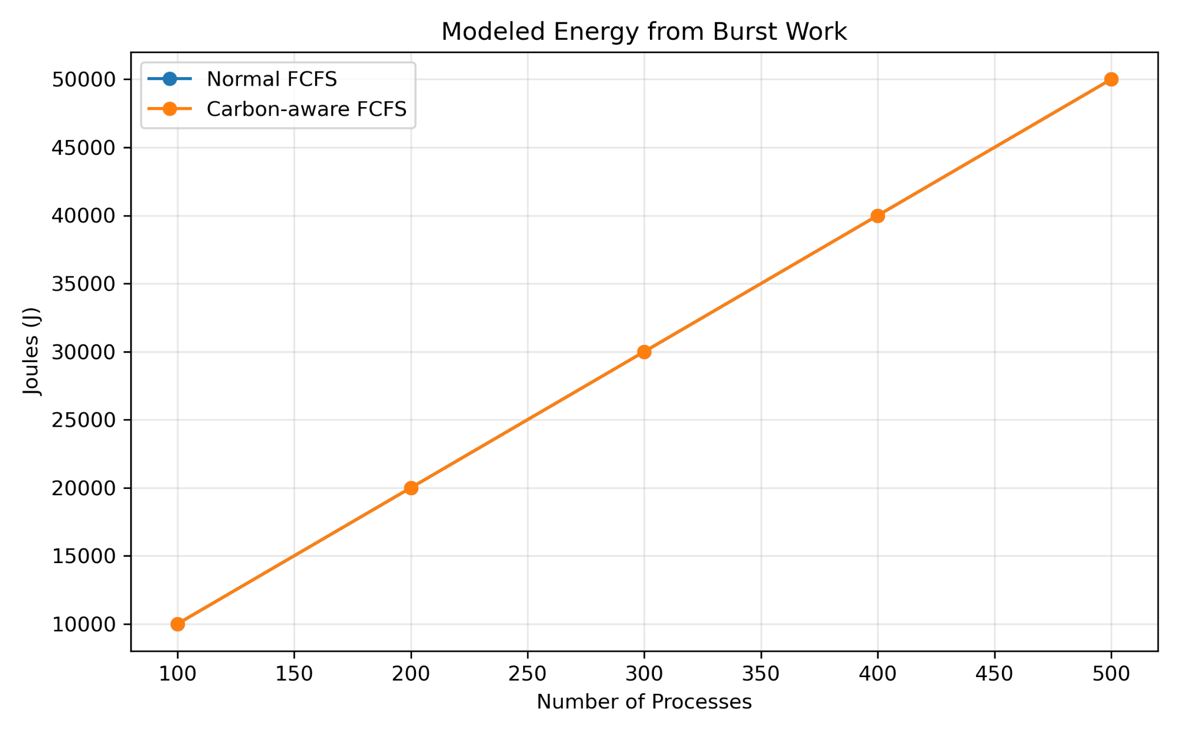
Figure 13. Modeled energy calculated from total burst work under the constant 50 W assumption.
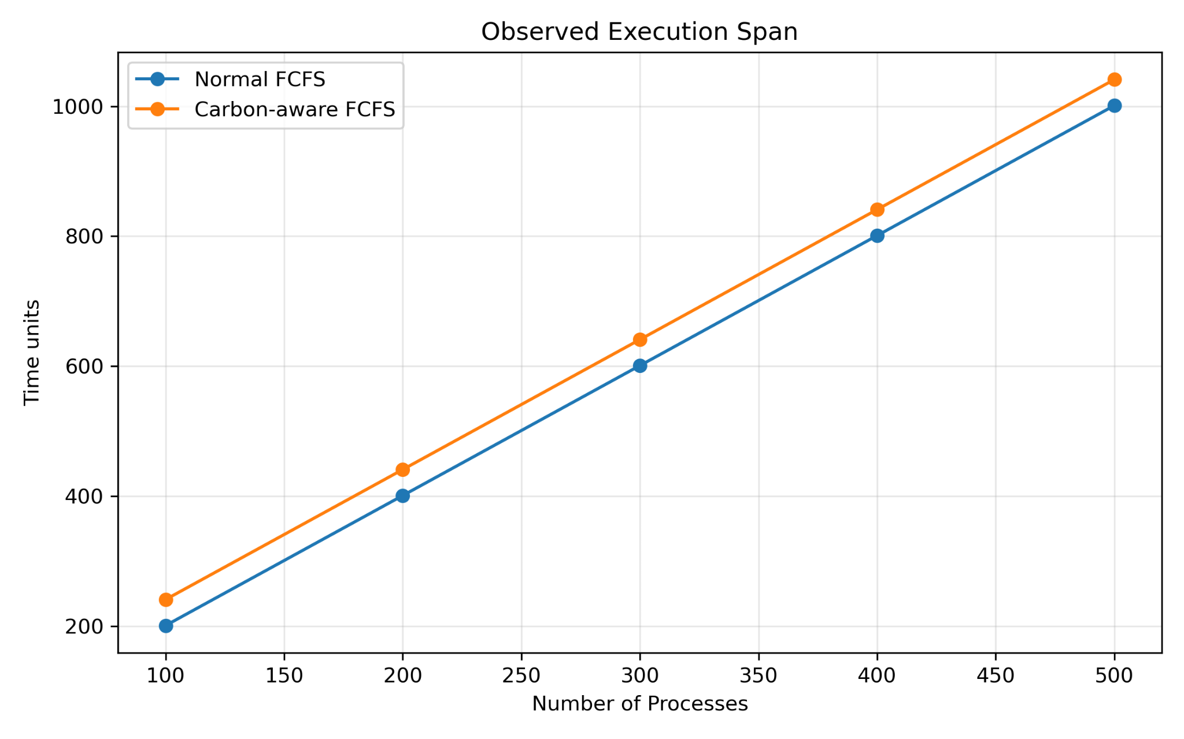
Figure 14. Observed simulated execution span; this is not executable wall-clock runtime.
Across the five workloads, carbon-aware FCFS reduced the model-derived carbon estimate by approximately 9.19%, 4.86%, 3.16%, 2.29% and 1.94%, respectively. This benefit came with a marked performance cost: deadline success declined from 100% under conventional FCFS to 53.80–69.00% under the carbon-aware variant. The current policy therefore demonstrates a carbon/performance trade-off, not an overall scheduling improvement. The deadline results indicate that the deferral rule requires stronger deadline-slack checks or an explicit penalty for missed deadlines before it is suitable for deadline-sensitive workloads.

8.9 Dataset Format and Reproducibility
Each workload file contains a process count on the first line, followed by one process per line with four integer fields: PID, arrival time (AT), burst time (BT) and deadline (DL). The five files are datasets/workload_100.txt, workload_200.txt, workload_300.txt, workload_400.txt and workload_500.txt. The generated workload is deterministic: process i has PID i, arrival time 2i, burst time following the repeating sequence 1, 2, 3, 2, 1, and deadline AT + BT + 40. The first records are shown below; the full files should be retained as supplementary experimental artifacts.
PID | Arrival time (s) | Burst time (s) | Deadline (s)
0 | 0 | 1 | 41
1 | 2 | 2 | 44
2 | 4 | 3 | 47
3 | 6 | 2 | 48
4 | 8 | 1 | 49
The original synthetic carbon trace contains the following 24 time-indexed values (time in seconds; intensity in gCO₂/kWh): 0:700, 1:700, 2:600, 3:600, 4:300, 5:300, 6:200, 7:200, 8:500, 9:500, 10:750, 11:750, 12:400, 13:400, 14:250, 15:250, 16:600, 17:600, 18:700, 19:700, 20:300, 21:300, 22:200, 23:200. For the large benchmark, this 24-second pattern was repeated cyclically to create carbon_extended.txt with 10,000 time points. The trace is synthetic and is not claimed to represent live grid conditions or AWS-region electricity data.
For reproduction on a Linux host, compile with `gcc newfcfs.c -o fcfs` and `gcc newcarbonfcfs.c -o carbon_fcfs`. Run each program with the same dataset, for example `./fcfs < datasets/workload_100.txt > logs/fcfs_100_test.txt` and `./carbon_fcfs < datasets/workload_100.txt > logs/carbon_100_test.txt`. Repeat for 200, 300, 400 and 500 processes. Keep the source files, dataset generator, carbon trace, raw logs and figures together so that reported metrics can be audited.

9. Discussion

9.1 What the Experiment Demonstrates
The current experiment demonstrates that a classical CPU scheduling policy can be augmented with a temporal carbon signal without completely redesigning the scheduling model. The base FCFS ordering remains understandable and predictable. The carbon-awareness layer acts at the process-start decision, making the prototype easy to reason about and compare against the baseline.

9.2 The Central Trade-Off
The central trade-off is straightforward: lower carbon can require waiting. Conventional FCFS prioritizes immediate service once a process reaches the front of the queue. Carbon-aware FCFS is willing to sacrifice some immediate utilization and responsiveness when the carbon trace suggests that a cleaner period is available.
This trade-off becomes particularly important for different workload classes. Batch jobs with flexible deadlines may tolerate temporal shifting, while interactive or real-time jobs may not. The final framework should therefore avoid assuming that every process has the same environmental flexibility.

9.3 Why the Current Prototype Is Useful
Although the current system is simplified, it provides an important experimental baseline. A controlled simulation makes it possible to isolate the scheduling logic before introducing the additional complexity of Linux scheduling behavior, virtualization overhead, multicore placement and hardware power measurement.

10. Limitations of the Current Study
- Carbon intensity is currently represented by a synthetic trace rather than a live external grid signal.
- The CPU uses a constant 50 W model, so frequency-dependent power behavior is not yet represented.
- The scheduler currently models a single CPU execution stream rather than a multicore system.
- The carbon decision uses a fixed threshold rather than a dynamic optimization objective.
- Only FCFS has been implemented and evaluated in the current research stage.
- The scheduler benchmark has been executed on an AWS EC2 Ubuntu 24.04 virtual machine, but this is not yet a validation of physical energy consumption. The scheduling logic remains a discrete-event simulation; it does not directly schedule Linux kernel processes according to grid carbon intensity.
- The reported energy and carbon are model-derived. AWS EC2 host power, CPU package energy and grid-specific carbon intensity were not measured directly; the t3.micro instance may also use virtualized CPU resources whose physical power characteristics are not exposed to the guest.
- Real-world carbon claims cannot be made from the present simulation alone.
SCOPE BOUNDARY
The present results should be described as estimated simulation results under the stated model. The project will become a systems-validation study only after the planned VM and, if possible, real-machine measurements are completed.

11. Completed VM Validation and Planned Framework Extensions
The VM and executable checks described in Section 11.2 have been completed. Expansion from the current carbon-aware FCFS prototype into a common multi-algorithm scheduling framework remains planned work. The intended design is for every algorithm to use the same workload files, carbon trace, metric definitions and result format so comparisons remain meaningful.
Algorithm | Base scheduling rule | Carbon-aware extension | Status
FCFS | Arrival order | Safe temporal shifting | Current
SJF | Shortest burst | Carbon-aware selection among candidates | Planned
SRTF | Shortest remaining burst | Dynamic carbon-aware decisions | Planned
Priority | Priority value | Priority + carbon feasibility | Planned
Round Robin | Time quantum | Carbon-aware execution/deferral policy | Planned

11.1 Common Experimental Harness
A fully automated common harness for multiple baseline and carbon-aware algorithms remains future work. The current completed validation script checked the existing FCFS and carbon-aware FCFS logs for five workload sizes, independently recomputed the implemented metrics, and generated seven comparison figures. It should not be interpreted as evidence that multiple additional scheduling algorithms have already been implemented or evaluated.

11.2 Virtual-Machine Validation
The VM validation stage was performed on an AWS EC2 t3.micro instance running Ubuntu 24.04.4 LTS. The guest reported x86-64 architecture, two online virtual CPUs, an Intel Xeon Platinum 8259CL CPU model at 2.50 GHz (as exposed to the guest), approximately 911 MiB of memory, and a 6.8 GB root filesystem. The Linux kernel reported by uname was 6.17.0-1017-aws. These values describe the virtualized environment visible from inside the guest; they do not identify the physical host configuration or expose host-level power measurements.

11.2.1 VM and Operating-System Checks
Environment checks confirmed that the SSH service was active, the primary network interface was up, outbound connectivity tests succeeded, and HTTPS access to the AWS website returned HTTP 200. These checks establish that the instance was reachable and functional for compiling and running the experiment harness. They are infrastructure checks rather than evidence of scheduler efficiency.

11.2.2 Linux Scheduler and Kernel-Facing Checks
The Linux scheduling interface was inspected using chrt, /proc/self/sched, /proc/schedstat and vmstat. The shell process reported the standard SCHED_OTHER policy with priority 0. This is the Linux policy of the inspected shell process; it is not a kernel scheduling policy implemented by the carbon-aware C program. /proc/schedstat was present and reported version 17, while vmstat samples showed the host/guest scheduling and system activity visible during the short inspection period. These observations confirm that standard Linux scheduler diagnostics were accessible, but they do not establish that the prototype altered kernel task scheduling.
The perf utility was present, but hardware performance-counter collection could not be performed: perf stat true was denied under the instance security setting perf_event_paranoid=4. The setting was not relaxed. Consequently, no claims are made about hardware counter events, CPU cycles, instructions, cache misses or package-energy counters. Short-lived /proc/self/sched observations and vmstat samples are reported only as diagnostic checks, not as algorithm-specific measurements.

11.2.3 Executable Runtime and Repeatability Checks
Both C executables completed successfully under GNU time. The recorded maximum resident set sizes were approximately 1,828 KB for normal FCFS and 1,888 KB for carbon-aware FCFS; both had 99 minor page faults, zero major page faults, one voluntary context switch, and zero swaps in the recorded runs. In separate 100-run process-level timing tests using Python perf_counter_ns, normal FCFS had a median elapsed time of 3.151 ms and mean of 3.354 ms; carbon-aware FCFS had a median of 2.970 ms and mean of 2.994 ms. These timings include process launch and input handling, and the differences are not interpreted as statistically significant or as proof that one scheduling policy is faster. They measure the runtime of the simulator executable, not the simulated process completion times.

11.2.4 Scope and Interpretation
The completed checks establish that the C simulator executables ran on the AWS EC2 Ubuntu environment, that basic VM/network and Linux diagnostic interfaces were available, and that repeated process-level timings could be collected. The process-log validator independently recomputed metrics and carbon totals for all ten workload/scheduler combinations; every implemented check passed. These checks validate execution and arithmetic consistency within the current experimental setup. They do not constitute a physical energy audit or validation of a new Linux kernel scheduler. Importantly, no separate controlled CPU-bound application benchmark was completed as part of this validation, and no algorithm-specific Linux kernel scheduling behavior was demonstrated. The current implementation remains a user-space discrete-event simulation; the 50 W power value and synthetic carbon trace are model inputs, and AWS host power, CPU package energy and live grid carbon intensity were not measured. A dedicated CPU-bound benchmark with controlled workload duration and measured runtime/CPU utilization remains future work.

12. Reproducibility and Experimental Discipline
A research-quality scheduling project needs more than source code. Each experiment should be reproducible from its input workload, carbon trace, scheduler version and execution command. Results should be stored in machine-readable form before graphs are generated.
- Keep each workload as a separate input file.
- Use the same carbon trace for paired baseline/carbon-aware comparisons.
- Record the scheduler configuration and threshold for every experiment.
- Store raw console output and parsed CSV results.
- Retain the independent validation script output, machine-readable CSV, generated comparison figures, and kernel/VM diagnostic summary alongside the raw experiment logs.
- Generate figures from the CSV rather than manually entering values.
- Keep simulation outputs, Windows development outputs and AWS EC2 Linux benchmark outputs clearly labeled and separate. Do not combine values from different runs unless the workload, trace, scheduler version and metric definitions are identical.
- Record any changes to the algorithm before rerunning the full benchmark set.

12.1 Suggested Project Structure
carbon_aware_scheduler/
│
├── algorithms/
│ ├── fcfs.c
│ ├── carbon_fcfs.c
│ ├── sjf.c
│ ├── srtf.c
│ ├── priority.c
│ └── round_robin.c
│
├── data/
│ ├── workload1.txt
│ ├── workload2.txt
│ ├── workload3.txt
│ └── ...
│
├── carbon.txt
├── results/
├── graphs/
├── scripts/
└── docs/

13. Future Research Directions

13.1 Better Carbon Decision Models
The fixed threshold is intentionally simple. Future versions can use a continuous carbon score, deadline slack, expected future carbon intensity and the cost of delaying a process. This would allow the scheduler to make more nuanced decisions than simply classifying periods as green or non-green.

13.2 DVFS-Aware Scheduling
The original research direction includes CPU frequency as a possible scheduling input. A DVFS-aware extension can model the relationship between frequency, execution time and power. This would allow the project to study both dimensions together: reducing energy through frequency decisions and reducing carbon through temporal decisions.

13.3 Fairness and Responsiveness
Carbon-aware scheduling must eventually consider who experiences the delay. A scheduler that repeatedly postpones particular processes could create unfairness even if the system-wide carbon value improves. Future experiments should therefore include per-process response time, maximum waiting time and fairness measures.

13.4 Realistic Carbon Data
A later experiment should replay a documented real carbon-intensity dataset or a realistic trace rather than relying only on synthetic values. The trace should have a clear time resolution and geographic interpretation so that carbon calculations are reproducible.

14. Conclusion
This project presents a research-oriented approach to bringing carbon awareness into operating-system CPU scheduling. The first implementation extends FCFS with a temporal carbon-awareness layer that can postpone execution when a lower-carbon and deadline-feasible period is available. The current C simulation demonstrates the intended behavior across five workload configurations: simulated carbon emissions decrease, while waiting time and turnaround time increase because execution is deliberately shifted.
The unchanged energy results are equally important. They show that carbon-aware scheduling is not simply another name for energy-efficient scheduling. Under a constant-power model, the same amount of energy can have different estimated carbon consequences depending on when it is consumed.
The project is deliberately structured as a progression rather than a one-off FCFS experiment. The next stage will introduce SJF, SRTF, Priority and Round Robin while preserving a common workload and measurement framework. The subsequent stage will enrich the power model, introduce DVFS and move the evaluation into controlled virtual machines. This progression will allow the final study to move from a simple proof of concept toward a more complete OS scheduling evaluation.
Ultimately, the value of the proposed framework lies in treating environmental impact as one of the dimensions of CPU scheduling while still measuring the traditional operating-system objectives that users and systems depend on. The project therefore aims not merely to reduce a carbon number, but to characterize the relationship between carbon reduction, system performance, deadline feasibility and scheduling behavior.

15. Selected References
1. A. Radovanović et al., “Carbon-Aware Computing for Datacenters,” IEEE Transactions on Power Systems, 2023.
2. “A Green Cloud-Based Framework for Energy-Efficient Task Scheduling Using Carbon Intensity Data for Heterogeneous Cloud Servers,” IEEE Xplore, 2025.
3. “Green Scheduling for Cloud Data Centers Using Renewable Resources,” IEEE Conference Publication.
4. “A Carbon-Aware Workload Dispatcher in Cloud Computing Systems,” IEEE Conference Publication, 2023.
5. “Electricity and Carbon-Aware Task Scheduling in Geo-Distributed Internet Data Centers,” IEEE Conference Publication.
6. “Does Energy-Efficiency Mean Carbon-Awareness? A Critical Evaluation of Sustainable Serverless Edge Scheduling,” IEEE/ACM UCC, 2025.
7. G. Perin et al., “EASE: Energy-Aware Job Scheduling for Vehicular Edge Networks with Renewable Energy Resources.”
8. S. Zhang et al., “Sustainable AIGC Workload Scheduling of Geo-Distributed Data Centers: A Multi-Agent Reinforcement Learning Approach,” 2023.
9. Z. Song et al., “A Carbon-Aware Framework for Energy-Efficient Data Acquisition and Task Offloading in Sustainable AIoT Ecosystems,” IEEE Internet of Things Journal, 2024.
10. D. Yan, M.-Y. Chow, Y. Chen, “Low-Carbon Operation of Data Centers with Joint Workload Sharing and Carbon Allowance Trading,” IEEE Transactions on Cloud Computing, 2024.
11. C. Scordino, L. Abeni, J. Lelli, “Energy-Aware Real-Time Scheduling in the Linux Kernel,” ACM SAC, 2018.
12. F. Qiao et al., “Energy-Aware Process Scheduling in Linux,” ACM SIGEnergy Energy Informatics Review, 2025.
13. “Energy-Aware Non-Preemptive Task Scheduling with Deadline Constraint in DVFS-Enabled Heterogeneous Clusters.”
14. “Thermal-Aware Energy-Efficient Task Scheduling for DVFS-Enabled Data Centers.”
15. “Energy-Aware Scheduling of Real-Time Workflow Applications in Clouds Utilizing DVFS and Approximate Computations.”

FINAL NOTE
The current FCFS results form the first experimental chapter of the project. Future results should be added using the same metric definitions and experimental discipline so that the final report can present a coherent multi-algorithm research study.

