SELECT * FROM coffee_shop_sales

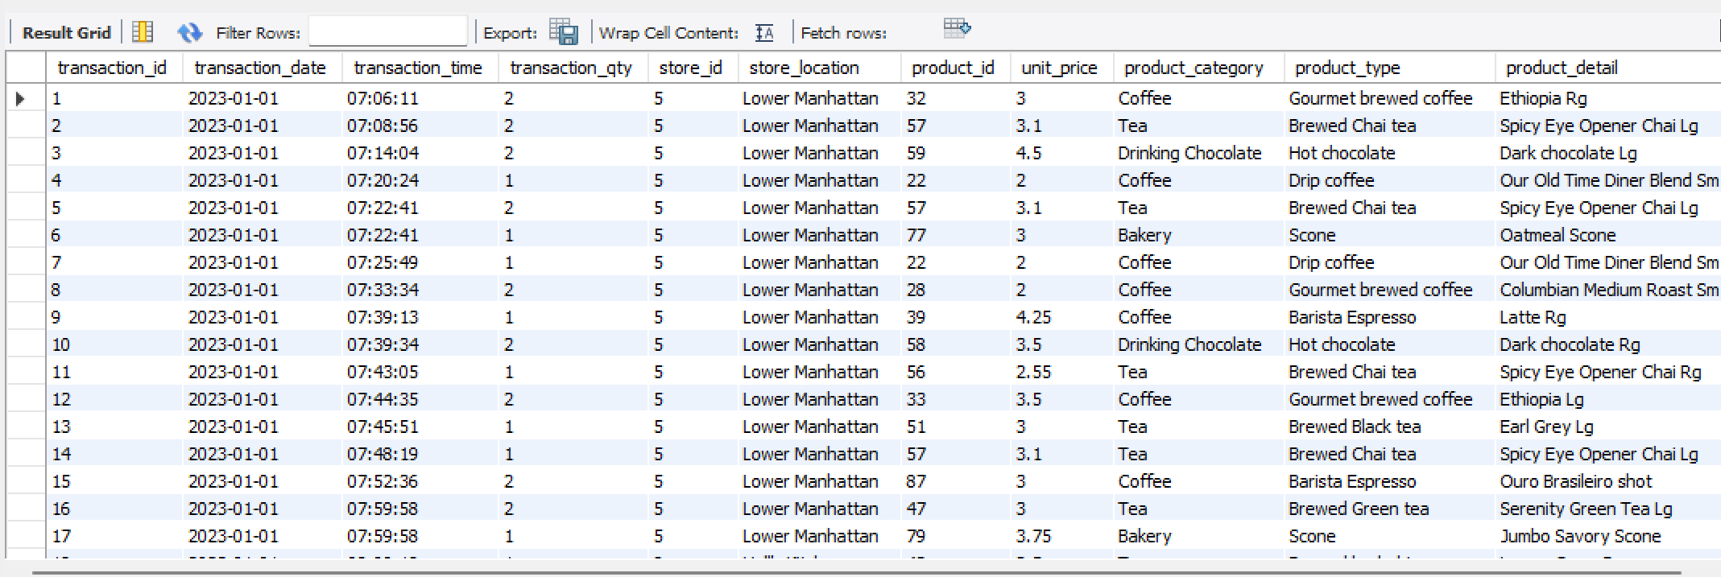

-- TOTAL SALES

SELECT ROUND(SUM(unit_price * transaction_qty)) as Total_Sales

FROM coffee_shop_sales

WHERE MONTH(transaction_date) = 5 -- for month of (CM-May)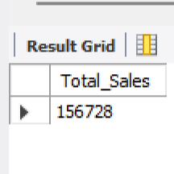

-- TOTAL SALES KPI - MOM DIFFERENCE AND MOM GROWTH

SELECT

MONTH(transaction_date) AS month,

ROUND(SUM(unit_price * transaction_qty)) AS total_sales,

(SUM(unit_price * transaction_qty) - LAG(SUM(unit_price * transaction_qty), 1)

OVER (ORDER BY MONTH(transaction_date))) / LAG(SUM(unit_price * transaction_qty), 1)

OVER (ORDER BY MONTH(transaction_date)) * 100 AS mom_increase_percentage

FROM

coffee_shop_sales

WHERE

MONTH(transaction_date) IN (4, 5) -- for months of April and May

GROUP BY

MONTH(transaction_date)

ORDER BY

-- TOTAL ORDERS

SELECT COUNT(transaction_id) as Total_Orders

FROM coffee_shop_sales

WHERE MONTH (transaction_date)= 5 -- for month of (CM-May)

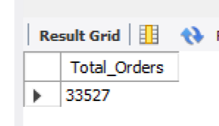

-- TOTAL ORDERS KPI - MOM DIFFERENCE AND MOM GROWTH

SELECT

MONTH(transaction_date) AS month,

ROUND(COUNT(transaction_id)) AS total_orders,

(COUNT(transaction_id) - LAG(COUNT(transaction_id), 1)

OVER (ORDER BY MONTH(transaction_date))) / LAG(COUNT(transaction_id), 1)

OVER (ORDER BY MONTH(transaction_date)) * 100 AS mom_increase_percentage

FROM

coffee_shop_sales

WHERE

MONTH(transaction_date) IN (4, 5) -- for April and May

GROUP BY

MONTH(transaction_date)

ORDER BY

MONTH(transaction_date);

-- TOTAL QUANITITY SOLD

SELECT SUM(transaction_qty) as Total_Quantity_Sold

FROM coffee_shop_sales

WHERE MONTH(transaction_date) = 5 -- for month of (CM-May)

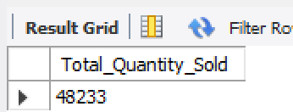

-- TOTAL QUANTITY SOLD KPI - MOM DIFFERENCE AND MOM GROWTH

SELECT

MONTH(transaction_date) AS month,

ROUND(SUM(transaction_qty)) AS total_quantity_sold,

(SUM(transaction_qty) - LAG(SUM(transaction_qty), 1)

OVER (ORDER BY MONTH(transaction_date))) / LAG(SUM(transaction_qty), 1)

OVER (ORDER BY MONTH(transaction_date)) * 100 AS mom_increase_percentage

FROM

coffee_shop_sales

WHERE

MONTH(transaction_date) IN (4, 5) -- for April and May

GROUP BY

MONTH(transaction_date)

ORDER BY

MONTH(transaction_date);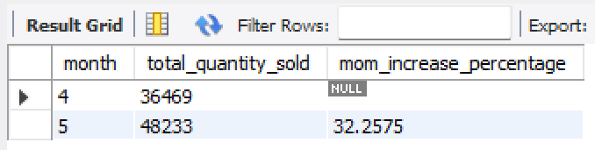

-- CALENDAR TABLE – DAILY SALES, QUANTITY and TOTAL ORDERS

SELECT

SUM(unit_price * transaction_qty) AS total_sales,

SUM(transaction_qty) AS total_quantity_sold,

COUNT(transaction_id) AS total_orders

FROM

coffee_shop_sales

WHERE

transaction_date = '2023-05-18'; -- For 18 May 2023

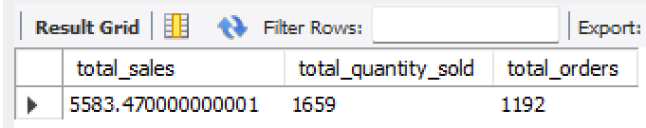

-- SALES TREND OVER A PERIOD

SELECT AVG(total_sales) AS average_sales

FROM (

SELECT

SUM(unit_price * transaction_qty) AS total_sales

FROM

coffee_shop_sales

WHERE

MONTH(transaction_date) = 5 -- Filter for May

GROUP BY

transaction_date

) AS internal_query;

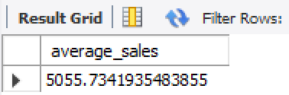

-- DAILY SALES FOR MONTH SELECTED

SELECT

DAY(transaction_date) AS day_of_month,

ROUND(SUM(unit_price * transaction_qty),1) AS total_sales

FROM

coffee_shop_sales

WHERE

MONTH(transaction_date) = 5 -- Filter for May

GROUP BY

DAY(transaction_date)

ORDER BY

DAY(transaction_date);

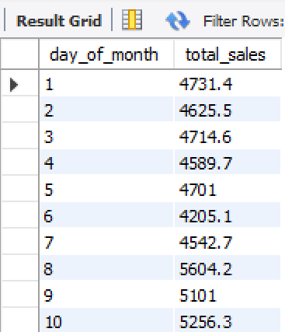

-- COMPARING DAILY SALES WITH AVERAGE SALES – IF GREATER THAN “ABOVE AVERAGE” and LESSER THAN “BELOW AVERAGE”

SELECT

day_of_month,

CASE

WHEN total_sales > avg_sales THEN 'Above Average'

WHEN total_sales < avg_sales THEN 'Below Average'

ELSE 'Average'

END AS sales_status,

total_sales

FROM (

SELECT

DAY(transaction_date) AS day_of_month,

SUM(unit_price * transaction_qty) AS total_sales,

AVG(SUM(unit_price * transaction_qty)) OVER () AS avg_sales

FROM

coffee_shop_sales

WHERE

MONTH(transaction_date) = 5 -- Filter for May

GROUP BY

DAY(transaction_date)

) AS sales_data

ORDER BY

day_of_month;

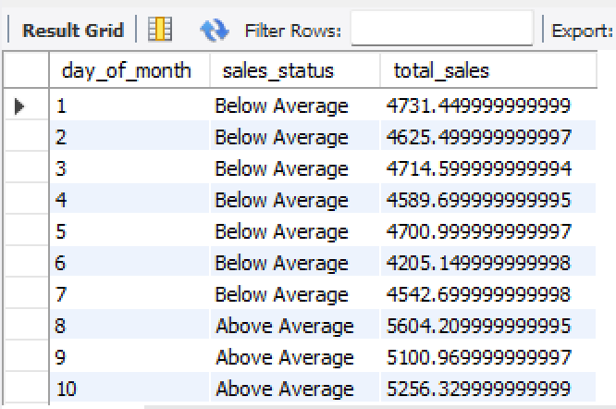

-- SALES BY WEEKDAY / WEEKEND:

SELECT

CASE

WHEN DAYOFWEEK(transaction_date) IN (1, 7) THEN 'Weekends'

ELSE 'Weekdays'

END AS day_type,

ROUND(SUM(unit_price * transaction_qty),2) AS total_sales

FROM

coffee_shop_sales

WHERE

MONTH(transaction_date) = 5 -- Filter for May

GROUP BY

CASE

WHEN DAYOFWEEK(transaction_date) IN (1, 7) THEN 'Weekends'

ELSE 'Weekdays'

END;

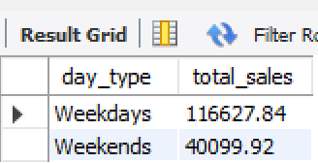

-- SALES BY STORE LOCATION

SELECT

store_location,

SUM(unit_price * transaction_qty) as Total_Sales

FROM coffee_shop_sales

WHERE

MONTH(transaction_date) =5

GROUP BY store_location

ORDER BY SUM(unit_price * transaction_qty) DESC

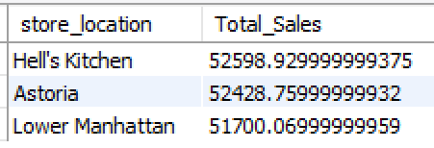

-- SALES BY PRODUCT CATEGORY

SELECT

product_category,

ROUND(SUM(unit_price * transaction_qty),1) as Total_Sales

FROM coffee_shop_sales

WHERE

MONTH(transaction_date) = 5

GROUP BY product_category

ORDER BY SUM(unit_price * transaction_qty) DESC

-- SALES BY PROUCTS (TOP 10)

SELECT

product_type,

ROUND(SUM(unit_price * transaction_qty),1) as Total_Sales

FROM coffee_shop_sales

WHERE

MONTH(transaction_date) = 5

GROUP BY product_type

ORDER BY SUM(unit_price * transaction_qty) DESC

LIMIT 10

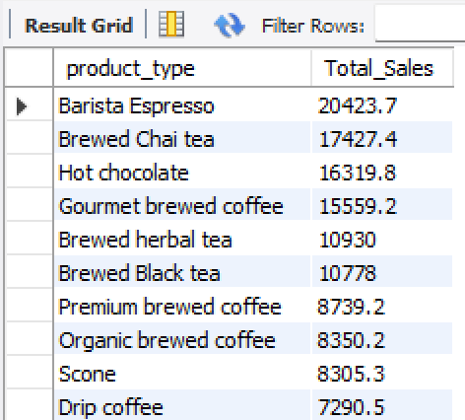

-- SALES BY DAY | HOUR

SELECT

ROUND(SUM(unit_price * transaction_qty)) AS Total_Sales,

SUM(transaction_qty) AS Total_Quantity,

COUNT(*) AS Total_Orders

FROM

coffee_shop_sales

WHERE

DAYOFWEEK(transaction_date) = 3 -- Filter for Tuesday (1 is Sunday, 2 is Monday, ..., 7 is Saturday)

AND HOUR(transaction_time) = 8 -- Filter for hour number 8

AND MONTH(transaction_date) = 5; -- Filter for May (month number 5)

