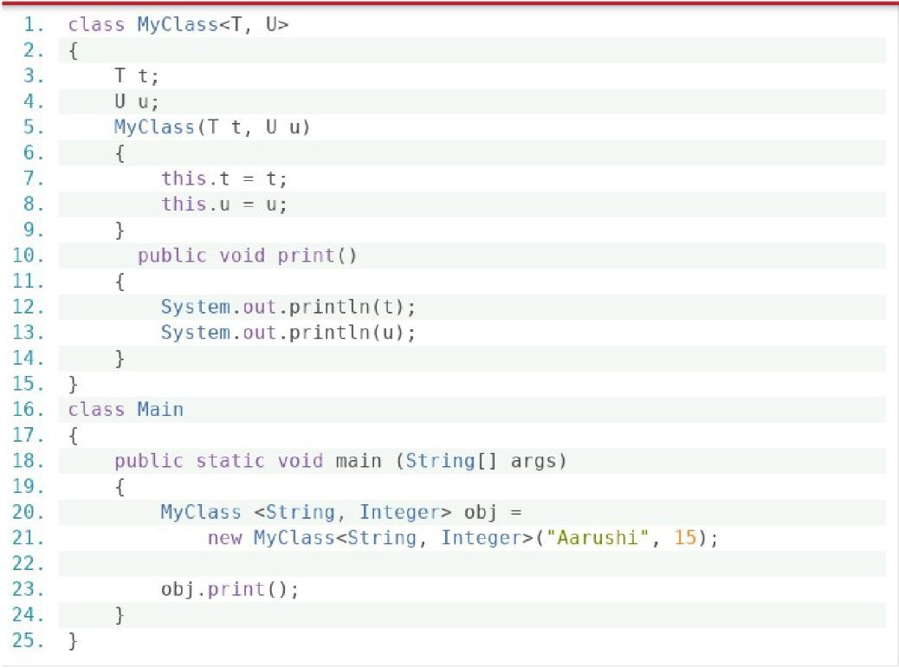

Output:

Aarushi

15

As we have take T and U as Generics They both can accept String Or integer Hence by String and Integer we can get values

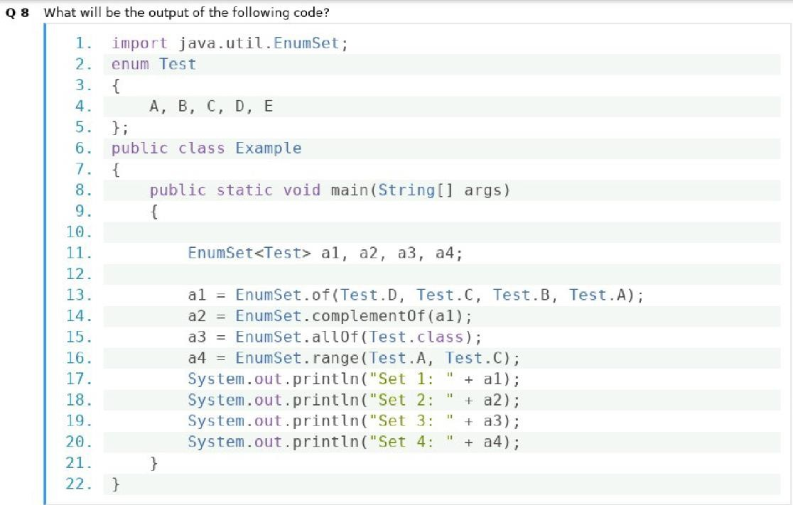

Output:

Set 1: [D,C,B,A]

Set 2: [E]

Set 3: [A,B,C,D,E]

Set 4: [A,B,C]

# **Of : the method can take multiple parameters as many as present in the enum**

# **ComplementsOf : method is used to create EnumSet containing elements of the same type as that of the specified EnumSet, with the values present in enum but other than those contained in the specified enum_set.**

# **allOf : contains all the elements in specified element type**

# **Range: contains all the elements in the range defined by two specified endpoints**

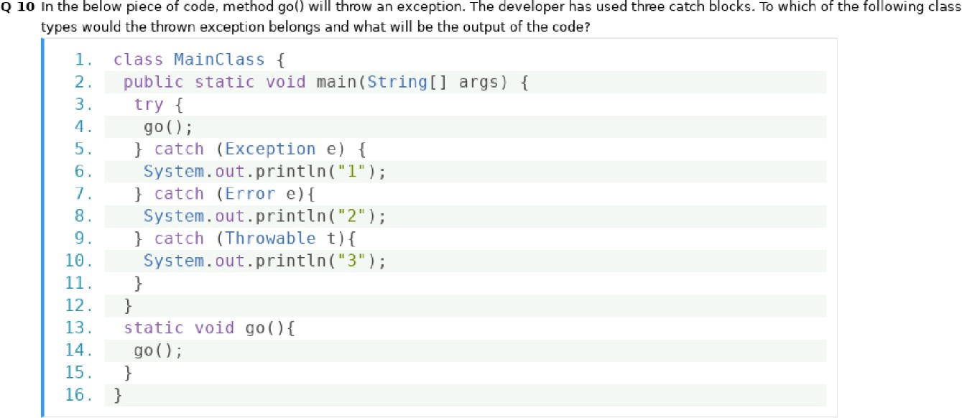

Output:

Error,2

stack Overflow Error.

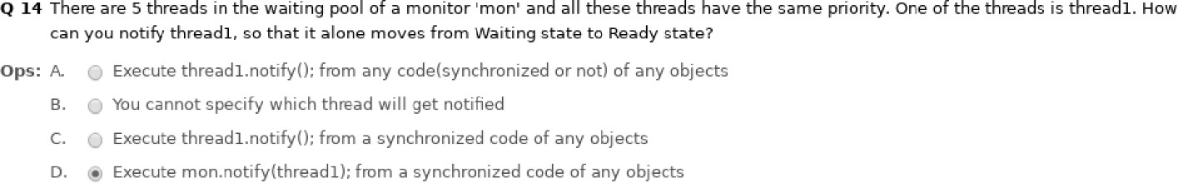

Answer:

You cannot specify which thread will get notified.

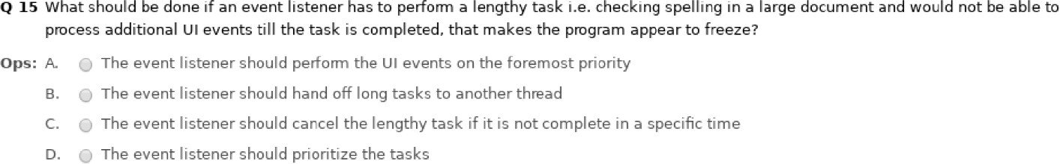

Output:

B

Multithreading will help into multitasking and prevent the program to freeze.

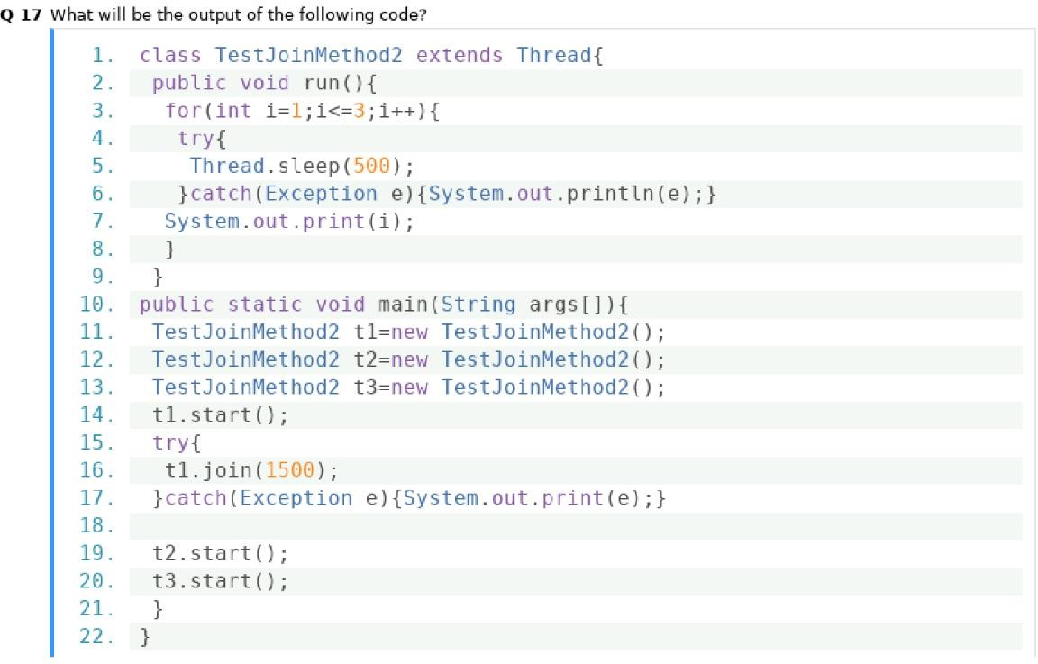

Output: 1

2

3

1

1

2

2

3

3

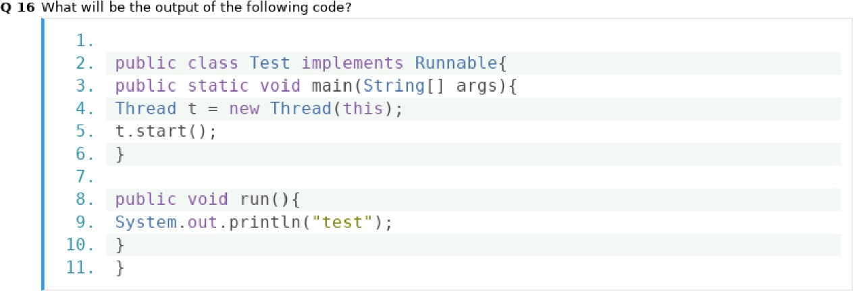

Output:

It will not Compile as this method cannot be referenced into a static method.