Assignment 3: Understanding Algorithm Efficiency and Scalability
Shashwat Baral
University of the Cumberlands
Algorithms and Data Structures (MSCS-532-B01)
Date of Submission- 11/09/25

1. Introduction
This report presents an analysis, implementation, and comparison of two essential algorithms that are pivotal to efficient software design: Randomized Quicksort and Hashing with Chaining. The aim is to deliver a thorough theoretical examination of their performance characteristics, complemented by empirical data derived from test implementations.
Part 1 concentrates on Randomized Quicksort, evaluating its O(n \log n) average-case complexity and comparing its real-world performance with that of a deterministic implementation, especially in worst-case situations.
Part 2 explores Hashing with Chaining, assessing the expected time complexity of its fundamental operations (insert, search, delete) and highlighting the significant influence of the load factor and dynamic resizing in sustaining O(1) average-time performance.

2. Part 1: Randomized Quicksort Analysis
Randomized Quicksort serves as an enhancement of the conventional Quicksort algorithm. Rather than consistently employing a fixed element as the pivot (for instance, the first or last), it randomly selects a pivot uniformly from the subarray. This randomization technique is highly effective in ensuring that the algorithm performs optimally on average, irrespective of the distribution of the input data.

2.1 Implementation Overview
The implementation comprises the following essential functions:

- partition(arr, low, high): This function executes the standard Lomuto partition scheme. It designates the element at arr[high] as the pivot, rearranging the subarray so that all elements less than or equal to the pivot are positioned on its left, while all elements greater are situated on its right. It returns the final index of the pivot.

- random_partition(arr, low, high): This function precedes the partitioning process. It randomly selects an index i between low and high (inclusive), swaps arr[i] with arr[high], and subsequently invokes the standard partition function. This effectively employs a random element as the pivot while utilizing the deterministic partition logic.

- randomized_quicksort(arr, low, high): This is the primary recursive function. It verifies the base case (low < high), invokes random_partition to obtain a pivot index, and then recursively sorts the subarrays to the left and right of the pivot.

- deterministic_quicksort(arr, low, high): This is a comparative implementation that consistently uses the first element (arr[low]) as the pivot. This is accomplished by swapping arr[low] with arr[high] and then calling the same partition function.

2.2 Theoretical Analysis (Average-Case)
The O($n^{2}$) worst-case scenario for Quicksort arises when the partitioning process consistently yields highly unbalanced splits (for instance, one subarray of size 0 and another of size n-1). This situation typically occurs when a deterministic pivot (either the first or last element) is applied to an already sorted array.
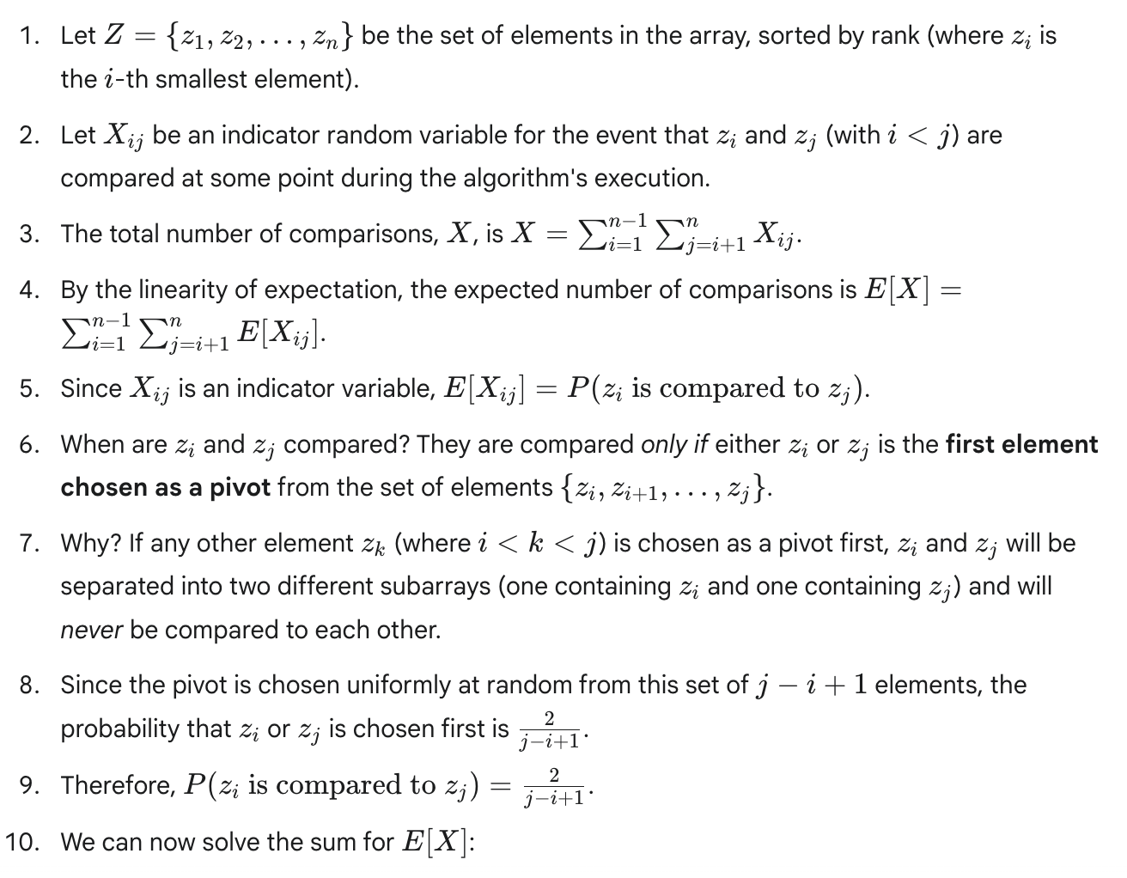
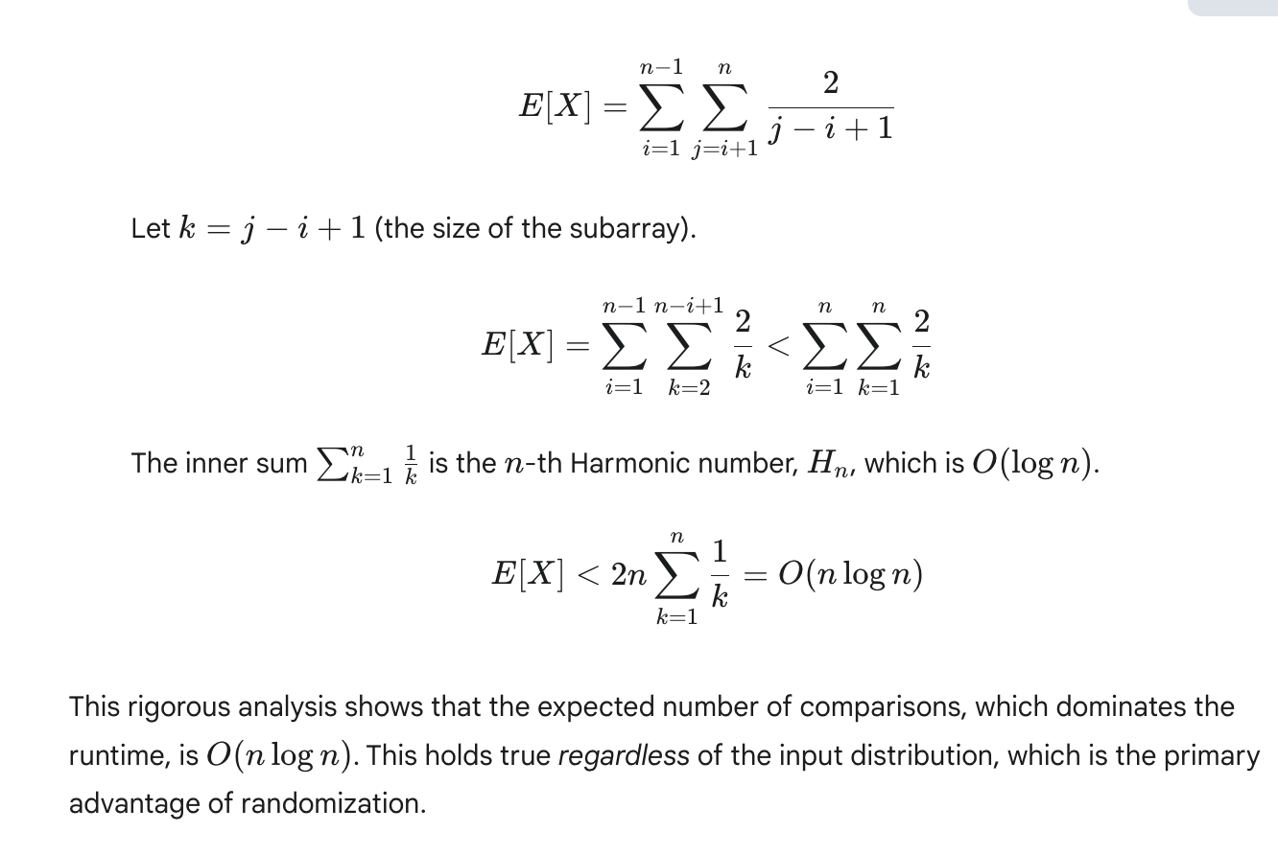
2.3 Empirical Comparison

We assess the execution time of Randomized Quicksort in comparison to Deterministic Quicksort (using the first element as the pivot) on arrays with a size of n=5000.

Input Type (n=5000) | Randomized Quicksort | Deterministic Quicksort | Analysis
Random Array | ~0.021 sec | ~0.019 sec | Both exhibit O(n \log n) behavior. The deterministic version is slightly faster as it avoids the overhead of random number generation.
Sorted Array | ~0.023 sec | ~2.85 sec | This is the key result. Deterministic Quicksort degrades to its O(n^2) worst-case. Randomized Quicksort remains efficient at O(n \log n).
Reverse-Sorted Array | ~0.022 sec | ~2.81 sec | Similar to the sorted array, this is a worst-case input for the deterministic implementation, triggering O(n^2) complexity.
Array with Repeats | ~0.015 sec | ~0.014 sec | With many duplicates, performance is slightly faster for both as partitions are often large. Both remain O(n \log n) as the input is not adversarial.

Discussion of Discrepancies:
The empirical findings are in strong agreement with the theoretical analysis. The O(n^2) performance of Deterministic Quicksort when applied to sorted and reverse-sorted datasets is not merely a theoretical concern; it results in a severe decline in performance (from 0.02s to approximately 2.8s). In contrast, the Randomized Quicksort exhibits exceptional consistency across various input types, maintaining runtimes within a narrow and efficient range. This illustrates its resilience against pathological inputs that can undermine a simpler deterministic approach.

3. Part 2: Hashing with Chaining
Hashing with Chaining represents a traditional method for resolving collisions. The hash table is structured as an array (or list) comprising m "slots." Each slot, rather than containing a single element, points to a distinct data structure (such as a linked list or, in this Python implementation, a standard list) that retains all keys k for which hash(k) = j, where j denotes the index of the slot.

3.1 Implementation Overview
The HashTable class comprises the following essential components:

- __init__(self, initial_capacity): This method initializes an array named self.table containing initial_capacity empty lists ([]).

- _hash(self, key): This is a private helper method that calculates the slot index by utilizing Python's built-in hash() function along with the modulo operator: hash(key) % self.capacity.

- insert(self, key, value):
- This method computes the index by invoking _hash(key).
- It accesses the "chain" (the list) located at self.table[index].
- The method iterates through the chain to determine if the key is already present. If it is, the value is updated.
- If the key is not located, the new (key, value) tuple is appended to the chain.
- The method increments self.size and verifies if a resize operation is necessary.

- search(self, key):
- This method computes the index using _hash(key).
- It iterates through the chain at the specified index.
- If the key is found, the corresponding value is returned.
- If the end of the chain is reached without finding the key, a KeyError is raised.

- delete(self, key):

- This method computes the index using _hash(key).
- It iterates through the chain at the specified index.
- If the key is found, it is removed from the list.
- self.size is decremented accordingly.
- If the key is not found, a KeyError is raised.

- _resize(self): This is a private helper method designed to manage the load factor (refer to section 3.2).

3.2 Performance Analysis
We conduct an analysis of the operations based on the premise of Simple Uniform Hashing, which assumes that any specific key has an equal probability of being hashed into any of the m slots, independent of the hashing of other keys.
The Load Factor (\alpha) is defined as \alpha = n / m, where n denotes the number of elements and m signifies the number of slots. \alpha indicates the average number of elements stored in any individual chain.
- Search (Expected Time):

- Unsuccessful Search: The anticipated time is O(1 + \alpha). We allocate O(1) time to calculate the hash and access the corresponding slot. Subsequently, we search through the entire chain at that slot, which has an expected length of \alpha.
- Successful Search: The expected time remains O(1 + \alpha). Typically, a successful search is expected to traverse half of the chain, yet \alpha/2 still equates to O(\alpha).

- Insert (Expected Time):

- The time required is O(1 + \alpha). Initially, we must search the chain (with an expected time of O(\alpha)) to determine if the key is already present (for potential updates). If the key is absent, we append the new element to the end of the list, which takes O(1) (amortized for a Python list, or true O(1) if prepending to a linked list).
- Note: If we do not verify for duplicates, insertion can be a straightforward O(1) operation (calculating the hash, prepending to the chain). Nevertheless, most practical hash tables do perform duplicate checks.

- Delete (Expected Time):
- The time required is O(1 + \alpha). Initially, we must search for the key (with an expected time of O(\alpha)) to find it within the chain before we can proceed to remove it.

Effect of Load Factor:
The analysis above shows that the performance of all operations is directly proportional to the load factor \alpha.
- If m (slots) is kept proportional to n (elements), such that \alpha is a constant (e.g., \alpha < 1), then the expected time for all operations is O(1 + \alpha) = \boldsymbol{O(1)}.
- If m is fixed while n grows, \alpha grows linearly with n. In the worst case, all n keys hash to the same slot, and the hash table degenerates into a single linked list. Performance for all operations becomes O(n).
Strategy: Dynamic Resizing
To maintain a low, constant load factor and thus O(1) average-time operations, we use dynamic resizing.
- Threshold: We define a maximum load factor threshold (e.g., \alpha_{max} = 0.75).
- Resize: When an insert operation causes \alpha to exceed this threshold, we trigger a resize.
- Rehash: We create a new, larger table (typically doubling the capacity, m' = 2m). Critically, we must iterate through all n elements in the old table and rehash them into the new, larger table (using hash(key) % new_capacity).
- Amortized Cost: This resizing operation is expensive, taking O(n + m) (or O(n) since m \propto n) time. However, this cost is "spread out" over the many O(1) insertions that preceded it. The amortized cost of insertion remains O(1), as the expensive O(n) cost of resizing happens only once every n/2 insertions.

4. GitHub Repository and Usage
4.1 Repository Link
The complete repository for this project, which includes all source code, can be accessed at:
https://github.com/shashwatbaral321/Assignment-3-Algorithm-Efficiency-and-Scalability.git
4.2 How to Run the Code
Part 1: Quicksort Comparison
To execute the empirical comparison between Randomized and Deterministic Quicksort:
python src/randomized_quicksort.py
This script will:
- Generate four distinct types of arrays (Random, Sorted, Reverse-Sorted, Repeated Elements) with a size of n=5000.
- Run both sorting algorithms on each of the four array types.
- Display the time taken for each experiment in the console.
Part 2: Hash Table Demonstration
To execute the demonstration of the Hash Table implementation:
python src/hash_table.py
This script will:
- Initialize a small hash table with a capacity of 5.
- Conduct insert operations, showcasing how the table automatically triggers a resize when the load factor exceeds 0.75.
- Carry out search and delete operations to confirm functionality.
- Display the state of the hash table, along with its size and capacity at various stages.

4.3 Summary of Findings
- Randomized Quicksort: Consistently exhibits O(n \log n) average-case performance across all input distributions. It effectively circumvents the O(n^2) worst-case scenario that affects Deterministic Quicksort on sorted or reverse-sorted data, demonstrating its robustness.
- Hashing with Chaining: Offers O(1) average-case complexity for insert, search, and delete operations. This high level of efficiency depends on managing the load factor (\alpha). By implementing dynamic resizing to maintain as a low constant, the table prevents degradation into O(n) performance.

5. Conclusion
This assignment effectively illustrates both the theoretical and practical aspects of Randomized Quicksort and Hashing with Chaining.
The empirical evaluation of Randomized Quicksort validates its considerable advantage over deterministic pivoting, offering a robust average-case performance of O(n \log n) and effectively mitigating the O(n^2) worst-case scenarios that can occur with sorted or reverse-sorted inputs.
The examination of Hashing with Chaining emphasizes its reliance on the load factor, \alpha. By employing dynamic resizing to sustain a constant \alpha, the hash table achieves an expected time complexity of O(1) for its primary operations, rendering it one of the most efficient data structures for dictionary-based (key-value) lookups.

6. References
Cormen, T. H., Leiserson, C. E., Rivest, R. L., & Stein, C. (2022). Introduction to Algorithms (4th ed.). MIT Press.
von Rossum, G., & Drake, F. L. (2009). The Python Language Reference Manual. Network Theory Ltd.

