Linux Programming Assignment-1: 05-12-2025
Name: SHASHWATH S SHETTY
Class: 3C
USN: ENG25CY3003
DATE: 05/12/2025
ROLL NO:70
Assignment – 10
1. Perform encryption and decryption of a text file or a random string using DES algorithm with openssl command. [Implement and give a demonstration.]
Encryption:
Run the command: openssl des –in <input_file> -out <output_file>
Enter the password and its done,
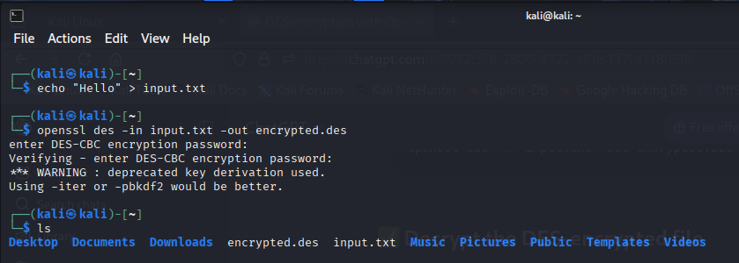
Decryption:
Run the command: openssl des -d <Encrypted_file> -out <out_file>
Enter the password and its decrypted
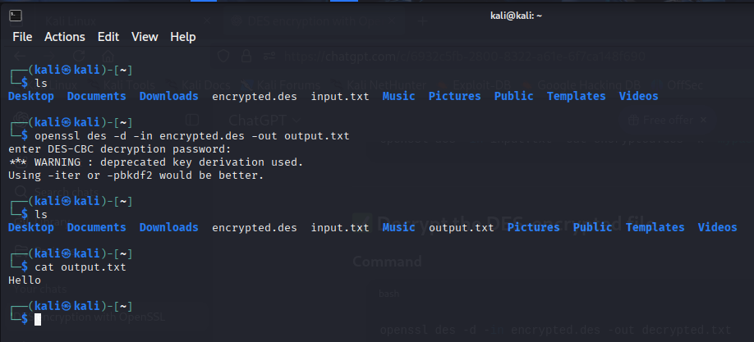
2. Write a bash shell script to encrypt 20 files in one shot with the help of openssl command. [Take any encryption algorithm to perform this task.] [Implement and give a demonstration.]
Code :
read -s -p "Password: " pass
echo

for f in *; do
if [[ -f "$f" ]]; then
gpg --batch --yes --passphrase "$pass" -c "$f"
fi
done

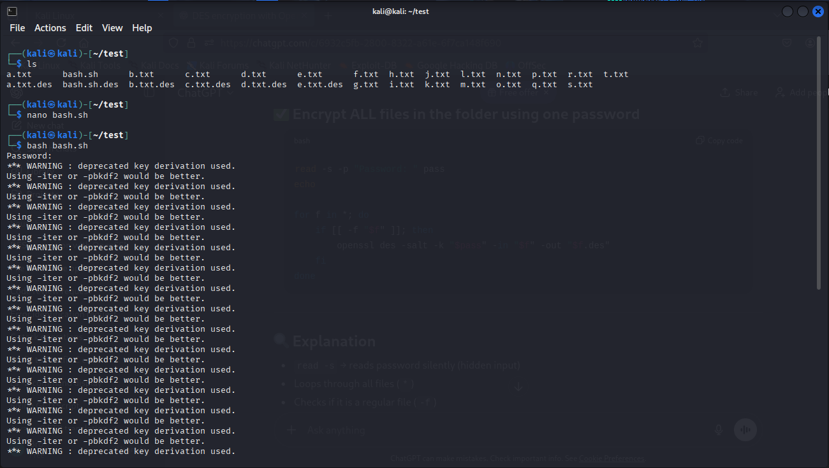

3. Perform encryption and decryption a text file or a random string using GPG command.
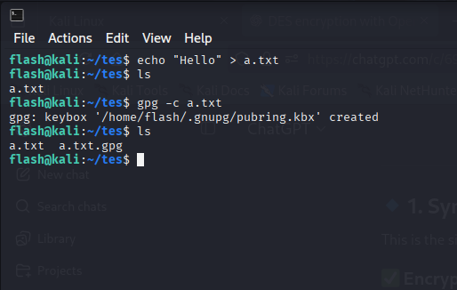
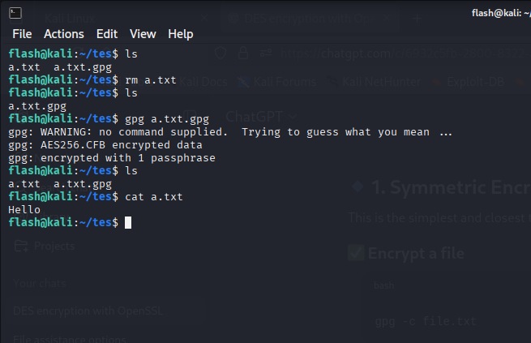

4. Write a brief description (What-Why-How formant) about the following commands:
• df • fdisk • dmesg • crontab • fsck

df:
df shows the amount of disk space used and available on mounted file systems.
Format : df [options] [filesystem]
Ex: df –h
df -T
fdisk:
fdisk is used to create, delete, resize, or manage disk partitions.
Format: fdisk [options] device
Example : sudo fdisk /dev/sda

dmesg:
dmesg prints kernel-related messages, such as hardware detection, driver logs, or boot messages.
Format: dmesg [options]
Example: dmesg | less
dmesg | grep usb

crontab:
crontab allows users to create scheduled jobs that run automatically at specified intervals.
Format: crontab [options]
Exmple: crontab –e

5. Write a step-by-step process to connect two Desktop machines using ssh command. [Implement and give a demonstration.]
Run the command: “sudo systemctl start ssh”
This hosts an ssh port.
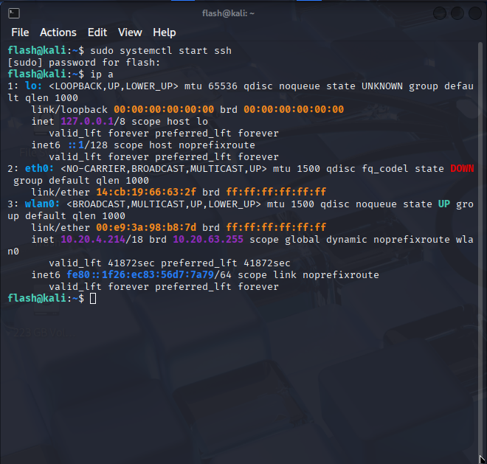
On another computer on the same LAN, run the command: ssh <user>@<ip_addr>
Where, user is flash and ip_addr is 10.20.4.214

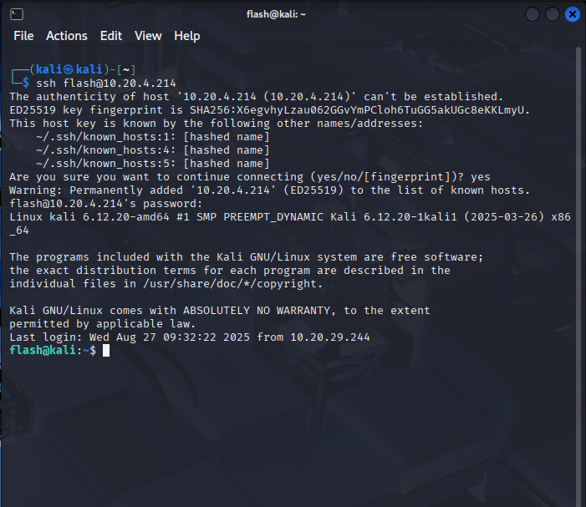Now we have complete access to the host computer on a different computer.

6. Write a step-by-step process how to connect two mobile devices using ssh command. [Implement and give a demonstration.]
Code:
pkg update && pkg upgrade -y
pkg install openssh -y
passwd
ssh-keygen -A
sshd
ip addr show wlan0

