TATA TECHNOLOGIES LTD.
TECH PULSE FY-26| AI/ML Capstone Project
TECHNICAL REPORT
AI CodeGuard: Secure Code Review and Debugging Assistant for ECU Software

Institution | Pimpri Chinchwad College of Engineering
Branch | Computer Engineering
Student name | Shashwati Rajendra Pawar
PRN | 123B1D035
Case Study ID | CS4
Project Title | AI CodeGuard: Secure Code Review and Debugging Assistant for ECU Software

1. Executive Summary

1. Executive Summary
AI CodeGuard is a locally deployable application intended to support secure code review and debugging for ECU-oriented software. It combines heuristic source-code checks, interpretation of supplied compiler/static-analysis/runtime diagnostic logs, repository-aware question answering, code summaries, and a workflow for reviewers to disposition findings.
The application uses a Streamlit interface and a FastAPI service. It supports authentication, role-based and path-level repository permissions, SQLite persistence, a local vector store, and an optional local language model. The default retrieval embedder is a dependency-free lexical hashing implementation. The optional language model is not required for deterministic review.
The recorded offline evaluation reported 15 passing automated tests. A single review of the demonstration repository scanned five files and produced 17 findings. In a five-question retrieval check, two questions had an exact top-ranked function citation and three had the expected file as the top citation. This is a small exploratory evaluation, not a general accuracy estimate. The project is heuristic, advisory, and not a claim of MISRA compliance or certification.

2. Introduction
ECU Software runs in an embedded environment where reliability and security become paramount considerations. Software review may entail evaluation of source code, code guidelines, build result, static analysis output, and runtime diagnostics. Connecting this information and taking decisions during review is cumbersome.
AI CodeGuard is an AI demonstration of an intelligent assistant which helps in managing all of this information and analyzing the potential problems. The tool provides supporting context and enables the users to make decisions. Automated and AI based decisions still need validation by the human mind.

3. Problem and Project Objectives
Problem
Reviewers can face fragmented information when they must separately inspect source code, diagnostics, and project guidance. A reported issue may be difficult to assess if the location, evidence, explanation, or review disposition is unclear.
Objectives
- Detect selected potential security, reliability, maintainability, and MISRA-oriented coding concerns in demonstration source.
- Interpret example build, static-analysis, and sanitizer logs and map messages to source locations where possible.
- Provide repository-aware answers with citations to retrieved source chunks.
- Restrict analysis and retrieval according to a user's repository and path permissions.
- Present structured findings and support a human review/disposition workflow.
- Record audit events and expose basic review metrics and reports.
- Evaluate the prototype with automated tests and a small, manually prepared retrieval question set.

4. Requirements
Functional requirements
- Authenticate users and apply roles to administrative and review actions.
- Register repositories and grant path-level allow/deny permissions.
- Review accessible source files using deterministic rules.
- Accept and interpret compiler and cppcheck output.
- Interpret runtime sanitizer/crash logs and identify candidate causes.
- Answer repository questions and provide retrieved-source citations.
- Summarize files/functions with structural metrics.
- List findings and permit authorized users to record dispositions.
- Export reports, publish accepted findings to an outbox, and view metrics.
- Optionally enrich results through an allow-listed local model endpoint.
Non-functional requirements and constraints
- Support offline operation without a language model.
- Keep the default model integration local and restrict configured hosts.
- Exclude unauthorized paths before retrieval ranking.
- Preserve a review trail through audit entries and persistent storage.
- Treat rule and model output as advisory; do not auto-edit or auto-merge code.
- Keep the scope appropriate for a prototype rather than a certified production ECU verification system.

5. System Architecture
The main components are listed below.
Sr. No. | Component | Responsibility
1 | Streamlit user interface | Provides sign-in, repository selection, review, Ask, Debug, Summaries, Findings, and Metrics/Audit screens.
2 | FastAPI application | Exposes HTTP endpoints for authentication, repository administration, review, question answering, summaries, debugging, findings, metrics, publishing, and audit operations.
3 | Services layer | Manages users, password verification, repository registration, safe repository paths, path-level authorization, finding persistence, and review workflow operations.
4 | Review engine | Coordinates source-rule checks, compiler/cppcheck parsing, LLM enrichment when enabled, finding citations, question-answer retrieval, code summaries, and runtime-log debugging.
5 | Rule and log analyzers | The rule catalogue defines selected internal ICR checks. Log parsers process supported compiler, cppcheck XML, and sanitizer/crash formats.
6 | Retrieval and persistence | A NumPy cosine-similarity vector store persists indexed chunks. SQLite stores users, repositories, permissions, findings, and audit records. Application settings store generated data separately from sample source.
7 | Optional local language model | The LLM client supports Ollama and OpenAI-compatible local endpoints. LLM use is configurable; source checks and extractive retrieval can run without model inference.
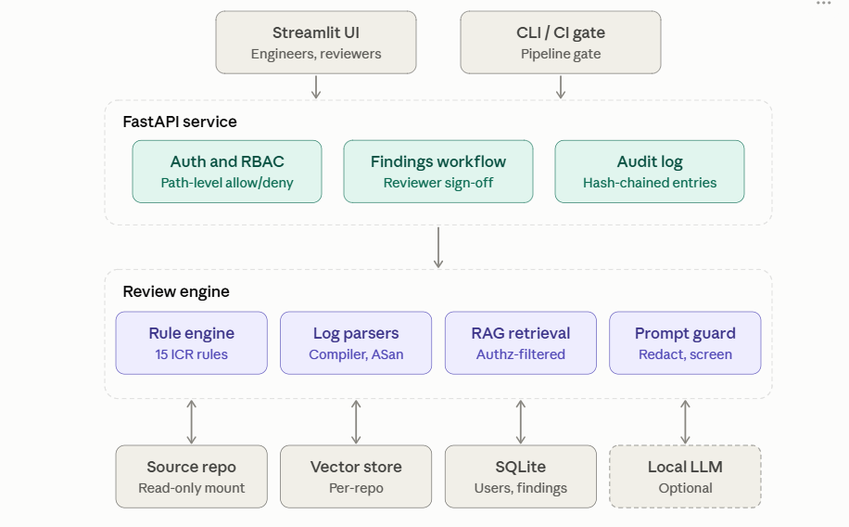
Fig. 1. Architecture Diagram

6. Implementation

6.1 Authentication and authorization

Users are stored with salted PBKDF2-HMAC-SHA256 password hashes. Tokens are signed for identifying authenticated users. The roles are administrator, reviewer, and developer. Permissions on repository paths support allow and deny prefixes, with deny rules taking precedence. The service resolves repository paths and rejects paths leaving the configured repository root. Authorized-file filtering is used for analysis and retrieval.

6.2 Source-code checks

The internal rule collection performs checks for certain patterns including dynamic memory usage, unsafe string manipulation, goto, switch without default, unchecked allocation return value, assignment in condition, recursion, array loop bound inclusion, hard-coded credential-like value, weak random generation, variable format string, resource closure, unchecked numeric conversion, complexity, and prompt injection-like source code.

These checks are heuristic pattern analyses and not the full compiler front-end. Each finding has a rule ID, severity, source code location, evidence, explanation/fix field, confidence, and references. The inline deviation annotations can silence a matching rule at this location.

6.3 Diagnostic log analysis

Messages from the compiler and cppcheck can be associated with files/functions if the message path matches an authorized repository file. The runtime diagnostic processing discovers the supported sanitizer/crash patterns, resolves the source code location and function name, and verifies the

6.4 Retrieval and repository Q&A

The default hash-768 embedder tokenizes identifiers and sub-words, hashes features to vectors, and normalizes them. The vector store ranks chunks based on cosine similarity. A retrieval predicate filters metadata according to the user’s authorization before ranking. Offline Ask mode retrieves relevant authorized chunks with references; it is an extraction method rather than a language-model answer.

Optional SentenceTransformer embedder can be enabled with a local model directory configuration. It was not used in the evaluation.

6.5 Optional LLM enrichment and prompt safety

The project supports Ollama and OpenAI-compatible local models. Compose sets the model tag as llama3.1:8b by default. The LLM client makes calls to the configured endpoint and expects structured JSON responses for enrichment. Repository contents are treated as untrusted inputs; outputs are filtered before usage.

Pretrained language-model inference was not used in the recorded evaluation. There is an automated test that invokes a fake local Ollama-compatible HTTP server to check the LLM path and rejection of unsafe content; it is a test double, not a pretrained language-model. The model tag configuration does not indicate whether the model was installed and used, and there is no immutable model digest recorded.

6.6 Findings, audit, and reporting

Findings persist and are de-duplicated using fingerprints. An authorized reviewer may accept, reject, or leave a finding open, and developers can log allowable actions on findings. Rejection must have a comment. Accepted findings may be exported into a workflow outbox optionally with an allow-listed webhook call. Reports may be exported in Markdown format. Audit logs use a hash chain that is verifiable via the administrative endpoint.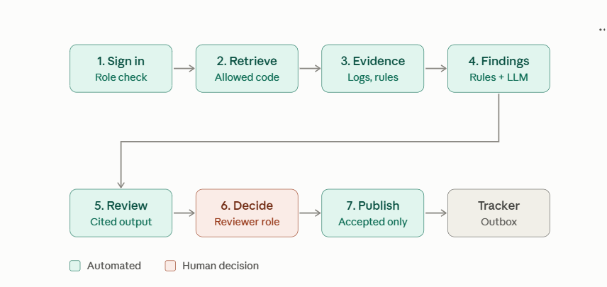
Fig. 2. System Workflow

7. Data and Configuration
Demonstration inputs
- A synthetic ECU sample repository with C source/header files.
- Example compiler and cppcheck diagnostics.
- An example AddressSanitizer global-buffer-overflow log.
- A project-specific ECU guideline document.
The status and provenance of the bundled input material should be confirmed by the project owner before submission. The separate DATASET_PROVENANCE.txt file provides a place to document that confirmation and any required approval/source details.
Recorded evaluation configuration
Setting | Value
Language-model inference | Offline / disabled
Embeddings | hash-768 signed feature hashing
Vector similarity | NumPy cosine similarity
Vector store | Project-local files
Database | Isolated temporary SQLite database for the evaluation run
Python | 3.11.9

Optional project configuration
Setting | Value
LLM runtime | Ollama or an OpenAI-compatible local endpoint
Compose model tag | llama3.1:8b (optional; actual model use was not part of the reported evaluation)
Embedding backend | Optional SentenceTransformer; local model path required

8. Security and Privacy Considerations
The project includes controls intended to reduce selected risks:
- No model is required for offline deterministic checks.
- The LLM client enforces a configured host allow-list.
- Docker Compose separates services and places the API/Ollama on an internal network; the sample repository is mounted read-only.
- Repository access is checked at path level before retrieval and analysis.
- Source-like secrets are redacted in selected evidence paths.
- Repository content is treated as untrusted prompt input.
- Audit operations are recorded and the audit chain can be verified.
- The application does not automatically change source code or merge fixes.
These controls are not a production security certification. Authentication is minimal, and production deployment would require an appropriate identity provider, TLS, operational monitoring, and deployment-specific security review. Generated databases, secret keys, and real credentials must not be included in a public submission archive.

9. Testing and Evaluation

9.1 Automated tests
The recorded command was:
python -m pytest -q tests
Observed result:
15 passed in 9.32s
The test suite exercises login rejection, seeded rule detection, evidence redaction, inline deviations, path-level authorization, traversal protection, prompt-injection defenses, compiler/cppcheck mapping, sanitizer debugging, cited Q&A, summaries, finding dispositions, publishing, audit integrity, metrics, host allow-listing, and LLM-path behavior using a fake local server.

9.2 Offline review result
One isolated deterministic review scanned five source files and returned 17 findings:
Severity | Findings
Critical | 2
High | 5
Medium | 7
Low | 3
Total | 17
These are observed finding counts, not precision or recall. Because the rules are heuristic, findings require manual validation.

9.3 Retrieval question set
Five manually authored questions were evaluated by checking the first retrieval citation against an expected file and function:
Measure | Result
Top-1 exact file-and-function matches | 2/5 (40%)
Top-1 expected-file matches | 3/5 (60%)
The questions and individual pass/fail citations are listed in EVALUATION_EVIDENCE.txt. The small set is not statistically representative. Observed ranking errors mean that citations should be verified by a human.

9.4 Sanitizer example
The supplied sample AddressSanitizer log was classified as a global-buffer-overflow in CanRx_Store at src/can_rx.c:17. The system identified the inclusive loop-bound finding ICR-008 at line 16 as corroborating evidence, with observed root-cause confidence 0.70. This checks interpretation of a supplied log; it does not claim the demo program was compiled and executed in the evaluation.

9.5 Evaluation limitations
The study uses one synthetic repository, five source files, five retrieval questions, and a small number of sample logs. No production data, independently labelled benchmark, precision/recall measurement, statistical test, or real pretrained-model evaluation was used. Results should be described as a functional demonstration.

10. Deployment and Operation
The project can be run locally with the documented Python quick-start or with Docker Compose. In Docker, the UI is exposed on port 8501 and the API on port 8000 on the local machine.
Item | Detail
UI | Port 8501
API | Port 8000
Health endpoint | /health (reports the selected backend and embedder). The root API path is not the health page.
API documentation | /docs
The Compose configuration includes an optional Ollama service. Starting the API with an Ollama backend configured does not by itself start Ollama or download the model. A model-based demonstration requires the service and model to be available, and its exact model tag/digest and settings should be recorded for reproducibility.
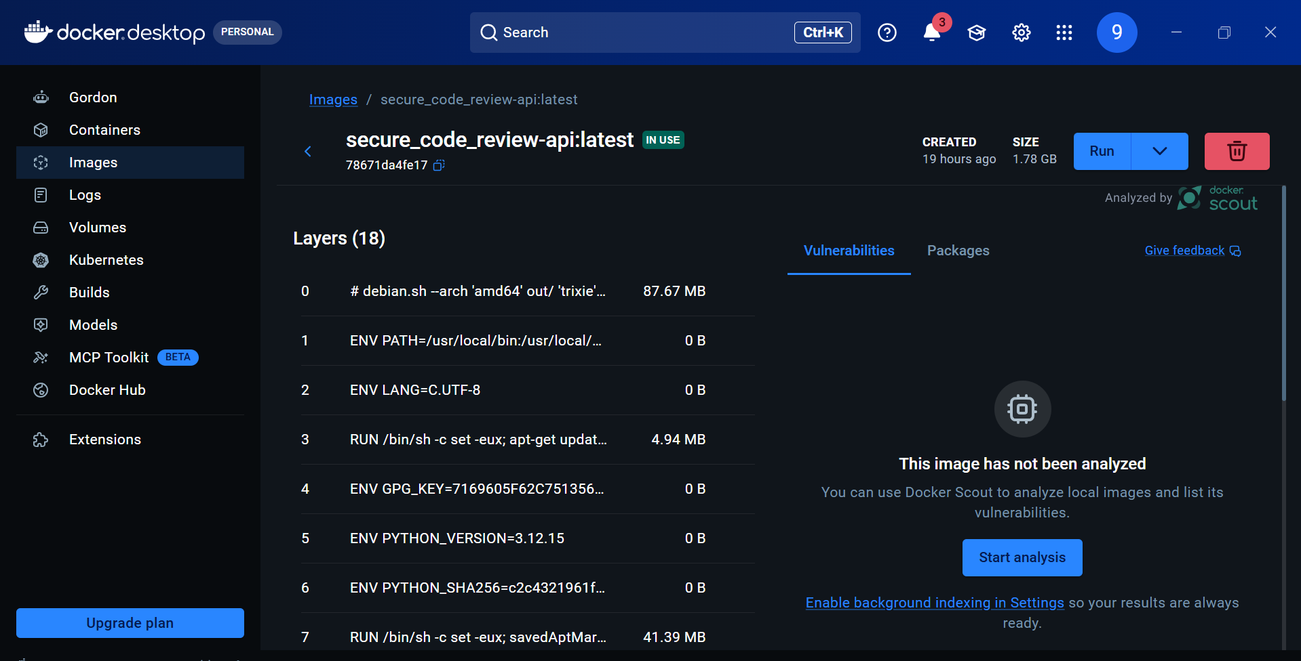
Fig. 3. Docker Container

11. Limitations and Future Work
Current limitations
- Pattern-based rules can fail to detect defects and return false positives.
- Defect retrieval ranking is flawed, evidenced by the small number of questions detected.
- The results logged do not test a pretrained LLM.
- The demonstration data set is small and artificial.
- The solution does not offer certification of MISRA compliance or safety.
- Secure SSO and TLS use are beyond the scope of the current prototype.
- Git/PR diff review, SARIF export and automatic remediation are unsupported..
Potential future work
- Grow the question/answer and source-citation test data sets.
- Test against more approved repositories and document examples.
- Evaluate precision/recall with independent ground truth labels.
- Optionally run and document evaluation against local pretrained model.
- Log the model digest, prompt version and inference parameters.
- Enhance code-aware chunking and defect retrieval ranking.
- Perform usability and security analysis with typical users.

12. Conclusion

AI CodeGuard illustrates a local and human-in-the-loop system for ECU software inspection and debugging. These include deterministic tests, diagnostic analysis, authorized fetching, structured observations, and the reviewer process. Test videos prove that the demonstrated paths are indeed used, whereas the retrieval errors and heuristic limitations reveal why human verification is still needed. More evaluations using independently labeled datasets are needed to make any other claims.

13. References
[1] A. Bacchelli and C. Bird, "Expectations, outcomes, and challenges of modern code review," Proceedings of the 2013 International Conference on Software Engineering (ICSE), 2013, pp. 712-721. DOI: https://doi.org/10.1109/ICSE.2013.6606617
[2] M. Souppaya, K. Scarfone, and D. Dodson, Secure Software Development Framework (SSDF) Version 1.1: Recommendations for Mitigating the Risk of Software Vulnerabilities, NIST Special Publication 800-218, February 2022. DOI: https://doi.org/10.6028/NIST.SP.800-218
[3] National Institute of Standards and Technology, Artificial Intelligence Risk Management Framework (AI RMF 1.0), NIST AI 100-1, January 2023. DOI: https://doi.org/10.6028/NIST.AI.100-1
[4] OWASP GenAI Security Project, Top 10 for Large Language Model Applications project resources. https://owasp.org/projects/top-10-for-large-language-model-applications/ Accessed 13 October 2026.AI Tool Usage Declaration
No. | AI tool / model | Purpose | Artifacts affected | Verified by student
1 | Claude (Anthropic) | Architecture design and code generation | Source code, backend, UI, and RAG pipeline | Yes / No
2 | GitHub Copilot | Code completion, debugging, and error correction | Python source code and bug fixes | Yes / No
3 | ChatGPT (OpenAI) | Documentation drafting and technical explanations | Project report, README, evaluation report, and presentation content | Yes / No

Declaration
Signature | 
Date | 14-10-2026
Name | Shashwati Rajendra Pawar
PRN | 123B1D035

