**KATHMANDU UNIVERSITY**

**DHULIKHEL, KAVRE**



**COMP 342**

**Submitted By:**

Shashwat Khadka(23)

**Submitted To:**

Mr. Dhiraj Shrestha

Department of Computer Science & Engineering

**INTRODUCTION**

This project aims to create a 2D game using OpenGL as the library and Python as the primary programming language. It will help to learn the various fundamentals of computer graphics and their application in computer visuals.

The 2D game is based on the famous-“Brick Breaker”. Brick Breaker is a classic 2D arcade game, where players control a paddle to bounce a ball upwards to break the bricks. The objective of the game is to clear/break all the bricks.

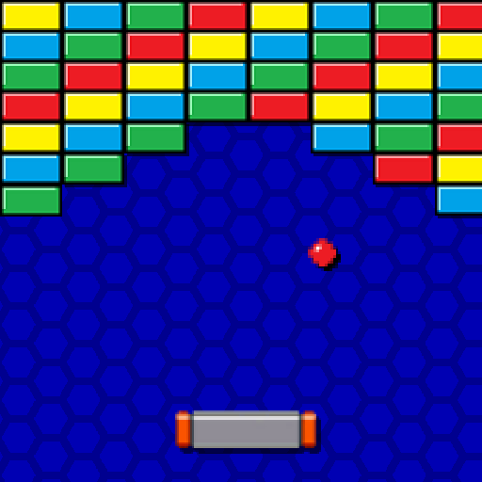

*Fig: The Brick Breaker Game sample*

**DESCRIPTION OF THE GAME**

Brick Breaker is an old-school 2D arcade game that's easy to understand yet captivating. The game screen is filled with bricks arranged in patterns, while a paddle sits at the bottom. Players control the paddle, keeping a ball bouncing around the screen.

The goal is simple: use the paddle to keep the ball in play and aim it at the bricks to break them. If the ball slips past the paddle, players lose.

**TOOLS USED**

* Python-Programming Language
* OpenGL- API
* PyGame and various other Python Libraries
* Git & GitHub

**DEVELOPMENT APPROACH**

I will be using a phase-based approach to create this 2D game, here is the breakdown of the developmental approach I will be using:

**PHASE I:**

Outlining Game Mechanics, Designing Visual Layout, Installing necessary libraries and setting up the environment, creating basic functionalities

**PHASE II:**  
Add game functionalities, logic and refine the code

**PHASE III:**

Adding Visual Tweaks, Optimisation and Documentation

**CONCLUSION**

This project aims to create an entertaining game and gain a deeper understanding of computer graphics principles, game development techniques, and integration of OpenGL with Python. It will help me understand various principles including coordinate systems, transformations, collision detection, and rendering techniques among many others