AI FOR FOUNDATIONAL LEARNING HACKATHON 2026 · CHALLENGE 3
Abhyas
Technical design document: the problem, the architecture, and how every part works
A practice partner for FLN teachers between trainings: rehearse a move with AI children, see it done well, get feedback, try it in class. Trainers finally see what reached the classroom.
Team Asymptotes · Shashwat Khandelwal – Vedant Arora – Divyansh Agrawal
Ideate stage · Version 1.0 · September 2026

Contents
Summary
1. The problem
2. Design principles and constraints
3. Users and the weekly loop
4. System architecture
5. The move library and the personal path
6. Rehearsal with AI children
7. "Explain it back": measuring what training conveyed
8. Ask any time
9. Evidence ladder and reporting
10. Content pipeline with Claude
11. Technology stack
12. Data model
13. Evaluation
14. Privacy, safety and ethics
15. Risks and mitigations
16. Build plan and team
References

Summary
Abhyas gives a government primary teacher what one-off training rarely does: a chance to practise a teaching move, see it done well, and get feedback on her own attempt, every week between trainings. It runs on WhatsApp, by voice, in Hindi, and takes about fifteen minutes a week. It is built into the system that already exists: each month's move is the Shikshak Sankul topic, and the ARP observes the same move on her visit.
Each week follows one loop: learn one move from the state FLN module, explain it back in her own words, hear a model teacher handle the scenario, rehearse it with three AI children, get feedback and retry, try it in class, and ask any time. What the loop records goes back to the people who design training: which key points of a module reached teachers, and which moves were actually adopted.
Four technical ideas make this work:
- AI children whose mistakes are computed, not improvised. A rule engine decides what each child answers from a documented misconception; Claude only voices the line. A child improves only when the teacher's move addresses the cause.
- A model teacher on the same scenario, so "observe it done well" never depends on finding a video.
- "Explain it back" scored against the module's key points, which measures what the training cascade actually conveyed.
- An evidence ladder for adoption, from rehearsed to children improved, labelled honestly, so trainers see adoption rather than attendance.

1. The problem

1.1 The challenge as posed
Challenge 3 asks for in-service training and ongoing support that helps public school teachers teach effectively. The brief names specific gaps. Each phrase sets a requirement:
Phrase in the brief | What it requires of a solution
continuous, practical guidance | Help that continues after training ends, for real classroom problems
day-to-day classroom challenges | Answers beyond pedagogy: two grades, absences, noise, no materials, parents
practise | A safe place to try a move before the real class
observe it being done well | A model of the move, available on demand
feedback on their own attempts | Specific feedback on what she did, and a chance to retry
not based on needs or experience | A path that adapts to each teacher, including first-year teachers
faithfully reaches the teachers | A measure of what the training actually conveyed
adopted in classrooms | Evidence of use in class, not attendance

1.2 Evidence on the size of the gap
Finding | Figure | Source
Spent a year by Samagra Shiksha on teacher training, through a cascade that loses quality at each step | ₹500 crore+ | Singh & Sarma (IDR, 2025)
Time on subject pedagogy in a 4-day induction for new teachers in Rajasthan (2024) | 3.5 of 22 hours | Shandilya (Azim Premji University, 2025)
Gain in teaching practice from coaching, across 60 causal studies (mostly US); effects shrink at scale | 0.49 SD | Kraft, Blazar & Hogan (2018)
At-scale government programmes in 14 countries: less practice and follow-up than effective ones | 139 programmes | Popova et al. (2022)
Teachers who engaged regularly with WhatsApp nudges in a Sitapur and Hardoi trial | 15–20% | Shashidhara & Garg (2025)

Two further findings shape the design. In South Africa, on-site coaching outperformed virtual coaching; in-person contact provided accountability and trust (Cilliers et al., 2021). And surveys of teachers point to training fatigue from too many mandatory programmes. A new tool must therefore extend in-person support rather than replace it, and must replace a task rather than add one.
What new teachers were told
When new Rajasthan teachers asked senior colleagues for help, the answer they got was "ye sab aise hi chalta hai" (this is just how it works) (Shandilya, 2025).

1.3 Who is affected
Group | How the gap affects them
Teachers | Training fatigue from many mandatory programmes; new teachers get almost no induction
Children | Keep getting whole-class, textbook-pace teaching
Mentors (ARPs) | Too many schools to coach each teacher often
Trainers (DIET, SCERT) | NISHTHA cannot show who did a course, what they understood, or what they use in class

1.4 Why existing support does not close the loop
Option | Practise first | Observe | Feedback on own attempt | Personal path | Fidelity and adoption data
Online courses (NISHTHA on DIKSHA) | No | Videos | Quizzes only | Same for all | Completion only
AI lesson planners | No | No | No | Per lesson | No
AI teacher-support apps (e.g. VallamAI) | Not described | Handbook prompts | Through coach observation | From class data | Coaching loop
Automated feedback on class audio (e.g. TeachFX) | No | No | From recordings | Partly | Aggregate
ARP / CRP visits | Demonstrations | When visiting | When visiting | Informal | Visit records
Abhyas | AI children | Model rehearsal | Every rehearsal, plus class | Needs, experience, first year | By module and batch

Randomised trials show that automated feedback can change specific practices: +13% uptake of student ideas in an online course, and +20% focusing questions in US classrooms (Demszky et al., 2023, 2025). None of the options above offers rehearsal before class, modelling on the same scenario, and fidelity checks, in Hindi by voice. Features vary by deployment; this comparison is based on public descriptions.

1.5 The part of the challenge Abhyas solves
Abhyas takes one part and solves it deeply: the practice-and-feedback loop between trainings, with what it reveals about fidelity and adoption sent back to the people who design training.

2. Design principles and constraints

2.1 Principles
- Practice, not content. Teachers already have modules. What they lack is rehearsal with feedback.
- Computed children. Every child answer comes from a rule engine. The language model only voices it.
- Extend the ARP, never replace the visit. Abhyas points visits at real needs and records observations.
- Replace a task, do not add one. The monthly move is the Sankul topic; logged practice can count towards CPD hours, with state approval.
- Voice first, nothing to install. WhatsApp, Hindi and Hinglish, about fifteen minutes a week.
- Every claim cites its source. Guide answers retrieve from state documents; feedback quotes the teacher's own words.
- Honest evidence. Each practised move is labelled by its strongest evidence; nothing is inflated.
- Private by default. No individual score goes upward without the teacher's consent.

2.2 Constraints
Constraint | Value designed for | Consequence
Channel | WhatsApp on the teacher's own phone | No app; voice notes and buttons; business-started messages use approved templates
Time | About 15 minutes a week | One move a week; each step under 3 minutes
Language | Hindi and Hinglish, spoken | Indian speech models; distinct voices; recorded fixed lines
Latency | Conversation must feel live | Under 20 seconds from voice note to reply for 95% of turns
Connectivity | Patchy mobile data | Short audio; retries; text fallback
Cost | Government scale | Teacher-started chats are free; weekly prompts are utility templates at about ₹0.12 each (Meta, 2026)
Law | DPDP Act 2023 and Rules 2025 | Teacher consent; minimal data; class audio off by default

3. Users and the weekly loop

3.1 Users
User | Role | What Abhyas gives them
Teacher (primary) | Composite persona: Ramesh, 29, teaches Class 1 and 2 together in rural Uttar Pradesh; joined two years ago; did a 5-day FLN training last year; prefers voice notes; attends the monthly Sankul | Weekly practice with feedback; answers when stuck; a path that fits his experience
First-year teachers | New to the job | A year-long induction track
Experienced teachers | Many years in class | Advanced moves; can become peer models
ARPs | Visit and coach teachers | Weekly digest to target visits; observation logging
DIET and SCERT | Design and run training | Fidelity and adoption by module and batch (groups of 10+)
Children | Benefit in class | Never scored or identified

3.2 One week and one month
When | Teacher does | Abhyas does | What changes
Monday | Hears the move; explains it back in one minute | Checks the explanation against the module's key points | Misunderstandings caught early
Tuesday | Hears a model rehearsal, then rehearses with AI children | Plays three children with set mistakes; feedback; retry | Practice without an audience
Wed and Thu | Uses the move in class; a colleague fills a 5-minute checklist | Feedback on the real attempt for the same move | Feedback on real teaching
Friday | Answers 2 reflection questions; asks "what do I do when..." | Updates the path; answers cite their source; follows up in 2 days | Help when needed, with follow-through
Once a month | Rehearses with peers at the Sankul; the ARP observes the move | Sends the ARP a visit list; trainers see gaps by module | Visits target real needs; training gets fixed

3.3 Time budget
Estimates below are design targets to be verified in the pilot.
Step | Teacher time
Learn: listen to one voice note | ~2 min
Explain it back | ~1 min
Model rehearsal (optional) | ~2 min
Rehearse, feedback, one retry | ~6 min
Reflection or checklist result | ~2 min
Total per week | ~13–15 min

4. System architecture
Abhyas has three layers. Build runs in the cloud once per content release: Claude drafts move cards, rubrics, model scripts and error rules, which are validated and approved by FLN coaches. Run handles every WhatsApp turn in seconds. Report runs in the background and turns practice logs into the ARP digest and the trainer view.
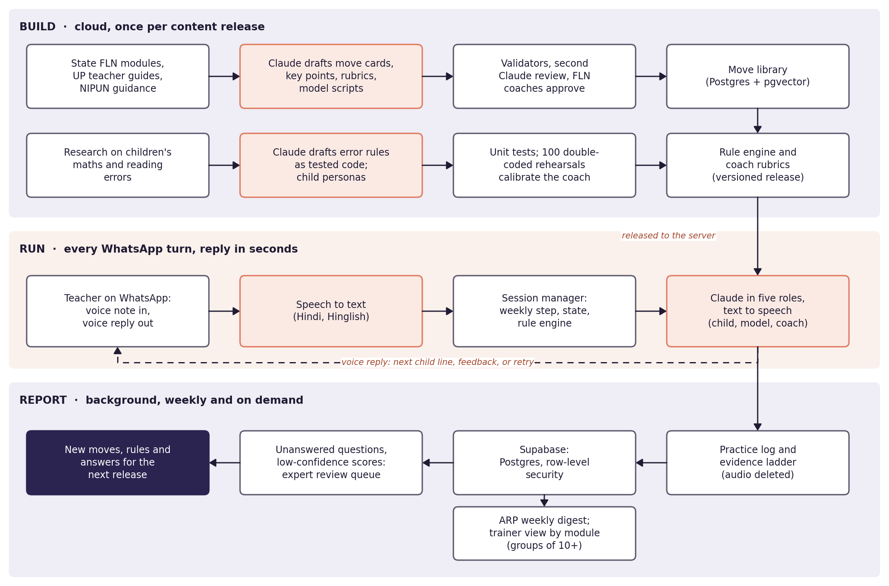
Figure 1. System overview. Coral boxes are where AI runs.
Component | Runs on | Responsibility
WhatsApp gateway | WhatsApp Cloud API via a provider (e.g. Gupshup) | Receive voice notes, text and button replies; send audio and templates
Speech to text | AI4Bharat IndicConformer or a hosted Indian API | Hindi and Hinglish transcripts
Session manager | Python FastAPI, job queue | Weekly state machine, timers, 24-hour window, routing
Rule engine | Pure Python | Each AI child's answer, reasoning and state change
Claude roles | Claude API, JSON output | Children's voices, model teacher, coach, fidelity checker, guide answerer
Text to speech | Indian-language TTS plus recorded lines | Distinct child, model and coach voices
Move library and retrieval | Supabase Postgres with pgvector | Moves, rubrics, state guides, reviewed practice library
Reports | Scheduled jobs; small web view | ARP digest; trainer view by module (groups of 10+)
Review console | Web | FLN coaches approve content; review queue

5. The move library and the personal path

5.1 What a move is
A move is one concrete teaching practice from the state FLN modules and teacher guides. The first release covers 12 numeracy and 4 literacy moves, for example bundles and sticks for place value, asking children to explain, grouping by level, and phonics routines. Each move is stored as a structured card:
Field | Purpose
Source reference | State module and section it comes from; the month it is the Sankul topic
Learn script | Two-minute voice note explaining the move
Key points (4–6) | What the teacher must understand; used to score "explain it back"
Scenario | The problem and three child personas with set misconceptions
Effective teaching acts | Which acts address the target misconceptions (used by the rule engine)
Rubric (3–5 criteria) | How a rehearsal is scored, 0–2 per criterion
Model rehearsal | Script of a model teacher handling the same three children
Class checklist and reflection | Five-minute peer checklist; two reflection questions

5.2 Placement and the path
On first contact the teacher does a short placement role-play with one AI child and answers three questions: years of experience, whether this is her first year, and which classes she teaches. The move order starts from the state and Sankul calendar and is then re-ranked by:
- placement result and experience level;
- first-year status (a year-long induction track);
- lowest rubric scores in recent rehearsals;
- key points missed in "explain it back";
- the topics of her own questions.
The Sankul move for the month is always included, so group rehearsal at the meeting and individual practice stay aligned.

6. Rehearsal with AI children

6.1 Why the children are computed
Language models asked to play a student tend to solve the problem correctly or give in too quickly (Markel et al., 2023; "Simulating Students or Sycophantic Problem Solving?", arXiv 2605.12748, 2026). A child who gives up her mistake after one generic prompt teaches the teacher the wrong lesson. In Abhyas, a rule engine computes each child's answer from a documented misconception, following the procedural-bug approach of Brown & Burton (1978). Claude only turns that result into a natural line.
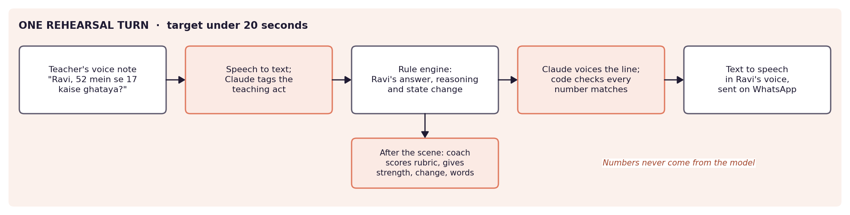
Figure 2. One rehearsal turn.

6.2 One turn, step by step
- Speech to text transcribes the teacher's voice note.
- Claude tags the teacher's teaching acts from a fixed list, for example asking the child to explain, using a concrete representation, contrasting two answers, telling the answer, or repeating the question.
- The rule engine takes the scenario, each child's current state and the acts, and returns the child's answer, the reasoning steps behind it and any change of state.
- Claude voices one short line in that child's style. Code checks every number in the line against the rule engine's output; if anything differs, the line is regenerated once and otherwise replaced by a template.
- Text to speech renders the line in the child's voice and it is sent on WhatsApp.

6.3 How a child changes
Child state | What the child does | Moves forward when the teacher...
Misconception | Applies the bug confidently | asks the child to explain her steps
Can explain | Still wrong, but shows the steps that reveal the bug | uses a concrete representation or a simpler case
Partial | Corrects with support; may slip on a new item | contrasts two answers or models the step aloud
Correct | Correct, and explains why | —

A child improves only when the teacher's act addresses that child's cause. If the teacher simply tells the answer, the child repeats it, then makes the same mistake on the next item. This tests transfer, which is what happens in a real class. A scene ends when all three children are correct, after eight teacher turns, or when the teacher stops it.
Worked example: Ravi and 52 − 17
Ravi holds the misconception "subtract the smaller digit from the larger". The rule engine gives 45.
Teacher: "Ravi, 52 mein se 17 kaise ghataya? Batao." → act: ask to explain → Ravi moves to "can explain".
Ravi: "2 mein se 7 nahi hota, to 7 mein se 2 kiya. 45!" (every number checked against the rule output).
Teacher shows 52 as 5 bundles and 2 sticks → act: concrete representation → Ravi moves to "partial".
If the teacher had said "the answer is 35", Ravi would repeat 35, then answer 43 − 27 with 24.

6.4 Feedback and retry
After the scene, Claude in the coach role scores the rehearsal against the move's rubric. Every score must cite a quote from the teacher's own words that appears in the transcript. The spoken feedback is always three parts: one strength, one change, and the exact words to try. The teacher can then retry, up to three times a week.
The coach is calibrated before release on 100 rehearsals double-coded by FLN coaches, with a target agreement of kappa 0.7 or more. Feedback with low model confidence is still sent, but is also queued for expert review.

7. "Explain it back": measuring what training conveyed
After hearing the move, the teacher explains it in her own words in a one-minute voice note. Claude in the fidelity checker role marks each of the move's key points as covered, partial or missing, quoting the words that support each mark. She hears a short confirmation and the one point she missed.
For trainers, the value is in aggregate. The trainer view shows which key points go missing, by module and training batch, only for groups of ten or more. That locates where the training cascade loses the message. A spoken explanation is much harder to hand off to someone else than a click-through quiz, so it is a more honest measure of understanding.
Key point status | Meaning | Shown to
Covered | Clearly stated, with a supporting quote | Teacher (as confirmation)
Partial | Mentioned but incomplete or confused | Teacher (with correction)
Missing | Not present | Teacher; aggregated for trainers

8. Ask any time
Teachers can ask a question at any point in the week, by voice or text. The flow is:
- Classify the question: pedagogy, classroom management (two grades, absences, noise, no materials, parents), administration, or out of scope.
- If it is unclear, ask one clarifying question first.
- Retrieve the most relevant passages from the state guides and a reviewed practice library.
- Claude in the guide answerer role writes a short spoken answer that must cite at least one retrieved source; the source is named in the reply.
- If nothing relevant is found, Abhyas says it will check with the ARP, and the question goes to the review queue and the ARP digest.
- Two days later, a follow-up asks whether it worked. The answer feeds the evidence ladder.

9. Evidence ladder and reporting

9.1 The evidence ladder
Every practised move is marked by its strongest evidence, labelled honestly:
Level | Evidence | Source
1 | Rehearsed | Completed rehearsal in Abhyas
2 | Self-reported | Reflection answers
3 | Peer-observed | Colleague's five-minute checklist
4 | ARP-observed | ARP observation logged on a visit
5 | Children improved | A short class check linked to the move; can take data from tools such as VallamAI

9.2 Who sees what
Audience | What they see | Rule
Teacher | Her own progress, scores and path | Always
ARP | Weekly digest: who practised which move, who asked for help, unanswered questions, a suggested visit list | Individual detail only for teachers who consent
DIET and SCERT | Fidelity and adoption by module and training batch | Groups of 10 or more only

10. Content pipeline with Claude
Claude does the heavy content work once, where it can be checked. The live conversation only voices, tags, scores and answers within those approved materials.
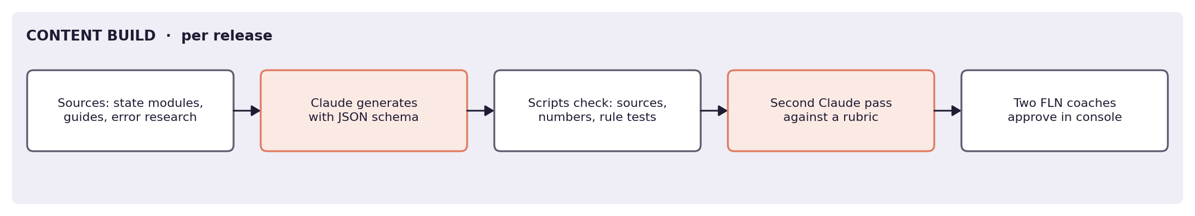
Figure 3. Content build pipeline.
Claude task | Constraints given | Automatic checks
Move cards and key points | State module text; one move per card; 4–6 key points | Every key point traced to a source section
Rubrics | 3–5 observable criteria, 0–2 descriptors | Reviewed with 2–3 FLN coaches
Model rehearsal scripts | Same scenario and children as the teacher's rehearsal | Rule engine replays the script; children's answers must match rules
Error rules | One Python function per misconception, with unit tests | Tests pass; each rule gives a distinct wrong answer on scenario items
Child personas | Name, grade, misconceptions, temperament, voice | Consistency with rules; cultural review
Practice library answers | Classroom situations beyond pedagogy | Source citation; length; safety filter

Every generation call uses a JSON schema. A second Claude pass reviews against a written rubric, then two FLN coaches approve in the review console. Unanswered questions and low-confidence scores from the field feed the next release.

11. Technology stack
Layer | Choice
Channel | WhatsApp Business Cloud API through a provider such as Gupshup
Backend | Python FastAPI with a job queue; Supabase Postgres with pgvector
Speech in | Hindi and Hinglish: AI4Bharat IndicConformer or a hosted Indian API
Reasoning | Claude in five roles with JSON output and code guards; rule engine for the children
Speech out | Indian-language TTS (e.g. AI4Bharat Indic Parler-TTS) plus recorded lines
Reports | ARP digest by WhatsApp; small web view for DIET and SCERT
Cost | Teacher-started chats are free; weekly prompts are utility templates, about ₹0.12 each in India

11.1 The five Claude roles
Role | Does | Guard
Children's voices | Turns the rule engine's result into a short line | Numbers must match; no leaked correct answer
Model teacher | Writes model rehearsal scripts (build time) | Replayed through the rule engine; coach-reviewed
Coach | Scores the rehearsal; strength, change, exact words | Every score cites a real quote
Fidelity checker | Marks key points in "explain it back" | Every mark cites a real quote
Guide answerer | Answers questions from retrieved guides | Must cite a retrieved source

11.2 WhatsApp specifics
- Voice notes arrive as compressed audio and are converted before transcription; replies are sent as audio with buttons for retry, continue and skip.
- Messages Abhyas starts outside the 24-hour service window use approved utility templates: the weekly prompt, the two-day follow-up, reminders and the ARP digest.
- A phone-call (IVR) version for teachers with basic phones is on the roadmap.

12. Data model
Table | Key fields | Notes
teacher | school, cluster, block, batch, experience band, first year, classes, consents | Consent flags control what goes upward
move, persona, rule | versioned content payloads | From the approved release
session_state | teacher, week, move, state, retries, last inbound time | Drives the weekly loop and the 24-hour window
turn | transcript, teaching acts, rule result, latency | Audio deleted after transcription
rehearsal_score | rubric scores, evidence quotes, confidence | Low confidence goes to review
explain_score | key point status, quotes | Aggregated for trainers at n ≥ 10
adoption_evidence | teacher, move, ladder level, source | Strongest level shown
question | text, category, answer, sources, follow-up date | Unanswered ones go to review
doc_chunk | source, section, text, embedding | Retrieval over state guides and practice library

13. Evaluation
Target | Threshold | Method
AI coach agreement | kappa ≥ 0.7 | Against expert coaches on 100 double-coded rehearsals
"Explain it back" scoring | kappa ≥ 0.7 | Against coaches on a coded sample
Realism of AI children | 4 of 5 | Teacher rating after rehearsals
Weekly activity | 50%+ of pilot teachers active weekly for 6 weeks | Logs; nudge baseline is 15–20%
Latency | < 20 s for 95% of turns | Server logs per turn

The pilot runs with 20 to 30 teachers through a partner NGO and their ARP, with consent. All targets will be measured in the Build stage and reported honestly, including any we miss. The six-week activity figure runs beyond the Build submission date; the interim weekly figures will be reported at submission and the full figure when the six weeks complete.

14. Privacy, safety and ethics
- Consent. Teachers consent at onboarding and stay private by default. No individual score goes to the ARP or anyone else without the teacher's consent.
- Minimisation. Voice notes are deleted after transcription; only transcripts are kept.
- Children. Children are never scored or identified. Class audio is off by default because it records children; it is enabled only where the school runs Abhyas as its own tool, with parents informed, and is deleted after scoring.
- Aggregation. Trainer views show only groups of ten or more.
- No invented facts. Children's mistakes never come from the model; answers must cite state sources; feedback must quote the teacher.
- Law. DPDP Act 2023 and Rules 2025.
- Security. Row-level security by school, cluster and block; audit logs on report access.

15. Risks and mitigations
Risk | Mitigation
Teachers drop off, as with nudges | Active practice with instant feedback; anchored in the Sankul; replaces a monthly task; counts towards CPD hours with state approval
AI children feel fake or too easy | Rule-computed mistakes; relapse after "telling the answer"; realism rating in the pilot
Coach feedback is wrong or generic | Rubric with quotes required; calibration to kappa 0.7; low-confidence review
Wrong or unsourced answers | Retrieval from state guides; must cite; hand-off to the ARP when unsure
Speech errors on Hinglish and accents | Indian speech models; clarifying question; text fallback
Slow replies break the conversation | Latency budget per step; TTS caching; recorded fixed lines
Scores used against teachers | Private by default; consent for any upward sharing; aggregates only for trainers
Basic-phone users excluded | IVR version on the roadmap

16. Build plan and team
Period | Deliverables
10–16 Oct | WhatsApp round trip with speech in and out; rule engine and personas with unit tests; first four moves drafted
17–23 Oct | Claude roles with schemas and guards; rehearsal loop end to end; weekly state machine; retrieval; review console
24 Oct – 1 Nov | Pilot with 20–30 teachers via a partner NGO and ARP; coach calibration; measurement against targets; Build submission
10–18 Nov | Fix what the pilot showed; ARP digest and trainer view; final demo

Member | Role | Owns
Shashwat Khandelwal | Backend developer and pedagogy lead | WhatsApp integration, session logic, database; moves, rubrics, model scripts, error profiles
Vedant Arora | Speech and AI developer | Speech models, Claude roles, rule engine, evaluation
Divyansh Agrawal | Field and evaluation lead | Teacher pilot, ARP partnership, coach calibration

References
Brown, J. S. & Burton, R. R. (1978). Diagnostic models for procedural bugs in basic mathematical skills. Cognitive Science.
Cilliers, J. et al. (2021). Can virtual replace in-person coaching? Experimental evidence on teacher professional development and student learning. RISE Working Paper 20/050.
CSF (2025). On Uttar Pradesh ARPs and Shikshak Sankul.
Demszky, D. et al. (2023). Can automated feedback improve teachers' uptake of student ideas? Evidence from a randomized controlled trial in a large-scale online course. Educational Evaluation and Policy Analysis.
Demszky, D. et al. (2025). Automated feedback on focusing questions in US classrooms.
Grossman, P. et al. (2009). Teaching practice: A cross-professional perspective. Teachers College Record.
Kraft, M. A., Blazar, D. & Hogan, D. (2018). The effect of teacher coaching on instruction and achievement: A meta-analysis of the causal evidence. Review of Educational Research.
Madhi Foundation. VallamAI (public description).
Markel, J. M. et al. (2023). GPTeach: Interactive TA training with GPT-based students. Learning @ Scale.
Meta (2026). WhatsApp Business Platform pricing.
NCERT. NISHTHA integrated teacher training programme.
Popova, A., Evans, D. K., Breeding, M. E. & Arancibia, V. (2022). Teacher professional development around the world: The gap between evidence and practice. World Bank Research Observer.
Shandilya (2025). On teacher induction in Rajasthan. Azim Premji University.
Shashidhara, S. & Garg, S. (2025). Using low-tech, behaviorally informed solutions to improve teacher adoption of foundational pedagogical practices. CSBC, Ashoka University.
Simulating Students or Sycophantic Problem Solving? (2026). arXiv 2605.12748.
Singh & Sarma (2025). On teacher training in India. India Development Review.
Government of India. Digital Personal Data Protection Act, 2023, and Rules, 2025.

