Activation of Biochar for Different Applications

Project Report (Phase I)

In partial fulfillment of the requirements

For the degree of

**Bachelor of Technology**

by

**Khushi Agrawal**

**(Roll No: 210107044)**

Under the Guidance of

**Dr Pankaj Tiwari**



**Department of Chemical Engineering**

**Indian Institute of Technology Guwahati**

**Nov – 2024**

**ABSTRACT**

The pressing issues of environmental pollution and global warming pose a significant threat to ecosystems, necessitating sustainable solutions. Converting renewable resources, particularly biomass, into biochar offers a promising pathway to mitigate these impacts. Traditional carbon materials derived from petrochemicals and coal require substantial energy and produce large amounts of pollutants. This underscores the need to develop alternative, eco-friendly methods to synthesize high-performance carbon materials from renewable resources with minimal environmental impact.

Biomass sources like agricultural residues, animal manure, and municipal waste can meet the growing demand for sustainable energy, reducing dependence on fossil fuels and lowering greenhouse gas emissions. Utilizing biomass also supports climate change mitigation while providing economic opportunities for small and marginal farmers.

In this project, bamboo sawdust—a sustainable and abundant biomass material—will be used as the feedstock for biochar production. The research will involve a detailed analysis of bamboo sawdust’s composition, biochar production through pyrolysis, and subsequent activation to enhance biochar properties. Proximate analysis of bamboo sawdust will provide insight into moisture content, volatile matter, ash, and fixed carbon levels. Thermogravimetric analysis (TGA) will be conducted to determine the optimal temperature for pyrolysis, facilitating efficient carbonization of the feedstock.

The biochar production process will involve both physical activation and chemical activation. Physical activation will be carried out using CO₂ under varying temperatures while keeping other conditions constant to enhance pore structure. Following this, chemical activation will be performed using potassium hydroxide (KOH) at a fixed impregnation ratio to further develop the surface area and porosity of the biochar. Analytical techniques, including X-ray diffraction (XRD) and Fourier-transform infrared spectroscopy (FTIR), will be employed to characterize the structural and chemical properties of the biochar, providing insights into its suitability for environmental applications. This study aims to establish an efficient biochar production process from bamboo sawdust with enhanced adsorption capabilities for pollutant removal and soil enhancement.

**Table of Contents**

Abstract…………………………………………………………………...…......2

1. Motivation………………………………………….........................................7
2. Introduction…………………………………………………………………...8
   1. Biochar….…………………………………………………………….8
   2. Biochar Market……………………………………………………….8
      1. Biochar Market Analysis by Technology……………………………………………………..9
      2. Biochar Market Analysis by Application……………………………………………………10
      3. Biochar Market Analysis by Region………………………………………………………...10
   3. Feedstock for Biochar……………………………………………….11
3. Literature Review…………………………………………………………...13
   1. Different Technique used for Biochar production.…………….……13
      1. Pyrolysis………………………………………………………13
      2. Gasification…………………………………………………...14
      3. Hydrothermal Carbonization.…………………………………15
   2. Activation of Biochar Produced.……………………………………15
      1. Chemical Activation………………………………………….16
      2. Physical Activation…………………………………………...17
      3. Microwave Mediated Activation……………………………..18
      4. Physicochemical Activation………………………………….18
4. Objective……………………………………………………………………19
5. Materials and Methodology…………………………………………………20
   1. Feedstock and Materials…………………………………………….20
   2. Methodology………………………………………………………..20
      1. Analytical Procedures………………………………………...20
         1. Proximate Analysis…….………………………………20
         2. Thermogravimetric Analysis (TGA)…………………..21
      2. Pyrolysis………………………………………………………21
      3. Chemical Activation…………………………………………..21
      4. Physical Activation…………………………………………...22
      5. Fourier Transform Infrared Spectroscopy (FTIR)……………22
      6. Brunauer–Emmett–Teller (BET) Surface Area and Porosity Analysis……………………………………………………….23
      7. Scanning Electron Microscopy (SEM)……………………….23
      8. X-Ray Diffraction (XRD)…………………………………….23
      9. Thermogravimetric Analysis (TGA)………………………….24
6. Results and Discussions...………………………………………………25
   1. Proximate Analysis………………….………………………………25
   2. Thermogravimetric Analysis (TGA)…….………………………….25
   3. Physical Activation…………………….……………………………27
   4. Chemical Activation……………………….………………………..28
7. Future Work…………………………………………………………….29
8. Conclusion………………………………………………………………30
9. References………………………………………………………………31

**Tables and Figures**

1. Table 1. Recent studies on the chemical activation of biochar precursors [22] …………..........................................................................................16
2. Table 2. Recent studies on the physical activation of biochar precursors [22]……………………………………………………………………...17
3. Table 3. Proximate analysis of bamboo [32]……………………………25
4. Table 4. Thermogravimetric analysis of bamboo [32]………………….26
5. Table 5 Effect of physical activation on bamboo [32]………………….27
6. Table 6 Effect of chemical activation on bamboo [33]…………………28
7. Fig. 1. Biochar Market Analysis by Technology [3]……………………..9
8. Fig. 2. Biochar Market Analysis by Application [3]……………………10
9. Fig. 3. Biochar Market Analysis by Region [3]………………………...11
10. Fig. 4. General Concept of the Pyrolysis Process [21]……………….…13
11. Fig. 5. The Differences of Pyrolysis Process of Biomass [21]……….…14
12. Fig. 6. Schematic illustrations of various methods for preparing activated biocarbon materials [31]…….………………….……………………….15
13. Fig. 7. TG and DTG curve of bamboo biomass [32]…………….……...26
14. **Motivation**

Producing biochar from biomass is a game-changer in the quest for sustainable solutions. When biomass, such as agricultural residues and organic waste, is converted into biochar through pyrolysis, it not only prevents the release of harmful greenhouse gases but also transforms waste into a valuable carbon sink. According to recent studies, biochar production has the potential to sequester significant amounts of carbon dioxide, mitigating climate change impacts and contributing to carbon neutrality goals. Additionally, when biochar is applied to soil, it improves water retention, nutrient availability, and overall soil health. Research indicates that biochar-amended soils can enhance crop yields, reduce the need for synthetic fertilizers, and improve soil resilience to drought. By harnessing the power of biochar, this research not only addresses environmental concerns but also paves the way for sustainable agriculture and a healthier planet.

The growing awareness of biochar's applications and benefits has driven significant market growth, with solid demand anticipated in both agricultural and environmental sectors. Increased collaboration among players, especially in rural areas within emerging economies, is also likely to expand the market as more communities recognize biochar's role in sustainable development. Producers employ various technologies to create biochar, with pyrolysis emerging as the preferred method due to its efficiency, scalability, and environmental effectiveness. Additionally, advancements in biochar production technology are making the process more accessible and cost-effective, further boosting market interest. The biochar market's revenue growth is projected to rise by 14% from 2022 to 2028, with Asia leading in technology adoption and market expansion as governments and industries invest in greener solutions.

**2. Introduction**

**2.1** **Biochar**

Biochar is a form of highly stable charcoal produced by heating biomass in an oxygen-limited environment. Common feedstocks for biochar include agricultural residues like corncobs, coconut shells, straw, and other organic materials rich in cellulose and lignin. During production, non-carbon materials gasify and are burned off, leaving behind a carbon-rich material that can retain up to 40% of the original carbon contained in the biomass. Although biochar is gaining attention now, it has historical roots. Ancient civilizations, particularly in the Amazon basin, enriched poor soils with **terra preta**—a type of biochar—enhancing soil fertility for sustained agriculture. Today, as we face challenges like climate change, environmental degradation, and resource scarcity, biochar's potential as a sustainable solution is being revisited [1].

When biomass undergoes pyrolysis in an oxygen-limited environment, it forms a porous, carbonaceous solid with high resistance to decomposition due to its aromatic structure. The properties of biochar—such as density, porosity, pH, and elemental composition—are influenced significantly by the feedstock type and production method, impacting its applicability across diverse fields. For instance, biochar has shown effectiveness in waste treatment by adsorbing dyes, heavy metals, and organic and inorganic pollutants from various industrial effluents. Additionally, biochar’s use in soil can enhance water retention, increase nutrient availability, and improve soil health, supporting sustainable agriculture [2].

**2.2. Biochar Market**

The biochar market is rapidly expanding, with India projected to achieve a compound annual growth rate of 15.77% in volume and 18.40% in revenue from 2022 to 2028. Driven by the demand for sustainable agriculture and carbon sequestration, biochar’s market growth is supported by India’s agricultural capacity, utilizing 10.57% of its 0.297 billion hectares for farming. Biochar, derived from feedstocks like forestry waste, animal manure, and agricultural residues, is produced mainly through pyrolysis and gasification. These methods yield high-quality biochar, valuable for applications in soil improvement, pollutant removal, and as a livestock feed additive.

The market segments into critical regions: North America, Europe, Asia-Pacific, South America, and the Middle East and Africa (MEA). Asia-Pacific, led by India and China, is a significant market due to government support for biochar in agriculture and environmental initiatives. North America and Europe have also led to the adoption of biochar for carbon sequestration and soil health. With its potential to improve soil properties, enhance crop yields, and aid in sustainable waste management, biochar is recognized as a powerful tool in global sustainability efforts, supporting environmental goals and agricultural productivity across regions.

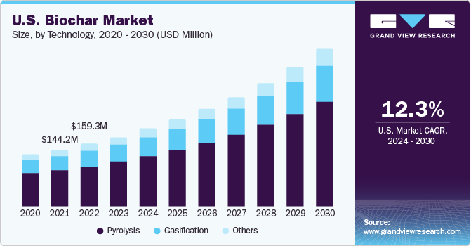 **2.2.1 Biochar Market Analysis by Technology**

**Fig. 1.** Biochar Market Analysis by Technology [3].

In 2023, pyrolysis remained the leading technology in the biochar market, accounting for approximately 62.5% of the revenue share. This dominance is attributed to its high yield of biochar with elevated carbon content and process stability. The pyrolysis segment is projected to grow at a compound annual growth rate (CAGR) of 13.9% from 2024 to 2030. [3]

Gasification technology has seen moderate growth, primarily driven by the increasing demand for electricity generation. However, it is expected to lose market share as it does not produce stable biochar suitable for agricultural use. [4]

Additionally, small-scale producers are exploring alternative methods such as hydrothermal carbonization, acid hydrolysis, and cooking stove techniques. These approaches are particularly favored in the Asia-Pacific region, where there is a growing number of small producers. [5]

**2.2.2 Biochar Market Analysis by Application**

In 2023, the agriculture sector led the biochar market, accounting for over 76% of the revenue share, driven by biochar's benefits in enhancing soil fertility and crop yields. [6] The power generation sector is also experiencing growth in biochar applications due to its potential as a renewable energy source. [7] Additionally, biochar's role in carbon sequestration is gaining attention, particularly in forestry management, as it aids in reducing atmospheric carbon levels and mitigating climate change impacts. [8]

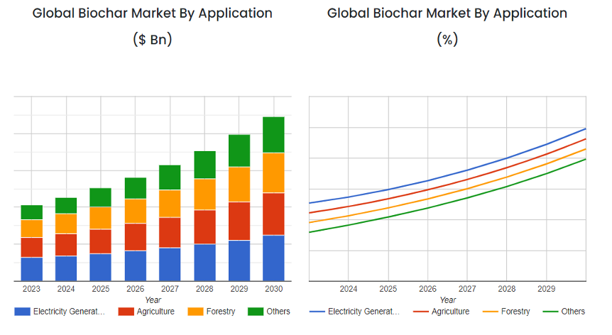  
**Fig. 2.** Biochar Market Analysis by Application [3].

**2.2.3 Biochar Market Analysis by Region**

North America is the largest biochar consumer, driven by high demand for organic food and sustainable livestock practices, with the U.S. leading in revenue. Asia-Pacific, particularly China and India, is expected to see strong growth due to expanding agricultural sectors and the adoption of sustainable practices.[9]

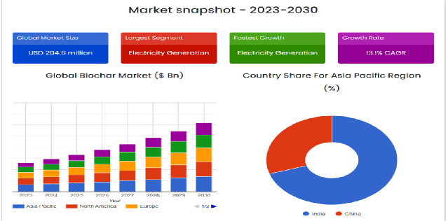**Fig. 3.** Biochar Market Analysis by Region [3].

**2.3 Feedstock for Biochar**

Depending on the source, biomass can be divided into five categories: woody, agricultural, aquatic, human and animal waste, and industrial waste biomass. The **woody biomass**, which includes stems, branches, leaves, bark, lumps, and chips from makes up the majority of the biomass. Forest regions are the primary source of woody biomass. The second major source of biomass is **agricultural biomass**, which includes a variety of distinct crops. These crops, stalks, straws, and shells are utilized as biomass. In addition to these distinct plant parts, grass can also be utilized as biomass in the form of the flowers.

Another class of biomass, known as **aquatic biomass**, is made up of many types of microalgae, plants, and microorganisms that are found in water. Aquatic biomass includes many types of water weeds, fungi, green and blue algae, and algae.

The next category of biomass is **waste from animals and humans**. This group includes various animal manures, cooked or raw food, fruits, paper, plastics, pulps, and other materials. Not only is energy produced when these waste materials are processed and turned into valuable energy products, but the issue of getting rid of them is also somewhat mitigated. Paper sludge from the paper industry, sugarcane residue from sugar mills, garbage from the food processing industry, and other wastes are examples of **industrial waste**. Biomass-derived from animal and human waste is classified differently from industrial biomass due to the presence of many toxic compounds and dangerous additives in industrial biomass, which are not present in animal or human waste.

**3. Literature Review**

**3.1 Different Technique used for Biochar production:**

Different feedstocks (forestry, agricultural and aquatic biomasses, livestock detritus, industrial and municipal wastes) can be used as the starting point for a variety of char production processes (pyrolysis, gasification, hydrothermal carbonization, etc.). These processes can be carried out in a wide range of installations and reactors based on different technologies of various sizes and operating under different conditions (residence time, particle size, heating rate, final temperature, etc.).

**3.1.1 Pyrolysis**

A non-oxidative method of heat breakdown is pyrolysis. It produces three distinct product fractions: non-condensable gaseous residue (biochar), condensable liquid (bio-oil), and solid residue (biochar) (syngas). Pyrolysis usually occurs at temperatures between 300 and 700 °C. More biochar is produced at lower pyrolysis temperatures and more extended residence periods.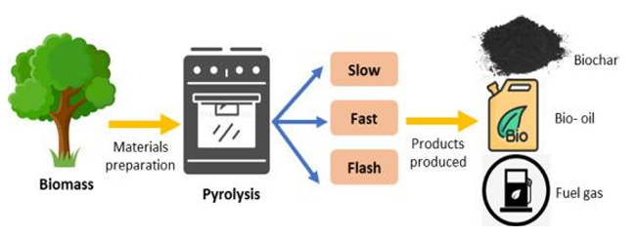  
**Fig. 4.** General Concept of the Pyrolysis Process [21].

Low heat (300–550 °C), slow heating rates (0.1–0.8 °C/s), and extended contact times (5–30 min or even 25–35 h) are characteristics of **slow pyrolysis**. Extended vapor residence durations 16 are used in slow pyrolysis to stimulate secondary reactions, which maximize biochar production. Primary and secondary char are produced via slow pyrolysis [20]. Furthermore, the creation of biochar is favored by the medium pyrolysis heat and the slow heating rate. Slow pyrolysis may be exothermic as a result of the secondary reactions' methodical development. The particles that are absorbed by slow pyrolysis have a size range of 5 to 50 mm. [21].  
Intermediate pyrolysis is slower than rapid pyrolysis but faster than slow pyrolysis. It occurs between 450 and 550 °C, proceeds more quickly than slow pyrolysis, takes 10 to 30 seconds to finish, and yields less charcoal. Regarding intermediate pyrolysis, the biomass particles' size and form are less important than they are for fast pyrolysis. It can handle a wider variety of biomass, including material with approximately 40% biomass content and larger particles, pellets, and chips.  
Extreme temperatures, quick heating rates (10–1000 °C/s), and short residence durations (0.5 2 s) are the hallmarks of **Fast pyrolysis**. By using short vapor residence times and maintaining high biomass heating rates, fast pyrolysis prevents secondary reactions. It increases the output of bio-oil. Because only primary carbon is created during fast pyrolysis, biochar yields are frequently inadequate. Since secondary reactions are not available, the fast pyrolysis process is endothermic.  
The goal of **flash pyrolysis** is to maximize bio-oil production. High temperatures, rapid heating (> 1000 °C/s), and short contact periods (< 0.5 s) are its defining characteristics. The main products of flash pyrolysis are the same as those of fast pyrolysis. Between 800 and 1000 °C is when it arises. Good biomass feed particles (less than 0.2 mm) are usually needed.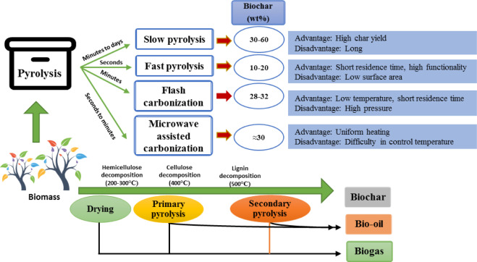  
**Fig. 5.** The Differences of Pyrolysis Process of Biomass [21].

**3.1.2 Gasification**

By transferring heat from carbonaceous materials to gasification agents like air, oxygen, or steam at temperatures exceeding 750 °C and at ambient or high pressures, gasification is a thermochemical process that yields biochar and oxygen-deficient states. Drying, pyrolysis, partial oxidation, and reduction are the four sequential processes that typically make up an gasification operation. Syngas is the process' main output, and char is referred to as a byproduct with a lower yield.

**3.1.3 Hydrothermal Carbonization**

The process known as hydrothermal carbonization (HTC) converts biomass into carbonaceous biofuel in the presence of water by applying pressure and heat. This could be a viable method to turn wet biomass into biofuels without using a lot of energy to dry it. When liquid-containing solid biomass is cooked at low temperatures (less than 200°C) in a closed chamber with autogenous pressure, an HTC process produces primary solids known as hydrochar.

**3.2 Activation of Biochar Produced**

Activation is the process that converts biochar (BC) (or) biomass in to activated carbons (AC), which exhibits very high porous structure associated with the larger specific surface area. Based on the activating agents and heating sources these activation processes can be classified into: (i) physical, (ii) chemical, (iii) physicochemical and (iv) microwave assisted activation processes.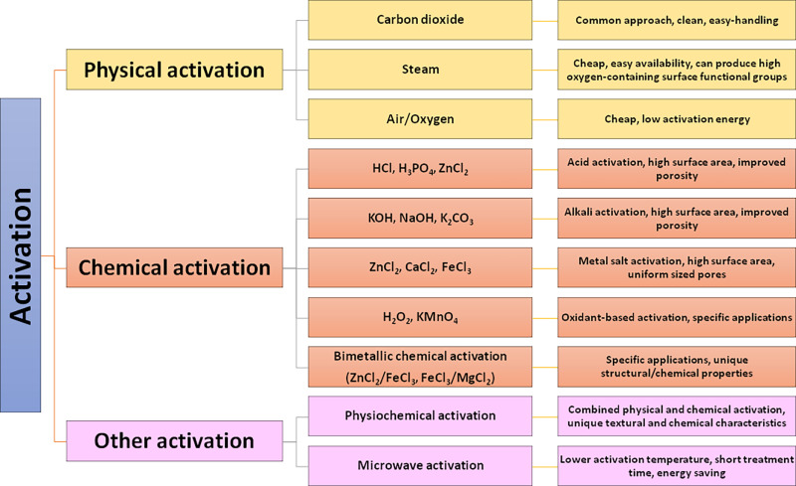  
**Fig. 6.** Schematic illustrations of various methods for preparing activated biocarbon materials [31].

**3.2.1 Chemical Activation**

After the raw material has been crushed and ground to the required particle size, it is combined with a concentrated solution of a dehydrating substance, such as zinc chloride, sulfuric acid, or phosphoric acid. After that, the mixture is dried and heated to a temperature of 400–700°C in an inert environment. After washing with water to get rid of the activation ingredient, the product is separated from the slurry, dried, and condition-specific to fit its intended use. The activating compound's primary function is to break down the cellulosic material. The degree of impregnation, or the ratio between the mass of chemical and the mass of raw material, in this process determines the pore size distribution and surface area for a given activating agent and raw material. The final activated carbon's pore size will increase with increasing impregnation degree. The temperature during pyrolysis and the duration of the soak are two other crucial preparatory features.

|  |  |  |  |  |  |  |  |  |
| --- | --- | --- | --- | --- | --- | --- | --- | --- |
| **Feedstock** | **Chemical agent** | **Temp**  **(°C)** | **Time (min)** | **Impregnation**  **Ratio**  **(Chemical:**  **feedstock)** | **BET surface area (m2/g)** | **Total pore volume (cm3/g)** | **Avg pore size (nm)** | **Yield (wt%)** |
| Canola meal | KOH | 800 | 120 | 03:01 | 1230 | 0.46 | 1.51 | – |
| Coffee residue | H3PO4 | 600 | 60 | 40% | 696 | 0.59 | 3.37 | 34.9 |
| Fox nutshell | ZnCl2 | 600 | 60 | 02:01 | 2869 | 1.96 | 2.73 | 38.1 |
| Golden shower | K2CO3 | 800 | 240 | 01:01 | 1413 | 0.66 | 1.86 | 57.7 |
| Pinewood | ZnCl2 | 580 | 120 | 01:01 | 1081 | 0.37 | 0.57 | 28.8 |
| KOH | 580 | 120 | 01:04 | 1185 | 0.35 | 0.52 | 19.5 |
| Pinewood sawdust | H3PO4 | 600 | 120 | 02:01 | 1547 | 1.17 | – | 43.3 |

**Table 1.** Recent studies on the chemical activation of biochar precursors [22].

**3.2.2 Physical Activation**

Through a dual-stage process, biomass is thermally treated at 600–900 °C in an inert atmosphere to form biochar, which is then further activated at 800–1100 °C with the help of appropriate activating or oxidizing agents to produce activated carbon. Commonly utilized physical activation agents, such as steam, CO2, air, or a binary combination of CO2 and N2, are oxidizing agents. The surface chemical characteristics of biochar vary in a complicated and unpredictable way during the pyrolysis process, which helps to speed up the activation process. Research on CO2-based physical activation has been extensive. It is favored over steam because it is simple to handle, requires a low activation temperature, and takes a carbon recyclability approach.

**Table 2.** Recent studies on the physical activation of biochar precursors [22].

|  |  |  |  |  |  |  |  |  |
| --- | --- | --- | --- | --- | --- | --- | --- | --- |
| **Feedstock** | **Physical agent** | **Activation temperature (°C)** | **Reaction time (min)** | **Key**  **attributes** | **BET surface area (m2/g)** | **Total pore volume (cm3/g)** | **Average pore size (nm)** | **Yield (wt%)** |
| Almond shell | Steam | 950 | 60 | Steam flow rate: 130 cm3/min | 1261 | – | – | 50 |
| Canola meal | Steam | 800 | 90 | Steam flow rate: 8 g/h | 403 | 0.18 | 2.07 | 69.5 |
| CO2 | 700 | 120 | CO2 flow rate: 24 mL/min | 320 | 0.3 | 3.67 | – |
| Coconut shell | CO2 | 850 | 60 | CO2 flow rate: 50 cm3/min | 1152 | 0.72 | – | 2.6 |
| Coffee residue | Steam | 700 | 120 | Steam/N2 ratio: 1:2 | 641 | 0.33 | 2.06 | 13.4 |
| Pine nutshell | Steam | 850 | 80 | Steam/biomass ratio: 1.5:1 | 1058 | – | – | 31.2 |
| Pistachio shell | Steam | 950 | 30 | Steam flow rate: 130 cm3/min | 1196 | – | – | 41.7 |

**3.2.3 Microwave Mediated Activation**

Microwave-assisted chemical synthesis/process is getting significant importance in recent years and it has also been explored for the biocarbon activation process as the heating source by utilizing either physical (or) chemical activating agents. In microwave activation process, the key parameters are the process configurations (either single step (or) two step), power of the microwave ration, duration of the microwave activation, nature of the biomass and activating agents and the interactive phenomena between microwave radiation and the activating agents in presence of biomass [31].

**3.2.4 Physicochemical Activation**

Along with physical and chemical activation processes, researchers also explored the integration of both the methods in order to improve the properties of resulting activated biochar. This process can be performed by two different methods such as (i) adopting physical and chemical activation methods one after other and (ii) simultaneous integration of physical and chemical activation methods. It was found that the execution of physicochemical process leads to the activated biochar with superior specific surface area then their individual counterpart [31].

**4. Objective**

Biochar holds significant potential to become an essential resource in sustainable energy and environmental applications, making it an exciting area of research. For this study, bamboo sawdust is selected as the feedstock to investigate biochar production and activation. Bamboo is an abundant resource, especially in regions like India, making it an ideal choice for this study.

The main objectives of this report are:

1. Determination of Physical and Chemical Properties of Bamboo Sawdust
2. Synthesis of Biochar

2.1 Pyrolysis of the Prepared Bamboo Sawdust to Produce Biochar.

2.2 Activation of Biochar through Physical and Chemical Methods to Obtain Activated Biochar.

2.3 Characterization and Analysis of the Properties of Activated Biochar.

**5. Materials and Methodology**

In the forthcoming phase of this BTP, the focus will be on producing and activating biochar derived from bamboo sawdust. Both chemical and physical activation methods will be employed to enhance the biochar's properties for environmental applications. The procedures will be conducted using the same equipment as in previous experiments, with adjustments to accommodate the specific characteristics of bamboo sawdust. The following sections outline the planned methodologies, referencing relevant studies that have utilized bamboo as a feedstock for biochar production and activation.

**5.1 Feedstock and Materials**

Bamboo sawdust has been chosen as the feedstock for biochar synthesis. Bamboo is widely cultivated across various regions, and India is one of the largest producers due to its favorable climate and agricultural practices. Its rapid growth rate and high yield make bamboo an ideal and sustainable choice for biochar production.

**5.2 Methodolgy**

**5.2.1 Analytical Procedures**

**5.2.1.1 Proximate Analysis**

Proximate analysis will be conducted to determine the moisture content, volatile matter, ash content, and fixed carbon of the bamboo sawdust biochar. These parameters are crucial for assessing the quality and suitability of the biochar for activation and subsequent applications.

* Moisture Content: A 10 g sample of bamboo sawdust will be dried at 105°C for 24 hours to determine moisture content. This method aligns with standard procedures used in biochar studies [14].
* Volatile Matter: A 5 g sample will be heated in a muffle furnace at 900°C for 7 minutes with the crucible lid closed. This approach is consistent with methods employed in previous research on bamboo biochar [15].
* Ash Content: A 5 g sample will be incinerated at 750°C for 6 hours in an open crucible. This procedure is in line with established protocols for determining ash content in biochar [14].
* Fixed Carbon: Calculated by subtracting the percentages of moisture, volatile matter, and ash from 100%.

**5.2.1.2 Thermogravimetric Analysis (TGA)**

Thermogravimetric Analysis (TGA) will be utilized to assess the thermal stability and decomposition behavior of the bamboo sawdust. TGA provides insights into the thermal degradation stages of biomass, which is essential for optimizing pyrolysis conditions [16].

* Procedure: Approximately 10 mg of the sample will be heated from room temperature to 800°C at a rate of 10°C/min under a nitrogen atmosphere. This heating rate and temperature range are consistent with those used in studies involving bamboo biochar [17].

**5.2.2 Pyrolysis**

Pyrolysis will be performed to convert bamboo sawdust into biochar under controlled conditions. The process parameters will be selected based on the literature to achieve optimal biochar yield and quality [18].

* Procedure: Approximately 50 g of dried bamboo sawdust will be placed in a stainless steel reactor. The reactor will be purged with nitrogen to create an inert atmosphere and then heated to 500°C at a rate of 10°C/min, with a holding time of 1 hour at the final temperature [19].
* Expected Yield: Biochar yields from bamboo pyrolysis are typically around 30–40%, depending on the specific conditions [16].

**5.2.3 Chemical Activation**

Chemical activation will be conducted using potassium hydroxide (KOH) to enhance the porosity and surface area of the biochar. KOH activation is known to produce biochar with high surface areas and well-developed pore structures [17].

* Procedure: The char will be impregnated with KOH at weight ratios of 1:1, 1:2, and 1:3, stirred at 100 rpm for 2 hours, and oven-dried at 120°C for 4 hours. The impregnated char will then be activated in a horizontal tubular furnace under a nitrogen flow of 200 mL/min, heated to activation temperatures of 600°C, 700°C, and 800°C, and held at the target temperature for 1 hour. Post-activation, the sample will be washed with 0.1 M HCl at 85°C to remove residual KOH and inorganic materials, rinsed with distilled water until the pH is neutral, and dried at 110°C for 24 hours before being stored for further characterization [33].

**5.2.4 Physical Activation**

Physical activation will be performed to further develop the pore structure of the biochar. This method involves using gases such as steam or carbon dioxide at high temperatures [32].

* Procedure: The activation of pyrolyzed bamboo char will be conducted at varying temperatures (**850°C, 900°C, 950°C, and 1000°C**) to study the effect of temperature on pore development and functional group formation. A **25 g sample of char**, prepared at 400°C under nitrogen flow (100 cm³/min), will be heated in a vertical tube furnace with a quartz tube reactor at a rate of 10°C/min. Upon reaching the desired temperature, nitrogen flow will be replaced with carbon dioxide (99.995% purity) at a flow rate of **100 cm³/min**, and the activation will be maintained for **60 minutes**. After activation, the CO₂ flow will be stopped, and nitrogen flow will resume for controlled cooling to ambient temperature. The activated carbon samples will then be stored in a desiccator for subsequent characterization [32].

**5.2.5 Fourier Transform Infrared Spectroscopy (FTIR)**

FTIR analysis will be conducted to identify the functional groups present on the surface of the activated biochar. Understanding these functional groups is essential for determining the biochar's interaction mechanisms with various pollutants [14].

* Procedure: FTIR spectra will be obtained in the range of 4000–400 cm⁻¹ using a Shimadzu IRAffinity-1 spectrometer [19].
* Expected Results: Functional groups such as hydroxyl, carboxyl, and carbonyl are expected to be present, which contribute to the biochar's adsorption properties [15].

**5.2.6 Brunauer–Emmett–Teller (BET) Surface Area and Porosity Analysis**

BET analysis will be conducted to measure the surface area, pore volume, and pore size distribution of the activated biochar. These parameters are crucial for evaluating the material's adsorption capacity in applications like pollutant removal and soil enhancement.

* **Procedure**: The BET surface area and pore characteristics will be measured under nitrogen adsorption conditions at 77 K [23].
* **Expected Results**: Activation is anticipated to increase the surface area and porosity of the biochar, enhancing its adsorptive capacity and making it more effective for applications requiring high interaction with target molecules [24].

**5.2.7 Scanning Electron Microscopy (SEM)**

SEM will be employed to analyze the surface morphology and pore structure of the activated biochar. Visual confirmation of structural changes, such as increased surface roughness and porosity, will support its characterization for adsorption applications.

* **Procedure**: The sample will be prepared on a carbon-coated grid and observed under high-vacuum conditions [25].
* **Expected Results**: SEM images are expected to reveal an enhanced porous structure and rougher surface on the activated biochar, both of which contribute to increased surface area and improved adsorptive capacity [26].

**5.2.8 X-Ray Diffraction (XRD)**

XRD will be used to determine the crystallinity and phase composition of the biochar, which influence its chemical stability and structural integrity.

* **Procedure**: XRD patterns will be obtained using Cu Kα radiation across a 2θ range of 10–80° [27].
* **Expected Results**: The biochar is anticipated to exhibit an amorphous structure with minimal crystallinity, indicating high stability and suitability for long-term environmental applications [28].

**5.2.9 Thermogravimetric Analysis (TGA)**

TGA will be performed to assess the thermal stability and decomposition profile of the biochar. This analysis provides insights into weight loss stages, helping to identify optimal pyrolysis conditions and material durability.

* **Procedure**: Approximately 10 mg of biochar will be heated from room temperature to 800°C at a rate of 10°C/min under a nitrogen flow [29].
* **Expected Results**: The TGA curve is expected to show distinct weight-loss phases for moisture, volatiles, and fixed carbon, confirming the biochar’s stability and suitability for applications involving exposure to heat [30].

**6. Results and Discussions**

**6.1 Proximate Analysis**

Based on reference studies, the proximate analysis of bamboo prior to carbonization revealed:

* **Moisture Content:** 6.97%, determined by drying a 10 g sample at 105°C for 24 hours.
* **Volatile Matter:** 73.02%, measured by heating a 5 g sample at 900°C for 7 minutes in a muffle furnace.
* **Ash Content:** 0.10%, calculated by incinerating a 5 g sample at 750°C for 6 hours.
* **Fixed Carbon:** 19.91%, estimated by subtracting moisture, volatile matter, and ash content from 100%.

**Table 3.** Proximate analysis of bamboo [32].

|  |  |
| --- | --- |
| PARAMETER | VALUE |
| Moisture Content | 6.97 |
| Volatile Matter | 73.02 |
| Ash Content | 0.10 |
| Fixed Carbon | 19.91 |

**6.2 Thermogravimetric Analysis (TGA)**

* The TGA curve is anticipated to show weight loss stages [32]:

**Table 4.** Thermogravimetric analysis of bamboo [32].

|  |  |  |  |  |  |  |
| --- | --- | --- | --- | --- | --- | --- |
| **Decomposition Stage** | **Temp  Range (°C)** | | **Weight loss (%)** | | **Observations** | |
| Moisture Evaporation | 25-110 | | 7 | | |  |  | | --- | --- | | First significant peak. |  | | |
| Hemicellulose Decomposition | 180-300 | | Major stage | | The first significant peak with maximum decomposition rate around 290°C. | |
| Cellulose Decomposition | | 300-390 | | Major stage | | Second major peak with maximum decomposition rate at 345°C. |
| Lignin Decomposition | | 150-900 | | Major stage | | Occurs across a broad range, contributing to the residual mass. |

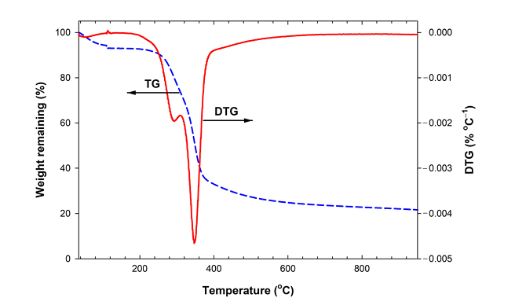Fig.7. TG and DTG curve of bamboo biomass [32].

**6.3 Physical Activation**

**Table 5.** Effect of physical activation on bamboo [32].

|  |  |  |  |
| --- | --- | --- | --- |
| **Activation Temperature (°C)** | **Surface Area (m²/g)** | **Pore Characteristics** | **Functional Groups** |
| **850°C** | ~600–800 | Predominantly micropores (0.65–1.4 nm). | Moderate oxygenated functional groups. |
| **900°C** | ~850–900 | Balanced micropores and mesopores (1.4–2 nm). | Increase in phenolic and carboxylic groups. |
| **950°C** | ~950 | Enhanced mesoporosity (2–4 nm). | High concentration of oxygenated functional groups. |
| **1000°C** | ~800–850 | Mesopores dominate, reduced microporosity. | Slight decrease in functional groups due to burn-off. |

* Optimal Activation Temperature: 900°C–950°C is ideal for achieving a balance between high surface area, microporosity, and mesoporosity, making the biochar suitable for versatile applications such as gas adsorption and pollutant removal.
* High Temperatures Impact: At 1000°C, pore coalescence leads to a reduction in micropore volume, emphasizing the importance of controlled temperature conditions to preserve the biochar’s adsorption efficiency [32].

**6.4 Chemical Activation**

**Table 6.** Effect of chemical activation on bamboo [33].

|  |  |  |  |  |  |
| --- | --- | --- | --- | --- | --- |
| **Activation Temperature (°C)** | **Activation Temperature (°C)** | **Activation Temperature (°C)** | **Activation Temperature (°C)** | **Activation Temperature (°C)** | **Activation Temperature (°C)** |
| **600°C** | 243 | 0.194 | 59.8 | 40.2 | Microporous |
| **700°C** | 342 | 0.31 | 76.5 | 23.5 | Microporous |
| **800°C** | 980 | 0.559 | 90.9 | 9.1 | Microporous |

* Optimal Conditions: Activation at 800°C with a char-to-KOH ratio of 1:3 provides the highest BET surface area and microporosity.
* Pore Structure: Higher activation temperatures and KOH ratios result in increased microporosity and pore volume, ideal for adsorption applications [33].

**7. Future Work**

In the next phase of my BTP, all the experiments and analyses outlined in the methodology and results sections will be executed. This will include performing pyrolysis of bamboo sawdust under specified conditions to produce biochar and study its yield and characteristics. The prepared biochar will undergo physical activation at varying temperatures (850°C, 900°C, 950°C, and 1000°C) to analyze the impact of temperature on surface area, pore structure, and functional groups.

Additionally, chemical activation will be performed using KOH at different impregnation ratios and activation temperatures (600°C, 700°C, and 800°C) to optimize porosity and adsorption capacity. The activated carbon will be comprehensively characterized using advanced techniques such as FTIR, BET surface area analysis, SEM imaging, and XRD analysis to evaluate its structural, morphological, and chemical properties. A comparative study of physical and chemical activation methods will be undertaken to understand their effects on surface area, pore size distribution, and functional group development.

Finally, the prepared activated carbon will be tested for adsorption applications, such as removing heavy metals, organic pollutants, and dyes, to assess its practical efficiency and suitability for environmental and industrial applications.

**8. Conclusion**

This study outlines a structured approach for investigating bamboo sawdust as a sustainable feedstock for biochar production. Planned analyses include proximate analysis, thermogravimetric analysis (TGA), and various characterization techniques, which will provide critical insights into the composition, stability, and structural properties of biochar. These steps will establish optimal conditions for biochar production and lay the groundwork for future activation processes.

In the next phase of this BTP, the biochar will undergo activation and detailed characterization to enhance its surface area, porosity, and adsorption properties. These efforts aim to maximize biochar's effectiveness in applications such as pollutant removal and soil improvement, ultimately contributing to sustainable environmental management and agricultural practices. This work positions bamboo-derived biochar as a promising, eco-friendly material with diverse potential applications.

**9. References**

[1] Lehmann, J.; Joseph, S. *Biochar for Environmental Management: Science, Technology and Implementation*; Earthscan, 2009.

[2] Wang, J.; Xiong, Z.; Kuzyakov, Y. Biochar Stability in Soil: Meta-Analysis of Decomposition and Priming Effects. *GCB Bioenergy* **2016**, *8* (3), 512–523.

[3] Gabhane, J.; Tripathi, A.; Athar, S.; William, S. P. M. P.; Vaidya, A. N.; Wate, S. R. Assessment of Bioenergy Potential of Agricultural Wastes: A Case Study Cum Template. *J. Biofuels Bioenergy* **2016**, *2*, 122.

[4] Pappu, A.; Saxena, M.; Asolekar, S. R. Solid Wastes Generation in India and Their Recycling Potential in Building Materials. *Build. Environ.* **2007**, *42* (6), 2311–2320.

[5] GVR Report. Biochar Market Size, Share & Trends Analysis Report By Technology (Gasification, Pyrolysis), By Application (Agriculture, Others), By Region (North America, Asia Pacific), And Segment Forecasts, 2024–2030.

[6] Kumar, S.; Kumar, G.; Avasthe, R. Applications of Biomass Derived Biochar in Modern Science and Technology. *Environmental Technology & Innovation* **2021**, *21*, 101306.

[7] Sakhiya, A. K.; Anand, A.; Kaushal, P. Production, Activation, and Application of Biochar in Recent Time. *Review* **2020**, *2*, 235–285.

[8] Xu, X.; Zhang, H.; Zheng, J. Characterization and Functional Applications of Enriched Biochar. *Environmental Technology & Innovation* **2024**, *21*, 381.

[9] GVR Report. Biochar Market Size, Share & Trends Analysis Report By Technology (Gasification, Pyrolysis), By Application (Agriculture, Others), By Region (North America, Asia Pacific), And Segment Forecasts, 2024–2030.

[10] Proximate Analysis and Moisture Content Determination. *ScienceDirect*.

[11] Volatile Matter and TGA Heating Process. *ResearchGate*.

[12] Ash Content Analysis. *ScienceDirect*.

[13] TGA Procedure Specifics for Bamboo. *Springer*.

[14] Cheng, C. H.; Sun, H.; Chen, T.; Wang, C. Effect of Pyrolysis Temperature on the Properties of Biochar Derived from Agricultural Residues. *Bioresource Technology* **2018**, *249*, 283–290.

[15] Wang, L.; Li, J.; Zheng, X. Production, Activation, and Applications of Bamboo-Derived Biochar. *Renewable and Sustainable Energy Reviews* **2020**, *127*, 109864.

[16] Liu, Z.; Ma, X.; Cheng, L. Chemical Activation of Biomass-Derived Biochar Using Potassium Hydroxide (KOH): Optimization and Characterization. *Industrial Crops and Products* **2019**, *133*, 251–258.

[17] Xu, X.; Chen, X.; Liu, Z. Physical and Chemical Activation of Biochar for Enhanced Adsorption Capabilities. *Environmental Technology & Innovation* **2021**, *22*, 101456.

[18] Zhang, H.; Zhu, H.; Liu, Y. Characterization and Adsorption Properties of Bamboo Biochar Activated with CO₂ and Steam. *Journal of Environmental Management* **2021**, *295*, 113089.

[19] Phansiri, M.; Anuwongcharoen, N. Characterization and Properties of Activated Carbon from Tamarind Seeds. *Environmental Science Journal* **2015**, *12* (4), 324–336.

[20] Environmental Technology & Innovation. *ScienceDirect*.

[21] Patra, B. R.; Mukherjee, A.; Nanda, S.; Dalai, A. K. Biochar Production, Activation, and Adsorptive Applications: A Review. *Environmental Chemistry Letters* **2021**, *19*, 2237–2259.

[22] Characterization of Biochar and Activated Carbon: Methods and Applications. *Journal of Environmental Management* **2020**, *256*, 109684.

[23] BET Surface Area Analysis in Biochar Characterization. *Applied Surface Science* **2019**, *476*, 925–934.

[24] SEM Analysis of Activated Biochar Derived from Agricultural Biomass. *Microscopy and Microanalysis* **2018**, *24* (5), 415–420.

[25] Microscopic and Structural Analysis of Biochar Surface Morphology. *Carbon* **2021**, *178*, 591–600.

[26] XRD Characterization of Amorphous Carbon Materials. *Materials Science Forum* **2022**, *1056*, 1–15.

[27] Crystallinity in Activated Biochar and Its Impact on Adsorption Efficiency. *Journal of Carbon Research* **2020**, *16*, 8.

[28] Thermogravimetric Analysis in Biochar Production and Stability Assessment. *Thermochimica Acta* **2019**, *677*, 83–91.

[29] Thermal Decomposition Profiles of Biochar from Various Feedstocks. *Renewable and Sustainable Energy Reviews* **2021**, *146*, 111123.

[30] Biocarbons as Emerging and Sustainable Hydrophobic/Oleophilic Sorbent Materials for Oil/Water Separation. *Environmental Technology and Innovations* **2021**, *22*, 101347.

[31] Phothong, K.; Tangsathitkulchai, C.; Lawtae, P. The Analysis of Pore Development and Formation of Surface Functional Groups in Bamboo-Based Activated Carbon During CO₂ Activation. *Journal of Environmental Research*.

[32] Mistara, E. M.; Alfatah, T.; Supardan, M. D. Synthesis and Characterization of Activated Carbon from Bambusa vulgaris striata Using Two-Step KOH Activation. *Materials Chemistry and Physics* **2022**, *284*, 126059.

[33] Environmental Technology and Innovations. Applications of Advanced Biochar Materials. *Materials Today* **2023**, *14* (2), 225–242.