**INSTRUCTIONS FOR SETTING UP DOCKER:**

Step 1 – Go to the following URL <https://hub.docker.com/editions/community/docker-ce-desktop-windows/>

Step 2 – Click on Get Docker.

Step 3 – Install Docker by double clicking on the exe file.

Step 4 – After installation Start the docker. Search of Docker in the search menu then click on Docker Desktop.

Step 5 – Then you will see docker starting pop up and in the tray icon the docker will be starting up.

Step 6 – Once Docker is running just click on it.

Step 7 – Open CMD and run the following command

docker pull scrapinghub/splash

Step 8 – Once the pulling of image is completed go to docker and click on run then you will be asked for optional settings click on that give the container name as splash and under ports for local host give 8050. Then click run.

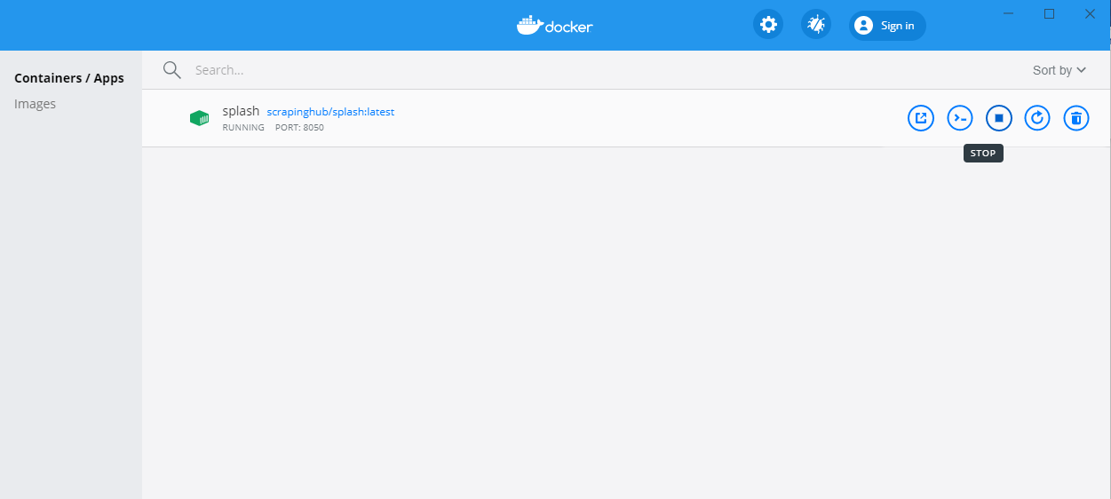

It should be up and running before running the python code. You can cross check this by typing in localhost:8085 in the browser. Below is the screen displayed on browser.

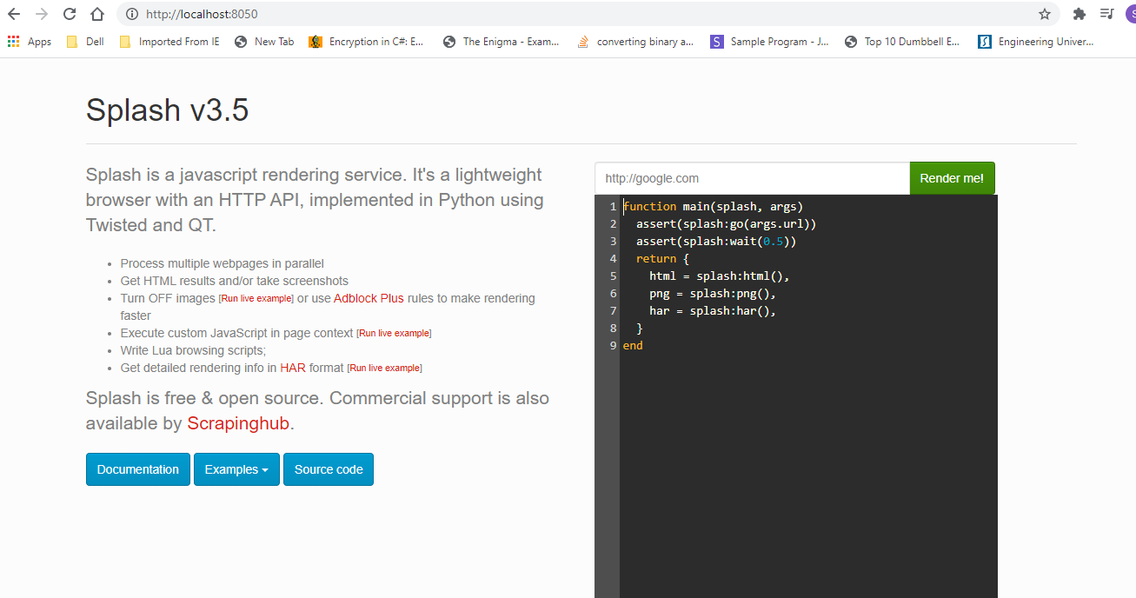

Setup NLTK library in your machine – (https://www.nltk.org/)

Step 1 – Before installing make sure you have installed Python 3.7 or higher

Step 2 – Open command prompt as an admin and run the command – “pip install nltk”

It will install all the required files if there isn’t any in the system.

Step 3 – Next step is to install nltk data.

Open Spyder and under console please write the code –

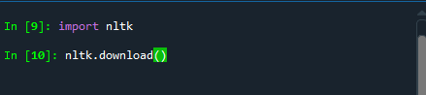

A window will be displayed after few minutes as below –

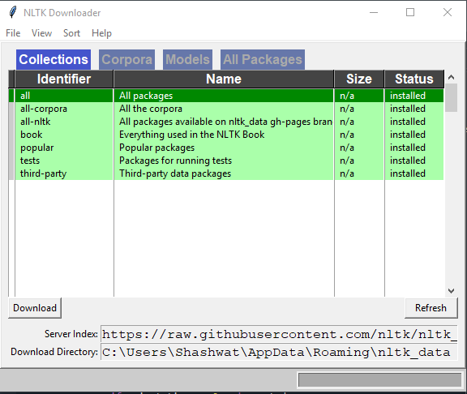

Click on Download button on the left and it will take few minutes to install all the Identifiers displayed in all the tabs.

Step 4 – Once completed close the window.

To Run the project

Step 1 – In Spyder, Under ‘Projects’ – click on “Open Projects” and select the project “Customer Review Summarizer”.

Step 2 – Open “main.py” file and run it.