Voice-Based AI Assistant Using Local API Integration

Anita Saroj
Computer Science & Engineering Department
Graphic Era (Deemed-to-be) University, Dehradun
Dehradun, India
anitasaroj786@gmail.com

Ritendra Negi
Computer Science & Engineering Department
Graphic Era (Deemed-to-be) University, Dehradun
Dehradun, India
retendranegi@gmail.com
Pramod Mehra
Computer Science & Engineering Department
Graphic Era (Deemed-to-be) University, Dehradun
Dehradun, India
pramodmehra11@gmail.com

Siddhant Srivastava
Computer Science & Engineering Department
Graphic Era (Deemed-to-be) University, Dehradun
Dehradun, India
sidhantsrivastav13@gmail.com
Shashwat Malviya
Computer Science & Engineering Department
Graphic Era (Deemed-to-be) University, Dehradun
Dehradun, India
shashwat.malviya123@gmail.com

Yash Rawat
Computer Science & Engineering Department
Graphic Era (Deemed-to-be) University, Dehradun
Dehradun, India
yashrawats005@gmail.com

Abstract—Cloud-based voice assistants raise concerns about privacy, network dependence and factually unsupported answers from large language models (LLMs). This paper presents a locally hosted, modular voice assistant that combines Whisper speech recognition, a rule-based intent classifier, retrieval-augmented generation (RAG) over local text documents, a 3.2-billion-parameter LLM served through Ollama, macOS application automation, and encrypted storage of recorded audio and transcripts behind a FastAPI interface. We evaluate it on a 22-page college-counselling catalogue with 52 questions (40 answerable, 7 unanswerable, 5 ambiguous), three generations per question, and a no-retrieval baseline using the same model and prompt template. Retrieval raised answer-level token F1 from 0.250 to 0.364 (paired difference +0.114, 95% CI [+0.050, +0.180], p < 0.001) and corpus BLEU-4 from 4.48 to 8.14; reading-based checks found 21 of 120 RAG generations fully correct against 1 of 120 without retrieval. Retrieval coverage was the main limitation: the annotated evidence was among the top three chunks for 52.5% of questions and reached the model after the similarity filter for 35%, and RAG did not improve abstention on unanswerable questions. The keyword intent classifier reached a macro-F1 of 1.000 on straightforward inputs but 0.125 on paraphrases, keyword traps and negations. The median end-to-end latency on an Apple M4 laptop was 4.0 s. The findings are specific to one document, and the evaluation annotations were drafted with AI assistance, with only a sample reviewed by an author.
Keywords—Voice Assistant, Speech Recognition, Retrieval-Augmented Generation, Local API, FastAPI, Large Language Models, Intent Classification, Trustworthy AI

Introduction
Voice-based assistants let people use computers through natural speech, and early products such as Apple’s Siri (2011) and Amazon Echo (2014) set expectations of constant availability, low latency and natural-language access to services [1], [2]. Commercial assistants, however, send raw or partially processed speech to remote servers for recognition and inference [3]. Users lose direct control over their audio, documented cases of retained and human-reviewed recordings have raised questions of informed consent [4], and network-dependent systems stop working offline. The LLMs behind modern assistants also produce fluent but factually unsupported answers [5], because standard inference does not consult the user’s documents [6], and closed ecosystems prevent developers from replacing components or adding knowledge sources.
This paper describes a locally hosted, modular voice assistant. Speech is transcribed on the host with OpenAI Whisper [7]; a rule-based intent classifier routes each transcript either to an operating-system (OS) automation module or to a retrieval-augmented generation (RAG) pipeline that retrieves passages from a local vector index and passes them to a locally served LLM [8]; recorded audio and transcripts are encrypted at rest; and the modules are exposed through a FastAPI REST interface [9]. Quantised LLMs that run on consumer hardware [10], [11] and efficient vector search [12] make such a design practical.
The contributions are: (i) a description of the implemented architecture with its actual components and limitations; (ii) a reproducible evaluation of answer quality with and without retrieval, retrieval coverage, intent classification, automation safety and latency, combining lexical metrics with reading-based correctness checks; and (iii) a trustworthy-AI analysis that separates implemented safeguards from proposed ones. Section II reviews related work, Section III describes the implementation, Sections IV and V present the evaluation, Section VI discusses trustworthy AI, and Sections VII and VIII give limitations and conclusions.

Literature Review

Voice Assistants and Speech Recognition
Early automatic speech recognition (ASR) combined hidden Markov models with Gaussian mixture models [13], and offline recognisers such as CMU Sphinx handled only limited vocabularies [14]. Whisper, a transformer-based ASR system trained on 680,000 hours of weakly supervised multilingual audio, is robust across acoustic conditions without fine-tuning, and its open weights make accurate recognition feasible on local hardware [7]. Commercial assistants instead keep a thin client on the device and send audio to the cloud [3], which excludes offline use and creates a privacy surface that has been exploited in documented incidents [4].

Language Models and Retrieval-Augmented Generation
The transformer replaced recurrence with self-attention [15]; BERT showed the value of bidirectional pre-training [16], GPT-style models extended the architecture to fluent long-form generation [17], and scaling laws related performance to model size and compute [18]. Post-training quantisation such as GPTQ [19] made multi-billion-parameter models usable on commodity hardware. Because such models answer from parameters fixed at training time, RAG retrieves passages from a document index and conditions generation on them [20]. Surveys classify RAG systems as naive, advanced or modular and identify retrieval accuracy and context integration as recurring problems [8], [21]. Dense sentence-transformer retrievers outperform sparse methods on semantically difficult queries [22], and FAISS provides efficient nearest-neighbour search [12].

Authentication and Secure Data Processing
Speaker-verification systems based on deep embeddings report equal error rates below 1% on standard benchmarks [23], but voice biometrics degrade with noise and are exposed to replay and cloning attacks. AES remains the most widely used symmetric cipher for data at rest [24]; authenticated encryption adds integrity protection, but a key stored next to the data it protects offers little protection if the host is compromised. Stored data and trained models can also leak information about individuals, as membership-inference attacks show [25], which argues for minimising retained data.

Research Gap
In the literature reviewed, we did not identify an open-source system that combines local ASR, retrieval-grounded LLM answers, OS automation and encrypted storage of interaction data behind one local REST interface together with a quantitative evaluation of answer quality. Commercial assistants rely on cloud processing, RAG research focuses largely on server-scale deployments, and local frameworks such as Home Assistant and Open Assistant provide only part of this functionality. This work contributes such an implementation and an evaluation that reports its limitations explicitly.

System Design and Implementation

Architecture and Speech Processing
The backend is written in Python 3.13; a React web interface records audio with the browser’s MediaRecorder interface and uploads it to the /assistant/run endpoint (Fig. 1). The backend stores a Fernet-encrypted copy of the upload, writes it to a temporary file, transcribes it with the openai-whisper implementation of the Whisper base model on the CPU (half precision disabled, default decoding), deletes the temporary file, encrypts and stores the transcript, and classifies the transcript as a command or a query. No voice-activity detection or signal pre-processing is applied. Commands go to the automation module and queries to the RAG pipeline; the reply is synthesised to speech and returned with the transcript, the detected intent and the retrieved sources. Each module also has its own endpoint (/stt/transcribe, /llm/generate, /rag_query, /execute/run, /tts/speak).
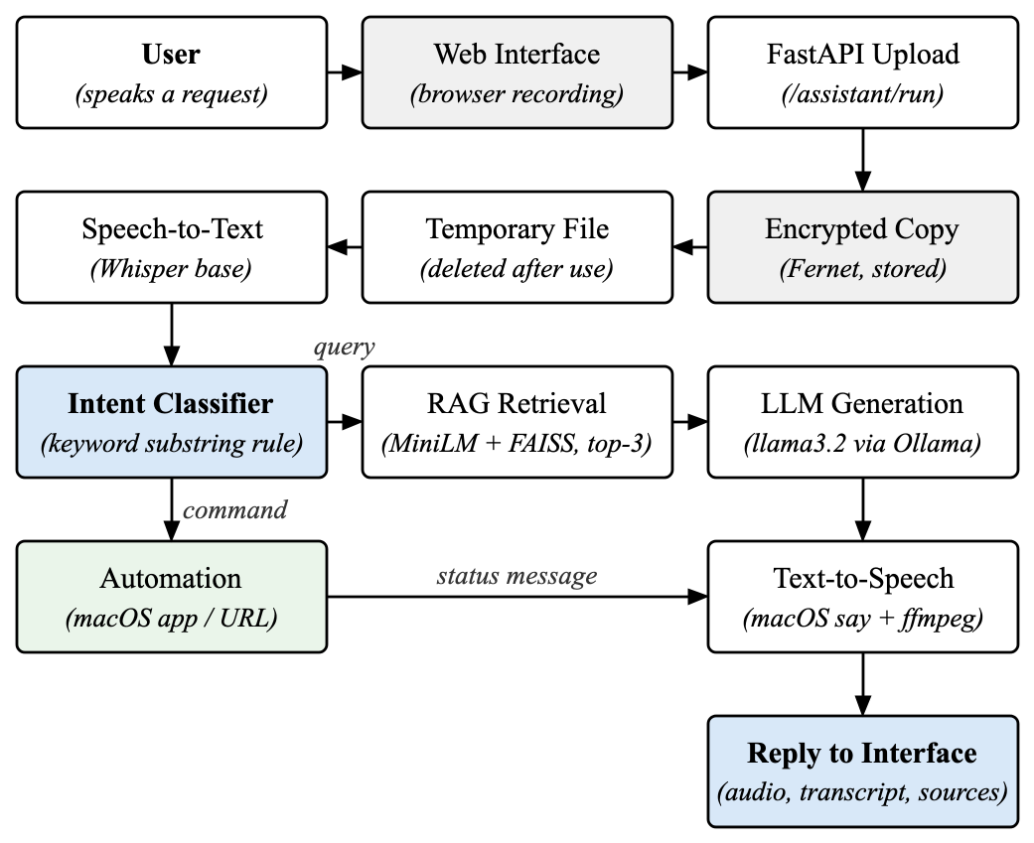
- Implemented processing pipeline, from browser recording to the spoken reply.

Intent Classification
The classifier lower-cases the transcript and labels it a command if any of the substrings “open”, “launch”, “start”, “play” or “close” occurs anywhere in it; otherwise it is a query. There is no confidence threshold and no separate class for retrieval and general queries. The rule is fast and transparent, but because it matches substrings it sends questions such as “which college is closest to Delhi” to the automation module and treats negated commands such as “don’t open Chrome” as commands (Section V-D).

Retrieval-Augmented Generation
The loader reads plain-text (.txt) files from a local knowledge directory; PDF, DOCX and Markdown files are not read natively. Text is whitespace-normalised and split into 500-character windows with a 100-character overlap, embedded with the all-MiniLM-L6-v2 sentence-transformer [22] into 384-dimensional unit vectors, and stored in an exact FAISS IndexFlatL2 index [12] built in memory (Fig. 2). At query time the three nearest chunks are retrieved and a chunk is kept only if its squared L2 distance is below 1.0, i.e., cosine similarity above 0.5. Kept chunks are inserted into a prompt that tells the model to use the context only if relevant and otherwise to answer from its own knowledge; if no chunk passes, the question is sent without context, and the user is not told which path produced the answer.

Generation, Speech Synthesis and Automation
Answers are generated by llama3.2 (3.2 billion parameters, Q4_K_M quantisation) served locally by Ollama 0.19.0, with a fixed system prompt requesting concise plain text. No sampling options are sent, so the runtime defaults apply and generation is not seeded. Replies are synthesised with the macOS say command and converted with ffmpeg to WAV. The automation module runs only on macOS: it opens applications with open -a using 25 aliases or, for phrases of the form “open/launch/start X”, the title-cased name X, and opens http(s) URLs in the default browser. Closing applications, volume, file and power control are not implemented, and no confirmation is requested before acting.
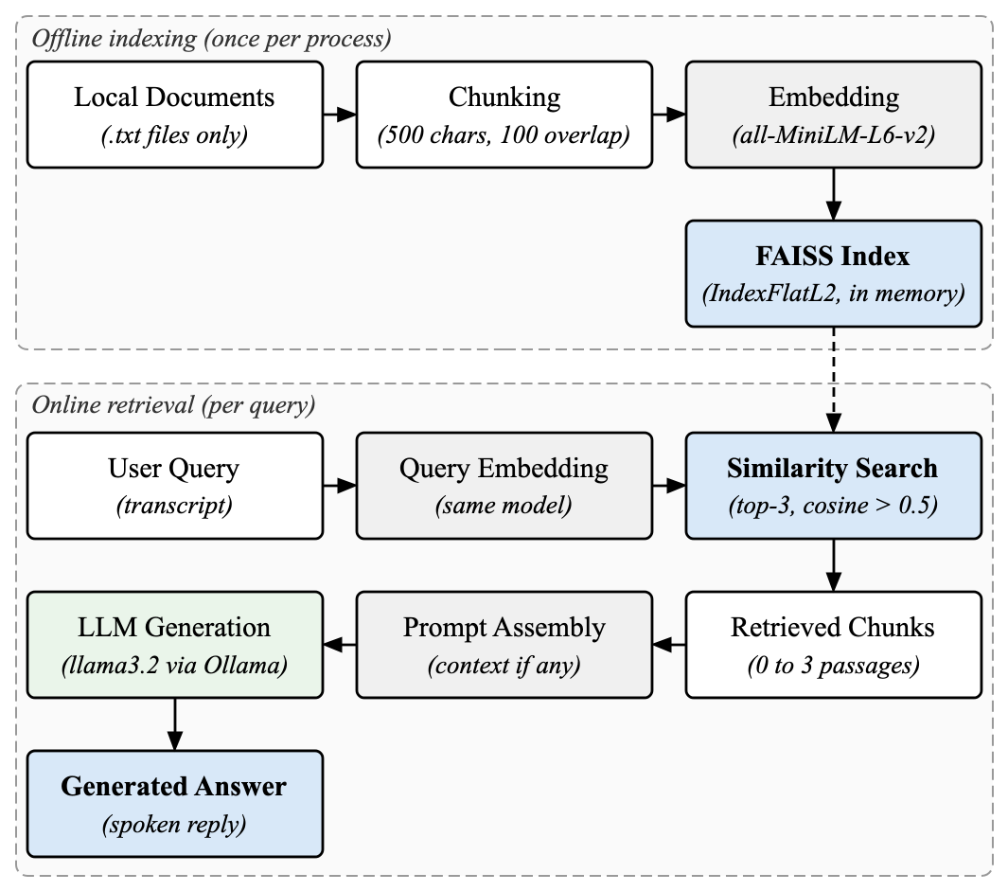
- RAG pipeline as implemented: offline chunking and FAISS indexing of local text files, and online top-3 retrieval with a similarity filter before prompt assembly.

Data Protection and API Access
Uploaded audio and transcripts are encrypted with Fernet (AES-128-CBC with an HMAC-SHA256 tag) before being written to disk. The key is read from an environment variable stored in a local configuration file, without passphrase-based derivation. The plaintext upload exists briefly as a temporary file, and synthesised reply audio is stored unencrypted. The supplied start-up script binds the API to all network interfaces without authentication; cross-origin requests are limited to the local web interface. A face-authentication module exists only as a stub that accepts every request and is not called by the pipeline.

Evaluation Methodology

Dataset and Scope
The knowledge source is one 22-page PDF catalogue of 22 engineering institutions prepared for college counselling. Because the application reads only text, the PDF was converted to text outside the application with Apple PDFKit and indexed, with the application’s existing knowledge file, by the unmodified retrieval code (123 chunks, 114 from the catalogue). The test set contains 52 questions drafted from the rendered pages with generative-AI assistance (see Acknowledgment): 40 answerable (13 numeric, 9 factual, 7 cross-page comparisons, 4 dates, 3 relationships, 3 multi-passage, 1 definition), 7 unanswerable and 5 ambiguous. Each question has a paraphrased reference answer, required key facts, and page-level evidence quotes. All annotations were drafted by a single AI annotator before any system output was generated. Afterwards an author reviewed the annotations of 24 questions and corrected 14 (key facts and evidence), and one reference answer was amended to state the full-programme scope printed in the catalogue; the remaining annotations were not human-verified. Results therefore describe performance on this catalogue only.

Configurations and Answer-Quality Metrics
Configuration A (RAG) is the full pipeline. Configuration B (no-RAG) uses the same model, system prompt and prompt template with retrieval disabled. Configuration C replaces the PDFKit text with pypdf extraction. Each configuration answered every question three times with default settings; no reference or evidence text appeared in any prompt.
Answer-level token F1 follows SQuAD [26]: answer g and reference r are normalised (NFKC, lower-casing, digit-group commas removed, dashes and slashes to spaces, punctuation and symbols deleted, articles removed) and tokenised on whitespace. With c the size of their multiset intersection,
P = c / |g|, R = c / |r|, F1 = 2PR / (P + R). (1)
F1 is averaged over the 40 answerable questions per run and then over runs. Corpus BLEU-4 [27] is computed with SacreBLEU 2.4.3 [28] (nrefs:1|case:mixed|eff:no|tok:13a|smooth:exp): 13a tokenisation, uniform 1–4-gram weights, exponential smoothing and brevity penalty, with counts pooled over the 40 questions of a run and the three run scores averaged. Both metrics measure lexical overlap with one reference and do not establish factual correctness. Key-fact recall is the share of required facts found in the answer by phrase matching; for 12 questions whose facts are relations (a figure bound to tuition or placements, a grade to an institution, a fee to its scope), rules require the value to be bound to its subject (in the same clause, or in a list naming it) and reject negated, hedged or per-year statements. These rules were refined after outputs were inspected. Because such rules can still credit a correct figure inside a wrong statement, every generation credited with all key facts was also read against the PDF and counted as fully correct only if it stated the requested facts without a contradiction; this count is a separate, lower-bound assessment. Responses to unanswerable and ambiguous questions were read and labelled as abstentions, clarifications or unsupported answers.

Retrieval, Intent and Automation Metrics
A chunk is relevant if it contains an annotated evidence quote from the cited page. Precision@k is the number of relevant chunks in the top k divided by k, Recall@k the fraction of a question’s evidence groups covered, and Hit@k whether any relevant chunk was retrieved. For intent classification, 120 utterances (60 commands, 60 queries) were labelled; negated or cancelled commands count as queries. The straightforward subset (n = 65) contains canonical and polite commands and plain questions; the challenging subset (n = 55) contains keyword-free commands, questions containing keyword substrings, negations and mixed requests. We report macro-F1 (unweighted mean of the two class F1 scores, scikit-learn 1.8.0), which is unrelated to answer-level token F1. Forty automation commands with expected actions were run through the classifier and automator with process launching intercepted, and six launches of built-in applications were verified live; no destructive command was executed.

Statistical Analysis and Latency
The unit of analysis is the question: the three generations are averaged per question, and configurations are compared on 40 paired values, so repeated generations are not treated as independent samples. We report mean paired differences with percentile bootstrap 95% confidence intervals (10,000 question resamples; 1,000 for BLEU with corpus BLEU recomputed per resample) and two-sided Wilcoxon signed-rank tests (SciPy 1.17.1, zero differences excluded), and a sign test for the fully-correct counts. Latency was measured with time.perf_counter on an Apple M4 laptop (16 GB RAM, macOS 26.6.2) after two warm-up calls: 20 calls per component and 10 end-to-end requests with synthesised spoken questions, excluding recording and playback.

Results and Discussion

Answer Quality With and Without Retrieval
Retrieval improved every measure (Table I). Token F1 rose from 0.250 to 0.364 (+0.114, 95% CI [+0.050, +0.180], Wilcoxon p = 0.0006; higher on 30 of 40 questions), corpus BLEU-4 from 4.48 to 8.14 (+3.66, 95% CI [+1.46, +6.28]) and key-fact recall from 0.054 to 0.297 (+0.243, 95% CI [+0.133, +0.358]). Key-fact recall uses scoring rules that were refined after the outputs were inspected and is not human-validated (Section IV-B).
- Answer Quality on 40 Answerable Questions (3 Runs Each)
Configuration | Token F1 | BLEU-4 | Key-fact recall | Fully correct
A. RAG | 0.364 ± 0.005 | 8.14 ± 0.64 | 0.297 | 21/120
B. No-RAG | 0.250 ± 0.015 | 4.48 ± 0.38 | 0.054 | 1/120
C. RAG, pypdf | 0.306 ± 0.006 | 6.13 ± 1.33 | 0.155 | 11/120
A: proposed system; B: same model and template without retrieval; C: A with pypdf text extraction. ± is the sample SD (n − 1) of the three run-level values, computed before rounding. Fully correct: judged by reading against the PDF (lower bound; A and B judgements confirmed by an author, C not human-verified). Key-fact recall uses rules refined after outputs were inspected (Section IV-B); it is not human-validated.
Reading-based review found 21 of 120 RAG generations fully correct against 1 of the 120 baseline generations (better on 8 questions, worse on none; sign test p = 0.008); an author confirmed these judgements. The scoring rules credited 24 RAG generations with all key facts, but three attached a correct year to a fee or echoed the question while denying the fact. Absolute quality therefore remains limited. With pypdf extraction every RAG measure fell (token F1 0.306, BLEU-4 6.13, 11 of 120 fully correct) because pypdf dropped headline fee and placement figures and range dashes, so the external extraction step affects the results.

Unanswerable and Ambiguous Questions
Retrieval did not improve abstention. Of 21 responses to unanswerable questions, RAG abstained in 15 and stated unsupported facts in 6, against 16 and 5 for the baseline; RAG typically reused a nearby catalogue figure in the wrong role, such as reporting a placement range as the “highest package”. On ambiguous questions RAG gave wrong or non-catalogue facts in 2 of 15 responses and the baseline in 6 of 15. These small counts were not tested for significance; retrieval did not prevent unsupported answers.

Retrieval Coverage
Retrieval coverage limits answer quality (Table II). At least one relevant chunk was among the top three for 52.5% of answerable questions (Recall@3 = 0.500) and among the top ten for 72.5%. The similarity filter passed 1.80 chunks per question on average; relevant evidence reached the model for only 35% of questions, and for 27.5% no chunk passed and the model answered without context. In a post-hoc breakdown, generations contained all key facts in 52% of cases when relevant evidence reached the model and in 3% otherwise. The catalogue repeats one page template, and 500-character windows often separate an institution’s name from its figures. Retrieval took a median of 11 ms.
- Retrieval Coverage (40 Answerable Questions)
Ranking | P@k | R@k | Hit@k
Top-1 | 0.275 | 0.258 | 0.275
Top-3 | 0.192 | 0.500 | 0.525
Top-5 | 0.150 | 0.571 | 0.600
Top-10 | 0.095 | 0.679 | 0.725
Top-3 + filter (deployed) | 0.133 | 0.325 | 0.350
P@k uses denominator k. The deployed filter keeps chunks with cosine similarity above 0.5.
In an exploratory run with the similarity filter disabled and all other settings unchanged, the share of prompts containing relevant evidence rose from 35% to 52.5%, and token F1 (0.364 to 0.404), key-fact recall (0.297 to 0.392) and fully correct generations (21 to 33 of 120) moved in the same direction, but the token-F1 interval included zero, the key-fact differences were borderline (Wilcoxon p = 0.078 and 0.055), and fully correct answers improved on 7 questions and worsened on 3 (sign test p = 0.34). The filter was chosen after inspecting these questions, so this is hypothesis-generating, not a validated improvement.

Intent Classification and Automation
The keyword rule was perfect on straightforward inputs (macro-F1 1.000, n = 65) but failed on challenging ones (macro-F1 0.125, accuracy 0.127, n = 55; Table III): it missed all 20 keyword-free commands (e.g., “bring up Safari”), sent 23 of 25 keyword-trap questions (e.g., “when was the programme launched”) to automation, and treated all 5 negated commands as commands. The overall macro-F1 of 0.598 (n = 120) depends on the share of challenging items. In the automation dry run, 27 of 31 commands that should execute resolved correctly; of nine that must not execute, four would have launched an application: “please close Safari” opens Safari, “don’t open Chrome” opens Chrome, “please do not launch Spotify” opens Spotify, and “open the pod bay doors” attempts to open a non-existent application. All six live launches were verified.
- Intent Classification (Rule-Based Keyword Classifier)
Subset | n | Macro-F1 | Accuracy
Straightforward | 65 | 1.000 | 1.000
Challenging | 55 | 0.125 | 0.127
All utterances | 120 | 0.598 | 0.600
Challenging subset, correct/total: keyword-free commands 0/20, keyword-trap questions 2/25, negations 0/5, mixed requests 5/5.

Latency
The median end-to-end time from upload of a spoken question to the synthesised reply was 4.0 s (mean 4.5 s, n = 10), dominated by LLM generation and speech synthesis (medians 2.6 s each; Table IV). Loading the embedding model and Whisper and building the index took about 4 s once per process; LLM loading after inactivity takes longer and was not measured systematically. Speech-recognition accuracy on real users’ speech was not evaluated, because no recordings with reference transcripts were available; the end-to-end test used synthesised speech and is reported for timing only.
- Latency on an Apple M4 Laptop (Warm, Seconds)
Component | n | Median | Mean | p95
Retrieval + prompt | 20 | 0.011 | 0.015 | 0.032
LLM generation | 20 | 2.61 | 2.39 | 3.73
Speech synthesis | 20 | 2.63 | 2.65 | 3.97
Whisper base (short clips) | 20 | 0.51 | 0.52 | 0.62
End-to-end /assistant/run | 10 | 4.04 | 4.48 | 6.96
Excludes recording, playback and one-off model loading. Intent classification: 0.25 µs per call.

Trustworthy AI Considerations
Trustworthy-AI frameworks treat privacy, accountability, transparency and safety as requirements alongside accuracy; for a recent overview of trends in the field, see [29]. We separate what the system implements from what is proposed.
Privacy-preserving computation. Recognition, embedding, retrieval and generation run on the host, and no cloud service is called to answer a question. The system has not been audited with network monitoring, model files are downloaded on first use, and URL commands open external sites; an offline mode and egress tests are proposed. Data confidentiality and key management. Audio and transcripts are encrypted at rest, but the key sits in a configuration file next to the data, the upload briefly exists as a plaintext file, reply audio is unencrypted and there is no retention policy, although retained data is itself a privacy risk [25]. We propose keys held in the operating-system keychain or derived from a passphrase, in-memory transcription, encrypted or deleted reply audio, and retention limits.
Authentication and access control. None is enforced: with the supplied script the API listens on all interfaces without authentication, and face authentication is a stub, so any host that reaches the port can query the documents or trigger launches. We propose loopback binding by default, a per-session token and user authentication before any command. Accountability and transparency. Responses return the transcript, intent and retrieved sources, and the evaluation retains every prompt, output and score for audit; however, answers produced without context are not marked and commands are not logged, so we propose grounded or ungrounded labels, visible sources and a command log. Safe automation. Section V shows that a substring rule executes negated commands and maps “close” to “open”; an allow-list, negation detection, confirmation before every action and refusal of low-confidence transcripts are needed. Reliable evaluation. The key-fact rules credited 24 RAG generations, of which 21 were fully correct on reading, and fact-level scores cannot detect an added false claim, so lexical metrics should be reported alongside correctness, abstention and retrieval coverage.

Limitations and Future Work
The evaluation uses one catalogue, 52 questions and one hardware platform, so it does not establish performance on other documents, domains or languages. Annotations and judgements were drafted by a single AI annotator; an author reviewed 53 sampled items and two later judgements, but the intent and abstention labels, most annotations and the pypdf and ablation judgements were not human-verified, and no agreement was measured. The relational scoring rules were refined after outputs were seen, and fully correct counts are lower bounds because uncredited answers were not re-read. Generation was unseeded, and three runs only roughly estimate variability. The PDF was converted to text outside the application, and the extractor changed the results. ASR accuracy on real speech and privacy under network monitoring were not evaluated. Future work will add native document ingestion, retrieval improvements evaluated on a held-out question set, a semantic intent classifier with negation handling, the safeguards of Section VI, and a real-speech ASR study reporting word error rate.

Conclusion
We presented a locally hosted voice assistant that combines Whisper ASR, keyword-based intent routing, RAG over local text, a 3.2-billion-parameter local LLM, macOS automation and encrypted storage behind a FastAPI interface, and evaluated it on a college-counselling catalogue. Retrieval improved answer-level token F1 from 0.250 to 0.364, corpus BLEU-4 from 4.48 to 8.14 and fully correct answers from 1 to 21 of 120 generations, but most answers remained incomplete or incorrect, mainly because relevant evidence reached the model for only 35% of questions, and retrieval did not improve abstention. The intent classifier and automation module handle clearly phrased commands but fail on paraphrases and negations. The median end-to-end latency was 4.0 s on a laptop. A fully local assistant is practical, and the results identify retrieval coverage, intent understanding and access control as the main areas to improve before deployment.

Acknowledgment
Generative AI (Claude, Anthropic) was used in this work beyond language editing. It drafted the 52 evaluation questions, reference answers, key-fact and evidence annotations and the 120 intent labels (Section IV), made the reading-based correctness and abstention judgements reported in Section V, wrote and ran the evaluation and metric-verification scripts whose outputs appear in Tables I–IV, drafted the key-fact scoring rules, redrew Figs. 1 and 2, and drafted revisions of the manuscript text. An author reviewed 53 sampled items (all 29 correctness judgements for configurations A and B, all confirmed, and the annotations of 24 questions, 14 corrected) and judged the two answers newly credited by the revised scoring; the other annotations and judgements were not verified by a human. The authors are responsible for the content of this paper.

References
- Apple Inc., “Siri: Intelligent Assistant,” Apple Developer Documentation, 2011.
- Amazon, “Amazon Echo: Technical Overview,” Amazon Developer Documentation, 2014.
- B. Kepuska and G. Bohouta, “Next-generation of virtual personal assistants (Microsoft Cortana, Apple Siri, Amazon Alexa and Google Home),” in Proc. IEEE 8th Annual Computing and Communication Workshop and Conference, 2018, pp. 99–103.
- C. Metz and N. Wingfield, “Amazon Employees Are Listening to Alexa Conversations,” The New York Times, 2019.
- J. Maynez, S. Narayan, B. Bohnet, and R. McDonald, “On Faithfulness and Factuality in Abstractive Summarization,” in Proc. 58th Annual Meeting of the Association for Computational Linguistics, 2020, pp. 1906–1919.
- Z. Ji, N. Lee, R. Frieske, T. Yu, D. Su, Y. Xu, E. Ishii, Y. J. Bang, A. Madotto, and P. Fung, “Survey of Hallucination in Natural Language Generation,” ACM Computing Surveys, vol. 55, no. 12, pp. 1–38, 2023.
- A. Radford, J. W. Kim, T. Xu, G. Brockman, C. McLeavey, and I. Sutskever, “Robust Speech Recognition via Large-Scale Weak Supervision,” in Proc. International Conference on Machine Learning, 2023, pp. 28492–28518.
- Y. Gao, Y. Xiong, X. Gao, K. Jia, J. Pan, Y. Bi, Y. Dai, J. Sun, Q. Guo, M. Wang, and H. Wang, “Retrieval-Augmented Generation for Large Language Models: A Survey,” arXiv preprint arXiv:2312.10997, 2023.
- S. Ramirez, “FastAPI,” Documentation and Source Code, 2018. [Online]. Available: https://fastapi.tiangolo.com
- T. Dettmers, M. Lewis, Y. Belkada, and L. Zettlemoyer, “LLM.int8(): 8-bit Matrix Multiplication for Transformers at Scale,” in Advances in Neural Information Processing Systems, vol. 35, 2022.
- T. Dettmers, A. Pagnoni, A. Holtzman, and L. Zettlemoyer, “QLoRA: Efficient Finetuning of Quantized LLMs,” in Advances in Neural Information Processing Systems, vol. 36, 2023.
- J. Johnson, M. Douze, and H. Jégou, “Billion-Scale Similarity Search with GPUs,” IEEE Transactions on Big Data, vol. 7, no. 3, pp. 535–547, 2021.
- L. Rabiner and B. Juang, “An introduction to hidden Markov models,” IEEE ASSP Magazine, vol. 3, no. 1, pp. 4–16, 1986.
- D. Huggins-Daines, M. Kumar, A. Chan, A. W. Black, M. Ravishankar, and A. I. Rudnicky, “Pocketsphinx: A free, real-time continuous speech recognition system for hand-held devices,” in Proc. IEEE International Conference on Acoustics, Speech and Signal Processing, vol. 1, 2006.
- A. Vaswani, N. Shazeer, N. Parmar, J. Uszkoreit, L. Jones, A. N. Gomez, L. Kaiser, and I. Polosukhin, “Attention Is All You Need,” in Advances in Neural Information Processing Systems, vol. 30, 2017.
- J. Devlin, M. W. Chang, K. Lee, and K. Toutanova, “BERT: Pre-training of Deep Bidirectional Transformers for Language Understanding,” in Proc. NAACL-HLT, 2019, pp. 4171–4186.
- T. Brown et al., “Language Models are Few-Shot Learners,” in Advances in Neural Information Processing Systems, vol. 33, 2020.
- J. Kaplan, S. McCandlish, T. Henighan, T. B. Brown, B. Chess, R. Child, S. Gray, A. Radford, J. Wu, and D. Amodei, “Scaling Laws for Neural Language Models,” arXiv preprint arXiv:2001.08361, 2020.
- G. Frantar, S. Ashkboos, T. Hoefler, and D. Alistarh, “GPTQ: Accurate Post-Training Quantization for Generative Pre-trained Transformers,” arXiv preprint arXiv:2210.17323, 2022.
- P. Lewis, E. Perez, A. Piktus, F. Petroni, V. Karpukhin, N. Goyal, H. Küttler, M. Lewis, W. T. Yih, T. Rocktäschel, S. Riedel, and D. Kiela, “Retrieval-Augmented Generation for Knowledge-Intensive NLP Tasks,” in Advances in Neural Information Processing Systems, vol. 33, 2020.
- Y. Gao, Y. Xiong, X. Gao, K. Jia, J. Pan, Y. Bi, Y. Dai, J. Sun, and H. Wang, “Modular RAG: Transforming RAG Systems into LEGO-like Reconfigurable Frameworks,” arXiv preprint arXiv:2407.21059, 2024.
- N. Reimers and I. Gurevych, “Sentence-BERT: Sentence Embeddings using Siamese BERT-Networks,” in Proc. EMNLP-IJCNLP, 2019, pp. 3982–3992.
- D. Snyder, D. Garcia-Romero, G. Sell, D. Povey, and S. Khudanpur, “X-Vectors: Robust DNN Embeddings for Speaker Recognition,” in Proc. IEEE International Conference on Acoustics, Speech and Signal Processing, 2018, pp. 5329–5333.
- National Institute of Standards and Technology, “Announcing the Advanced Encryption Standard (AES),” Federal Information Processing Standards Publication 197, 2001.
- R. Shokri, M. Stronati, C. Song, and V. Shmatikov, “Membership Inference Attacks Against Machine Learning Models,” in Proc. IEEE Symposium on Security and Privacy, 2017, pp. 3–18.
- P. Rajpurkar, J. Zhang, K. Lopyrev, and P. Liang, “SQuAD: 100,000+ questions for machine comprehension of text,” in Proc. Conf. Empirical Methods Natural Lang. Process. (EMNLP), 2016, pp. 2383–2392, doi: 10.18653/v1/D16-1264.
- K. Papineni, S. Roukos, T. Ward, and W.-J. Zhu, “BLEU: A method for automatic evaluation of machine translation,” in Proc. 40th Annu. Meeting Assoc. Comput. Linguistics (ACL), 2002, pp. 311–318, doi: 10.3115/1073083.1073135.
- M. Post, “A call for clarity in reporting BLEU scores,” in Proc. 3rd Conf. Machine Translation: Research Papers, 2018, pp. 186–191, doi: 10.18653/v1/W18-6319.
- S. Sudarsan and N. Karra, “The future of trustworthy AI: Trends and predictions,” in Trustworthy AI Systems, V. Gudur, B. Pandey, and A. Patel, Eds. Cham, Switzerland: Springer Nature, 2026, pp. 247–261, doi: 10.1007/978-3-032-15606-8_15.

