Please follow all the steps and version.

lets start from fresh and please share ss of every steps .

1. download and install java8

Link: https://www.oracle.com/technetwork/java/javase/downloads/jdk8-downloads-2133151.html (this is working fine)

For windows:

Windows x64 211.54 MB

jdk-8u251-windows-x64.exe

Follow the below video to install java

https://www.youtube.com/watch?v=ClcHrcNXP9g

Note: Please skip Step 1 if java 8 is already installed on your windows machine.

please check version as

java -version

2. Download spark 2.4.4 from below link:

http://archive.apache.org/dist/spark/spark-2.4.4/spark-2.4.4-bin-hadoop2.7.tgz

please copy and paste the link in another tab , downloading will automatically started.

3.The above Spark bundle in in tgz compressed format. We need to decompress it. For that download a software using below link:

https://www.rarlab.com/rar/winrar-x64-561.exe

and then install it by clicking the executable.

Note: No need to download the above software if you are able to decompress it or you already have WinRAR with you.

and then extract the spark folder by right clicking and extract

and add your spark in your system variable and path in environment variable as SPARK_HOME as per ss

4. Download scala ide

Try the Mac link

Scala IDE for Windows

https://drive.google.com/file/d/1FeLtk83tX5EHkMpNKISMpbnwN_t_2NlX/view?usp=sharing

Scala IDE for Mac

https://drive.google.com/file/d/1O-YBrpjNx0mpqxzyd2CRlfFECYcOlgJl/view?usp=sharing

extract this and open the eclipse.exe.

and add your scala in your system variable and path in environment variable as SCALA_HOME as per ss  
  
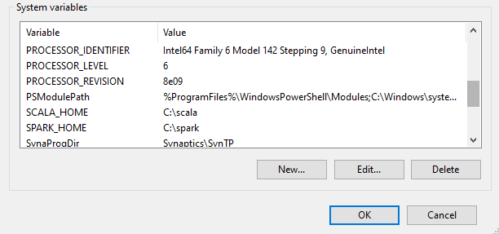

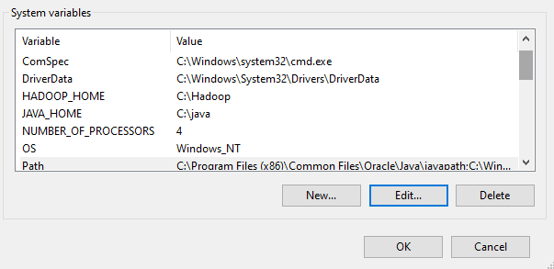

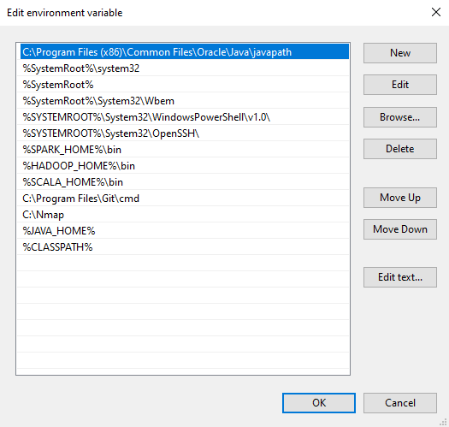

Note: if java version is compatible then eclipse will open without any issues.