Chatbot Project Report

**NAME: KRITHIKA R**

**REGISTRATION NUMBER:**

|  |  |
| --- | --- |
| 1 | Introduction |
| 2 | Objective |
| 3 | Features |
| 4 | Technologies Used |
| 5 | Implementation |
| 6 | Challenges |
| 7 | Proof of Work |
| 8 | Future Enhancements |
| 9 | Conclusion |

**1. Introduction**

The chatbot project aims to create a conversational AI that can interact with users in natural language. The chatbot, named Robo, is designed to respond to predefined questions, provide casual interactions, and assist users in various topics. Built using Flask for the web framework, NLTK for natural language processing, and scikit-learn for machine learning-based similarity detection, the chatbot can analyze and respond intelligently based on the user’s input.

**2. Objective**

The primary objective of the chatbot is to simulate human-like conversations and provide informative, fun, and relevant responses. The bot can answer questions in categories like:  
- General greetings and responses  
- Educational and scientific queries  
- Math problem-solving  
- Fun and casual interactions

**3. Features**

Key Features of the Chatbot:  
1. Greeting Detection: The chatbot can recognize and respond to common greetings like "Hello", "Hi", "What's up", etc.  
2. Predefined Responses: It can answer frequently asked questions, such as "What is AI?", "What is data science?", and "Who is Einstein?".  
3. Cosine Similarity-based Responses: For user inputs that are not predefined, the chatbot uses TF-IDF vectorization and cosine similarity to identify the most relevant response from its knowledge base.  
4. Mathematical Queries: The chatbot can solve simple arithmetic problems like "What is 5 plus 2?".  
5. Casual Interactions: It can respond to casual queries, such as "What's your favorite food?" or "Tell me a joke".  
6. Machine Learning Integration: The chatbot utilizes scikit-learn's TF-IDF vectorizer and cosine similarity to determine the relevance of a user’s query to the stored responses.

**4. Technologies Used**

- Flask: A web framework for creating and serving the chatbot application.  
- NLTK: Natural Language Toolkit for text processing tasks like tokenization, lemmatization, and stopword removal.  
- scikit-learn: For machine learning models such as TF-IDF vectorization and cosine similarity calculation.  
- HTML/CSS: For creating the web interface and user interaction.  
- Gunicorn: For running the application in production mode.  
- Python 3.x: The programming language used for the backend development of the chatbot.

**5. Implementation**

The chatbot was developed in several stages:  
  
1. Data Preparation:   
 - A knowledge base was created by compiling various questions and responses (in a file called chatbot.txt).  
 - The data was preprocessed using NLTK functions like tokenization, lemmatization, and punctuation removal.  
  
2. Natural Language Processing:   
 - The TF-IDF vectorizer was used to convert the text data into numerical format for comparison.  
 - Cosine similarity was applied to compare the similarity between the user input and the predefined responses.  
  
3. Web Integration:   
 - The Flask web framework was used to create routes that accept user input and return the bot's response.  
 - The user interface was designed using simple HTML and CSS to allow easy interaction with the chatbot.  
  
4. Deployment:   
 - The chatbot was deployed using Gunicorn, which serves the Flask application for production in Render

**6. Challenges**  
During the development of the chatbot, several challenges were encountered:  
1. Data Quality: The quality of predefined responses significantly affects the bot’s ability to provide meaningful answers. Ensuring that the responses cover a broad range of topics was a challenge.  
2. Cosine Similarity Limitation: The cosine similarity approach, while effective for basic responses, struggles with more complex or ambiguous queries.  
3. Handling Ambiguity: Sometimes, the bot may provide irrelevant or repetitive responses due to the limitations in the dataset or similarity calculation methods.  
4. Performance at Scale: Handling multiple simultaneous users can be challenging without further optimization in performance.

**7. Proof of Work**

WEBSITE URL: <https://chatbot-1-znyi.onrender.com/>

GITHUB REPOSITORY LINK: <https://github.com/R-Krithika21/Chatbot>

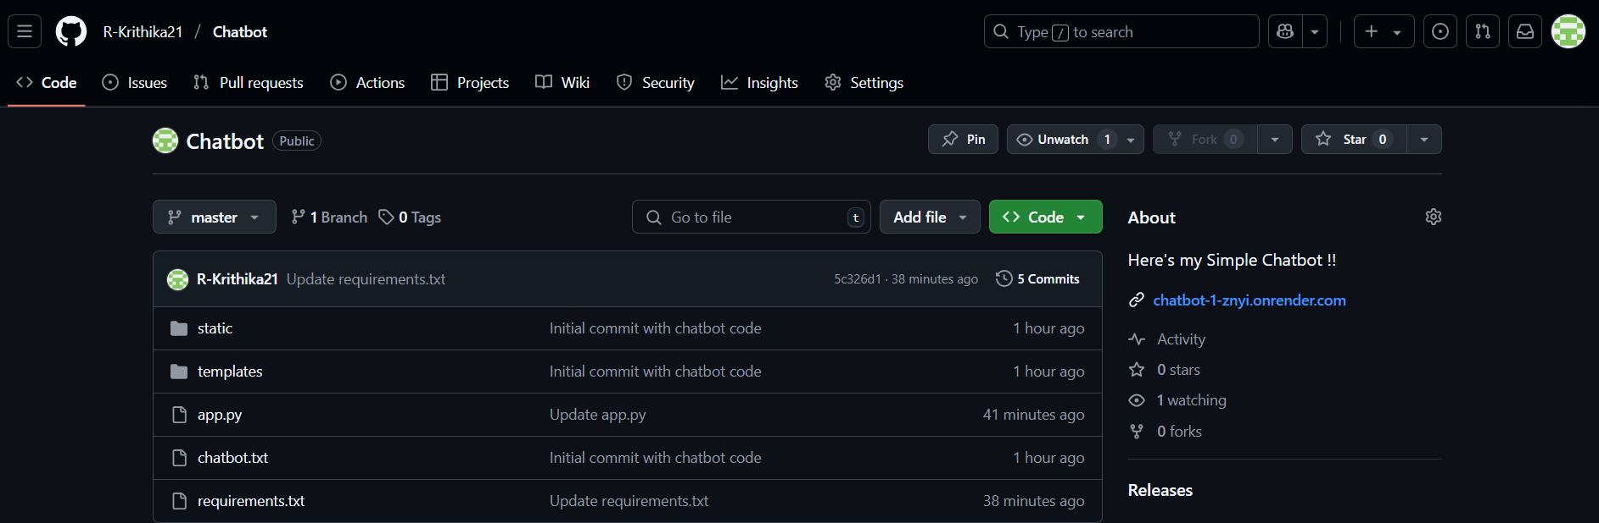

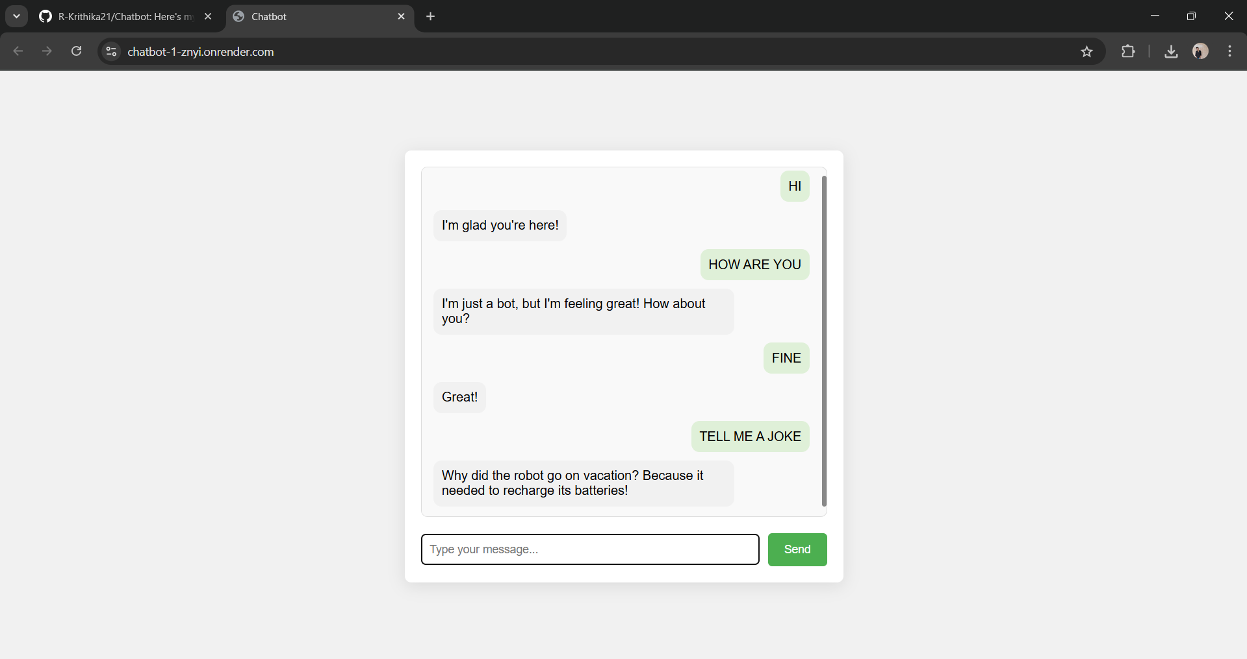

**8. Future Enhancements**

The chatbot can be further enhanced in several ways:  
1. Dynamic Learning: Implement machine learning techniques that allow the bot to learn from new data and improve its responses over time.  
2. Multilingual Support: Add support for multiple languages to expand the chatbot’s reach.  
3. Integration with APIs: Incorporate external APIs to provide real-time data, such as live weather information, news, or financial data.  
4. Natural Language Understanding (NLU): Implement more advanced NLU techniques for better understanding of complex user queries.  
5. Voice Interaction: Add a voice interface to allow users to interact with the bot using speech instead of text.

**9. Conclusion**  
This chatbot project provides a basic but functional conversational agent capable of interacting with users in an engaging manner. While there are still improvements to be made, it serves as a foundational model for building more advanced and capable chatbots in the future.  
  
The use of machine learning techniques like TF-IDF and cosine similarity helps in enhancing the chatbot's response accuracy, making it an exciting project for further research and development.