**Student Development**

**Programme**

**“Embedded system & programing”**

**OBJECTIVES**

An **embedded system** is a computer system with a dedicated function within a larger mechanical or electrical system, often with real time computing constraints. It is *embedded* as part of a complete device often including hardware and mechanical parts. Embedded systems control many devices in common use today. 98 percent of all microprocessors and microcontrollers that are being manufactured are used in embedded systems. The main objective of the SDP is to make the student understand the importance Embedded System Design and their importance in day to day life with the advances in technology. The course gives complete hands on experience to the participant Arduino making the student design and develop their own Embedded System(Project\mini project). The course also gives an insight into open source and application of sensors.

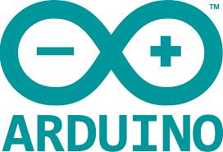

**speakers** :

**Mr.Ganesh shastri**

Mob no**:**9620360907

E-mail:ganesh.s.shastri@gmail.com

**Mr. Bhaskar hegde**

Mob No:9535020423

E-mail:bhaskarhegde14@gmail.com

**Mr. Anish hegde**

Mob No:9740674827

E-mail:hegdeanish96[@gmail.com](mailto:sgravi2@gmail.com)



**REGISTRATION**

**Registration fee 500/- per participant.**

**Register your name with**

***Mr.Guru vighnesh bhat***

***dept.chemistry***