**NeoLearn**

**(A Smart E-Learning Platform)**

**TECH TITANS**

Shasty Venkatesh G  
Maha Raja C  
Ramana Kumar M  
Sridharshan M N

## 

## **1. Introduction**

Managing online courses and tracking student progress is a complex challenge. Traditional e-learning platforms often lack strong administrative tools, interactive assessments, and intelligent recommendations, leading to low engagement and inefficient content delivery.

## **2. Problem Statement**

### **⚠️ Key Issues**

* Existing platforms provide limited admin functionalities.
* Lack of interactive assessments and instant feedback mechanisms.
* Absence of AI-driven course recommendations for personalized learning.
* Inefficient tracking of student progress and engagement.

## **3. Solution Overview**

### **🚀 NeoLearn – A Smarter Learning Platform**

NeoLearn is designed to provide a seamless learning experience through AI-driven recommendations, real-time performance tracking, and interactive content integration. The platform offers:

* **AI-Driven Course Suggestions** – Personalized learning paths based on student behavior.
* **Real-Time Performance Tracking** – Progress monitoring for students and instructors.
* **Seamless Media Integration** – Support for video, interactive content, and assessments.
* **Personalized Learning Experiences** – Adaptive learning with intelligent feedback.

## **4. Real-World Example**

**Moodle**, a powerful LMS, assists colleges in managing enrollments, courses, and assessments. It automates grading, tracks performance, and provides AI-powered recommendations, ensuring an engaging and streamlined learning process.

## **5. Key Features of NeoLearn**

### **🛠️ Admin Dashboard**

* Course creation, updating, and management.
* User roles for structured access and control.

### **🤖 AI-Powered Recommendations**

* Personalized course suggestions.
* Adaptive learning paths based on student progress.

### **📊 Student Progress Tracking**

* Dashboard with visual insights.
* Real-time tracking of completed lessons, quiz scores, and learning analytics.

### **📝 Interactive Assessments**

* Timed quizzes, auto-graded MCQs, and assignments.
* Instant feedback with downloadable study materials.

### **🎥 Live Classes & Media Support**

* Seamless integration of live classes.
* Video, PDF, and interactive content uploads.

## **6. Multi-User Role System**

|  |  |
| --- | --- |
| **User Role** | **Responsibilities** |
| **Student** | Track progress, take quizzes, complete assignments |
| **Instructor** | Create courses, monitor student performance |
| **Admin** | Manage users, analytics, and platform operations |
| **Parent** | View student progress and performance |

## **7. Technology Stack**

|  |  |
| --- | --- |
| **Component** | **Technology** |
| **Frontend** | React.js – Dynamic UI |
| **Backend** | Node.js + Express.js – Scalable APIs |
| **Database** | MongoDB – Flexible NoSQL storage |
| **AI Integration** | Smart recommendations & insights |

## **8. Interactive Course Management**

* Upload and manage multimedia learning content.
* Drip content scheduling for structured learning.

## **9. Assessment & Feedback System**

* Auto-graded quizzes and timed assessments.
* Instant feedback and progress analytics.

## **10. Workflow**

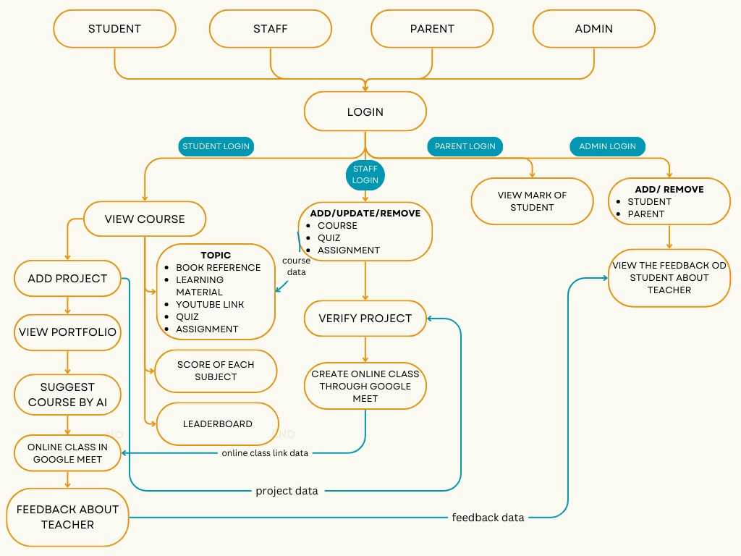

## **11.Implementation**

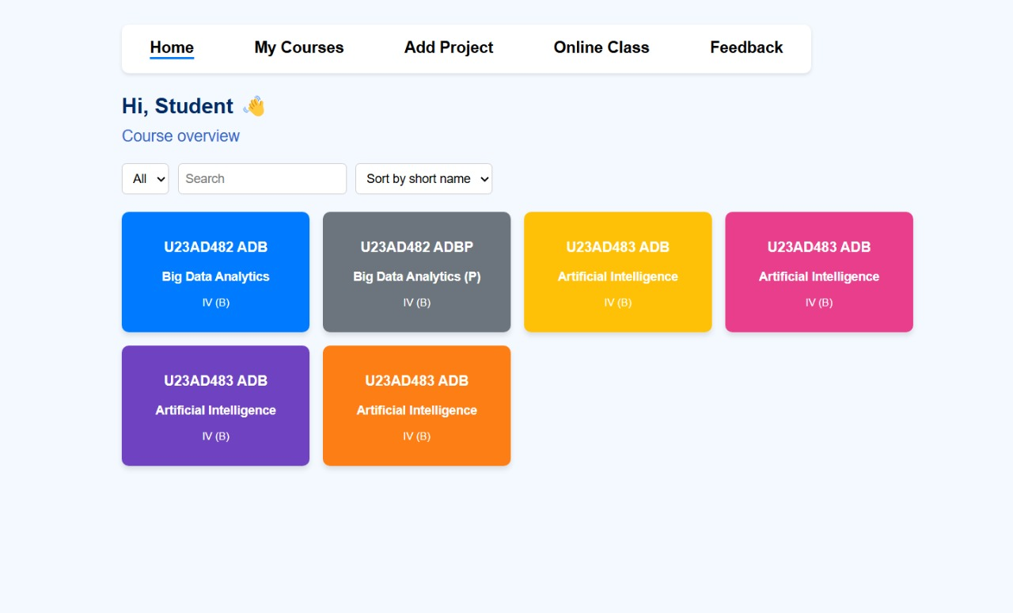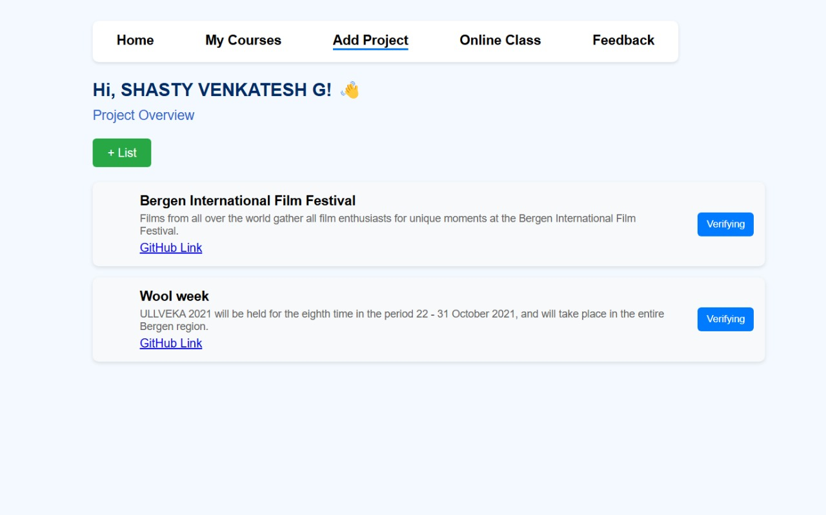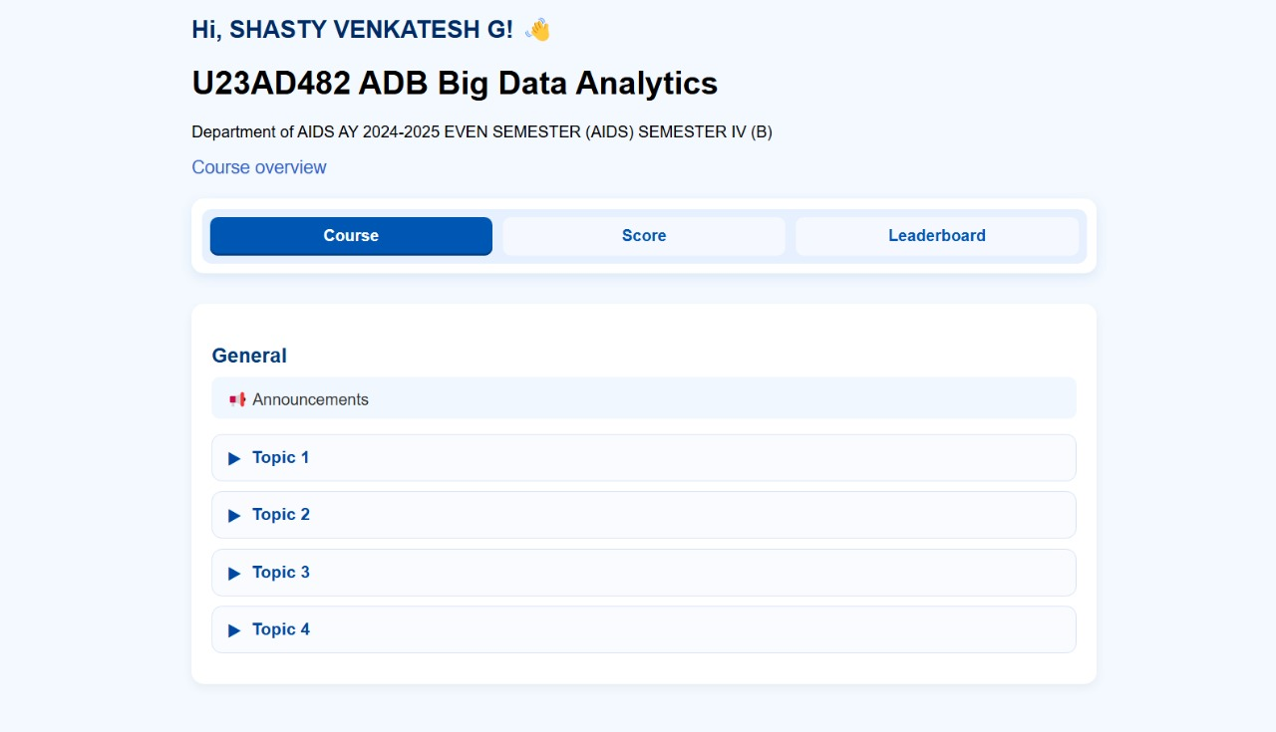

## **12. Conclusion**

NeoLearn is a next-generation learning platform that combines AI-powered insights, interactive assessments, and comprehensive student tracking to enhance engagement and learning outcomes. With its structured course management system and multi-user support, NeoLearn aims to revolutionize online education by making learning smarter, more engaging, and highly personalized.