Speech Stuttering Detection and Removal

Shaswat Rajput
School of Electrical Engineering
Vellore Institute of Technology
Vellore, INDIA
shaswat.rajput2015@vit.ac.in
Ruban Nersisson
School of Electrical Engineering
Vellore Institute of Technology
Vellore, INDIA
nruban@vit.ac.in

Abstract- There are more than 70 million people worldwide who suffer from stuttering problems. Many people who suffer from this issue lose their confidence to speak in public and they find it difficult to fit in society. To solve this problem many people take therapy sessions but research have shown that while therapy sessions might help those who suffer from stuttering but as soon as they leave therapy sessions this problem might arise again. Hence therapy sessions might be a temporarily solution to the problem of stuttering. This project aims to use state of the art machine learning algorithms that have improved over the past few years and concept from mirror neurons to solve this problem. We have used the dataset from UCLASS archives which provides the data for stuttered speech in .wav format with time-aligned transcriptions. We have tried different algorithms and optimized our model by hyper parameter tuning to maximize the model’s accuracy.
Keywords: Machine Learning, Deep Learning, Stuttering,
Mirror Neurons.

Introduction
Speech is considered as universal form of communication. People communicate everyday through speech. It is a motor function that involves the movement of articulators. When there is some problem in this motor function then it causes pauses in speech, better known as stammering. Stuttering is considered as social barrier for those who suffer from it and can’t have a proper social life. Stuttering cause them to lose their confidence to speak in public and as a result most people are not able to fit in a society. Our project aims to use the concept of mirror neurons and machine learning algorithm to generate a feedback signalaofauser’savoice. The existing work that has been done for this problem is just classification of stuttered and normal speech. The approach they used is pre-emphasis of audio and then extracts audio features. There is not much research been done using the mirror neurons for solving the stuttering problem. Most of the existing work is just classification of stuttering. Few researchers have used the hand movements as a mirroring technique to solve stuttering problems.

Post/Related Work
Most of the work that has been done is mostly classification of stuttering. The approach ^{[1]} they use is pre-emphasis of the audio and then they extract the audio features and training the classifier models. They used the median frequency, RMS, standard mean, peak to peak analysis and a specialised mean feature extractor as the features for ANN. Most of current system uses Artificial Neural Networks (ANN’s), Hidden Markov Chain (HMMs) and Gaussian Models (GMMs) ^{[2][3][4]}. Mirror neurons are a new concept that was founded accidentally by Italian neuroscientist, Giacomo Rizzolatti and his group in University of Panama in Italy. There is not so much research being done which involves the concept mirror neurons and machine learning to solve the problem of stuttering.

Importance
Right now there are not so much methods exists that can help people to reduce their stuttering. The methods that exists now is to use a professional vocal teacher. While taking sessions may help the people but some research has shown that the aid might be temporarily and that the user has to continue the sessions for longer time. Some people might not go for therapy sessions because of lack of social confidence or for some other reasons. The project that we made might help people to overcome their stuttering problem at the comfort of their home.

Literature review
Humans are social beings. Communicating to each other through a medium known as speech is what humans different from other animals. We share mirror neurons that enable us to coordinate each other's feelings unwittingly and right away. We spill feelings to one another. We foresee and reflect each other's developments when we're in compassion or concurrence with each other when we're with each other. Also, we can reflect each other's cerebrum movement when we're occupied with narrating and tuning in – the two parts of the correspondence problem.

What is Stutttering?
Stuttering is a discourse issue described by redundancy of sounds, syllables, or words; prolongation of sounds; and interferences in discourse known as blocks. A person who stammer precisely recognises what the person in question might want to state however experiences difficulty delivering a typical stream of discourse. These discourse interruptions might be joined by struggle practices, for example, fast eye flickers or tremors of the lips. Stammering can make it hard to speak with other individuals, which regularly influences an individual's personal quality and relational connections. Stammering can likewise adversely impact work execution and openings, and treatment can come at a high money related expense.
Side effects of stammering can change altogether all through an individual's day. When all is said in done, talking before a gathering or chatting on the phone may make an individual's stammering progressively extreme, while singing, perusing, or talking as one may briefly lessen stammering. Stuttering here and there alluded to as stammering and by a more extensive term, dis-fluent discourse.

How many suffer from stammering?
There are around roughly more than 70 million people worldwide who suffer from stuttering. Mostly stuttering occurs in children who are in age group of 2-7 years old as in this course of time they learn languages and how to communicate. Around 5 to 10 percent of all kids will stammer for some period in their life, enduring from half a month to quite a long while. Young boys are 2 to multiple times as prone to stammer as young girls and as they get older this sexual orientation distinction expands; the number of young boys who keep on stammering is three to multiple times bigger than the quantity of young girls. Most youngsters outgrow stammering. Roughly 75 percent of kids recuperate from stammering. For the rest of the 25 percent who keep on stammer, stammering can endure as a long-lasting communication disorder.

How we speak?
Speaking is complex task. It involves series of precisely co-ordinated muscle movements. Speaking involves formulation of language. Physical movement of speech is motor task. Muscle movements in speaking involve breathing, phonation and articulation. The movements of the muscles are controlled by the brain and are being monitored through our senses of touch and hearing. People who stutter know exactly what they want to speak but the problem arises when they go on to speak. When they try to speak, the muscle movement doesn’t happen the way it normally does. They experience what is known as ‘stop block’ or it is better known as stammering. Their motor execution doesn’t happen the way it should. The precise mechanism that causes stammering is still not understood completely.

Types of Stmmering
There are many type of stuttering but they fall under 3 main categories. So, we can say that there are 3 main type of stuttering, namely:
1. Prolongations: In this type of stuttering the user prolongate the word he/she is speaking.
2. Repetition: In this type of stuttering the user repeat words when they try to speak.
3. Interruption: In this type of stuttering the user took a pause or break when they try to speak.
On the basis of cause, there are 2 types of stuttering, namely:
1. Neurogenic Stammering:
When someone suffers from head trauma, stroke or other type of brain injury to the area of brain that manages the task of speaking and motor task, then this type of stammering arises. Scientist have concluded that when a person suffers from brain injury then the brain will have problem with coordinating with other part of brain that manages the task of speaking and other motor functions.
Before scientist use to believe that all stuttering is psychogenic that is caused by emotional trauma, but today to find a psychogenic stammering is rare.
2. Developmental Stammering:
As the name suggests, this type of stuttering mostly starts to occur in young children when they are learning languages and how to communicate. A few researchers and clinicians trust that formative stammering happens when youngsters' speech and language capacities are unfit to fulfil the child's verbal needs. Most researchers and clinicians trust that formative stammering originates from complex collaborations of numerous variables. Ongoing cerebrum imaging examines have indicated steady contrasts in the individuals who stammer contrasted with non-stammering peers. Formative stammering may likewise keep run in families and research has shown hereditary components add to this kind of stammering. Beginning in 2010, specialists at the National Organisation on Deafness and Other Communication Disorders (NIDCD) have recognised four unique qualities in which changes are related with stammering.

What are mirror neurons?
“A mirror neuron is a neuron that fires both when an animal demonstrates and when the animal watches a similar activity performed by another.” ^{[5][9]} Therefore, the neuron "reflects" the conduct of alternate, just as the spectator were itself acting. Such neurons have been specifically seen in primate species. Winged creatures have been appeared to have imitative reverberation practices and neurological proof recommends the nearness of some type of reflecting framework. “In people, cerebrum action predictable with that of mirror neurons has been found in the premotor cortex, the supplementary motor region, the essential somatosensory cortex and the mediocre parietal cortex.” ^{[6]}
The mystery behind how mirror neurons works is still under speculation as nobody to this date understand how they works and why they work. Some researchers in cognitive neuroscience tried to connect and explain the working of mirror neurons through the Common Coding Theory ^{[7]}. Common Coding theory provides the physiological mechanism for perception coupling ^{[7]}. They believe and argued that to understand better about how humans developed, how human learns by imitation and their actions we must understand how the mirror neurons work.
The most widely recognised hypothesis behind the origin of mirror neuron is the hereditary record which recommends that the mirrorness of mirror neurons is expected principally to heritable genetic elements and that the hereditary inclination to create Mirror neuron advanced in light of the fact that they encourage action understanding.
To this date, there is no theory that can explain why and how mirror neurons work. No-one is still able to decipher the mystery of mirror neurons. Mirror Neurons discovery is relatively new and many researchers around the world have started to research on this topic as many believes that mirror neurons can explain the behaviour of humans and also how humans have developed many skills over the period of time. Some researchers also believe that deciphering the working of mirror neurons can also explain the theory of evolution of humans.

Motor Mimicry
Meta-investigation of impersonation ponders in people propose that there is sufficient proof of mirror framework initiation amid impersonation that reflect neuron association is likely, despite the fact that no distributed examinations have recorded the exercises of particular neurons. In any case, it is likely lacking for engine impersonation. Studies demonstrate that areas of the frontal and parietal lobes that stretch out past the traditional mirror framework are similarly actuated amid impersonation. This recommends different zones, alongside the mirror framework are critical to impersonation practices ^{[8].}

Stuttering and Mirror Neurons
Any hypothesis that endeavours to clarify the idea of stammering must most likely sufficiently address its marvels. A standout amongst the most outstanding and astounding marvels with respect to stammering is the way that numerous individual’s stutter identity familiar when they are separated from everyone else. Survey this equitably; you see that an adjustment in the environment (alone versus with others) of an individual who falters influences their capacity to control their speech.
That being stated, being distant from everyone else or being in the organisation of others isn't the main change in condition that causes an adjustment in a person's stammering seriousness. Numerous adjustments in the environment can either diminish the familiarity of an individual who stammers or increment the familiarity of an individual who stammers.
Speaking is intricate. It includes the definition of language. In any case, the physical execution of discourse is a motor task. It is development of the articulators (lips, tongue and so forth.) just as breath control and vocal overlay vibration. Individuals who stammer recognise what they need to state. The issue emerges when they go to make the talking developments to "state so anyone can hear" what they need. Simply, the developments don't occur and they experience a "discourse square" or stammer. Something turns out badly with the motor execution.
Things being what they are, how is it that a motor ability (talking) can be so significantly influenced by changes in the environment? How is it conceivable that an individual can talk easily in a room alone, and the minute someone else goes into that room, they become unfit to play out precisely the same motor ability (talking)? How could it be that discourse developments are hindered (discourse obstructs) within the sight of someone else yet allowed to stream when alone? How does condition which is "outside of us" drastically influence an intentional motor development (talking) of our bodies which are controlled "within us"? Very bewildering.
There really is a connection between these two apparently separate elements (environment and motor development). It is a genuinely ongoing disclosure. The connection is "mirror neurons". They are called mirror neurons since they reflect the environment motorically. In view of mirror neurons, natural boosts that is seen by an individual resounds and initiates the engine frameworks that control development. Mirror neurons give an immediate connection between changes in the environment and changes in action in the neurological engine framework. Generally, changes in environment influence the human motor framework fundamentally.
For instance, if you watch an individual raise their hand in class, your neurological framework has practiced this equivalent development itself through mirror neurons. In the event that you watch an individual get an apple, you have practiced similar developments in your neurological framework through mirror neurons.
You may ask, if your neurological framework is emulating the developments of others, for what reason aren't you yourself mimicking out similar developments? Great inquiry, and an imperative one in clarifying stammering. This is on the grounds that there are frameworks set up to keep you from physically playing out the developments. All things considered, it would not be useful if everybody was strolling around impersonating each development they watched. In this manner, there are frameworks set up that repress/hinder the development your neurological framework is practicing. So regardless of the neurological framework "carrying on" developments one might say, the physical outcome is a nonattendance of development. This is on the grounds that the components that decide if a development gets physically performed or blocked/restrained has decided they ought to hinder the development.
Suppose that you are an individual who stammers, does having a development get "blocked" sound natural? At the point when an individual who stammers goes to talk, the developments appear to get blocked. Actually, that is the precise word individuals who falter use to portray a stammer; a "block".
Quickly abridging the above-mentioned, when an individual watch another individual playing out a physical demonstration, the watching individual practices the physical demonstration they are seeing in the piece of their neurological framework that is in charge of motor development.
Along these lines, when an individual who stutters is alone and talking, the environment does not have someone else in it for the neurological framework to imitate the developments of. Subsequently, the neurological engine framework isn't meddled with. When someone else enters the individual who falter's condition, the neurological engine arrangement of the individual who stammers winds up dynamic as it emulates the developments of the individual who has entered the environment. The neurological motor development framework is essentially influenced by the nearness of someone else instead of the nearness of no one. This is potentially a critical disclosure in the comprehension of stammering.
The issue emerges when the individual stammer's swing to talk in the discussion. The neurological framework that was hindering development when the conversational accomplice was talking is presently expected to empower discourse and play out the discourse developments. Be that as it may, it keeps on inhibiting discourse activities as if they ought to be stifled and not said boisterously.
In addition, when an individual is alone, their motor framework is significantly less dynamic since mirror neurons have no one to imitate the developments. Subsequently there are less contending development signals. The neurological framework has less flags to repress when an individual is separated from everyone else, thusly it experiences less difficulty empowering an individual who stammer's endeavours to stand up boisterous. At the point when another new individual enters the earth, in any case, the neurological framework starts emulating this new individual's developments clandestinely (counting their discourse developments). The individual who stammer's neurological framework should then hinder the majority of the developments of the other individual they are secretively executing because of mirror neurons. While repressing these new flags, the neurological framework is asked to empower the talking activities of the individual who stammer. When another individual is in the environment, there are more flags contending and more flags for the neurological framework to need to figure out which ones to perform and which ones to restrain. The issue is, the neurological framework decides it ought to restrain discourse that the individual stutters' identity endeavouring to state boisterously. This is stammering. This is blocking.

dataset
One of the challenges for this project was to get a time-aligned labelled dataset. The dataset we are using is University College London archive of Stuttered Speech (UCLASS)^{[10]}. It contains recordings of monologues, reading and conversations of different speakers ranging from 7 years old to 20 years old. Unfortunately, most of the recordings do not have orthographic transcriptions and/or time aligned transcriptions. The database has audio files in 2 releases, release 1 and release 2. Release 1 has 16 files which have time-aligned transcriptions and release 2 has only 4 files which have time-aligned transcriptions. So, we worked with the 16 files from release 1 to train our models.
The audio files are in .wav format having a sampling rate of 22050Hz and the corresponding time-aligned transcriptions are in CHILDES CHAT format ^{[11]}. The orthographic transcriptions are in plain text.

metholodogy

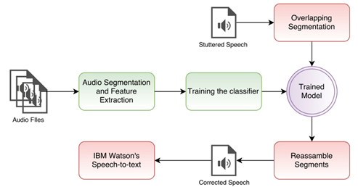
FIG.1 FLOW DIAGRAM

Data Pre-Processing
We used the time-aligned transcriptions to split the data files into stuttered segments and normal segments. The transcriptions had the start time and end time (in milliseconds) for each segment. So there were in all 12,633 segments that we got after splitting the audio files.

TABLE 1 DATA STATISTICS
 | ALL | STUTTER | NORMAL
COUNT | 12633 | 2643 | 9990
MAX (ms) | 17044 | 17044 | 14499
MIN (ms) | 0 | 1 | 0
MEAN (ms) | 315.09 | 762.63 | 196.71
MEDIAN (ms) | 192 | 486 | 168
MODE (ms) | 109 | 201 | 93

From Table 1 we can see that the average duration of all the segments is ~315 ms and stuttered segments are 2.5 times longer than the normal segments. The longest stutter was about 17 seconds long. Training on such skew data will not be useful because it is highly unlikely that we will encounter any stammer segment which is as long as 17 seconds.
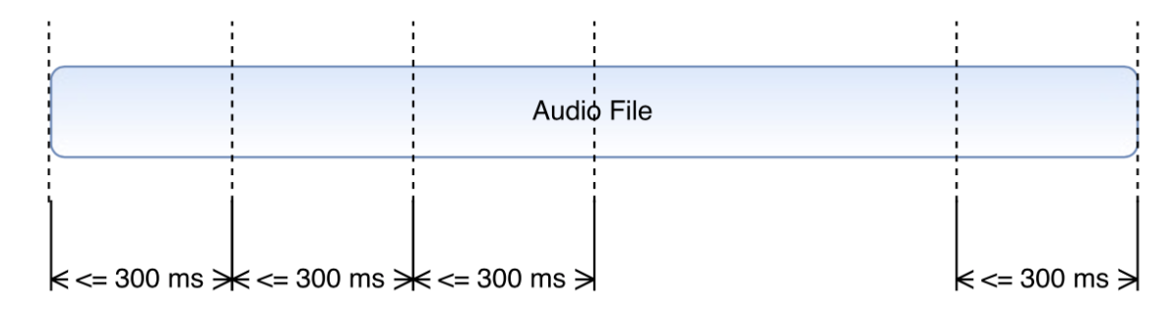
So, instead of using the segments of variable duration, we segmented the files segments further down to less than or equal to 300 ms which is close to the average length of the segments. This segmentation created 17,545 segments which will be used for training the models.
FIG. 2 AUDIO SEGMENTS

Feature Extraction
Once the audio segments were prepared, we then extracted the features from each segments which can be fed to the classification models. We used MFCC features as they are very representative of human speech and RMSE which represents the loudness of a speech. We extracted 39 MFCC features and RMSE for each segment and stored the mean and variance of all 40 features (39 MFCC + 1 RMSE) to get a feature vector of 80 components.
In the end, our dataset had 17,545 rows each having 80 features.

Classification
Now with the dataset ready, next step was to train the classifier models. We used Deep Neural Network, Support Vector Classifier, Decision Trees, Gaussian Naïve Bayes.
DNN model gave the highest accuracy and took around ∼2 min to train as compared with SVC which took more than 2.5 hours. The DNN model had 3 hidden layers, each having 10 neurons. Learning rate was 0.001 and training epochs were 1,200.
TABLE 2 CLASSIFICATION ACCURACY OF MODELS
Algorithms | Accuracy (%)
Decision Trees | 76.98
Gaussian Naïve Bayes | 75.22
Support Vector Classifiers | 79.32
Deep Neural Network | 85.89

Neural Network Configuration
One of the most important and hardest task is find the optimum number of batches and epochs. Accuracy and performance of the model depends on the structure of model.
The number of the input is the size of the feature vector used. In our model, we used learning rate of 0.001, batch size of 100 and num of epoch to be 1200. If wi is a signal, for each hidden unit hj, then:
hj = σ(vj · φ(wi))
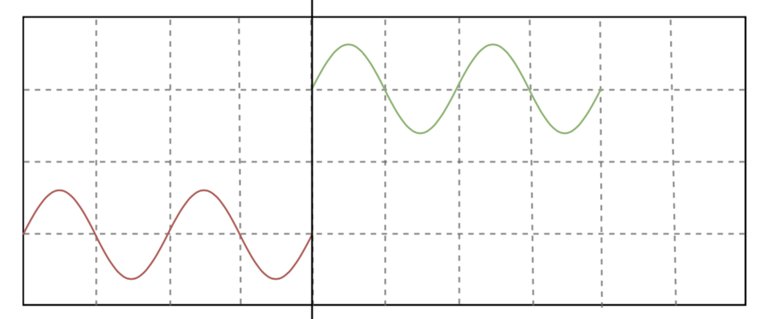
For, optimiser function we used Adam Optimizer. We used Adam function because it combines the the advantage of both Adaptive Gradient Algorithm and Root Mean Square Propagation. Instead of adjusting the parameter learning rates dependent on the average first moment (the mean) as in RMSProp, Adam likewise makes utilization of the normal of the second moment of the gradient.
In particular, the calculation computes an exponential moving average of the inclination and the squared angle, and the parameters beta1 and beta2 control the decay rates of these moving midpoints.

Implementation details

Audio Correction
Our classifier achieved the accuracy of around ~86% using Artificial Neural Network. Now, next in the pipeline is audio correction.

Overlapping Segmentation
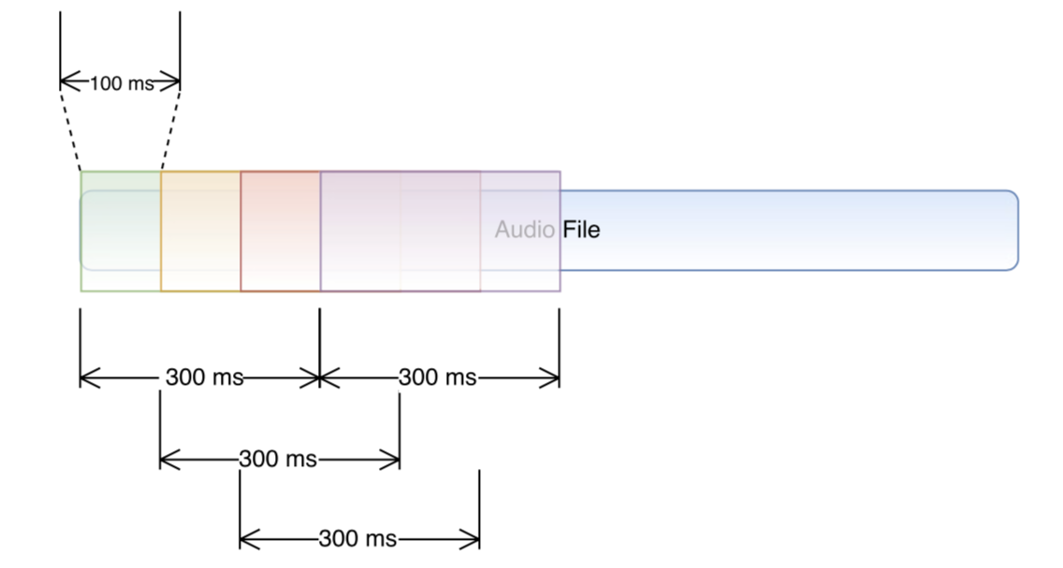
The model is trained on audio segments <=300 ms, so it’s obvious that the audio to be corrected needs to be segmented with duration of 300ms, but what’s less obvious is to detect the stutter boundaries. So, instead of naively segmenting the audio in contagious manner, we overlapped the segments as shown in figure 3. The overlapping was 200 ms.

FIG.3 OVERLAPPING SEGMENTATION
With this segmentation, we could detect the stuttered and non-stuttered parts with the granularity of 100 ms. after segmentation; these segments were sent to the classifier for classification.

Reassembling the Segments
The classifier gave the labels of the overlapping segments. So, all we had to do was to remove the segments which were labelled as STUTTER and combine the segments labelled as NORMAL. We took a set difference to get the chunks of audio which contains only NORMAL speech.
Now there are different ways to assemble the segments. One way is to assemble the segments in contiguous chunks together as shown in figure 4 below, but it will result in sharp interjections at the point of concatenation and will result in very artificial sounding voice.
So, instead of naively appending the adjacent chunks, we interpolated the audio samples between the end of the previous chunk and the beginning of the current chunk as shown in fig 5.

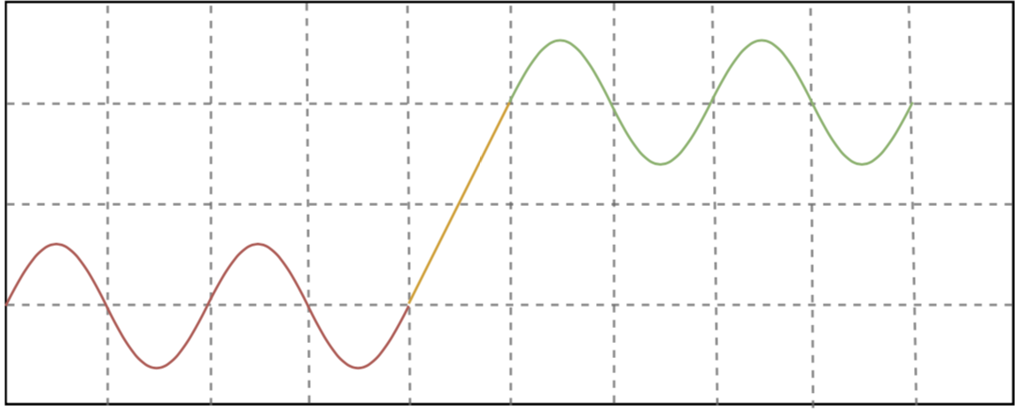
FIG.4 NAÏVE RE-ASSEMBLING

FIG. 5 SMOOTHED RE-ASSEMBLING

The entire audio correction pipeline took 24 sec for an audio of duration 2 min 50 sec. And out of the 24 seconds, ∼98% time was for feature extraction. Segmentation and classification were instantaneous.

Speech to Text
Now, there are many ways to check the model capability to see if the model is successfully correcting the stuttered voice. One of the best way is to pass the voice to a speech recognition software to see if there is any reduction in Word Error Rate (WER).
So, to check the WER, we passed the original and corrected audio through IBM Watson’s Speech to text. We chose IBM Watson because our dataset, UCLASS speech archives is recorded in British English and IBM Watson has model which is already trained on British English. So, instead of programming our own speech to text model, we used IBM Watson’s speech to text program.

Results
As we can see from the table 3, we observe that the WER of the corrected voices is reduced significantly as compared to the original ones. So, we can say that our algorithm worked successfully in removing most of the ‘pause blocks’ or the stutter blocks from the input voice.

TABLE 3 COMPARISON OF WER OF CORRECTED AND ORIGINAL VOICE
Subject | Original (%WER) | Corrected (%WER)
M_1017_11y8m_1 | 54.35 | 46.74
M_1017_13y2m_1 | 61.55 | 43.12
M_0065_20y1m_1 | 92.35 | 76.12
M_0017_19y2m_1 | 73.07 | 73.92

As we can see above that in the first three voices, WER in corrected one is reduced significantly but in the last voice it is rather increased a bit. The reason behind is that we have limited dataset available for training. So, because of this reason we were able to achieve this much accuracy only.

summary and future work
We can say that our model did a good job in removing the stutter block in the speech. Even the corrected voices made by our model were able to reduce the %WER from the original voice. There is so much which is still can be done to increase the accuracy of model and to decrease more WER from the stuttered voice. With more modification to the algorithm and with considerable amount of dataset, we can achieve better results for almost 70 million people out there who suffer from stammering.
The thing which is still left to do is to use this algorithm on people who suffer from stammering. The experimental setup will consist of people of suffer from stammering sitting in front of mirror with headset and mic. They will read some pre-written speech which will act as input and our model will try to remove the stammering from the speech and the algorithm will provide feedback output of their voice into the headset. By listening to their voice with less stuttering and seeing their reflection in mirror will activate the motor function and mirror neurons. Doing this in an iterative loop may help in reducing the stammering in people.
Also, as mention above, around 98% of the time was spent for feature extraction, maybe we can find some other feature extraction library (currently using librosa ^{[12]}) which can extract feature in less time or even look for more features that are more representative of stammering speech.

References

- Manu Chopra, Kevin Khieu and Thomas Liu. Classification and recognition of stuttered speech.
- Geoffrey Hinton, Li Deng, Dong Yu, George E. Dahl, Abdel-rahman Mohamed, Navdeep Jaitly, Andrew Senior, Vincent Vanhoucke, Patrick Nguyen, Tara N. Sainath, and Brian Kingsbury, ”DNN for acoustic modelling in speech recognition”, IEEE Signal Processing Magazine November 2012
- M. Kesarkar, “Feature Extraction For Speech Recognition, ” Indian Institute of Technology, Bombay 2003
- I.Szczurowska, W.Kuniszyk-Jozkowiak, and E.Smolka, “The application of Kohonen and Multilayer Perceptron Networks in the speech nonfluency analysis,” Archives of Acoustics, Vol. 31, p. 205, 2006
- Rizzolatti, Giacomo; Craighero, Laila (2004). "The mirror-neuron system" (PDF). Annual Review of Neuroscience. 27 (1): 169–192. doi:10.1146/annurev.neuro.27.070203.144230. PMID 15217330
- Molenberghs P, Cunnington R, Mattingley JB (July 2009). "Is the mirror neuron system involved in imitation? A short review and meta-analysis". Neuroscience and Biobehavioral Reviews
- Keysers, Christian (2011-06-23). The Empathic Brain
- Molenberghs P, Cunnington R, Mattingley JB (July 2009). "Is the mirror neuron system involved in imitation? A short review and meta-analysis". Neuroscience and Biobehavioral Reviews
- Keysers, Christian (2010). "Mirror Neurons" (PDF). Current Biology. 19 (21): R971–973. doi:10.1016/j.cub.2009.08.026. PMID 19922849
- Peter Howell, Stephen Davis, and Jon Bartrip. The University College London archive of stuttered speech (UCLASS). Journal of Speech, Language, and Hearing Research, 52(2):556–569, 2009
- Brian MacWhinney. The childes project part 1: The chat transcription format. Department of Psychology, page 181, 2009
- Brian McFee, Colin Raffel, Dawen Liang, Daniel PW Ellis, Matt McVicar, Eric Battenberg, and Oriol Nieto. librosa: Audio and music signal analysis in python. In Proceedings of the 14th python in science conference, pages 18–25, 2015
- Snyder GJ¹, Waddell DE, Blanchet P. , ”Mirror neurons as a model for the science and treatment of stuttering." in PubMed, US National Institute of Health

