🔷 Project Title
E-commerce Analytics Project using Big Query

🔷 Project Overview
This project analyses an e-commerce platform’s data to extract insights about:
- Customer behaviour
- Sales trends
- Product performance
- Revenue analytics
The project uses Big Query SQL, focusing on:
- Joins (INNER, LEFT)
- Window functions (RANK, ROW_NUMBER, LAG, SUM OVER)
- Aggregation
I built an end-to-end SQL analytics project on Big Query using an e-commerce dataset where I performed customer segmentation, revenue analysis, and product performance tracking using joins and advanced window functions.

🔷 Dataset (You will create these tables)
We’ll simulate a real-world dataset with 4 tables:

🧾 Table 1: customers
column | type
customer_id | INT
name | STRING
city | STRING
signup_date | DATE

🛒 Table 2: orders
column | type
order_id | INT
customer_id | INT
order_date | DATE
order_amount | FLOAT

📦 Table 3: order_items
column | type
order_item_id | INT
order_id | INT
product_id | INT
quantity | INT
price | FLOAT

🏷 Table 4: products
column | type
product_id | INT
product_name | STRING
category | STRING
price | FLOAT

🔷 Schema Diagram (Star Schema)
customers
|
| customer_id
|
orders
|
| order_id
|
order_items
|
| product_id
|
products

The schema follows a star schema design where orders act as a fact table and customers/products as dimension tables.

THE ASKED QUERIES AND THEIR SOLUTIONS ALONG WITH SCREENSHOTS OF THE OUTPUT ATTACHED ARE AS FOLLOWS:

🔷 1. Total Orders per Customer
SELECT
customer_id,
COUNT(order_id) AS total_orders
FROM ecommerce_project.orders_large
GROUP BY customer_id;

🧠 Explanation
This query looks at the orders table and counts how many orders each customer has placed. It groups the data by customer so each customer appears only once, with their total number of orders.

📊 Expected Output
Customer ID | Total Orders
Each row shows how many times a customer purchased.

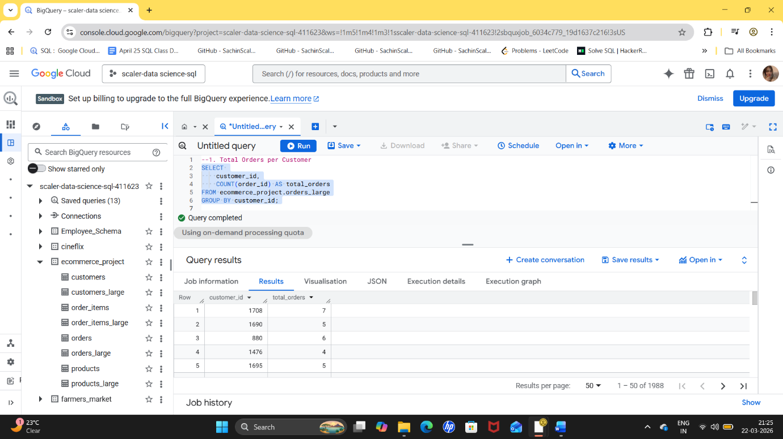

💡 Insight
This tells us which customers are active and which are not. Some customers will have many orders, while others only one.

🎯 Recommendation
Focus on customers with only one order and try to convert them into repeat buyers using discounts or follow-ups.

🔷 2. Total Revenue per Day
SELECT
order_date,
SUM(order_amount) AS daily_revenue
FROM ecommerce_project.orders_large
GROUP BY order_date
ORDER BY order_date;
🧠 Explanation
This query groups all orders by date and adds up the total revenue for each day. Sorting by date helps us see the trend over time.
📊 Expected Output
Date | Daily Revenue
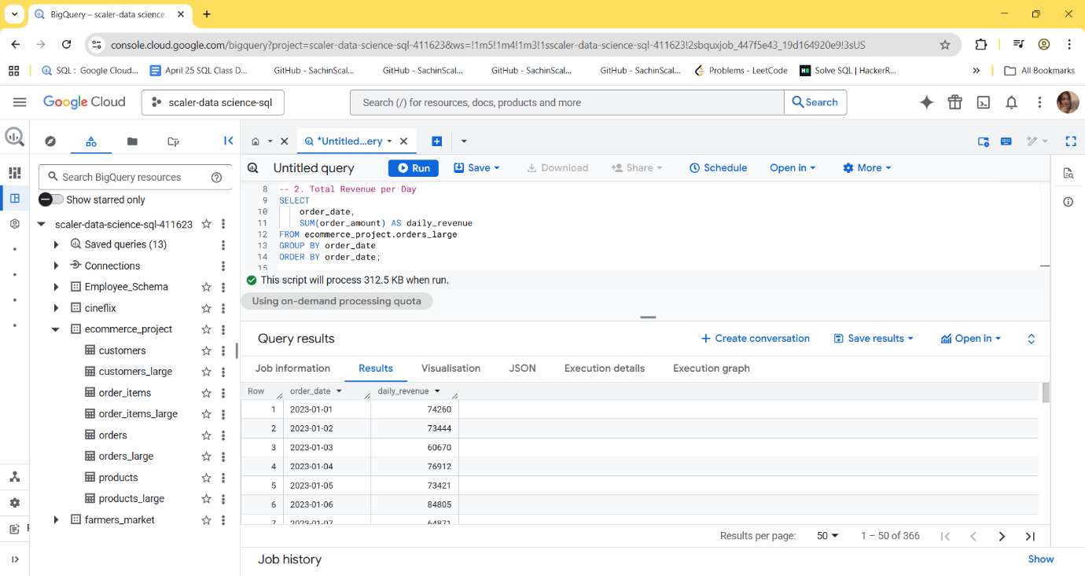
💡 Insight
Shows which days have high or low sales.
🎯 Recommendation
Identify high-performing days and replicate those conditions (offers, ads, timing). Improve low-performing days with promotions.

🔷 3. Average Order Value
SELECT
AVG(order_amount) AS avg_order_value
FROM ecommerce_project.orders_large;
🧠 Explanation
This calculates the average amount customers spend per order by dividing total revenue by number of orders.
📊 Expected Output
Single value like: ₹850 (example)
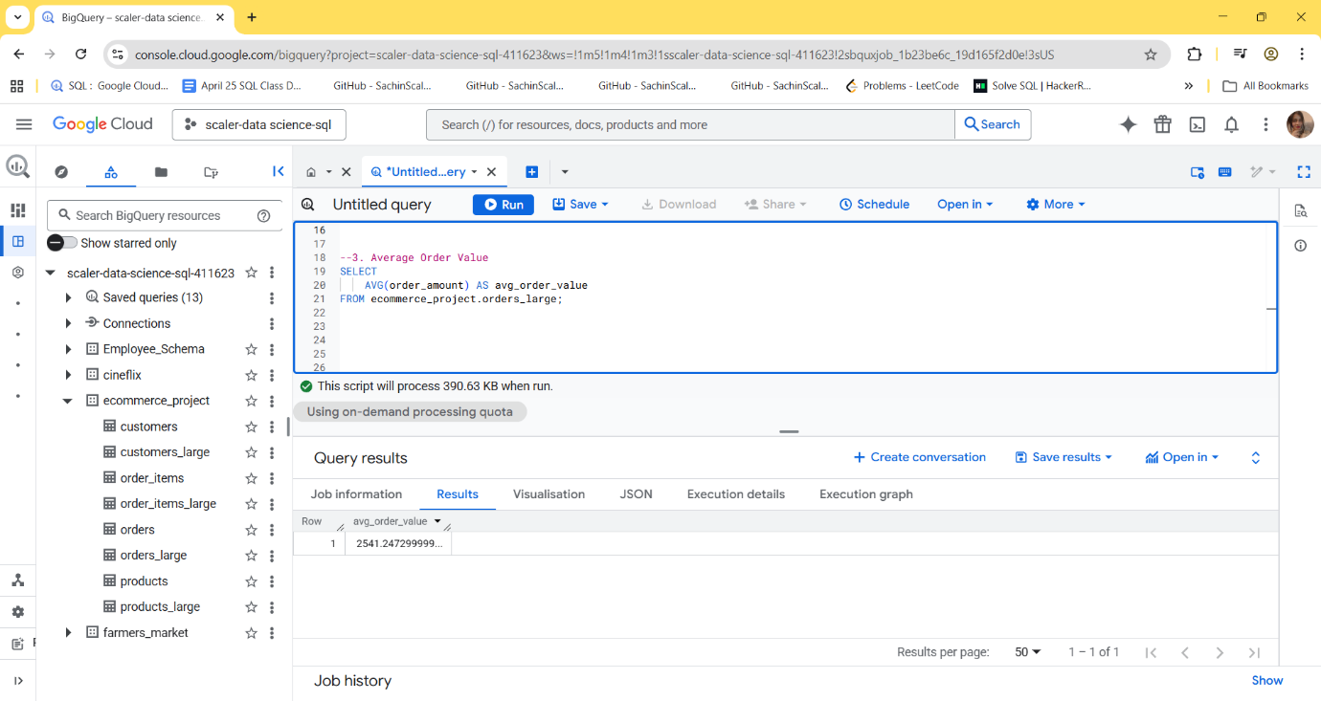
💡 Insight
Shows typical spending behaviour of customers.
🎯 Recommendation
Increase this by bundling products or offering “buy more, save more” deals.

🔷 4. Orders per City
SELECT
c.city,
COUNT(o.order_id) AS total_orders
FROM ecommerce_project.customers_large c
JOIN ecommerce_project.orders_large o
ON c.customer_id = o.customer_id
GROUP BY c.city;
🧠 Explanation
This joins customers with orders to know which city each order belongs to, then counts orders per city.
📊 Expected Output
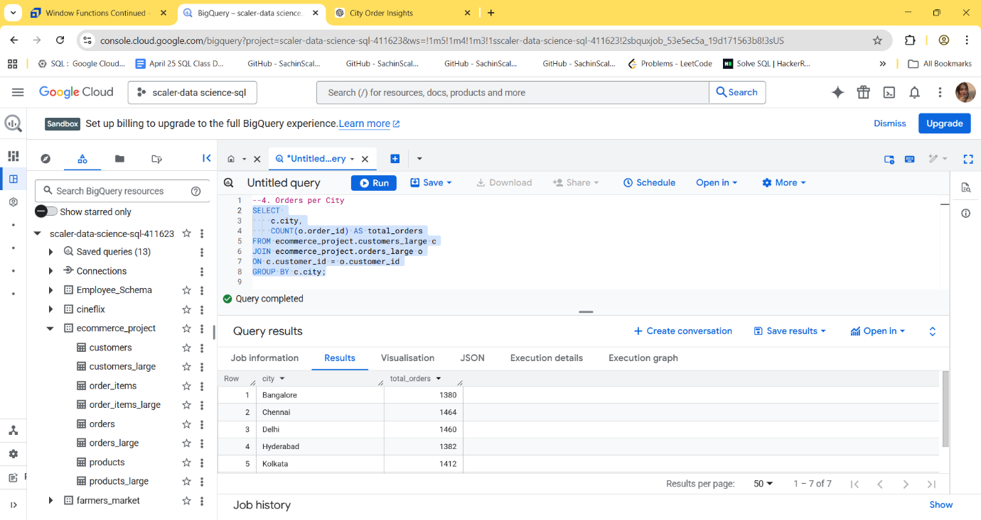
💡 Insight
Orders are fairly evenly distributed across cities, with Chennai and Delhi slightly leading, indicating strong and consistent demand. Kolkata performs moderately, while Bangalore and Hyderabad are slightly lower but not significantly behind, showing no major underperformance.

🎯 Recommendation
Focus on maximizing growth in Chennai and Delhi through marketing and retention strategies, while improving Bangalore and Hyderabad with targeted offers and better service or delivery efficiency. The overall stable performance suggests the business can confidently expand into similar markets.

🔷 5. Total Revenue per Category
SELECT
p.category,
SUM(oi.quantity * oi.price) AS revenue
FROM ecommerce_project.order_items_large oi
JOIN ecommerce_project.products_large p
ON oi.product_id = p.product_id
GROUP BY p.category;
🧠 Explanation
This joins order items with products, then calculates revenue by multiplying quantity and price, and groups it by category.

📊 Expected Output
Category | Revenue
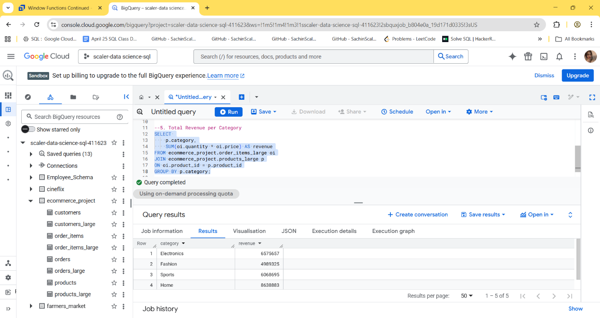
💡 Insight
The Home category generates the highest revenue, indicating strong customer demand and possibly higher-value purchases. Electronics and Sports also perform well, contributing significantly to overall revenue. Accessories show stable performance, while Fashion generates the lowest revenue among all categories, suggesting relatively lower demand or smaller average order value.
🎯 Recommendation
Focus on scaling the Home category further through promotions and ensuring product availability, as it is the top revenue driver. Strengthen Electronics and Sports with targeted marketing to maintain growth. Improve Fashion performance by introducing better pricing strategies, trendy products, or discounts. Additionally, bundle Accessories with high-performing categories to increase overall sales.

🔷 6. Number of Products Sold
SELECT
product_id,
SUM(quantity) AS total_sold
FROM ecommerce_project.order_items_large
GROUP BY product_id;
🧠 Explanation
This query adds up how many units of each product were sold.
📊 Expected Output
Product ID | Total Sold
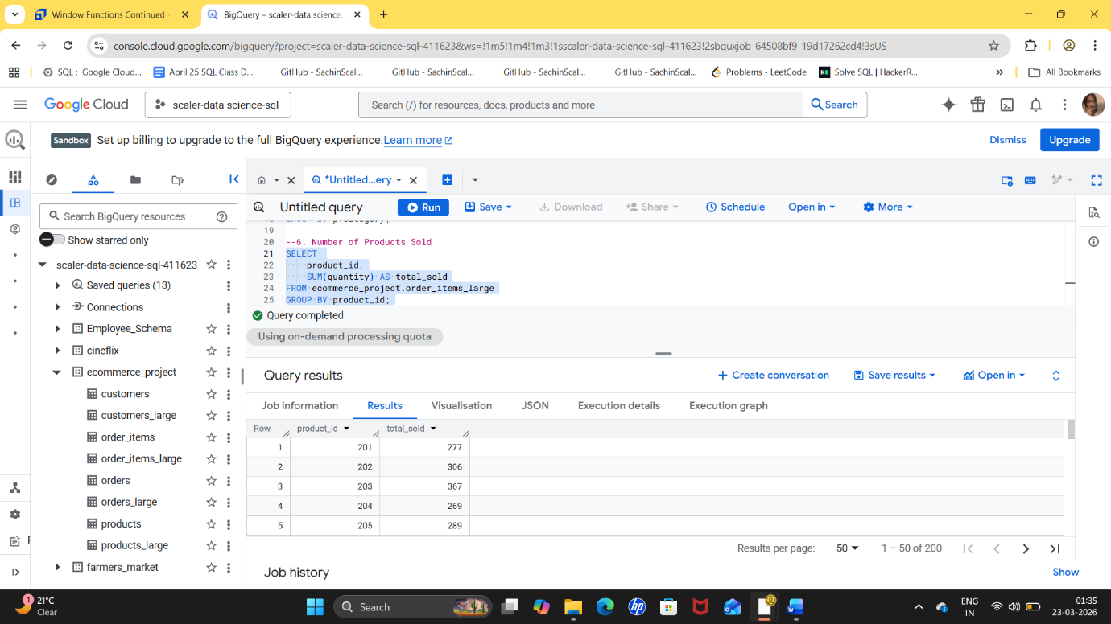
💡 Insight
Product 203 (367 units) is the top-selling item, indicating strong customer preference. Product 202 (306) and 205 (289) also perform well, while 201 (277) and 204 (269) have relatively lower sales. However, the differences are not very large, suggesting that demand is fairly evenly distributed across products.
🎯 Recommendation
Focus on promoting and maintaining stock for top-performing products like 203 and 202 to maximize sales. Analyse why lower-selling products like 204 and 201 are underperforming—this could be due to pricing, visibility, or customer preference—and improve them through discounts, better marketing, or product enhancements. Additionally, use bundling or cross-selling strategies to boost sales of weaker products.

🔷 7. Customers Who Never Ordered
SELECT
c.customer_id
FROM ecommerce_project.customers_large c
LEFT JOIN ecommerce_project.orders_large o
ON c.customer_id = o.customer_id
WHERE o.order_id IS NULL;
🧠 Explanation
This uses a LEFT JOIN to include all customers, even those without orders. Then it filters those who never placed any order.
📊 Expected Output
List of customer IDs with no orders
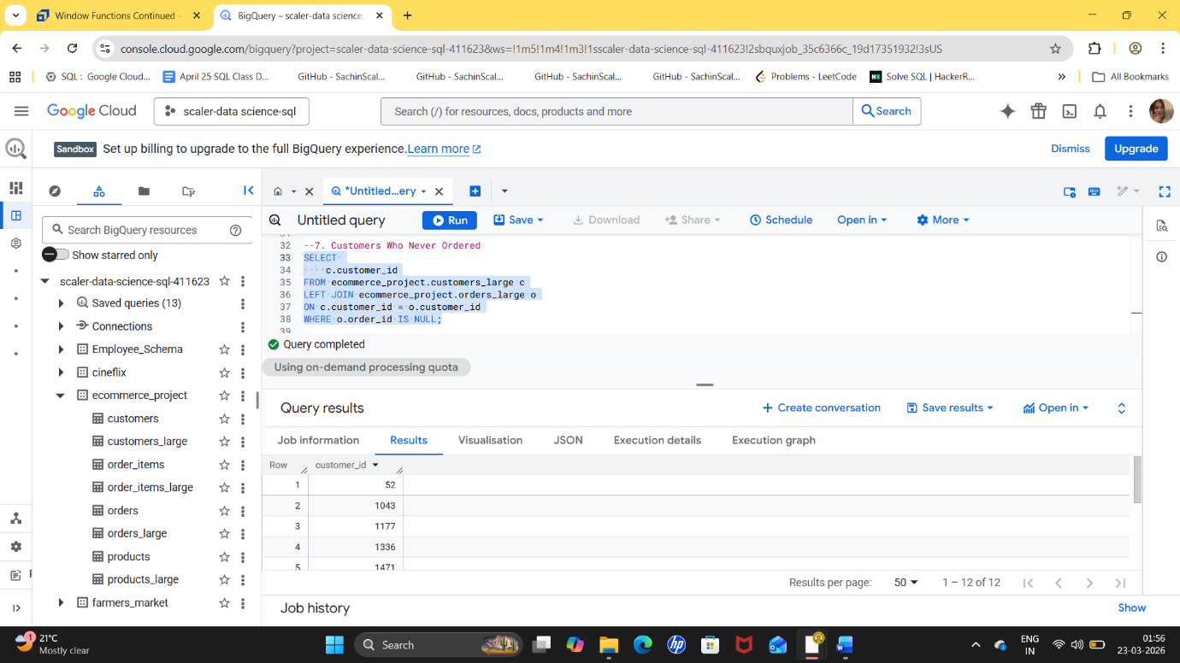
💡 Insight
A significant number of customers have never placed an order, indicating a growing drop-off after customer acquisition. The higher numbers suggest that a large portion of users are not converting into paying customers, pointing to possible issues in onboarding, pricing, or user experience.
🎯 Recommendation
Focus on converting these inactive customers by offering first-order discounts, personalized deals, and reminder notifications. Improve the onboarding experience to make purchasing easier and more intuitive. Additionally, analyse customer behaviour to identify where users drop off and address those gaps, while using targeted marketing campaigns to re-engage these users.

🔷 8. Highest Order Amount per Customer
SELECT
customer_id,
MAX(order_amount) AS highest_order
FROM ecommerce_project.orders_large
GROUP BY customer_id;
🧠 Explanation
This finds the biggest order each customer has ever placed.
📊 Expected Output
Customer ID | Highest Order
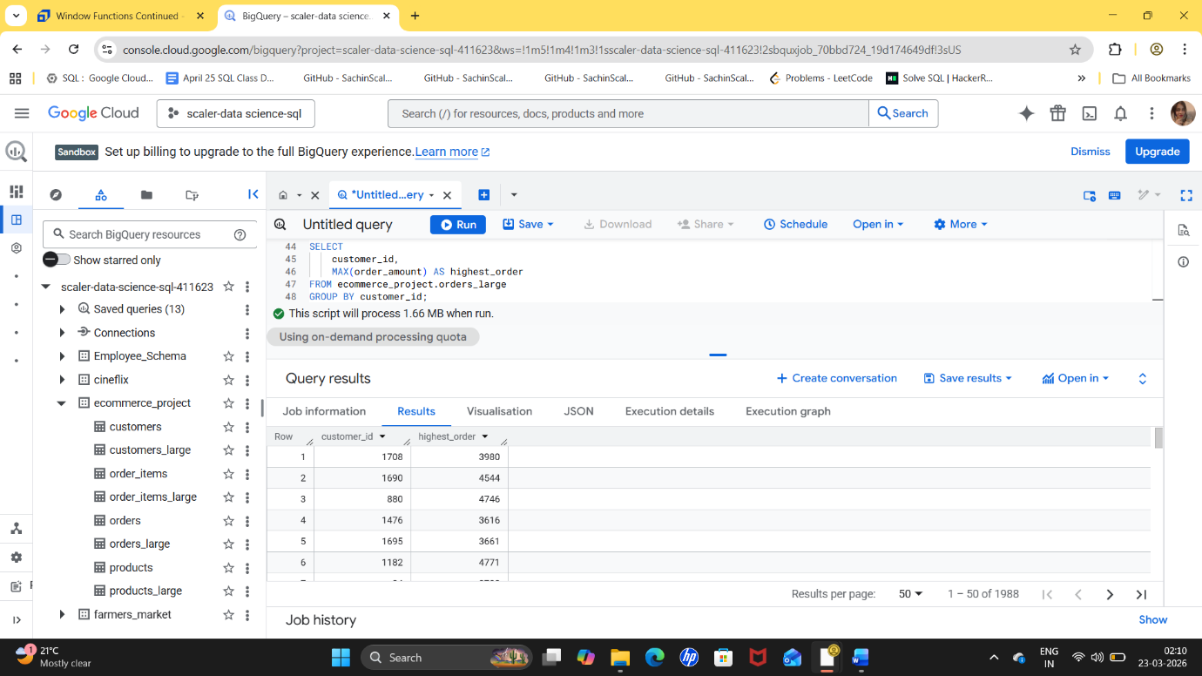
💡 Insight
The highest order values range from 3616 to 4843, showing a segment of high-value customers with strong purchasing power. Customers like 1195 (4786), 1182 (4771), and 880 (4746) are top spenders, contributing significantly to revenue. The variation in order values suggests differences in purchasing behaviour, but overall indicates the presence of a valuable premium customer segment.
🎯 Recommendation
Focus on retaining these high-value customers through loyalty programs, exclusive offers, and personalized experiences. Encourage repeat high-value purchases by providing premium product recommendations and special discounts. Additionally, analyse what drives these large orders (such as product categories or bundles) and replicate those strategies to increase the average order value among other customers.

🔷 9. Total Items per Order
SELECT
order_id,
SUM(quantity) AS total_items
FROM ecommerce_project.order_items_large
GROUP BY order_id;
🧠 Explanation
This adds up how many items were purchased in each order.
📊 Expected Output
Order ID | Total Items
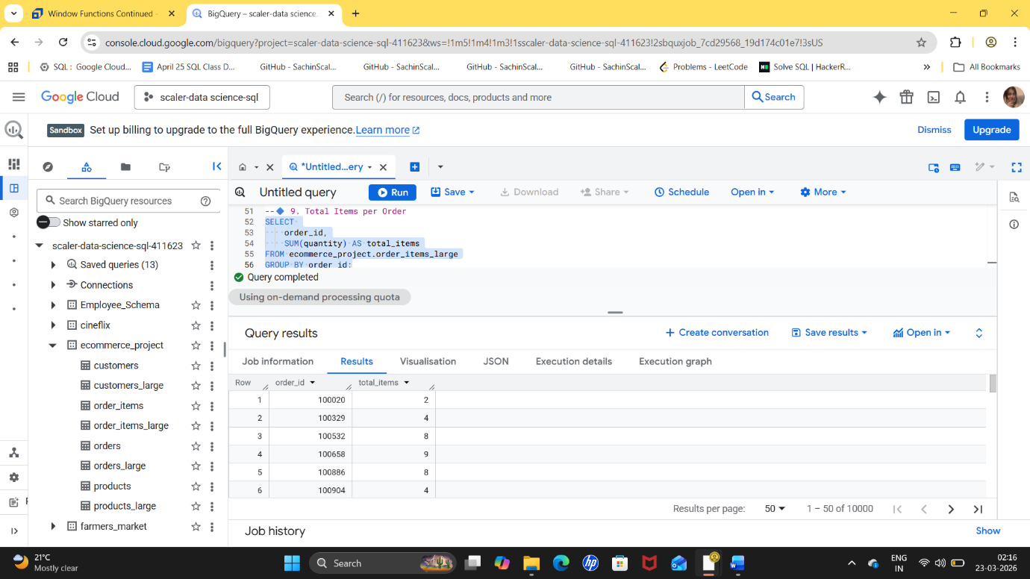
💡 Insight
Shows whether customers buy in bulk or small quantities. The number of items per order ranges from 2 to 11, indicating variation in customer purchasing behaviour. Orders like 101666 (11 items) and 100658 (9 items) show bulk buying, while others with 2–4 items reflect smaller, regular purchases. Overall, most orders fall in the mid-range (4–8 items), suggesting a balanced buying pattern with opportunities to increase basket size.
🎯 Recommendation
Encourage customers with smaller orders to buy more through bundle offers, discounts on bulk purchases, and free delivery thresholds. Promote combo deals based on frequently bought items to increase the average number of items per order. Additionally, analyse high-item orders to understand what drives bulk purchases and replicate those strategies across other customers.

🔷 10. Rank Orders by Amount (Highest to Lowest)
SELECT
order_id,
order_amount,
RANK() OVER (ORDER BY order_amount DESC) AS rank
FROM ecommerce_project.orders_large;
🧠 Explanation
This query takes all orders and sorts them based on how much money was spent. The RANK() function assigns a position to each order, where the highest amount gets rank 1. If two orders have the same value, they get the same rank.
📊 Expected Output
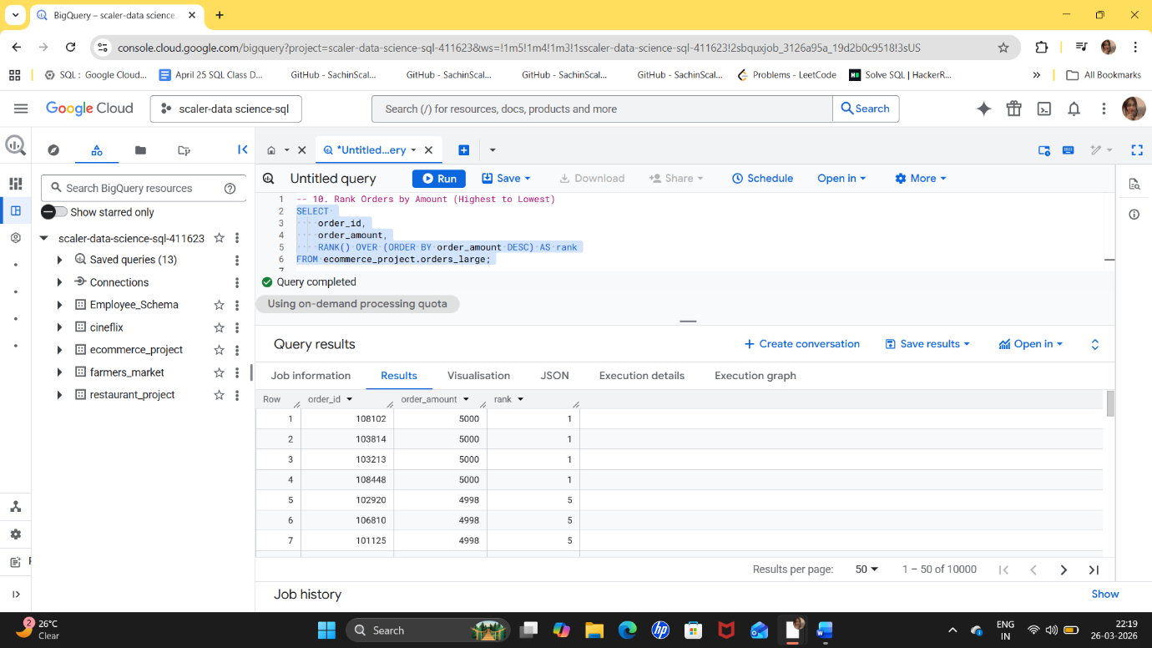
Order ID | Order Amount | Rank
Top rows = highest-value orders
💡 Insight
This helps identify the biggest transactions in your business. Multiple orders share the top rank with an order amount of 5000, indicating a common maximum purchase limit or pricing cap. There is a very small difference between ranks, with amounts gradually decreasing from 5000 to 4994, showing that high-value orders are closely clustered. This suggests strong customer willingness to spend near the upper price range.
🎯 Recommendation
Leverage this behaviour by introducing premium bundles or offers slightly above the 5000 range to increase revenue. Encourage customers to cross the threshold with incentives like discounts or free delivery on higher amounts. Additionally, analyse what products are included in these top orders and promote similar combinations to drive more high-value purchases.

🔷 11. Running Total of Revenue per Customer
SELECT
customer_id,
order_date,
order_amount,
SUM(order_amount) OVER (
PARTITION BY customer_id
ORDER BY order_date
) AS running_total
FROM ecommerce_project.orders_large;
🧠 Explanation
This query tracks how much each customer has spent over time. It groups data by customer and keeps adding each new order to the previous total, creating a running sum.
📊 Expected Output
Customer ID | Date | Order Amount | Running Total
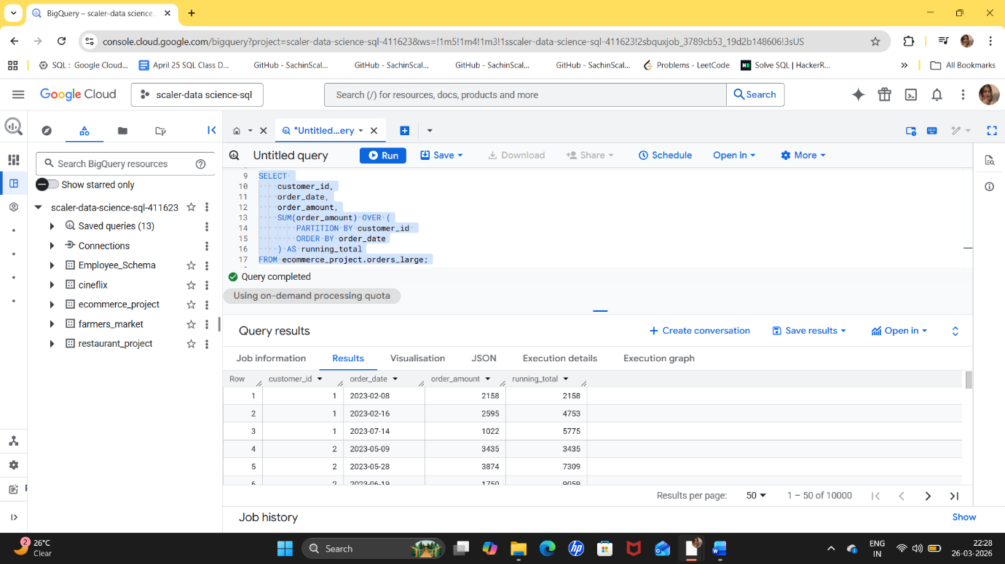
💡 Insight
Shows how customer value grows over time. The running total shows how customer spending grows over time, highlighting Customer 3 (13286) as the highest revenue contributor, followed by Customer 2 (10684) and Customer 1 (5775). Customer 3 also demonstrates consistent purchasing across multiple months, indicating strong engagement and loyalty, while Customer 1 has fewer transactions and lower cumulative spend.
🎯 Recommendation
Identify customers whose spending is increasing and target them with premium offers or loyalty rewards. Focus on retaining high-value customers like Customer 3 and 2 through loyalty programs, exclusive offers, and personalized recommendations to maintain their spending. For lower-value customers like Customer 1, encourage more frequent purchases through targeted discounts and engagement campaigns. Additionally, analyse purchase patterns of top customers and replicate those strategies to increase overall customer lifetime value.

🔷 12. Row Number for Each Customer’s Orders
SELECT
customer_id,
order_id,
order_date,
ROW_NUMBER() OVER (
PARTITION BY customer_id
ORDER BY order_date
) AS order_number
FROM ecommerce_project.orders_large;
🧠 Explanation
This assigns a number to each order per customer. The first order gets number 1, the second gets 2, and so on.
📊 Expected Output
Customer ID | Order ID | Order Date | Order Number
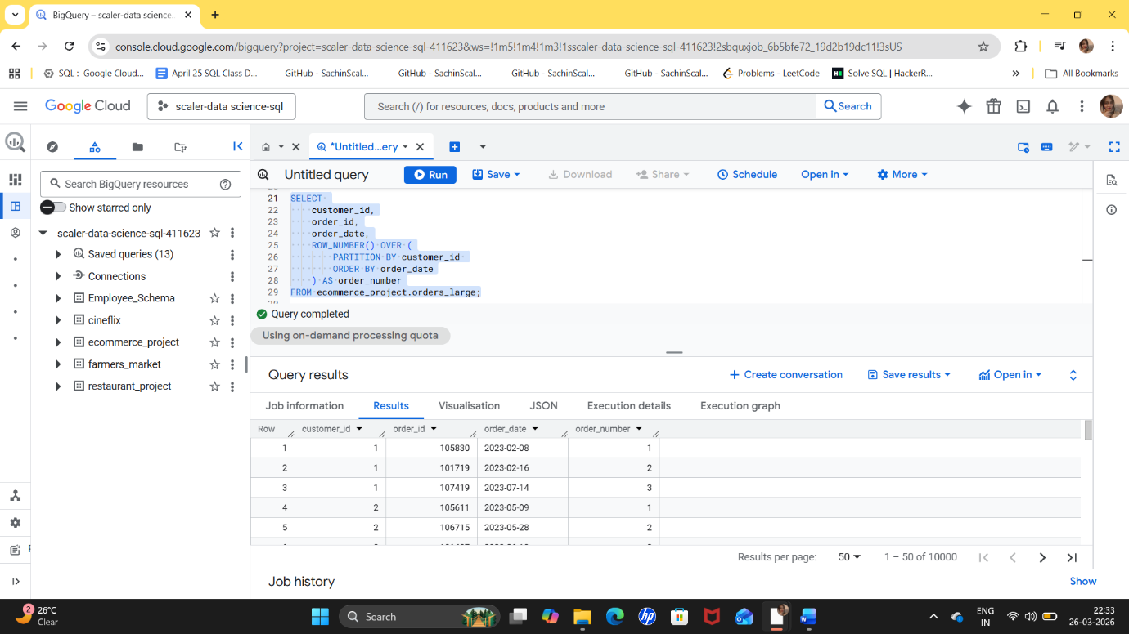
💡 Insight
Helps track customer journey (first order, second order, etc.). The data shows the order sequence for each customer, highlighting purchase frequency and engagement. Customer 3 has the highest number of orders (5), indicating strong loyalty and repeat behaviour. Customer 2 follows with 4 orders, while Customer 1 has only 3 orders with a noticeable gap between purchases, suggesting lower engagement. This variation reflects different levels of customer retention.
🎯 Recommendation
Focus on retaining highly engaged customers like Customer 3 and 2 through loyalty rewards and personalized offers to maintain repeat purchases. For less active customers like Customer 1, use reminders, discounts, and re-engagement campaigns to encourage more frequent orders. Additionally, analyse what drives repeat purchases in top customers and apply those strategies to improve overall customer retention.

Also we can target customers differently:
- First-time buyers → onboarding offers
- Repeat buyers → loyalty rewards

🔷 13. Percentage Contribution of Each Order per Customer
SELECT
customer_id,
order_id,
order_amount,
order_amount / SUM(order_amount) OVER (PARTITION BY customer_id) AS contribution
FROM ecommerce_project.orders_large;
🧠 Explanation
This calculates how much each order contributes to the customer’s total spending. It divides the order amount by total spending of that customer.
📊 Expected Output
Customer ID | Order ID | Order Amount | Contribution (%)
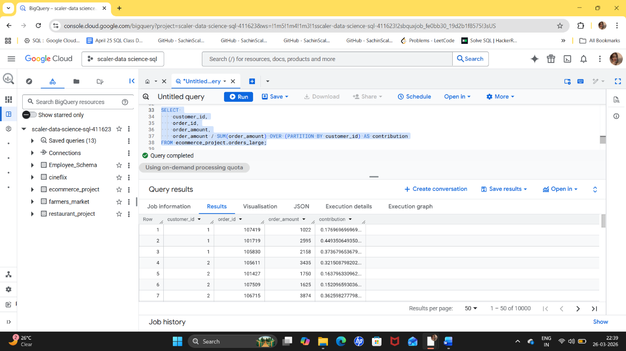
💡 Insight
Shows which orders are most important for each customer. Customer 1 depends heavily on one order (~45%), while Customer 2 is moderately balanced with one higher contribution (~36%). Customer 3 shows the most consistent behaviour with evenly spread contributions across orders.
🎯 Recommendation
Focus on high-value purchase behaviour. If customers make one big purchase, try to encourage similar purchases again. Encourage customers like Customer 1 to make more frequent purchases to reduce dependence on one large order, using targeted offers and reminders. For Customer 2, promote repeat purchases similar to their highest-value orders. Maintain engagement with Customer 3 through loyalty programs and personalized recommendations, as they show stable and consistent buying behaviour. Overall, aim to increase purchase frequency and balance spending across multiple orders to improve customer lifetime value.

