Assignment 4
Name:Tehzeeb Khalil Shaikh
Roll no:19
SET A
Q1.
import numpy as np
import matplotlib.pyplot as plt
rand_arr = np.random.randint(0,100,50)
print("\n ***** Random Number ******\n",rand_arr)
#Line Chart
x=rand_arr
y=x
plt.plot(x,color='red')
plt.xlabel("X-axis")
plt.ylabel("Y-axis")
plt.title("Line Chart")
plt.show()
#Scatter Plot
plt.scatter(x,y,marker="*",c="blue")
plt.xlabel("X-axis")
plt.ylabel("Y-axis")
plt.title("Scatter Plot")
plt.show()
#Histogram
plt.hist(x,color='green')
plt.xlabel("X-axis")
plt.ylabel("Y-axis")
plt.title("Histogram")
plt.show()
#Box Plot
plt.boxplot(x)
plt.xlabel("X-axis")
plt.ylabel("Y-axis")
plt.title("Box Plot")
plt.show()
OUTPUT: ***** Random Number ******
[62 99 73 77 34 12 36 42 5 9 12 40 39 43 72 83 77 69 74 73 92 25 72 12
49 58 46 22 62 46 49 50 21 28 18 5 71 27 76 85 97 86 57 97 15 46 49 63
85 8]
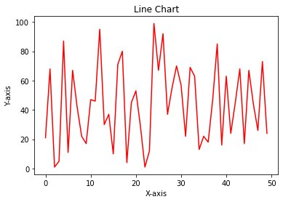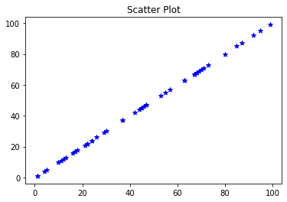

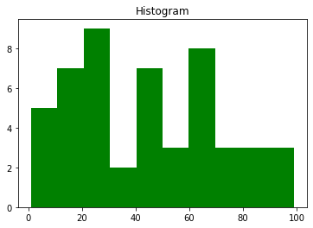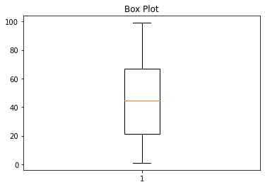
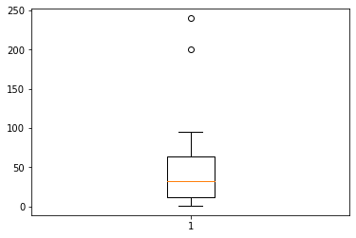
Q2.
#SETA Q2
import numpy as np
import matplotlib.pyplot as plt
arr = np.random.randint(0,100,50)
arr[48] = 200
arr[49] = 240
plt.boxplot(arr)
plt.xlabel("X-axis")
plt.ylabel("Y-axis")
plt.show()

Q3.
# SETA Q3
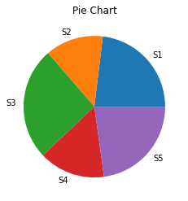
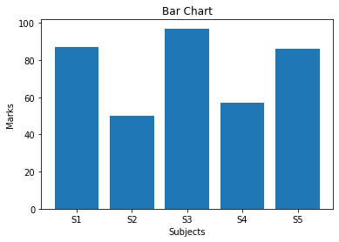
import matplotlib.pyplot as plt
import matplotlib.pyplot as plt
subject= ['S1','S2','S3','S4','S5']
marks= [87,50,97,57,86]
#Pie Chart
plt.pie(marks,labels=subject)
plt.xlabel("Subject")
plt.ylabel("Marks")
plt.title("Pie Chart")
plt.show()
#Bar Chart
plt.bar(subject,height=marks)
plt.xlabel("Subjects")
plt.ylabel("Marks")
plt.title("Bar Chart")
plt.show()

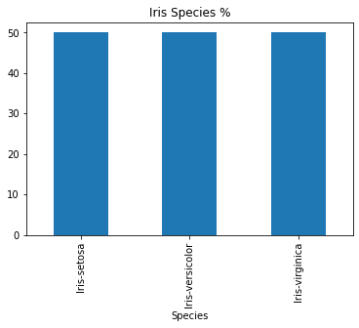
Q4.
import pandas as pd
import matplotlib.pyplot as plt
#Reading data
iris=pd.read_csv("Iris.csv")
iris['Species'].value_counts().plot.bar()
plt.title("Iris Species %")
plt.show()

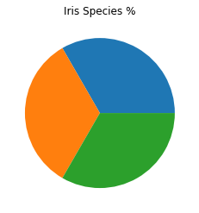

Q5.
#importin libraries
import pandas as pd
import matplotlib.pyplot as plt
#Reading data
iris=pd.read_csv("Iris.csv")
plt.pie(x=iris['Species'].value_counts())
plt.title("Iris Species %")
plt.show()

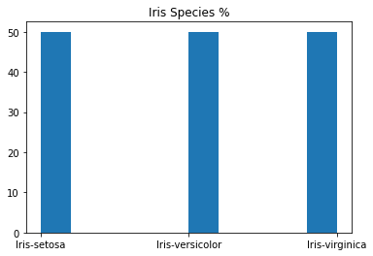
Q6.
#importing libraries
import pandas as pd
import matplotlib.pyplot as plt
#Reading data
iris=pd.read_csv("Iris.csv")
plt.hist(x=iris['Species'])
plt.title("Iris Species %")
plt.show()

SET B

Q1.
#importing libraries
import pandas as pd
import matplotlib.pyplot as plt
#loading data
iris=pd.read_csv("Iris.csv")
fig=iris[iris.Species=='Iris-setosa'].plot.scatter(x='PetalLengthCm',y='PetalWidthCm',color='orange', label='Setosa')
iris[iris.Species=='Iris-versicolor'].plot.scatter(x='PetalLengthCm',y='PetalWidthCm',color='blue', label='versicolor',ax=fig)
iris[iris.Species=='Iris-virginica'].plot.scatter(x='PetalLengthCm',y='PetalWidthCm',color='green', label='virginica',ax=fig)
fig.set_xlabel("Petal Length")
fig.set_ylabel("Petal Width")
fig.set_title("Petal Length VS Width")
plt.show()

