NAME:BAGWAN ADEEBA NADEEM
CLASS:TYBCS DIV:A
ROLL NO:03
SUBJECT:DATA SCIENCE(PRACTICAL)

Q1)
import pandas as pd
df=pd.DataFrame(columns=['Tag','Number'])
df.loc[0]=['Search',110]
df.loc[1]=['Quality',45]
df.loc[2]=['Minimum',24]
print(df)

OUTPUT:
Tag Number
0 Search 110
1 Quality 45
2 Minimum 24

Q2)
import pandas as pd
df=pd.DataFrame(columns=['FName','LName','Age'])
df.loc[0]=['tom','reacher',25]
df.loc[1]=['krish','pete',30]
df.loc[2]=['nick','wilson',26]
df.loc[3]=['juli','willians',26]
print(df)

OUTPUT:
FName LName Age
0 tom reacher 25
1 krish pete 30
2 nick wilson 26
3 juli willians 26
Q3)
import pandas as pd
df=pd.DataFrame(columns=['Category','Name','Marks'])
df.loc[0]=['DS','Linked_list',10]
df.loc[1]=['DS','Stack',9]
df.loc[2]=['DS','Queue',7]
df.loc[3]=['Algo','Greedy',8]
df.loc[4]=['Algo','DP',6]
df.loc[5]=['Algo','Backtrack',5]
print(df)

OUTPUT:
Category Name Marks
0 DS Linked_list 10
1 DS Stack 9
2 DS Queue 7
3 Algo Greedy 8
4 Algo DP 6
5 Algo Backtrack 5

Q4)
import pandas as pd
df=pd.DataFrame(columns=['Name','Marks','Status'])
df.loc[0]=['Tom',9,'Fail']
df.loc[1]=['Jack',19,'Pass']
df.loc[2]=['Lucy',20,'Pass']
df.loc[3]=['Bob',17,'Pass']
df.loc[4]=['Jerry',11,'Pass']
df.loc[5]=['Alice',18,'Pass']
df.loc[6]=['Thomas',5,'Fail']
df.loc[7]=['Barbie',8,'Fail']
print("First 3 rows:\n")
print(df.head(3))
print("Last 5 rows:\n")
print(df.tail(5))
print("First 3 records using iloc:\n")
df.iloc[0:3]
print(df)

OUTPUT:
Name Marks Status
0 Tom 9 Fail
1 Jack 19 Pass
2 Lucy 20 Pass
3 Bob 17 Pass
4 Jerry 11 Pass
5 Alice 18 Pass
6 Thomas 5 Fail
7 Barbie 8 Fail
First 3 rows:

Name Marks Status
0 Tom 9 Fail
1 Jack 19 Pass
2 Lucy 20 Pass
Last 5 rows:

Name Marks Status
3 Bob 17 Pass
4 Jerry 11 Pass
5 Alice 18 Pass
6 Thomas 5 Fail
7 Barbie 8 Fail
First 3 records using iloc:

 | Name | Marks | Status
0 | Tom | 9 | Fail
1 | Jack | 19 | Pass
2 | Lucy | 20 | Pass

Q5)
import pandas as pd
df=pd.read_csv('diamonds.csv')
print('Entire DataFrame:')
print(df)
print("\nFirst 5 records of diamonds.csv:")
print(df.head(5))
print("\nLast 5 records of diamonds.csv:")
print(df.tail(5))
print("\n Satistics details of diamonds.csv:")
print(df.describe())
print("\nSize of columns of diamonds.csv:")
print(df.shape)

OUTPUT:
Entire DataFrame:
Unnamed: 0 carat cut color clarity depth table price x \
0 1 0.23 Ideal E SI2 61.5 55.0 326 3.95
1 2 0.21 Premium E SI1 59.8 61.0 326 3.89
2 3 0.23 Good E VS1 56.9 65.0 327 4.05
3 4 0.29 Premium I VS2 62.4 58.0 334 4.20
4 5 0.31 Good J SI2 63.3 58.0 335 4.34
... ... ... ... ... ... ... ... ... ...
53935 53936 0.72 Ideal D SI1 60.8 57.0 2757 5.75
53936 53937 0.72 Good D SI1 63.1 55.0 2757 5.69
53937 53938 0.70 Very Good D SI1 62.8 60.0 2757 5.66
53938 53939 0.86 Premium H SI2 61.0 58.0 2757 6.15
53939 53940 0.75 Ideal D SI2 62.2 55.0 2757 5.83

y z
0 3.98 2.43
1 3.84 2.31
2 4.07 2.31
3 4.23 2.63
4 4.35 2.75
... ... ...
53935 5.76 3.50
53936 5.75 3.61
53937 5.68 3.56
53938 6.12 3.74
53939 5.87 3.64

[53940 rows x 11 columns]

First 5 records of diamonds.csv:
Unnamed: 0 carat cut color clarity depth table price x y \
0 1 0.23 Ideal E SI2 61.5 55.0 326 3.95 3.98
1 2 0.21 Premium E SI1 59.8 61.0 326 3.89 3.84
2 3 0.23 Good E VS1 56.9 65.0 327 4.05 4.07
3 4 0.29 Premium I VS2 62.4 58.0 334 4.20 4.23
4 5 0.31 Good J SI2 63.3 58.0 335 4.34 4.35

z
0 2.43
1 2.31
2 2.31
3 2.63
4 2.75

Last 5 records of diamonds.csv:
Unnamed: 0 carat cut color clarity depth table price x \
53935 53936 0.72 Ideal D SI1 60.8 57.0 2757 5.75
53936 53937 0.72 Good D SI1 63.1 55.0 2757 5.69
53937 53938 0.70 Very Good D SI1 62.8 60.0 2757 5.66
53938 53939 0.86 Premium H SI2 61.0 58.0 2757 6.15
53939 53940 0.75 Ideal D SI2 62.2 55.0 2757 5.83

y z
53935 5.76 3.50
53936 5.75 3.61
53937 5.68 3.56
53938 6.12 3.74
53939 5.87 3.64

Satistics details of diamonds.csv:
Unnamed: 0 carat depth table price \
count 53940.000000 53940.000000 53940.000000 53940.000000 53940.000000
mean 26970.500000 0.797940 61.749405 57.457184 3932.799722
std 15571.281097 0.474011 1.432621 2.234491 3989.439738
min 1.000000 0.200000 43.000000 43.000000 326.000000
25% 13485.750000 0.400000 61.000000 56.000000 950.000000
50% 26970.500000 0.700000 61.800000 57.000000 2401.000000
75% 40455.250000 1.040000 62.500000 59.000000 5324.250000
max 53940.000000 5.010000 79.000000 95.000000 18823.000000

x y z
count 53940.000000 53940.000000 53940.000000
mean 5.731157 5.734526 3.538734
std 1.121761 1.142135 0.705699
min 0.000000 0.000000 0.000000
25% 4.710000 4.720000 2.910000
50% 5.700000 5.710000 3.530000
75% 6.540000 6.540000 4.040000
max 10.740000 58.900000 31.800000

Size of columns of diamonds.csv:
(53940, 11)

Q6)
import pandas as pd
import numpy as np
#provided data
exam_data={'Name':['Anastasia', 'Dima','Katherine','James','Emily','Michael','Matthew','Laura','Kevin','Jonas'],'score':[12.5,9,16.5,np.nan,9,20,14.5,np.nan,8,19],'Attempts':[1,3,2,3,2,3,1,1,2,1],'qualify':['yes','no','yes','no','no','yes','yes','no','no','yes']}
labels=['a','b','c','d','e','f','g','h','i','j']
df=pd.DataFrame(exam_data, index=labels)
total_rows = df.shape[0]
total_columns = df.shape[1]
print("Total number of rows:",total_rows)
print("Total number of columns:",total_columns)

OUTPUT:
Total number of rows: 10
Total number of columns: 4
Q8)
import pandas as pd
data=[50000,65890,56780,89000,77900]
index=['QTR1','QTR2','QTR3','QTR4','QTR5']
series=pd.Series(data,index=index,name='SQTR')
print(series)

OUTPUT:
QTR1 50000
QTR2 65890
QTR3 56780
QTR4 89000
QTR5 77900
Name: SQTR, dtype: int64
Q9)
import pandas as pd
a=[10,20,25,50]
b=pd.Series([10,20,25,50])
print(a*2)
print(b*2)

OUTPUT:
[10, 20, 25, 50, 10, 20, 25, 50]
0 20
1 40
2 50
3 100
dtype: int64
Q10)
import pandas as pd
#define the series
S1=pd.Series([10,20,30,40,50,30])
S2=pd.Series([5,10,15,20,25,35],index=[0,1,2,3,4,5])
S3=pd.Series([3,1,2,3,4])
#perform the operations
print("S1 + S2:")
print(S1+S2)
print("\nS1 * S3:")
print(S1 * S3)
print("\nS1 - S2:")
print(S1 – S2)

OUTPUT:
S1 + S2:
0 15
1 30
2 45
3 60
4 75
5 65
dtype: int64

S1 * S3:
0 30.0
1 20.0
2 60.0
3 120.0
4 200.0
5 NaN
dtype: float64

S1 - S2:
0 5
1 10
2 15
3 20
4 25
5 -5
dtype: int64
Q11)
import numpy as np
data=[13,43,54,34,40,56,34,61,64,23]
#calculate range
range_value = np.max(data) - np.min(data)
#display the range
print("Range:",range_value)

OUTPUT:
Range: 51

Q12)
import matplotlib.pyplot as plt
#data
years=[2000,2002,2004,2006,2008,2010,2012,2014,2016,2018]
production=[4,6,7,15,24,2,19,5,16,4]
#create the histogram
plt.figure(figsize=(10,6))
plt.bar(years,production,color='skyblue')
plt.title('Wheat production in different years')
plt.xlabel('Year')
plt.ylabel('Production(in million tons)')
plt.xticks(years)
plt.grid(axis='y')
plt.show()

OUTPUT:
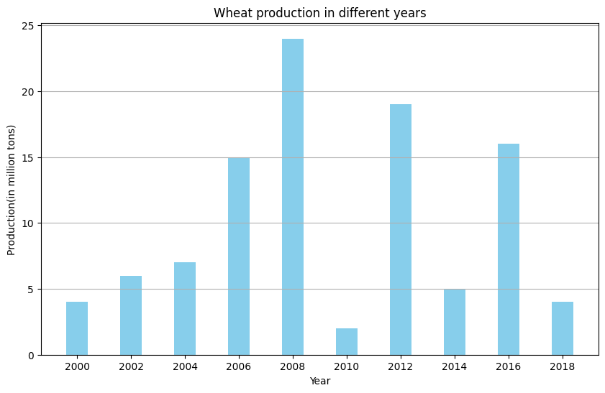

Q13)
import pandas as pd
import numpy as np
data=np.array([86,87,88,86,87,85,86])
print("Standard Deviation:",np.std(data))

OUTPUT:
Standard Deviation: 0.9035079029052513

Q14)
import numpy as np
from scipy import stats
data=[1,3,7,2,5]
arithemetic_mean=np.mean(data)
geometric_mean=stats.gmean(data)
harmonic_mean=stats.hmean(data)
print(f"Arithemetic Mean:{arithemetic_mean}")
print(f"Geometric Mean:{geometric_mean}")
print(f"harmonic Mean:{harmonic_mean}")

OUTPUT:
Arithemetic Mean:3.6
Geometric Mean:2.913693458576192
harmonic Mean:2.2975929978118166

