Name:- Shadab Sayyed
Batch:-A4 Roll No:-231
Miscellanous 1
Q1.
Program:
import pandas as pd
data={"Tag":["search","Quantitiy","Mininmum"],"Number":[110,45,24]}
df=pd.DataFrame(data)
print(df)

Output:-

Tag Number
0 search 110
1 Quantitiy 45
2 Mininmum 24

Q2.
Program:
import pandas as pd
data={"fname":["Tom","Krish","Nick","Juli"],
"lname":["Reacher","Peter","Wilson","Willams"],
"age":[25,30,26,22]}
df=pd.DataFrame(data)
print(df)

Output:-

fname lname age
0 Tom Reacher 25
1 Krish Peter 30
2 Nick Wilson 26
3 Juli Willams 22

Q3.
Program:
import pandas as pd
data={"Category":["DS","DS","DS","ALGO","ALGO","ALGO"],"Name":["LInked_list","stack","Queue","Greedy","Dp","Backtrack"],"age":[10,9,7,8,6,5]}
df=pd.DataFrame(data)
print(df)

Output:-

Category Name age
0 DS LInked_list 10
1 DS stack 9
2 DS Queue 7
3 ALGO Greedy 8
4 ALGO Dp 6
5 ALGO Backtrack 5

Q4.
Program:
import pandas as pd
df=pd.DataFrame(columns=['Name','Marks','Status'])
df.loc[0]=['Tom',9,'Fail']
df.loc[1]=['Jack',19,'Pass']
df.loc[2]=['Lucky',20,'Pass']
df.loc[3]=['Bob',17,'Pass']
df.loc[4]=['Jerry',11,'Pass']
df.loc[5]=['Alice',18,'Pass']
df.loc[6]=['Thomas',5,'Fail']
df.loc[7]=['Barbie',8,'Fail']
print(df)
print("First 3 rows:\n")
print(df.head(3))
print("Last 5 rows:\n")
print(df.tail(5))
print("First 3 records using iloc:\n")
print(df.iloc[0:3])

Output:-

Name Marks Status
0 Tom 9 Fail
1 Jack 19 Pass
2 Lucky 20 Pass
3 Bob 17 Pass
4 Jerry 11 Pass
5 Alice 18 Pass
6 Thomas 5 Fail
7 Barbie 8 Fail
First 3 rows:

Name Marks Status
0 Tom 9 Fail
1 Jack 19 Pass
2 Lucky 20 Pass
Last 5 rows:

Name Marks Status
3 Bob 17 Pass
4 Jerry 11 Pass
5 Alice 18 Pass
6 Thomas 5 Fail
7 Barbie 8 Fail
First 3 records using iloc:

Name Marks Status
0 Tom 9 Fail
1 Jack 19 Pass
2 Lucky 20 Pass

Q5.
Program:
import pandas as pd
df = pd.read_csv("diamonds.csv")
print(df)
print(df.head(5))
print(df.tail(5))
print(df.describe())
for i in df.columns:
print(f"size of {i}",df [i].size)

Output:-

Unnamed: 0 carat cut color clarity depth table price x \
0 1 0.23 Ideal E SI2 61.5 55.0 326 3.95
1 2 0.21 Premium E SI1 59.8 61.0 326 3.89
2 3 0.23 Good E VS1 56.9 65.0 327 4.05
3 4 0.29 Premium I VS2 62.4 58.0 334 4.20
4 5 0.31 Good J SI2 63.3 58.0 335 4.34
... ... ... ... ... ... ... ... ... ...
53935 53936 0.72 Ideal D SI1 60.8 57.0 2757 5.75
53936 53937 0.72 Good D SI1 63.1 55.0 2757 5.69
53937 53938 0.70 Very Good D SI1 62.8 60.0 2757 5.66
53938 53939 0.86 Premium H SI2 61.0 58.0 2757 6.15
53939 53940 0.75 Ideal D SI2 62.2 55.0 2757 5.83

y z
0 3.98 2.43
1 3.84 2.31
2 4.07 2.31
3 4.23 2.63
4 4.35 2.75
... ... ...
53935 5.76 3.50
53936 5.75 3.61
53937 5.68 3.56
53938 6.12 3.74
53939 5.87 3.64

[53940 rows x 11 columns]
Unnamed: 0 carat cut color clarity depth table price x y \
0 1 0.23 Ideal E SI2 61.5 55.0 326 3.95 3.98
1 2 0.21 Premium E SI1 59.8 61.0 326 3.89 3.84
2 3 0.23 Good E VS1 56.9 65.0 327 4.05 4.07
3 4 0.29 Premium I VS2 62.4 58.0 334 4.20 4.23
4 5 0.31 Good J SI2 63.3 58.0 335 4.34 4.35

z
0 2.43
1 2.31
2 2.31
3 2.63
4 2.75
Unnamed: 0 carat cut color clarity depth table price x \
53935 53936 0.72 Ideal D SI1 60.8 57.0 2757 5.75
53936 53937 0.72 Good D SI1 63.1 55.0 2757 5.69
53937 53938 0.70 Very Good D SI1 62.8 60.0 2757 5.66
53938 53939 0.86 Premium H SI2 61.0 58.0 2757 6.15
53939 53940 0.75 Ideal D SI2 62.2 55.0 2757 5.83

y z
53935 5.76 3.50
53936 5.75 3.61
53937 5.68 3.56
53938 6.12 3.74
53939 5.87 3.64
Unnamed: 0 carat depth table price \
count 53940.000000 53940.000000 53940.000000 53940.000000 53940.000000
mean 26970.500000 0.797940 61.749405 57.457184 3932.799722
std 15571.281097 0.474011 1.432621 2.234491 3989.439738
min 1.000000 0.200000 43.000000 43.000000 326.000000
25% 13485.750000 0.400000 61.000000 56.000000 950.000000
50% 26970.500000 0.700000 61.800000 57.000000 2401.000000
75% 40455.250000 1.040000 62.500000 59.000000 5324.250000
max 53940.000000 5.010000 79.000000 95.000000 18823.000000

x y z
count 53940.000000 53940.000000 53940.000000
mean 5.731157 5.734526 3.538734
std 1.121761 1.142135 0.705699
min 0.000000 0.000000 0.000000
25% 4.710000 4.720000 2.910000
50% 5.700000 5.710000 3.530000
75% 6.540000 6.540000 4.040000
max 10.740000 58.900000 31.800000
size of Unnamed: 0 53940
size of carat 53940
size of cut 53940
size of color 53940
size of clarity 53940
size of depth 53940
size of table 53940
size of price 53940
size of x 53940
size of y 53940
size of z 53940
Q6.
Program:
import numpy as np
import pandas as pd
import scipy.stats as sc
arr=np.array([24,29,20,22,24,26,27,30,20,31,26,38,44,47])
q3,q1=np.percentile(arr,[75,25])
print("IQR:",q3-q1)

Output:-

IQR: 6.75

Q7.
Program:
import pandas as pd
import numpy as np
exam_data={'Name':['Anastasia','Dima','Katharine','James','Emily','Micheal','Matthew','Laura','Kevin','Jonas'],'Score':[12.5,9,16.5,np.nan,9,20,14.5,np.nan,8,19],'Attempts':[1,3,2,3,2,3,1,1,2,1],'Qualify':['yes','no','yes','no','no','yes','yes','no','no','yes']}
labels = ['a','b','c','d','e','f','g','h','i','j']
df=pd.DataFrame(exam_data,index=labels)
print(df)
total_rows=len(df.axes[0])
total_col=len(df.axes[1])
print("Number of rows:",total_rows)
print("Number of columns:",total_col)

Output:-

Name Score Attempts Qualify
a Anastasia 12.5 1 yes
b Dima 9.0 3 no
c Katharine 16.5 2 yes
d James NaN 3 no
e Emily 9.0 2 no
f Micheal 20.0 3 yes
g Matthew 14.5 1 yes
h Laura NaN 1 no
i Kevin 8.0 2 no
j Jonas 19.0 1 yes
Number of rows: 10
Number of columns: 4
Q8.
Program:
import pandas as pd
a=[50000,65898,56780,89000,77900]
b=['QTR1','QTR2','QTRE3','QTRE4','QTRE4']
SQRT=pd.Series(a,index=b)
print(SQRT)

Output:-

QTR1 50000
QTR2 65898
QTRE3 56780
QTRE4 89000
QTRE4 77900
dtype: int64
Q9.
Program:
import pandas as pd
a = [10,20,25,50,]
b = pd.Series([10,20,25,50])
print(a*2)
print(b*2)

Output:-

[10, 20, 25, 50, 10, 20, 25, 50]
0 20
1 40
2 50
3 100
dtype: int64

Q10.
Program:
import pandas as pd
S1=pd.Series([10,20,30,40,50])
S2=pd.Series([5,10,15,20,25,35])
S3=pd.Series([3,6,9,10,11])
print("S1+S2:")
print(S1+S2)
print("\nS1*S3:")
print(S1*S2)
print("\n S1-S2")
print(S1-S2)

Output:-

S1+S2:
0 15.0
1 30.0
2 45.0
3 60.0
4 75.0
5 NaN
dtype: float64

S1*S3:
0 50.0
1 200.0
2 450.0
3 800.0
4 1250.0
5 NaN
dtype: float64

S1-S2
0 5.0
1 10.0
2 15.0
3 20.0
4 25.0
5 NaN
dtype: float64
Q11.
Program:
import numpy as np
data=[13,43,54,34,40,56,34,61,64,23]
range_value=np.max(data)-np.min(data)
print("Range:",range_value)

Output:-

Range: 51

Q12.
Program:
import pandas as pd
import matplotlib.pyplot as plt
years=[2000,2002,2004,2006,2008,2010,2012,2014,2016,2018]
production=[4,6,7,15,24,2,19,5,16,4]
plt.figure(figsize=(10,6))
plt.bar(years,production,color='skyblue',width=2)
plt.title("Wheat Production in Diffirent Years")
plt.xlabel('Year')
plt.ylabel('Production (in million tons)')
plt.xticks(years)
plt.grid(axis='y')
plt.show()

Output:-

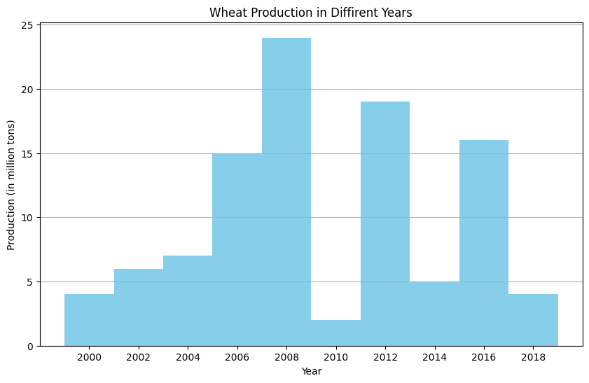

Q13.
Program:
import pandas as pd
import numpy as np
data=np.array([86,87,88,86,87,85,86])
print("Standard Deviation:",np.std(data))

Output:-

Standard Deviation: 0.9035079029052513

Q14.
Program:
import numpy as np
from scipy import stats
data=[1,3,7,2,5]
arithmetic_mean=np.mean(data)
geometric_mean=stats.gmean(data)
harmonic_mean=stats.hmean(data)
print(f"Arithmetic Mean:{arithmetic_mean}")
print(f"Geometric Mean:{geometric_mean}")
print(f"Harmonic Mean:{harmonic_mean}")

Output:-

Arithmetic Mean:3.6
Geometric Mean:2.913693458576192
Harmonic Mean:2.2975929978118166

