What are the five things you can do to help your spouse/partner who has been recently diagnosed with dementia ?

Person with dementia gradually lose their mental faculties and become confused. They tend to forget things that have happened quite recently,but may seem to have clear memory of things that happened a long time ago.They will experience mood changes, can appear to be anxious, often agitated with small issues. This can be difficult, stressful for the carer especially if the person is your spouse whom you have loved for many years.

* **Accept the diagnosis**

When your spouse is been diagnosed with a conditions that has no cure,is progressive it is natural that you might be experiencing range of emotions like guilt, grief and loss, even anger.

However you can lower your stress if you ,your family continue to live lives of acceptance, creativity instead of trying to fix the problem or meet impossible expectations. This is the first step for providing good care for your loved one living with dementia. Accept the diagnosis, understand the disease, learn tips and techniques to work effectively with your spouse who is living with dementia, you can take help, guidance of dementia care books, Psychologist ,dementia care counsellors who can prepare you better for the upcoming caregiving journey.

You will be playing an important role as a carer for your spouse who may perceive his/her circumstances differently due to memory impairment. their reality at times will not be of present but of past. They may ask for her deceased parents, may struggle to remember important events like retirement, son/daughter’s wedding etc.When you are prepared to deal with situations like this, you can provided emphatetic care that can provide your spouse support to deal with their symptoms of dementia.

* **Include the person with dementia in decisions**

Do involve your partner as much as possible in decision processes that affect them like buying anything for your partner, deciding on daily routine activities etc. It will persuade him/her to accept and use procedures ,devices etc that would help them.

Your spouse may find is confusing to handle bank or other financial task ,you will need to offer help to manage many of routine tasks. Since impaired judgement, communication is part and parcel of dementia, it is crucial that Person with dementia is provided safe and positive environment to live well with dementia .Cooking alone,driving, going out alone is best avoided for safety of the person with dementia.

* **Key is to have a daily routine :**

Set up a routine for your spouse that incorporates balanced physical activities like exercise,walking. Alongwith regular contact with family,friends ,however you may want to avoid going in crowded places as your spouse may prefer to have one to one social contact compared to group conversations. If dementia care professional home visits are available in your area,you may opt for them as they provide stimulating activities, much needed social contact which is proven to reduce anxiety,agitation in people with dementia. It is important that you encourage your spouse to maintain his independence. This can be achieved by letting him/her involve in housework, outings, any hobby of their choice.

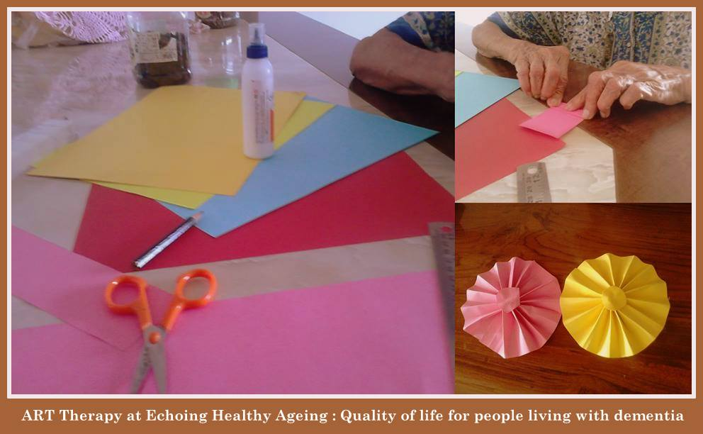

* **Set up a support system for yourself**

Decide early on ,how you wish to be involved in the care of your partner.Would you be taking help from professional carers,what kind of help you would require from your family ,friends? Think about your own health,other responsibilites while setting up care support system for your spouse.

The caregiver journey is rewarding but at the same time painful, exhausting, and long. You may experience ongoing sadness and grief.But the sake of your and partner’s health, there can also be acceptance of the good enough. Find a support group in your area that will offer you platform to discuss caregiving issues, receive support, guidance from fellow caregivers who are in similar situations.

Alzheimer’s society’s [Talking point](http://forum.alzheimers.org.uk/index.php?_ga=1.239361793.345564472.1465627303) is an international online community of caregivers, alternately [Dementia Alzheimer's Carers support India](https://www.facebook.com/groups/313578952314031/) is professionally facilitated Caregivers online group

* Look after yourself

It is difficult caring for someone when you don’t feel in good shape yourself, emotionally or physically. You may worry over the person you are caring for and worry that you are losing control of your life as you increasingly react to external demands placed on you. Try to resolve whatever is causing you to worry, then you are thinking positively and productively.

Learn simple ways to calm your mind and body, regular periods of relaxation are essential. This can be achieved by regular social contact with family, friends. Short vacations, movie outings, daytrips could offer you much needed calm, relaxed state.

Other than this, I would highly recommend learning quick relaxation techniques, like meditation, breathing exercise, incorporating positive thoughts that can influence your behaviour and will allow you to be more in control of yourself e.g “I feel at peace”, “I am content”, ”I am in control of my feelings”.

Diagnosis of dementia does not apply that person has to stop doing activities that they enjoy. With appropriate care and support person with dementia and their spouse can continue to live quality of life.

.

---------------------------------------------------------

About the Author

Amrita Patil Pimpale – Dementia Care Consultant ,Mumbai (India)

E : <amrita.p@echoinghealthyageing.com>

***Founder,Lead Consultant in***[*Echoing Healthy Ageing*](http://www.echoinghealthyageing.com)*, a social enterprise working in Dementia care sector, focusing on home based therapies, counselling, Dementia care training for family carers and professional in Mumbai.Consultant to geriatric care facilities to implement best practices. Winner of* ***Social Entrepreneur ‘ Unltd India award’*** *for Year 2012 and 2013. Previously* ***Project Manager*** *of care home improvement project in England.* ***Certified Trainer*** *of* ***Person centred dementia care*** *from University of Bradford, UK ;* ***Dementia care mapping advance practitioner*** *(an international framework used for training needs analysis, staff development, quality improvement, benchmarking and quality assurance) and Best practices dementia care from University of Stirling, Scotland. Designed, delivered training for care staff (dementia care), NHS nurses in England and has internationally published research papers in dementia care.*